UNIT 4: MUSIC AND ARTS

Lesson 1: Getting started – A talk at the school gate

  - I. OBJECTIVES
By the end of this lesson, students will be able to:
1. Knowledge
- Have an overview about the topic Music and arts
- Use the vocabulary to talk about Music and arts
2. Core competence
- Develop communication skills and creativity
- Be collaborative and supportive in pair work and team work
- Actively join in class activities
3. Personal qualities
- Develop self-study skills

II. MATERIALS
- Grade 7 textbook, Unit 4, Getting Started
- Computer connected to the Internet.
- Projector/ TV/ pictures and cards
- hoclieu.vn

  - Language analysis
Form | Pronunciation | Meaning | Vietnamese equivalent
1. classical (adj) | /ˈklæsɪkəl/ | traditional in style or form, or based on methods developed over a long period of time, and considered to be of lasting value | cổ điển
2. spare time (n) | /speər taɪm/ | time when you are not working | thời gian rảnh rỗi
3. musical instruments (n) | / ˈmjuːzɪkl ˈɪnstrəmənt/ | an object, such as a piano, guitar, or drum, that is played to produce musical sounds | nhạc cụ
4. landscape (n) | /ˈlændskeɪp/ | a large area of countryside, especially in relation to its appearance | cảnh quan
5. art gallery (n) | /ˈɑːt ˌɡæləri/ | a building where works of art can be seen by the public, are shown and can be bought | phòng trưng bày nghệ thuật

Assumptions
Anticipated difficulties | Solutions
1. Students may be lack knowledge and experiences about the topic. | Prepare some handouts.
2. Students may have underdeveloped listening, speaking and co-operating skills. | - Play the recording many times if necessary.  - Encourage students to work in pairs, in groups so that they can help each other.  - Provide feedback and help if necessary.

  - Board Plan
Date of teaching
UNIT 4: MUSIC AND ARTS
Lesson 1: Getting started – A talk at the school gate
*Warm-up
Chatting
I. Vocabulary:
1. classical (adj): cổ điển
2. spare time (n): thời gian rảnh rỗi
3. musical instruments (n): nhạc cụ
4. landscape (n): cảnh quan
5. art gallery (n): phòng trưng bày nghệ thuật
II. Practice:
Task 1: Tick the correct answers.
Task 2: Complete the sentences with a suitable word or phrase from the box.
Task 3: Write the correct word or phrase under each picture.
Task 4: Quiz “How artistic are you?”.
*Homework

III. PROCEDURES
Notes:
In each activity, each step will be represented as following:
* Deliver the task
** Implement the task
*** Discuss
 Give comments or feedback

Stage | Stage aim | Procedure | Interaction | Time
WARM-UP | - To create an active atmosphere in the class before the lesson.  - To introduce the topic. | CHATTING  * Teacher plays a piece of music and lets students listen to.  https://www.youtube.com/watch?v=rotCiRkaE08&ab_channel=Dmusix  ** Students listen to music.  *** After that, teacher asks students some questions about it and calls some students to give their ideas.  - Do you like the piece of music you have listened?  - Do you know what kind of music it is?  - When do you listen to music?  - How do you feel when you listen to music?  - Is music important to our life?   Teacher comments on their ideas and then leads students to the new topic in Unit 4. | T-Ss  Ss-Ss  T-Ss  T-Ss | 5 mins
LEAD-IN | To lead in the topic. | Teacher says: “As you can see, music and arts play an important role in our life. It can help people relax, entertain, or enrich their mind. Therefore, in Unit 4 we are going to learn more about them Music and Arts.”  SET THE SCENE: PRE- QUESTIONS  * Teacher draws students’ attention to the pictures in the textbook and asks them some questions about the pictures. Teacher don’t confirm whether their answers are right or wrong.  1. Who are they?  2. What are they doing?  3. What are you going to learn in this lesson today?  Suggested answers:  1. They are Trang and Nick / students.  2. Nick is playing the piano and Trang is drawing.  3. (Students’ answer)  ** Students work out and answer questions in pairs.  *** Students share their answers as a whole class.   Teacher asks them to read and listen to the conversation to check their answers. | T-Ss  T-Ss  Ss-Ss  Ss-Ss  T-Ss | 5 mins
PRESENTATION  (VOCAB  PRE-TEACH) | To introduce the new words. | VOCABULARY:  * Teacher introduces the vocabulary by:  + showing the pictures illustrating the words;  + providing the synonym or antonym of the words;  + providing the definition of the words.  1. classical (a): [antonym]  2. spare time (n): [synonym / explanation]  3. musical instruments (n): [visual]  4. landscape (n): [explanation]  5. art gallery (n): [visual]  1.   2.   3. 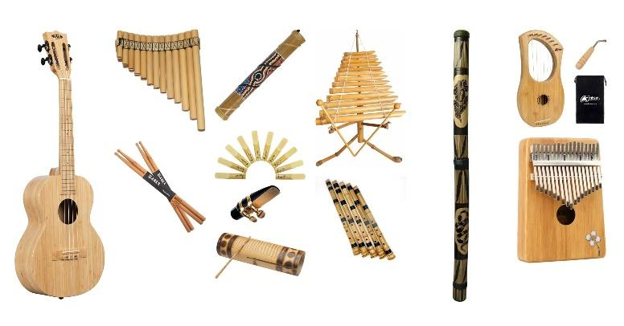  4.   5. 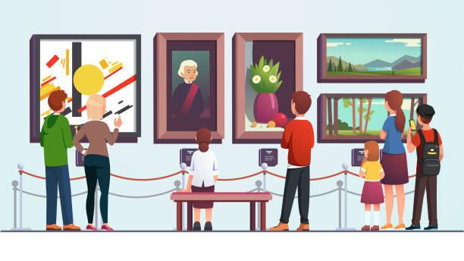  ** Students say the words.  *** Other students correct if the previous answers are incorrect.   Teacher shows and says the words aloud and asks students to repeat them.  LISTEN AND READ. (Ex. 1, p. 40)  * Teacher plays the recording, asks students to underline the words related to the topic Music and arts. (Teacher may check the meaning of some words if necessary.)  - Teacher can play the recording more than once.  - Students listen and read.  ** Teacher can invite some pairs of students to read aloud.  *** Teacher refers to the questions previously asked.   Then, teacher confirms the correct answer: “Trang and Nick are going to tell us about their hobbies, especially about music and arts. | T-Ss  Ss  Ss-Ss  T-Ss  T-Ss  T-Ss  T-Ss  T-Ss | 8 mins
PRACTICE (CONTROLLED PRACTICE) | To help students understand the main idea of the conversation.  To help students understand more the text; to acquaint students with the grammar points and new vocabulary of the unit.  To develop students’ knowledge of the vocabulary about music and arts.  To help students revise the vocabulary related to the topic Music and arts and to evaluate how artistic they are. | TASK 1: TICK THE CORRECT ANSWERS. (Ex. 2, p. 41)  * Teacher asks students to answer without reading the conversation again.  ** Ss work out and answer questions in pairs.  *** Teacher asks some students to explain why they did not choose the other two options.   Teacher confirms the correct answer.  Answer key: C  TASK 2: COMPLETE EACH OF THE SENTENCES WITH A SUITABLE WORD OR PHRASE FROM THE BOX. (Ex 3, p. 41)  * Teacher asks students to work independently to read the sentence, identify the kind of information to fill in the blanks, read the text again to locate the place to find the word.  ** Students work individually, then they can share their answers with their partners before discussing as a class.  *** Teacher calls some students to check.   Teacher confirms the right answers and writes on the board.  Answer key:  1. art gallery  2. photos  3. different from  4. like  5. musical instruments  TASK 3: WRITE THE CORRECT WORD OR PHRASE UNDER EACH PICTURE. (Ex 4, p. 41)  * Teacher asks students to work in pairs to do the task.  ** Students work in pairs.  *** Teacher plays the recording for students to check and repeat.   Teacher checks and corrects their pronunciation and gives students the meaning of the words if needed.  Answer key:  1. paintbrush  2. camera  3. painting  4. musical instruments  5. water puppet show  6. art gallery  TASK 4: QUIZ HOW ARTISTIC ARE YOU? (Ex 5, p. 41)  * Teacher asks students to work individually to answer all the questions and add up their points.  ** Students work individually to do the task.  *** Students report to their groups how artistic they are. Then, teacher calls on some students to report to the whole class.   Teacher gives some comments. | T-Ss  Ss  S  T-Ss  T-Ss  S  T-Ss  T-Ss  T-Ss  Pair work  T-Ss  T-Ss  T- Ss  S  Group work  T- Ss | 25 mins
CONSOLIDATION | To consolidate what students have learnt in the lesson. | - Ask one or two students to tell the class what they have learnt.  - Ask students to say aloud some words they remember from the lesson. If there is an overhead projector in the classroom, show the dialogue and highlight the key words related to the topic. | T-Ss | 1 min
HOMEWORK | To prepare vocabulary for the next lessons. | - Prepare the vocabulary for the next lesson: A closer look 1.  - Project preparation  + Teacher informs student of the final project of the Unit’s project.  + Explain the requirements of the project: Imagine that you are going to organise a music show and then design an invitation for that show. Students will show their posters and present their ideas in Lesson 7 – Looking back and Project.  + Teacher explains to students how they can get the information.  + Put students into groups and ask them to discuss to assign tasks for each member. Help them set a deadline for each task.  (Teacher should check the progress of students’ preparation after each lesson.) | T-Ss | 1 min

UNIT 4: MUSIC AND ARTS

Lesson 2: A closer look 1

  - I. OBJECTIVES
By the end of this lesson, students will be able to:
1. Knowledge
- Vocabulary:
+ use the lexical items related to the topic Music and arts;
+ pronunciation: pronounce and recognize the sounds /ʃ/ and /ʒ/.
2. Core competence
- Develop communication skills
- Be collaborative and supportive in pair work and teamwork
- Actively join in class activities
3. Personal qualities
- Be ready to know the words about music and arts
- Develop self-study skills

  - II. MATERIALS
- Grade 7 textbook, Unit 4, A closer look 1
- Computer connected to the internet
- TV/ Projector/ Pictures/ Cards
- hoclieu.vn

  - Language analysis
Form | Pronunciation | Meaning | Vietnamese equivalent
1. concert hall (n) | /ˈkɒnsət ˌhɔːl/ | a large building in which concerts are performed | phòng hòa nhạc
2. actress (n) | /ˈæktrəs/ | a woman who pretends to be someone else while performing in a film, play, or television programme | nữ diễn viên
3. artist (n) | /ˈɑːtɪst/ | someone who paints, draws, or makes sculptures | nghệ sĩ
4. composer (n) | /kəmˈpəʊzə(r)/ | a person who writes music | nhà soạn nhạc
5. puppet (n) | /ˈpʌpɪt/ | ​a toy in the shape of a person or animal that you can move with strings or by putting your hand inside | con rối
6. portrait (n) | /ˈpɔːtrət/ | a painting, photograph, drawing, etc. of a person or, less commonly, of a group of people | chân dung
7. photography (n) | /fəˈtɒɡrəfi/ | the activity or job of taking photographs or filming | nhiếp ảnh
8. perform (v) | /pəˈfɔːm/ | to do an action or piece of work | thực hiện/ trình diễn

Assumptions
Anticipated difficulties | Solutions
1. Students may lack knowledge about some lexical items. | Provide students with the meaning and pronunciation of some lexical items.
2. Students may have underdeveloped listening, speaking and co-operating skills. | - Play the recording many times if necessary.  - Encourage students to work in pairs, in groups so that they can help each other.  - Provide feedback and help if necessary.
3. Some students will excessively talk in the class. | - Define expectation in explicit detail.  - Have excessive talking student’s practise.  - Continue to define expectations in small chunks (before every activity).

  - Board Plan
Date of teaching
Unit 4: Music and arts
Lesson 2: A closer look 1
*Warm-up
Game: Guessing game
I. Vocabulary
1. concert hall (n)
2. actress (n)
3. artist (n)
4. composer (n)
5. puppet (n)
6. portrait (n)
7. photography (n)
8. perform (v)
Task 1: Listen and repeat these words and phrases, then write them in the correct columns.
Task 2: Match a word in A with a word or phrase in B.
Task 3: Underline the correct word to complete each sentence.
II. Pronunciation: /ʃ/ and /ʒ/
Task 4: Listen and repeat.
Task 5: Listen and repeat, and single-underline the words with the sound /ʃ/ and double-underline the words with the sound /ʒ/.
III. Production
Game: Simon says
*Homework

III. PROCEDURES
Notes:
In each activity, each step will be represented as following:
* Deliver the task
** Implement the task
*** Discuss
 Give comments or feedback

Stage | Stage aim | Procedure | Interaction | Time
WARM-UP | To activate students’ prior knowledge and vocabulary related to the topic, the targeted vocabulary, and its pronunciation. | Game: Guessing game: Kinds of music  * Teacher divides students into 2 groups and has them listen to some songs to guess what kinds of music they are.  ** Students work in 2 groups, try to listen, and guess.  *** The member in each group which has the answer can raise hand. If student has the correct answer, he/ she will get 1 point for his/ her group.   Teacher confirms the winner.  Suggested answers:  1. Classical music:  https://www.youtube.com/watch?v=zHvBPwNUBS8&ab_channel=JervyHou  2. Rock:  https://www.youtube.com/watch?v=AW8AFTBbetI&ab_channel=Infraction-NoCopyrightMusic  3. Jazz:  https://www.youtube.com/watch?v=jUCxIbI9cak&ab_channel=bojunc  5. Pop:  https://www.youtube.com/watch?v=8xg3vE8Ie_E&ab_channel=TaylorSwiftVEVO  6. Country music:  https://www.youtube.com/watch?v=rCIXjYo9qs4&ab_channel=MusicTravelLove | T-Ss  Group work  Ss-Ss  T-Ss | 5 mins
LEAD-IN | To lead in the lesson about vocabulary and pronunciation. | Teacher leads students into the lesson by telling them that “In today lesson, we are going to learn more words to talk about Music and arts and two sounds /ʃ/ and /ʒ/.” | T-Ss | 1 min
VOCABULARY | To introduce visually some words related to the topic.  To revise / teach the names of some people and places related to the topic.  To teach students how to combine a verb and a noun to talk about music and arts.  To give students practice in how to use words/ phrases related to music and arts in context. | VOCABULARY  * Teacher introduces the vocabulary by:  + providing the synonyms or antonyms of the words;  + providing the pictures of the words.  - Teacher has students read the phrases aloud and corrects their pronunciation if needed.  - Teacher asks students for the Vietnamese meanings of these phrases.  1. concert hall (n): [visual + explanation]    2. actress (n): [visual + explanation]    3. artist (n): [visual + explanation]    4. composer (n): [visual + explanation]  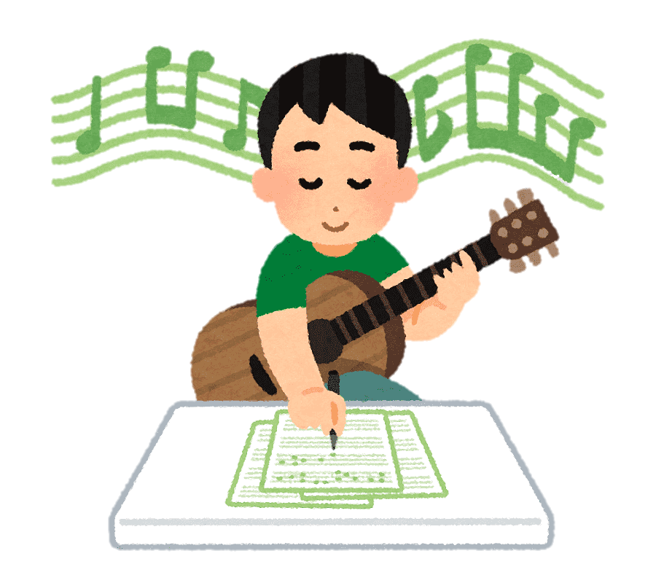  5. puppet (n): [visual + explanation]  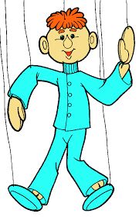  6. portrait (n): [visual + explanation]    7. photography (n): [visual + explanation]    8. perform (v): [visual + explanation]    ** Students say the words.  *** Other students correct if the previous answers are incorrect.   Teacher shows and says the words aloud and asks students to repeat them.  Checking techniques:  “Rub out and remember”  - TASK 1: LISTEN AND REPEAT THESE WORDS AND PHRASES, THEN WRITE THEM IN THE CORRECT COLUMNS. (Ex. 1, p. 42)  * Teacher asks students to listen and repeat the words independently.  ** Students work individually.  *** Teacher calls on some students to read aloud the words.   Teacher corrects their pronunciation and explains the meaning of these words/ phrases if needed.  * After that, teacher asks students work in pairs to put these words / phrases in the correct box.  ** Students work in pairs.  *** Some students read out their answers.   Teacher confirms the correct answers.  Answer key:  People Places  actress artist composer musician painter art gallery concert hall puppet theatre  TASK 2: MATCH A WORD IN A WITH A WORD OR PHRASE IN B. (Ex 2, p. 42)  * Teacher asks students to work in pairs to do the task and explains to students that in English some verbs and nouns go together, and some don’t.  ** Students work in pairs to do matching to form collocations.  *** Some students give their answers.   Teacher checks students ‘answers as a class.  Answer key:  1. e  2. d  3. a  4. c  5. b  TASK 3: UNDERLINE THE CORRECT WORD TO COMPLETE EACH SENTENCE. (Ex 3, p. 42)  * Teacher has students work individually to read the sentences carefully and look for clues to complete the sentences.  ** Students work individually to do the task.  *** One student writes the words on the board.   Teacher confirms the correct answers.  Suggested answers:  1. drawing  2. composer  3. museum  4. concert  5. photography | T-Ss  Ss-Ss  Ss-Ss  T-Ss  T-Ss  S  T-Ss  T-Ss  T- Ss  Pair work  Ss  T-Ss  T-Ss  Pair wok  Ss  T-Ss  T-Ss  Ss  Ss  T-Ss | 9 mins
PRONUNCIATION | To help students identify how to pronounce the sounds /ʃ/ and /ʒ/.  To help students practise pronouncing these sounds in words.  To help students pronounce the final sounds /ʃ/ and /ʒ/ correctly in context. | PRONUNCIATION  *Teacher writes on the board two words musician and television. Then, teacher has students focus on the sounds of the two underlined letters “c” and “s”.  ** Students practice saying the word individually.  *** Teacher calls some students to read aloud.   Teacher corrects if needed.  * After that, teacher says “In this lesson we are going to learn how to pronounce two sounds /ʃ/ and /ʒ/”.  **Teacher asks students to watch Tiếng Anh 7 - Pronunciation video, Unit 4  (link youtube)  *** Students imitate and practise the two sounds together.   Teacher explains if needed.  TASK 4: LISTEN AND REPEAT. (Ex 4, p. 42)  * Teacher has students read out the words first.  ** Students practice saying the words independently.  ***Teacher asks students to listen and try to repeat the words as a class, a group, and individually.   Teacher may play the recording as many times as necessary and correct their pronunciation.  TASK 5: LISTEN AND REPEAT, AND SINGLE-UNDERLINE THE WORDS WITH THE SOUND /ʃ/ AND DOUBLE-UNDERLINE THE WORDS WITH THE SOUND /Ʒ/. (Ex 5, p. 42)  * Teacher has students read the sentences and tells them to pay attention to the words with sounds /ʃ/ and /ʒ/ to underline.  ** Students read and underline words with the two sounds they have learnt.  *** Teacher plays the recording for students to listen and repeat each sentence. Teacher calls on some students to read the sentences individually.   Teacher corrects their pronunciation if needed.  Suggested answers:  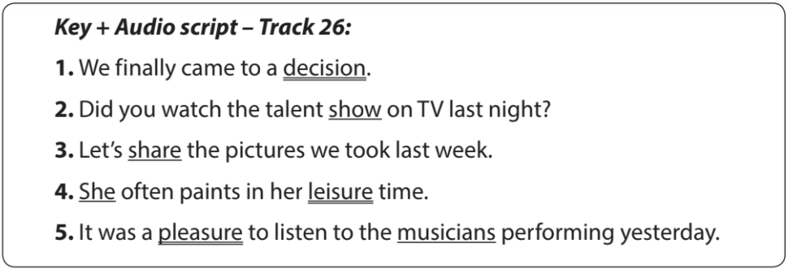 | T-Ss  Ss  T-Ss  T-Ss  T-Ss  T-Ss  Ss-Ss  T-Ss  T-Ss  Ss  T-Ss  T-Ss  T-Ss  S  T-Ss  T-Ss | 12 mins
 | To give students chances to apply what they have learnt. | GAME: SIMON SAYS  * Teacher prepares some words which include the two sounds students have learnt.  - Teacher gives students the rules of the game:  + If teacher says only one word 🡪 all students must sit still. The person who stands up will be the loser.  + If teacher says, “Simons says …….” 🡪 all students must listen carefully to identify which sound mentioned in each word.  🡪 /ʃ/: students stand up.  🡪 /ʒ/: students sit still.  + At the end of the game: the group which has more students with correct answers will be the winner.  ** Students listen to the rules of the game and can discuss with other members in their groups.  *** Students play in groups.   Teacher informs which group is the winner.  Suggested answers:  condition, ocean, measure, pleasure, shy, vision, sugar, machine, closure, dishwasher, occasion, leisure, rubbish, etc. | T-Ss  Ss-Ss  Ss-Ss  T-Ss | 6 mins
CONSOLIDATION | To consolidate what students have learnt in the lesson. | Teacher asks students to talk about what they have learnt in the lesson. | T-Ss | 1 min
HOMEWORK | To revise what they have learnt. | Find 5 more words with the sound /ʃ/ and 5 more words with the sound /ʒ/. Write them down and practice pronouncing the words. | T-Ss | 1 min

UNIT 4: MUSIC AND ARTS

Lesson 3: A closer look 2

  - I. OBJECTIVES
By the end of this lesson, students will be able to:
1. Knowledge
- Know how to recognize and write comparisons with like, different from, (not) as … as:
Types of comparisons | How to use | Examples
1. like | to show that sth is similar to sth else. | This picture is like the one I saw at the art museum.
2. different from | to show that two or more things are not similar. | Painting portraits is different from painting landscapes.
3. as + adj + as | to show that two things are similar. | My brother is as tall as my father.
4. not as + adj + as | to show that sth is “more” or “less” than sth else. | Classical music is not as exciting as rock.
2. Core competence
- Develop communication skills
- Be collaborative and supportive in pair work and team work
- Actively join in class activities
3. Personal qualities
- Be responsible and hard-working

  - II. MATERIALS
- Grade 7 textbook, Unit 4, A closer look 2
- Computer connected to the Internet
- TV/ Projector/Pictures, sets of word cards
- hoclieu.vn

Assumptions
Anticipated difficulties | Solutions
1. Students may lack knowledge and experiences about the topic. | Prepare some hand-outs.
2. Some students will excessively talk in the class. | - Define expectation in explicit detail.  - Have excessive talking student’s practise.  - Continue to define expectations in small chunks (before every activity).

Board Plan
Date of teaching
Unit 4: Music and arts
Lesson 3: A closer look 2
*Warm-up
BRAINSTORMING
I. Grammar: Comparisons
1. like → To show that sth is similar to sth else.
2. different from → To show that two or more things are not similar.
3. as + adj + as → To show that two things are similar.
4. not as + adj + as → To show that sth is “more” or “less” than sth else.
II. Practice
Task 1: Write like, as, or different in the blanks.
Task 2: Finish the second sentence in each pair.
Task 3: Compare the two museums.
Task 4: Rewrite the sentences.
III. Production
Task 5: Look at the two pictures and compare them.
*Homework
III. PROCEDURES
Notes:
In each activity, each step will be represented as following:
* Deliver the task
** Implement the task
*** Discuss
 Give comments or feedback

Stage | Stage aim | Procedure | Interaction | Time
WARM-UP | To activate students’ prior knowledge and vocabulary related to the targeted grammar. | GAME: BRAINSTORMING  * Teacher asks students to work in 2 teams to think of as many adjectives to describe as possible.  ** Students work in 2 teams.  *** In 1 minute, students from each team, turn by turn, run to the board and write down one adjective.   Teacher comments and counts how many correct answers for each team.  - The team which has more correct answers will be the winner.  Adjectives  Suggested answers:  big, small, heavy, light, cheap, expensive, boring, interesting, special, fun, thin, fat, tall, short, handsome, ugly, etc.  * Teacher shows the picture and asks students to use one adjective they have found to make comparisons.  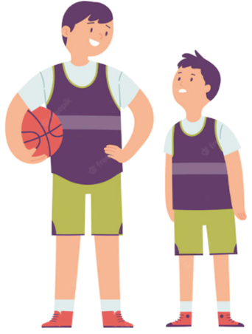  ** Students work individually.  *** Students give teacher a sentence:  “The boy on the left is taller than the boy on the right.”   Teacher gives feedback, then lead to the new lesson. | T-Ss  Team work  Ss-Ss  T-Ss  T-Ss  Ss  Ss  T-Ss | 5 mins
LEAD-IN | To introduce the targeted grammar of the lesson. | Teacher says: “This lesson today is going to tell you more about comparisons using like, different from, (not) as … as” | T-Ss | 1 min
PRESENTATION | To introduce the form of comparisons to students. | COMPARISONS  * Teacher prepares some pictures and asks students to make comparisons.  ** Students make comparison, using the pictures teacher shows on the screen.  Elicit the model sentences:  1. Teacher points to the yellow pencil and the orange pencil.    Students: The yellow pencil is shorter than the orange one.  Teacher: Right! Or I can say: “The yellow pencil is not as long as the orange one.”  2. Teacher points to the yellow pencil and the pen and asks students to focus on the length of the two things.    🡪 The pen is as long as the yellow pencil.  3. Teacher points to the yellow pencil and the pen again and has students focus on their shape.  🡪 The pen is different from the yellow pencil.  4. Teacher says: “This is Robert’s pencil case and this is Mary’s pencil case” and asks them make comparison with “like”.  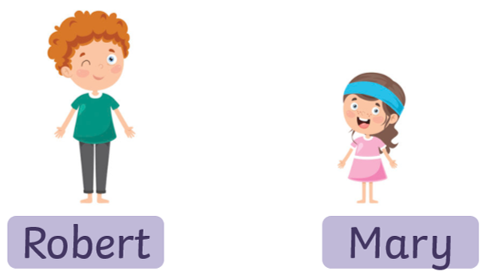  🡪 Robert’s pencil case is like Mary’s pencil case.  *** Students find out the form and the usage of comparisons using “like, different from, (not) as … as”  Concept checking:  + Form:  1. (not) as + adj + as  2. as + adj + as  3. to be different from  4. like  + Use: ask students to read “Remember box”, then teacher asks students some questions to check understanding.   Teacher gives comments and writes on the board the form and the usage. | T-Ss  Ss-Ss  Ss  T-Ss | 9 mins
PRACTICE/ CONTROLLED PRACTICE | To help students identify the correct form of comparisons using like, different from, (not) as … as.  To help students use the correct comparisons using like, different from, (not) as … as.  To help student practiSe using like, different from, (not) as … as.  To help students revise to write comparisons using like, different from, (not) as … as. | TASK 1: WRITE LIKE, AS, OR DIFFERENT IN THE BLANKS. (Ex 1, p. 43)  * Teacher asks students to do the exercise individually and then compare their answers with a classmate.  ** Students do the task individually.  *** Some students explain their choices.   Teacher confirms the correct answers.  Answer key:  1. as  2. like  3. different  4. as  5. different  TASK 2: FINISH THE SECOND SENTENCE IN EACH PAIR, USING LIKE, AS … AS, OR DIFFERENT FROM. (Ex 2, p. 43)  * Teacher has students do this exercise individually.  ** Students do the task individually.  *** Students give and explain their answers.  ****Teacher confirms the correct answers.  Answer key:  1. different from  2. like  3. as … as  4. different from  5. as … as  TASK 3: COMPARE THE TWO MUSEUMS: HISTORY AND SCIENCE, USING LIKE, AS … AS, OR DIFFERENT FROM. (Ex 3, p. 43)  * Teacher asks students to work in pairs and helps them interpret the table first.  ** Students work in pairs to do the task and teacher encourages students to talk as much as possible.  *** Teacher calls on students to read aloud the complete sentences.   Teacher confirms the correct answers and helps them to correct mistakes if needed.  Suggested answers:  1. The History Museum is not as modern as the Science Museum.  2. The staff in History Museum is as friendly as ones in Science Museum.  3. Things in History Museum are more interesting than things in Science Museum.  4. The price in History Museum is like in Science Museum.  TASK 4: REWRITE THE SENTENCES, USING THE WORDS GIVEN AT THE BEGINNING. (Ex 4, p. 43)  * Teacher asks students to do the task individually to write down the sentences in their notebooks.  ** Students do the task individually and compare with their partners.  *** Some students write their answers on the board.   Teacher confirms the correct answers.  Suggested answers:  1. I think comedies are not as interesting as action films.  2. Our history homework is not as difficult as our maths homework.  3. This year’s music contest is not like last year’s.  4. The characters in the film are different from the ones in the play.  5. That picture is not as bright as this one. | T-Ss  Ss  Ss  T-Ss  T-Ss  Ss  Ss  T-Ss  T-Ss  Pair work  T-Ss  T-Ss  T-Ss  Ss  Ss  T-Ss | 20 mins
PRODUCTION | To help students practise speaking, using like, different from, (not) as … as through pictures. | TASK 5: LOOK AT THE TWO PICTURES AND COMPARE THEM. (Ex 5, p. 43)  * Teacher asks students to work in groups to find out the similarities and differences between the two pictures and the things in them.  ** Students work in groups to do the task.  *** Students give as many sentences as possible.   Teacher listens to students to correct common errors after finishing speaking.  Suggested answers:  - Picture A is not as big as picture B.  - The cat in picture A is different from the cat in picture B.  - The cat in the house in picture A is like the cat in the house in picture B.  - The fish in picture A is not as big as the fish in picture B.  - The flower in picture A is not as small as the flower in picture B. | T-Ss  Group work  Ss  T-Ss | 7 mins
CONSOLIDATION | To consolidate what students have learnt in the lesson. | Teacher asks students to talk about what they have learnt in the lesson. | T-Ss | 2 mins
HOMEWORK | To revise what they have learnt. | Do exercises in the workbook. | T-Ss | 1 min

UNIT 4: MUSIC AND ARTS

Lesson 4: Communication

  - I. OBJECTIVES
By the end of this lesson, students will be able to:
1. Knowledge
- Learn how to deal with some ways of expressing preferences
- Practise using some grammar points and vocabulary related to the topic
2. Core competence
- Develop communication skills
- Be collaborative and supportive in pair work and team work
- Actively join in class activities
3. Personal qualities
- Be benevolent and responsible

  - II. MATERIALS
- Grade 7 textbook, Unit 4, Communication
- Computer connected to the internet
- TV/ Pictures/ Projector
- hoclieu.vn

Assumptions

Anticipated difficulties | Solutions
1. Students may lack knowledge about the topic. | Provide students with information about the knowledge they do not know.
2. Students may have underdeveloped reading, speaking and cooperating skills. | - Encourage students to work in pairs, in groups so that they can help each other.  - Provide feedback and help if necessary.
3. Some students will excessively talk in the class. | - Define expectation in explicit detail. Have excessive talking students practise.  - Continue to define expectations in small chunks (before every activity).

Board Plan
Date of teaching
Unit 4: Music and arts
Lesson 4: Communication
*Warm-up
Game: Pelmanism

I. Everyday English
Expressing preferences
Structure: to express preferences
- prefer sth
- like sth better
Task 1: Listen and read the dialogue.
Task 2: Make similar conversation.
II. Music and arts in school
Task 3: Choose the correct answer to each question.
Task 4: Read and underline the words related to the topic of arts and music.
Task 5: Talk about how you learn music and arts. Compare Susie’s school with your school.
*Homework

III. PROCEDURES
Notes:
In each activity, each step will be represented as following:
* Deliver the task
** Implement the task
*** Discuss
 Give comments or feedback

Stage | Stage aim | Procedure | Interaction | Time
WARM-UP | To revise the old lesson and introduce the new lesson. | GAME: PELMANISM  * Teacher divides the class into 2 teams and asks them to think of the vocabulary they have learnt in the previous lessons.  ** In 2 minutes, each member from each team has to take turns to turn over one card and try to find a card that matches it.  *** If the two cards match each other, the team gets one point.  - If the two cards are different, put them back in the same places, facing down.   The team with more points will win the game.  art gallery concert hall actress portrait  composer landscape painter puppet theatre | T-Ss  Team work  Team work  T-Ss | 5 mins
LEAD-IN | To lead in the lesson. | Teacher leads students into the lesson by telling what they are going to learn: “We are going to learn how to express preferences and use the grammar and the vocabulary related to our topic Music and arts”. | T-Ss | 1 min
EVERYDAY ENGLISH | To introduce two ways of expressing preferences. | TASK 1: LISTEN AND READ THE DIALOGUE, PAYING ATTENTION TO THE HIGHLIGHTED PARTS. (Ex. 1, p. 45)  * Teacher plays the recording for students to listen and read the conversation.  ** Students listen and practise saying with their partners.  *** Teacher calls some pairs to read aloud.   Teacher corrects pronunciation if needed.  * Teacher asks students to pay attention to the highlighted parts and asks them some questions to elicit the new structure  ** Students answer teacher’s questions to find out new structure to express preferences.  *** Some students give the new structure to the teacher.   Teacher corrects and writes on the board:  Structure: to express preference  - prefer sth  - like sth better | T-Ss  Pair work  T-Ss  T-Ss  T-Ss  T-Ss  T-Ss  T-Ss | 10 mins
 | To help students practise expressing their preferences. | TASK 2: MAKE SIMILAR CONVERSATION. (Ex. 2, p. 45)  Work in pairs. Ask and answer questions about your preferences for painting and taking photos; singing and dancing.  * Teacher has students look at the situation in Ex. 2 to make similar dialogue:  1. painting and taking photos  2. singing and dancing  ** Students work in pairs to make similar dialogue.  *** Teacher calls some pairs to present it in front of the class.   Teacher gives feedback and some comments.  Suggested answers:  A: Which do you prefer, painting or taking photos?  B: I prefer taking photos because it is more interesting.  A: And which do you like better, singing or dancing?  B: I like dancing better. | T-Ss  Pair work  T-Ss  T-Ss | 7 mins
MUSIC AND ARTS IN SCHOOL | To help students recall or get to know some information about famous people in the field of music and arts, and some common forms of arts. | TASK 3: CHOOSE THE CORRECT ANSWER TO EACH QUESTION. (Ex. 3, p.45)  What do you know? Work in groups and choose the correct answer to each question.  * Teacher asks students to work in pairs to choose the correct answer.  ** Students do the task in pairs.  *** Teacher calls some students to give their answer and explain it.   Teacher confirms the correct answers.  Answer key:  1. B  2. A  3. A  4. B | T-Ss  Pairs work  T-Ss  T-Ss | 5 mins
 | To help students revise vocabulary related to the topic and to introduce how students in other countries learn music and arts. | TASK 4: READ THE FOLLOWING PARAGRAPH. UNDERLINE THE WORDS RELATED TO THE TOPIC OF ARTS AND MUSIC. (Ex. 4, p. 45)  * Teacher asks students to work individually to read through the paragraph, find, and underline the words related to the topic.  ** Students work in individually.  *** Some students read aloud.   Teacher confirms and corrects if needed.  Suggested answer: (Teacher’s book, p.69)  Hi. My name is Susie. I’m from Australia. I’m in grade 7. My school teaches arts and music to all the students. Some forms of art such as painting or drama are optional: you can choose to learn them if you like. Music and dancing are compulsory: all of us must study them every week. The school even has a choir, and they perform every month. There are also different art clubs, and you can join any of them. | T-Ss  Ss  T-Ss  T-Ss | 5 mins
 | - To help students talk about how students in Viet Nam study music and arts.  - To help them compare their school and schools in other countries. | TASK 5: TALK ABOUT HOW YOU LEARN MUSIC AND ARTS. COMPARE SUSIE’S SCHOOL WITH YOUR SCHOOL. YOU CAN USE LIKE, AS … AS, OR DIFFERENT FROM. (Ex 5, p. 45)  * Teacher asks students to work in group to discuss how students in Viet Nam learn music and arts, then compare with Susie’s school.  ** Students work in groups to take notes some activities they have when learning music and arts, then compare.  - Teacher goes round the class to monitor and give support if necessary.  *** Students from each group present their ideas to the class.  ****Teacher comments on their clarify, language, fluency, grammar,… | T-Ss  Group work  T-Ss  T-Ss | 6 mins
CONSOLIDATION | To consolidate what students have learnt in the lesson. | Teacher asks students to talk about what they have learnt in the lesson. | T-Ss | 1 min
HOMEWORK | To prepare for the next lesson:  Skills 1. | Do exercises in the workbook. | T-Ss | 1 min

UNIT 4: MUSIC AND ARTS

Lesson 5: Skills 1

  - I. OBJECTIVES
By the end of this lesson, students will be able to gain:
1. Knowledge
- read for specific information about traditional art.
- talk about a musical performance at their school.
2. Core competence
- Develop communication skills
- Be collaborative and supportive in pair work and team work
- Actively join in class activities
3. Personal qualities
Be benevolent and responsible

  - II. MATERIALS
- Grade 7 textbook, Unit 4, Skills 1
- Computer connected to the internet
- TV/ Pictures, cards
- hoclieu.vn

  - Language analysis
Form | Pronunciation | Meaning | Vietnamese equivalent
1. puppetry (n) | /ˈpʌpɪtri/ | the skill or activity of making puppets or entertaining people with puppets (= toys in the shape of people or animals, moved with strings or by someone's hand inside) | nghệ thuật múa rối
2. string (n) | /strɪŋ/ | (a piece of) strong, thin rope made by twisting very thin threads together, used for fastening and tying things | sợi dây
3. (to) control | /kənˈtrəʊl/ | to order, limit, or rule something, or someone's actions or behaviour: | kiểm soát, điều khiển

Assumptions
Anticipated difficulties | Solutions
1. Students may lack knowledge about some lexical items. | Provide students with the meaning and pronunciation of words.
2. Students may have underdeveloped reading, speaking and co-operating skills. | - Let students read the text again (if needed).  - Create a comfortable and encouraging environment for students to speak.  - Encourage students to work in pairs, in groups so that they can help each other.  - Provide feedback and help if necessary.
3. Some students will excessively talk in the class. | - Define expectation in explicit detail.  - Have excessive talking students practise.  - Continue to define expectations in small chunks (before every activity).

  - Board Plan
Date of teaching
Unit 4: Music and arts
Lesson 5: Skills 1
*Warm-up
Game: Face to face
I. Reading:
1. Vocabulary
a. puppetry (n) /ˈpʌpɪtri/: nghệ thuật múa rối
b. string (n) /strɪŋ/: sợi dây
c. control (v) /kənˈtrəʊl/: kiểm soát
2. Discussion
3. Practice
Task 1: Read the email and match the highlighted words with their meanings.
Task 2: Read the passage again and decide these statements are True (T) or False (F).
Task 3: Read the email again and answer the questions.
II. Speaking:
Task 4: Ask and answer about Mark’s school musical performance last year.
Task 5: Make a plan for the performance and talk about the items you will contribute.
*Homework

III. PROCEDURES
Notes:
In each activity, each step will be represented as following:
* Deliver the task
** Implement the task
*** Discuss
 Give comments or feedback

Stage | Stage aim | Procedure | Interaction | Time
WARM-UP | To introduce the topic of reading. | GAME: FACE TO FACE  TRADITIONAL PERFORMANCES  * Teacher writes on the board “Traditional performances”, then divides the class into 2 teams and asks them to think of the words and list as many words as possible.  ** Students work in groups and have 1 minute to think of the words related to the topic.  *** Each member from each team takes turns to says one word.   Teacher confirms the correct answers. The team which has more than right will be the winner.  Suggested answers: Quan Ho singing, Xoan singing, Ca Tru singing, Nha nhac, Bai Choi Folk Singing, Cultural Space of Gong, A O show, Don Ca Tai Tu, water puppet show, … | T-Ss  Group work  Ss  T-Ss | 5 mins
LEAD-IN | To lead in the lesson about Skills 1. | Teacher leads students into the lesson by telling what they are going to learn: “In the lesson today, we are going to read and find some information about one of the most famous traditional performances in Viet Nam.” | T-Ss | 1 min
PRE-READING | To provide students with some lexical items before reading the text.  To activate students’ knowledge of the topic of the reading text (a traditional art form). | 1. VOCABULARY  - Teacher introduces the vocabulary by:  + providing the synonym or antonym of the words;  + providing the pictures of the words;  + providing the definition of the words.  a. puppetry (n): [visual + explanation]  b. string (n): [visual + explanation]  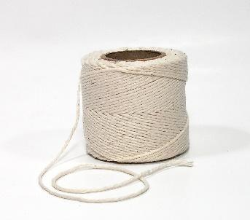  c. control (v): [ explanation]  Concept check: Rub out and Remember technique  2. DISCUSSION: LOOK AT THE PICTURES. DISCUSS THE QUESTIONS BELOW WITH A PARTNER.  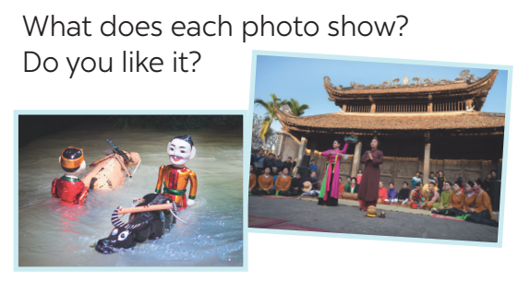  * Teacher asks students to work in pairs to look at some pictures in Ex. 1 on page 46 to discuss with their partners.  ** Students work in pairs to do the task.  *** Teacher calls some students to check what they have discussed.   Teacher listens and does not need to care about whether they know or don’t know about these traditional art forms, whether they like them or not. | T-Ss  T-Ss  Pair work  T-Ss  T-Ss | 6 mins
WHILE-READING | To help students read to find some words in context, and their meaning.  - To help students further develop their reading skill for specific information (scanning).  - To give students some understanding of water puppetry – a traditional art form of north Viet Nam. | TASK 1: READ THE EMAIL AND MATCH THE HIGHLIGHTED WORDS WITH THEIR MEANINGS. (Ex 2, p. 46)  * Teacher has students read the text very quickly and focus on the four phrases given and the four highlighted words in passage.  ** Students do the task independently.  *** Teacher tells students to compare their answers in pairs before calling some of them to check.   Teacher confirms the correct answer and explains if needed.  Answer key:  1. performed  2. traditional  3. fantastic  4. festival  TASK 2: READ THE PASSAGE AGAIN AND DECIDE THESE STATEMENTS ARE TRUE OR FALSE.  Statements True False  1. Mary went to see a puppet show in an art museum in the centre of Ha Noi. √  2. The show was presented by the artists who stood behind a screen in a pool. √  3. These shows are normally about everyday life in the countryside and in the city of Viet Nam. √  4. Tourists coming to Viet Nam love to see it because it is a special traditional art form. √  * Teacher asks students to read the passage in detail to find the information to finish the task.  ** Students do the task independently.  *** Teachers has students compare their answers in pairs and call some students to give their ideas.   Teacher checks and confirms the correct answers. | T-Ss  Ss  T-Ss  T-Ss  T-Ss  Ss  T-Ss  T-Ss | 8 mins
 | - To help Ss read for specific information about a traditional art form;  - To give Ss some understanding of water puppetry – a traditional art form of north Viet Nam. | TASK 3: READ THE EMAIL AGAIN AND ANSWER THE QUESTIONS. (Ex 3, p. 46)  * Teacher asks students to read the email again, work in pairs to ask and answer the questions.  ** Students work in pairs.  *** Teacher uses the game “Lucky numbers” to check their comprehension.  - Teacher divides the class into 2 teams.  - Each team, turn by turn, chooses one number: If the number is a question, they must answer it correctly to get 1 point. If the number is a lucky one, they will get 2 points without having to answer any questions.  - The team who gets more points will be the winner.  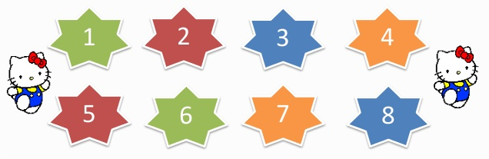   Teacher corrects the answers.  Answer key:  Lucky numbers: 1, 4, 8  Number 2: Question 1: Mary did.  Number 3: Question 2: In a pool.  Number 5: Question 3: The artists did.  Number 6: Question 4: (They are) about everyday life in the countryside of Viet Nam.  Number 7: Question 5: Yes, it is. | T-Ss  Pair work  Team work  T- SS | 8 mins
PRE-SPEAKING | To help students ask and answer questions about a school musical performance. | TASK 4: WORK IN PAIRS. ASK AND ANSWER ABOUT MARK’S SCHOOL MUSICAL PERFORMANCE LAST YEAR. (Ex 4, p. 46)  * Teacher asks students to read about Mark’s school musical performance last year, then let them work in pairs to ask and answer questions about the performance.  ** Students work in pairs to do the task. Teacher goes around and corrects mistakes or gives help when necessary. Encourage students to ask more questions.  *** Teacher calls on some pairs to perform the task in front of the class.   Teacher and other students listen and comment.  Suggested answer:  A: When was the performance?  B: On Saturday night.  A: How long did it last?  B: It lasted three hours.  A: Where did it take place?  B: In the schoolyard.  A: What did they perform?  B: They performed some plays, danced, sang songs, …  … | T-Ss  Pair work  T-Ss  T-Ss | 5 mins
WHILE-SPEAKING | To help students practise speaking about what they will do and how they will prepare for their school performance. | TASK 5: MAKE A PLAN AND TALK.(Ex 5, p. 46)  Your school is going to have a musical performance to celebrate Teacher’s Day. Work in groups. Make a plan for the performance and talk about the items you will contribute.  * Teacher has students work in groups and asks them to give their ideas about the items they’d like to contribute  ** Students work in groups to do the task. Teacher goes around, listens and gives help if needed.  *** Teacher asks students to talk about the item they have agreed on, and how they will prepare for it.   Teacher comments.  Suggested answers:  A: I think we will perform a play.  B: A play takes a long time to prepare. I think we will sing in a choir.  C: Quang can sing solo. He has a nice voice for singing.  … | T-Ss  Group work  T-Ss  T-Ss | 7 mins
POST-SPEAKING | To help students improve next time. | - Have students give comments on their friends and vote for the most interesting and informative presentation.  - Teacher gives feedback and comments. | Ss-Ss  T-Ss | 3 mins
CONSOLIDATION | To consolidate what students have learnt in the lesson. | Teacher asks students to talk about what they have learnt in the lesson. | T-Ss | 1 min
HOMEWORK | To prepare for the next lesson Skills 2. | - Do exercises in the workbook.  - Prepare for the next lesson: Skills 2. | T-Ss | 1 min

UNIT 4: MUSIC AND ARTS

Lesson 6: Skills 2

  - I. OBJECTIVES
By the end of this lesson, students will be able to:
1. Knowledge
- Listening:
+ use the lexical items related to the topic Music and arts;
+ listen for specific information about street painting.
- Writing: write an informal letter of invitation.
2. Core competence
- Develop communication skills
- Be collaborative and supportive in pair work and team work
- Actively join in class activities
3. Personal qualities
Be benevolent and responsible

  - II. MATERIALS
- Grade 7 textbook, Unit 4, Skills 2
- Computer connected to the internet
- Pictures
- hoclieu.vn

  - Language analysis
Form | Pronunciation | Meaning | Vietnamese equivalent
1. pavement (n) | /ˈpeɪvmənt/ | a path with a hard surface on one or both sides of a road, that people walk on | vỉa hè, đường cho người đi bộ
2. occur (v) | /əˈkɜː(r)/ | to happen (especially of accidents and other unexpected events) | xảy ra, diễn ra
3. support (n) | /səˈpɔːt/ | agreement with and encouragement for an idea, group, or person | sự ủng hộ
4. huge (adj) | /hjuːdʒ/ | extremely large in size or amount | to lớn

Assumptions
Anticipated difficulties | Solutions
1. Students may lack knowledge and experiences about the topic. | Prepare some hand-outs.
2. Students may have underdeveloped listening, writing and co-operating skills. | - Play the recording many times if any necessary.  - Encourage students to work in pairs, in groups so that they can help each other.  - Provide feedback and help if necessary.
3. Some students will excessively talk in the class. | - Define expectation in explicit detail.  - Have excessive talking students practise.  - Continue to define expectations in small chunks (before every activity).

  - Board Plan
Date of teaching
Unit 4: Music and arts
Lesson 6: Skills 2

*Warm-up
Brainstorming
I. Listening
Vocabulary
1. pavement (n): vỉa hè, đường cho người đi bộ
2. occur (v): xảy ra, diễn ra
3. support (n): sự ủng hộ
4. huge (a): to lớn
Task 1: Discuss the question below with a partner.
Task 2: Listen to a man talking about street painting and tick (√) the words you hear.
Task 3: Listen to the passage again and choose the correct answers.
Task 4: Retelling
II. Writing: an informal letter of invitation
Writing tip: you can use
- Let’s …
- How about + V-ing?
Task 5: Read the following letter and choose the correct answers.
Task 6: Write a letter to invite someone to a street painting festival.
*Homework

III. PROCEDURES
Notes:
In each activity, each step will be represented as following:
* Deliver the task
** Implement the task
*** Discuss
 Give comments or feedback

Stage | Stage aim | Procedure | Interaction | Time
WARM-UP | To activate students’ prior knowledge and vocabulary related to the lesson. | BRAINSTORMING  Traditional arts around the world  * Teacher writes on the board the phrase “Traditional arts around the world” and asks students to think of it.  ** Students think of it and can discuss with their partners.  *** Teacher calls some students to give their answers.   Teacher listens and gives comments.  Suggested ideas:  Lam vong dance of Laos; Chinese Opera; ballet of France and Russia; Origami in Japan; Kite making and flying in India; Watchmaking in Switzerland; … | T-Ss  Group work  T-Ss  T-Ss | 5 mins
LEAD-IN | To introduce the new lesson. | Teacher introduces students the content of the lesson: “In the lesson today, we are going to listen to find out the information about very special type of art. It called: street art/ street painting.” | T-Ss | 1 min
PRE-LISTENING | To provide students with some lexical items before listening the text.  To activate students’ knowledge of the topic of the listening text. | VOCABULARY  - Teacher introduces the vocabulary by:  + Providing the synonym or antonym of the words.  + Providing the pictures of the words.  + Providing the definition of the words.  1. pavement (n): [visual + explanation]    2. occur (v): [explanation]  3. support (n): [explanation]  4. huge (adj): [explanation]  Concept check: Rub out and Remember  TASK 1: DISCUSS THE QUESTION BELOW WITH A PARTNER (Ex. 1, p. 47)  What do you know about street painting?  Where do artists paint their pictures? Do they have to pay to paint there?  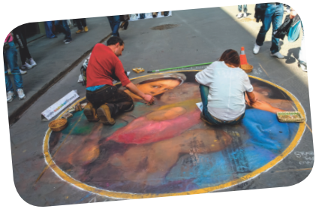  * Teacher asks students to work in pairs to ask and answer about street painting.  ** Students work with their partner to do the task.  *** Teacher calls on some students to answer.   Teacher gives comments and leads students to task 2.  Suggested questions and answers:  - Do you know about street painting?  - Where do artists paint their pictures?  - Do they have to pay to paint there? | T-Ss  T-Ss  Pair work  T-Ss  T-Ss | 3 mins
WHILE-LISTENING | To help students practise listening for specific information (to find some words while listening to the recording).  To develop students’ skill of listening for specific information (scanning). | TASK 2: LISTEN TO A MAN TALKING ABOUT STREET PAINTING AND TICK (√) THE WORDS YOU HEAR. (Ex.2, p.47)  * Teacher asks students to read the five words given and try to predict what words they will hear in the listening.  ** Students work independently to read and predict. Then, teacher plays the recording once or twice for students to listen carefully and tick the words they hear.  *** Teacher calls some Ss to give the answers.   Teacher plays the recording again and confirms the correct answers for their prediction.  TASK 3: LISTEN TO THE PASSAGE AGAIN AND CHOOSE THE CORRECT ANSWERS. (Ex. 3, p. 47)  * Teacher asks students to read the questions carefully then plays the recording again to choose the correct answer to each question.  ** Students work independently to listen.  *** Students give their answers.   Teacher plays the recording as many times as necessary and confirms the correct answers.  Suggested answers:  1. A  2. C  3. C  4. B  Audio script – Tracks 28 + 29:  Street painting – or street art – is an old type of art. In the 16th century artists began to draw on the pavement using chalk. Today, you can see street painting events everywhere. They attract many people who come to enjoy and take part in them. Many of them are free too. So join in and become an artist yourself!  One of the largest events in the United States is the Lake Worth Street Painting Festival. It began in 1994 and now occurs every February with the support of artists and volunteers. It is free for everyone.  About 100,000 visitors come to enjoy it. About 600 artists work on the pavement to make the street a huge art gallery! | T-Ss  Ss  T-Ss  T-Ss  T-Ss  Ss  T-Ss  T-Ss | 10 mins
POST-LISTENING | To help students retell what they have listened. | TASK 4: RETELLING  * Teacher asks students to work in groups and take turns to retell the information about “Street painting” as much as they can.  ** Students work in groups to do the task. Teacher moves around and offers help if needed.  *** Teacher invites some students to retell it.   Teacher confirms the correct answers. | T-Ss  Group work  T-Ss  T-Ss | 3 mins
PRE-WRITING | To help students learn the purpose and format of an informal letter of invitation | TASK 5: READ THE FOLLOWING LETTER AND CHOOSE THE CORRECT ANSWERS. (Ex. 4, p. 47)  * Teacher asks students to do the task in Ex. 4, p. 47.  ** Students do the task individually.  *** Students give their answers.   Teacher corrects.  Answer key:  1. A  2. B  Informal letter of invitation:  * Teacher asks students to look at the letter again and try to answer some questions:  + Is it an invitation letter? (Yes. Because it invites Jack to see the water puppet show.)  + Is it formal or informal? (It is informal because Jack is Chau’s friend.)  + What is the event? (The water puppet show.)  + What time does the show begin? (At 8 p.m.)  + Where does it take place? (At 57 B Dinh Tien Hoang St, Hoan Kiem Dist.)  + What time do Chau want to meet Jack for the show? (At 7:45.)  ** Students do the task independently.  *** Teacher calls students to check their understanding.   Teacher corrects and then, asks them to read “Writing tip”. After that, teacher writes on the board the format of informal letter of invitation:  - Invitation: Let’s / How about + V-ing?  - Event  - Start time  - Place  - Time to meet | T-Ss  Ss  T-Ss  T-Ss  T-Ss  Ss  T-Ss  T-Ss | 7 mins
WHILE-WRITING | To help students write an informal letter of invitation. | TASK 6: WRITE A LETTER TO INVITE SOMEONE TO A STREET PAINTING FESTIVAL, USING THE FOLLOWING CUES. (Ex. 5, p. 47)  * Teacher tells students that they are going to write a letter to invite someone to a street painting festival. Students should follow the cues and base on the format to write.  ** Students work independently to do the task and teacher goes around and helps if necessary. | T-Ss  Ss | 8 mins
POST-WRITING | To peer check, cross check and final check students’ writing. | PEER CHECKING  *** Teacher asks students to share their writing with their partners. Then, call on some students to show their writing in front of the class.   Teacher checks ideas, grammar, vocabulary and gives comments. | Ss-Ss  T-Ss | 4 mins
CONSOLIDATION | To consolidate what students have learnt in the lesson. | Teacher asks students to talk about what they have learnt in the lesson. | T-Ss | 2 mins
HOMEWORK | To allow students finalize their letter after being checked by friends and the teacher. | Rewrite the letter on the notebook. | T-Ss | 1 min

UNIT 4: MUSIC AND ARTS

Lesson 7: Looking back & Project

  - I. OBJECTIVES
By the end of this lesson, students will be able to:
1. Knowledge
- review the vocabulary and grammar of Unit 4
- apply what they have learnt (vocabulary and grammar) into practice through a project
2. Core competence
- Develop communication skills and creativity
- Be collaborative and supportive in pair work and team work
- Actively join in class activities
3. Personal qualities
- Be benevolent and responsible
- Develop self-study skills

  - II. MATERIALS
- Grade 7 textbook, Unit 4, Looking back & Project
- Computer connected to the Internet
- TV/ Pictures,
- hoclieu.vn

Assumptions
Anticipated difficulties | Solutions
1. Students may have underdeveloped speaking, writing and co-operating skills when doing project. | - Encourage students to work in pairs, in groups so that they can help each other.  - Provide feedback and help if necessary.
2. Some students will excessively talk in the class. | - Define expectation in explicit detail.  - Have excessive talking students practise.  - Continue to define expectations in small chunks (before every activity).

  - Board Plan
Date of teaching
Unit 4: Music and arts
Lesson 7: Looking back & Project

*Warm-up
Mind map
I. Looking back
Task 1: Write a word or phrase in each blank.
Task 2: Fill in each gap with a word or phrase from the box.
Task 3: Complete the sentences. Add the necessary words.
Task 4: Rewrite the sentences.
II. Project
Organising music shows
Task 5: Posters exhibition
* Homework

III. PROCEDURES
Notes:
In each activity, each step will be represented as following:
* Deliver the task
** Implement the task
*** Discuss
 Give comments or feedback

Stage | Stage aim | Procedure | Interaction | Time
WARM-UP | To help students revise the vocabulary items they have learnt in the unit.  To enhance students’ skills of cooperating with team mates. | MIND MAP  * Teacher writes on the board “Unit 4” and asks students to think of what they have learnt already in this unit.  Unit 4  Vocabulary  Grammar  Pronunciation  ** Students work in pairs to do the task.  *** Teacher calls some students to retell.   Teacher confirms and leads them to do all the exercises in books. | T-Ss  Pair work  T-Ss  T-Ss | 3 mins
VOCABULARY | To help students revise the collocations with some verbs used in the field of music and arts. | TASK 1: WRITE A WORD OR PHRASE IN EACH BLANK TO GO WITH THE GIVEN VERB. (Ex. 1, p. 48)  * Teacher has students work individually to read the verbs and write the correct words / phrases to go with these verbs.  ** Students do this activity individually, and then compare their answers with their partners.  *** Teacher asks for students’ answers.   Teacher confirms the correct ones  Answer key:  1. draw: a picture, a bird, a car  2. perform: a puppet show, a concert, a play  3. write: a book, a poem, a song  4. watch: TV, a film, a football match | T-Ss  Ss  T-Ss  T-Ss | 16 mins
 | - To help students review the words / phrases about music and arts used in the context of a passage.  - To give students some information of the Louvre Museum - the world’s largest art museum. | TASK 2: FILL IN EACH GAP WITH A WORD OR PHRASE FROM THE BOX TO COMPLETE THE PASSAGE. (Ex. 2, p. 48)  * Teacher has students work individually to revise the words / phrases given in the box, then do the task.  ** Students do this activity individually, and then compare their answers with their partners.  *** Teacher asks for students’ answers.   Teacher confirms the correct ones  Answer key:  1. art collections  2. exhibition  3. works of art  4. paintings  5. visitors | T-Ss  Ss  T-Ss  T-Ss
GRAMMAR | To help students revise the comparisons they have learnt in the context of sentences. | TASK 3: COMPLETE THE SENTENCES, USING THE WORDS IN BRACKETS. ADD THE NECESSARY WORDS. (Ex. 3, p. 48)  * Teacher asks students to revise how to use the different ways of comparing they have learnt and then complete the task. Tell them to add the necessary words.  ** Students do the exercise individually and swap with their partners.  *** Teacher calls some students to check their answer.   Teacher confirms the correct answer.  Answer key:  1. old as  2. different from  3. more important  4. not as good  5. not as easy as | T-Ss  Ss-Ss  T-Ss  T-Ss
 | To help students to write sentences using the comparisons they have learnt. | TASK 4: REWRITE THE SENTENCES, USING THE GIVEN WORDS. (Ex. 4, p. 48)  * Teacher asks students to write sentences in their notebooks, using the comparisons they have learnt, and the words provided.  ** Students work individually to do the task.  *** Teacher calls 1- 2 students to write on the board.   Teacher checks and confirms their answer.  Answer key:  1. Exercising is better than playing video games.  2. Duong doesn’t / can’t draw animals as well as his father.  3. The Mona Lisa is more valuable than this painting.  4. Nick is not as artistic as David.  5. The second / first version of the play is like the first / second. | T-Ss  Ss  T-Ss  T-Ss
PROJECT | To allow Ss to apply what they have learnt (vocabulary and grammar) into practice through a project. | TASK 5: POSTERS EXHIBITION  * Ask Ss to read the instructions again (T has already assigned the project since the first lesson of the Unit and check their progress after each lesson). Let students have some time to check their posters for the final time and make any adjustments if neccessary.  ** T has groups show and present the invitation to the class.  *** Students in other groups comment and vote for the best poster.   Teacher confirms and corrects. | T-Ss  Group work  T-Ss  Ss-Ss  T-Ss | 23 mins
CONSOLIDATION | To consolidate what students have learnt in the lesson. | Teacher asks students to talk about what they have learnt in the lesson. | T-Ss | 2 mins
HOMEWORK | To prepare for the next lesson. | Prepare for the next lesson: Unit 5 – Getting Started. | T-Ss | 1 min
* Pictures' source: From Internet.

