|  |  |  |
| --- | --- | --- |
| PHÒNG GIÁO DỤC VÀ ĐÀO TẠO…… ĐỀ CHÍNH THỨC | ĐỀ KIỂM TRA __________ Năm học: 20__ - 20__ Tiếng Anh - Lớp 7 Thời gian làm bài: 60 phút | |
| Trường: ________________________ Họ tên: _______________________ Lớp: _____________ | Điểm | Nhận xét của giáo viên |

|  |  |  |
| --- | --- | --- |
|  | **Tiếng Anh 7 i-Learn Smart World - Unit 6.1 Time allotted: 60** | Mã đề: a |

|  |  |
| --- | --- |
| **PART 1** | **Pronunciation (4 questions)** |

**Choose the word whose underlined part is pronounced differently.**

1. A. before B. report C. homework D. uniform

2. A. excited B. annoyed C. pleased D. surprised

**Choose the word that has a different stressed syllable from the rest.**

3. A. classmate B. finish C. essay D. abroad

4**.** A. difficult B. however C. positive D. chemistry

|  |  |
| --- | --- |
| **PART 2** | **Vocabulary and Grammar (12 questions)** |

**Choose the best option (A, B, C or D) to complete each of the following questions.**

5. Sammy studied really hard, so she ______________ all of her tests.

A. passed B. failed C. got D. did

6. Student A: How’s the course going?  
Student B: I’m ______________ enjoying it.

A. very B. much C. really D. a lot

7. Ivy was so ______________ because she failed two tests last semester.

A. pleased B. delighted C. relaxed D. upset

8. We ______________ buy lunch in the canteen. There’s a shop next to the school and it sells sandwiches and other snacks.

A. have to B. don’t have to C. mustn’t D. should

9. The teacher asked us to choose a book from the list, read it at home and then write a ______________ about it.

A. project B. presentation C. report D. revision

10. Our math teacher, Mr. Thomas, is funny and friendly, but he gives us too much ______________ to do after school.

A. homework B. exams C. essays D. exercise

11. Nick got 100% on his physics test. His twin brother, Adam, ______________, had to retake the test.

A. although B. but C. so D. however

12. I’m really ______________ with Nick. We have an important biology project, but he doesn’t do his part.

A. hopeful B. annoyed C. pleased D. excited

13. Yesterday, I wrote a(n) ______________ about the benefits of studying overseas, and the teacher said it was good.

A. homework B. test C. essay D. paper

14. Student A: I’m going to the movies this evening. Do you want to join me?  
 Student B: ______________. I have too much homework to do.

A. Sure, I can. B. Thanks, but I don’t think I can. C. Of course, I will. D. Thanks, but sorry, I’m not.

**Choose the best option (A, B, C or D) to complete each of the following questions.**

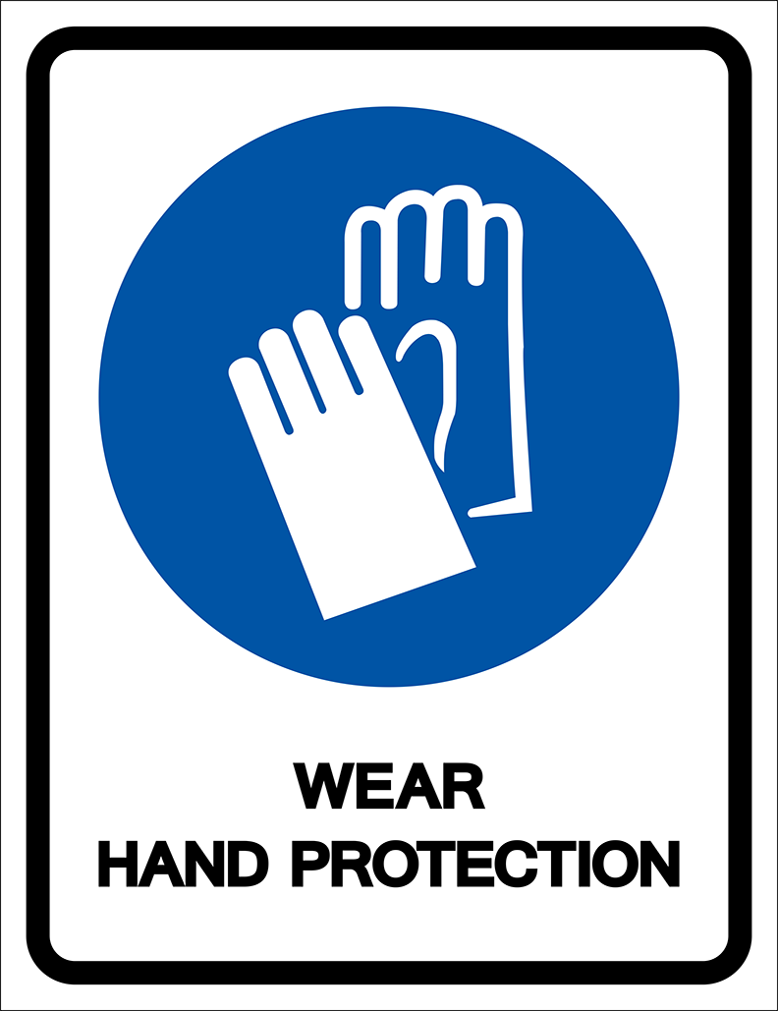

15. Read the notice and choose the correct statement.

A. You have to wear gloves when you enter this place. B. You don’t have to wear gloves in this place.

C. It’s a good idea to wear gloves in this place. D. You need to bring gloves to this area.

**Choose the best option (A, B, C or D) to complete each of the following questions.**

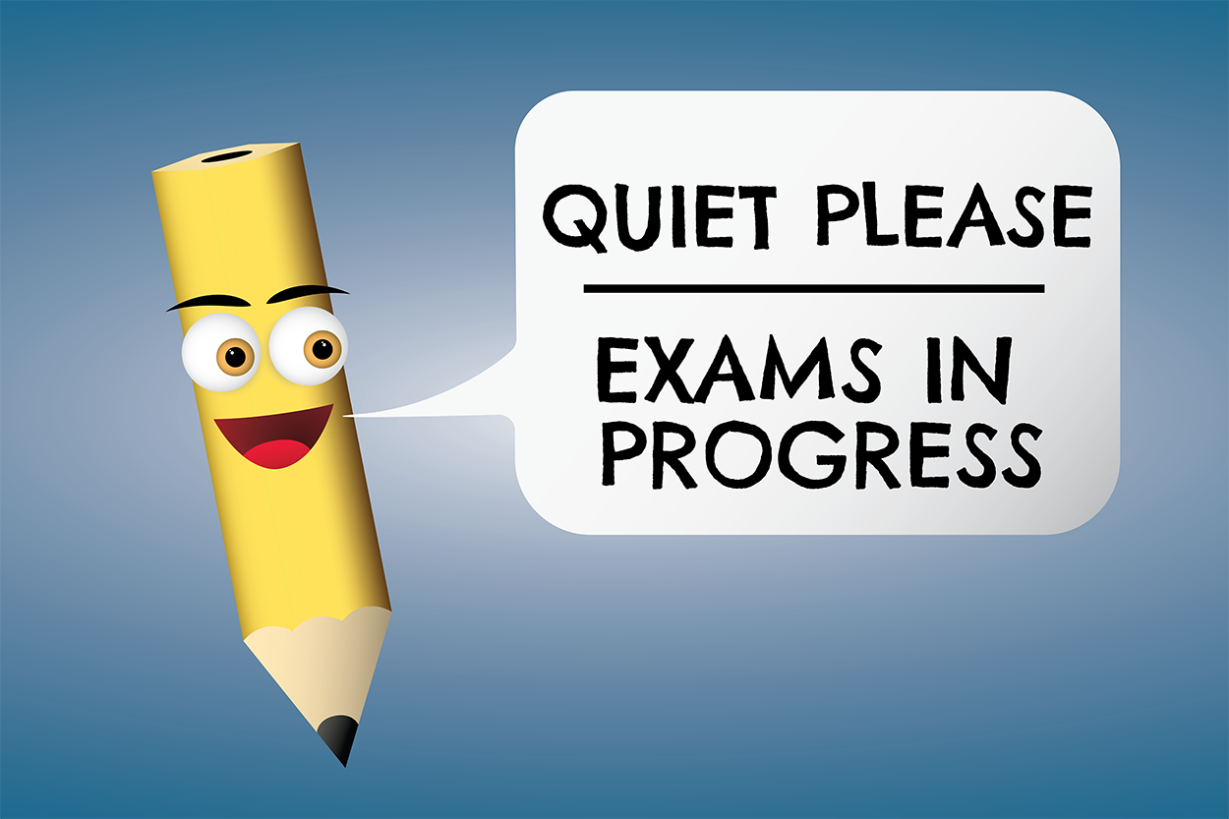

16. What does this sign mean?

A. You don’t have to talk in this area. B. You have to keep silent in this area.

C. You have to take the exam in this area. D. You don’t have to make any noise during the exam.

|  |  |
| --- | --- |
| **PART 3** | **Word Formation (6 questions)** |

**Write the correct form of the words in brackets.**

17. I was so ___________ because I got an A plus on my English test. ***(SURPRISE)***

18. In my English class, we have to give ___________ about various topics. ***(PRESENT)***

19. Philip was really ___________ when he got a D on his math test. He studied very hard for it. ***(DISAPPOINT)***

20. Studying abroad puts you into an unfamiliar situation, so you will become more ___________. ***(DEPEND)***

21. Studying overseas also gives you the opportunity to make friends with people from ___________ backgrounds.

***(DIFFER)***

22. When I first came to the USA, I was ___________ and lonely because I couldn’t understand what other people said.

***(SCARY)***

17. surprised

18. presentations

19. disappointed

20. independent

21. different

22. scared

|  |  |
| --- | --- |
| **PART 4** | **Reading (10 questions)** |

**Read the following passage. For each question, choose the correct option that best suits each blank. (5 questions)**

Studying abroad is becoming popular for many students looking to learn more about other languages and countries. Sometimes, students (23)___________ work with an online exchange organization to make travel arrangements and make sure they have a wonderful and safe experience while away.   
   
Studying abroad is also a (24)___________ way to meet new friends, visit new places, and experience different things. Students are (25)___________ to learn about new opportunities and meet people from other cultures. (26)___________ learning in a foreign country can be difficult, they are pleased when they (27)___________ their first test, complete their first project, or meet amazing new people. Overall, it’s a great way to travel to other countries and learn more about the world.

(23) A. have B. have to C. to have D. has to

(24) A. great B. terrible C. pleased D. surprised

(25) A. upset B. disappointed C. annoyed D. delighted

(26) A. Because B. Although C. However D. So

(27) A. present B. fail C. pass D. make

**Read the following passage. For each question, write T if the statement is TRUE, F if the statement is FALSE, and NI if there is NO INFORMATION on it. (5 questions)**

When Sophie was a little girl, she dreamed about visiting another country. One day, while looking on the internet, she was surprised to learn about a way to travel and study abroad. First, Sophie would have to decide which country to visit. She would also need to learn a foreign language to take tests and write essays. Sophie quickly knew it would take a lot of work to make her dreams come true, so she began working with her parents on making plans.

Sophie was so excited about her future that she spent an entire summer working with her dad to save money. She also took French lessons because she always dreamed about traveling to Paris. The following summer, Sophie was accepted into an exchange program and spent a year traveling and studying abroad.

**Answers** **True** **False** **Not given**

28. Sophie made her dreams of traveling abroad come true by working hard. **◯** **◯** **◯**

29. Sophie didn’t have to learn a foreign language. **◯** **◯** **◯**

30. Sophie planned to take a train to Paris. **◯** **◯** **◯**

31. Sophie worked with her dad to save money. **◯** **◯** **◯**

32. Sophie spent one whole summer studying abroad. **◯** **◯** **◯**

|  |  |
| --- | --- |
| **PART 5** | **Writing (8 questions)** |

**Rewrite the following sentences without changing their meaning.**

33. Anna’s mother is from China, but she can’t speak Chinese. (HOWEVER)

→ Anna’s mother___________

34. Luke wants to study overseas, but he is afraid of living alone.

→ Although___________

35. According to the rules, it’s necessary for students to hand in their assignments on time.

→ Students___________

36. It isn’t necessary for Cathy to buy new textbooks because she can borrow them from the library.

→ Cathy___________

**Use the given words or phrases to make complete sentences.**

37. I / have / be / school / 8:50 / because / first lesson / start / 9:00.

→ ___________

38. Although / Ann / not like / sports / she / have / play / basketball / P.E. lessons.

→ ___________

39. I / pass / all / exams / so / parents / be / so / delighted.

→ ___________

40. Tom / play / computer games / right now / although / he / have / important test / tomorrow morning.

→ ___________

33. Anna’s mother is from China. However, she can’t speak Chinese./Anna’s mother is from China. She, however, can’t speak Chinese.

34. Although Luke wants to study overseas, he is afraid of living alone.

35. Students have to hand in their assignments on time.

36. Cathy doesn’t have to buy new textbooks because she can borrow them from the library./Cathy doesn’t need to buy new textbooks because she can borrow them from the library./Cathy needn’t buy new textbooks because she can borrow them from the library.

37. I have to be at school at 8:50 because the first lesson starts at 9:00.

38. Although Ann doesn’t like sports, she has to play basketball in P.E. lessons.

39. I passed all my exams, so my parents were so delighted./I passed all of my exams, so my parents were so delighted./I passed all of the exams, so my parents were so delighted./I passed all exams, so my parents were so delighted./I passed all the exams, so my parents were so delighted.

40. Tom is playing computer games right now although he has an important test tomorrow morning./Tom is playing computer games right now although he is having an important test tomorrow morning.

|  |  |
| --- | --- |
| **PART 6** | **Listening (10 questions)** |

**You will listen to Alex talking to his friend Tom about studying abroad. Complete the notes with NO MORE THAN TWO WORDS for each blank. (5 questions)**

Tom’s trip was amazing, although he (41)___________ missed his friends and family. The thing that (42)___________ him was how welcoming everyone was.   
His friend Alex was (43)___________ to hear Tom didn’t have trouble making friends.   
Tom thought the food was (44)___________ delicious because it tasted hot and spicy, and he found it hard to take a (45)___________ in a foreign language.

41. really

42. surprised

43. pleased

44. so

45. test

**You will listen to a student and teacher talking about studying abroad. For each question, circle the correct option. (5 questions)**

46. How many years did Ms. Sullivan spend teaching abroad?

A. one B. two C. four D. six

47. What can an online exchange provider do?

A. help make travel arrangements B. call your parents

C. drive you to the airport D. cook you food

48. Why should Simon start saving money?

A. to buy a plane ticket B. in case something happens

C. to be prepared D. in case it rains

49. Why would Simon’s mom be pleased with him?

A. because he cleaned his room B. because he talked with his teacher

C. because he saved money D. because he passed his test

50. What is true about the conversation?

A. Ms. Sullivan traveled to Europe. B. Simon’s mom was pleased he passed his test.

C. Simon doesn’t need to save money. D. Simon needs advice about studying abroad.

**---THE END---**