|  |  |  |
| --- | --- | --- |
| UBND QUẬN _________ PHÒNG GIÁO DỤC VÀ ĐÀO TẠO ĐỀ CHÍNH THỨC | ĐỀ KIỂM TRA __________ Năm học: 20__ - 20__ Tiếng Anh - Lớp 7 Thời gian làm bài: 60 phút | |
| Trường: ________________________ Họ tên: _______________________ Lớp: _____________ | Điểm | Nhận xét của giáo viên |

|  |  |  |
| --- | --- | --- |
|  | **Tiếng Anh 7 i-Learn Smart World - Unit 10.1 Time allotted: 60** | Mã đề: A |

|  |  |
| --- | --- |
| **PART 1** | **Pronunciation (4 questions)** |

**Choose the word whose underlined part is pronounced differently.**

1. A. sources B. types C. advantages D. exercises

2. A. turbine B. nuclear C. useful D. future

**Choose the word that has a different stressed syllable from the rest.**

3. A. power B. thirty C. easy D. thirteen

4. A. energy B. dangerous C. expensive D. microwave

|  |  |
| --- | --- |
| **PART 2** | **Vocabulary and Grammar (12 questions)** |

**Choose the best option (A, B, C or D) to complete each of the following questions.**

5. ______________ uses moving water to produce electricity.

A. Solar power B. Wind power C. Hydropower D. Natural power

6. Solar power seems like a great future source of energy, ______________ it has some disadvantages. For example, it doesn’t work at night.

A. and B. but C. so D. because

7. Energy ______________ are various in Vietnam, ranging from coal, oil, natural gas, hydropower and renewable energy.

A. power B. uses C. plants D. sources

8. Denmark gets twenty percent of its electricity ______________ wind power.

A. from B. with C. in D. by

9. They are building a nuclear ______________ near my town.

A. factory B. station C. power plant D. industry

10. In Vietnam, hydropower is one of the largest sources of renewable energy. It ______________ about 40% of the total national energy resources.

A. uses B. provides C. has D. creates

11. Vietnam’s largest wind power plant with 45 ______________ is in central Ninh Thuận Province.

A. wheels B. engines C. panels D. turbines

12. People are now trying to lead a greener way of life by using ______________ coal and oil.

A. less B. more C. most D. fewer

13. On 14th August, a fishing boat sank off the west side of San Juan Island, sending heavy black ______________ flowing into the sea and destroying the marine life.

A. coal B. gas C. oil D. energy

14. Person A: What is a disadvantage of wind power?  
Person B: ______________

A. Wind power is clean to run. B. Wind turbines are cheaper. C. Wind power produces more energy. D. Wind turbines can harm wildlife such as birds and bats.

**Choose the best option (A, B, C or D) to complete each of the following questions.**

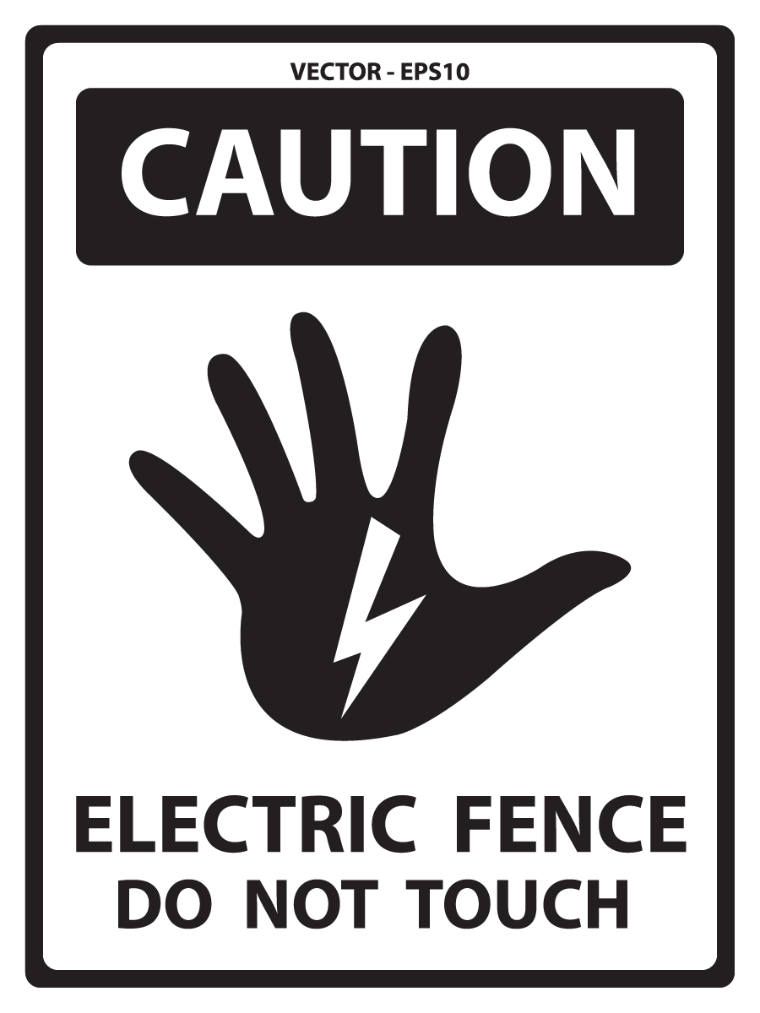

15. What does this sign mean?

A. You can’t touch the electricity on the fence. B. You don’t touch the fence, so it is electric.

C. You mustn’t touch the fence because it has electricity. D. Touching the fence causes electricity, so don’t do it.

**Choose the best option (A, B, C or D) to complete each of the following questions.**

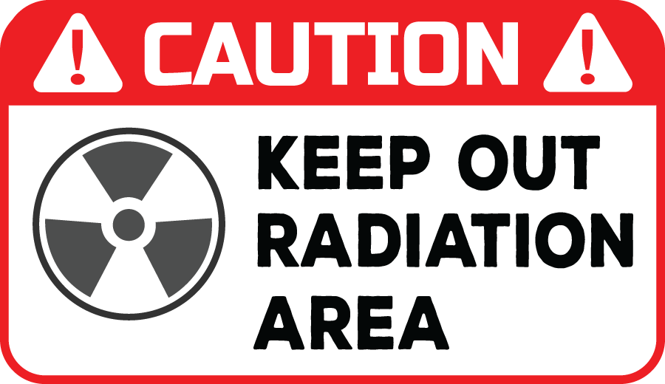

16. What does this sign mean?

A. You can’t enter this area because the level of radiation can be dangerous.

B. You can’t keep radiation out of this area because it’s dangerous.

C. This area is dangerous because people keep the radiation out.

D. You should be careful when you keep out of the radiation.

|  |  |
| --- | --- |
| **PART 3** | **Word Formation (6 questions)** |

**Write the correct form of the words in the brackets. (6 questions)**

Today, we get a lot of energy from fossil fuels: coal, oil, and (17)___________ (NATURE) gas. But when we burn fossil fuels, they cause air (18)___________ (POLLUTE), and they are (19)___________ (NEW). This means they will not last forever. In the long term, we will have to find alternative sources of energy. (20)___________ (SUN) energy uses panels to catch sunlight and convert it into electricity. However, it doesn’t work at night and needs a lot of space. Wind power is another type of (21)___________ (RENEW) energy source. It’s cheap and produces clean energy, but wind turbines can be (22)___________ (NOISE) and some people think they look ugly.

17. natural

18. pollution

19. non-renewable

20. Solar

21. renewable

22. noisy

|  |  |
| --- | --- |
| **PART 4** | **Reading (10 questions)** |

**Read the following passage. For each question, choose the correct option that best suits each blank. (5 questions)**

Dear Mayor Glenn,   
This email is about the advantages of new renewable energy sources. As you may know, 80% of the electricity for the town comes from the coal plant, which is the cause of (23)___________ in the city. After researching new technologies, I suggest the city develop more renewable sources like (24)___________ , wind, and nuclear power. Progress in the last couple of years has made renewables better energy sources than non-renewables like coal and gas. For example, solar panels have become less (25)___________ than coal, cheap to build, and cleaner for the environment. (26)___________ have gotten larger, make less noise, and produce more energy with less wind. Nuclear power can sometimes be (27)___________ , but it’s cheap to run.

(23) A. expense B. pollution C. weather D. noise

(24) A. solar B. oil C. gas D. coal

(25) A. advantage B. noise C. expensive D. dangerous

(26) A. Nuclear B. Solar panels C. Hydropower D. Wind turbines

(27) A. safe B. dangerous C. advantage D. expensive

**Read the following passage. For each question, write T if the statement is TRUE and F if it is FALSE. (5 questions)**

Dear Mayor Khan,

My name is Henry. I recently visited your city, London, England, and I would like you to know how surprised I was at how clean and beautiful the city has become. On my last visit twenty years ago, the pollution was so terrible I had to stay inside the hotel during the day, and I could not exercise in the park. Now, the air is cleaner and easier to breathe. It was also great to see the dirty coal plant replaced with solar panels and wind turbines. I read in the newspaper that the city now gets 60% of its energy from renewable energy sources and will add another 20% by 2030. These changes make London more eco-friendly, and visitors like me notice the difference. My only suggestion to make the city more eco-friendly would be to reduce the use of natural gas for cooking.

**Answers** **True** **False**

28. Henry was surprised at how clean and beautiful London became after 20 years. **◯** **◯**

29. On Henry’s last visit to the city, the pollution was so terrible he could only go outside during the day. **◯** **◯**

30. London replaced the coal plant with solar panels and wind turbines. **◯** **◯**

31. By 2030, the city will get 60% of its energy from renewable energy sources. **◯** **◯**

32. Henry suggested the city should add more renewable energy like natural gas. **◯** **◯**

28. True

29. False

30. True

31. False

32. False

|  |  |
| --- | --- |
| **PART 5** | **Writing (8 questions)** |

**Rewrite the following sentences without changing their meaning. Use the given word(s) if any.**

33. I’m going to buy a hybrid car because it doesn’t use as much gas as other cars.

→ I’m going to buy a hybrid car because it uses___________

**Rewrite the following sentences without changing their meaning. Use the given word(s) if any.**

34. China is the largest producer of wind power in the world.

→ China produces___________

**Rewrite the following sentences without changing their meaning. Use the given word(s) if any.**

35. Although solar panels are quite expensive to install, you’ll save money on electricity in the end. (BUT)

→ Solar panels___________

**Combine the following sentences using “and” or “but”.**

36. This backpack has small solar panels on it. You can actually use them to charge your phone.

→ ___________

**Combine the following sentences using “and” or “but”.**

37. Nuclear power is a clean and efficient way of producing electricity. It may be dangerous.

→ ___________

**Use the information in the table and write sentences with the given words or phrases. (3 questions)**

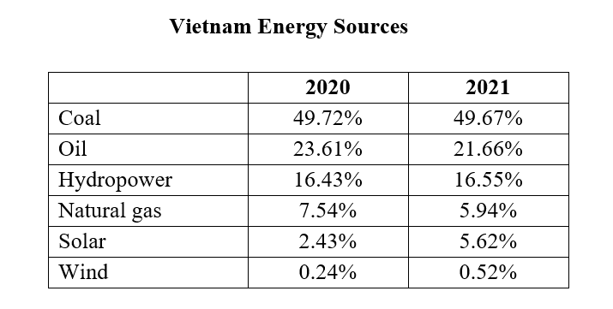

In 2020 / Vietnam / get / energy / solar power / 2021.   
→ (38)___________   
   
Natural gas / produce / energy / in 2020 / 2021.   
→ (39)___________   
   
Vietnam / get / energy / from / coal / other energy sources.   
→ (40)___________   
33. I’m going to buy a hybrid car because it uses less gas than other cars.

34. China produces more wind power than any other countries in the world.

35. Solar panels are quite expensive to install, but you’ll save money on electricity in the end.

36. This backpack has small solar panels on it, and you can actually use them to charge your phone.

37. Nuclear power is a clean and efficient way of producing electricity, but it may be dangerous.

38. In 2020, Vietnam got less energy from solar power than in 2021.

39. Natural gas produced more energy in 2020 than in 2021.

40. Vietnam got more energy from coal than from other energy sources.

|  |  |
| --- | --- |
| **PART 6** | **Listening (10 questions)** |

**You will listen to a conversation. Complete the notes with NO MORE THAN TWO WORDS for each blank. (5 questions)**

In this interview, Mr. Stark explains the difference between renewable and non-renewable (41)___________. He says renewables can be used again and again like the (42)___________ or the sun, and non-renewables like coal or (43)___________ have limited resources and can be used only once. Because of this, Chris suggests we build more wind turbines and (44)___________. Mr. Stark agreed and said renewables also cause (45)___________ pollution and are better for the environment.

41. energy sources

42. wind

43. gas

44. solar panels

45. less

**You will listen to a conversation. For each question, circle the correct option. (5 questions)**

**Questions:**

46. What can cause water pollution on the beach?

|  |
| --- |
| A. natural gas |
| B. oil |
| C. coal |
| D. smoke |

47. How can natural gas make it rain more?

|  |
| --- |
| A. by polluting the ocean |
| B. it makes the planet colder |
| C. it blows through the city |
| D. by warming the planet |

48. What causes air pollution that can blow through the city and hurt someone's throat?

|  |
| --- |
| A. burning coal |
| B. solar power |
| C. oil spill |
| D. renewable energy |

49. Which renewable energy sources pollute less than non-renewable energy sources?

|  |
| --- |
| A. coal power, solar power, hydropower |
| B. solar power, oil power, hydropower |
| C. wind power, oil power, solar power |
| D. wind power, solar power, hydropower |

50. What is the topic of the conversation?

|  |
| --- |
| A. oil, natural gas, and coal are a renewable energy source |
| B. natural gas causes the planet to warm |
| C. oil, natural gas, and coal pollute the community |
| D. oil pollution can be found on the beach |

**---THE END---**