LỚP HỌC THẦY (CÔ) ___________________________ ĐỀ ÔN TẬP: READING SIGNS/ NOTICES – A2
Test 6
Thời gian làm bài: [Time]
Họ và tên: ________________________________________________ Lớp: 9/___
Nội dung:
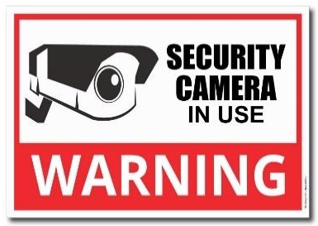
Question 1: What does the sign say?

A. Security cameras are not being used in this area.
B. Security cameras are watching and recording in this area.
C. There are no security cameras around this building.
D. Security cameras are only active during the night.

Question 2: What can't theatre customers do?
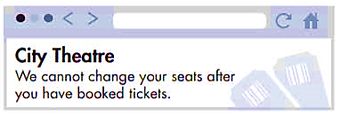
A. ask for different seats after they've paid B. choose where they sit before they book
C. get their money back on tickets. D. buy tickets at the City Theatre

Question 3: What does the sign say?

A. You are allowed to take photos in this area.
B. Photography is not allowed in this area at any time.
C. You can take photos if you have permission.
D. Taking photos is encouraged and permitted here.

Question 4: Why has Josh sent this message?
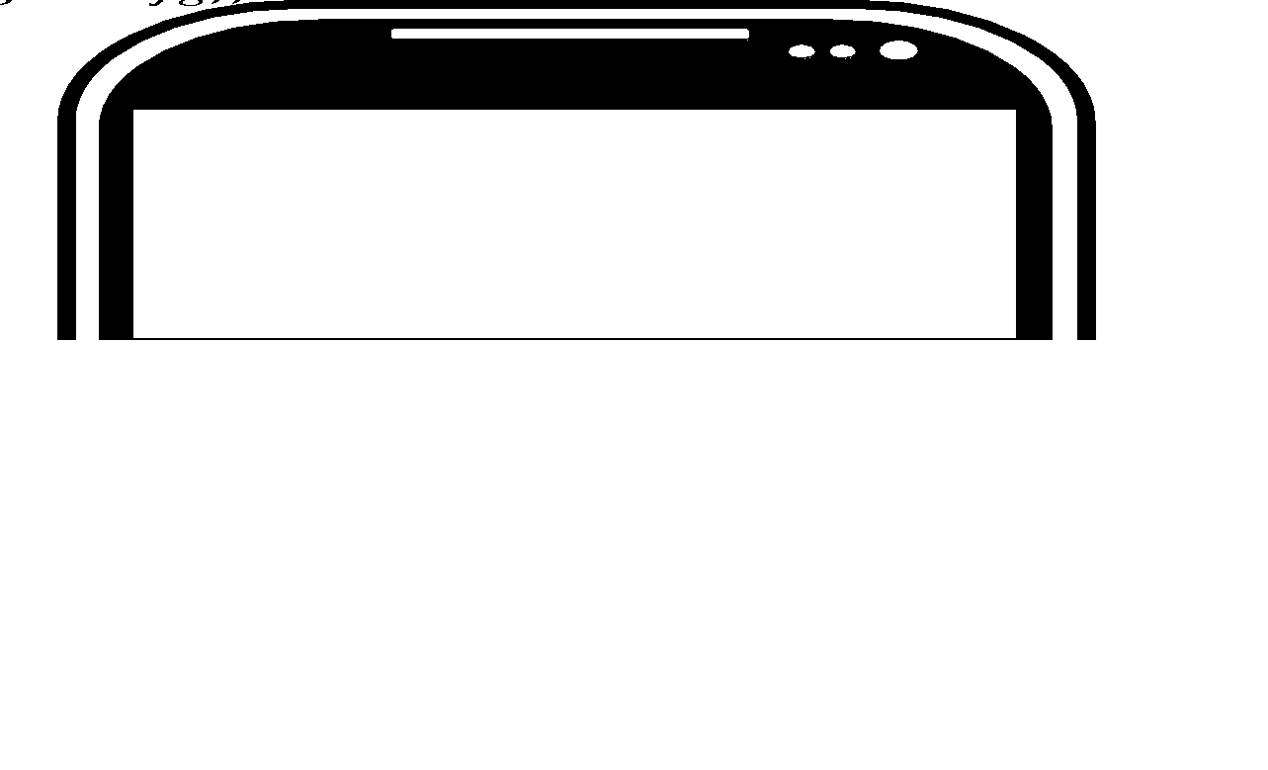
A. to ask George to go camping with him next weekend.
B. to ask if George will lend him some camping equipment.
C. to tell George about a new tent he's going to buy.
D. to tell George to buy a tent
Question 5: What does the sign say?

A. You can get assistance and help at this location.
B. This desk is closed and cannot provide any help.
C. Help is not given at this location right now.
D. This desk is only for the use of staff members.
Question 6: Which information is correct from the announcement?
Art workshop
Saturdays 10.30 – 12.30
From 15 September for 5 weeks
Suitable for all abilities

A. There will be five workshops each week.
B. You don't have to be talented to go to the workshops
C. The final workshop is on Saturday 15 September
D. The workshop is for good painters.
Question 7: Which information is correct from the announcement?
Announcement:
Library Hours
Monday - Friday: 9 AM - 6 PM
Saturday: 10 AM - 4 PM
Closed on Sundays
A. The library is open every day of the week. B. The library closes at 6 PM on weekdays.
C. The library opens at 9 AM on Saturdays. D. The library is open on Sundays.
Question 8: What does the sign say?
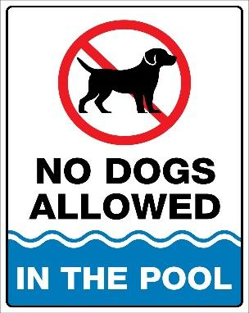
A. Dogs are always allowed to be in the pool area.
B. Dogs are not usually allowed in the pool area, but there are exceptions.
C. Dogs can swim in the pool whenever they like.
D. Dogs cannot be in the pool area at any time.

Question 9: Which information is correct from the announcement?
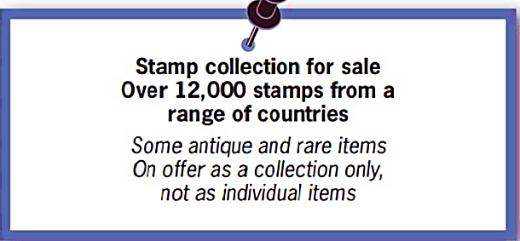
A. The stamps are all very old. B. Some of the stamps are very unusal.
C. You can buy just a few of the stamps. D. You can buy any single stamp.
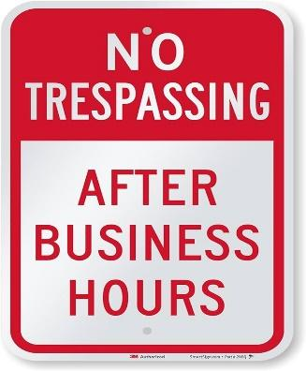
Question 10: What does the sign say?

A. You are allowed to enter this area at any time.
B. Do not enter this area after the designated hours.
C. Entry is only allowed during regular working hours.
D. You cannot enter this area, even with special permission.
[HẾT]

