**PHIẾU 9**

*Giaoandethitienganh.info*  có rất nhiều tài liệu tiếng anh file word hay, chất lượng, mời bạn đăng ký tài khoản ( chỉ 100k/ năm) để chủ động tự tải tài liệu khi cần!

***Mark the letter A, B, C or D on your answer sheet to indicate the word whose underlined part differs from the other three in pronunciation in each of the following questions.***

**Question 1.** A. counsellor B. physical C. optimistic D. submit

**Question 2.** A. deadline B. minimize C. physical D. priority

***Mark the letter A, B, C or D on your answer sheet to indicate the word that differs from the other three in the position of primary stress in each of the following questions.***

**Question 3.** A. delay B. mental C. deadline D. balance

**Question 4.** A. accomplish B. minimize C. physical D. liveable

***Mark the letter A, B, C or D on your answer sheet to indicate the correct answer to each of the following questions.***

**Question 5.** Maintaining a life often means making time for the things you have to do, as well as the things you want to do in a suitable way.

A. Educational B. mental C. well-balanced D. social

**Question 6.** When we our task, we headed home.

A. Succeeded B. won C. accomplished D. managed

**Question 7.** She’s in poor health, but she’s optimistic her future.

A. About B. of C. with D. to

**Question 8.** A. There are too many in this classroom it’s hard for me to pay attention to the lesson.

A. Difficulties B. distractions C. obstacles D. omissions

**Question 9.** Hong Kong is like a concrete jungle with so many people in it. It’s a city.

A. Calm B. quiet C. bustling D. high

**Question 10.** The the price of living in the city, the people can afford to live there comfortably.

A. Higher/ less B. lower/ more C. higher/ more D. lower/ less

**Question 11.** The the sky train system is, the it is for people to travel across the city.

1. More efficient/ easier C. less efficient/ easier
2. more efficient/ harder D. less efficient/ harder

**Question 12.** Tom: “ Would you like to come to dinner next Friday?” Lan: “ . I have much homework to do.”

1. Certainly not C. Unfortunately not.
2. I’m afraid, I can’t D. I hope not.

**Read the following announcement and mark the letter A, B, C, or D on your answer sheet to indicate the correct option that best fits each of the numbered blanks from 13 to 16.**

|  |
| --- |
| **Announcement: Social Community Clean-Up**  The Local Volunteer Group invites:   * All community members to participate (13) __________ a clean-up day on September 10 starting at 8:00 AM. * Each participant is to (14) __________ gloves and trash bags for the clean-up. * If you haveany issues during the event, please (15) __________ a volunteer leader know   The clean-up will take place (16) __________ the town center. |

**Question 13:** **A.** an **B.** a **C.** the **D.** no article

**Question 14:** **A.** bring **B.** bringing **C.** brought **D.** brings

**Question 15:** **A.** agree **B.** let **C.** allow **D.** say

**Question 16:** **A.** in **B.** at **C.** on **D.** with

**Mark the letter A, B, C, or D on your answer sheet to indicate the correct answer to each of the following questions from 17 to 18.**

**Question 17:** Put the sentences (a-c) in the correct order, then fill in the blank to make a logical text.

__________. Vietnamese soldiers are ready to face challenges and do their best to finish their missions. __________

**a.** After completing their missions, they feel proud because they helped keep the country safe and stable.

**b.** Even when things get tough, they stay brave and determined.

**c.** While working, they are strong, work together, and are willing to make sacrifices to protect the country

**A.** c-b-a **B.** a-c-b **C.** b-c-a **D.** c-a-b

**Question 18:** Choose the sentence that best fits as the opening sentence for the text (in Question 17).

**A.** Many people respect the bravery of Vietnamese soldiers.  
**B.** The mission had some problems but was finished successfully.  
**C.** Vietnamese soldiers are important for keeping the country safe and peaceful.

**D.** Soldiers received awards for their hard work and bravery.

**Mark the letter A, B, C, or D on your answer sheet to indicate the correct option that best fits each of the numbered blanks from 19 to 24.**

**WEATHER**

         Weather influences die lives of everyone. The climate of any country' (19) ____________ position on Earth, its distance from the sea and how high it is. In countries which (20) ____________ sea all around them, like Britain and New Zealand, winters are mild and summers are cool. There is not a huge change from one season to another. Countries near the equator have hot weather all year with some heavy rain, except deserts where it rains very little. Above the desert there are no clouds in the sky, so the heat of the sun can (21) ____________ warm the ground during the day, but (22) ____________ at night. People are always interested in unusual weather and pictures of tornadoes, (23) ____________, are shown on television. Strong winds and rain can cause (24) ____________ to buildings, and in spite of modern methods of weather forecasting they can still surprise us.

**Question 19:****A.** depends on it **B.** depends to its **C.** depends to it **D.** depends on its

**Question 20:****A.** has **B.** had not **C.** have **D.** has not

**Question 21:****A.** ease **B.** easily **C.** easier **D.** easy

**Question 22:****A.** it’s very cold **B.** it very cold **C.** it get very cold **D.** it gets very cold

**Question 23:****A.** however **B.** because **C.** for example **D.** although

**Question 24:****A.** some of damage **B.** any damage **C.** many of damage **D.** a lot of damage

**Mark the letter A, B, C, or D on your answer sheet to indicate the sentence that is made from the given cues in each of the following questions.**

**Question 25.** Lan/ her brother/ missed/ came down/ the concert/ because/ with/ a fever.

🡪

**Question 26.** diverse city/ in/ a/ new language/ learn/ challenging/ It/ is/ while living/ to

🡪

**Question 27.** She eats much, she will become fat.

🡪

**Question 28.** She is older, she becomes more beautiful.

🡪

**Read the following sign or notice and mark the letter A, B, C, or D on your answer sheet to indicate the correct answer to each of the following questions.**

**Question 29:**What does the sign say?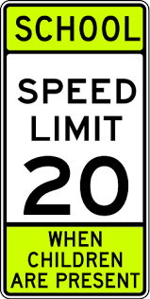

**A.** You drive as fast as you can.

**B.** You stop right now.

**C.** You drive slowly to a speed at no greater than 25km/h when children are present

**D.** You drive to a speed at over 25 km/h when children are present.

**Question 30:**

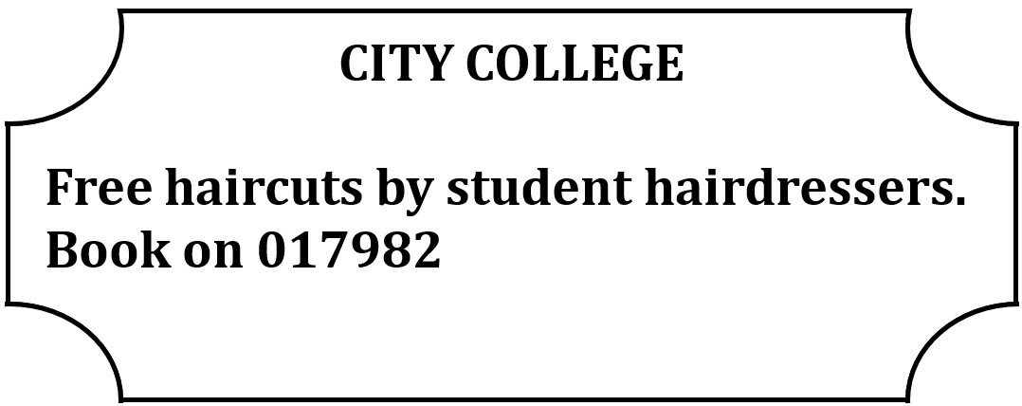

**A.** You can book a free haircut with City College students.

**B.** The haircuts at City College are only free for students.

**C.** You need to pay to book a haircut here.

**D.** The haircuts are given by professional hairdressers.

**Read the following passage and mark the letter A, B, C, or D on your answer sheet to indicate the correct answer to each of the following questions from 31 to 36**

        The environment is the natural world dial surrounds US, consisting of the air we breathe, the water we drink, the land we live on, and the ecosystems dial support life. It is essential for the well-being of all living beings on Earth.  
One of the issues concerning the environment is climate change. Human activities, such as burning fossil fuels and deforestation, contribute to the release of greenhouse gases, leading to global warming and the change of **ecosystems**. Climate change has serious consequences, including extreme weather events, sea-level rise, and the loss of biodiversity. Another important aspect of die environment is pollution. Industrial activities, and the use of harmful chemicals **contaminate** die air, waler, and soil. Pollution has negative effects on human health, wildlife, and the overall balance of ecosystems.

        Preserving and protecting the environment requires collective actions. Conservation efforts, such as sustainable resource management and afforestation, play a crucial role in reducing environmental damage. Besides, individual actions, such as reducing waste, and adopting eco-friendly practices, contribute to a more sustainable future. It is essential to raise awareness and educate the public about environmental issues. By this way. individuals can make informed choices and lake steps to minimize their ecological footprint.

**Question 31:**Which of the following can be the best title for the passage?

**A.** The Importance of Environmental Preservation

**B.** Pollution and Its Impact on the Environment

**C.** Climate Change: A Global Crisis

**D.** Raising Awareness for a Sustainable Future

**Question 32.** The word "ecosystems" in paragraph 1 is CLOSEST in meaning to ____________.

**A.** habitats **B.** species **C.** climates **D.** environments

**Question 33.** According to paragraph 2, which of the following is NOT mentioned as the consequences of climate change?

**A.** sea-level rise **B.** extreme weather events

**C.** the loss of biodiversity **D.** reducing temperature

**Question 34.** The word “**contaminate**” is closest in meaning to _____________.

**A.** pollute **B.** protect **C.** improve **D.** destroy

**Question 35.** According to the passage, pollution _____________.

**A.** contaminates the environment **B.** does not affect the air

**C.** has no effect on human health **D.** does not change ecosystems

**Question 36.** According to the passage, what is one important thing individuals can do to help protect the environment?

**A.** Use more energy and fossil fuels  
**B.** Reduce waste and use eco-friendly practices  
**C.** Depend only on factories for environmental care  
**D.** Ignore environmental problems and think only about personal gain

**Four phrases/sentences have been removed from the text below. For each question, mark the letter A, B, C, or D on your answer sheet to indicate the correct option that best fits each of the numbered blanks from 37 to 40.**

Education has transformed significantly over the years. The advent of online learning (37) ____________. Students can now access courses from anywhere and learn at their own pace. Technology has also changed teaching methods, (38) ____________. Interactive tools and digital resources help educators engage students more effectively. However, this shift has brought about challenges, as (39) ____________. It is essential for schools to adapt to these changes and ensure that all students benefit. In conclusion, education has improved dramatically, and (40) ____________.

**A.** has made learning more accessible

**B.** not all students have equal access to technology

**C.** allowing for personalized learning experiences

**D.** it will continue to improve in the future

**Question 37. ____________**  
**Question 38. ____________**  
**Question 39. ____________**  
**Question 40. ____________**

*Giaoandethitienganh.info*  có rất nhiều tài liệu tiếng anh file word hay, chất lượng, mời bạn đăng ký tài khoản ( chỉ 100k/ năm) để chủ động tự tải tài liệu khi cần!