|  |  |
| --- | --- |
| **Tiếng Anh 8 Friends Plus** | **FP 8 - UNIT 6 - TEST 1**  **Test for Unit**  *Thời gian làm bài: 40 phút (Không kể thời gian giao đề)*  *-------------------------* |

**I. Pronunciation**

**Question 1.** Which word has the underlined part pronounced differently from that of the others?

**A.** believe  **B.** because

**C.** college  **D.** university

**Đáp án đúng**: D

**Question 2.** Which word has the underlined part pronounced differently from that of the others?

**A.** about  **B.** management

**C.** apply  **D.** apprenticeship

**Đáp án đúng**: B

**Question 3.** Which word has a different stress pattern from that of the others?

**A.** computing  **B.** career  **C.** advice  **D.** payment

**Đáp án đúng**: D

**Question 4.** Which word has a different stress pattern from that of the others?

**A.** involve  **B.** position

**C.** construction  **D.** panic

**Đáp án đúng**: D

**II. Choose the answer (A, B, C or D) that best fits the space in each question.**

**Question 5.** The car is too expensive so we're trying to find a cheaper _____________.

**A.** subtitle  **B.** alternative

**C.** difference  **D.** flip side

**Đáp án đúng**: B

**Question 6.** Readers of the magazine said they wanted more stories about _____________ people and fewer stories about the rich and famous.

**A.** ordinary  **B.** unknown

**C.** extraordinary  **D.** unusual

**Đáp án đúng**: A

**Question 7.** All the citizens must _____________ the traffic rules to protect themselves and the others.

**A.** break  **B.** listen  **C.** obey  **D.** distract

**Đáp án đúng**: C

**Question 8.** More and more teenagers are _____________ about the protection of the environment. It’s a good sign.

**A.** uncared  **B.** distracting

**C.** neglected  **D.** concerned

**Đáp án đúng**: D

**Question 9.** My friends believed that I _____________ become an engineer.

**A.** won’t  **B.** mustn’t  **C.** can’t  **D.** couldn’t

**Đáp án đúng**: D

**Question 10.** Tom: “Which careers involve helping people?” – Susan: “________”

**A.** I always dream to be an astronaut when I grow up.

**B.** A transporter job is the best choice if you don’t mind traveling a lot.

**C.** Nurses promote health, prevent disease, and help patients cope with illness.

**D.** Carpenters can make masterpieces from wood

**Đáp án đúng**: C

**Question 11.** ___________ school is a school equipped with rooms where its students live instead of living in their own homes.

**A.** formal  **B.** primary  **C.** mixed  **D.** boarding

**Đáp án đúng**: D

**Question 12.** You _____________ do something you aren’t sure about.

**A.** should  **B.** won’t  **C.** mustn’t  **D.** must

**Đáp án đúng**: C

**Question 13.** Lee: “We have a great football match on TV tonight.” – Maria: “______”

**A.** I think I can practice it all day.

**B.** Yes, but we have to finish our homework on time.

**C.** I played for the school team last year.

**D.** It’s really expensive. I think.

**Đáp án đúng**: B

**Question 14.** Max is going to _____________ in the IT department because he likes working on computers.

**A.** exit  **B.** quit  **C.** give in  **D.** enroll

**Đáp án đúng**: D

**III. Look at the signs. Choose the best answer (A, B, C or D).**

**Question 15.**

What does this sign mean?

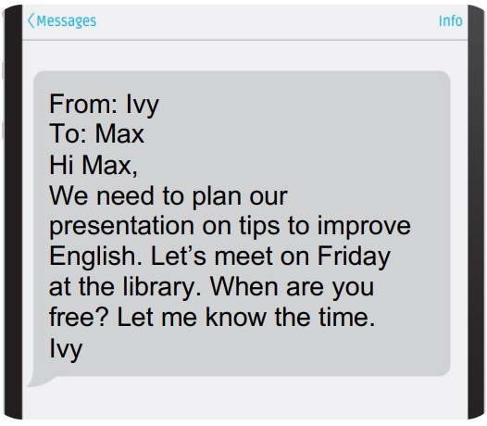

**A.** Ivy wants to find out more about the project from Max.

**B.** Ivy wants to remind Max of the project's deadline.

**C.** Ivy wants to thank Max for doing the presentation.

**D.** Ivy wants to know when they will meet to work on the project.

**Đáp án đúng**: D

**Question 16.**

What does this sign mean?

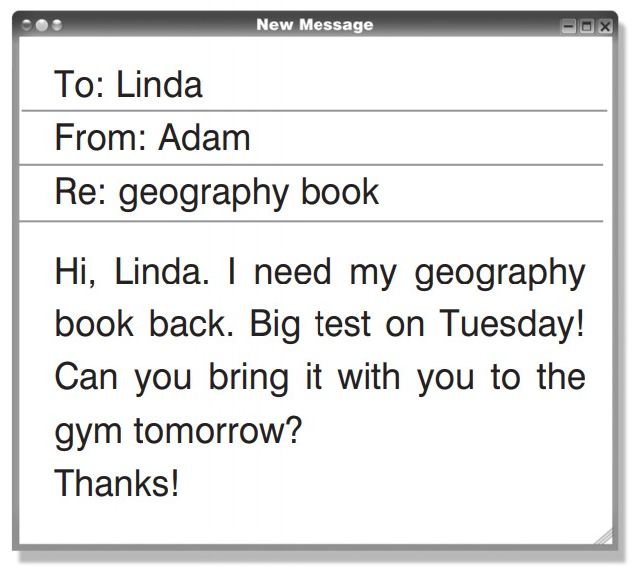

**A.** On Tuesday, Adam has a geography exam.

**B.** Adam requests to take Linda's book.

**C.** The book belongs to Linda.

**D.** Linda wants to study in the fitness center.

**Đáp án đúng**: A

**IV. Read the following passage. Decide if the statements from 17 to 20 are True or False, and choose the correct answers (A, B, C or D) for questions 21 and 22.**

Hi, I’m Mason and I’m 14. I live in a small town in Texas in the USA. I’ve got three sisters and two brothers. I love basketball and baseball. I’m into hip hop and comics. I often ride a bike or go swimming. I read a lot of books, but I don’t go to school. I study at home together with my brothers and sisters. Our mum is our teacher and I love it! Why is homeschooling great? We learn the same things as our friends at school but it’s more fun. Our mum knows what we like and what is difficult for us. Just like in every school, we do homework and take tests. We don’t use course books because Mum usually prepares the lessons. She uses information from the internet or books. We sometimes go to the library or meet with other homeschooling families. We go on trips together to museums or to other interesting places. Homeschooling helps me enjoy studying. In the future, I want to go to university and study history. People always ask me ‘Don’t you miss friends?’ But I say, ‘How can you feel lonely when you’ve got three sisters and two brothers?’ We are very close, and we enjoy doing things together.

**Question 17.** Mason will be 15 next year.

**A.** False  **B.** True

**Đáp án đúng**: B

**Question 18.** He studies with his siblings at home.

**A.** True  **B.** False

**Đáp án đúng**: A

**Question 19.** His dad often organizes the lessons.

**A.** False  **B.** True

**Đáp án đúng**: A

**Question 20.** They never go to the library or museums.

**A.** True  **B.** False

**Đáp án đúng**: B

**Question 21.** What does the author think about homeschooling?

**A.** Bad  **B.** Excellent

**C.** Boring  **D.** Unimportant

**Đáp án đúng**: B

**Question 22.** They never feel lonely because _____.

**A.** They enjoy doing things together.  **B.** They rarely meet new friends.

**C.** They are brothers and sisters.  **D.** They go to the library once a week.

**Đáp án đúng**: A

**V. Choose the word (A, B, C or D) that best fits the blank space in the following passage.**

English is a language that many students ____23____ every year. These students ____24____ some younger ones. Others are young adults. Most are adults. Some people study on their own while others learn in class. Some people pick up the language ____25____ by hearing it spoken in movies, on television, in the workplace, or among their friends. But few people have the good fortune to accomplish it. The majority of people struggle to learn a new language.

Acquiring new language skills! What ____26____ everyone here to desire to study English? That question is tough to respond ___27_____. Because it is one of their topics, English is a subject that both boys and girls study at school. They study math, English, and their native language. Adult learners of English frequently do so for professional reasons. Because some of their college or university textbooks are in English, teenagers frequently learn English for their high school courses. ____28____ pick up the language so they can read English-language publications like newspapers and magazines.

**Question 23.**

**A.** research  **B.** study  **C.** report  **D.** survey

**Đáp án đúng**: B

**Question 24.**

**A.** have  **B.** exclude  **C.** include  **D.** consist

**Đáp án đúng**: C

**Question 25.**

**A.** simplicity  **B.** simplify

**C.** simply  **D.** simple

**Đáp án đúng**: C

**Question 26.**

**A.** drives  **B.** pulls  **C.** needs  **D.** lifts

**Đáp án đúng**: A

**Question 27.**  **A.** from  **B.** to  **C.** in  **D.** at

**Đáp án đúng**: B

**Question 28.**

**A.** Each other  **B.** Others

**C.** Another  **D.** Other

**Đáp án đúng**: B

**VI. Supply the correct form of the word given in each sentence.**

**Question 29.** ________ at these lectures is compulsory. (attend)

**Đáp án đúng**: Attendance

**Question 30.** Time ________ skills are important for every student. (manage)

**Đáp án đúng**: management

**Question 31.** Tom’s parents are ________ about his study after seeing his report at school. (concern)

**Đáp án đúng**: concerned

**Question 32.** Waking up at 5 in the morning to study is not ________ for me. I’m a morning person. (usually)

**Đáp án đúng**: unusual

**Question 33.** Students can draw some ________ from their discussion. (conclude)

**Đáp án đúng**: conclusions

**Question 34.** She's a ________ child who will talk to anyone. (social)

**Đáp án đúng**: sociable

**VII. Rearrange the groups of words in a correct order to make complete sentences.**

**Question 35.** in /Max has /applied for /an apprenticeship / computing.

Max ____________________________________________________________

**Đáp án đúng**: Max has applied for an apprenticeship in computing.

**Question 36.** and see famous /football matches /can watch /Students /players practice.

Students ____________________________________________________________

**Đáp án đúng**: Students can watch football matches and see famous players practice.

**VIII. Rewrite each of the following sentences in another way so that it means almost the same as the sentence printed before it.**

**Question 37.** It took Susie an hour to do her homework last night.

Susie spent ____________________________________________________________

**Đáp án đúng**: Susie spent an hour doing her homework last night.

**Question 38.** Having a school-life balance is important for students.

It is ____________________________________________________________

**Đáp án đúng**: It is important for students to have a school-life balance.

**Question 39.** I am interested in learning chemistry.

I find ____________________________________________________________

**Đáp án đúng**: I find learning chemistry interesting.

**Question 40.** You should study hard for the coming exam.

If I ____________________________________________________________

**Đáp án đúng**: If I were you, I would study hard for the coming exam.

**IX. Listen and fill in the blanks with one word/ number.**

**Question 41.** John is doing well in his _____________ class.

**Đáp án đúng**: French

**Question 42.** Ann is going to have a party ____________.

**Đáp án đúng**: tonight

**Question 43.** _________ is lying in bed watching TV.

**Đáp án đúng**: harry

**Question 44.** Jane is going shopping to buy some _________.

**Đáp án đúng**: jeans

**Question 45.** Kate is going to rent a ________ tonight.

**Đáp án đúng**: DVD

**X. Listen again and decide whether the statements are true or false.**

**Question 46.** Ann wants to invite all her classmates to her party.

**A.** True  **B.** False

**Đáp án đúng**: A

**Question 47.** John is doing some research for his chemistry project.

**A.** True  **B.** False

**Đáp án đúng**: B

**Question 48.** Helen is making dinner for her brother.

**A.** True  **B.** False

**Đáp án đúng**: A

**Question 49.** Jane wants to buy some new shirts.

**A.** False  **B.** True

**Đáp án đúng**: A

**Question 50.** John suggests Ann should postpone the party until next week.

**A.** False  **B.** True

**Đáp án đúng**: B

**----HẾT---**