LỚP HỌC THẦY (CÔ) ___________________________ ĐỀ ÔN TẬP: READING SIGNS/ NOTICES – A2
Test 7
Thời gian làm bài: [Time]
Họ và tên: ________________________________________________ Lớp: 9/___
Nội dung:
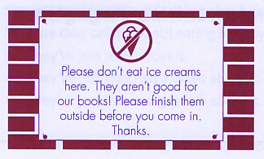
Question 1: Where might you see this?

A. in a café B. in a swimming pool
C. in a library D. in a picnic area

Question 2: Who is this message for?
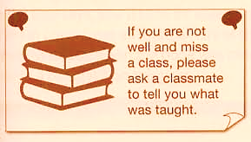
A. Pupils who are feeling not well B. Pupils who couldn't go to a lesson
C. Pupils who would like to help their friends D. The student does not study.
Question 3: What does the sign say?
A. Please go to the science room now.
B. You cannot go out through this door.
C. The science lab is being used by others today.
D. Use this door to get to the science room now.

Question 4: What should the club members do?
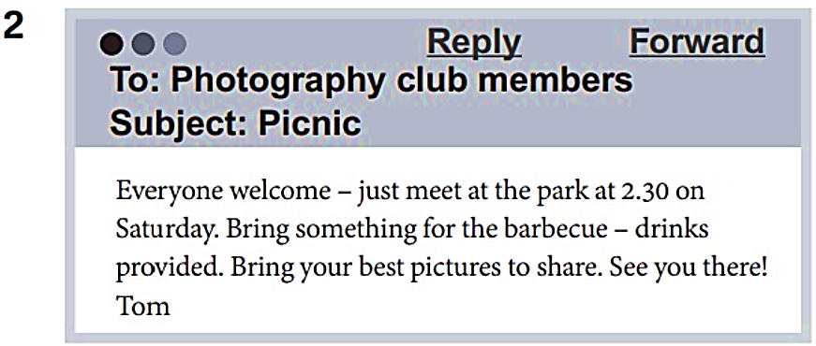
A. bring food to cook on the picnic B. take lots of photos at the picnic
C. tell Tom if they want to go on the picnic D. have a barbecue on the picnic

Question 5: What does the sign mean?

A. Bad students will be punished at school.
B. Violence is not allowed at school.
C. Classmates should not talk too much to each other.
D. Younger students mustn't obey their monitors at school.
Question 6: Who are this message for?
How about joining the school singing group? It doesn't matter if you can't read music. All staff and pupils welcome! Mondays after lessons at 4 p.m.

A. Anyone at the school B. Pupils who have music lessons
C. People who can already read music D. You must know how to sing
Question 7: What does the sign say?

A. Do not touch the artwork or you may be fined.
B. Touch the artwork if you need a closer look.
C. Only touch the artwork that is labeled for touching.
D. Do not touch the artwork to keep it safe and clean.

Question 8: Which of the following information is correct?
DAN'S ICE CREAMS
Buy one, get one free! (Special offer 12-2 p.m. only)

A. The ice cream shop is open for only 2 hours. B. Two ice creams will cost the same as one.
C. You can get free ice creams all afternoon. D. You can only buy 2 ice creams at a time.
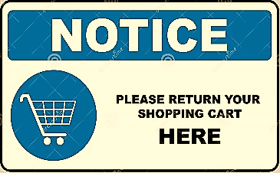
Question 9: What does the sign tell you?
A. Return your cart anywhere in the parking lot.
B. Return the cart to the designated cart area.
C. Keep the cart in your car until you get home.
D. Return the cart at the store entrance.

Question 10: Who is this message for?
Bring your parents to the school’s Open Day this Saturday! All students are encouraged to attend with their families from 10 a.m. to 2 p.m.

A. Only new students. B. All students and their families.
C. Teachers and staff. D. Parents only.
[HẾT]

