UBND QUẬN TÂN PHÚ  TRƯỜNG THCS PHAN BỘI CHÂU  ĐỀ THAM KHẢO |  | ĐỀ TUYỂN SINH 10  Bộ môn: TIẾNG ANH – LỚP 9  Thời gian làm bài: 60 phút (Không kể thời gian giao đề)  (Đề kiểm tra này gồm 4 trang)
Họ và Tên: _____________________  ______________________________  Lớp: 9/_________________________  Số thứ tự: ______________________ |  | Chữ ký giám thị 1 | Chữ ký giám thị 2 | Số thứ tự bài KT  Mật mã bài KT
Điểm bằng số | Điểm bằng chữ | Chữ ký  giám khảo 1 | Chữ ký  giám khảo 2 | Mật mã bài KT
 |  |  |  | Số thứ tự bài KT
LƯU Ý: Đề kiểm tra gồm 4 trang. Thí sinh làm bài ngay trên đề kiểm tra này. Thí sinh phải làm đúng theo hướng dẫn cách ghi câu trả lời ở mỗi phần. Bài làm chỉ được chấm ở các Phần trả lời. Mọi cách ghi khác đều không được chấm điểm.
- Choose the word / phrase (A, B, C or D) that best fits the space in each sentence: (4.0 pts)
- Choose the word whose underlined part is pronounced differently from the other three
A. picnic B. install C. Viking D. simple
- Choose the word whose underlined part is pronounced differently from the other three
A. capsule B. advent C. damage D. rare
- Choose the word whose stress pattern is different from the others
A. career B. option C. nomad D. modern
- Choose the word whose stress pattern is different from the others
A. knowledge B. career C. access D. passion
- In order to stand _______ from the crowd, you have to embrace your true self.
A. up B. by C. out D. back
- Why don’t you start out _______ early _______ you don’t have to hurry?
A. such - that B. X – so that C. X – such that D. so - that
- Dangerous sports are something that I am not _______
A. interested of B. fond to C. crazy with D. keen on
- Phobia never _______ if you don’t have the proper treatments.
A. makes up B. takes off C. looked into D. goes away
- You look absolutely _______ in that dress. How lovely!
A. stunning B. terrifying C. exciting D. depressing
- The pavilion would include a theatre-in-the-round with seating _______ for about 2,000.
A. capability B. ability C. capacity D. inability
- Hours after Japan’s surrender in World War II, Vietnam declared _______ from France..
A. dependent B. independence C. independent D. dependence
- I admired the stuntman _______ part was so dangerous.
A. that B. which C. whose D. whom
FB: Thầy Đình (Dạy Tiếng Anh)
- Archaeologists are _ the burial site. Surprisingly, they have found fragments of Iron Age pottery.
A. excavating B. restoring C. destroying D. covering
- Timothy: “I think swimming should be part of the school curriculum
Jeremy: “_______. It is an essential life skill.”
A. I can’t agree with you more. B. Not at all.
C. You can make it. D. That’s a big problem.
THÍ SINH KHÔNG ĐƯƠC VIẾT GÌ VÀO Ô PHÁCH NÀY

...................................................................................................................................................................

- What does the sign say?
A. Flash photography prohibited.
B. Flash photography allowed.
C. Flash photography not forbidden.
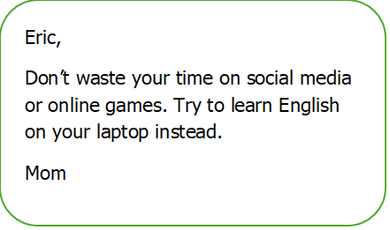
D. Flash photography permitted.

- What does Mom want Eric to do?
A. stop playing offline games.
B. stop learning English.
C. learn English with the laptop.
D. practice speaking English with his mom..

Thí sinh chỉ viết mẫu tự (A, B, C, hoặc D) đại diện cho câu trả lời đúng vào Phần trả lời.
Phần trả lời: | 1._______ | 2._______ | 3._______ | 4._______ | 5._______ | 6._______
Phần trả lời: | 7._______ | 8._______ | 9._______ | 10._______ | 11._______ | 12.______
 | 13._______ | 14._______ | 15._______ | 16._______
II. Read the following passage. Decide if the statements from 17 to 20 are True or False
and choose the correct answer (A, B, C or D) for the questions 21 and 22. (1.5 pts)

Hue Imperial Citadel is a UNESCO World Heritage Site located in the city of Hue, Vietnam. It served as the political and cultural center of the Nguyen Dynasty, Vietnam’s last royal dynasty, from 1802 until the dynasty’s downfall in 1945. Hue Imperial City was founded in 1802 by Gia Long, the first emperor of the Nguyen Dynasty. During its peak, Hue Imperial City was a grand and impressive complex that included the Forbidden Purple City, the Imperial City, and the royal tombs. It was a center of political power, as well as a hub for cultural and artistic expression. Hue Imperial Citadel is not only a beautiful example of Vietnamese architecture and design, but it also holds significant cultural and historical value which plays a vital role in shaping Vietnamese culture and identity. The citadel is an impressive complex of palaces, temples, and gardens that showcases the unique architecture and artistry of Vietnamese culture. All the typically traditional Eastern architectures including majestic palaces, tombs and museums stand accordantly together to make an utmost amusing attraction – our Hue Imperial Citadel.
- The political and cultural center of Vietnam has been set in Vietnam since the Nguyen Dynasty.
- The Nguyen Dynasty is the last dynasty of Vietnam, beginning in 1802 and ending in 1945.
- Hue Imperial Citadel plays an important role in shaping the identity and culture of Viet Nam.
- The uniqueness of the architecture is showcased only by the tombs and temples.
- What can be served as the best title of the passage?
A. The construction of Hue Imperial Citadel.
B. The design of Hue Imperial Citadel.
C. The history and architecture of Hue Imperial Citadel.
D. The culture of Hue Imperial Citadel.
- What is not included in Hue Imperial Citadel?
A. The Purple City. B. The Royal Tombs. C. The World Heritage Site. D. The Imperial City

THÍ SINH KHÔNG ĐƯƠC VIẾT GÌ VÀO Ô PHÁCH NÀY
........................................................................................................................................................................

Từ câu 17 đến câu 20, thí sinh phải viết đầy đủ từ True hoặc False vào ô trả lời. Mọi cách viết khác đều không được chấm điểm. Đối với câu 21 và 22, thí sinh chỉ viết mẫu tự (A, B, C hoặc D) đại diện cho câu trả lời đúng vào Phần trả lời.
FB: Thầy Đình (Dạy Tiếng Anh)
Phần trả lời: 17. ________ 18. ________ 19. ________ 20. ________ // 21. _______ 22. _______
III. Choose the word (A, B, C or D) that best fits the blank space in the following passage. (1.5 pts)

Earth's Moon is the brightest and largest object (23) _________ our night sky. The Moon makes Earth a more livable planet by moderating our home planet's wobble on its axis, leading to a relatively stable climate. It also causes tides, (24) _________ a rhythm that has guided humans for thousands of years. The Moon was likely formed after a Mars-sized body collided with Earth several billion years ago. Earth's only natural satellite (25) _________ "the Moon" because people didn't know other moons existed until Galileo Galilei discovered four moons orbiting Jupiter in 1610. In Latin, the Moon was called Luna, (26) _________ is the main adjective for all things Moon-related: lunar. (27) _________ Earth, the Moon has a day side and a night side, which change as the Moon rotates. The Sun always illuminates half of the Moon while the other half remains (28) _________.

- A. on B. in C. at D. under
- A. created B. that creates C. creating D. create
- A. is simply called B. simply called C. simply is called D. called simply is
- A. that B. which C. X D. All are correct
- A. As B. Whereas C. Unlike D. Like
- A. dark B. darker C. more and more dark D. darker and darker

Thí sinh chỉ viết mẫu tự (A, B, C, hoặc D) đại diện cho câu trả lời đúng vào Phần trả lời.

Phần trả lời: 23. ________ 24. ________ 25. ________ 26. ________ 27. _______ 28. _______
FB: Thầy Đình (Dạy Tiếng Anh)
IV. Fill in the gaps with the correct form of words in the brackets. (1.5 pts)
- Don’t be scared, just speak _______ and pretend the microphone isn’t there. (NATURE)
- Farmers use _________ to kill insects that would destroy their crops. (CHEMIST)
- When he __________ the picture of his family, he gave a cry of pain. (COVER)
- Smoking during pregnancy _____________ your baby’s life. (DANGEROUS)
- The whole family is ______ by the side of the park. They are having a fun time together. (PICNIC)
- Leonardo da Vinci was a man who became as _________ in art as he was in all of our hearts. (REPLACE)
Chú ý: Thí sinh phải viết từ cần điền vào Phần trả lời dưới dây
Phần trả lời: 29. __________________ 30. ____________________ 31. __________________ 32. __________________ 33. ____________________ 34. __________________
THÍ SINH KHÔNG ĐƯƠC VIẾT GÌ VÀO Ô PHÁCH NÀY
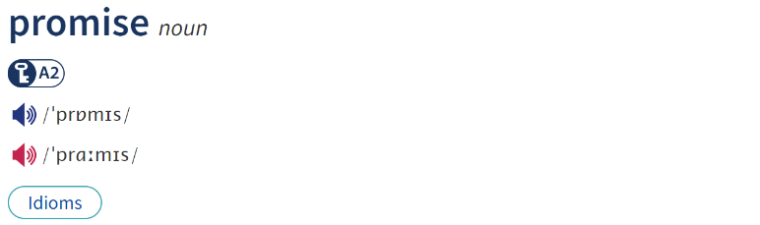
........................................................................................................................................................................
I
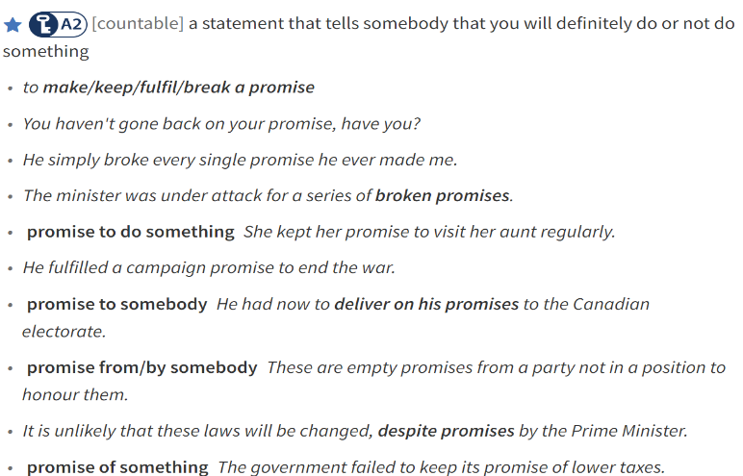
V. Look at the entry of the word “promise” in a dictionary. Use what you can get from the entry to complete the sentences with two or three words. (0.5 pt)
- Marc know that his sister will hate him if he ________________.
- I felt encouraged by the ___________ my parents’ support.
Thí sinh viết các nhóm từ còn thiếu vào Phần trả lời để hình thành câu hoàn chỉnh.
Phần trả lời:
35. _________________________________
36. _________________________________
VI. Rewrite each of the following sentences in another way so that it means almost the same as sentence printed before it. (1.0 pt)
37. The boy can’t wait to ride his new bike.
The boy is really looking
38.After having filled more than 600 boxes with objects from his everyday life, Andy Warhol died in 1987.
By the time
39. You are obliged to stop music after 10 when living on campus.
You must
40. Marc was envious of his sister when she was given a new computer by their parents.
Marc was green
Thí sinh viết tiếp những câu trên theo đúng yêu cầu của đề dẫn vào Phần trả lời dưới đây.
Phần trả lời:
37. The boy is really looking
38. By the time
39. You must
40. Marc was green
THE END OF THE TEST

