Week:  Period: | Date of planning:  Date of teaching:

UNIT 12: LIFE ON OTHER PLANETS

Lesson 6: Skills 2
I. OBJECTIVES
By the end of this lesson, Ss will be able to:
1. Knowledge
+ Listening
- Listen about an imaginary planet and its creatures.
+ Writing:
- Write a paragraph to describe imaginary planet and its creatures.
2. Competences
- Develop creativity and communication skills
- Be collaborative and supportive in pair work and team work
- Actively join in class activities
3. Personal qualities
- Be benevolent and responsible
II. MATERIALS
- Grade 8 textbook, Unit 12, Getting started
- Computer connected to the Internet
- Projector / TV/ pictures and cards
- Phần mềm tương tác hoclieu.vn
III. PROCEDURES
1. WARM-UP (5 mins)
a. Objectives:
- To create an active atmosphere in the class before the lesson
- To lead into the new unit.
b. Content:
- Describe the aliens
c. Expected outcomes:
- Ss know how to describe the aliens
d. Organisation:
TEACHER’S AND STUDENTS’ ACTIVITIES | CONTENTS
- Teacher divides class into 4 groups and ask them to draw the picture about the alien they like (What does it look like? Where does it live?) in 3 minutes  - Ss work in group  – Some presenters in each group will present what they draw in front of the class.  - Ss present in group  – Teacher gives feedback | - What does the alien look like?  - Where does it live? Can you describe about that place?

2.ACTIVITY 1: PRESENTATION: LISTENING(15 mins)
a. Objectives:
- To help Ss understand and activate their knowledge of the topic.
- To help Ss develop their skill of listening for specific information.
b. Content:
- Look at the picture and answer questions.
- Listen and choose correct answer.
- Listen and fill in the blank.
c. Expected outcomes:
-Ss can answer the questions correctly.
- Ss can develop the skill of listening for specific information
d. Organisation
TEACHER’S AND STUDENTS’ ACTIVITIES | CONTENTS
Task 1: Work in pairs. Look at the picture and answer the following questions. (Ex 1, p.131)
– T asks Ss to work in pairs, discussing questions about the creature in the picture.  - Ss do the task in pairs  – T asks some Ss to say their answers in front of the class. If necessary, ask them some other questions about what planet in the solar system we could live on.  - Ss answer individually | 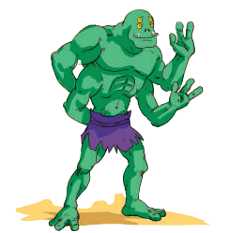  1. Where do you think this creature is from?  2. What do you think it can do?  Suggested answers:  - It is from another planet/Mars/Venus….  - It can jump. It can catch 4 fish at the same time with his hands. It can do handstand….
Task 2: You will hear a student talking about an imaginary planet that supports life. Listen and choose the correct answer A, B, or C.(Ex 2, p.131)
- T has Ss read the questions in this activity quickly and underline the key words. This gives them some idea of what they are going to listen to and the information they need for answering the questions.  - Ss read and do the task individually  - T plays the recording twice for Ss to do the exercise. For stronger classes, asks Ss to take notes of the information to explain their answers.  - Ss listen and do the task individually  - T has Ss share their answers in pairs.  - Ss share answer with friends.  - T invites some Ss to answer and confirm the correct ones.  - Ss answer individually  - T plays the recording again if needed, stopping at places where students are having difficulties.  - WC listen and check answer again. | Answer key  1. A  2. C  3. A  4. A  5. B
Task 3: Read the following information about Hopeans. Listen again and fill in each blank with ONE word or number that you hear.(Ex 3, p.131)
- T has Ss read the text and determine the part of speech of the word they are to use to fill in the blanks and the needed information to listen for. Remind them that they need only one word or number for each blank.  - Ss Read and determine individually  - T plays the recording once or twice more for Ss to do the exercise. For stronger classes, ask Ss to take notes of the information to explain for their answers.  - Ss listen and do the task individually  - T has Ss share their answers in pairs.  - Ss compare answer in pairs  - T invites some Ss to answer and confirm the correct ones.  - Ss answer individually  - T plays the recording again if needed, stopping at the places where Ss are having difficulties.  - WC listen and check the answer | Answer key  1. 4 (four)  2. 4 (four)  3. hospitable  4. dangerous  5. plants  6. rockets  Audio script – Track 79 + 80:  Good morning, everyone. Today I’d like to tell you about life on a planet called Planet Hope.  Planet Hope is in the Milky Way Galaxy. It is three times bigger than Earth. It has three suns and four  moons, so the weather is hot all year round, and its surface is quite dry. Planet Hope has only one season. The creatures living there are Hopeans, and they don’t look like us. They have a big head, four eyes, two legs and four arms. They have thick skin to protect them from the heat. They are very friendly and hospitable. They are only dangerous to people who try to attack them. Hopeans grow special plants for food. They don’t drink liquid water; they drink a type of petrol from under the ground. Hopeans use rockets to travel at very high speeds. That is my description of Planet Hope and the creatures living on it. I hope you enjoyed it and thank you for listening.
3.ACTIVITY 2: PRACTICE : WRITING (15 mins)
a. Objectives:
-To write a paragraph describing aliens living on another planet.
b. Content:
- To make notes about describing aliens.
- To write a paragraph describing aliens.
c. Expected outcomes:
- Students can write a paragraph correctly.
d. Organisation:
TEACHER’S AND STUDENTS’ ACTIVITIES | CONTENTS
Task 4.Work in pairs. Use your imagination to make notes in the table below about what aliens living on another planet would be like. (Ex 4, p.131)
- T asks Ss to discuss and take notes about imaginary aliens living on another planet. Remind them that they can both write full sentences and make notes, and they can even use abbreviations.  - Ss discuss in pairs  - Then T asks Ss to share their writing with their partners. T may read out writings from some more able Ss to the whole class. | 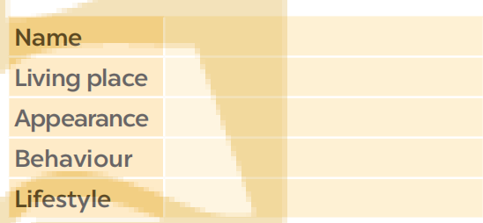
Task 5.Write a paragraph (80 - 100 words) describing aliens living on another planet. Use your notes in4. (Ex 5, p.131)
- Set up the writing activity: T reminds Ss that the first important thing is always to think about what they are going to write. Ss can use the ideas they have prepared in Activity 4.  - T asks Ss to brainstorm the ideas and language needed for writing. Asks Ss to refer back to the reading for useful expressions  and ideas and write on the board.  Ss do the task individually  - Ask Ss to write the first draft individually.  Ss do the task individually | 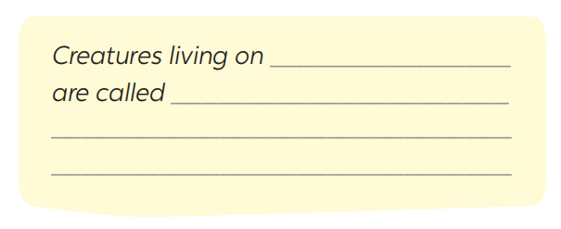
4. ACTIVITY 3: PRODUCTION: WRITING CORRECTION (7’)
a. Objectives:
-To correct some student’s mistakes
b. Content:
- To make notes about student’s mistakes .
c. Expected outcomes:
- Students can write a paragraph correctly.
d. Organisation

TEACHER’S AND STUDENTS’ ACTIVITIES | CONTENTS
- Display all or some of the Ss’ writings on the wall / notice board. T and other Ss comment.  - T takes note some mistakes that Ss need to correct. Asks Ss to edit and revise their writing as homework. If time is limited, ask Ss to write the final version at home | Display some mistakes that ss need to correct.
5. CONSOLIDATION (3’)
a. Wrap-up:
- Ask Ss to summarise what they have learnt in the lesson.
- Have Ss look at the objectives written on the board at the beginning of the lesson and tick the objectives they have learnt.
b . Homework:
- Rewrite the paragraph on the notebook.
- Prepare Unit 12 – Lesson 7: Looking back + Project
(Ask Ss to do exercise in looking back and prepare their presentation)

