Thời gian làm bài: 40 phút (Không kể thời gian giao đề)
-------------------------
Họ tên thí sinh: .................................................................
Số báo danh: ......................................................................
Mã Đề: 031.
Câu 1. What is the condition of the bicycle's tyres according to the advertisement?
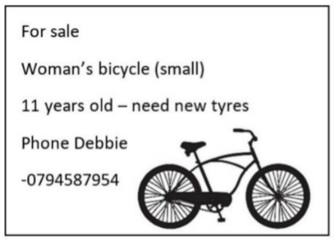
A. The advertisement doesn't mention the tyres B. They are brand new
C. They need to be replaced D. They are in good condition
Câu 2. What can be inferred about the new location of the post office?
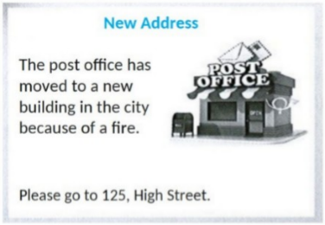
A. It's in a shopping mall B. It's on High Street in the city
C. It's in a residential neighborhood D. It's in a rural area
Câu 3. What is true about the Tanzania advertisement?
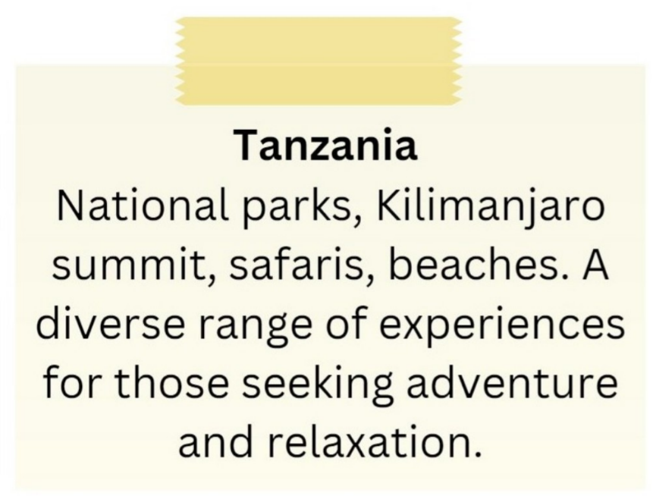
A. It excludes beach-related experiences.
B. It promotes a single national park as the main attraction.
C. It features Kilimanjaro summit and safaris.
D. It is focused solely on relaxation.
Câu 4. When can students receive a 20% discount at Sam's Café?
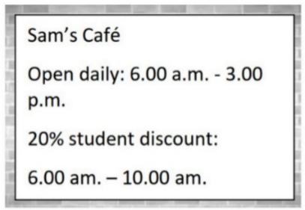
A. From 6:00 a.m. to 10:00 a.m. B. From 6:00 a.m. to 3:00 p.m.
C. After 10:00 a.m. D. All day
Câu 5. What does this sign mean?
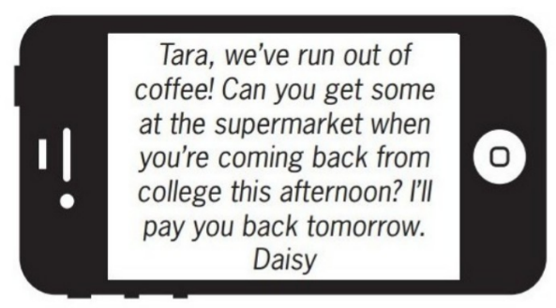
A. Daisy wants Tara to buy some coffee this afternoon.
B. Daisy will buy coffee tomorrow when she returns home.
C. Tara should give Daisy some money to buy coffee.
D. Tara will go to the supermarket tomorrow.
Câu 6. Look at the signs. Choose the best answer for the question.
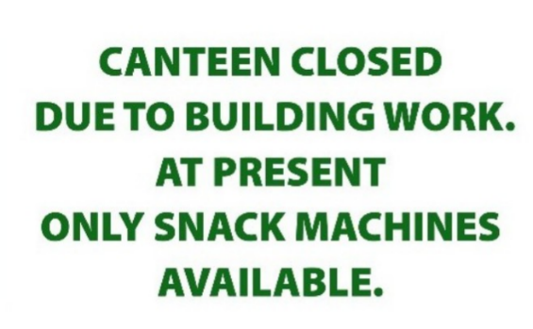
A. Students can only buy food from the snack machines.
B. Students have to stop buying food till the canteen is opened.
C. Students can’t buy food until the snack machines are fixed.
D. Students can’t buy snacks because the machines are closed.
Câu 7. Look at the signs. Choose the best answer for the question.

A. You should keep the door open unless there is a fire.
B. You should only shut the door when it is on fire.
C. You mustn’t put the door on fire.
D. This door must remain closed to prevent the spread of fire.
Câu 8. What is the offer for the swim class?
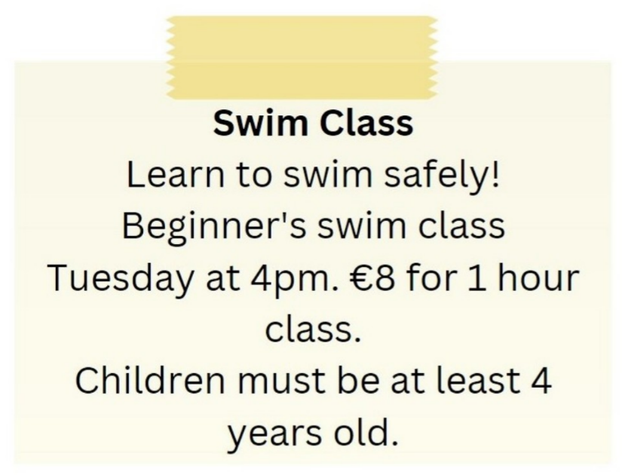
A. Beginner's swim class on Tuesday at 5pm for €10
B. Beginner's swim class on Tuesday at 4pm for €8
C. Advanced swim class on Tuesday at 4pm for €8
D. Beginner's swim class on Wednesday at 4pm for €8
Câu 9. "What does the person sending the message want to do?"
Hi there! I hope you're doing well. I wanted to see if you're interested in going to a show this weekend. There's a new play that just opened at the local theatre, and I've heard great things about it. Let me know if you're free and we can get tickets together.
A. Go to a show B. Visit a museum C. Attend a concert D. Watch a movie
Câu 10. What is true about the Iceland advertisement?
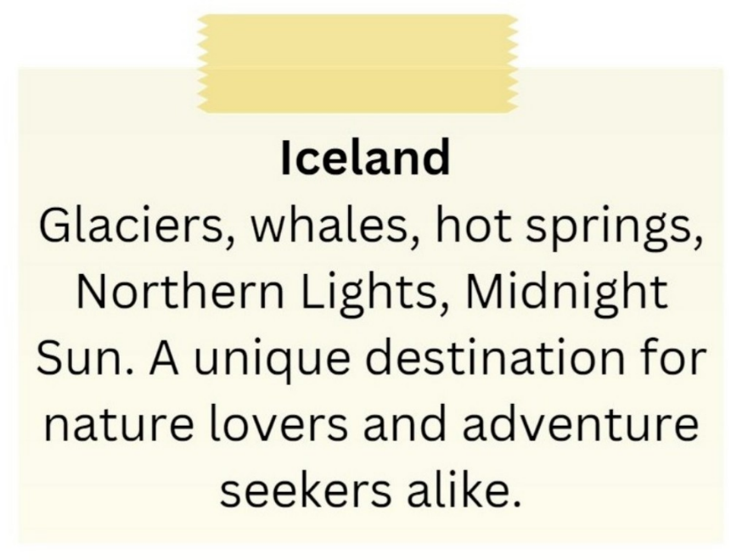
A. It showcases skyscrapers and bustling city life.
B. It is exclusively for adventure seekers.
C. It emphasizes tropical beaches and sunbathing.
D. It includes attractions such as glaciers, whales, hot springs, and the Northern Lights.
----HẾT---

