**TEST 02**

**Listening**

**There are 25 questions**

**You will need coloured pens and pencils.**

**My name is…………………………….**

## PART 1

**5 questions**

**This is an example. Now you listen and draw lines.**

|  |  |  |  |  |  |
| --- | --- | --- | --- | --- | --- |
| Fred | Emily | | Minh | | Jack |
| M_T2_LIS_P1_1_5_0_A1_T25_LIS_P1_2_0-82 | | | | | |
| Rose | | Jill | | Tom | |

## PART 2

**5 questions**

**Listen and write. There is one example.**

|  |  |  |
| --- | --- | --- |
|  |  | |
|  | **LOST SCHOOL THING** | |
| **0** | What: | a…*pencil…* |
| **1** | Colour: | …… |
| **2** | When lost: | last……. |
| **3** | Where lost: | on the…. |
| **4** | Student’s name: | …… |
| **5** | Phone number: | …… |

## PART 3

**5 questions**

**What did Hoa do yesterday?**

**Listen and draw a line from the time to the correct picture**

**There is one example**

|  |  |  |  |  |  |  |  |  |  |  |  |  |  |  |  |  |
| --- | --- | --- | --- | --- | --- | --- | --- | --- | --- | --- | --- | --- | --- | --- | --- | --- |
|  | |  | | --- | | **7 a.m** | |  | | **9 a.m** | |  | | **11 a.m** | |  | | **1 p.m** | |  | | **3 p.m** | |  | | **5 p.m** | |  | | **7 p.m** | |  | |  |
|  |  |
|  |  |
|  |  |
| **A1_T25_LIS_P3_12_2** |  |
|  |  |

**PART 4**

**5 questions**

**Listen and tick (✓) the box. There is one example.**

|  |  |  |
| --- | --- | --- |
| **Example : What time did Laura go to school?** | | |
|  |  |  |
| **A ⬜** | **B ⬜** | **C ⬜** |
| 1. **Where’s Long’s grandma?** | | |
|  |  |  |
| **A ⬜** | **B ⬜** | **C ⬜** |
| 1. **What’s Tim doing?** | | |
| **M_T2_LIS_P4_2_0_M_T2_LIS_P4_2_0** | **M_T2_LIS_P4_2_1_M_T2_LIS_P4_2_1** | **M_T2_LIS_P4_2_2_A1_T25_REA_P1_2_0** |
| **A ⬜** | **B ⬜** | **C ⬜** |
| 1. **What did Khanh buy yesterday?** | | |
|  |  |  |
| **A ⬜** | **B ⬜** | **C ⬜** |
| 1. **What was Emily’s dream about?** | | |
|  |  |  |
| **A ⬜** | **B ⬜** | **C ⬜** |

|  |  |  |
| --- | --- | --- |
| 1. **Where’s the dog?** | | |
|  |  |  |
| **A ⬜** | **B ⬜** | **C ⬜** |

## PART 5

**5 questions**

**Listen and colour and draw.**

|  |
| --- |
|  |

**Reading and Writing**

**There are 35 questions**

**You have 30 minutes.**

**You will need a pen or pencil.**

**My name is…………………………….**

## PART 1

**5 questions**

**Look and read. Choose the correct word and write them on the lines.**

|  |  |
| --- | --- |
|  |  |
| **A hospital** | **A shower** |
|  | M_T2_REA_P1_1_5_6 |
| **A parent** | **A mistake** |
|  |  |
| **A bowl** | **A moustache** |
|  |  |
| **A neck** | **Weather** |

***Example***

|  |  |  |
| --- | --- | --- |
| (0) | It is a place. A doctor works there. | A hospital |

**Questions**

|  |  |  |
| --- | --- | --- |
| 1 | It’s round. You put food such as soup in it. | \_\_\_\_\_\_\_\_\_\_\_ |
| 2 | It looks like hair. It’s above your lip. | \_\_\_\_\_\_\_\_\_\_\_ |
| 3 | You make this when write something not correct. | \_\_\_\_\_\_\_\_\_\_\_ |
| 4 | When you open this, water falls from it. | \_\_\_\_\_\_\_\_\_\_\_ |
| 5 | This person can be your mother or your father. |  |

## PART 2

**6 questions**

**Read the text and choose the best answer.**

**Tony is talking to his friend, Susan, on his first day at school.**

|  |
| --- |
|  |

|  |  |  |
| --- | --- | --- |
| **Example:** | | |
|  | Susan: | Hello. I’m Susan. Nice to meet you. | |
|  | Tony: | A. Good bye! |
|  |  | B. What’s your name? |
|  |  | C. Nice to meet you, too. |
|  |  |  |

**Questions:**

|  |  |  |
| --- | --- | --- |
| 1 | **Susan:** | How many members are there in your family? |
|  | **Tony:** | A. There are four people in my family. |
|  |  | B. My father is a teacher. |
|  |  | C. I share my bedroom with my brother. |

|  |  |  |
| --- | --- | --- |
| 2 | **Susan:** | Have you got any brothers and sisters? |
|  | **Tony:** | A. Yes, we’ve got some of it. |
|  |  | B. Yes, they’ve got a big family. |
|  |  | C. Yes, I’ve got a brother. |

|  |  |  |
| --- | --- | --- |
| 3 | **Susan:** | What are you doing this weekend? |
|  | **Tony:** | A. I go to school every day. |
|  |  | B. I am going camping with my family. |
|  |  | C. The lake near my house is very beautiful. |

|  |  |  |
| --- | --- | --- |
| 4 | **Susan:** | Which school do you go to? |
|  | **Tony:** | A. I am a student in class 4C. |
|  |  | B. I love my school very much. |
|  |  | C. I study in Nhân Hòa Primary School. |

|  |  |  |
| --- | --- | --- |
| 5 | **Susan:** | How do you go to school? |
|  | **Tony:** | A. My mom drives me to school every day. |
|  |  | B. I often go for a walk with my mom. |
|  |  | C. School is not far from our house. |

|  |  |  |
| --- | --- | --- |
| 6 | **Susan:** | What is your favourtie sports? |
|  | **Tony:** | A. I like playing the piano. |
|  |  | B. I like swimming and outdoor activities. |
|  |  | C. My favourite one is chicken. |

## PART 3

**6 questions**

**Read the story. Choose a word from the box. Write the correct word next to the numbers 1-5. There is one example.**

James is a hardworking (0) …*student*.... He goes to the library every afternoon to do his homework and read books. One day, he found a strange book on the (1) …. It was all black and there were no words on its cover. He was very curious and he decided to read the book.

He came back to his seat and opened a book. Strangely, there was only one line on the first (2) … of the book. It said “Write your wish here and it will come true”. He was so (3) … that he couldn’t say a word. He put up his pen and wrote: “I wish to have a new school bag for a new school year.” After he finished writing, he sat still and (4) …. 30 minutes passed but nothing happened. He became so (5) … and decided to go home. Suddenly, the librarian brought him a new school bag. She said: “It’s a gift for you, James – a hard-working boy.”

|  |  |  |  |  |  |  |  |  |  |  |  |  |  |  |  |  |  |  |
| --- | --- | --- | --- | --- | --- | --- | --- | --- | --- | --- | --- | --- | --- | --- | --- | --- | --- | --- |
| **Example**   |  |  |  | | --- | --- | --- | |  |  | M_T2_REA_P3_11_15_2 | | shelf | surprised | disappointed | |  |  |  | | pen | library | student | |  |  | M_T2_REA_P3_11_15_8 | | bike | waited | page | |

**(6) Choose the best name for the story.**

**Tick one box.**

|  |  |
| --- | --- |
| A day at school | ⬜ |
| A librarian’s day | ⬜ |
| A strange book | ⬜ |

## PART 4

**5 questions**

**Choose the right words and write them on the line.**

|  |  |
| --- | --- |
|  | **Jungles** |
|  |
| **Example**  1 - 2  3  4  5 | Jungles are very hot and wet (0) **places**. They are very green because it  … rains there. In the jungles, there are different … of beautiful flowers, plants and animals living there. Jungles also have many long rivers. But these rivers are very …. Sometimes, we can find hungry crocodiles there. Some people live in the jungles. Their homes are often next to a river because they need water to …. They also need to move around by using boats on the river. Rivers are … road in the jungle. |

|  |  |  |  |
| --- | --- | --- | --- |
| **Example:** | places | place | a place |
| 1. | often | never | rarely |
| 2. | ones | lots | kinds |
| 3. | safe | dangerous | beautiful |
| 4. | drink | eat | sleep |
| 5. | as | such | like |

## PART 5

**7 questions**

**Look at the picture and read the story. Write some words to complete the sentences about the story. You can use 1, 2 or 3 words.**

|  |
| --- |
| **A Grandpa’s Visit** |
|  |

Last week, Grandpa Richard came to visit Alex and Emily. They really loved days with their grandfather because they can do many funny and exciting things together.

**Example:**

Grandpa’s name is …**Richard**…..

Alex and Emily … **loved** … being with their grandpa.

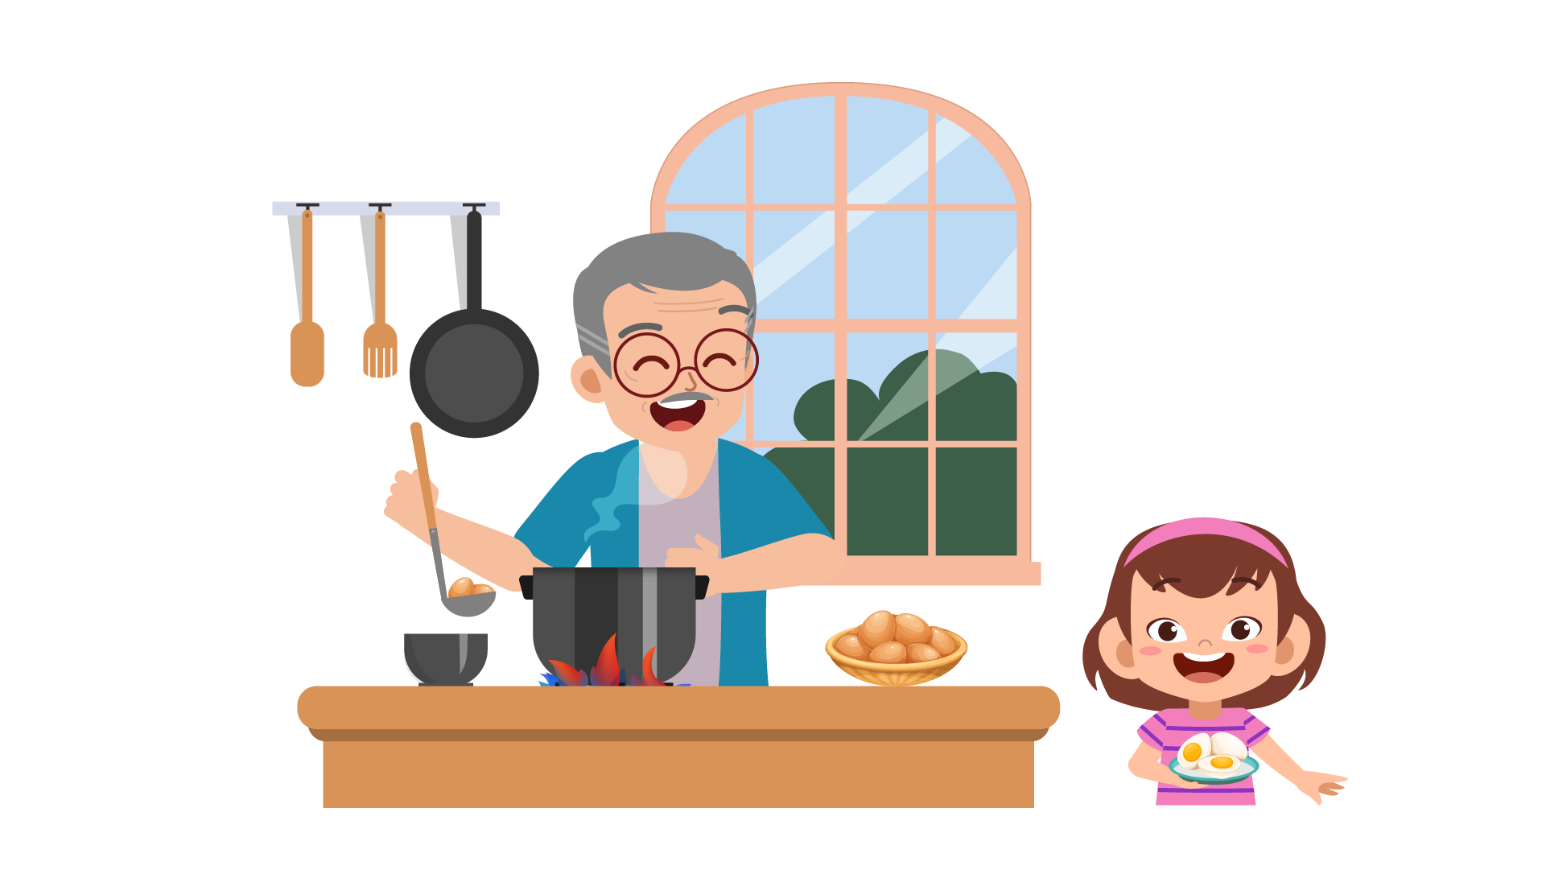

On Saturday, the children stayed at home with Grandpa Richard. Grandpa Richard taught them many things. He showed them how to make a paper dog. They had a lot of fun. In the afternoon, Grandpa Richard helped Alex and Emily to prepare for the dinner. He showed them how to boil eggs. Alex and Emily’s mother was very surprised when eating the eggs cooked by her children.

**Questions**

|  |  |
| --- | --- |
| 1 | On Saturday, the children played a lot of games with their grandpa at … |
| 2 | In the afternoon, they cooked … for dinner. |
| 3 | Their mother was very … at their food. |

|  |
| --- |
| M_T2_REA_P5_1-7_2 |
| On Sunday, Grandpa Richard took the children to the zoo. They went in Grandpa’s car. Alex loved the elephants and Emily loved the monkeys. At the end of the day, they wanted to go home. But Grandpa Richard couldn’t start their car. So they ran quickly to the bus stop to catch a bus. |

**Questions:**

|  |  |
| --- | --- |
| 4 | Grandpa took children to the zoo in a … |
| 5 | At last, they had to go home by … |

|  |
| --- |
| M_T2_REA_P5_1-7_3 |
| On the bus, they met some new friends. Grandpa Richard told the four children some funny stories. They laughed a lot. When they got home, Alex and Emily’s mother asked: “How was today?”. The children said “We had a great day with Grandpa. We love Grandpa so much!” |

**Questions:**

|  |  |
| --- | --- |
| 6 | On the bus, Grandpa Richard made students happy by telling … |
| 7 | When they got home, the children talked to their … |

## PART 6

**6 questions**

**Look, read and write.**

|  |
| --- |
|  |

**Example:**

There is a …**coconut**… tree on the beach.

What is the weather like? …**sunny**…

**Complete the sentences.**

1. We can see three children … in the sea.

2. The … is talking on the tree.

**Answer the questions.**

3. Which animal is swimming in the sea?

4. What is the girl with fair hair wearing?

**Now write two sentences about the picture.**

5. …………………………………….

6. …………………………………….

**Speaking**

**My name is…………………………….**

*Summary of Procedures*

The usher introduces the child to the examiner. The examiner asks how old the child is.

1. The examiner asks the child to describe several differences between the *two Find the Differences* pictures, e.g. “In picture 1, the birds are on the tree but in picture 2, the birds are flying in the sky”.
2. The examiner tells the child the name of the story and describe the first picture, e.g. “Dad comes home. He brings Cody and Emily a puppy.” The examiner then asks the child to continue to tell the story.
3. The examiner shows how to do the task with the first odd-one-out set of pictures. For example: ‘These are all places. But this is a room in a house’. Then the examiner asks the child to choose one picture in the other three sets and say which is different and why.
4. The examiner asks questions about the child, e.g. ‘Who do you love the most in your family?’

|  |  |  |  |  |
| --- | --- | --- | --- | --- |
|  | |  |  | |
| C:\Users\admin\AppData\Local\Microsoft\Windows\INetCache\Content.Word\M_T2_SPE_P2_1_0.png |  | | |  |
| C:\Users\admin\AppData\Local\Microsoft\Windows\INetCache\Content.Word\M_T2_SPE_P2_2_0.png | C:\Users\admin\AppData\Local\Microsoft\Windows\INetCache\Content.Word\M_T2_SPE_P2_3_0.png | | | C:\Users\admin\AppData\Local\Microsoft\Windows\INetCache\Content.Word\M_T2_SPE_P2_4_0.png |

|  |  |  |  |
| --- | --- | --- | --- |
|  |  |  |  |
|  |  |  |  |

|  |  |  |  |
| --- | --- | --- | --- |
|  |  |  |  |
|  |  |  |  |