WEEK 33
Class | Date of teaching
4A | April 29 ^{th}, 2025
4B | April 26 ^{th} , 2025
4C | April 29 ^{th} , 2025
PERIOD 129
UNIT 19: THE ANIMAL WORLD
LESSON 3 (4-6)
A. OBJECTIVES:
By the end of the lesson, pupils will be able to:
1. Knowledges:
- Read and show understanding of a paragraph by answering four questions about it.
- Complete a gapped paragraph about a visit to the zoo, their favourite animals and the reasons why they like these animals.
- Collect or draw pictures of favourite animals at home and present them to the class by using the target language.
2. Skills: Reading and writing
3. Attributes:
- Show pride in what they can do and their hobbies by using appropriate gesture and intonation when talking about hobbies.
4. Competency 3.1CB2b: Express oneself (drawing/telling about favorite animals). Students use their creativity to draw and their speaking skills to present their personal connection to the animal world.
B. INSTRUCTIONAL RESOURCES
- Student’s book: Page 63
- Teacher’s guide: Pages 253, 254
- Hoclieu.vn
- Flash cards/ pictures and posters
- Computer, projector
C. LEARNING PLAN:
Teacher’s activities | Student’s activities
1. Warm up (5’)  Greet the class.  - Have pupils open their books at page 62 and look at Lesson 3, Activity 3  - Play the recording and have pupils say the chant in chorus.  2. Practice (25’)  Activity 1-4. Read and answer.  * Goal: To read and show understanding of a paragraph by answering four questions about it.  * Procedure:  - Have pupils read the questions carefully. Tell them to read Question 1 and pay attention to keywords such as Where and go. Then they should scan the paragraph for relevant information.  - Repeat for Questions 2, 3 and 4. Set a time limit for pupils to do the activity independently. Go around the classroom and offer help where necessary.  - Get pupils to swap books with their partners and check the answers before checking as a class.  - Invite some pairs to take turns asking and answering the questions.  Key:  1. They are at the zoo.  2. They want to see the animals  3. Because they have long necks and legs. They can run very quickly.  4. Because they sing merrily.  Activity 2-5. Let’s write.  * Goal: To complete a gapped paragraph about a visit to the zoo, their favourite animals and the reasons why they like these animals  * Procedure:  - Tell pupils what they are going to do: complete a paragraph about a visit to the zoo. Remind them to pay attention to the context (the words before and after the gaps) before completing the paragraph with appropriate words.  - Have pupils fill in the first gap as an example, using the animals they like.  - Set a time limit for pupils to complete the paragraph independently. Go around the classroom and offer help where necessary.  - Get pupils to swap books with their partners and check their answers in pairs or groups before checking as a class.  Suggested answer: Our favourite zoo animals  It is a sunny Sunday. My brother and I are at the zoo because we want to see the animals. My brother like lions because they roar loudly. I like peacocks because they dance very beautifully. We have a lot of fun there.  Activity 3-6. Project.  * Goal: To collect or draw pictures of favourite animals at home and present them to the class by using the target language.  * Procedure:  - Explain that each pupil has to show a simple picture of their favourite animals (e.g. lions) which they have prepared at home as homework. They will tell the class about the animals in the picture and the reasons why they like them.  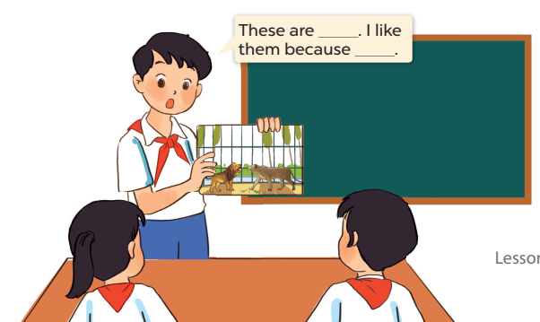  - Developing 3.1CB2b: Encourage pupils to explain why they chose those specific colors or styles for their drawings.  - Have pupils work in groups of six. Each pupil shows his / her picture to the group and describes what the animals in his / her picture are, and tells why he / she likes these animals.  - Invite a few pupils to show their pictures and tell the class about the animals and the reasons why they like these animals in front of the class, e.g: These are lions. I like them because they roar loudly. Have the rest of the class comment and praise their friends’ performance.  - The disabled: Collect or draw pictures of favourite animals at home and present them to the class by using the target language.  Game: Sentence Puzzle  - Divide the class into groups of four.  - Give each group a sentence that is broken/cut into pieces.  - Ask them to arrange them to make a complete sentence, then read it aloud.  - The group that makes it first will be the winner.  3. Consolidation (3’)  - Ask students to answer the following questions:  What have you learnt from the lesson today?  (use the words lions, crocodiles, giraffes, hippos in relation to the topic “The animal world”)  4. Homework (2’)  - Redo Ex. 4, 5 and do the parts E, F in the workbook at home.  - Prepare the new lesson: Unit 20-Lesson 1 (1,2,3). | - Listen to the techer  Whole class/ Individual work  - Whole class/Individual work  - Listen to the T's instruction  - Individual work  - Do the activity independently  - Swap books with their partners and check the answers  - Listen to the T's instruction  - Individual work  - Write their favourite zoo animals  - Read/write their writing  - Listen to the teacher  - Individual work  - Work in group  - Play in group  - Listen to the T's instruction.  - Whole class/ Individual work
D. Recommendation:
…………………………………………………….….……………………………
WEEK 33
Class | Date of teaching
4A | May 6 ^{th}, 2025
4B | May 7 ^{th}, 2025
4C | May 6 ^{th}, 2025
PERIOD 130
UNIT 20: AT SUMMER CAMP
LESSON 1 (1-3)
A. OBJECTIVES:
By the end of the lesson, pupils will be able to:
1. Knowledges:
- Use the phrases building a campfire, putting up a tent, taking a photo and telling a story in relation to the topic “At summer camp”;
- Use What’s he / she doing? – He's / She’s _____. to ask and answer questions about what someone is doing at a camp;
2. Skills: Listening and speaking
3. Attributes:
- Show pride in what they can do and great respect for other people’s abilities by using appropriate gestures and intonation when asking and answering about abilities.
4. Competency 1.1CB2b (Searching for data about summer camp activities): Observe pictures and listen to recordings to actively identify and collect information about various activities happening at a summer camp.
B. INSTRUCTIONAL RESOURCES
- Student’s book: Page 64
- Audio tracks 93, 94
- Teacher’s guide: Pages 255, 256
- Flash cards/ pictures and posters (Unit 20)
- Hoclieu.vn
- Computer, projector
C. LEARNING PLAN:
Teacher’s activities | Student’s activities
1. Warm up (5’)  - Greet the class.  - Spend a few minutes revising Unit 19 by getting the class to chant to revise the expressions “dance beautifully” ”run quickly” “sing merrily”  - Play the chant once and require pupils to listen carefully to recall the rhythm and lyrics.  - If possible, ask pupils to chant and clap their hands without music to recall the chant. Correct pronunciation if necessary.  2. Presentation (10’)  Activity 1-Vocabulary  * Goals: Ss will be able to know the vocab, before starting the new lesson.  * Procedure:  - T elicits the new words  - Data Search Task: T shows a big picture of a summer camp and asks: "What activities can you find in this camp?"  + camp : cắm trại (picture)  + campfire: lửa trại (picture)  + tent : cái lều (picture)  + story : câu truyện (picture)  + photo : bức ảnh (Explain)  + put : đặt, để (Explain)  + build : xây dựng (Explain)  + tell : nói, kể (Explain)  + take : cầm, nắm, mang (Explain)  - T models (3 times).  - T writes the words on the board.  - Checking: Rub out and remember  - The disabled: Practice reading vocab.  Activity 2-1. Look, listen and repeat.  * Goal: To understand and correctly repeat the sentences in two communicative contexts focusing on asking and answering questions about what someone is doing at a camp.  * Procedure:  - Have pupils look at Pictures a and b, and identify the characters and their activities at the summer camp.  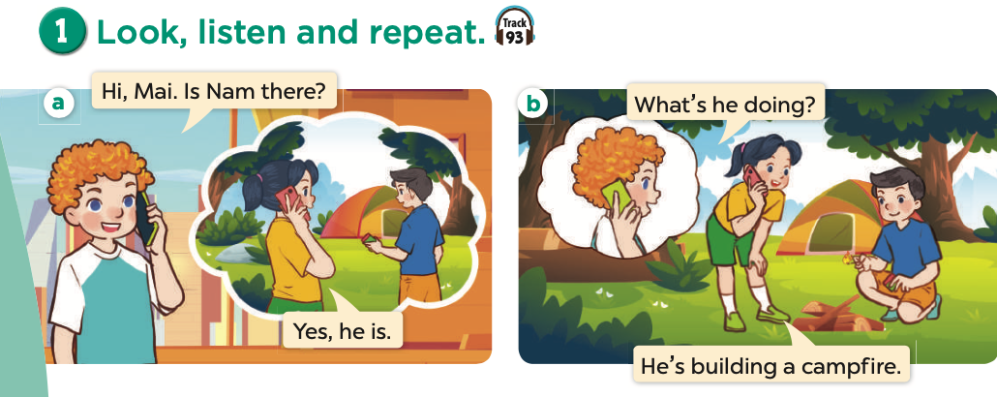  - Data Identification: Ask Ss: "Who can you see? What is the boy in picture a doing?" (Encourage them to find the 'data' before hearing it).  - Ask pupils to look at Picture a. Play the recording for them to listen. Play the recording again, sentence by sentence, for pupils to listen and repeat individually and in chorus. Correct their pronunciation where necessary. Repeat the same procedure with Picture b.  - Play the recording again for pupils to listen and repeat in chorus sentence by sentence.  - Invite a few pairs to the front of the classroom to listen to and repeat the sentences in the recording.  - Draw pupils’ attention to the question What’s he doing? and the answer He’s building a campfire. Tell pupils that they are used to ask and answer questions about what someone is doing at a camp.  3. Practice (15’)  Activity 2-1. Listen, point and say.  * Goal: To correctly say the phrases and use What's he / she doing? – He's / She's _____. to ask and answer questions about what someone is doing at a camp.  * Procedure:  - Have pupils look at the pictures and elicit the activities of the characters.  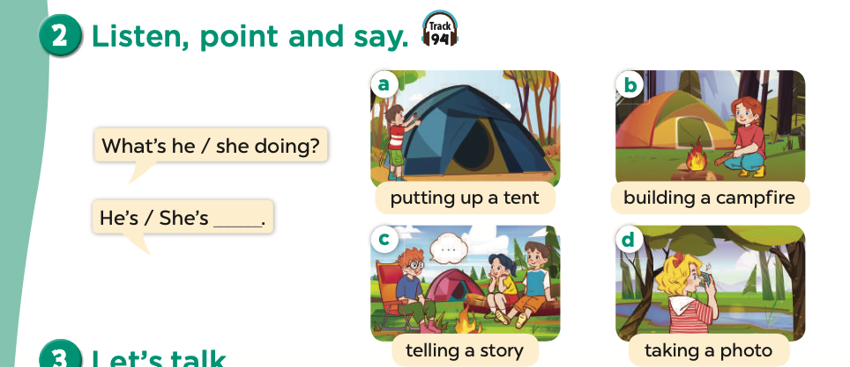  - Have pupils point at Picture a, listen to the recording and repeat the phrase (putting up a tent). Point at the speech bubbles and Picture a again and have pupils listen to and repeat after the recording (What's he doing? – He's putting up a tent.). Have the class repeat the question and answer a few times.  - Repeat Step 2 with the other three pictures.  - Have pairs practise asking and answering the questions What's he / she doing?  – He's / She's ___. using the picture cues.  - Invite a few pairs to point at the pictures and say the questions and answers in front of the class.  – Picture cues:  a. A boy putting up a tent  b. A girl building a campfire  c. A boy telling a story and his friends listening to him  d. A girl taking a photo  – Speech bubbles: What's he / she doing? – He's / She's _____.  Audio script:  a. putting up a tent  c. telling a story  a. A: What’s he doing?  B: He’s putting up a tent. b. A: What’s she doing?  B: She’s building a campfire. c. A: What’s he doing?  B: He’s telling a story. d. A: What’s she doing?  B: She’s taking a photo.  Activity 4-3. Let’s talk.  * Goal: To enhance the correct use of What's he / she doing? – He's / She's _____. to ask and answer questions about what someone is doing at a camp in a freer context.  * Procedure:  - Draw pupils’ attention to the picture. Ask questions to help them identify the context (see Input).  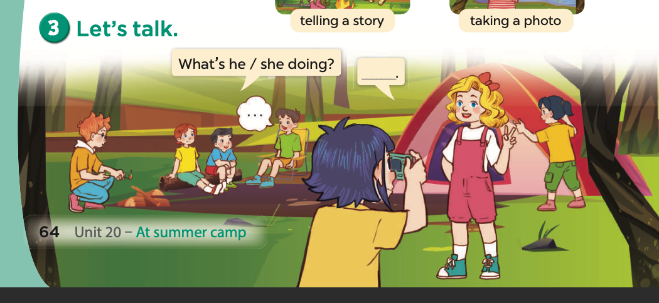  - Elicit the missing words in the speech bubble and write them on the board. Get pupils to say the completed sentences.  - Put pupils into pairs and encourage them to practise asking and answering questions about what someone is doing at a camp. Go around the classroom to offer support where necessary.  - Invite a few pairs to the front of the class to ask and answer questions about what someone is doing at a camp using the picture cue. Praise pupils if they perform well.  Game: Spelling Game  - Divide pupils into groups.  - Find the V-ing form of the verbs  - Groups get more answers win and get stickers  4. Consolidation (3)  - Ask students to answer the following questions:  1. What have you learnt from the lesson today?  2. What are the core values of the lesson?  Preparation for the project: Tell pupils about the project on page 69, Lesson 3, Activity 6. Ask each pupil to draw a simple picture of three or four friends and their activities at a camp at home. They will say what the friends in the picture are doing at Project time.  5. Homework (2’)  - Learn by heart vocab and structure at home.  - Prepare the new lesson: Unit 20-Lesson 1 (4,5,6). | - Listen to the techer  Whole class/ Individual work  - Whole class/Individual work  - Ss listen and answer  - Ss listen and repeat  + Choral repetition (3 times).  + Individual repetition (3 ss)  - Ss take note  - Ss look, remember and write  - Listen to the T's instruction  - Listen to the recording  - Individual work  - Listen and repeat  - Whole class/Pair work  - Listen to the T's instruction  - Listen to the teacher  Whole class/ Individual work  - Listen and repeat  - Practise asking and answering  - Listen to the teacher  - Practice in front of class  - Listen to the T's instruction.  - Play game in group  - Whole class/ Individual work
D. Recommendation:
WEEK 33
Class | Date of teaching
4A | May 6 ^{th}, 2025
4B | May 7 ^{th}, 2025
4C | May 6 ^{th}, 2025
PERIOD 131
UNIT 20: AT SUMMER CAMP
LESSON 1 (4-6)
A. OBJECTIVES:
By the end of the lesson, pupils will be able to:
1. Knowledges:
- Use the phrases building a campfire, putting up a tent, taking a photo and telling a story in relation to the topic “At summer camp”;
- Use What’s he / she doing? – He's / She’s _____. to ask and answer questions about what someone is doing at a camp.
2. Skills: Listening and reading
3. Attributes:
- Self-control & independent learning: perform listening tasks.
4. Digital Competency (2.6CB2b): Protecting online reputation (when sharing photos). Students recognize which photos are appropriate to share on social media to maintain a positive digital image for themselves and their friends.
B. INSTRUCTIONAL RESOURCES
- Student’s book: Page 65
- Audio track 95
- Teacher’s guide: Pages 257-259
- Flash cards/ pictures and posters (Unit 20)
- Hoclieu.vn
- Computer, projector
C. LEARNING PLAN:
Teacher’s activities | Student’s activities
1. Warm up (5’)  - Greet the class.  - Spend a few minutes revising the previous lesson by asking the questions What's he / she doing? and call on a few pupils to answer the questions.  2. Practice (25’)  Activity 1-4. Listen and match.  * Goal: To listen to and understand four communicative contexts in which characters ask and answer questions about what someone is doing at a camp and match the correct pictures.  * Procedure:  - Draw pupils’ attention to the pictures and stick figures. Ask questions to help pupils identify the characters in the pictures and the activities of the stick figures.  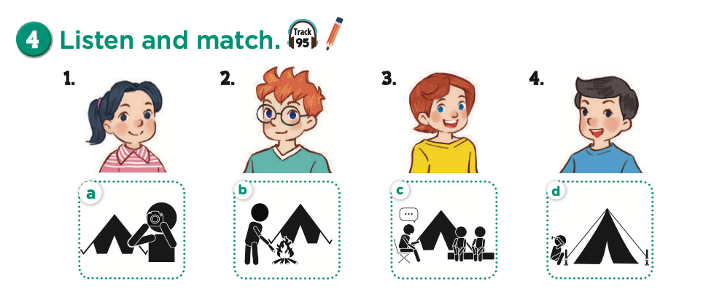  - Play the recording for pupils to listen to. Play the recording again for them to do the task by matching the characters to their activities. Play the recording a third time to give pupils another listening opportunity.  - [Integrate 2.6CB2b] At item 4 (taking a photo): Ask: "If Lucy takes a photo of Nam sleeping and it looks funny, should she post it on the internet?" -> Lead Ss to understand that they must ask for permission before sharing photos to protect their friends' reputation.  - Check answers as a class. Play the recording again for pupils to double-check their answers.  Extension: If time allows, play the recording, sentence by sentence, for the class to listen and repeat individually and in chorus. Correct their pronunciation where necessary.  Picture cues:  1. Mai 2. Ben 3. Lucy 4. Nam  a. a person taking a photo (stick figure)  b. a person building a campfire (stick figure)  c. a person telling a story and two friends listening (stick figures) d. a person putting up a tent (stick figure)  Audio script:  1. A: What is Mai doing?  B: She’s telling a story.  2. A: What is Ben doing?  B: He’s putting up a tent.  3. A: What is Lucy doing?  B: She’s taking a photo.  4. A: What is Nam doing?  B: He’s building a campfire.  Key: 1. c 2. d 3. a 4. b  Activity 2-5. Look, complete and read.  * Goal: To complete four gapped exchanges with the help of picture cues.  * Procedure:  - Have pupils look at the pictures. Get them to identify the characters and their activities in the pictures.  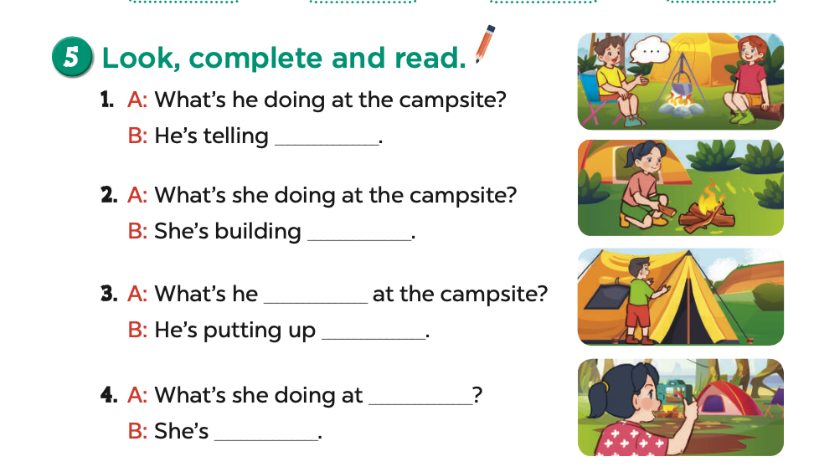  - Have pupils look at the exchanges and guess the missing words with the help of picture cues.  - Model Exchange 1. Have pupils look at the gap. Ask them what phrase is missing (a story). Then have pupils complete the answer (He's telling a story.). Repeat the same procedure with Exchanges 2, 3 and 4.  - Have pupils complete the exchanges individually. Check their answers as a class and ask a few pairs to read them aloud.  - Have pupils complete the exchanges individually. Check their answers and ask a few pairs to read them aloud.  Key;  1. a story  2. a campfire  3. doing/a tent  4. the campsite/taking a photo  Activity 3-6. Let’s play  * Goal: To revise target words about what someone is doing at a camp by playing Whispering game.  * Procedure:  - Tell pupils that they are going to play Whispering game in groups of four or five. Write sentences from the unit on small pieces of paper, e.g. He's building a campfire; She's telling a story; She's putting up a tent; He's taking a photo.  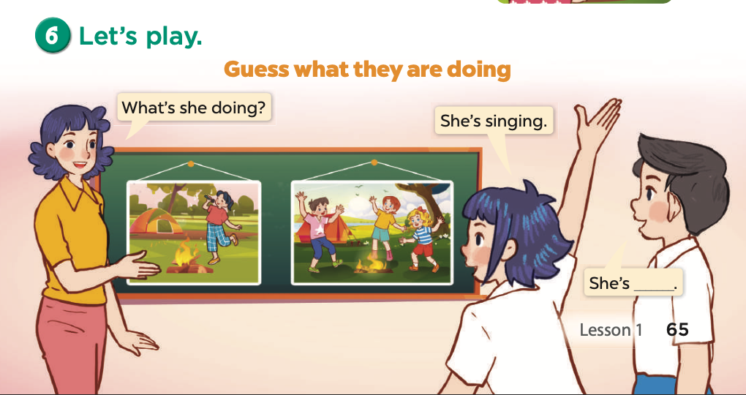  - Give a piece of paper with a secret sentence to the first player of two groups.  - The first player of each group reads the secret sentence in silence and whispers it to the next player. Then the second player whispers the sentence to the next player in his / her group until the last player gets the sentence.  - The group that first correctly reads the sentence is the winner. Have pupils work in groups. Invite two groups to the front of the class to play the game each time.  - The disabled: Play a game Guess what they are doing, following the teacher’s guide.  Game:  - Planning a camping trip. The teacher prepares some real things for a camping trip. Give pupils time to think and plan their group camping trip. Mind-mapping the things and discussing. This activity will help pupils to train their critical thinking.  3. Consolidation (3’)  - Ask students to answer the following questions:  1. What have you learnt from the lesson today?  4. Homework (2’)  - Redo Ex. 4, 5 and do the parts A, B in the workbook at home.  - Prepare the new lesson: Unit 20-Lesson 2 (1,2,3). | - Listen to the techer  Whole class/ Individual work  - Listen to the T's instruction  - Listen to the recording  - Individual work  - Listen and repeat  - Listen to the T's instruction  - Individual work  - Listen to the teacher  Whole class/ Individual work  - Check  - Listen to the T's instruction.  - Play in group  - Whole class/ Individual work
D. Recommendation:
…………………………………………………….….……………………………
…………………………………………………………………………………………

WEEK 34
Class | Date of teaching
4A | May 8 ^{th}, 2025
4B | May 9 ^{th}, 2025
4C | May 8 ^{th}, 2025

PERIOD 132
UNIT 20: AT SUMMER CAMP
LESSON 2 (1-3)
A. OBJECTIVES:
By the end of the lesson, pupils will be able to:
1. Knowledges:
- Use the phrases building a campfire, dancing around the campfire, playing card games, playing tug of war, putting up a tent, singing songs, taking a photo and telling a story in relation to the topic “At summer camp”;
- Use What’s he / she doing? – He's / She’s _____. to ask and answer questions about what someone is doing at a camp;
- Use What are they doing? – They’re _____. to ask and answer questions about what people are doing at a camp;
2. Skills: Listening and speaking
3. Attributes:
- Self-control & independent learning: perform listening tasks.
4. Digital Competence: 2.1CB2b (Appropriate communication tools): Pupils practice using a digital interactive tool (e.g., Padlet, digital polling, or a shared screen) to discuss and plan group activities for a summer camp scenario.
B. INSTRUCTIONAL RESOURCES
- Student’s book: Page 66
- Audio tracks 96, 97
- Teacher’s guide: Pages 259-261
- Hoclieu.vn
- Flash cards/ pictures and posters (Unit 20)
- Computer, projector
C. LEARNING PLAN:
Teacher’s activities | Student’s activities
1. Warm up (5’)  - Greet the class.  - Spend a few minutes revising the previous lesson by asking the class to name their favourite activities at the camping trip.  2. Presentation (10’)  Activity 1-Vocabulary  * Goals: Ss will be able to know the vocab, before starting the new lesson.  * Procedure:  - T elicits the new words  + tug of war : kéo co (picture)  + card game : chơi bài (picture)  - T models (3 times).  - T writes the words on the board.  - Checking: Rub out and remember  - The disabled: Practice reading vocab.  Activity 2-1. Look, listen and repeat.  * Goal: To understand and correctly repeat the sentences in two communicative contexts focusing on asking and answering questions about what people are doing at a camp.  * Procedure:  - Have pupils look at Pictures a and b and identify the places, characters and their activities.  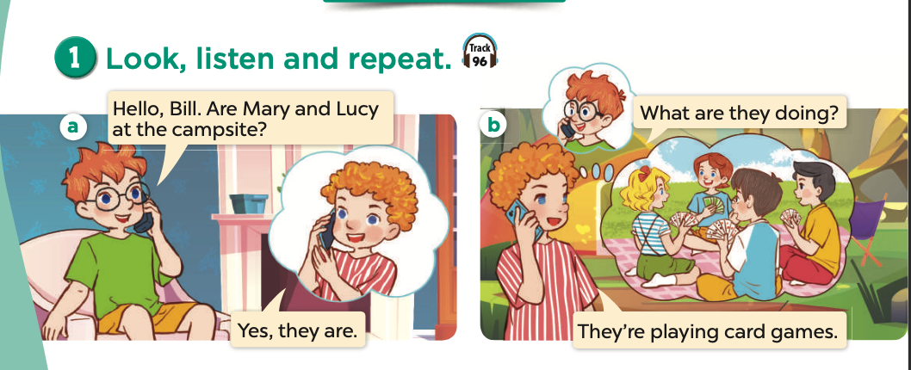  - Ask pupils to look at Picture a. Play the recording for them to listen. Play the recording again, sentence by sentence, for pupils to listen and repeat in chorus. Repeat the same procedure with Picture b. Correct their pronunciation where necessary.  - Play the recording again for pupils to listen and repeat in chorus, sentence by sentence.  - Invite a few pairs to the front of the classroom to listen to and repeat the sentences in the recording.  - Draw pupils’ attention to the question What are they doing? and the answer They’re playing card games. Tell pupils that they are used to ask and answer questions about what people are doing at a camp.  3. Practice (15’)  Activity 3-2. Listen, point and say.  * Goal: To correctly say the phrases and use What are they doing? – They’re _____. to ask and answer questions about what people are doing at a camp.  * Procedure:  - Have pupils look at the pictures and elicit the activities.  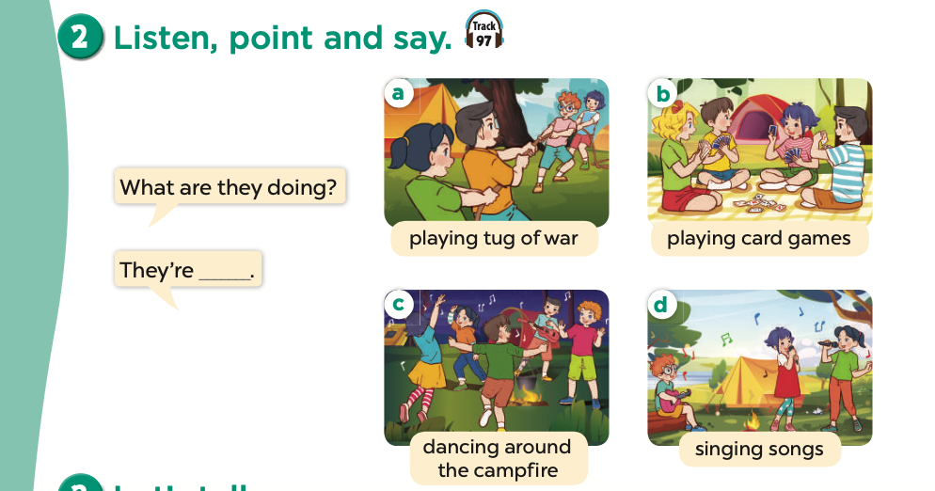  - Have pupils point at Picture a, listen to the recording and repeat the phrases (playing tug of war). Point at the speech bubbles and Picture a again and have pupils listen to and repeat after the recording (What are they doing? – They’re playing tug of war.).  - Have pairs practise asking and answering the question What are they doing? – They’re ____. using the picture cues.  - Invite a few pairs to point at the pictures and say the questions and answers in front of the class.  – Picture cues:  a. Two teams of friends playing tug of war  b. Some friends playing card games  c. Some friends dancing around a campfire  d. Some friends singing songs  – Speech bubbles: What are they doing? – They’re _____.  Audio script:  a. playing tug of war  c. dancing around the campfire  - A: What are they doing?  B: They’re playing tug of war.  - A: What are they doing?  B: They’re playing card games.  - A: What are they doing?  B: They’re dancing around the campfire.  - A: What are they doing?  B: They’re singing songs.  Activity 4-3. Let’s talk.  * Goal: To enhance the correct use of What are they doing? – They’re _____. to ask and answer questions about what people are doing at a camp in a freer context.  * Procedure:  - Digital Integration (2.1CB2b): T introduces a digital board (e.g., Padlet). T asks: "To plan our camp fun, which tool is better: paper or this digital board?". T explains that digital boards help everyone see the plan at once.  - Draw pupils’ attention to the pictures. Ask questions to help them identify the context (see Input).  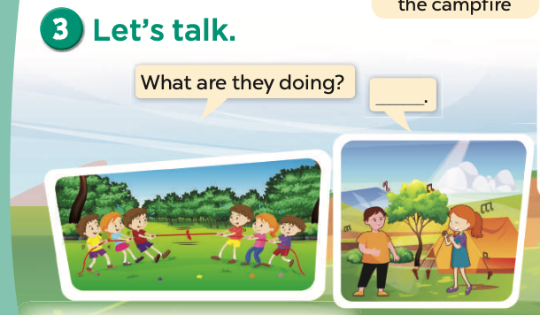  - Elicit the missing words in the bubble and write them on the board. Get pupils  to say the completed sentences.  - Put pupils into pairs and encourage them to ask and answer questions about what people are doing at the camp, using What are they doing? – They’re _____. Go around the classroom to offer support where necessary.  - Invite a few pairs to the front of the class to perform their conversations.  Game: Action game  Round 1: Divide pupils into groups of 6, ask them to take turns draw to the air or act without saying a word to show their guessing about their friends’ favourite activities for example singing, dancing, playing a tug war, building a campfire, telling a story, taking a photo. Round 2: each pupil takes turns to ask the friend on their left hand “Why…. “ the being asked answers “because I….”. Count the same activities and report the teacher when she/ he attends the group.  - 2.1CB2b Reinforcement: The group leader uses a tablet/computer to record the group's "final camp plan" to report to the teacher.  4. Consolidation (3’)  - Ask students to answer the following questions:  1. What have you learnt from the lesson today?  2. What are the core values of the lesson?  5. Homework (2’)  - Redo Ex. 4, 5 and do the parts C, D in the workbook at home.  - Prepare the new lesson: Unit 20-Lesson 2 (4,5,6). | - Listen to the techer  Whole class/ Individual work  - Ss listen and answer  - Ss listen and repeat  + Choral repetition (3 times).  + Individual repetition (3 ss)  - Ss take note  - Ss look, remember and write  - Listen to the T's instruction  - Individual work  - Listen and repeat  - Listen to the T's instruction  - Listen to the teacher  - Whole class/ Individual work  - Pair work  - Listen to the teacher  - Pair work  - Listen to the T's instruction.  - Play in group  - Whole class/ Individual work
D. Recommendation:
…………………………………………………….….……………………………
…………………………………………………………………………………………

WEEK 34
Class | Date of teaching
4A | May 8 ^{th}, 2025
4B | May 9 ^{th}, 2025
4C | May 8 ^{th}, 2025

PERIOD 133
UNIT 20: AT SUMMER CAMP
LESSON 2 (4-6)
A. OBJECTIVES:
By the end of the lesson, pupils will be able to:
1. Knowledges:
- Use the phrases building a campfire, dancing around the campfire, playing card games, playing tug of war, putting up a tent, singing songs, taking a photo and telling a story in relation to the topic “At summer camp”;
- Use What’s he / she doing? – He's / She’s _____. to ask and answer questions about what someone is doing at a camp;
- Use What are they doing? – They’re _____. to ask and answer questions about what people are doing at a camp;
- Listen to and demonstrate understanding of simple communicative contexts in relation to the topic “At summer camp”;
2. Skills: Listening and reading
3. Attributes:
- Self-control & independent learning: perform listening tasks.
4. General Competency 1.3CB2b (Recognizing where to arrange/organize data): Know how to categorize and arrange camp activities of different characters into an information table or a simple summer plan.
B. INSTRUCTIONAL RESOURCES
- Student’s book: Page 67
- Audio tracks 98, 99
- Teacher’s guide: Pages 261-263
- Hoclieu.vn
- Flash cards/ pictures and posters (Unit 20)
- Computer, projector
C. LEARNING PLAN:
Teacher’s activities | Student’s activities
1. Warm up (5’)  - Greet the class.  - Spend a few minutes revising the previous lesson by inviting a few pairs to the front of the class to take turns asking for and giving answers with the flashcards givien by the teacher What are they doing?- They are….; What is he/ she doing? -He/she…  2. Practice (25’)  Activity 1-4. Listen and tick.  * Goal: To listen to and understand two communicative contexts in which pupils ask and answer questions about what people are doing at a camp and tick the correct pictures.  * Procedure:  - Draw pupils’attention to Pictures 1a and 1b. Ask questions to help them identify the characters and their activities.  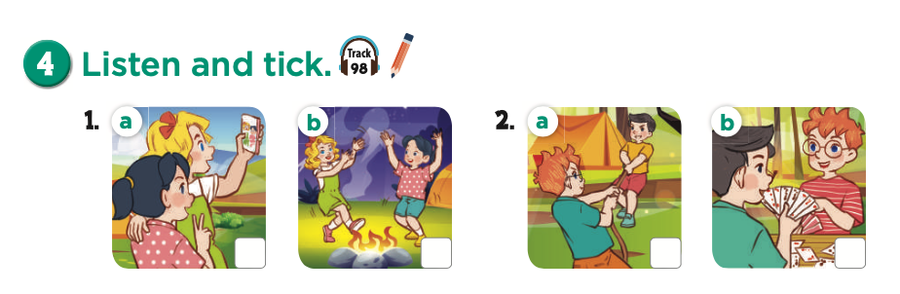  - Play the recording of the first dialogue for pupils to listen to. Then play the recording again for pupils to tick the correct picture.  - Repeat Steps 1 and 2 for Pictures 2a and 2b.  - Tell pupils to swap books with a partner, then check their answers as a class. Play  the recording again for pupils to double-check their answers.  Picture cues:  1a. Mary and Mai taking a photo  1b. Mary and Mai dancing around the campfire 2a. Nam and Ben playing tug of war  2b. Nam and Ben playing a card game  Audio script:  1.  A: Where are Mary and Mai?  B: They’re at the campsite.  A: What are they doing?  B: They’re dancing around the campfire.  2.  A: Are Nam and Ben at the campsite? B: Yes, they are.  A: What are they doing?  B: They’re playing tug of war.  Key: 1. b 2. a  Activity 2-5. Look, complete and read.  * Goal: To complete two gapped exchanges with the help of picture cues.  * Procedure:  - Have pupils look at the pictures. Get them to identify the places, characters and their activities in the pictures.  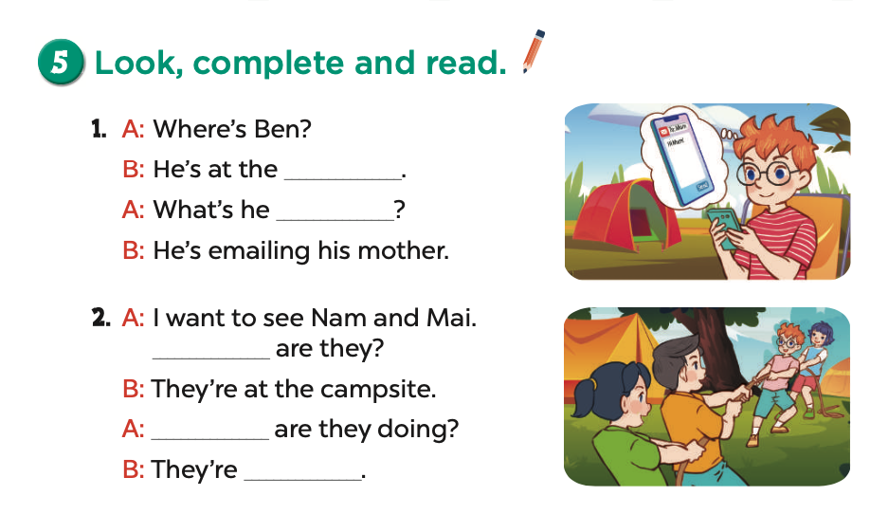  - Model Exchange 1. Have pupils look at the gaps. Ask them what words are missing (camp; doing). Then have pupils complete the sentences (He’s at the camp.; What’s he doing?). Repeat the same procedure with Exchange 2.  - Integrate Comp 1.3CB2b: T asks Ss to draw a quick table: Column 1 (Who), Column 2 (What). Then fill in the information from Activity 4 & 5.  - Have pupils complete the exchanges individually. Check their answers, and then ask a few pairs to read them aloud.  Key: 1. campsite; doing 2. Where; What; playing tug of war  Activity 3-6. Let’s sing.  * Goal: To sing the song What are they doing? with the correct pronunciation, rhythm and melody.  * Procedure:  - Draw pupils’ attention to the title and lyrics of the song. Encourage them to point at the characters and their activities at the camp to reinforce their understanding.  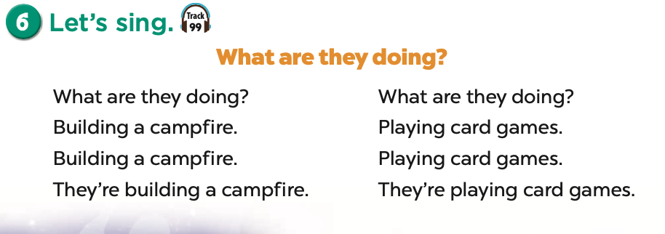  - Play the recording all the way through for pupils to listen to the whole song. Encourage them to listen carefully to the pronunciation and the melody.  - Play the recording, line by line, for pupils to listen and repeat. Correct their pronunciation where necessary.  - Play the recording all the way through for pupils to sing along.  - Play the recording again for pupils to sing and clap along.  Extension: Invite some groups to the front of the class to perform while the rest of the class sings and claps along.  - The disabled: Sing a song, following the teacher’s guide  Game: Guess who?  - Call some pupils to write down or draw their favourite activities,  - Describe the word/ drawing and ask the rest to guess the activity and who likes it.  3. Consolidation (3’)  - Ask students to answer the following questions:  1. What have you learnt from the lesson today?  2. What are the core values of the lesson?  4. Homework (2’)  - Learn by heart vocab and structure at home.  - Prepare the new lesson: Unit 20-Lesson 2 (4,5,6). | - Listen to the techer  Whole class/ Individual work  - Listen to the T's instruction  - Individual work  - Whole class  - Listen to the T's instruction  - Whole class/ Individual work  - Listen to the teacher  - Listen carefully to the pronunciation and the melody.  - Listen to the T's instruction.  - Play in group  - Whole class/ Individual work
D. Recommendation:
…………………………………………………….….……………………………
…………………………………………………………………………………………
WEEK 34
Class | Date of teaching
4A | May 8 ^{th}, 2025
4B | May 9 ^{th}, 2025
4C | May 8 ^{th}, 2025
PERIOD 134
UNIT 20: AT SUMMER CAMP
LESSON 3 (1-3)
A. OBJECTIVES:
By the end of the lesson, pupils will be able to:
1. Knowledges:
- Correctly repeat the words 'visit and 'email with the stress on the first syllable in isolation and in the sentences They 'visit their grandparents in summer. and We 'email our friends at the weekend. with the correct pronunciation and intonation.
- Identify the target words like and write while listening.
- Say the chant with the correct pronunciation, word stress and rhythm.
2. Skills: Listening and speaking
3. Attributes:
- Self-control & independent learning: perform listening tasks.
4. Language Competency (1.1CB2c - Accessing sounds/Word stress): Pupils can perceive and access the prominence of the first syllable in two-syllable words. They can identify where the stress mark (') is placed and reproduce the "High-Low" pitch pattern in words and sentences.
B. INSTRUCTIONAL RESOURCES
- Student’s book: Pagen68
- Audio tracks 100, 101, 102
- Teacher’s guide: Pages 263-264
- Flash cards/ pictures and posters (Unit 20)
- Hoclieu.vn
- Computer, projector
C. LEARNING PLAN:
Teacher’s activities | Student’s activities
1. Warm up (5’)  - Greet the class.  Lip- reading game  - Guide pupils to pronounce without making sound  divide them into groups each pupil takes turns to pronounce without making sound while the rest guess the sound  2. Presentation (10’)  Activity 1-1. Listen and repeat.  * Goal: To correctly repeat the words 'visit and 'email with the stress on the first syllable in isolation and in the sentences They 'visit their grandparents in summer. and We 'email our friends at the weekend. with the correct pronunciation and intonation.  * Procedure:  - Draw pupils’ attention to the word 'visit and the sentence They 'visit their grandparents in summer. Play the recording and encourage them to point at the word and the sentence while listening.  - (Focusing on 1.1CB2c): T explains the "Accessing" technique: Use a "Big Ball - Small Ball" gesture (Hands open wide for the stressed syllable, close for the unstressed one).  - Play the recording again and encourage pupils to listen to and repeat the word and the sentence. Do this several times until pupils feel confident. Correct their pronunciation where necessary.  - Repeat Steps 1 and 2 for the word 'email and the sentence We 'email our friends at the weekend.  - Have pupils work in pairs or groups, saying the words and reading the sentences until they feel confident.  - The disabled: Correctly repeat the words 'visit and 'email with the stress on the first syllable in isolation, following the teacher’s guide  3. Practice (15’)  Activity 2-2. Listen and circle.  * Goal: To identify the target words like and write while listening.  * Procedure:  - Tell pupils the goal of the activity. Explain that they have to listen to the recording and circle the correct options. Check comprehension.  - Play the recording all the way through for pupils to listen to the sentences. Play the recording again for pupils to circle the correct options.  - Tell pupils to swap books with a partner, then check the answers as a class. Write the correct answers on the board.  - Play the recording again for pupils to double-check their answers.  - Competency check: Ask Ss "Which syllable did you hear more loudly?" to reinforce 1.1CB2c.  Extension: Invite one or two pupils to stand up, listen to and repeat the completed sentences.  Audio script:  1. We email our grandparents at the weekend.  2. Linh and Nam visit their friends on Sundays.  Key: 1. b 2. c  Activity 3-3. Let’s chant.  * Goal: To say the chant with the correct pronunciation, word stress and rhythm.  * Procedure:  - Draw pupils’ attention to the lyrics of the chant. Check their comprehension.  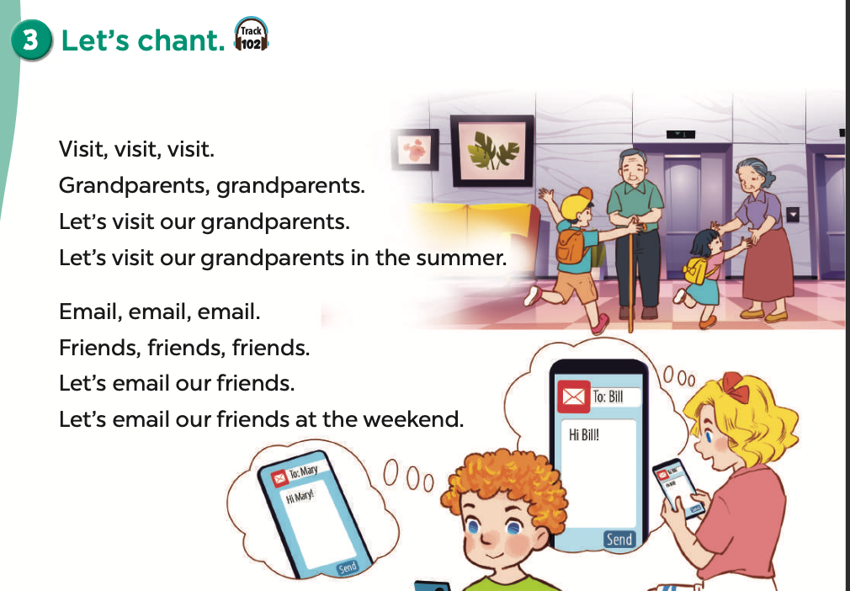  - Play the recording all the way through for pupils to listen to the whole chant. Encourage them to listen carefully to the rhythm and pronunciation. Draw pupils’ attention to the word stress in the words visit and email.  - Play the recording, line by line for pupils to listen and repeat. Correct their pronunciation where necessary.  - Play the recording all the way through for pupils to chant along. Encourage them to clap along while chanting.  Extension: Divide the class into two groups to take turns listening and repeating the chant while the rest of the class claps along.  Game: Write the words on the board. Ask pupils to find the stressed syllable from the words learnt in the unit.  dancing; singing; playing; email; writing; visit; weekend; summer; vacation; grandparents; classmate; campsite;  4. Consolidation (3’)  - Ask students to answer the following questions:  1. What have you learnt from the lesson today?  2. What are the core values of the lesson?  5. Homework (2’)  - Practice the sound and the chant at home.  - Prepare the new lesson: Unit 20-Lesson 3 (4,5,6). | - Listen to the techer  Whole class/ Group work  - Listen to the T's instruction  - Individual work  - Listen and repeat  - Work in pairs or groups, saying the words and reading the sentences  - Listen to the T's instruction  - Circle the correct options  - Check  - Listen to the teacher  - Whole class/ Individual work  - Listen and repeat  - Clap along while chanting.  - Listen to the teacher  - Listen to the T's instruction.  - Play in group  - Whole class/ Individual work
D. Recommendation:
…………………………………………………….….……………………………
…………………………………………………………………………………………
WEEK 34
Class | Date of teaching
4A | May 13 ^{th}, 2025
4B | May 14 ^{th}, 2025
4C | May 13 ^{th}, 2025
PERIOD 135
UNIT 20: AT SUMMER CAMP
LESSON 3 (4-6)
A. OBJECTIVES:
By the end of the lesson, pupils will be able to:
1. Knowledges:
- Read and write about what someone is / people are doing at a camp;
- Draw a simple picture of friends and their activities at a camp, then tell the class about it at Project time.
2. Skills: Reading and writing
3. Attributes:
- Self-control & independent learning: perform listening tasks.
4. Digital Competency 2.4CB2a (Choose digital collaboration tools for group planning): Students can discuss and select appropriate digital platforms (e.g., Padlet, Zalo, PowerPoint) to collect images and plan their group's project presentation.
B. INSTRUCTIONAL RESOURCES
- Student’s book: Page 69
- Teacher’s guide: Pages 265; 266
- Flash cards/ pictures and posters (Unit 20)
- Hoclieu.vn
- Computer, projector
C. LEARNING PLAN:
Teacher’s activities | Student’s activities
1. Warm up (5’)  Greet the class.  - Greet the class and encourage pupils to respond to the greeting. Spend a few minutes revising the previous lesson by inviting two groups of three to the front of the class to take turns saying the two verses of the chant and clapping their hands.  2. Practice (25’)  Activity 1-4. Read and tick True or False.  * Goal: To read a text and decide whether statements about Minh and his friends’ activities are true or false.  * Procedure:  - Draw pupils’ attention to the four statements focusing on what Minh and his friends are doing.  - Ask pupils to read the text individually first, then in pairs to decide if the statements are true or false.  - Set a time limit for pupils to do the task. Go around the classroom and offer help where necessary.  - Get pupils to provide reasons for their answers, then check their answers as a class and give explanations where necessary.  Key:  1.T; 2.F; 3.T; 4.T  Activity 2-5. Let’s write.  * Goal: To complete a text about what pupils are doing at a camp.  * Procedure:  - Ask pupils to read the gapped text and fill in the gaps with details about what pupils and their friends are doing at a camp. Check comprehension.  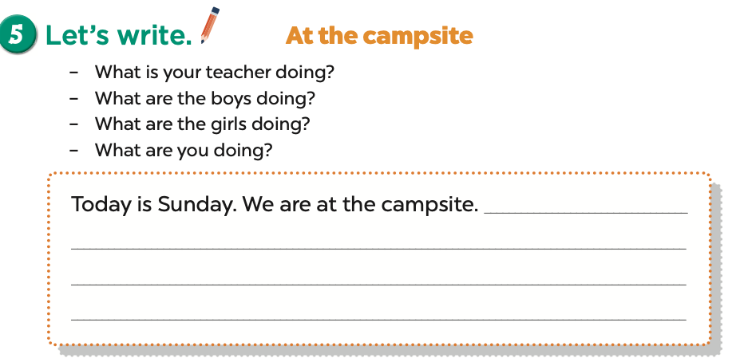  - Have pupils do the first gapped sentence together as an example. Ask them to read the sentence and elicit what day it is today. Then have them write an answer, e.g. Today is Sunday.  - Give pupils time to complete the text independently. Go around the classroom and offer help if necessary.  - Get pupils to swap their books with a partner and check their answers in pairs before checking as a class.  Extension: Invite a few pupils to read their completed texts in front of the class.  Suggested answer: At the campsite  Today is Sunday. We are at the campsite. Tram is telling a story. Lan and Hoa are playing card games. Some girls are singing and dancing. Some boys are playing tug of war. I am taking some photos. We are having a lot of fun.  Activity 3-6. Project.  * Goal: To draw a simple picture of three or four friends and their activities at a camp, and tell the class about what the friends are doing.  * Procedure:  - Explain that each pupil has to show a simple picture of three or four friends and their activities at a camp which they have drawn at home. They will tell the class about the activities of the friends in the picture.  - [Digital Competency 2.4CB2a]: Teacher asks groups to discuss and choose a digital tool to organize their pictures (e.g., Group A chooses Padlet to display drawings; Group B chooses PowerPoint for a slideshow).  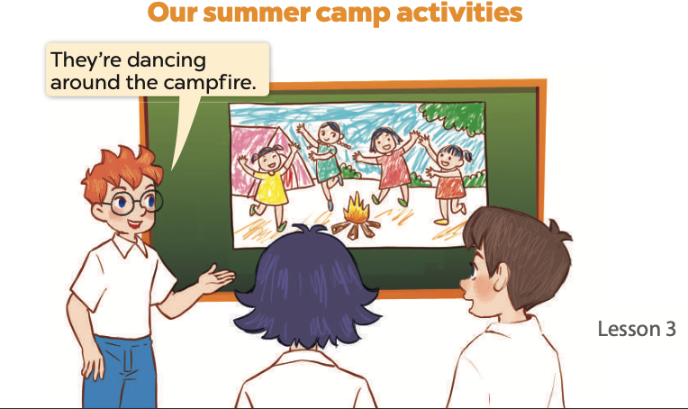  - Have pupils work in groups of six. Each pupil shows his / her picture to the group and describes what the characters in the picture are doing.  - Invite a few pupils to show their pictures and tell the class about the activities of their friends, e.g. Look at this picture. They are my friends. They’re dancing around the campfire.  - Have the rest of the class comment and praise their classmates.  - The disabled: Do a project, following the teacher’s guide.  Singing along with TPR  - Say some subjects, using TPR technique to guide pupils how to sing with TPR  - Random pupils are called to sing without sound.  - The rest can guess the name of the camping activities or things in a campsite  3. Consolidation (3’)  - Ask students to answer the following questions:  1. What have you learnt from the lesson today?  2. What are the core values of the lesson?  4. Homework (2’)  - Redo Ex. 4, 5 and do the parts E, F in the workbook at home.  - Prepare the new lesson: Review 4 (1,2) | - Listen to the techer  Whole class/ Individual work  - Listen to the T's instruction  - Individual work  - Tick T/F  - Listen to the T's instruction  - Individual work  - Listen to the teacher  Whole class/ Individual work  - Swap their books with a partner and check their answers in pairs  - Listen to the teacher  - Group work  - Play in group  - Listen to the T's instruction.  - Whole class/ Individual work
D. Recommendation:
…………………………………………………….….……………………………
…………………………………………………………………………………………

WEEK 34
Class | Date of teaching
4A | May 13 ^{th}, 2025
4B | May 14 ^{th}, 2025
4C | May 13 ^{th}, 2025

PERIOD 136
REVIEW 4
PARTS 1, 2
A. OBJECTIVES:
By the end of the lesson, pupils will be able to:
1. Knowledges:
- correctly use the following sentence patterns:
What was the weather like last weekend? – It was _____.
Do you want to go to the ____? – Great! Let’s go. / Sorry, I can’t.What does it say? – It says ʽ____ʼ.
How can I get to the ____? – ____.
Where’s the bookshop? – It’s ____.
How much is the ____? – It’s ____.
What are these animals? – They’re ____.
Why do you like ____? – Because they ____.
What's he / she doing? – He's / She's ____.
What are they doing? – They’re ____.
- Take part in three fun activities to apply their language knowledge and competences
2. Skills: Listening and speaking
3. Attributes:
- Communication and collaboration: work in pairs and groups to complete the learning tasks
- Self-control & independent learning: perform listening tasks.
4. Specific Competency 1.3CB2a (Organizing and storing year-end knowledge): Categorize sentence patterns into 5 major themes (Units 16-20) and systematize them into a review portfolio for year-end preparation.
B. INSTRUCTIONAL RESOURCES
- Student’s book: Page 70
- Teacher’s guide: Pages 267, 268
- Audio: Track 102
- Hoclieu.vn
C. LEARNING PLAN:
Teacher’s activities | Student’s activities
1. Warm up (5’)  Greet the class.  Game: Choose and throw  - Divide class into 2 teams.  - Call 1 pupil from each team to come to the board and throw a sticky ball at the answer.  - Teacher marks the place where they throw it.  - Teacher reveals the score for the correct answer.  2. Practice (25’)  Activity 1-1. Listen and tick.  * Goal: To listen to and understand five communicative contexts in which characters talk about familiar topics such as weather, directions, items price, animals and camp activities and tick the correct pictures.  * Procedure:  - Draw pupils’ attention to Pictures 1a, 1b and 1c. Elicit the words or phrases to describe the pictures in each option (e.g. rainy, sunny, windy). Elicit the questions the speaker may ask. (e.g. 1. What was the weather like yesterday?). Play the recording for pupils to listen. Play the recording again for pupils to do the task. Play the recording a third time for pupils to check their answers.  - Repeat Step 1 for the rest of the pictures: 2a, 2b and 2c, 3a, 3b and 3c, 4a, 4b and 4c, and 5a, 5b and 5c.  - Get pupils to swap books with a partner to check their answers before checking as a class. Write the correct answers on the board.  - Play the recording again for pupils to double-check their answers.  Extension: If time allows, play the recording, sentence by sentence, for pupils to listen to and repeat some exchanges individually and in chorus. Correct their pronunciation where necessary.  Picture cues:  1a. a rainy icon  1b. a sunny icon  1c. a windy icon  2a. a ʽturn rightʼ road sign  2b. a ʽturn leftʼ road sign  2c. a ʽstopʼ road sign  3a. a notebook and a price tag: 10,000 dong  3b. a notebook and a price tag: 15,000 dong  3c. a notebook and a price tag: 20,000 dong  4a. Two giraffes  4b. Two lions  4c. Two hippos  5a. Two boys taking a photo  5b. Two boys putting up a tent  5c. Two boys dancing around the campfire  Audio script:  1. A: What was the weather like yesterday?  B: It was sunny.  2. A: What does it say?  B: It says ʽturn rightʼ.  3. A: How much is the notebook?  B: It’s 15,000 dong.  4. A: What are these animals?  B: They’re hippos.  5. A: What are they doing?  B: They’re putting up a tent.  Key: 1. b 2. a 3. b 4. c 5. b  Activity 2-2. Ask and answer.  * Goal: To ask and answer questions using picture cues.  * Procedure:  - Draw pupils’ attention to the first question. Get the class to read it in chorus. Elicit the answer and give feedback. Then get pupils to role-play the exchange. Repeat the same procedure with the rest of the questions.  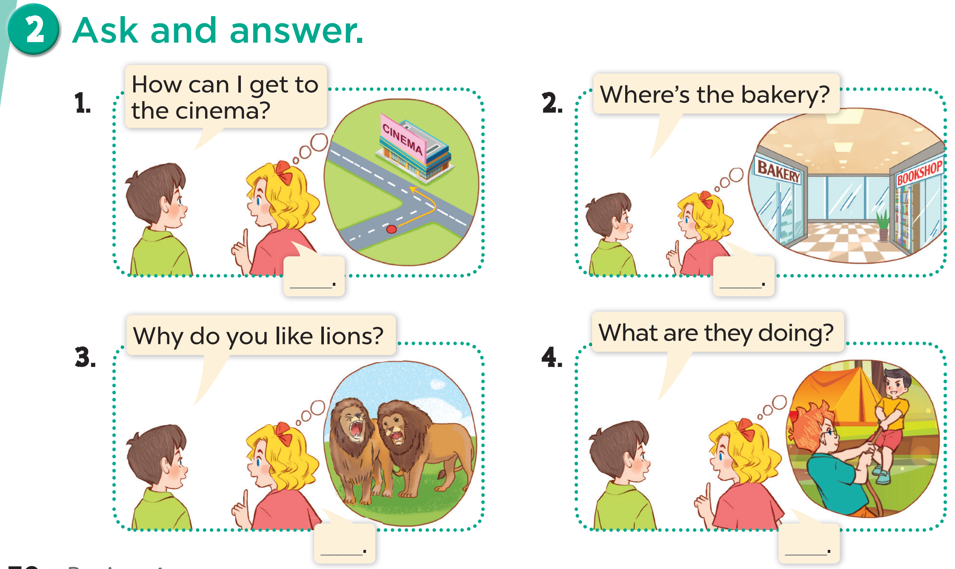  - Give pupils time to take it in turns to role-play the four exchanges. Go around the classroom to offer support where necessary.  - Storage Task (Competency 1.3CB2a): Ask Ss to write down the 4 key structures practiced into their "Review Notebook" or "Knowledge Tree" under the correct headings.  Extension: Invite pairs of pupils to stand up and take it in turns to role-play the target exchanges.  Key:  1. You can turn left.  2. The bakery is opposite the bookshop.  3. Because they roar loudly.  4. They are playing tug of war.  Game: Play Madagascar 3 Bomb Game (PPT)  - Divide the class into 2 teams.  - T ask pupils to choose a penguin and answer the question  - If the answer is correct, they can get points or choose the mystery box they want to explore.  - The team with the most points is the winner.  3. Consolidation (3’)  - Ask students to answer the following questions:  What have you learnt from the lesson today?  Review Units 16-20: Weather, In the city, At the shopping centre, The animal world, At summer camp  4. Homework (2’)  - Redo Ex. 1,2 and at home.  - Prepare the new lesson: Review 4 (3,4,5) | - Listen to the techer  Whole class/ Group work  - Listen to the T's instruction  - Individual work  - Listen and tick the appropriate box  - Check  - Listen to the T's instruction  - Listen to the teacher  Whole class/ Individual work  - Pair work  - Listen to the teacher  - Play in group  - Listen to the T's instruction.  - Whole class/ Individual work
D. Recommendation:

WEEK 35
Class | Date of teaching
4A | May 15 ^{th}, 2025
4B | May 16 ^{th}, 2025
4C | May 15 ^{th}, 2025

PERIOD 137
REVIEW 4: FUN TIME
PART 3, 4, 5
A. OBJECTIVES:
By the end of the lesson, pupils will be able to:
1. Knowledges:
- Correctly use the following sentence patterns:
What was the weather like last weekend? – It was _____.
Do you want to go to the ____? – Great! Let’s go. / Sorry, I can’t.
What does it say? – It says ʽ____ʼ.
How can I get to the ____? – ____.
Where’s the bookshop? – It’s ____.
How much is the ____? – It’s ____.
What are these animals? – They’re ____.
Why do you like ____? – Because they ____.
What's he / she doing? – He's / She's ____.
What are they doing? – They’re ____.
- Take part in three fun activities to apply their language knowledge and competences
2. Skills: Reading and writing
3.Atributes :
- Communication and collaboration: work in pairs and groups to complete the learning tasks
- Self-control & independent learning: perform listening tasks
4. Specific Competency 5.4CB2a: Identify digital competencies (NLS) needing improvement (Year-end review). (Students reflect on their ability to use digital learning tools throughout the school year and identify which digital skills they need to improve for the next grade).
B. INSTRUCTIONAL RESOURCES
- Student’s book: Page 71
- Teacher’s guide: Pages 269, 270
- Flash cards/ pictures and posters
- Hoclieu.vn
- Computer, projector
C. LEARNING PLAN:
Teacher’s activities | Student’s activities
1. Warm up (5’)  Greet the class.  Odd one out  - Divide class into teams. Number the pupils in each team (make sure that each team has the same numbers).  - Show the question on the screen, ask them to whisper the answers to their friends.  - Teacher calls out a number, the pupils with that number from each team stands up and shout out the answer (or race to the board and write the answer)  - Give points for the correct answer, give extra points to the quickest team.  2. Practice (25’)  Activity 1-3. Read and match.  * Goal: To read and match pairs of target sentence patterns  * Procedure:  - Draw pupils’ attention to the sentences. Tell them about this activity. Point at Sentence 1, elicit the answer and give feedback. Draw a line to match Sentence 1 with the letter c.  - Give pupils time to do the task individually. Go around the classroom to offer support.  - Get pupils to swap books with a partner, then check answers as a class. Write the correct answers on the board.  Extension: Invite some pairs of pupils to stand up and read the matched exchanges aloud.  Key: 1. c 2. a 3. b 4. e 5. d  Activity 2-4. Read and complete.  * Goal: To read and show understanding of a text by completing the gaps.  * Procedure:  - Tell pupils the goal of the activity and explain that they should read the text and circle the correct options to complete the gapped text. Check comprehension.  - Do Sentence 1 as an example. First, have pupils read Sentence 1 and decide what information they need to find in the text. Then, read two options and choose the correct option to complete the sentence. Circle the correct option.  - Set a time limit for pupils to do the task independently. Go around the classroom and offer help where necessary.  - Get pupils to swap their books with a partner and check their answers together before checking as a class. Correct the answers where necessary.  Extension: Invite one or two pupils to read the text in front of the class. Correct their pronunciation where necessary.  Key:  1. sunny  2. playing  3. dancing  4. photos  Activity 3-5. Let’s write.  * Goal: To use the target language to complete a gapped paragraph using a picture cue.  * Procedure:  - Tell the class the goal of the activity and explain that they should read the gapped text and fill in the gaps with the information from a leaflet. Check comprehension.  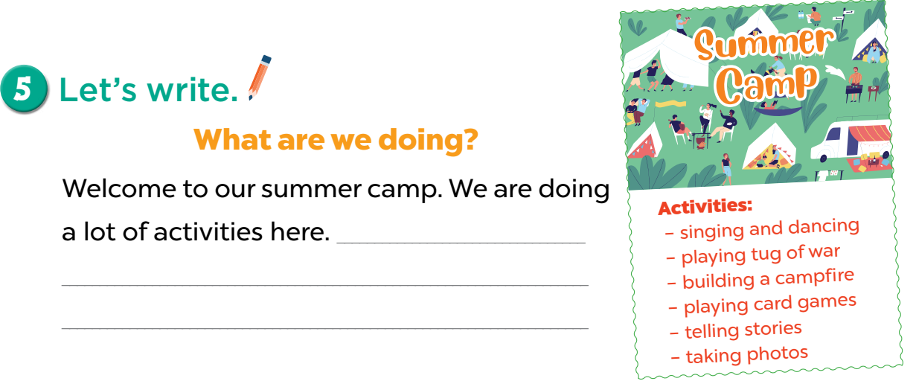  - Have pupils do the first gapped sentence together as an example. Ask them to read the first sentence and elicit phrases (singing and dancing). Then have them write it in the gap.  - Give pupils time to complete the text independently. Go around the classroom and offer help where necessary.  - Get pupils to swap their books with their partner and check their answers before checking as a class.  Extension: Invite one or two pupils to read their completed texts in front of the class.  Suggested answer:  Welcome to our summer camp. We are doing a lot of activities here. Tram is telling a story. Lan and Hoa are playing card games. Some girls are singing and dancing. Some boys are playing tug of war. I am taking some photos. We are having a lot of fun.  Game: Play Review Game (PPT)  - Divide the class into 2 or 4 teams.  - T reminds pupils of 5 topics (Weather, In the city, At the shopping centre, The animal world, At summer camp) they reviewed in this lesson.  - T/Pupil spins the wheel, answers a question from the teacher and gets points.  - The team with the most points is the winner.  3. Consolidation (3’)  - Ask students to answer the following questions:  What have you learnt from the lesson today?  Review Units 16-20: Weather, In the city, At the shopping centre, The animal world, At summer camp  - Digital Skill Reflection: Ask: "Over the past year, which digital tool (sachmem, online games, videos) did you like most? Which one do you still find difficult to use by yourself?"  4. Homework (2’)  - Redo Ex. 3, 4, 5 at home.  - Prepare the new lesson: Extension activities. | - Listen to the techer  Whole class/ Individual work  - Listen to the T's instruction  - Individual work  - Read, match aand check  - Listen to the T's instruction  - Individual work  - Listen to the teacher  Whole class/ Individual work  - Listen to the teacher  - Complete the text independently  - Play in group  - Listen to the T's instruction.  - Whole class/ Individual work  - Reflect on their digital learning experience throughout the year and identify areas to improve (5.4CB2a).
D. Recommendation:
…………………………………………………….….……………………………
…………………………………………………………………………………………
WEEK 35
Class | Date of teaching
4A | May 15 ^{th}, 2025
4B | May 16 ^{th}, 2025
4C | May 15 ^{th}, 2025
PERIOD 138
EXTENSION ACTIVITIES
A. OBJECTIVES:
By the end of the lesson, pupils will be able to:
1. Knowledges:
- Correctly use the following sentence patterns:
What was the weather like last weekend? – It was _____.
Do you want to go to the ____? – Great! Let’s go. / Sorry, I can’t.
What does it say? – It says ʽ____ʼ.
How can I get to the ____? – ____.
Where’s the bookshop? – It’s ____.
How much is the ____? – It’s ____.
What are these animals? – They’re ____.
Why do you like ____? – Because they ____.
What's he / she doing? – He's / She's ____.
What are they doing? – They’re ____.
- Take part in three fun activities to apply their language knowledge and competences
2. Skills: Listening and speaking
3. Attributes:
- Communication and collaboration: work in pairs and groups to complete the learning tasks
- Self-control & independent learning: perform listening tasks.
4. Competency 3.2CB2a (Evaluate personal progress): Reflect on their own performance, identify strengths and weaknesses in the reviewed topics, and track their learning improvement through self-assessment tools.
B. INSTRUCTIONAL RESOURCES
- Student’s book: Page 72
- Teacher’s guide: Pages 271, 272
- Flash cards/ pictures and posters
C. LEARNING PLAN:
Teacher’s activities | Student’s activities
1.Warm up: 5 minutes  Greet the class.  Game  - Ask pupils to choose a chant from Units 16 to 20 and chant together.  - Get pupils to open their books at page 72 and look at Fun time, Activity 1.  3. Practice (25’)  Activity 1-1. Look and match.  * Goal: To match the animals with their correct homes.  * Procedure:  - Draw pupils’ attention to the pictures. Tell pupils the goal of the activity and explain that they should match the animals with their correct homes. Check comprehension.  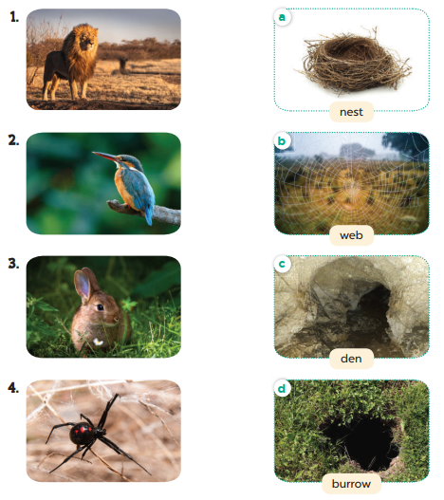  - Do Sentence 1 as an example. First, elicit the name of the animal in the picture. Then ask them to choose its home.  - Set a time limit for pupils to do the task independently. Go around the classroom and offer help where necessary.  - Apply 3.2CB2a via self-correction. Self-Evaluation Step: After checking answers, ask Ss to draw a "Smiley Face" if they got all correct, or a "Thinking Face" if they missed any.  - Get pupils to swap their books with a partner and check their answers before checking as a class. Correct the answers where necessary.  - Have pupils repeat the words nest, web, den, burrow.  - The disabled: Do Ex.1, following the teacher’s guide.  Key: 1. c; 2. a; 3. d; 4. b  Activity 2-2. Complete.  * Goal: To complete four sentences to introduce the animals and their homes.  * Procedure:  - Draw pupils’ attention to the pictures in 2. Tell pupils the goal of the activity and explain that they need to choose the animal homes in 2 to complete the sentences in 3. Check comprehension.  - Do Sentence 1 as an example. Read the sentence aloud and elicit the answer (den).  - Set a time limit for pupils to do the task independently. Go around the classroom and offer help where necessary.  - Get pupils to swap their books with a partner and check their answers before checking as a class. Correct the answers where necessary.  - Have pupils repeat the completed sentences.  Key: 1. den 2. nest 3. burrow 4. Web  Activity 3-3. Board game. Roll a dice. Listen to a question and answer it.  * Goal: To review the target vocabulary and sentence patterns by playing Board games.  * Procedure:  - Teacher leads the game for the whole class. Divide the class into four groups. Determine which group goes first, second, third and fourth.  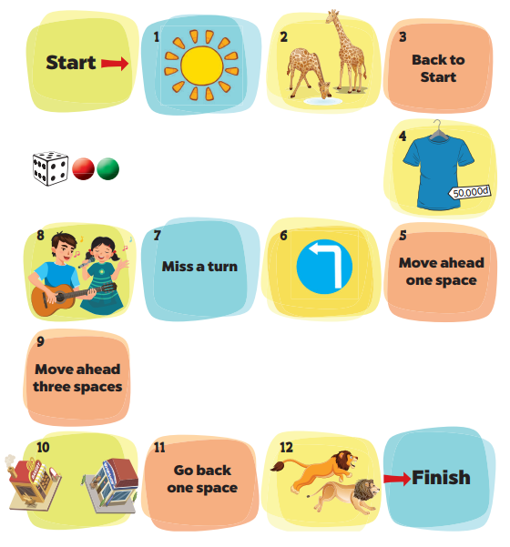  - Each group rolls the dice in turn. On their turns, they move their game piece along the path according to the number of spaces by the dice.  - When the groups land on a space, the teacher asks a question. The group gives the answer. If it is correct, they can stay in the box. Explain that there are some boxes like back to start, move ahead one space, miss a turn, move ahead three spaces, go back one space. Check comprehension.  Questions:  1. What was the weather like yesterday? (It was sunny.)  2. What are these animals? (They’re giraffes.)  3. Back to Start  4. How much is this T-shirt? (It's 50,000 dong.)  5. Move ahead one space  6. What does it say? (It says ʽturn leftʼ.)  7. Miss a turn  8. What are they doing? (They’re singing a song.)  9. Move ahead three spaces  10. Where’s the bakery? (It’s opposite the bookshop.)  11. Go back one space  12. What are these animals doing? (They’re running.)  - The game continues until one or all groups reach the “Finish” space.  - Write the questions on the board. Have pupils sit in groups of three or four and repeat Steps 1-4 to play in groups.  Game: Play Bibimbap Game (PPT)  - Divide the class into 2 or 4 teams.  - T reminds pupils of 5 topics (Weather, In the city, At the shopping centre, The animal world, At summer camp) they reviewed in this lesson.  - T/Pupil chooses a number, answers a question from the teacher and gets points.  - The team with the most points is the winner.  3. Consolidation (3’)  - Ask students to answer the following questions:  What have you learnt from the lesson today?  - Review Units 16-20: Weather, In the city, At the shopping centre, The animal world, At summer camp  4. Homework (2’)  - Redo Ex. 1,2,3 at home.  - Prepare the final semester test well. | - Listen to the techer  Whole class/ Individual work  - Listen to the T's instruction  - Individual work  - Whole class/Do the task independently  - Listen to the T's instruction  - Listen to the teacher  Whole class/ Individual work  - Listen to the teacher  - Individual work  - Pair work  - Listen to the T's instruction.  - Play a game  - Whole class/ Individual work
D. Recommendation:
…………………………………………………….….……………………………
…………………………………………………………………………………………

WEEK 35
Class | Date of teaching
4A | May 20 ^{th}, 2025
4B | May 21 ^{th}, 2025
4C | May 20 ^{th}, 2025
PERIOD 139 + 140

THE FINAL TERM TEST
A. OBJECTIVES:
By the end of the lesson, Ss will be able to:
1. Knowledge:
- Check Ss’ comprehension about this theme and get marks.
- Vocabulary: Review
- Model sentences: Review
- Skills: speaking, writing and listening
2. Competences:
- Co-operation: ready to help friends in pair work/ group work.
- Sociability: Talk to each other, say good words to others.
3. Attributes:
- Kindness: Help partners to complete learning tasks.
- Honesty: tell the truth about feelings and emotions.
B. INSTRUCTIONAL RESOURCES
- Teacher: Paper test
- Students: School things.
C. LEARNING PLAN:
 | THE MATRIX OF THE 2ND FINAL SEMESTER TEST
Kỹ năng |  | Nhiệm vụ đánh giá/kiến thức cần đánh giá | Mức/Điểm |  |  | Tổng số câu, số điểm, tỷ lệ %
Nghe |  | Nhiệm vụ đánh giá/kiến thức cần đánh giá | M1 | M2 | M3 | 16 câu  4 điểm  40%
 |  | Listen and tick  Sunny/ cook meals/ lions/ read books | 2  0,5đ | 1  0,25đ | 1  0,25đ
 |  | Listen and number  Farmer/ T-shirt / clean the floor/ big eyes | 1  0,25 | 2  0,5đ | 1  0,25
 |  | Listen and draw the line  Giraffe/ policeman/ hat/ play tennis | 2  0,5đ | 1  0,25đ | 1  0,25đ
 |  | Listen and write  Slim/ peacocks/ hair/ crocodiles | 2  0,5đ | 1  0,25 | 1  0,25
Đọc |  | Read and match the words with the pictures  Turn around/ rainy/ do housework/ a quiet village | 1  0,25 | 2  0,5 | 1  0,25 | 10 câu  2,5 điểm  2,5%
 |  | Read and choose A, B or C to complete sentences.  Wash/ cleans/ cooking | 2  0,5đ |  | 1  0,25
 |  | Read and tick True or False  Supermarket / bookshop / buy some rulers, books and pens. | 2  0,5đ |  | 1  0,25đ
Viết |  | Look at the pictures and the letters. Write the words  Actor/ hippo/ cinema | 1  0,25đ | 2  0,5đ |  | 6 câu  1,5 điểm  15%
 |  | Rearrange the words to make the sentences  My sister watches a film at the cinema.  What was the weather like yesterday?  The bookshop is on the left of the street. | 1  0,25đ | 1  0,25đ | 1  0,25đ
Nói |  | Getting to know each other  What’s your name?/ Where do you live?/ What’s your hometown like? | 1  0,25đ | 1  0,25đ | 1  0,25đ | 8 câu  2 điểm  20%
 |  | Point at the picture and say the words / sentences  The examiner point to the pictures and ask ss some questions.  What does he/ she do?; What does he/she look like?  What was the weather like last weekend?; Where does she go on Saturday? |  | 1  0,75đ | 1  0,25đ
 |  | Answer the questions: The examiner asks 3 questions below:  When do you……………?  Why do you like…………?  How much is your……….? | 1  0,25đ | 1  0,25đ | 1  0,25đ
Tổng |  |  | 16 – 40% | 13– 32,5% | 11 – 27,5% | 40câu–10 điểm/  100%

LISTENING
PART 1:Listen and tick. There is one example.(1pt)

0. |  | 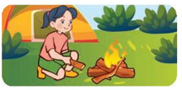 | 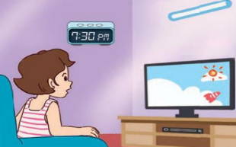
  A.
  B.
  C.
1. |  |  | 
  A.
  B.
  C.
2. | 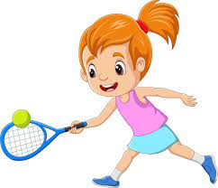 |  | 
  A.
  B.
  C.
3. |  | 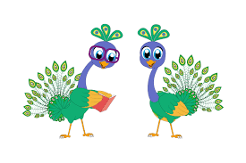 | 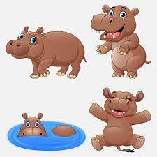
  A.
  B.
  C.
4. |  |  | 
  A.
  B.
  C.
PART 2: Listen and number. There is one example.(1pt)
A   | B  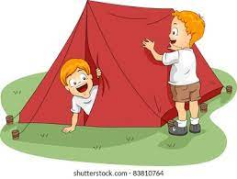 | C   | D   | E  
0

PART 3: Listen and draw line. There is one example. (1pt)

 | A   | B   | C   | D  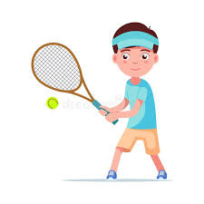 | E  
4
3
2
1
0

PART 4: Listen and write. There is one example.(1pt)
0. Linh and Nam visit their friends on Sunday.
1. What does your mother look like? – She’s ………………….
2. Why do you like ……………………? –> Because they dance beautifully.
3. What does she look like ? – She has long …………………….
4. What are these animals? – They’re ………..…………………
READING
PART 1: Read and match the words with pictures. There is one example. (1pt)
(0) Example  0) crocodiles | A 
1. turn round | B 
2. rainy | C 
3. do housework | D 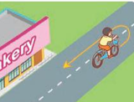
4. a quiet village | E 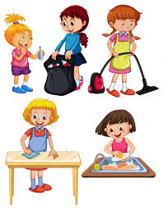
PART 2. Read and choose A, B or C to complete text. There is one example. (0,75pts)
Today is (0) Saturday. I and my family stay at home. We do a lot of housework. In the morning, I and my sister (1)……………….……… the clothes. My father (2)……………….……… the floor. In the afternoon, my brother helps my mom with the (3)……………….……….We have dinner at six thirty. In the evening, our family watch TV together.
0.a. day b.May c.Saturday
1. a. wash b. washes c. watchs
2. a. cleaning b. cleans c. clear
3. a. cook b. cooks c. cooking
PART 3 .Read and tick (√) True or False. There is an example .(0,75pts)
Mary wants to go to the supermarket. It is at 67 Le Hong Phong Street. can she get there? She can go straight and turn right. The supermarket is on the left. She wants to buy some food and drinks to make a small party at her home with their friends.
Ben wants to go to the bookshop. It is in Le Loi road and near the cinema. How can he get there? He can turn left and then go straight. The bookshop is on the right of the road. He wants to buy some books, pens and rulers.
 |  | TRUE | FALSE
0. | Mary wants to go to the supermarket. | √
1. | The supermarket is at 67 Le Hong Phong road.
2. | The bookshop is in Le Loi road and near the cinema.
3 | Ben wants to buy some rulers, books and pens.

WRITING
PART 1.Look at the pictures and the letters. Write the words. (0,75pts)
 |  |  | 
Example (0).  - runes  -> nurse | 1. torac  ->____________ | 2. pophi  ->____________ | 3. neciam  ->_____________
PART 2. Rearrange the words to make the sentences. There is one example. (0,75pts)

(0). get/ campsite/ I/ How/ to/ can/ the /?/

→ How can I get to the campsite?

1. on/ street/ The/ of/ bookshop/ the/ is/ the/ left/./

………………………………………………………………………………………

2. / weather/ yesterday/ the/ like/ was/ What/? /

………………………………………………………………………………………

3. watches/ cinema/ a/ sister/ film/ My/ at/ the/./

………………………………………………………………………………………

SPEAKING . (2pts)

Part 1

Part 2

Part 3

The end
ĐÁP ÁN VÀ BIỂU ĐIỂM BÀI KIỂM TRA ĐỊNH KỲ HỌC KÌ II
MÔN TIẾNG ANH LỚP 4 – NĂM HỌC 2024-2025
LISTENING
PART 1. (0,25*4 =1pt)
1.B 2.C 3.A 4.B
PART 2. (0,25*4 =1pt)
1.D 2.A 3.E 4.C
PART 3.(0,25*4 =1pt)
1.C 2.E 3.A 4.D
PART 4. (0,25*4 =1pt)
1. slim 2.peacocks 3. hair 4.crocodiles
READING
PART 1(0,25*4 =1pt)
1.D 2. A 3. E 4.C
PART 3 (0,25*3 =0.75 pts )
1.A 2. B 3. C
PART 2 (0,25*3 =0.75 pts )
1. FALSE 2. TRUE 3. TRUE
WRITING
PART 1 (0,25*3 =0.75 pts )
1. actor 2.hippo 3. cinema
PART 2 (0,25*3 =0.75 pts )

1. The bookshop is on the left of the street.

2.What was the weather like yesterday?

3. My sister watches a film at the cinema.
SPEAKING
Greeting & test taker’s name check.
The examiner says “My name is…It’s nice to talk to you today.”
Part 1: Getting to know each other
The examiner asks 3 questions below:
- What’s your name?
- Where do you live?
- What’s your hometown like?
Part 2: Point at the picture and say the words / sentences
The examiner point to the pictures and ask ss some questions.
- What does he/ she do?
- What does he/she look like?
- What was the weather like last weekend?
- Where does she go on Saturday?

 |  |  | 
 |  | 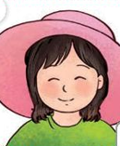 | 
 |  | 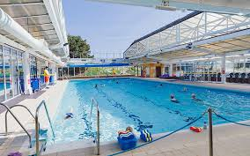 | 
Part 3: Answer the questions:
The examiner asks 3 questions below:
- When do you……………?
- Why do you like…………?
- How much is your……….?
That’s the end of the speaking test. You did a great job. Thank you.

Gio Quang, ngày14 tháng4 năm 2025
Duyệt của Chuyên môn Người lập

NguyễnThị Thu Hiền
Nguyễn Thị Thu Hà

