Week : Date of planning:
Period: Date of teaching :

UNIT 9: NATURAL DISASTERS

Lesson 6: Skills 2

I. OBJECTIVES

By the end of this lesson, students will be able to:

1. Knowledge:

- Listen and get general and specific about things to do before, during, and after a natural disaster;

- Write instructions about things to do before, during, and after a natural disaster.

2. Competences:

- Develop communication skills and creativity.

- Be collaborative and supportive in pairwork.

- Actively join in class activities.

3. Personal qualities

- Develop awareness of Natural disasters.

- Be concerned and know what to prepare when natural disasters happen.

II. MATERIALS

- Grade 8 textbook, Unit 9 Skills 2.

- Computer connected to the Internet.

- Projector / TV

- hoclieu.vn

III. PROCEDURES

1. WARM-UP (5 mins)

a. Objectives:

- To create an active atmosphere in the class before the lesson.

- To lead into the new lesson.

b. Content:

- Chatting

c. Expected outcomes:

- Ss can talk about what people should do before, during and after a storm.

d. Organisation
TEACHER AND STUDENTS’ ACTIVITIES | CONTENTS
- Teacher shows a picture of a storm and asks Ss what people should do before, during and after a storm.  - Teacher asks Ss to work individually and think of the answers.  - Teacher invites some Ss to share their ideas.  - Teacher gives comments and leads to the new lesson. | 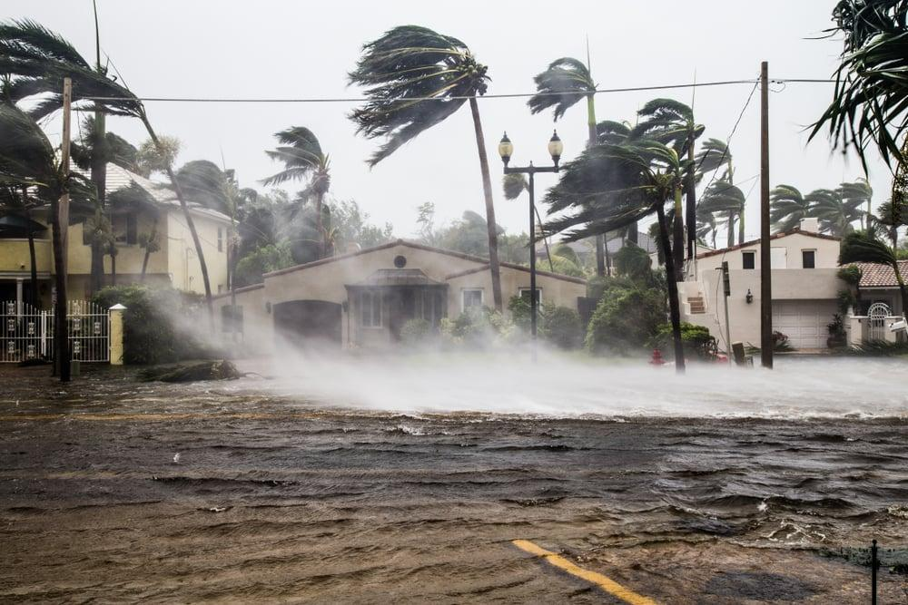  Suggested answer:  – Prepare food, drink an emergency kit with necessary things.  – lock all the doors of the house tiny.  – Move to a higher place if necessary.  During:  – Listen to the radio or television for more information.  After:  – Avoid moving water.  – Stay away from damaged areas

2. ACTIVITY 1: PRESENTATION (5 mins)
a. Objectives:
- To introduce some vocabulary
- To activate Ss’ knowledge of the topic of the reading text.
b. Content:
- Vocabulary pre-teach
- Match the headlines with the natural disasters.
c. Expected outcomes:
- Ss understand new vocabulary
d. Organisation
TEACHER’S AND STUDENTS’ ACTIVITIES | CONTENTS
Vocabulary :  - Teacher introduces the vocabulary.  - Teacher explains the meaning of the new vocabulary, using pictures and translation.  - Teacher checks students’ understanding with the “Matching” technique. | New words:  1. authority (n)  2. warn (v)  3. avoid (v)

3. ACTIVITY 2: PRACTICE(18 mins)

a. Objectives:

- To help Ss develop the skill of listening for specific information.

- To help Ss further develop the skill of listening for specific information.

b. Content:

- Task 1: Work in pairs. Look at the picture and answer the questions.

- Task 2: Listen to a broadcast. Put the activities in the correct column.

- Task 3: Listen again and tick T (True) or F (False) for each sentence.

c. Expected outcomes:

- Ss can answer the questions correctly.

- Ss can listen for specific information and do the learning tasks

d. Organisation
TEACHER AND STUDENTS’ ACTIVITIES |  | CONTENTS

Task 1: Work in pairs. Look at the picture and answer the questions. (4 mins)
- Teacher asks Ss to work in pairs and look at the pictures carefully.  - Ss look at the pictures and answer the two questions.  What can you see in the picture ?  When do we need these things ?  - Teacher elicits the answers from Ss.  - Teacher invites some Ss to answer in front of the class. | Suggested answer:  A torch, a mask, a lamp, a whistle, a bottle of water, some medicine, matches, a radio, some plasters, a candle, a multi-purpose knife, some batteries, a blanket.

Task 2: Listen to a broadcast. Put the activities (1 – 6) in the correct column. (7 mins)
- Teacher tells Ss that they are going to listen to a broadcast in which instructions to prepare for a natural disaster are given.  - Teacher has them read the activities 1-6 and try to guess which activities go into which column.  - Teacher invites some Ss to share their answers and write them on the board.  - Teacher has Ss read the activities again and underline the key words.  - Teacher plays the recording and asks Ss to listen and put the activities in the correct columns.  - Ss work in pairs to compare their answers.  - Teacher asks Ss to compare their answers with the ones on the board.  - Teacher confirms whether they are right or wrong, playing the audio again if necessary. | Answer key:  - Before a storm: 2,6  - During a storm: 3,5  - After a storm: 1,4

Task 3. Listen again and tick T (True) or F (False) for each sentence. (7 mins)
- Teacher tells Ss that they are going to listen to the broadcast again and decide if the statements are true or false.  - Without playing the recording again, teacher has Ss read the statements and decide if they are true or false.  - Teacher plays the recording and asks Ss to listen again to check their answers.  - Teacher asks Ss to work in pairs to compare their answers.  - Teacher asks for Ss’ answers and confirms the correct ones. | Answer key:  1. F  2. T  3. F  4. T

4. ACTIVITY 3: PRODUCTION (15 mins)

a. Objectives:

- To brainstorm ideas and make an outline for Ss’ writing.

- To help Ss practise writing instructions about things to do before, during and after a flood.

b. Content:

- Task 4: Work in pairs. Discuss what you should do before, during, and after a flood. Write your ideas in the columns.

- Write instructions (80 - 100 words) about things to do before, during, and after a flood.

c. Expected outcomes:

- Ss can write instructions about things to do before, during, and after a flood.

d. Organisation

TEACHER AND STUDENTS’ ACTIVITIES |  | CONTENTS

Task 4: Work in pairs. Discuss what you should do before, during, and after a flood. Write your ideas in the columns. (5 mins)
 | - Teacher asks Ss to work in pairs.  - Ss discuss what they should do before, during and after a flood.  - Ss write their ideas in the columns.  - Teacher has some Ss present their ideas.  - Teacher comments on their answers. |  |  | 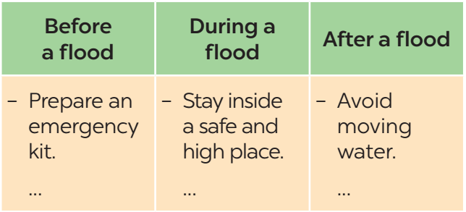

Task 5: Write instructions (80 - 100 words) about things to do before, during, and after a flood. (10 mins)
- Teacher asks Ss to work individually and write their instructions based on their answers in task 4.  - Teacher asks one student to write his/ her answer on the board. Other Ss and teacher comment on the writing on the board. |  |  | Suggested answer:  Here are the things you should do before, during, and after a ﬂood.  Before:  – Prepare an emergency kit with necessary things.  – Build barriers to stop ﬂoodwater from entering the house.  – Move to a higher place if necessary.  During:  – Listen to the radio or television for warnings and information.  – Be careful with ﬂash ﬂooding.  After:  – Avoid moving water.  – Stay away from damaged areas unless the local authority needs your help.  – Listen for local warnings of ﬂash ﬂoods.

5. CONSOLIDATION (3 mins)

a. Wrap-up

- Teacher asks Ss to summarise the main points of the lesson.

b. Homework

- Learn by heart all the words that they have just learnt.

- Rewrite the instructions.

- Do exercises in the workbook.

