UNIT 10.
OUR HOUSES IN THE FUTURE
PART 1. THEORY
I. VOCABULARY
No. | English | Type | Pronunciation | Vietnamese
1 | apartment | n | /ə'pɑ:tmənt/ | căn hộ
2 | basement apartment | n | /'beɪsmənt ə'pɑ:tmənt/ | tầng hầm
3 | CD player | n | /,si: 'di: 'pleɪər/ | máy chạy CD
4 | condominium | n | /.kɒndə'mɪnɪəm/ | chung cư
5 | cook meals | v | /kʊk mi:lz/ | nấu ăn
6 | electric fire | n | /ɪlektrɪk 'faɪər/ | lò sưởi điện
7 | games console | n | /geɪm kən'səʊl/ | máy chơi điện tử
8 | gas fire | n | /gæs 'faɪər/ | lò sưởi ga
9 | hoover /  vacuum cleaner | n | /'hu:vər/  /'vækjuəm 'kli:nər/ | máy hút bụi
10 | houseboat | n | /'haʊsbəʊt/ | nhà thuyên
11 | iron | n | /'aiən/ | bàn là
12 | look after children | v | /lʊk ‘ɑ:ftər ‘tʃɪldrən/ | chăm sóc trẻ
13 | motorhome  (motor home) | n | /’məʊtəhəʊm/ | nhà trên xe  (xe được thiết kế để làm nhà)
14 | mountain | n | /’maʊntən/ | núi
15 | ocean | n | /’əʊʃn/ | đại dương
16 | palace | n | /’pæləs/ | cung điện
17 | penthouse | n | /.pent ‘haʊs/ | tầng cao nhất của một tòa nhà cao tầng
18 | radiator | n | /'reɪdɪeɪtər/ | lò sưởi
19 | record player | n | /'rekɔ:d 'pleɪər/ | máy hát
20 | skyscraper | n | /'skaɪskreɪper/ | tòa nhà trọc trời
21 | spin dryer | n | /spɪn 'draɪər/ | máy sây quần áo
22 | UFO | n | /ju: ef' əʊ/ | vật thể bay không xác định
23 | villa | n | /'vɪlə/ | biệt thự
24 | wash and dry clothes | V | /wɒʃ ənd draɪ kləʊðz/ | giặt và làm khô quần áo
25 | wash and dry dishes | V | /wɒʃ ənd draɪ dɪʃɪz/ | rửa và làm khô bát đĩa

Một số tính từ thường gặp
No. | English | Type | Pronunciation | Vietnamese
1 | automatic | adj | /ɔ:tə'mætɪk/ | tự động
2 | modern | adj | /'mɒdn/ | hiện đại
3 | wireless | adj | /'waɪələs/ | không dây
4 | comfortable | adj | /'kʌmftəbl/ | thoải mái
5 | different | adj | /'dɪfərənt/ | khác biệt
6 | fantastic | adj | /fæn'tæstɪk/ | tuyệt vời
7 | smart | adj | /smɑ:t/ | thông minh
8 | special | adj | /'speʃl/ | đặc biệt

II. GRAMMAR
1. FUTURE SIMPLE TENSE (THÌ TƯƠNG LAI ĐƠN)
a. Cấu trúc
Khẳng định | S + will + V-inf
Phủ định | S + will + not + V-inf
Nghi vấn | Will + S + V-inf ?
Ex 1: My mother will buy a birthday cake tomorrow.
Ex 2: She wont come my house tomorrow.
b. Usage (Cách sử dụng)
- Thì tương lai đơn diễn tả một hành động sẽ xảy ra trong tương lai. Trong câu thường có từ chỉ tín hiệu thời gian trong tương lai.
Ex: I will go to the zoo with Tony tomorrow. (Ngày mai tôi sẽ đi sở thú với Tony.)
- Thì tương lai đơn diễn tả một quyết định được thực hiện tại thời điểm nói.
Ex: - It’s so hot. (Trời nóng quá.)
- OK. I will turn on the air conditioner, (ừ. Tớ sẽ bật điều hòa.)
- Thì tương lai đơn diễn tả một dự đoán không có căn cứ.
Ex: I think they will not come to the party. (Tôi nghĩ họ sẽ không đến dự tiệC.)
- Thì tương lai đơn có thể dùng để đưa ra yêu cầu, đê' nghị, lời mời, lời hứa hoặc một sự đe dọa.
Ex 1: Will you go to the cinema with me tonight? (Bạn đi xem phim với tôi tối nay nhé?)
Ex 2: I promise I will pay you tomorrow. (Tôi hứa tôi sẽ trả tiền bạn vào ngày mai.)
c. Signals (Dấu hiệu nhận biết thì tương lai đơn)
Ta có thể nhận biết thì tương lai đơn qua các trạng từ chỉ thời gian hay các động từ chỉ quan điểm, suy nghĩ.
Nhận biết qua các trạng từ chỉ thời gian
- tomorrow: ngày mai
- next week/ next month/ next year: tuần tới/ tháng tới/ năm tới
- in + thời gian trong tương lai.
- soon: sớm, chẳng bao lầu nữa
Ex: We’ll have a part next week.
Nhận biết qua các động từ chỉ quan điểm
- think/ assume/ believe...: nghĩ rằng/ cho rằng/ tin rằng
- expect/ hope: mong đợi, hi vọng
Ex: They hope they will study in the USA in the future. (Họ hi vọng họ sẽ học o Mỹ trong tương lai.)
2. MIGHT FOR FUTURE POSSIBILITY – MIGHT DIỄN TẢ KHẢ NĂNG TRONG TƯƠNG LAI

Might (có lẽ, có thể) là một động tù khuyết thiếu.

a. Form (Câu trúc)
Khẳng định: S + might + V (bare inf)
Phủ định: S + might + not + V (bare inf)
Chú ý: Không dùng might ở dạng nghi vấn để diễn tả sự nghi ngờ.
b. Usage (Cách sử dụng)
Might dùng để chỉ khả năng xảy ra của một hiện tượng, sự việc.
Ex 1: He might be back at any moment. (Anh ấy có thể sẽ về bất cứ lúc nào.)
Ex 2: The teacher might call my parents. (Cô giáo có thể sẽ gọi cho bố mẹ của tôi.)
Lựu ý:
Might có cách dùng tương đối giống may về việc diễn tả một khả năng nào đó. Tuy vậy may dùng để diễn tả khả năng xảy ra của sự việc có độ chắc chắn cao hơn might.
Ex 1: It’s sunny this weekend, we may go swimming on Sunday.
(Cuối tuấn này trời nắng, chúng ta có thể đi bơi vào Chủ nhật.)
Ex 2: I haven’t seen him come out yet. He may be in his office.
(Tôi không nhìn thấy anh ấy. Anh ấy có thể ở trong văn phòng.)

iii. PHONETICS
STRESS IN TWO-SYLLABLE WORDS – TRỌNG ÂM CỦA TỪ CÓ HAI ÂM TIẾT
Trọng âm là một điều rất quan trọng trong tiếng Anh. Nếu chúng ta phát âm không đúng trọng âm thì người nghe sẽ rất khó để hiểu được. Do vậy, chúng ta cần phát âm thật chuẩn và rõ ràng.
Trọng âm của từ có 2 âm tiết
a. Với danh từ và tính từ có 2 âm tiết
- Thông thường đối với các danh từ hoặc tính từ có 2 âm tiết, trọng ầm thường rơi vào âm tiết thứ nhất.
Danh Từ (noun) | Tính từ (adjective)
’sister | ’better
’worker | ‘early
’pupil | ’happy
’table | ’busy
Ngoại lệ: Nếu âm tiết thứ hai có chứa nguyên âm đôi hoặc nguyên âm dài, trọng âm sẽ rơi vào âm tiết thứ 2.
Ex: de’sign, ba’lloon, e’state, mis’take, a’lone, a’sleep, to’day, to’night
b. Với động từ có 2 âm tiết
Đối với các động từ có 2 âm tiết, trọng âm thường rơi vào âm tiết thứ hai.
in’vest  co’llect  co’nnect | be’gin  for’give  a’gree
Ngoại lệ: Nếu âm tiết thứ hai là một nguyên âm ngắn và kết thúc bởi 1 phụ âm (hoặc không có phụ âm), hoặc động từ đó có tận cùng là -er, -en, -ish, -age thì trọng ầm sẽ rơi vào âm tiết thứ nhất.
Ex: ‘enter, ‘open, ’manage, ’happen, ’answer, ’listen, ’finish, study, ’offer, ’damage

PART 2. LANGUAGE
I. VOCABULARY
Exercise 1. Look at the picture and fill in the blank with the correct word from the box.
CD player | skyscraper | ocean | iron
motorhome | hoover/ vacuum cleaner | radiator | UFO
CD player | skyscraper | ocean | iron

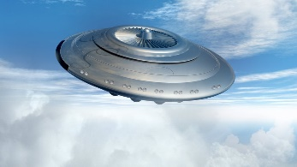 | 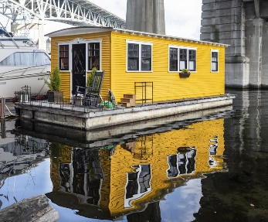 | 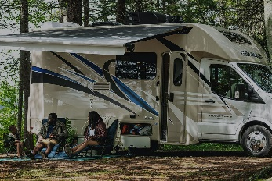 | 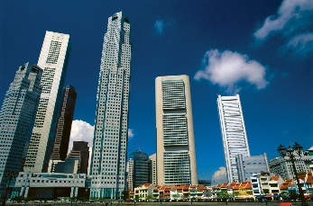
1. | 2. | 3. | 4.
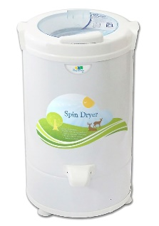 | 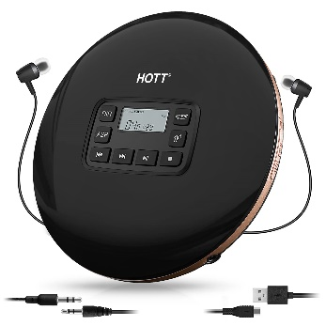 | 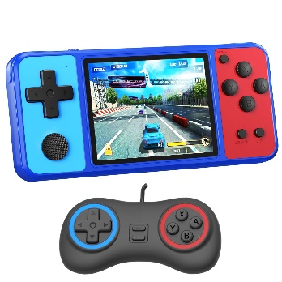 | 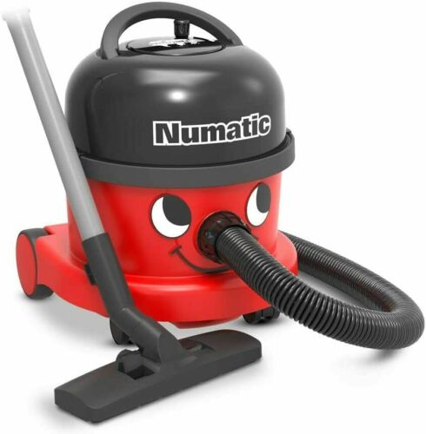
5. | 6. | 7. | 8.
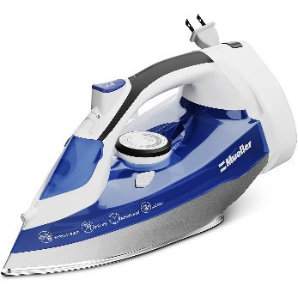 | 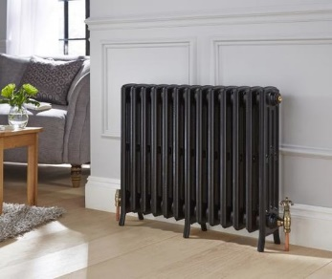 | 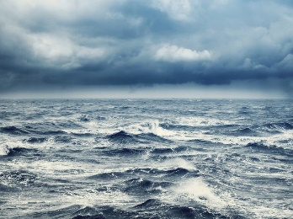 | 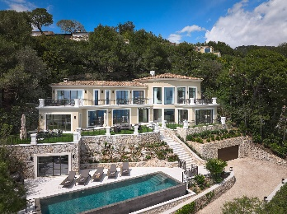
9. | 10. | 11. | 12.
Exercise 2. Fill in each blank with a suitable phrase from the box.
wireless TV | smart washing machine | modern fridge
hi-tech robots | dishwasher
1. We will use a _________________ to wash all the dishes and containers after a meal.
2. A _________________ will wash dirty clothes and make them ready for you to put on.
3. _________________ will understand what we say and will do all things around the house.
4. We will watch TV programmes from other countries by using _________________.
5. Do you think a _________________ will choose suitable food for our meals?
Exercise 3. Use the words or phrases given in the box to complete the following sentences. There are 2 extra words or phrases you don't need to use.
take care of | water | look after | do | send and receive | mountain | surf
1. My future house will have a self-cleaning feature to _________________ all the housework for me.
2. We will use an automatic machine to _________________ the flowers when we are not at home.
3. In 2000, Sony launched a wireless gadget that can be used to _________________ the Internet and watch TV.
4. In the future, robots will help to _________________ patients in the hospital.
5. We will have special remote control units to _________________ emails and order food from the markets without getting out of bed.
Exercise 4. Complete the gap with suitable word. The first letter is a hint for you.
1. H____________ is a boat that is designed as a house.
2. S____________ is a very tall building.
3. P____________ is a type of house usually for King and Queen to live in.
4. In winter, you usually use a r____________ to keep warm.
5. When you sweep the floor, instead of using a broom, you can use a h____________.
6. You use an i____________ to iron your clothes.
7. In humid days, you use a s_______ d_______ to make your wet clothes dry.
8. P____________ is the highest floor of a building.
9. M____________ is a vehicle that is designed as a house.
10. C____________ is a block of apartments.
Exercise 5. Give the correct form of the word in brackets to complete the following sentences.
1. When will they finish the ____________ of your house? (DECORATE)
2. Many reports talked a lot about the ____________ of UFOs. (APPEAR)
3. She would love to have a bed that ____________ makes itself every morning. (AUTOMATIC)
4. Her imagination of a perfect home will be a quiet ____________ and beautiful house located by the sea. (SPACE)
5. Robots in the future house will be smart to make our lives as ____________ as possible. (COMFORT)
6. The house is in beautiful ____________. (SURROUND)
7. The ____________ in the future houses helps them make more efficient use of energy compared to ordinary houses. (TECH)
8. I think UFOs might be the ____________ of people. (IMAGINE)
9. I haven’t find a convenient ____________ for the television. (LOCATE)
10. The modern appliance will control the ____________ in the house. (TEMPER)

II. GRAMMAR
Exercise 1a. Using the words or phrases given to write complete sentences in the simple future form.
1. My mother/ make / a big meal/ tonight.
__________________________________________________________________________________
2. I / finish/ work / 6 p.m.
__________________________________________________________________________________
3. I /not have/ a birthday party/ this year.
__________________________________________________________________________________
4. My friends/ not come / tonight.
__________________________________________________________________________________
5. I /not come /class / tomorrow.
__________________________________________________________________________________
Exercise 1b. Use might to rewrite the sentences without changing the meaning of the original sentences.
1. Maybe we go on holiday to the Moon.
__________________________________________________________________________________
2. Maybe we send video cards to friends.
__________________________________________________________________________________
3. Maybe we study on computers at home.
__________________________________________________________________________________
4. Maybe we call friends on our computers.
__________________________________________________________________________________
5. Maybe we take pictures with our watches.
__________________________________________________________________________________
Exercise 2. Choose the correct answer to complete the sentence.
1. You are very good at college. I believe you (will have/ won’t have) ___________________ an excellent job after graduation.
2. It’s very important. Are you sure that there (will be/ won’t be) ___________________ any problems?
3. Your parents (will be/ won’t be) ___________________ very proud of you if you win this last match.
4. They (will let/ won’t let) ___________________ you come because they hate you.
5. I am wondering if she (will be/ won’t be) ___________________ able to help me.
6. If my parents give me some money, I (will buy/ won’t buy) ___________________ a new sweater. My sweater is quite old fashioned.
7. I (will go/ wont’ go) ___________________ to South Africa. I prefer England.
8. I’m afraid I (will be/ won’t be) ___________________ able to come tomorrow.
9. She (might be/ won’t be) ___________________ Linh. I guess.
10. We (might have/ might not have) ___________________ a barbecue next weekend if you are free.
Exercise 3. Complete the sentence with "might" or "might not":
1. I’m tired. I ___________________ go to bed early tonight.
2. He left the office very late so he ___________________ be home for dinner.
3. There are a lot of clouds in the sky so it ___________________ rain later.
4. She didn’t pass her driving test so she ___________________ be happy.
5. They’re a very good team. They ___________________ win the championship this year.
Exercise 4. Write complete sentences using the simple future in declarative and negative form. Number 1 is an example for you.
1. I/ answer/ all/ question/ of/ teacher
I will answer all the questions of the teacher.
I won't answer all the questions of the teacher.
2. She/ read/ book/ library/ tomorrow
___________________________________________________________________________________
___________________________________________________________________________________

3. We/ send/ the postcard/ our parents
___________________________________________________________________________________
___________________________________________________________________________________
4. James/ buy/ somebooks/ next week
___________________________________________________________________________________
___________________________________________________________________________________
5. We/ listen/ to the radio
___________________________________________________________________________________
___________________________________________________________________________________
6. They/ eat/ seafood/ Ha Long Bay
___________________________________________________________________________________
___________________________________________________________________________________
7. She/ give/ him/ some apples
___________________________________________________________________________________
___________________________________________________________________________________
8. Tony/ go/ zoo/ tomorrow
___________________________________________________________________________________
___________________________________________________________________________________
Exercise 5. Complete the sentences with the correct forms of "will (not)" or "might (not)".
1. Leave early so that you ____________ miss the bus.
2. ____________ you be in Rome tonight?
3. Today is a busy day. We ____________ have time to help you tomorrow.
4. I think I ____________ go shopping. I’ve run out of food.
5. We have enough food for dinner, so I ____________ go shopping today.
6. The space explorers ____________ find water on Mars.
7. Regular trips to space ____________ be available in the next century.
8. One day they ____________ find life on other planets.
9. It ____________ be sunny tomorrow.
10. It ____________ be cloudy in June.
III. PHONETICS
Exercise 1. Choose the word whose main stressed syllable is placed differently from that of the others in each group.
1. A. exist | B. evolve | C. enjoy | D. enter
2. A. doctor | B. modern | C. corner | D. Chinese
3. A. complain | B. machine | C. music | D. instead
4. A. writer | B. baker | C. builder | D. career
5. A. provide | B. adopt | C. happen | D. inspire
6. A. result | B. region | C. river | D. robot
7. A. constant | B. basic | C. irate | D. obvious
8. A. become | B. carry | C. appoint | D. invent
9. A. engine | B. battle | C. rabbit | D. career
10. A. attract | B. destroy | C. occur | D. level
Exercise 2. Choose the word whose main stressed syllable is placed differently from that of the others in each group.
1. A. money | B. army | C. afraid | D. people
2. A. enjoy | B. daughter | C. provide | D. decide
3. A. begin | B. pastime | C. finish | D. summer
4. A. reply | B. appeal | C. offer | D. support
5. A. profit | B. delay | C. apply | D. suggest
6. A. direct | B. idea | C. suppose | D. figure
7. A. revise | B. happy | C. contain | D. desire
8. A. standard | B. happen | C. handsome | D. destroy
9. A. about | B. around | C. between | D. under
10. A. knowledge | B. enjoy | C. science | D. sudden

PART 3. COMMUNICATION SKILLS
I. LISTENING
Listen and do the tasks followed.
Exercise 1. Listen and answer the question: "What type of house is it?". Track 07
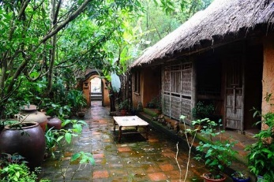 | 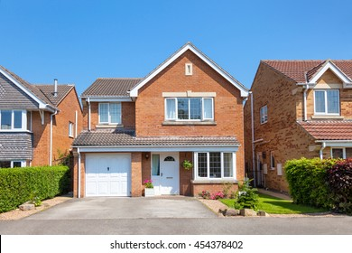 | 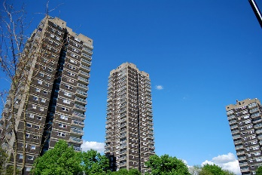 | 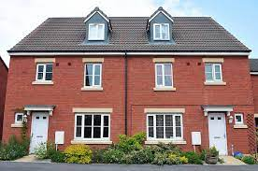
1. | 2. | 3. | 4.
Exercise 2. Listen and complete the blank with available type of house. Track 08
A. Tower block
B. Semi-detached house
C. Detached house
D. Cottage
1. use reinforced concrete
2. stands alone with nothing on either side
3. is joined to another house on one side
4. is divided into flats and offices
5. traditional one had a thatched roof
6. mainly founded in the residential areas of towns or cities
7. many of them have become very fashionable on the property market
8. have an upstairs and a downstairs and a small garden
9. is also called skyscraper
10. is a small house in the countryside
11. can be found in the suburbs
12. usually surrounded by a garden
II. SPEAKING
Exercise 1. Complete the conversation with suitable phrases.
clean energy | How are
the appliance | very modern
TV programmes from space | do all the housework
A: Will you live in a hi-tech house?
B: Yes, I think so.
A: (1) ______________________ our houses in the future?
B: I think they will be (2) ______________________.
A: Is it friendly to the environment?
B: Yes, that’s right. It will only use (3) ______________________ so that we can keep the environment clean.
A: What about (4) ______________________?
B: The Internet TV helps us to watch (5) ______________________.
A: Will you have any robots in your house?
B: Well, robots will (6) ______________________, so we will have more time for our family and relax.
Exercise 2. Complete the conversation with the missing sentences then practise speaking it.
It’s fantastic
It’s better for the environment
I’m drawing cars in the future
It is used to transfer heat from sun to energy
Is there anything else
It will have a GPS, and it can drive itself
Emma: What are you doing?
Nam: (1) __________________________________________________
Emma: It looks different from cars now. It has wings.
Nam: Yes. It has two wings, so it can fly.
Emma: So it’s a type of plane. (2) __________________________________________________.

Nam: (3) __________________________________________________.
Emma: So we can sleep while it is working. And when we are awake, we reach the destination.
Nam: Is it interesting?
Emma: (4) __________________________________________________. And, what is it?
Nam: It’s solar panel. (5) __________________________________________________.
Emma: So will we have to use oil anymore?
Nam: I think we won’t. (6) __________________________________________________.
III. READING
Exercise 1. Read the following text and choose the best option A, B, C or D.
My dream is to live in a big house surrounded by a big garden full of flowers and trees. I don’t like to live in an apartment with blocks of flats and rude neighbors making noise in the middle of the night. My future house will be located outside the city. It might be near a river. I have always dreamt of living near rivers and hearing the sound of the birds in the morning.
My house will have a smart appliance which will monitor the current weather forecast to keep the temperature inside the house comfortable. It will use solar energy to heat the water; run computers and other electronics. My future house will be an eco-house that uses clean energy to save the environment.
It will have a large garden for me to have as many pets as I wish for. Then there will be some robots in the house to help me with my housework. They will clean the house every morning, prepare all the meals for me and feed the dogs and cats.
1. Where will the house be located?
A. inside the river B. outside the city C. in the sky D. in the village
2. Why doesn’t the author like to live in an apartment?
A. He/she doesn’t like to live in blocks of flats.
B. He/she doesn’t like the city.
C. He/she doesn’t like to live with rude neighbors.
D. Both A and c are correct.
3. Solar energy is used to __________.
A. prepare meals B. run computers and other electronics
C. cool the water D. water the flowers
4. Why does the author want to live in an eco-house?
A. to save energy B. so save the wild animals
C. to save the environment D. to save water
5. What will the robots do?
A. feed the pets B. clean the house C. cook meal D. All are correct
Exercise 2. Read the following text and decide which answer best fits each numbered blank.
What (1) __________ the future be like? We know everything about the past but we don’t know about our future. Now, we (2) __________ in the world of technology. Technology, has the greatest influence on the daily lives of people. So what differences will there be in technology in next hundred years?
By this time, (3) __________ robots are doing a lot of difficult tasks. In the future, robots will replace people in many jobs such as housekeepers, baby-sitters, cleaners, taxi drivers. In the hospitals, robots (4) __________ help doctors and nurses (5) __________ the patients. Even our house will (6) __________ a “big robot”. (7) __________ machines in the house will be smart to make life comfortable. They will take care of our children, cook (8) __________, clean the house, and even (9) __________ our dogs and cats. Robots in the future will understand people and they will be able to send and (10) __________ orders through the Internet.
1. A. will B. are C. is
2. A. will live B. might live C. are living
3. A. wireless B. hi-tech C. bad
4. A. will B. are C. are going
5. A. look after B. look for C. look at
6. A. is B. be C. are
7. A. Automatic B. Auto C. Automatically
8. A. water B. flowers C. meals
9. A. surf B. do C. Feed
10. A. care B. receive C. wash
Exercise 3. Read the passage carefully and then choose the correct answers.
In the future, schools will be better. Computers will be much quicker and we might have pencils which write for us! All the students will have their own computers.
When there is a history lesson, the computers will show important events. The students will be dressed up as the characters from the period they are studying. There will be hover boards in the playground, and students will come to school by hover cars.
Every child will have a robot like themselves. The robots will have to go to school while the students sit at home controlling them in front of their computers. The robots will have laser pens and the student will have laser ink pens.
The classroom will be floating, and the tables and chairs will, too. There will be no homework, and teachers won’t take away the toys.
1. The student wants all of the following but not ______________.
A. having laser ink pens B. going to school
C. staying at home controlling a robot D. having a robot like himself
2. In history lessons, the student wants the computer to ______________.
A. show important people in history events
B. have new games
C. show history events and the student will be one of the important characters
D. find all information about the events from the Internet
3. If the history lesson today is about ancient Egypt, the student will ______________.
A. watch films about Egypt on the computer
B. become the queen
C. get dressed like the queen
D. see things and houses at that time
4. The student wants to have ______________.
A. floating classrooms B. no homework
C. toys in the classroom D. all A, B, and C
5. The word “hover” in paragraph 2 means ______________.
A. colourful B. flying C. moving D. large
IV. WRITING
Exercise 1. Use the given words from the box to write complete sentences about things you "might" or "might not" do in the future.
1. write a book  2. become famous  3. work in a different planet  4. build houses in a different planet | 5. have a hi-tech robot  6. have children  7. break a world record  8. fly in a rocket
1. _________________________________________________________________________________
2. _________________________________________________________________________________
3. _________________________________________________________________________________
4. _________________________________________________________________________________
5. _________________________________________________________________________________
6. _________________________________________________________________________________
7. _________________________________________________________________________________
8. _________________________________________________________________________________
Exercise 2a. Use the given words to write the complete sentences.
A: Do you think people will take vacations to the Moon? (might not)
B: I think people _____________________________________________________________________
A: Do you think there will be a robot that can cook all meals for us? (might)
B: I think there ______________________________________________________________________
A: Do you think Hang will be able to find the swimming pool? (might not)
B: I think she _______________________________________________________________________
A: Do you think the water will be heated by wind energy? (might)
B: ________________________________________________________________________________
A: Do you think scientists will find life on another planet? (might)
B: ________________________________________________________________________________
A: Do you think robots will help US do the homework? (might not)
B: ________________________________________________________________________________
A: Do you think we will travel into space? (might)
B: ________________________________________________________________________________
A: Do you think you will live in a houseboat? (might not)
B: ________________________________________________________________________________
Exercise 2b. Use the given words to write the complete sentences with "will".
1. In/ future/ people/ travel/ driverless cars.
________________________________________________________________________________
2. In/ fifty years/ you/ fly/ work/ your car.
________________________________________________________________________________
3. In/ future/ students/ stay/ home/ study/ the Internet.
________________________________________________________________________________
4. In/ next/ decade/ scientists/ find/ life/ another/ planet.
________________________________________________________________________________
5. In/ future/ all information/ probably/ be/ stored/ computers.
________________________________________________________________________________
Exercise 3. Answer these questions and then write a passage about your future house (about 80-90 words).
1. What type of house will it be?
________________________________________________________________________________
2. Where will it be?
________________________________________________________________________________
3. What will there be around your house?
________________________________________________________________________________
4. How many rooms does it have?
________________________________________________________________________________
5. What will you have in your house?
________________________________________________________________________________
6. Will you have a robot in your house? If yes, what will your robot do?
________________________________________________________________________________
Your writing
________________________________________________________________________________
________________________________________________________________________________
________________________________________________________________________________
________________________________________________________________________________
________________________________________________________________________________
________________________________________________________________________________
________________________________________________________________________________
________________________________________________________________________________
________________________________________________________________________________

