SPEAKING
1. Introduction:
Introduce yourself with basic information (name, class, age, hobby, family, etc.)(0.5 point)
2. Each of you will now receive a card. On the card there is a picture and clues for five questions. You should use the words to make questions and ask your friend. Your friend will answer the questions based on the picture he/she has (0.5 point)
City life  1. Which city is it ?  2. Where is it located ?  3. What is the main features of this city?  4. What are its attractions ? | 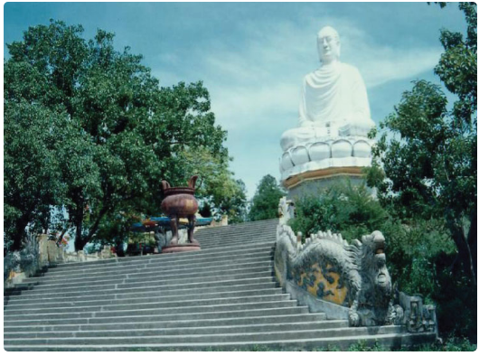
1. Which city is it ?  2. Where is it located ?  3. What is the main features of this city?  4. What are its attractions ? | 
3. Answer further questions (1 point)
- Have you ever been to these cities ?
- What do you like most about that city ?
- What is the most attractive there?
- When is the ideal time to visit it?
- How should we go there?

