Họ và tên: ....................................................  Lớp: ............................................................. | PHIẾU GHI BÀI HÓA HỌC 11 CÁNH DIỀU  Bài 18: HỢP CHẤT CARBONYL
MỞ ĐẦU
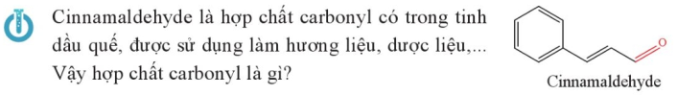
..........................................................................................................................................................................
..........................................................................................................................................................................

I. KHÁI NIỆM VÀ DANH PHÁP
1) Khái niệm
■ Aldehyde: .....................................................................................................................................................
..........................................................................................................................................................................
..........................................................................................................................................................................
..........................................................................................................................................................................
..........................................................................................................................................................................
■ Ketone: .........................................................................................................................................................
..........................................................................................................................................................................
..........................................................................................................................................................................
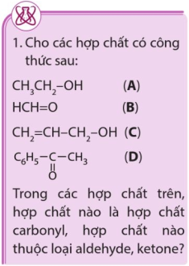 | ...................................................................................................................  ...................................................................................................................  ...................................................................................................................  ...................................................................................................................  ...................................................................................................................  ...................................................................................................................  ...................................................................................................................  ...................................................................................................................  ...................................................................................................................
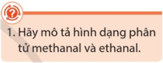 | ...................................................................................................................  ...................................................................................................................  ...................................................................................................................  ...................................................................................................................  ...................................................................................................................  ...................................................................................................................
2) Danh pháp
a) Tên thay thế
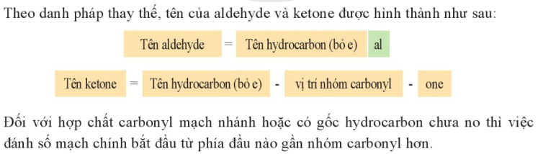
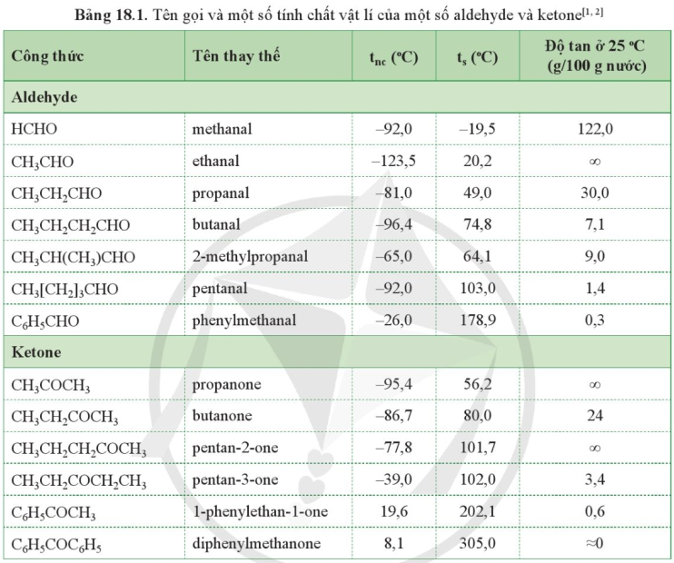
b) Tên thông thường
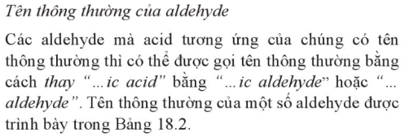
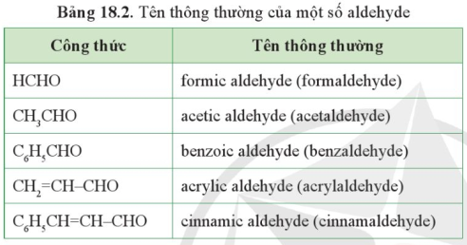
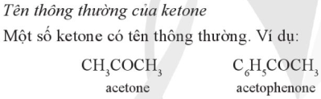
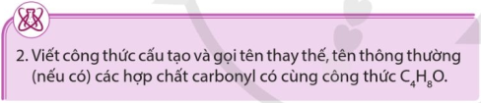
..........................................................................................................................................................................
..........................................................................................................................................................................
II. TÍNH CHẤT VẬT LÍ
..........................................................................................................................................................................
..........................................................................................................................................................................
..........................................................................................................................................................................
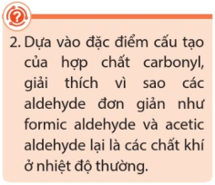 | ..................................................................................................................  ..................................................................................................................  ..................................................................................................................  ..................................................................................................................  ..................................................................................................................  ..................................................................................................................
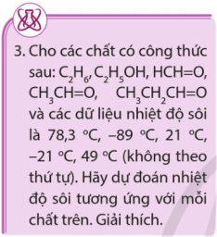 | ..................................................................................................................  ..................................................................................................................  ..................................................................................................................  ..................................................................................................................  ..................................................................................................................  ..................................................................................................................  ..................................................................................................................
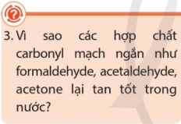 | ..................................................................................................................  ..................................................................................................................  ..................................................................................................................  ..................................................................................................................
III. TÍNH CHẤT HÓA HỌC
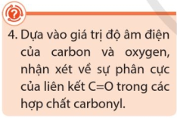 | ..................................................................................................................  ..................................................................................................................  ..................................................................................................................  ..................................................................................................................  ..................................................................................................................
1) Phản ứng khử hợp chất carbonyl
..........................................................................................................................................................................
..........................................................................................................................................................................
..........................................................................................................................................................................
..........................................................................................................................................................................
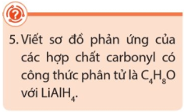 | ..................................................................................................................  ..................................................................................................................  ..................................................................................................................  ..................................................................................................................  ..................................................................................................................
2) Phản ứng oxi hóa aldehyde
a) Phản ứng với nước bromine
..........................................................................................................................................................................
..........................................................................................................................................................................
..........................................................................................................................................................................
..........................................................................................................................................................................
b) Phản ứng với thuốc thử Tollens
..........................................................................................................................................................................
..........................................................................................................................................................................
..........................................................................................................................................................................
..........................................................................................................................................................................
..........................................................................................................................................................................
..........................................................................................................................................................................
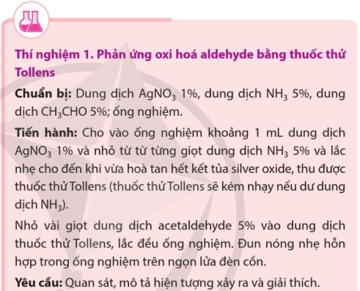 |  | ...............................................................  ...............................................................  ...............................................................  ...............................................................  ...............................................................  ...............................................................  ...............................................................  ...............................................................  ...............................................................  ...............................................................  ...............................................................
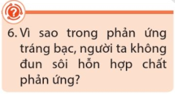 | ..................................................................................................................  ..................................................................................................................  ..................................................................................................................  ..................................................................................................................
c) Phản ứng với Cu(OH)₂/OH⁻
..........................................................................................................................................................................
..........................................................................................................................................................................
..........................................................................................................................................................................
..........................................................................................................................................................................
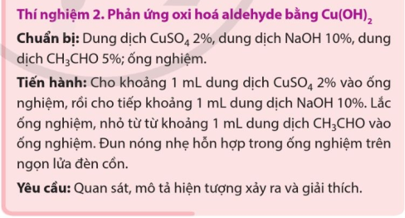 |  | ...............................................................  ...............................................................  ...............................................................  ...............................................................  ...............................................................  ...............................................................  ...............................................................
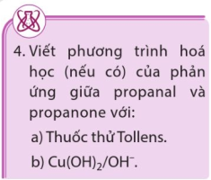 | ..................................................................................................................  ..................................................................................................................  ..................................................................................................................  ..................................................................................................................  ..................................................................................................................
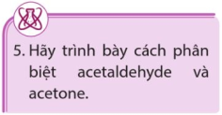 | ..................................................................................................................  ..................................................................................................................  ..................................................................................................................
3) Phản ứng với hydrogen cyanide
...................................................................................................................  ...................................................................................................................  ...................................................................................................................  ...................................................................................................................  ...................................................................................................................  ...................................................................................................................  ...................................................................................................................  ................................................................................................................... | 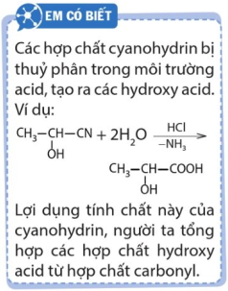
4) Phản ứng tạo iodoform
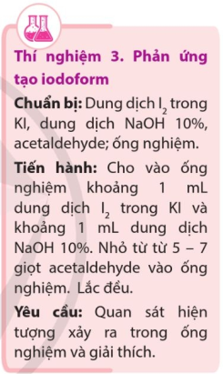 | 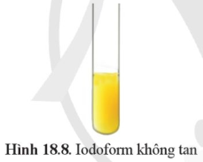 | .............................................................
..........................................................................................................................................................................
..........................................................................................................................................................................
..........................................................................................................................................................................
..........................................................................................................................................................................

IV. ỨNG DỤNG VÀ ĐIỀU CHẾ
1) Ứng dụng
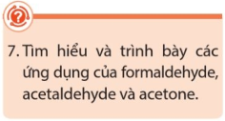  ..................................................................................................................  ..................................................................................................................  ..................................................................................................................  ..................................................................................................................  ..................................................................................................................  ..................................................................................................................  ..................................................................................................................  ..................................................................................................................  .................................................................................................................. | 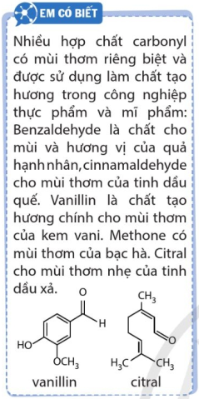
..........................................................................................................................................................................
..........................................................................................................................................................................
..........................................................................................................................................................................
..........................................................................................................................................................................
..........................................................................................................................................................................
..........................................................................................................................................................................
..........................................................................................................................................................................
..........................................................................................................................................................................
..........................................................................................................................................................................
..........................................................................................................................................................................
..........................................................................................................................................................................
..........................................................................................................................................................................
2) Điều chế
..........................................................................................................................................................................
..........................................................................................................................................................................
..........................................................................................................................................................................
..........................................................................................................................................................................
..........................................................................................................................................................................
..........................................................................................................................................................................

