Date of preparing: ………………………………….
Date of teaching: ………………………………….

Period……
UNIT 2: SCHOOL
Lesson 1 - Part 2 (Page 15) - Grammar

I. OBJECTIVES
By the end of the lesson, Ss will be able to
1. Knowledge
- use “and” or “or” for positive and negative statements.
- use possessive pronouns.
- ask and answer about favorite subjects.
2. Ability
- improve speaking skills, listening skill.
- improve the use of English.
3. Quality
- have positive attitude in English language learning so that they actively participate in all classroom activities, especially with the topic “School” conducted by the teacher.
- love their school, identify their favorite subject(s) and even orient what they want to do in the future, using the knowledge from the subject(s) they like.

II. TEACHING AIDS AND LEARNING MATERIALS
Lesson plan, PPT slides, student’s book, workbook, notebook, personal computer (if any), projector/TV, speakers, DCR & DHA on EDUHOME, handouts…

III. PROCEDURES
A. Warm up: (5’)
a) Objective: to introduce the new lesson and set the scene for Ss to acquire new language; to get students' attention at the beginning of the class by means of enjoyable and short activities as well as to engage them in the steps that follow.
b) Content: introduction of connectives “and” to join nouns in positive sentence and “or” to join nouns in negative sentence.
c) Product: Ss get general ideas about connectives: and, or
d) Competence: Collaboration, communication, creativity.
e) Organization of the activity:
Teacher’s Activities | Students’ Activities
- Give greetings  - Check attendance  - Option 1: Game “SENTENCE BUILDING”  - Ask 5 Ss to volunteer to take part in the game, let them stand in front of the class  - Give each S a piece of paper, each of which contains a word. The Ss then have to change their position in order to make the words in their paper together bring a meaningful sentence  - Ask the whole class to help them if they have an incorrect answer  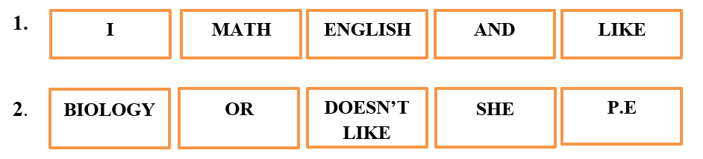  - Check Ss’ answers, give feedback and lead to the new lesson  - Option 2: CHATTING  - Ask Ss: Who likes English?  - Ask Ss another question: Who likes Music?  - Point to the S who raises his / her hand for both questions, then make a sample sentence, like:  Minh likes English and Music/Hoa likes English and Music  - Follow the same steps with the negative idea:  Who doesn’t like black?  Who doesn’t like yellow?  -Then, make another sample sentence, example:  Lan doesn’t like black or yellow.  - Ask Ss to pay attention to the words that teacher uses to connect 2 nouns in the two sample sentences  - Lead to the new lesson | - Greet T  - Take part in the game  - Observe and help 5 volunteers if their answer is incorrect  Answers keys  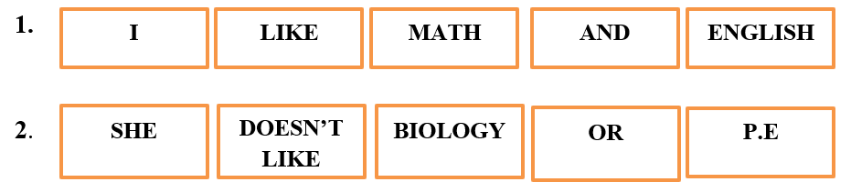  - Raise hands (If he/she likes English)  - Raise hands (If he/she likes Music)  - Raise hands (If he/she doesn’t like black)  - Raise hands (If he/she doesn’t like yellow)  - Listen

B. New lesson (34’)
- Activities 1: Grammar: Connectives: “and” and “or” (15’)
a) Objective: Ss know how to use “and” and “or” to join nouns in a positive and negative statement.
b) Content:
- The usage of “and”, “or”
- The practice of speaking and writing
c) Products: Ss can use “and”, “or” to join nouns in everyday communication.
d) Competence: Communication, collaboration, presentation
e) Organization of the activity:
Teacher’s Activities | Students’ Activities
c. Write sentences, using the prompts  - Option 1:  - From the warm-up activity, T explains more about how to use “and”, “or” to join nouns in a statement.  - Ask Ss to do the exercise individually  - Call Ss to write answers on the board  - Have other Ss make comments on their friends’ answers  - Check and correct Ss’ answers if necessary  - Ask Ss to use the comma if there are more than 2 nouns in a sentence  - Option 2:  - Ask Ss to work in groups to write sentences on the extra board, using the prompts given in the book  - Ask Ss to hang their extra board on the big board in front of the class, check, correct Ss’ answers  d. Now, with a partner, say what subjects you like and don’t like  - Option 1:  - From task c, T can have Ss read the sentences in the task again, then ask them to make their own sentences  - Call Ss to present their answers  - Option 2:  - T can let Ss do this speaking activity at the end of the lesson; they can use all the knowledge from the lesson to make up their dialogue | - Listen  - Work individually.  - Write on the board  - Comment  Answer keys  1. I like history, I.T and physics.  2. I don’t like art or music.  3. I like literature and biology.  4. I don’t like P.E, geography or physics.  5. I like music, literature, and art.  - Work in groups  - Hang the extra board, listen and correct mistakes  - Read the sentences in task c  - Work in pairs  - Do what the teacher requests
- Activity 2: Grammar: Possessive pronouns: mine and yours (19’)
a) Objective: Ss can make questions or answer the questions to develop a conversation.
b) Content: Listening and repeating; doing multiple choice exercise
c) Products: Ss can apply the use of “mine” and “yours” to everyday communication.
d) Competence: Collaboration, listening, communication, creativity.
e) Organization of the activity:
Teacher’s Activities | Students’ Activities
a. Listen and repeat  - Let Ss look at a sample dialogue:  A: What’s your favorite subject?  B: My favorite subject is Biology. What’s your favorite subject?  A: My favorite subject is Art.  B: Oh, I don’t like Art.  - Ask 2 Ss to read this dialogue  - Ask Ss to make comments on the words used in the dialogue (hint: the words that are used repeatedly)  - Play the audio once. Ask Ss to listen and notice how they replace the repeated words, then repeat the sentences  - Explain more about “mine” and yours”:  We use “mine” and “yours” so we don’t say the same words again. It makes the sentence shorter and more coherent  mine = my + noun  yours = your + noun  b. Circle the correct words  - Option 1:  - Have Ss do the task in pairs  - Call Ss to read their answers  - Give feedback and correct Ss’ answers if necessary  - Ask Ss to make more sentences, using “mine” and “yours”  - Have Ss read their answers or write on the board  - Give feedback, if Ss’ answers are good, give them evaluation by giving extra marks  - Option 2: Game: “LUCKY NUMBER”  - Design game “Lucky number”, let Ss time to prepare, then answer the questions randomly by choosing number  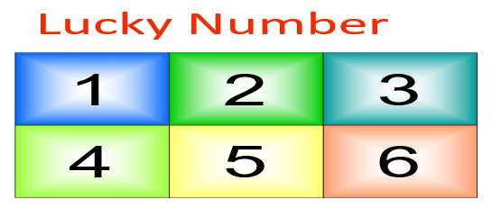  - Ask Ss to make more sentences, using “mine” and “yours”  - Have Ss read their answers or write on the board  - Give feedback and evaluation | - Look and read  - Make comments on the dialogue, pay attention to the words that are used many times.  - Listen and repeat  - Listen and take notes  - Work in pairs  - Read the answers aloud  Answer keys  2. yours 3. Mine 4. yours  5. Mine 6. Mine  - Make sentences (Ss can write them in notebooks)  - Read or write  - Take part in the game  - Make sentences  - Read or write  Suggested answer keys  (Up to the questions designed by each teacher)

C. Consolidation (4’)
* Connectives: “and”: join 2 or more nouns in a positive statement; “or”: join 2 or more nouns in a negative statement.
* Asking and answering about school subjects you like:
What subjects do you like?
What’s your favorite subject?
Which subject do you like best?
* Possessive pronouns: Mine and yours (in order not to repeat the words that go before, example: My favorite subject is English. What’s yours? – Mine’s Music.)

D. Homework (2’)
- Make 2 sentences, using “and” or “or” for positive and negative statements.
- Practice asking and answering about school subjects you like and don’t like, using possessive pronouns
- Do exercises in Workbook: Lesson 1 - Grammar (page 9) and Writing (page 9)
- Prepare: Lesson 1 – Pronunciation and Speaking (page 16 – SB)

