School: ……………………………………….. | Date:……………………………………..
Class: ……………………………..................... | Period: …………………………….........

UNIT 3: MUSIC AND ARTS
Lesson 1.1 - Vocabulary and Reading (Page 20)

I. OBJECTIVES
By the end of the lesson, Ss will be able to:
1.1. Language knowledge and skills
- talk about types of music (jazz, hip hop, pop, classical music, rock, country music).
- use some adjectives to describe types of music (boring, noisy, interesting, exciting, fun, terrible, beautiful).
- read and understand general and specific information about two students’ favorite types of music.
- use Present simple for facts.
1.2. Competences
- improve communication, collaboration, analytical and critical thinking skills.
1.3. Attributes
- love music.
- relax with music after hard studying days.

II. TEACHING AIDS AND LEARNING MATERIALS
1. Teacher’s aids: Student book and Teacher’s book, class CDs, Digital Book (DCR phần mềm tương tác SB, DHA (từ vựng/ cấu trúc) phần mềm trò chơi tương tác), projector/interactive whiteboard / TV (if any), PowerPoint slides.
2. Students’ aids: Student’s book, workbook, notebook.

III. ASSESSMENT EVIDENCE
Performance Tasks | Performance Products | Assessment Tools
- Introduce some words about types of music.  - Introduce adjectives to describe types of music.  - Match the words with the pictures in a.  - Listen and repeat.  - Discuss which types of music you like and dislike. Describe them using the adjectives in the book.  - Read the blog post of Binh and Linh. Do they like rock music?  - Read the unfinished sentences and circle the correct answers. | - Ss’ answers in notebooks.  - Ss’ answers.  - Ss’ answers.  - Ss’ answers.  - Ss’ answers/ presentation.  - Ss’ answers.  - Ss’ answers. | - T’s feedback.  - T’s observation/ DCR.  - T’s feedback/Peers’ feedback.  - T’s observation / feedback.  - T’s feedback/Peers’ feedback.  - T’s feedback/Peers’ feedback.

IV. PROCEDURES
A. Warm up: (5’)
a) Objective: Introduce the new lesson and set the scene for Ss to acquire new language; get students' attention at the beginning of the class by enjoyable and short activities as well as to engage them in the follow-up steps.
b) Content: Introduce some words about types of music (jazz, hip hop, pop, classical music, rock, country music).
c) Expected outcomes: Ss have general ideas about the topic of the new lesson: “music and arts”.
d) Organization of the activity:
TEACHER’S ACTIVITIES | STUDENTS’ ACTIVITIES
- Option 1: Matching  - Use the “New words” part a.– page 20 for the warm-up activity.  - Show pictures and words using DCR, have Ss match the words and phrases with the pictures (in pairs).  - Call Ss to give answers.  - Give feedback and show correct answers.  - Lead to the new lesson.  - Play the audio (CD1 – Track 24), have Ss listen and repeat.  - Correct Ss’ pronunciation if necessary.  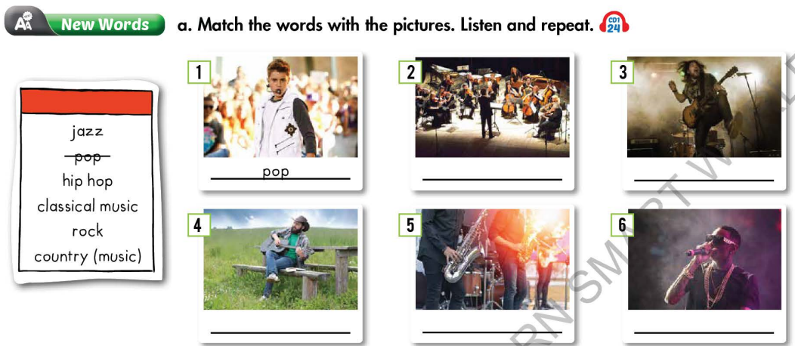  - Option 2:  - Play a video clip about kinds of music.  - Have Ss listen and watch, then try to remember the kinds of music listed in the clip.  - Call Ss to give answers.  - Give feedback and lead to the new lesson: Music and arts.  *Link: https://www.youtube.com/watch?v=wiF8YlKNx4g  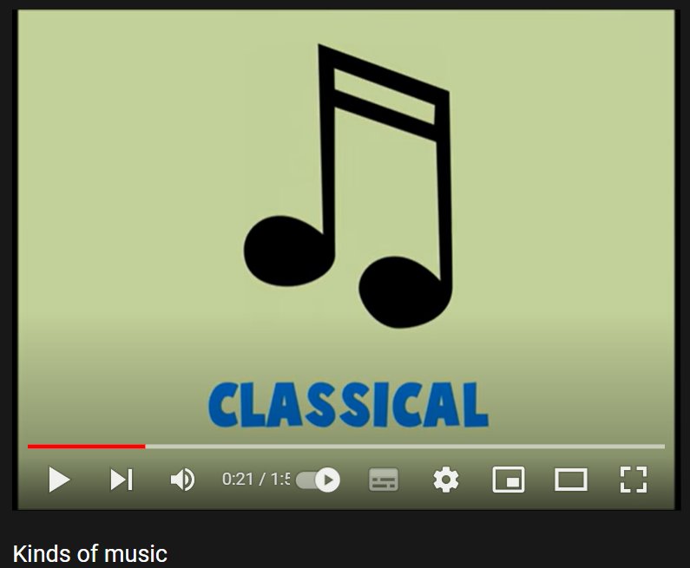 | - Work in pairs to match the words and phrases with the pictures.  - Give answers.  - Listen.  Answer keys  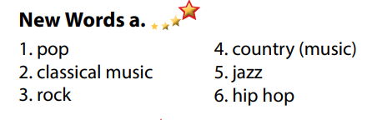  - Listen, watch and try to remember the kinds of music listed in the clip.  - Give answers.  Suggested answers  Kinds of music listed in the clip: blues, classical, country, rock, folk, hip hop, jazz, pop, reggae, rock.

B. New lesson (35’)
- Activity 1: Pre-Reading (Vocabulary) (12’)
a) Objective: Ss know some words about types of music and adjectives to describe them
b) Content:
- Vocabulary study: words about types of music (jazz, hip hop, pop, classical music, rock, country music) and some adjectives to describe types of music (boring, noisy, interesting, exciting, fun, terrible, beautiful).
- Speaking: Say which types of music do you like and dislike. Use the adjectives in the box to describe them.
c) Expected outcomes: Ss know how to pronounce the new words correctly and use them in appropriate situations.
d) Organization of the activity:
TEACHER’S ACTIVITIES | STUDENTS’ ACTIVITIES
Task a. Match the words and phrases with the pictures. Listen and repeat.  - Option 1 (If the teacher hasn’t used this part for the Warm-up activity)  - Demonstrate the activity on DCR, using the example.  - Have Ss match the words and phrases with the pictures.  - Divide class into pairs and have them check their answers with their partners.  - Call Ss to give answers (read or write).  - Check answers as a whole class.  - Play audio (CD1 – Track 24). Have Ss listen and repeat.  - Correct Ss’ pronunciation.  - Option 2: Matching (If the teacher has used part a. for the Warm-up activity)  - Have Ss review the words they have known in the warm-up activity by looking at the pictures of some famous music bands / singers (Artists) in the word and matching them with words about types of music Ss have learnt.  - Call Ss to give answers (read or write).  - Check answers as a whole class.  - Call some Ss to read the words again.  - Correct Ss’ pronunciation if necessary.  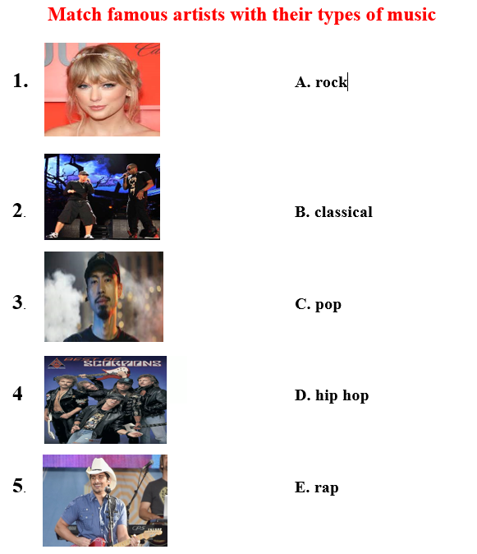  Task b. Discuss which types of music do you like and dislike. Describe them using the adjectives in the box.  - Have Ss discuss in pairs which types of music they like and dislike, encourage Ss to use some more adjectives besides the ones given in the textbook.  - Have Ss share their ideas in front of the class.  - Give feedback and evaluation. | - Look and listen.  - Work individually.  - Work in pairs.  - Give answers.  - Listen and repeat.  Answer keys  - Work in groups of 3 or 4.  - Give answers.  - Read.  Answer keys  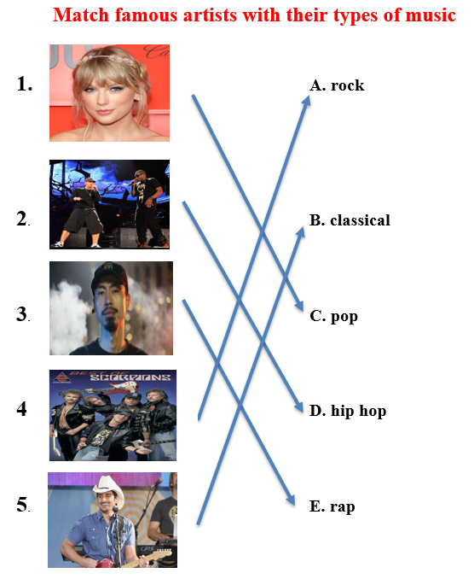  - Work in pairs.  - Present.
- Activity 2: While - Reading (17’)
a) Objective: Students can develop their reading skill.
b) Content: Read the blog post. Do Bình and Linh both like rock music?
c) Expected outcomes: Students can read and understand general and specific information about a blog post about music types.
d) Organization of the activity:

TEACHER’S ACTIVITIES | STUDENTS’ ACTIVITIES
Task a. Read the blog post. Do Bình and Linh both like rock music?  - Ask Ss to read the blog post, and then answer the question.  - Remind Ss to underline or highlight the keywords or supporting ideas for their answers.  - Have Ss exchange their answers with a partner.  - Have some Ss share their answers with the class (read), explain for their answers.  - Give feedback.  - Give feedback and correct Ss’ answers if necessary.  Task b. Now, read and circle the correct answers.  - Have Ss read the questions, underline key words and guess the answers.  - Have Ss read the blog post again and circle the correct answers – underline or highlight the supporting ideas.  - Have Ss check answers with their partners.  - Call Ss to give answers, explain.  - Give feedback and evaluation. | -Work individually.  - Exchange answers.  - Read answers, explain.  - Check answers.  Answer keys    - Read and underline.  - Do the task.  - Check answers.  - Give answers.  Answer keys  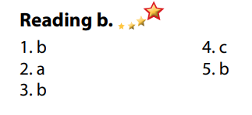

- Activity 3: Post - Reading (6’)
a) Objective: Students can use the vocabulary and ideas from the reading text to develop their speaking skill.
b) Content: Speaking: When do you like to listen to music?
c) Expected outcomes: Students can talk about their favorite kinds of music and the time they listen to them.
d) Organization of the activity:
TEACHER’S ACTIVITIES | STUDENTS’ ACTIVITIES
Task c. In pairs: When do you like to listen to music?  - Have Students work in pairs to favorite kinds of music and the time they listen to them  - Call some Ss to share their ideas with the whole class  - Give feedback and evaluation. | - Discuss in pairs.  - Present.  - Listen.

C. Consolidation and homework assignments (5’)

* Consolidation:
- Words about types of music (jazz, hip hop, pop, classical music, rock, country music).
- Adjectives to describe types of music (boring, noisy, interesting, exciting, fun, terrible, beautiful).
* Homework:
- Learn the new words by heart.
- Practice talking about types of music.
- Do the exercises in WB: New words + Reading (pages 14, 15).
- Do the vocabulary exercise in Tiếng Anh 7 i-Learn Smart World Notebook (page 16).
- Play consolation games in Tiếng Anh 7 i-Learn Smart World DHA App on www.eduhome.com.vn- - - Prepare: Unit 3 - Lesson 1.2 – Grammar (page 21 – SB).

D. Reflection
a. What I liked most about this lesson today:
…………………………………………………………………………………………
- What I learned from this lesson today:
…………………………………………………………………………………………
c. What I should improve for this lesson next time:
…………………………………………………………………………………………

