ĐỀ VIP 8+ SỐ 10
Read the following leaflet and mark the letter A, B, C, or D to indicate the correct option that best fits each of the numbered blanks from 1 to 6.

CITY LIFE: NOW AND THEN
Explore the (1) evolution of city life at our exhibition, “City Life: Now and Then”.
This exhibition, held at The Urban History Museum, reminds visitors (2) how cities have grown and changed over the decades. It showcases a(n) (3) of photos, objects, and videos, helping you
(4) both old traditions and modern developments.
Designed to educate and inspire, the exhibition offers visitors the chance (5) guided tours and hands-on activities. Some displays focus on what remains timeless in city life, while (6) highlight the exciting transformations.
Dates: December 1–15
Location: Urban History Museum Admission: Free
Don’t miss this incredible journey through the history of urban living!
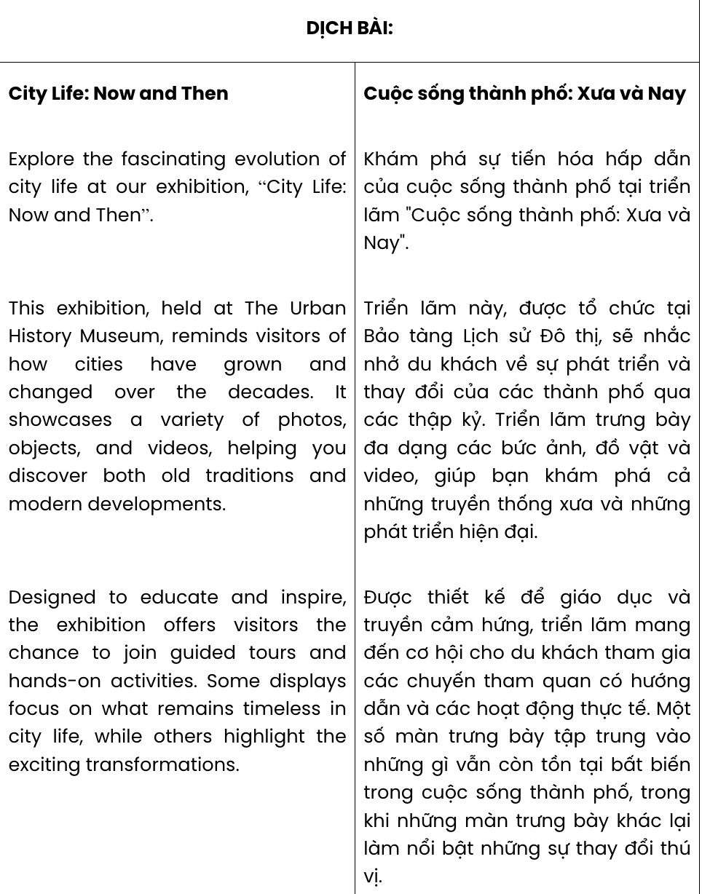
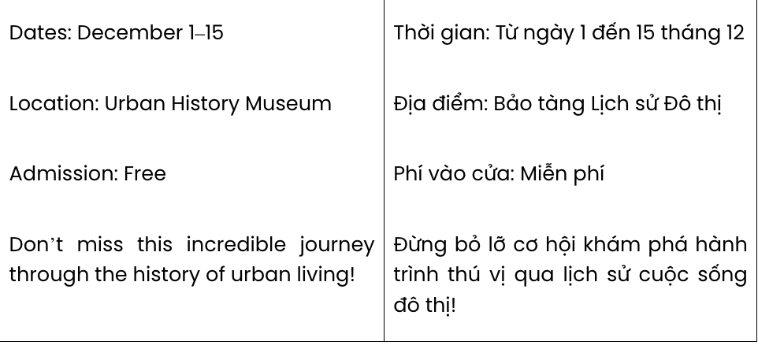
Question 1. A. fascinated B. fascinating C. fascinate D. fascination
GIA SƯ TẠI HUẾ (0793833272)
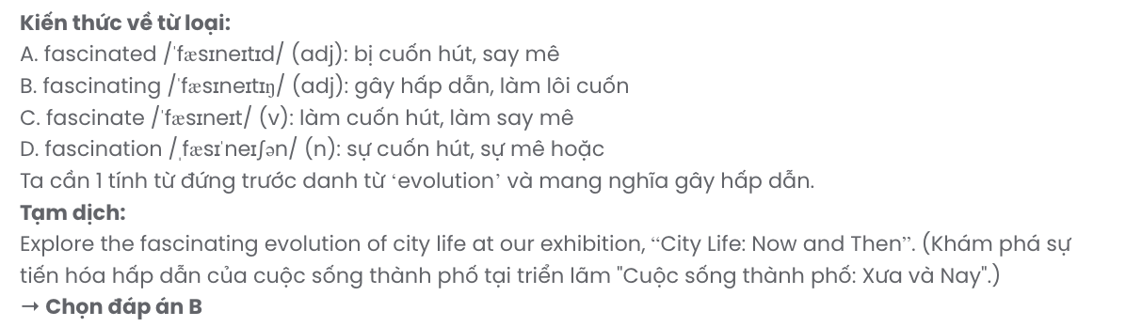
Question 2. A. for B. with C. of D. at
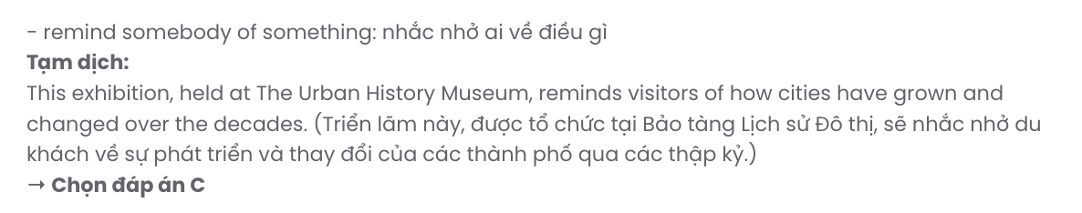
Question 3. A. variety B. degree C. lack D. amount
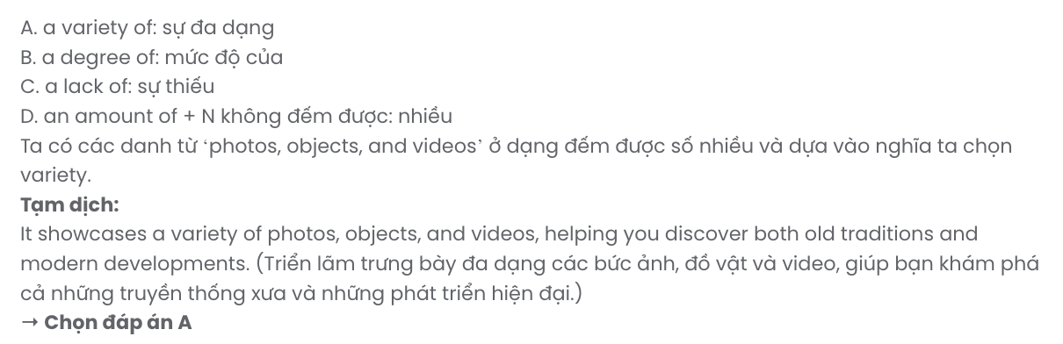
Question 4. A. discover B. investigate C. enrich D. inspire
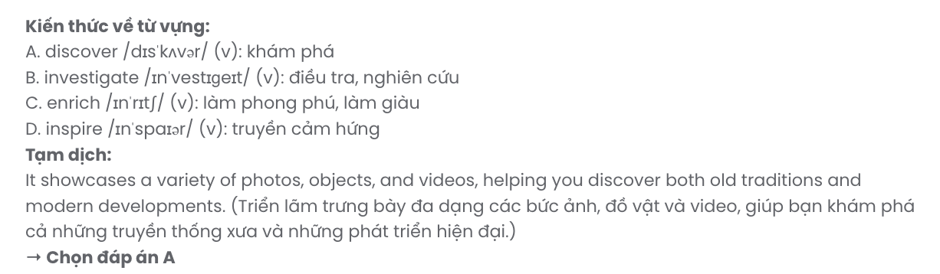
Question 5. A. joining B. to join C. to joining D. join

Question 6. A. another B. the other C. others D. each
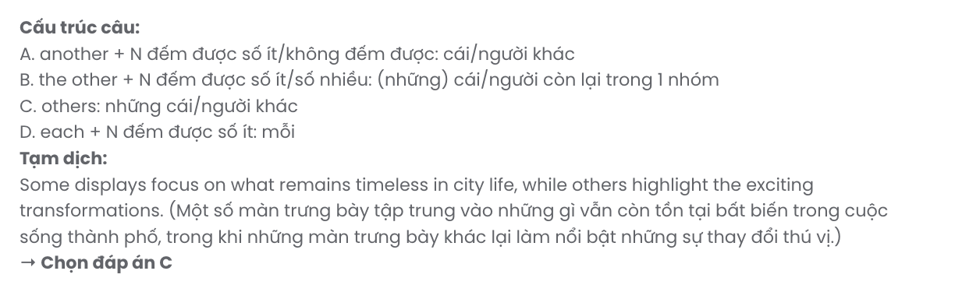
Read the following advertisement and mark the letter A, B, C, or D to indicate the correct option that best fits each of the numbered blanks from 7 to 12.

RIDE INTO A GREENER FUTURE WITH THE ECO-FRIENDLY GLIDEBIKE!
Looking for an efficient, eco-friendly bike that combines style and sustainability? The (7) ensures strength and comfort, making the GlideBike ideal for your daily commute. This bike, designed to reduce your carbon footprint, allows you to (8) green while saving on fuel and maintenance (9)
. (10) with ergonomic features, the GlideBike ensures comfort and functionality for riders of all ages. (11) traditional vehicles that emit harmful gases, this bike lets you enjoy a cleaner, healthier lifestyle. By choosing the GlideBike, you can also (12) transportation costs while contributing to a sustainable planet.
Ride smarter, live greener. Choose GlideBike today!

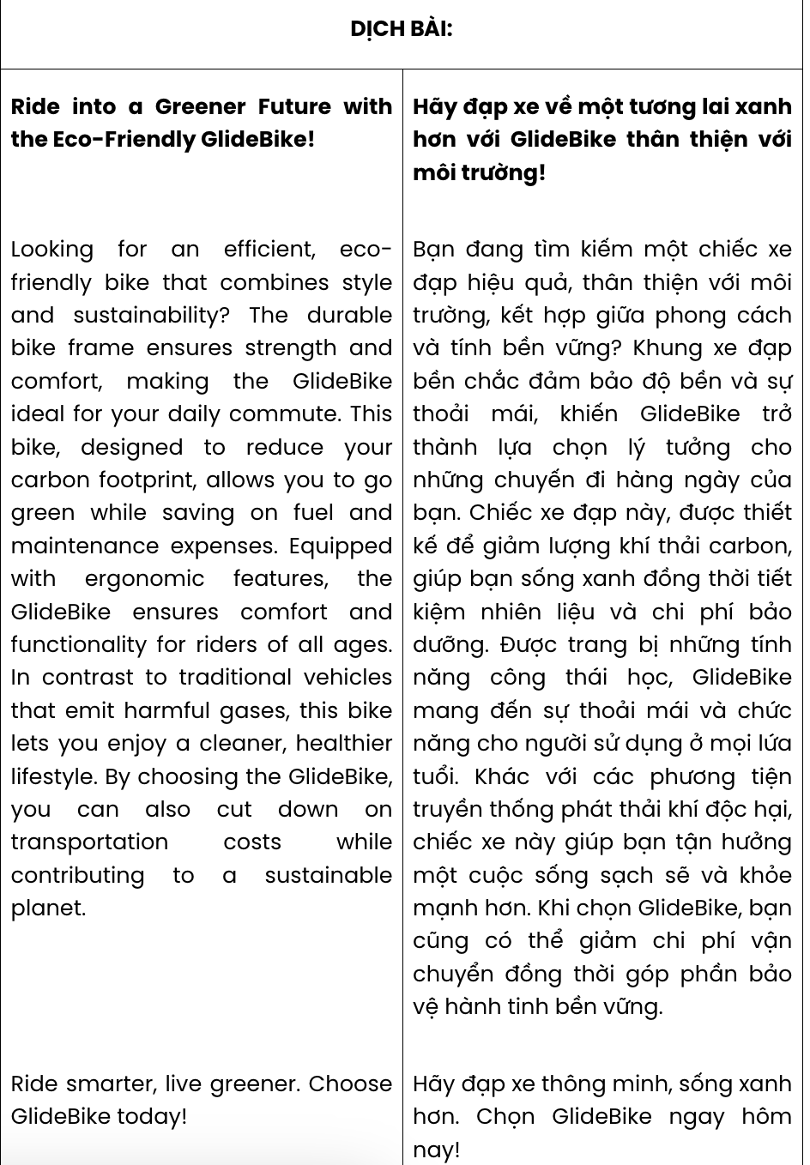

Question 7. A. bike durable frame B. frame durable bike
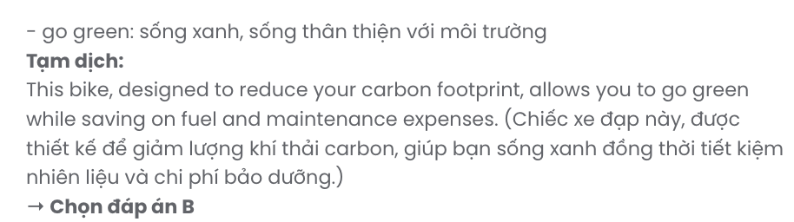
C. durable frame bike D. durable bike frame

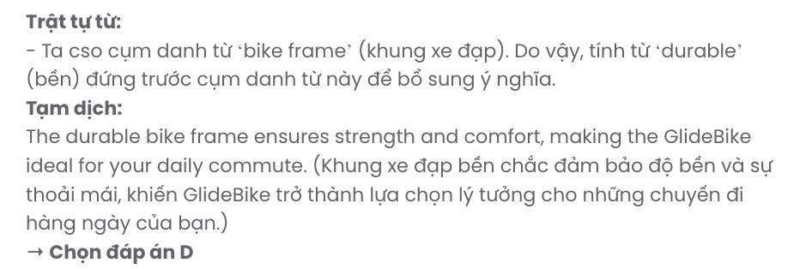
Question 8. A. make B. go C. put D. do

Question 9. A. expenses B. fares C. profits D. fines
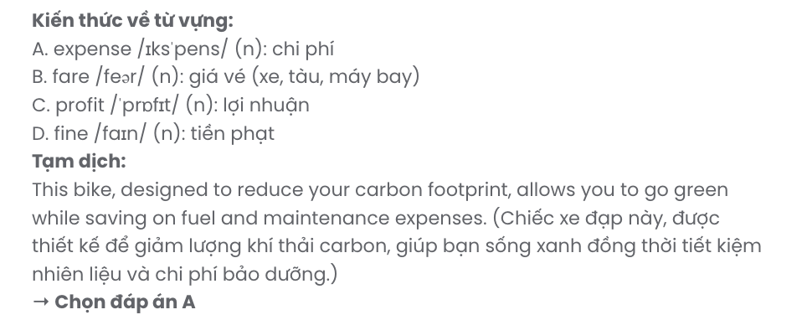

Question 10. A. Equipping B. Has equipped C. Equipped D. Equip

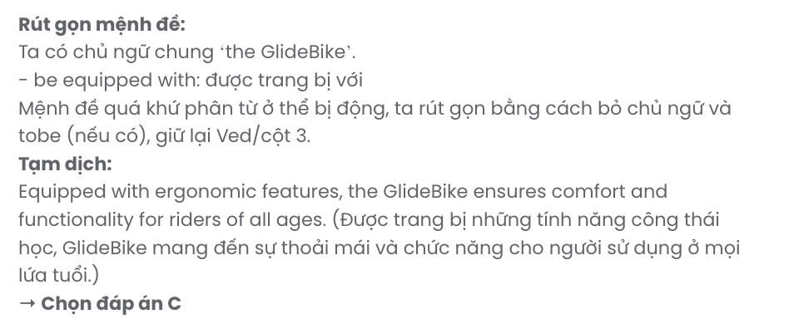

Question 11. A. In addition to B. In contrast to C. Thanks to D. Irrespective of

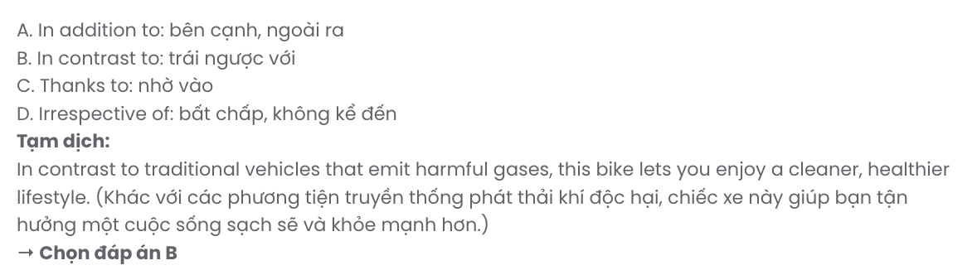

Question 12. A. make up for B. get through to C. cut down on D. keep up with

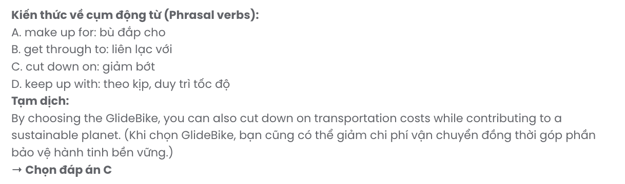
Mark the letter A, B, C or D to indicate the best arrangement of utterances or sentences to make a meaningful exchange or text in each of the following questions from 13 to 17.

Question 13.
- Minh: I have! Last week, I ordered a new pair of headphones. They arrived in just two days!
- Lan: Have you tried online shopping recently? It's so convenient these days.
- Minh: Better, actually. The reviews on that website really helped me pick the right one.
- Lan: That’s great to hear. I might try ordering something small first to see how it goes.
- Lan: Was the quality as good as expected?
A. e – c – d – a – b B. b – c – e – a – d C. b – a – e – c – d D. e – a – d – c – b
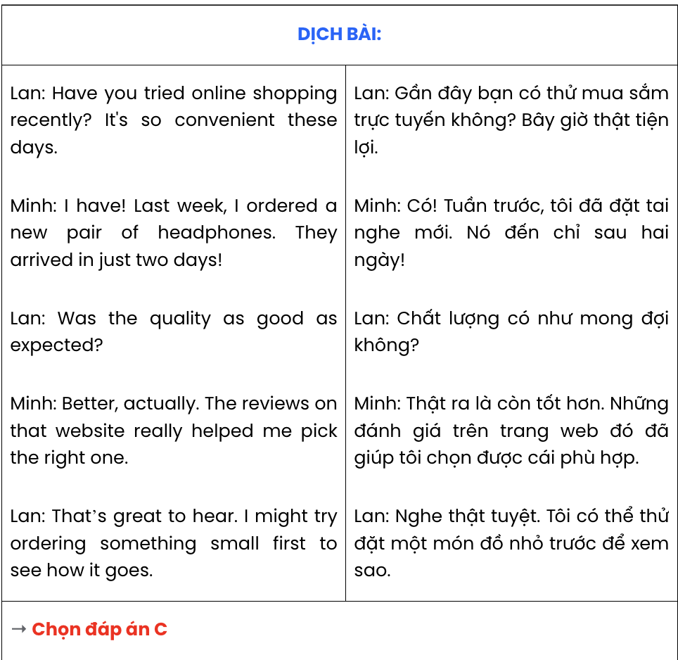

Question 14.
- Every evening, we enjoyed fresh seafood at a cosy restaurant that overlooked the sunset.
- That holiday will always hold a special place in my heart.
- The sandy beaches were breathtaking, and the water was so clear that we could see schools of fish swimming near the shore.
- One day, we even went kayaking through hidden caves, which was both thrilling and unforgettable.
- I visited a small coastal town with my family during my summer break, and it turned out to be one of the best trips I’ve ever had.
A. d – c – a – e – b B. a –d – e – c – b C. c – e – a – d – b D. e – c – a – d – b
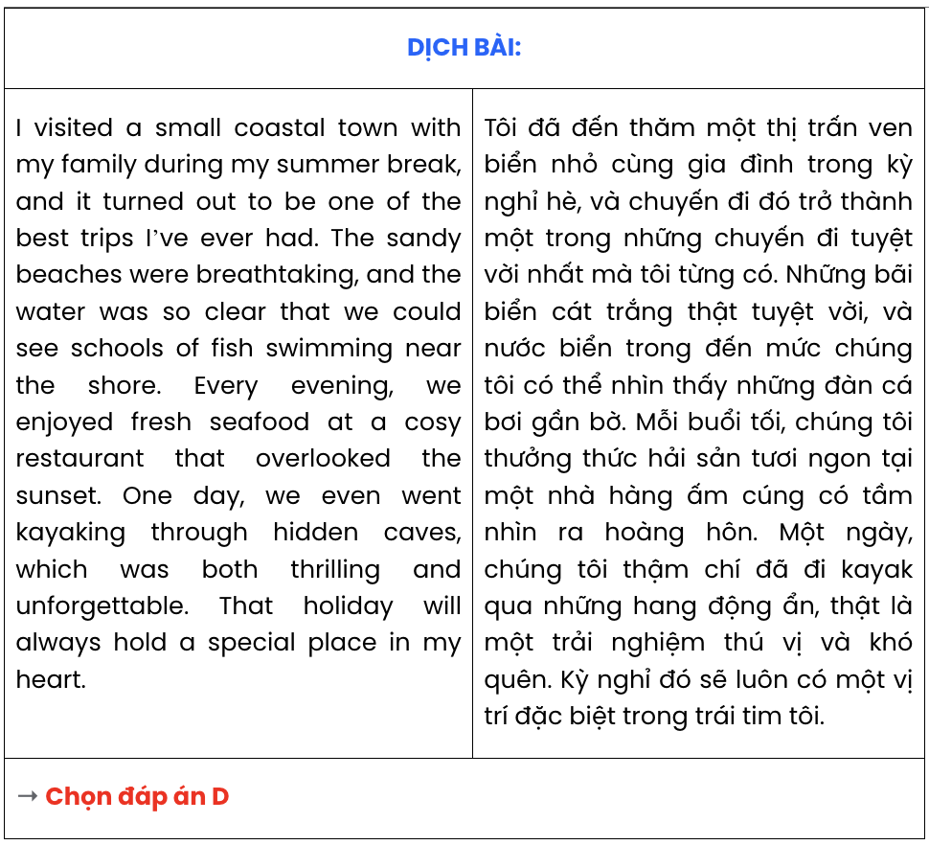

Question 15.
Hi Minh,
- I’ve learned some useful tips for saving electricity online, and I think you may find them helpful too.
- These small changes not only reduce our bills but also help protect the environment.
- Let’s both try to follow these habits and see how much energy we can save!
- Turning off lights when leaving a room and unplugging unused devices can make a big difference.
- Another great idea is to use energy-efficient appliances, which save money in the long run. Take care,
Lan
A. d – b – c – e – a B. a – d – e – b – c C. c – e – d – a – b D. e – a – b – c – d
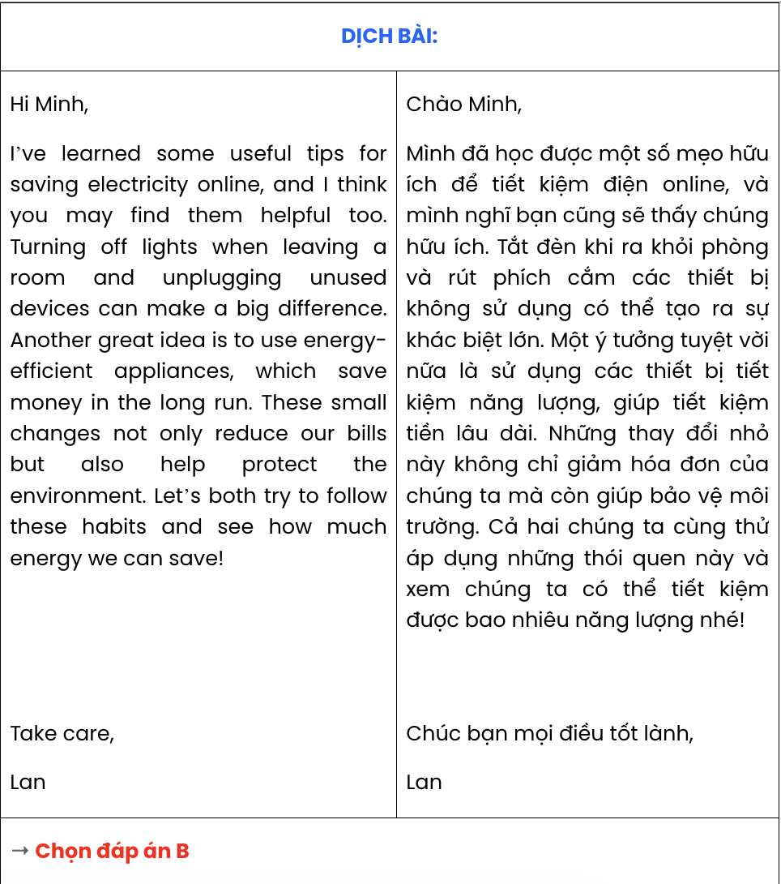

Question 16.
- Nam: I had a big argument with my sister yesterday. She borrowed my laptop without asking. b. Nam: We sorted it out. She apologised, and I realized I overreacted a bit.
c. Hieu: Did you talk to her about it afterward?
A. a – b – c B. b – c – a C. c – b – a D. a – c – b
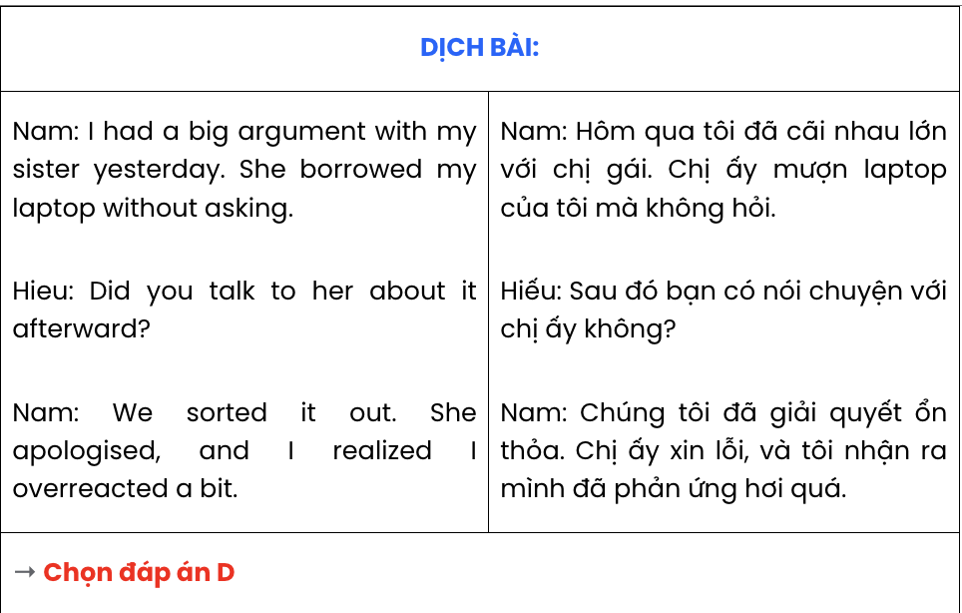

Question 17.
- Many elders, who are the keepers of these tales, have passed on without teaching the younger generation.
- In the past, these stories were told during festivals, bringing families and neighbours together.
- Without immediate efforts to preserve it, such as recording the stories or hosting workshops, this cherished part of our culture may soon disappear.
- The art of traditional storytelling in our village is at risk of fading away.
- Now, with modern entertainment taking over, fewer people value this unique tradition.
A. d – c – e – b – a B. d – a – b – e – c C. d – b – c – a – e D. d – e – a – c – b

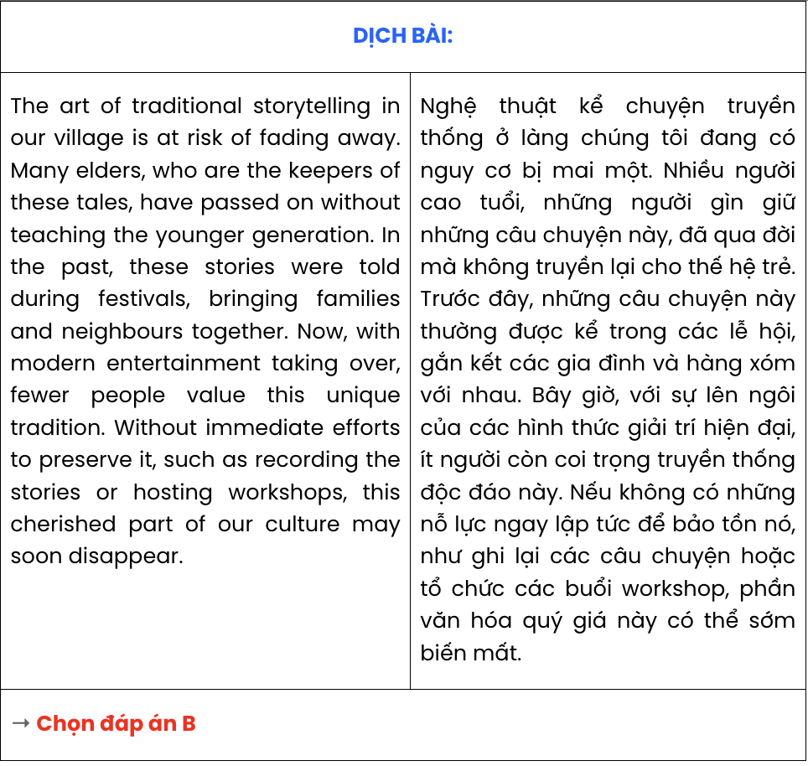
Read the following passage about recycling and mark the letter A, B, C, or D to indicate the correct option that best fits each of the numbered blanks from 18 to 22.
Recycling is an innovative way to reduce waste and promote sustainability. Discarded materials, such as wood, metal, and fabric, are often repurposed into functional objects, giving them a second life instead of ending up in landfills. Items that are no longer needed, collected from households and businesses, (18) .
One inspiring example is the process of turning old wooden pallets into furniture, designed to fit modern spaces. By carefully sanding and painting the wood, (19) . Similarly, worn-out clothes can be converted into reusable shopping bags, a step toward reducing single-use plastics, which significantly harm the environment.
Motivated by creativity and the desire to protect the planet, many people have embraced DIY recycling projects. (20) , creating a ripple effect in communities to adopt sustainable practice. Recycled by skilled artisans, (21) .
Recycling old items demonstrates how waste can be reimagined as a resource, (22) . This practice is an essential part of building a greener future and showing that even the smallest changes can make a big difference.
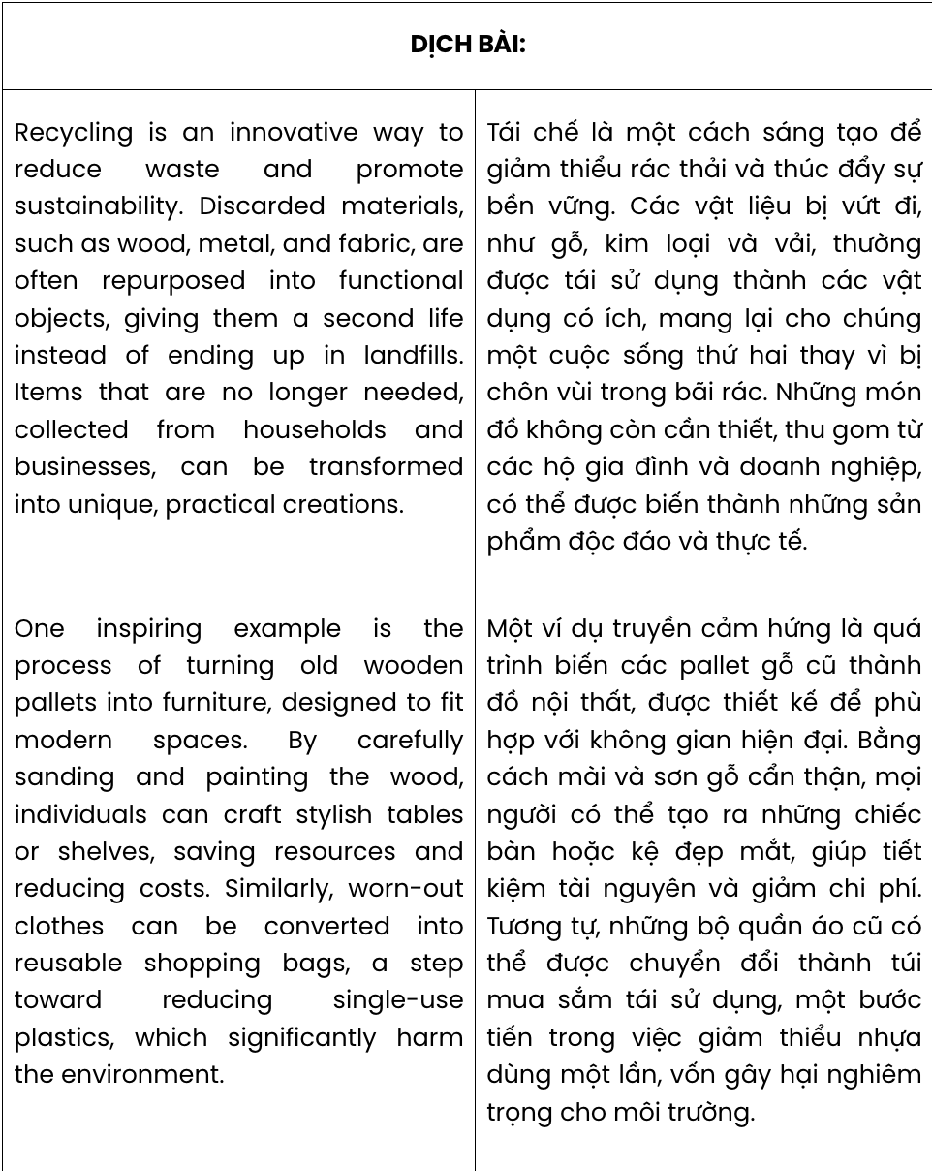
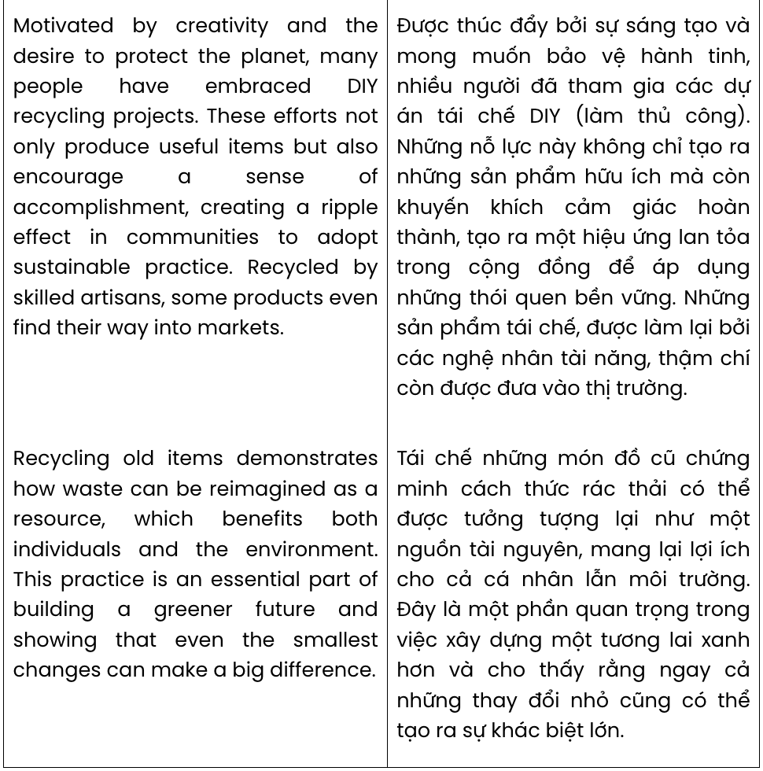

Question 18.
  - which can be crafted into unique and functional items
  - can be transformed into unique, practical creations
  - whose potential to turn into special and practical items
  - having been shaped into special and functional creations
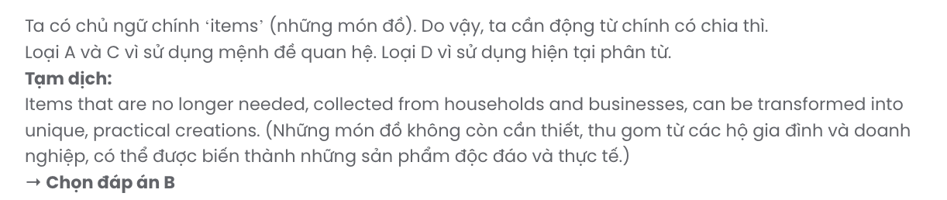

Question 19.
- stylish tables or shelves can be created without saving resources and reducing costs
- individuals can save resources and reduce costs so that stylish tables or shelves are crafted
- the creation of stylish tables or shelves helps save resources and reduce costs
- individuals can craft stylish tables or shelves, saving resources and reducing costs
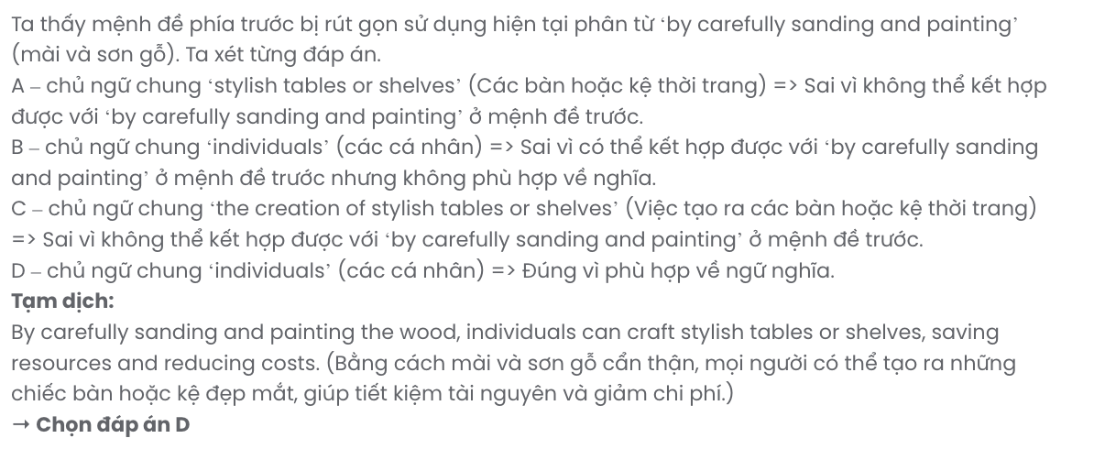

Question 20.
- These efforts not only produce useful items but also encourage a sense of accomplishment
- Encouraging a sense of fulfilment, useful items have been produced thanks to these efforts
- Intending to produce useful times, these efforts encourage a sense of accomplishment
- Useful items help to encourage a sense of fulfilment even though the efforts are limited
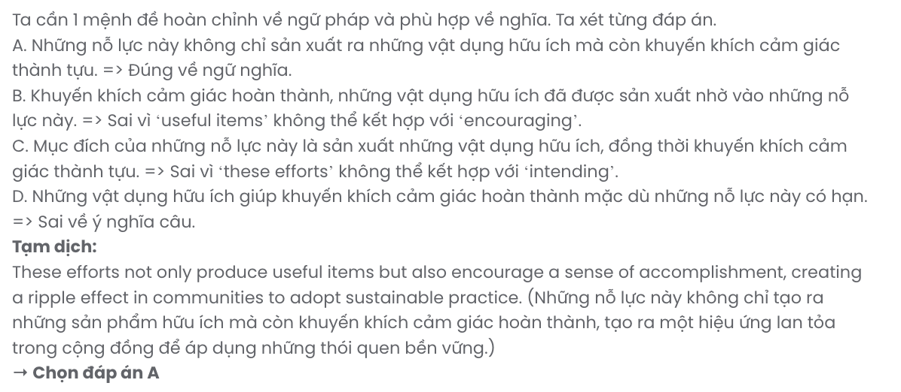

Question 21.
- many markets gradually accept these products
- it is challenging to compete with other products
- some products even find their way into markets
- they try to sell these products at local markets
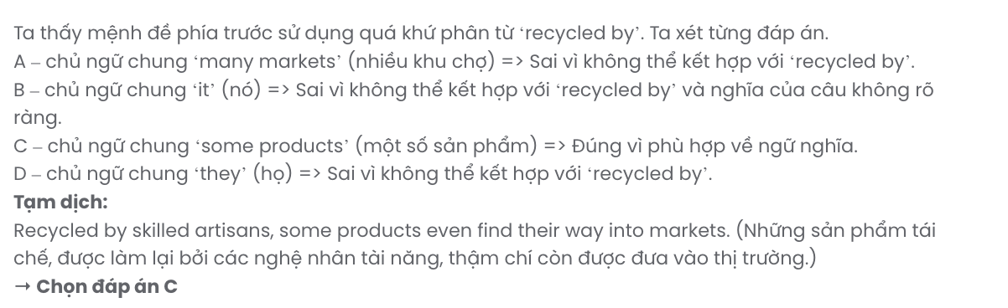

Question 22.
- brought many benefits to humans and the environment
- which benefits both individuals and the environment
- whose long-term benefits for humans and the environment
- is beneficial to both individuals and the environment

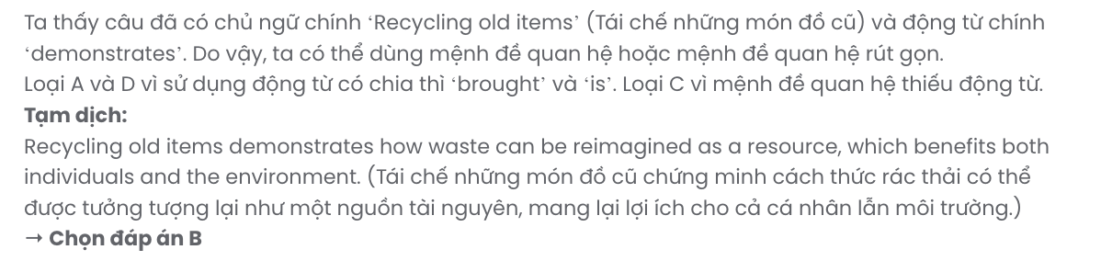
Read the following passage about weddings across cultures and mark the letter A, B, C, or to indicate the correct answer to each of the questions from 23 to 30.
Weddings have always been important moments for families and societies. Not surprisingly, they involve celebrations and rituals. Apart from the religious celebrations, there are many interesting elements in Southeast Asian countries' wedding rituals.
In Vietnam, a bridal shower is usually held the night before the wedding ceremony. In this event, gifts are presented after older women in the family give the bride some tips on how to behave well toward her husband's family. The most common gifts are gold pieces and gold jewellery. These are considered the bride's dowry and also a way to help the couple to partly cover the expenses of starting their own family.
Meanwhile, in Thailand, it is not gold but water that plays a central role in Thai wedding rituals. While the bride and the groom sit next to each other and are joined by a headdress made from a single white thread, their most honoured guests will use a blessed conch shell to pour water on their hands. The water is also blessed from a ceremony that was held earlier. This ritual is believed to bring good luck to the couple.
Among the Hindus in Singapore, however, good luck is brought about by henna. A natural dye made from the henna plant, henna has been used for centuries as a form of body art. Before the wedding ceremony, the bride has henna patterns applied to her palms, her hands, and her feet. People believe that the deeper its colour is, the happier the couple's marriage will be.
(Adapted from Explore New World)

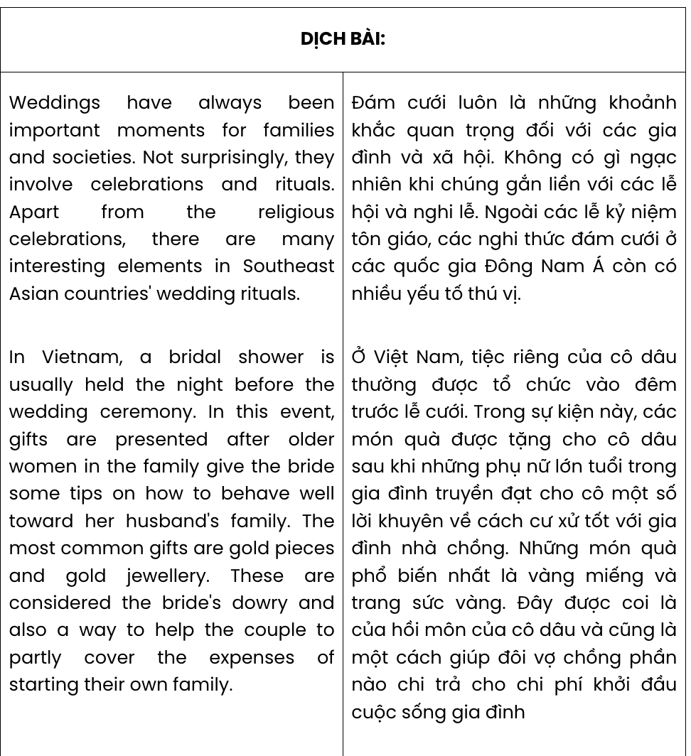

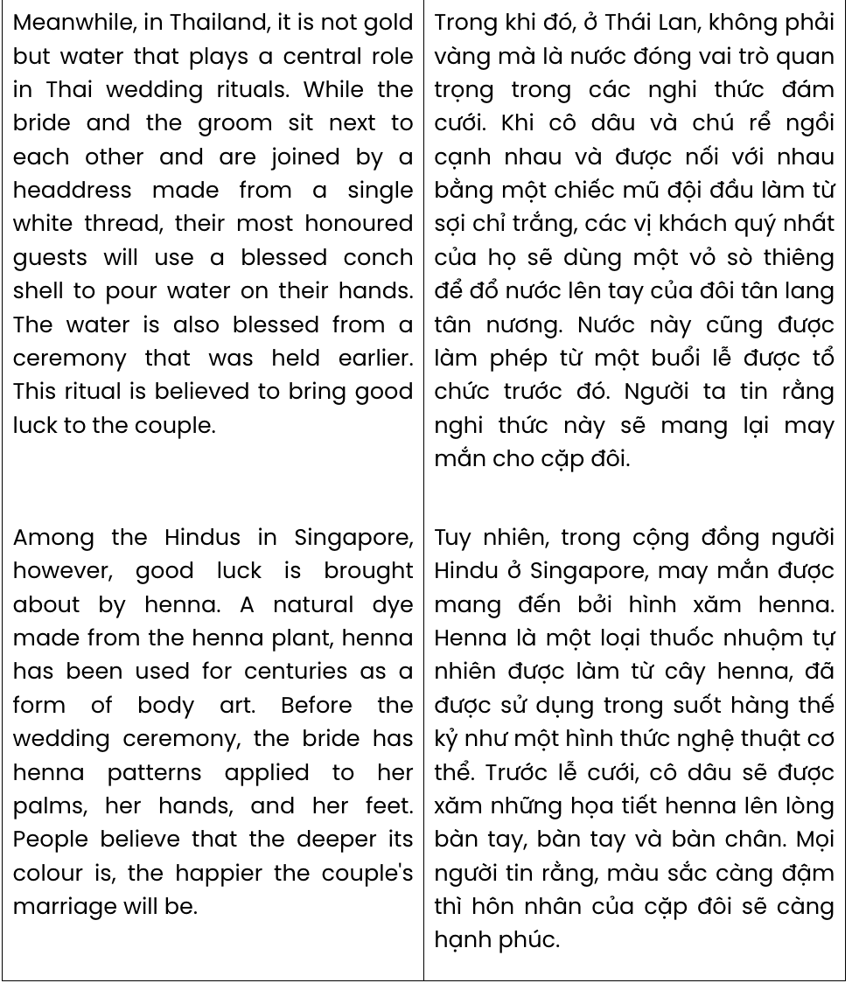
Question 23. The word they in paragraph 1 refers to .
A. moments B. weddings C. celebrations D. rituals
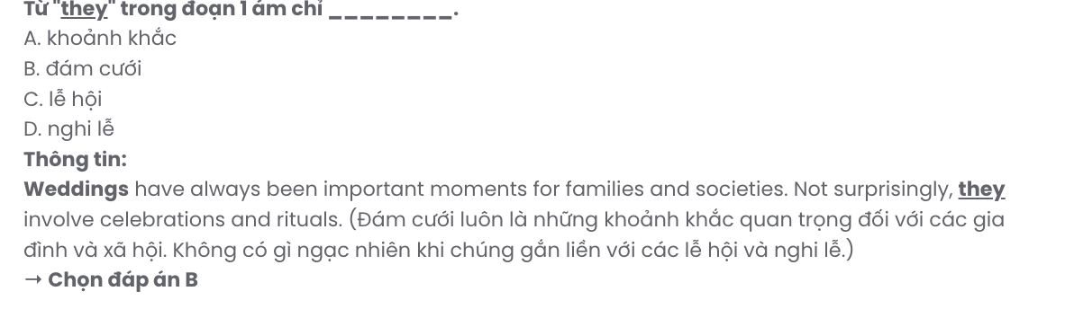
Question 24. The word expenses in paragraph 2 is closest in meaning to .
A. costs B. threats C. hardships D. incomes GIA SƯ TẠI HUẾ (0793833272)
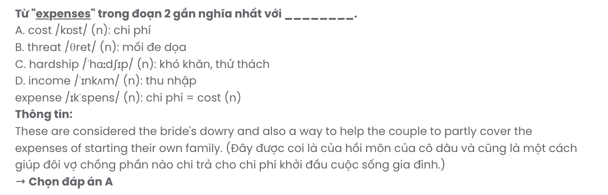
Question 25. Which of the following best paraphrases the underlined sentence in paragraph 3?

Meanwhile, in Thailand, it is not gold but water that plays a central role in Thai wedding rituals.
- Water, rather than gold, is the central element of wedding traditions in Thailand.
- Gold is more significant than water in traditional Thai wedding rituals.
- Thai wedding traditions prioritise gold over any other element, including water.
- Both gold and water hold equal importance in Thai wedding ceremonies.
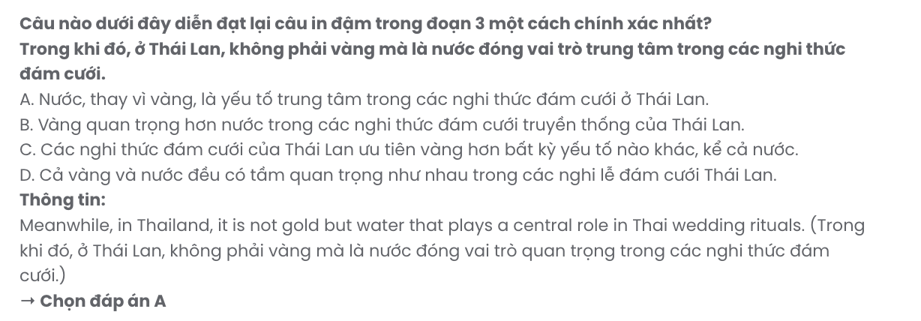
Question 26. The word honoured in paragraph 3 is OPPOSITE in meaning to .
A. unrespectful B. dishonest C. disloyal D. unimportant
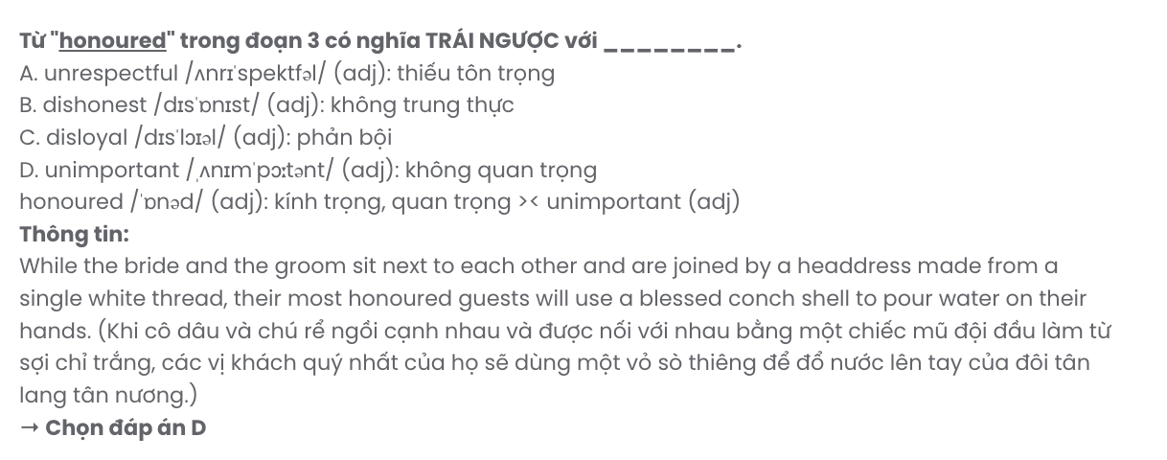
Question 27. Which is NOT ONE of the elements in wedding rituals according to the passage?
A. henna B. shower C. gold jewellery D. headdress
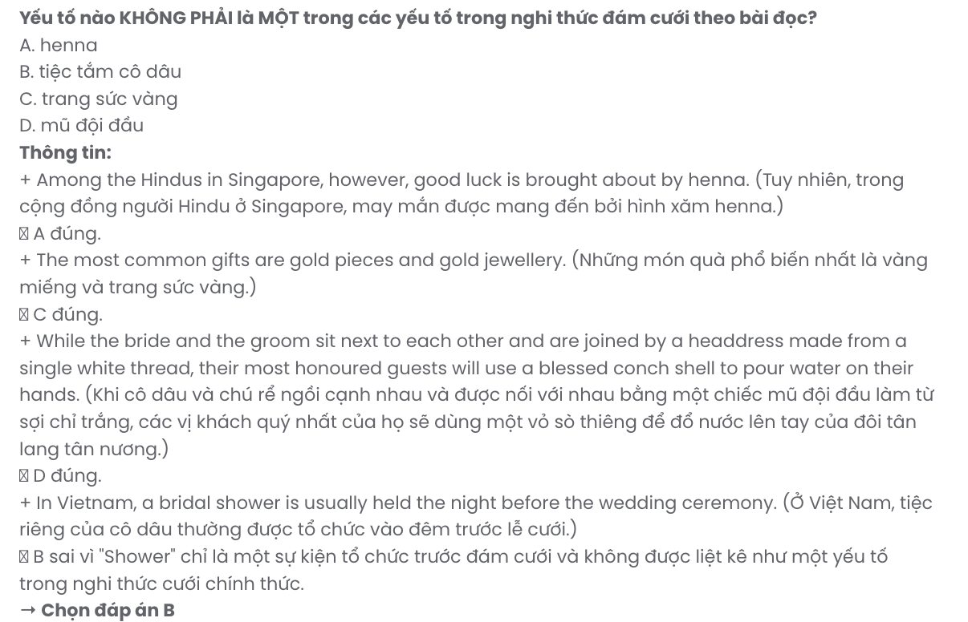
Question 28. Which of the following is TRUE according to the passage?
- Both gold jewelry and blessed water play important roles in Thai wedding rituals.
- Weddings around the world contain different elements but the same religious celebrations.
- Among the Hindus in Singapore, henna is applied to the bride's whole body for good luck.
- In Vietnam, presents given at the bridal shower will support the bride's new family.
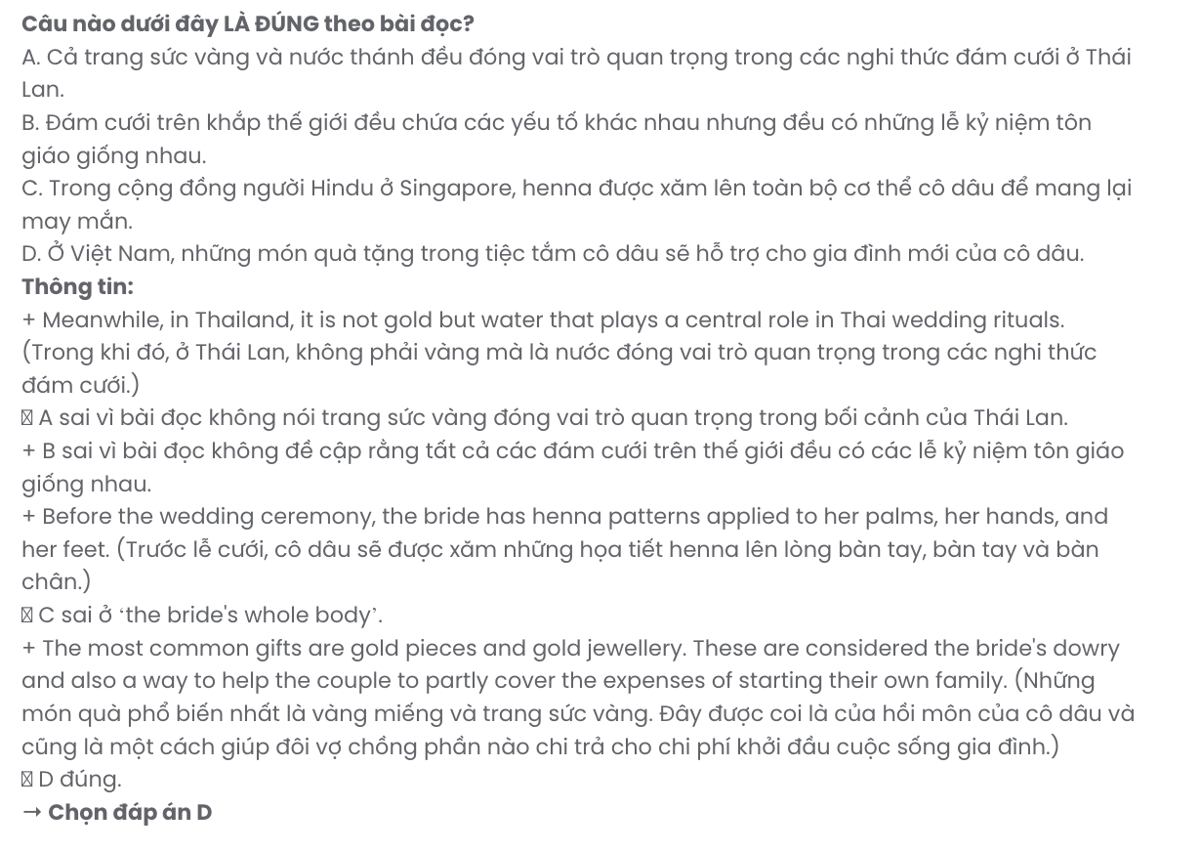
Question 29. In which paragraph does the writer mention a party before the wedding?
A. Paragraph 1 B. Paragraph 2 C. Paragraph 3 D. Paragraph 4
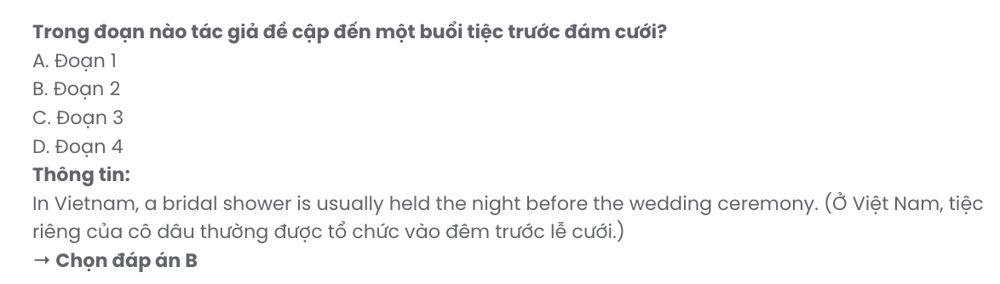
Question 30. In which paragraph does the writer explore the cultural significance of a dye?
A. Paragraph 1 B. Paragraph 2 C. Paragraph 3 D. Paragraph 4

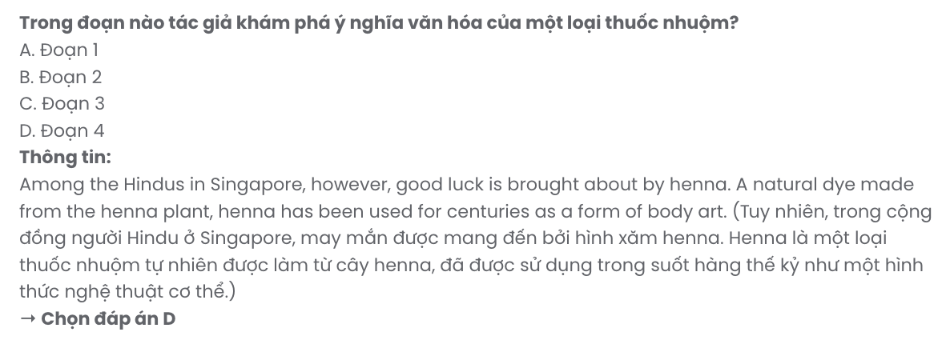
Read the following passage about birds in jeopardy and mark the letter A, B, C, or D to indicate the correct answer to each of the questions from 31 to 40.
[I] Every summer, three billion birds of some 300 species-songbirds, waterbirds, and many others migrate from northern Africa to Europe and Asia. [II] In the winter, they return to Africa's warmer shores.
[III] As they travel from one place to another, they navigate using the sun, the stars, smells, and land forms to help them find their way. [IV]
The birds’ migration is long and difficult, and some of the animals inevitably die during each trip. However, it is not this twice-a-year journey that poses the greatest risk to these animals. The main threat to the birds’ survival comes from human hunters. All over the Mediterranean, millions of migrating birds are killed for food, profit, and sport every year. In nations along the Mediterranean, many migratory birds are illegally trapped or shot. In addition to traps, hunters also use electronic calls to catch birds. This tool, which a hunter can operate from a cell phone, mimics bird sounds and is very effective in attracting the animals so effective that in some countries, bird populations have plummeted.
Countries all over the Mediterranean are aware that bird populations are in danger, and many are working to address this problem. In the European Union, hunting migratory birds is illegal in some countries, while in others, it is strictly controlled - the birds can only be hunted at a certain time of year. This hasn't completely stopped bird poaching in Europe, but more nature-protection groups are making sure that laws are obeyed.
Across the Mediterranean, another group - Nature Conservation Egypt - is working to increase protection of its country's natural scenery and wildlife, including its migratory birds. As part of a current project, the organisation is trying to promote activities such as eco-tourism along the coasts. Wildlife organisations around the Mediterranean are helping to bring about change. Hunting bans are working, says Martin Schneider-Jacoby, a bird specialist for the German organisation EuroNatur. But there is still more to do. Conservationists hope to stop hunting and restore bird habitats all over the Mediterranean. If this can be done, the birds’ numbers will increase. There's a long way to go, Schneider-Jacoby says, but like an Oasis in the desert after a long journey, there is hope.
(Adapted from Reading Explorer)
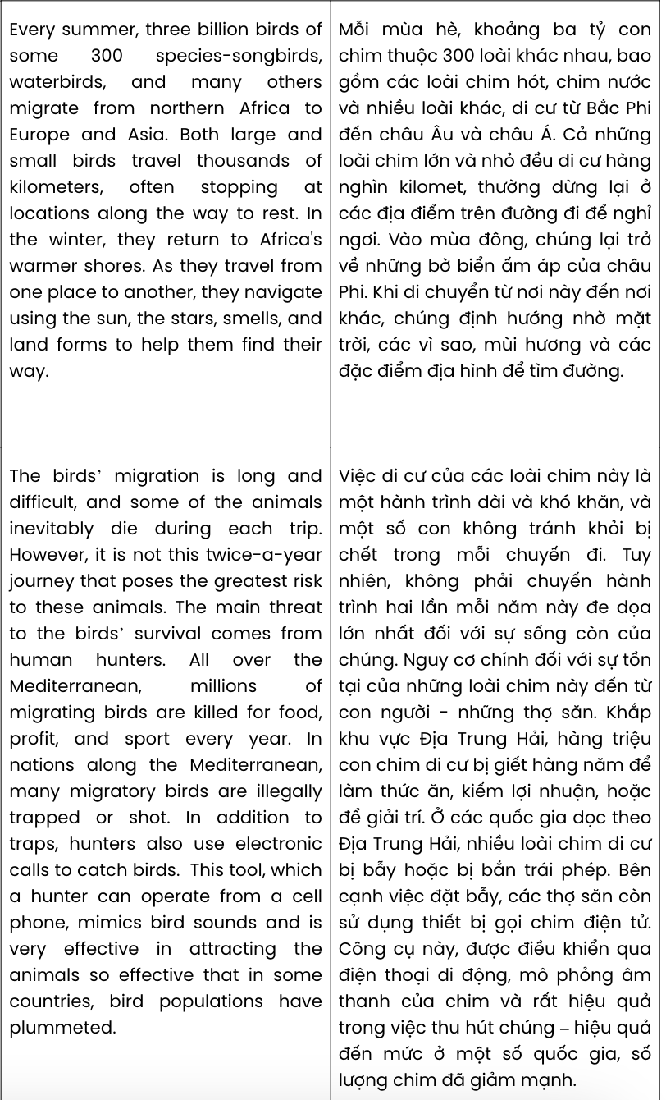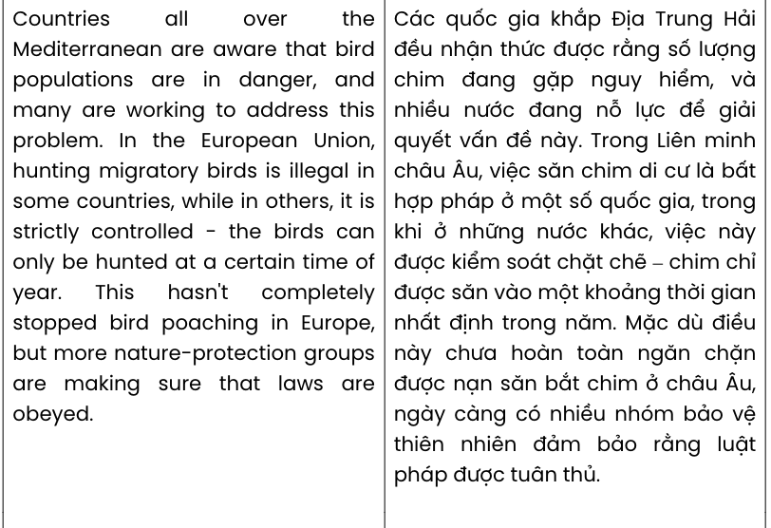

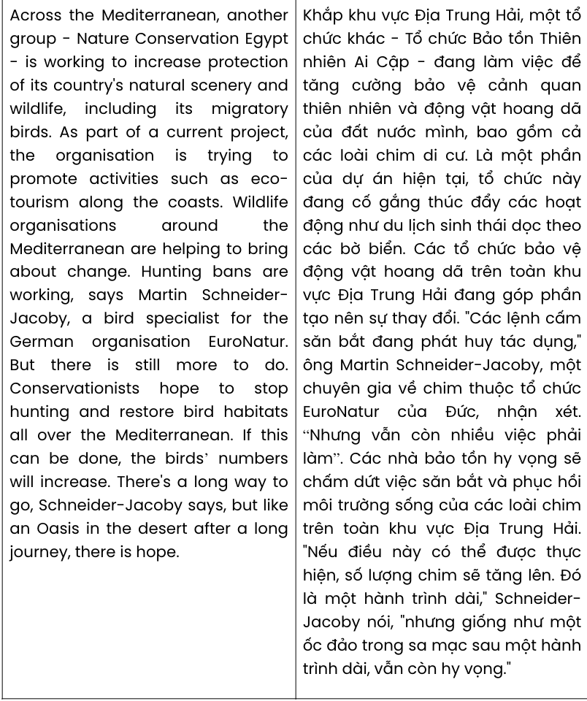
Question 31. The word they in paragraph 1 refers to .
A. warmer shores B. locations C. bird species D. land forms
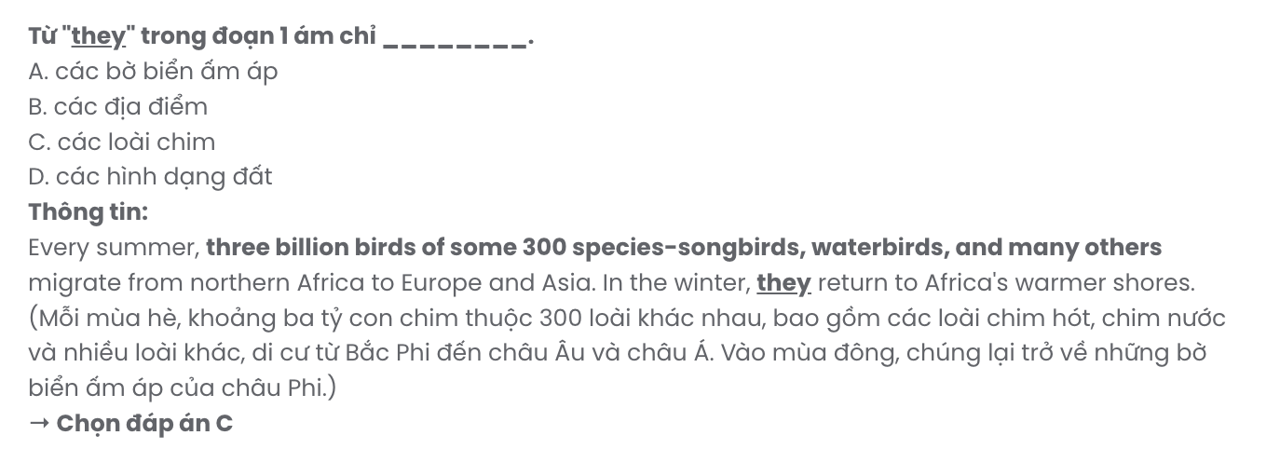
Question 32. Where in paragraph 1 does the following sentence best fit?

Both large and small birds travel thousands of kilometers, often stopping at locations along the way to rest.
A. [I] B. [II] C. [III] D. [IV]
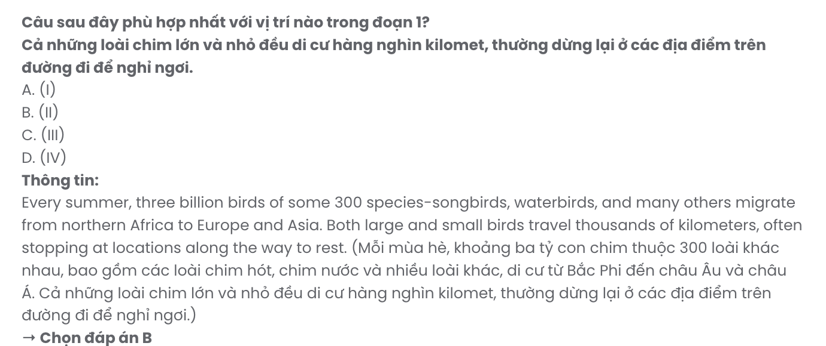
Question 33. The word poses in paragraph 2 is closest in meaning to .
A. presents B. addresses C. controls D. manages
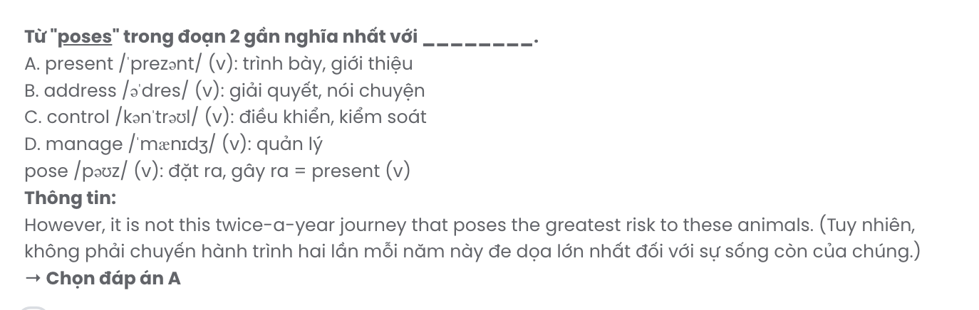
Question 34. As stated in paragraph 2, migrating birds are killed for all of the following EXCEPT
.
A. medicine B. sport C. food D. profit GIASƯTẠI HUẾ (0793833272)
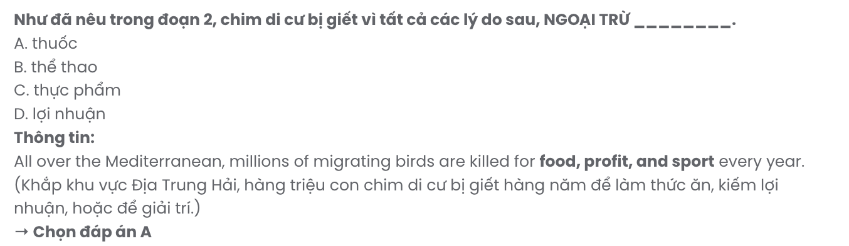
Question 35. The word plummeted in paragraph 2 is OPPOSITE in meaning to .
A. declined B. disappeared C. increased D. emerged

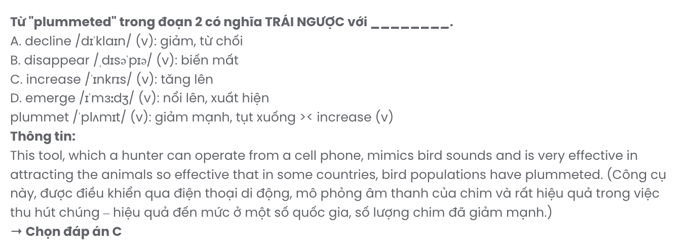
Question 36. Which of the following best paraphrases the underlined sentence in paragraph 3? Countries all over the Mediterranean are aware that bird populations are in danger, and many are working to address this problem.
- Not many Mediterranean countries acknowledge the decline in bird populations and have acted on it.
- Mediterranean nations are deeply concerned about the risks facing bird populations, but only a few are trying to deal with this issue.
- Bird populations are gradually disappearing across the Mediterranean, calling for nations to take immediate action.
- Many Mediterranean countries recognise the threat to bird populations and are taking steps to tackle it.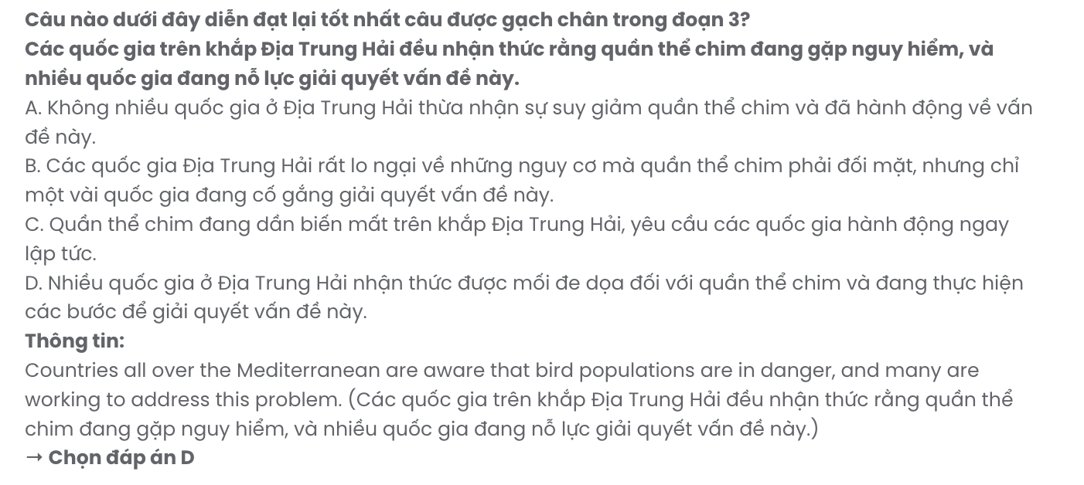

Question 37. Which of the following best summarises paragraph 3?
- Hunting birds is banned across Europe, and nature groups have successfully ended poaching in Mediterranean countries.
- Bird protection in the Mediterranean focuses solely on banning hunting during migration seasons in some EU nations.
- Mediterranean countries are working to protect birds, with the EU enforcing strict hunting laws and nature groups ensuring compliance, though poaching persists.
- Mediterranean nations are aware of the threat to bird populations, with some European countries trying to make hunting migrating birds illegal.
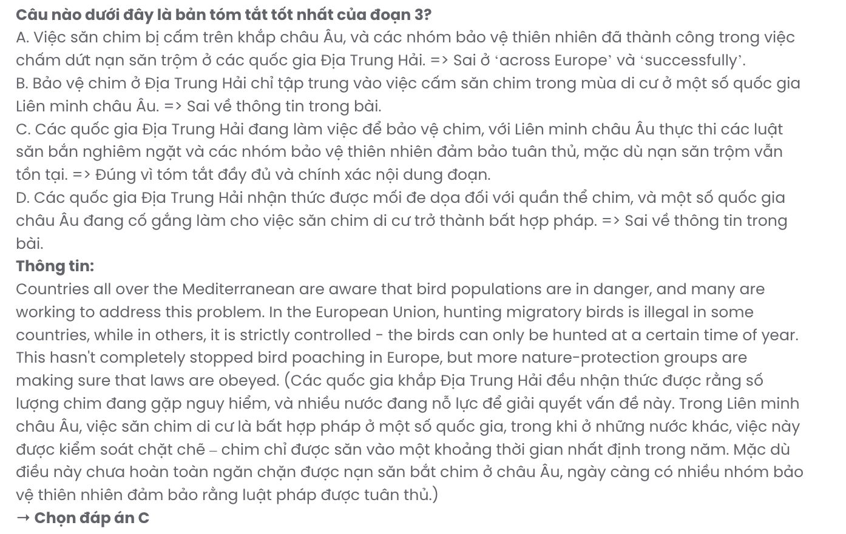
Question 38. Which of the following is TRUE according to the passage?
- Electronic calls that imitate bird sounds can be used for attracting and catching birds.
- Bird poaching is still rampant across Europe as a result of a lack of effective solutions.
- The sharp decline in migrating bird populations is partly attributed to human hunters.
- Nature Conservation Egypt is trying to protect wildlife by promoting eco-tourism.
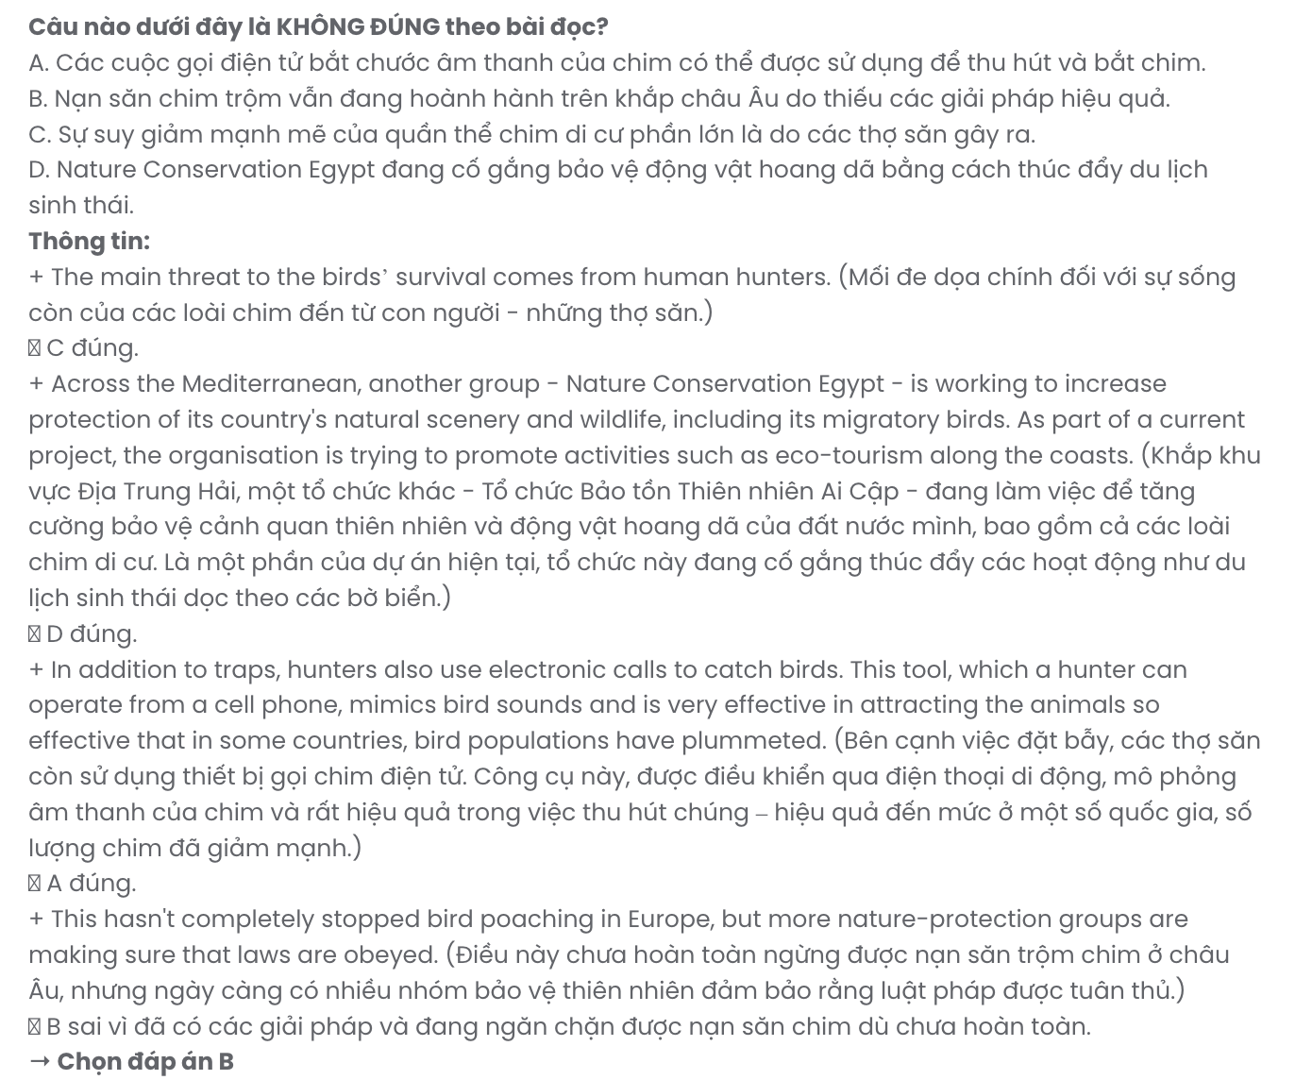
Question 39. Which of the following can be inferred from the passage?
- Schneider-Jacoby is sceptical about the chances of eradicating bird poaching.
- Wildlife conservation programmes have been ineffective in stopping bird hunting.
- In order to restore the habits of migratory birds, eco-tourism must be prioritised.
- The problem of bird poaching still exists in some parts of the Mediterranean.
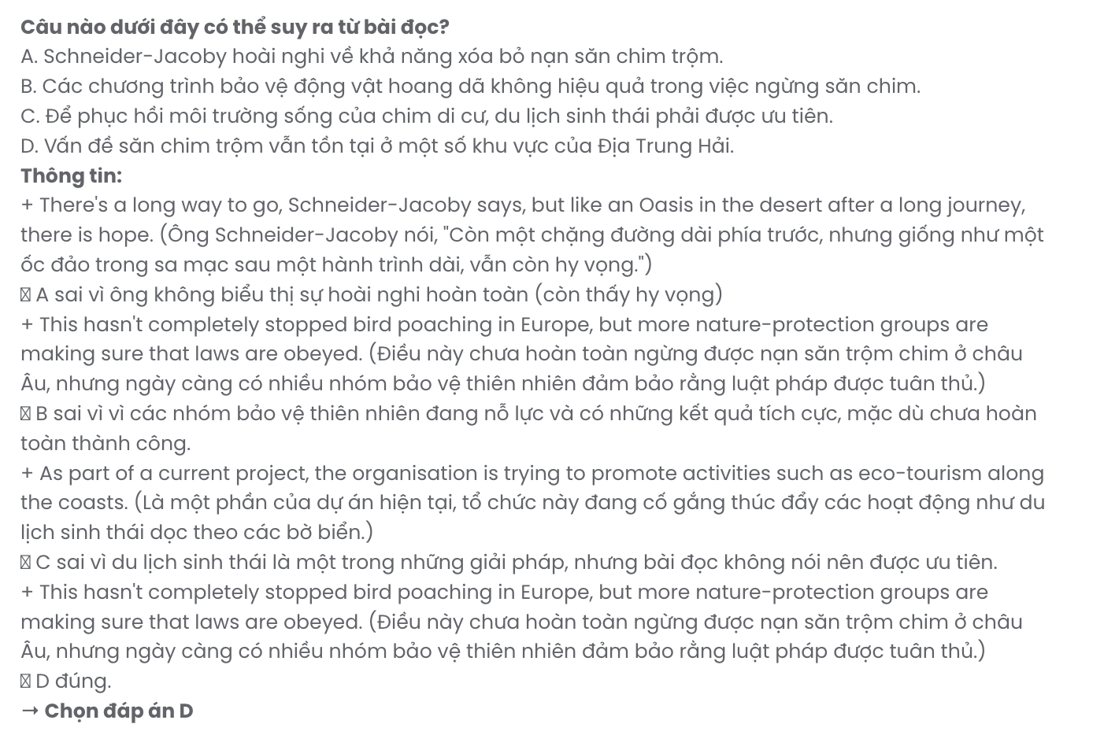
Question 40. Which of the following best summarises the passage?
- Millions of birds migrate through the Mediterranean, with human hunters being their greatest threat, yet hunting bans have completely stopped poaching and restored bird habitats in most countries.
- Illegal hunting is the main danger for migratory birds in the Mediterranean, and while some nations have banned it, no major actions have been taken to restore bird habitats or populations.
- Migratory birds face illegal hunting across the Mediterranean, but efforts like eco-tourism, hunting bans, and habitat restoration are being promoted to protect these birds and increase their populations.
- Conservation groups focus on eco-tourism and wildlife education, but hunting bans remain ineffective, and migratory birds are still hunted for food and sport across the Mediterranean.
GIASƯTẠIHUẾ(0793833272)

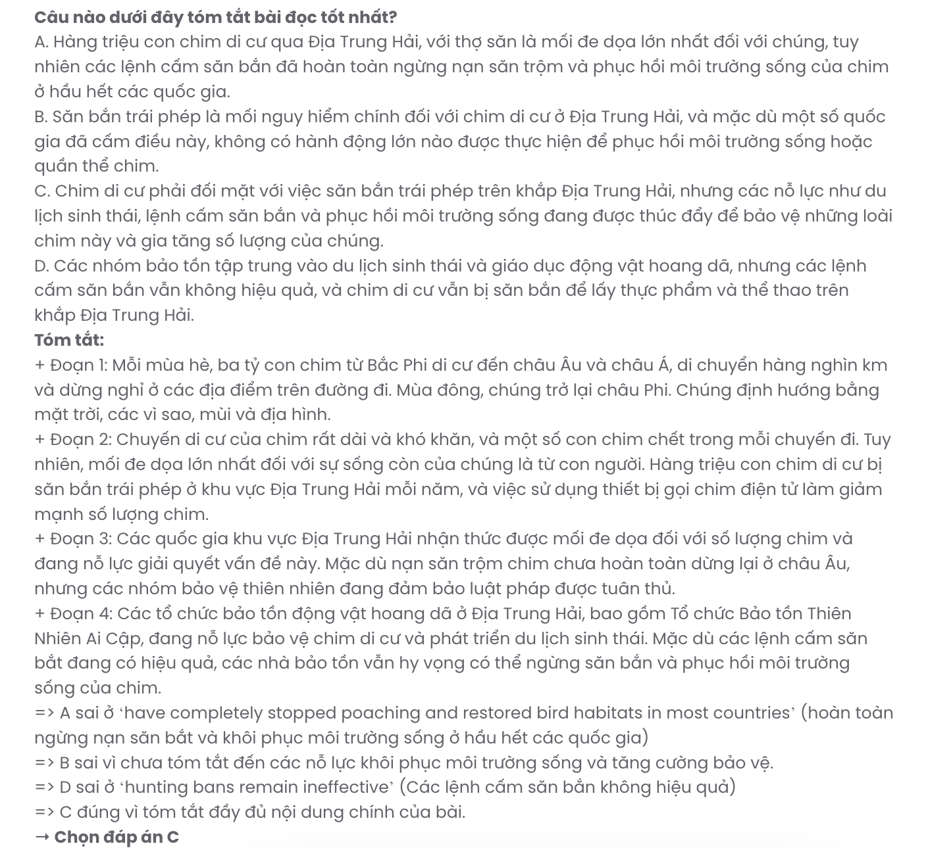

BẢNG TỪ VỰNG
STT | Từ vựng | Từ loại | Phiên âm | Nghĩa
1 | exhibition | n | /ˌeksɪˈbɪʃən/ | triển lãm
2 | showcase | v | /ˈʃəʊkeɪs/ | trưng bày
3 | inspire | v | /ɪnˈspaɪə | /lấy cảm hứng
4 | hands-on | adj | /ˈhændzɒn/ | thực tế
5 | timeless | adj | /ˈtaɪmləs/ | vượt thời gian
6 | transformation | n | /ˌtrænsfɔːˈmeɪʃən/ | sự biến đổi
7 | eco-friendly | adj | /ˌiːkəʊˈfrendli/ | thân thiện với môi trường
8 | combine | v | /kəmˈbaɪn/ | kết hợp
9 | commute | v | /kəˈmjuːt/ | di chuyển (đi làm, học
10 | carbon footprint | n | /ˈkɑːbən ˈfʊtprɪnt/ | dấu vết carbon
11 | ergonomic | adj | /ˌɜːɡəˈnɒmɪk/ | thuộc về công thái học
12 | maintenance | n | /ˈmeɪntənəns/ | bảo trì
13 | functionality | n | /ˌfʌŋkʃəˈnælɪti/ | chức năng
14 | emit | v | /ɪˈmɪt/ | phát ra
15 | durable | adj | /ˈdjʊərəbl/ | bền bỉ
16 | expense | n | /ɪkˈspens/ | chi phí
17 | fare | n | /feə | /giá vé
18 | profit | n | /ˈprɒfɪt/ | lợi nhuận
19 | fine | adj | /faɪn/ | phạt
20 | innovative | adj | /ˈɪnəveɪtɪv/ | sáng tạo
21 | sustainability | n | /səˌsteɪnəˈbɪləti/ | sự bền vững
22 | repurpose | v | /ˌriːˈpɜːpəs/ | tái sử dụng
23 | worn-out | adj | /ˌwɔːnˈaʊt/ | mòn, hư hỏng
24 | landfill | n | /ˈlændfɪl/ | bãi rác
25 | artisan | n | /ˈɑːtɪzən/ | thợ thủ công
26 | sand | v | /sænd/ | chà, mài
27 | reusable | adj | /ˌriːˈjuːzəbl/ | có thể tái sử dụng
28 | single-use | adj | /ˈsɪŋɡlˈjuːz/ | sử dụng một lần
29 | embrace | v | /ɪmˈbreɪs/ | đón nhận
30 | reimagine | v | /ˌriːɪˈmædʒɪn/ | tưởng tượng lại
31 | dowry | n | /ˈdaʊri/ | món sính lễ
32 | ritual | n | /ˈrɪtʃʊəl/ | nghi thức
33 | honoured | adj | /ˈɒnəd/ | vinh dự
34 | headdress | n | /ˈhedres/ | mũ đội đầu
35 | ceremony | n | /ˈserəˌməni/ | lễ nghi
36 | inevitably | adv | /ɪˈnevɪtəblɪ/ | không thể tránh khỏi
37 | survival | n | /səˈvaɪvəl/ | sự sống sót
38 | illegally | adv | /ɪˈlɪɡəli/ | bất hợp pháp
39 | plummet | v | /ˈplʌmɪt/ | rơi thẳng xuống
40 | mimic | v | /ˈmɪmɪk/ | bắt chước
41 | scenery | n | /ˈsiːnəri/ | phong cảnh
42 | restore | v | /rɪˈstɔː/ | khôi phục

BẢNG CẤU TRÚC
STT | Cấu trúc | Nghĩa
1 | Remind somebody of something | nhắc nhở ai đó về điều gì
2 | Focus on | tập trung vào
3 | Look for | tìm kiếm
4 | Allow somebody to do something | cho phép ai đó làm gì
5 | Let somebody do something | để ai đó làm gì
6 | Contribute to | đóng góp vào
7 | Make up for | bù đắp cho
8 | Cut down on | cắt giảm
9 | Keep up with | theo kịp
10 | Instead of | thay vì
11 | Convert into | chuyển đổi thành
12 | Turn into | biến thành
13 | Play a role in | đóng vai trò trong
14 | Made from | được làm từ
15 | Migrate from | di cư từ
16 | Pose a threat to | đe dọa đến

