Unit 1 | Generation gap and Independent life

C. EXERCISE (BÀI TẬP)
❶ PHONETICS
I. Choose the words whose underlined part is pronounced differently from that of the others in each group.
1. A. argument B. manner C. attitude D. nag
2. A. generation B. independent C. pocket D. medical
3. A. strict B. selfish C. image D. reliable
4. A. relationship B. trend C. invent D. incredible
5. A. agree B. mad C. afterwards D. attention
6. A. speaking B. teaching C. cleaning D. wearing
7. A. farmers B. groups C. markets D. parks
8. A. museums B. apartments C. buildings D. schools
9. A. stores B. temples C. houses D. grades
10. A. watches B. classes C. dishes D. aeroplanes
II. Choose the word whose main stressed syllable is placed differently from that of the other in each group.
11. A. difficult B. worried C. career D. campfire
12. A. manner B. body C. future D. remote
13. A. money B. attend C. access D. selfish
14. A. performance B. astronaut C. relationship D. reliable
15. A. museum B. beautiful C. library D. concentrate
❷ VOCABULARY AND GRAMMAR
Word formation
Complete the sentences with the correct form of the words.
- I had been experiencing a lot of technical difficulties. (difficult)
- Mary has developed a deep dependence on her husband. (depend)
- I'm not too worried about the weather. (worry)
- They want to empower their students to get the skills they need for future jobs. (power)
- She had a good relationship with his family. (relate)
- "I can't finish my assignment on time," she said worriedly. (worry)
- We have reliable information that a strike is planned next month. (rely)
- Your son’s selfishness here must be very disappointing. (selfish)
- She always wears trendy clothes. (trend)
- She should go to the doctor because she has a nagging cough. (nag)
- This would be the perfect setting for a wedding. (set)
- John has been financially independent. (depend)
- We had an argument about what game to play. (argue)
- They are studying the behavior of elephants in the wild. (behave)
- Some of them give really helpful advice about the job market. (advise)

UNIT OPENER
I. Write the suitable word for each picture.
(Student’s book, Unit Opener. Page 15)

 | 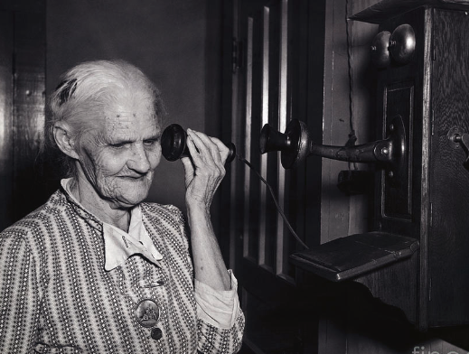 | 
1. independent | 2. old-fashioned | 3. strict
  4. worried |   5. easy-going | 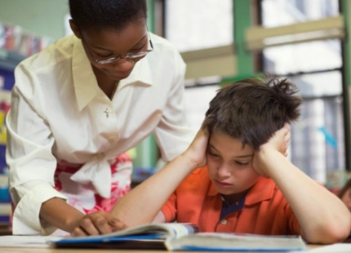  6. difficult
II. Complete the sentences with the words in exercise I.
- He's very old-fashioned and thinks that women should not work outside the home.
- The manager is a difficult person to deal with.
- I've always been financially independent.
- My parents were very strict with me when I was young.
- She's a generous and easy-going boss.
- Mary had a worried look on her face.
LESSON 1A. READING
I. Fill in the blanks using the words in the box.
trend | relationship | argument | selfish | teenagers | agree | reliable
rules | understand | powerless | chatting | mad | fashion | complained
(Student’s book, Reading, Page 16)
- Scientists have established the relationship between lung cancer and smoking
- She never considers anyone but herself - she's totally selfish.
- Her long skirt is right on trend this winter.
- My car is old but it’s reliable.
- I had an argument with my boss.
- The police seem to be powerless to prevent these attacks.
- Many parents find it hard to relate to their children when they are teenagers.
- My parents don’t understand me.
- Most parents set studying rules for their children.
- She complained that she had too much work to do.
- She spends hours on the phone chatting to her friends.
- You must be mad to go out in this weather.
- Long skirt is back in fashion for women.
- Although we like his plan in general, we don't agree with him on every issue.
II. Complete the sentences with the correct form of the words.
- These behaviours can be observed among many children who have lost a parent or other loved one. (behave)
- I don't think that's a very strong argument. (argue)
- Mary is very independent and does all her own shopping and cooking. (independence)
- We were very worried when he did not answer his phone. (worry)
- I've made a complaint to the police about the noise. (complain)
- I think I’ll take your advice and go home. (advise)
- Jane and her sister are completely different. (differ)
- She's an extremely powerful runner. (power)
- The whole family was in agreement with her about what they should do. (agree)
- Mr. Phong made an arrangement to see us at two o’clock. ( arrange )
III. Fill in the blanks with words from the unit. The first letter is already there.
- My parents complain that I don’t listen to their advice.
- My mum's always nagging me to get my hair cut.
- Emma complains that her daughter usually breaks the rules.
- My sister doesn’t help with the chores.
- Peter complains that his parents don’t like his friends.
- My mom always helps me when I have problems.
- Mr. and Mrs. Smith complain that their children don’t get enough sleep.
- Mr. John often set studying rules for his sons.

IV. Reading
Help Me Holly: Advice for teens
Q: I’m Tina and I’m in my last year at school so I’m busy studying for my exams, but I want to stay fit. What should I do?
A: I can imagine that you don’t have much free time, but you must try and get some exercise. 0 [E] Exercise is good because your heart pumps more blood around your body. This produces more oxygen and helps the brain. This means we can then think clearer and concentrate more, which will help your school work. If our brains didn’t get enough oxygen, they wouldn’t work well. 1 [_]
Q: I’m Oliver. I really love seafood but sometimes after I’ve eaten it, my skin gets itchy. What can I do?
A: I wonder whether you are allergic to it. It’s quite common. You should see your doctor straight away. 2 [_] You don’t have to worry, but you should get some medical advice. And you should stop eating seafood in the meantime.
Q: I’m Paul and I want to try surfing because it looks fun. Do I have to have lessons?
A: Surfing is a great activity to do to keep fit. 3 [_] It’s a safe sport, but you ought to have lessons with a qualified instructor. They can tell you where and when is the best place and time to surf. You must be a good swimmer and you should already be quite fit. You must also have the right equipment – the correct size surfboard and a wetsuit.
Q: I’m Sarah and I’m 14. I’m really stressed about school and homework. What can I do?
A: I understand what you’re going through and you mustn’t feel like you’re alone. 4 [_] You should speak to a teacher or a parent. 5 [_] You ought to try yoga, as well. Activities like yoga help reduce stress and improve your health. Remember, life is about having fun! Don’t forget to hang out with your friends and relax. Sleep is vital too. You can deal with everything better after a good night’s sleep!
1. Read the webpage and put these missing sentences in the correct part of the text.
A Lots of teens get stressed.
B And because you’re in water, you can avoid injuries like sprained ankles or pulled muscles.
C You should go to the gym or have regular breaks throughout the day and go for a walk.
D Or speak to a friend to see if they feel the same way

Keys 1 C 2 F 3 B 4 A 5 D

2. Read the webpage again and answer the questions.
1. Why is exercise good for your body?
___________________________________________________________________________________________________
2. In what way does the extra oxygen help your brain?
___________________________________________________________________________________________________
3. What’s Oliver’s health problem?
___________________________________________________________________________________________________
4. What can a qualified surfing instructor give you advice on?
___________________________________________________________________________________________________
5. What equipment do you need for surfing?
___________________________________________________________________________________________________
6. What activity is a good stress reliever?
___________________________________________________________________________________________________
7. What is important for teenagers’ health?
___________________________________________________________________________________________________
Keys
1. Because your heart pumps more blood around your body and this produces more oxygen.
2. It makes you think clearer and concentrate
more.
3. He might be allergic to seafood.
4. Where and when is the best place and
time to surf.
5. The correct size surfboard and a wetsuit.
6. Yoga.
7. A good night’s sleep.

V. Read the passage below and choose one correct answer for each question.
It is generally accepted that teenage is a difficult period of life for the teenagers and even for the parents. Frequent fighting over the most trivial things is one main characteristic of every household with a teenager.
Parents expect their children to come back home earlier. What parents consider the reasonable time limit is not accepted by their teens. Curfew and time restrictions become one of the main reasons for fights.
Teenage is a time when a lot of kids want to show their independence. The problem arises when parents, fearing the safety of their teens, often refuse to give them their own bikes or motorbikes. This, of course, leads to more fights.
A decrease in grades due to increasing difficulty level of school work, newer subjects, more socializing is very common among teens but their parents are not sympathetic. Parents try to impose studying rules and insist that their teens finish their homework before going out. This makes the situation worse.
That children spend too much time on the phone is one complaint that most parents have. The age of smartphones has ensured that kids put their smartphones above almost everything else. Parents, however, worry that teens spending too much time on their phones lose out on family time and real human interaction, besides harming their eyes.
Teenagers develop a taste for unhealthy but delicious fast food, while parents believe that a growing body needs proper nutrition. As cold drinks, burgers and pizzas replace wholesome, home cooked meals, parents worry. Moreover, teenage is a time when kids become more and more conscious of their weight and body image. To achieve the ‘ideal’ thin body type, girls often starve themselves and skip meals. Of course, this also leads to a lot of arguments between parents who try to convince their daughters that proper meals are more important than being thin.
- Teenage is a difficult period of life for both teenagers and parents because ________
A. children always do the most trivial things in every household.
B. parents expect their children to come back home as they would like to.
C. children spend too much time on their phones, talking to their friends.
D. parents don’t understand what their children think and believe.
2. Children would like to have their own bikes or motorbikes ____________.
A. to satisfy their parents
B. to show their independence
C. lose out on family time and real human interaction
D. to a void curfew and time restrictions
3. All of the following are the results why there is a decrease in grades EXCEPT ________.
A. sympathy from parents
B. newer subjects
C. higher level of school work
D. social life
4. Parents believed that _____________.
A. teenagers love unhealthy but delicious fast food
B. children should have a good shape rather than proper nutrition
C. a growing body requires proper diets and nutrients
D.cold drinks, burgers and pizzas become more popular
5. The main idea of the passage is ______________.
A. different tastes between parents and children in food
B. common reasons why teenagers fight with parents
C.curfew and time restriction on children
D.development of physical and mental aspects during teenage.

LESSON 1B. GRAMMAR
I. Put the verbs in brackets into the Present simple.
- It (be)__________a fact that smart phone (help)__________ us a lot in our life.
- I often (travel)__________ to some of my favorite destinations every summer.
- Our Math lesson usually (finish)__________ at 4.00 p.m.
- The reason why Susan (not eat)__________ meat is that she (be)__________ a vegetarian.
- People in Ho Chi Minh City (be)__________ very friendly and they (smile)__________ a lot.
- The flight (start)__________ at 6 a. m every Thursday.
- Peter (not study)__________ very hard. He never gets high scores.
- I like oranges and she (like)__________ apples.
- My mom and my sister (cook)__________ lunch every day.
- They (have)__________ breakfast together every morning.
- What time __________ (you /get) _________ up every morning?
- Mr. Smith (work) __________ for Eastern Airlines.
- My friends (go) __________ camping every summer.
- (you / like) ___________________ swimming?
- Katie (get up) __________ at 6:00 am every day.
- We always (use) __________ dictionary in class.
- School (start) __________ at 9:00 in the morning.
- My parents (not live) ___________________ in Chicago.
- Your aunt (not like) _________________ pop music.
- (Kara / study) ___________________ French?
- (he / play) ____________________ basketball?
- Lea and her sister (watch) __________ TV every day after dinner.
- Pamela never (play) __________ video games.
- Dogs (not play) __________ with cats.
- Claire (listen) __________ to jazz music.
- His daughter always (take) __________ their dog out for a walk.
- I usually (go) __________ to bed around 10 o'clock.
- What time (you / get up) ___________________ on weekdays?
- Which bus (you / take) _________________ to go to school?
- My son usually (visit) __________ his grandpa on the weekends.
KEYS
1. is/ helps
2. travel
3. finishes
4. doesn’t eat / is
5. are / smile
6. starts
7. doesn’t
8. likes
9. cook
10. have
11. do you get
12. works
13. go
14. Do you like
15. gets up
16. use
17. starts
18. don't live
19. doesn't like
20. Does Kara study
21. Does he play
22. watch
23. plays
24. don't play
25. listens
26. takes
27. go
28. do you get up
29. do you take
30. visits
II. Complete the following sentences using present continuous tense.
- My son (talk) __________ on the phone right now.
- (you / sleep) ____________________?
- Jason (do) __________ his homework at the moment.
- Tom (work) __________ on a project nowadays.
- My kids (play) __________ in the garden now.
- Some people (wait) __________ to talk to you.
- My wife (not cook) __________ today.
- (Lucas / study) __________ for his exam right now?
- (Ryan / play) __________ the piano now?
- Lea and I (paint) __________ the fences today.
- Andrea (help) __________ me at present.
- My children (not listen) __________ to the radio now.
- Selena (not drink) __________ tea now.
- I (vacuum) __________ the carpet right now.
- My father (watch) __________ TV now.
- What (she / eat) __________ right now?
- (your dog / hide) __________ from me?
- What book (you / read) __________ nowadays?
- Thomas (drive) __________ me home now.
- I (wash) __________ my face at the moment.
KEYS
1. is talking
2. Are you sleeping
3. is doing
4. is working
5. are playing
6. are waiting
7. isn't cooking
8. Is Lucas studying
9. Is Ryan playing
10. are painting
11. is helping
12. aren't listening
13. isn't drinking
14. am vacuuming
15. is watching
16. is she eating
17. Is your dog hiding
18. are you reading
19. is driving
20. am washing
III. Complete the following sentences using present continuous tense.
- I __________ a letter now.
A. write B. am writing C. am writting D.wrote
- Susan __________ the garden at the moment.
A. is diging B. digs C. is digging D. dig
- Jane __________ to bed at 10 o'clock on weekdays.
A. goes B. is going C. go D. going
- I am in London this summer. I __________ English.
A. learn B. am learning C. learning D. learned
- We __________ our friends very often.
A. are seeing B. seeing C. see D. sees
- My brothers __________ basketball every Saturday.
A. plays B. are playing C. play D. playing
- The bus sometimes __________ in the morning.
A. is arriving B. arrive C. arrives D. arriving
- James is a student. But he __________ this week.
A. works B. work C. is working D. worked
- Lions __________ in Africa.
A. are living B. live C. is living D. lives
- Our train __________ the platform.
- just leaves B. just leave C. is just leaving D. just leaving
- My parents __________ TV now.
- are watching B. watch C. watching D. watches
- Tonight, she ______________ my friends at a restaurant.
- meets B. meet C. are meeting D. is meeting
- My parents _______________me what to do!
- always tells B. always telling C. are always telling D. always tell
- They _______________English and maths and literature these days to prepare for their university entrance exam.
- study B. are studying C. studying D. studied
- Max usually __________ to the movies on Friday nights.
- go B. is going C. goes D. went
KEYS
- I am writing a letter now.
- Susan is digging the garden at the moment.
- Jane goes to bed at 10 o'clock on weekdays.
- I am in London this summer.
- I am learning English.
- We see our friends very often.
- My brothers play basketball every Saturday.
- The bus sometimes arrives in the morning.
- James is a student. But he is working this week.
- Lions live in Africa. Our train is just leaving the platform.
- My parents are watching TV now.
- Tonight, she is meeting my friends at a restaurant.
- My parents are always telling me what to do!
- They are studying English and maths and literature these days to prepare for their university entrance exam.
- Max usually goes to the movies on Friday nights.
III. Stative Verbs
Stative verb or action verb? Choose the most appropriate answer.
Top of Form
1. Mary often helps other people. I ______________ she is a good woman.
A. think B. am thinking C. have been thinking D. had been thinking
2. I ______________ about this project since last summer.
A. think B. am thinking C. have been thinking D. thought
3. Can you help me, please? I ______________ for Mr. Smith's office.
A. look B. am looking C. have looked D. looked
4. Is that Peter over there? He ______________ old and tired. Is he sick?
A. looks B. has looked C. has been looking D. looked
5. My mom ______________ the soup in the kitchen when the telephone rang.
A. has tasted B. has been C. tasting D. was tasting
6. This soup ______________ good. I really like it.
A. is tasting B. has been tasting C. tastes D. tasted
7. Could you call a little later? We ______________ dinner now.
A. are having B. have had C. had D. have
8. Kate ______________him for quite a long time. They are good friends.
A. knows B. has known C. has been knowing D. had known
9. Your bag ______________a ton. There are too many books and notebooks in it.
A. weighs B. is weighing C. has been weighing D. weighed
10. I______________a little girl in the room. She is sleeping on the sofa.
- see B. am seeing C. saw D. had seen
IV. Linking verbs
1. Circle the linking verb in each sentence below. Then, underline the words that are linked by the verb.
EXAMPLE: Daisy grew tall over the winter.

- Janes feels listless much of the time recently.
- The candidates seem confident.
- The inexperienced traveler felt tired.
- Those cookies smelt good.
- Mr. Brown was a farmer in the Midwest.
- My neighbour sounded frightened on the phone.
- This new book looks interesting.
- With Steven away on vacation, I am bored.
- Alan remained calm throughout the blackout.
- The speaker appeared relaxed.
- Robert turned red with embarrassment.
- This holiday dinner smells delicious.
- Nick became impatient after ten minutes.
- This new report sounds accurate.
- John seemed fit for the job.
LESSON 1C LISTENING
I. Read the description and write the words.

1. unhappy because you are thinking about problems or unpleasant things that might happen. _____________________ worried
2. not taking help or money from other people. ________________independent
3. not modern; belonging to or typical of a time in the past. ____________________old-fashioned
4. deserving trust; dependable. __________________________reliable
5. not friendly, easy to deal with, or behaving well. ________________difficult
6. to continue doing something. _________________________carry on
7. to do or complete something.___________________________carry out
II. Complete the sentences with the words in exercise I.
1. Her husband is a very difficult man.
2. Employers want reliable workers.
3. Our soldiers carried out a successful attack last night.
4. She wears really old-fashioned clothes!
5. She is carrying on the family tradition by becoming a lawyer.
6. Phil was now much more independent of his parents.
7. He is also feeling worried about his future mortgage payments.
III. Match the words in the column A to their synonyms or similar words in column B.
A | B
worried | demanding
independent | trustworthy
old-fashioned | self- reliant
reliable | traditional
difficult | upset

KEYS

A | B
worried | upset
independent | self- reliant
old-fashioned | traditional
reliable | trustworthy
difficult | demanding

IV. Listen to the first part of the radio programme about well-being and answer the questions.
0 Why is Chris under pressure at the moment?
He says he has to juggle his schoolwork, studying for his exams and his part-time job.
1 What does he do to deal with the pressure?
_________________________________________________________________________________________________________
2 How does he say this benefits him?
_________________________________________________________________________________________________________

3 What does Jade say she is a part of?
_________________________________________________________________________________________________________

4 Where does she like to sing?
_________________________________________________________________________________________________________

5 What does she do when she’s feeling a bit down?
_________________________________________________________________________________________________________

Keys
- He does athletics twice a week at the running track.
- It makes him feel better and helps him concentrate.
- A band.
- She sings everywhere – in the shower, the car, in her bedroom.
- She puts on her favourite music and sings along.
Audio Scripts
E – Emma C – Chris J – Jade
E: Welcome to Mind and Body with me, Emma Watts. Today we’re talking about well-being and how it can be achieved. It isn’t always easy being a teen, is it? There’s so much pressure, so it’s important that teens take care of themselves. In a moment I will talk to Dr Robert Freedman. But first, I asked two students how they deal with the pressure. First, Chris.
C: Well, I’m trying to juggle my schoolwork, studying for my exams and a part-time job. How do I stay happy? I do athletics twice a week. I go to the running track and run my cares away. It makes me feel better and helps me concentrate.
E: Jade.
J: I love singing. I’m the lead singer in a band. And whenever I’m not singing in the band, I sing everywhere else – in the shower, the car, in my bedroom… If I’m feeling a bit down, I put on my favourite music and sing along.

LESSON 1D SPEAKING
I. Write the suitable word for each picture.

 |  | 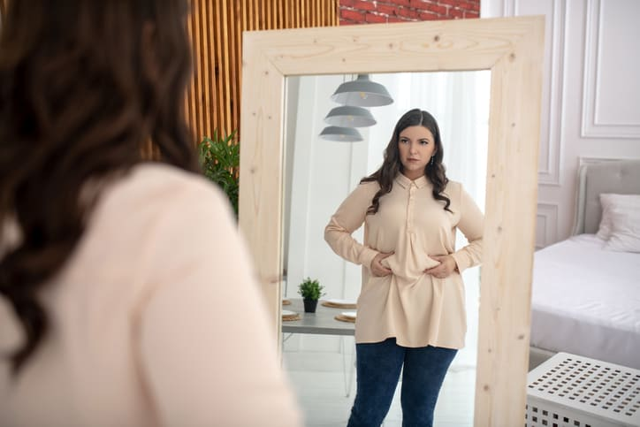
1. attitude and behaviour | 2. friends and relationships | 3. body image
  4. family problems |   5. future career | 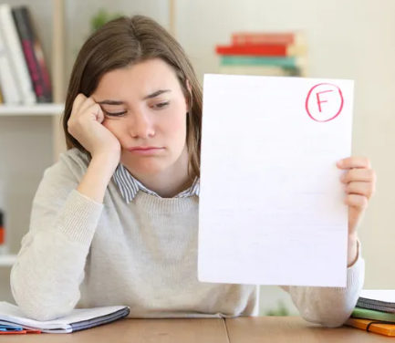  6. school performance
II. Match the sentences with the teenage problems in exercise I.
- I had gained about 20 lbs of fat. I can't stand seeing myself in the mirror. _____________________ body image
- Every night my parents fight and fight. What can I do?________________________family problems
- I don’t like our classroom do? _ rules and guidelines so I don’t follow them. ______________________attitude and behaviour
- I feel so worried about my grades. _____________________ school performance
- I don’t know what I am good at so I cannot choose what to do in the future. _______________future career
- I didn’t agree with my roommates, so we haven’t talked to each other for 2 days. _________________ friends and relationships.
LESSON 1D WRITING

I. Rewrite the sentences using the given words.
1. classmates / well/ with/ gets/ Mary/ most/ of/on/ her/.
…………………………………………………………………………………………………………
Mary gets on well with most of her classmates.
2. rules/ I/ break/ never/ the/.
…………………………………………………………………………………………………………
I never break the rules.
3. parents/ rules/ hard/ always/ my/ set/.
…………………………………………………………………………………………………………
My parents always set hard rules.
4. mom/ out/ worried/ me/ my/ about / is/ go/ when/.
…………………………………………………………………………………………………………
My mom is worried about me when I go out.
5. dad/ Jane’s/ agree/ wears/ doesn’t/ with/ she/ What/.
…………………………………………………………………………………………………………

II. Write an informal email
You had problems with your close friend.
Write an email to Jane. In the email, you should:
- tell her about the problem you had.
- say what you worry about the problem?
- ask Jane for advice
Write your email in about 100 words.

…………………………………………………………………………………………………………
…………………………………………………………………………………………………………
…………………………………………………………………………………………………………
…………………………………………………………………………………………………………
…………………………………………………………………………………………………………
…………………………………………………………………………………………………………
…………………………………………………………………………………………………………
…………………………………………………………………………………………………………
…………………………………………………………………………………………………………
…………………………………………………………………………………………………………

Tài liệu được chia sẻ bởi Website VnTeach.Com
https://www.vnteach.com

