TRƯỜNG THCS-THPT HAI BÀ TRƯNG  ĐỀ CHÍNH THỨC | ĐỀ KIỂM TRA CUỐI KỲ 2  NĂM HỌC 2021 - 2022  MÔN TIẾNG ANH – LỚP : 8  Thời gian: 60 phút  (Không kể thời gian phát đề)
I./ PRONUNCIATION: Choose the word whose main stress pattern is not the same as that of the others: (1.0 PT)
- A. mountain B. valley C. prison D. surprise
- A.wonderful B. magnificent C. unsuitable D. participant
- A. faucet B. machine C. contest D. plumber
- A. perform B. award C. decorate D. design

II./ MULTIPLE CHOICE: (4.5 PTS)
- A: Could you collect my new Aodai at the tailor around the corner? –B:____________
A. Sure, I will. B. Yes, you could. C. No, thank you. D. Of course not.
- .Shall we go somewhere for a drink? - __________________________.
A. Yes, let’s B. No, we shan’t C. Yes, please D. No, thank you
- They have to_________ the rice from the husk before cooking it.
A. take B. bring C. separate D. make
- I was taking a shower ______ the phone rang.
A. when B. if C. as D. because
- A: ‘Would you like a glass of green tea?” B: “____________”
No, let’s not B. No, I don’t C. No, thanks D. No, I wouldn’t
- The music at the party yesterday was very loud and ____________ from very far away
A. can hear B. could hear C. can be heard D. could be heard
- Mr. Brown: “Could you bring me some water, waiter?” – The boy: “ ___________ “
A. Yes, I’d love to B. Certainly, Sir
C. No, I can’t D. It’s very kind of you.
- Their products are ________________________ priced.
Traditionally B. comfortably C. magnificently D. competitively
- . May I suggest you let …………….
A. Mary doing so B. Mary do so C. Mary does to D. Mary to do so
- . She …………. him when he called her.
A. pretended not hear B. pretended she heard not
C. pretended not to hear D. did not pretend hear
- .………….. able to take part in the international math contest two years from now, Son works very hard in his math class.
A. In order to be B. Being C. Been D. So that he be
- . Angkor Wat is the largest …………… in the world.
A. temple B. statue C. pagoda D. city
- . The detective saw the woman putting the jewelry …………... her bag.
A. on B. of C. off D. in

- . I asked Hoa …………..
A.if Phong Nha Cave was in Southern Viet Nam.
B.if Phong Nha Cave is in Southern Viet Nam.
C.whether Phong Nha Cave was in Southern Viet Nam.
D. A and C are correct.
19. The trailer gives a few important …………. about the film’s plot.
A. guessing B. clues C. lists D. suggestions
20. Angkor Wat was built ………….. the year 1100 to honor a Hindu God.
A. at B. for C. around D. about
21. They built the statue to ………….. a great hero of their country.
A. honor B. thank C. remember D. survive
22. Can you ………….. who I saw today?
A. compile B. design C. claim D. guess

III./ SIGNS:(0.5 PT)
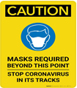 | 23. What does the sign say?  A. Virus around  B. Masks required  C. Stop going  D. Dangerous area
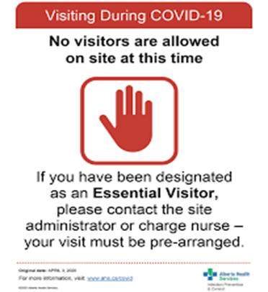 | 24. What do these signs mean ?  A. Visitors can enter the place.  B. All visitors can enter the place if they contact the  site administrator or charge nurse.  C. No one can visit the place during Covid-19 except  some special cases.  D. No one can visit the place if they don’t contact the  site administrator or charge nurse.

IV./ WORD FORMS (1.0 PT)

25./ There were over 500 ……………………….. joined in that contest. (compete)
26./ Vietnam has many …………………….. scenes. (wonder )
27./ I think these thick clothes are ……………………. for hot weather. (suit )

28./ The area ............................. the temple, Angkor Thom, used to be the royal capital city. (surround)
V./ SENTENCE REARRANGEMENT (2.0 PTS)
29. food and drink /showed /my mother /to buy /where /me
My mother .................................................................................................................................
30. him / the stolen /the police /is questioning /goods /about
The police ………………………………………………………………………………………
31. asked /I / him/ English/ his parents/ whether/ spoke
I asked ………………………………………………………………………………………….
32. a long time / was part of / ago / Angkor Wat / a royal Khmer city /.
Angkor Wat …………………………………………………………………………………….
VI./ SENTENCE TRANSFORMATION (1.0 PT)

33. “Do you know the name of the person who first climbed Mount Everest?”

He asked me …………………………………………………………

34. “Have you ever played a musical instrument before?”.

She asked me …………………………………………………………

THE END

