Week 35 Preparing date: May ……. 2023
Period 137 Teaching date: May ……, 2023

Review 4
Parts 3,4,5
A. OBJECTIVES:
By the end of the lesson, Ss will be able to:
1. Knowledge:
- correctly use the following sentence patterns:
+ Do you have any…….? Yes, I do/ No, I don’t
+ How many……do you have? I have……
+ He/ She has…………
+ They have………..
+ I’m………….
+ What are you doing? I’m……….
+ He’s/ She’s………
+ What’s he/ she doing? He’s/ She’s…………
+ What can you see? I can see……
+ What’s the………….doing? It’s………..
- Vocabulary: Review
- Skills: speaking, listening, reading and writing.
2. Competences:
- Co-operation: ready to help friends in pair work/ group work.
- Self-control and independent learning: perform listening tasks.
3. Attitude/ Qualities:
- Kindness: Help partners to complete learning tasks.
- Honesty: tell the truth about feelings and emotions.
- Diligence: complete learning tasks.
B. TEACHING AIDS:
- Teacher: Teacher’s guide Pages 255, 256; website sachmem.vn, posters, laptop, pictures, textbook, lesson plan, TV or projector.
- Students: Pupil’s book Page 71, notebooks, workbooks, school things.
C. PROCEDURES:
Teacher’s activities | Students’ activities
1.Warm- up: (5’)  Game: Whispering  *Aims: to review the vocabulary and structure about greet and respond to greetings.  *Procedure:  - Divide class into 2 groups.  -Ask 5 Ss in each group stand in a straight line.  - T says a word or phrase to the first pupil in this line.  - Then, the first pupil whispers what she/ he hear to the second person in line; the second one whispers what he/ she hears to the third one and so on until the last pupil in group hears the word or phrase.  - The last pupil says the word or phrase out loud.  - The faster group has correct word or phrase is the winner.  - Say “Open your book page 71” and look at Review 4.  2.Practice: (27)  Activity 1. Read and match  *Aims: Ss will be able to read and match pairs of target sentence patterns  *Procedure:  - Tell Ss about this activity. Point at sentence 1, elicit the answer and models.  - Give Ss work in pairs to do the sentence 2,3,4,5.  - Tell Ss to swap their books with their partners, then check answers together as a class.  - Write the correct answers on the board for Ss to correct their answers.  - Invite some pairs to stand up and read the matched exchanges aloud.  Key:  1. b 2. e 3. d 4. a 5. c  Activity 4. Read and complete  *Aims: Ss will be able to read and complete a gapped text.  *Procedure:  - Elicit the words in the box and the passage.  - Tell Ss about this activity. Point at number 1, elicit the answer and models.  - Give Ss work in pairs to do the task  - Tell Ss to swap their books with  their partners, then check answers together as a class.  - Write the correct answers on the board for Ss to correct their answers.  - Invite some pairs to stand up and read the passage aloud.  Key:  1. watching 2. reading  3. in 4. drawing  Activity 5. Ask and answer  *Aims: Ss will be able to read and answer questions using picture cues *Procedure:  - Ask Ss to read the question and elicit the answer  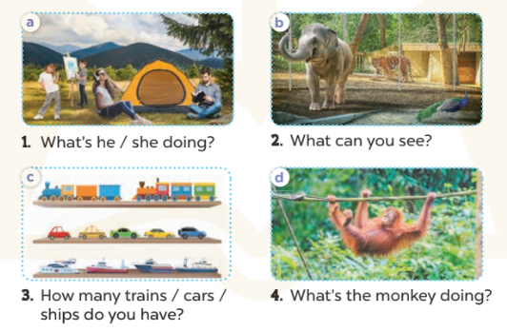  - Get Ss to role-play the exchange with sentence 1  - Give Ss time to take it in turns to role-play the four exchanges.  - Invite some paris to stand up and role-play.  Key: Pupil’s answer  *Consolidation  *Aims: Ss will be able consolidate and wrap up the content of the lesson.  *Procedure:  - T asks ss to answer the following questions:  + What have you learnt from the lesson today?  - T praises some Ss who are hardworking / active/ good…. as well as encourage others to try more.  4. Homework. (3’)  - Prepare the new lesson: Fun time 4 | - Ss listen  -Ss play game  - Ss open their books  -Ss look at the sentence 1 and say  -Ss work in pairs and match  -Ss swap their books and match  -Ss check  -Ss read aloud  -Ss listen and answer  -Ss look at the dialogue and say number 1  -Ss work in pairs and complete  -Ss swap their books and complete  -Ss check  -Ss read aloud  -Ss listen and answer  -Ss role play sentence 1  -Ss work in paris  -Ss role play  -Ss listen and answer  -Ss listen and clap their hands  -Ss listen and take note
D. ADJUSTMENTS (if necessary):
………………………………………………………………………………………….…..……………………………………………………………………………...…………

Week 35 Preparing date: May ……., 2023
Period 138 Teaching date: May………, 2023

Fun time 4
A. OBJECTIVES:
By the end of the lesson, Ss will be able to:
1. Knowledge:
- revise key vocabulary and sentence patterns by doing the crossword with the picture cues and completing the gapped sentences using the words from the crossword
- prepare the questions, interview one of their friends and write down the answers.
- Skills: speaking, writing and listening
2. Competences:
- Co-operation: ready to help friends in pair work/ group work.
- Sociability: Talk to each other, say good words to others.
3. Attitude/ Qualities:
- Kindness: Help partners to complete learning tasks.
- Honesty: tell the truth about feelings and emotions
B. TEACHING AIDS:
- Teacher: Teacher’s guide Pages 256, 257; website sachmem.vn, posters, laptop, pictures, textbook, lesson plan, TV or projector.
- Students: Pupil’s book Page 72, 73, notebooks, workbooks, school things.
C. PROCEDURES:
Teacher’s activities | Students’ activities
1.Warm- up: (3’)  Sing: Head, shoulders, knees and toes  *Aims: to create a friendly and active atmosphere in the class to beginning the lesson.  *Procedure:  - Show the song on the screen.  https://www.youtube.com/watch?v=WX8HmogNyCY  - Ask Ss to listen, sing and dance the song.  - Say “Open your book page 72” and look at “Fun time”.  2. Practice (30’)  Activity 1. Do the puzzle:  *Aims: Ss will be able to revise key vocabulary and sentence patterns by doing the crossword with the picture cues and completing the gapped sentences using the words from the crossword.  *Procedure:  - Have Ss look at the puzzle and ask: Who do you see in the pictures?  - Stick the flash cards of the words, one by one, on the board.  - Point to each word on the board, and have Ss say the word as a class.  - Point at Picture 1, elicit the word, write it in the crossword as an example.  - Ask Ss to repeat the same procedure with the other picture cues.  - Check the answers as a class.  Key:  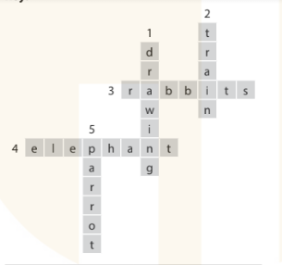  Activity 2. Quiz time  *Aims: Ss will be able to prepare the questions, interview one of their friends and write down the answers. *Procedure:  -Tell Ss that each of them needs to interview three different classmates  - Give Ss 10 minutes to circulate and complete their survey tables  - After Ss have interviewed their classmates and taken notes, give them another 5 to 10 minutes to prepare to share their findings.  - Invite different Ss to come to the front of the class and share their findings.  Activity 3. Look and match. Then talk.  *Aims: Ss will be able to learn the names of baby animals and match them to their parents  *Procedure:  - T elicits the names of the animals: elephant, dog, cat, tiger.  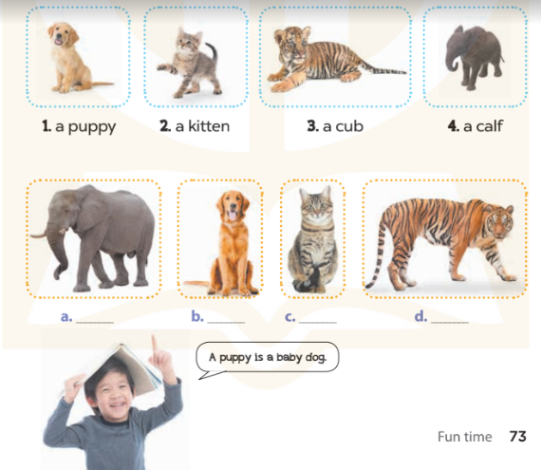  - Write puppy on the board and model it for Ss to repeat.  - Repeat for the another animals  - Have Ss complete the activity by drawing lines to match the baby animal to their parents.  - Check answers together.  Key: 1.b – dog  2.c- cat  3. d- tiger  4. a- elephant.  *Consolidation  *Aims: Ss will be able consolidate and wrap up the content of the lesson.  *Procedure:  - T asks ss to answer the following questions:  + What have you learnt from the lesson today?  +What are the core values of the lesson? (if the teacher can take from the lesson).  - T praises some Ss who are hardworking / active/ good…. as well as encourage others to try more.  3. Homework. (2’)  - Prepare the second term test | - Ss listen  - Ss sing a song  -Ss look at the puzzle and answer  - - Ss note  - Ss say the word  - Ss look and write  -Ss find the words  -Ss check their answer  -Ss listen  -Ss interview and complete the survey tables.  -Ss prepare to share their findings.  -Ss come to the front of the class and share their findings.  - Ss look, listen and answer  - Ss repeat  -Ss listen and do the task  -Ss read and match  -Ss check their answer  -Ss answer the questions  -Ss listen and clap their hands  -Ss listen and take note

D. ADJUSTMENTS (if necessary):
………………………………………………………………………………………….…..……………………………………………………………………………...………………………………………….…..……………………………………………………………………………….……………………………………………………………………...

Week 35 Preparing date: May……, 2023
Period 139, 140 Teaching date: May……, 2023

The second term test

A. OBJECTIVES:
By the end of the lesson, Ss will be able to:
1. Knowledge:
- Check Ss’ comprehension about this theme and get marks.
- Vocabulary: Review
- Model sentences: Review
- Skills: speaking, writing and listening
2. Competences:
- Co-operation: ready to help friends in pair work/ group work.
- Sociability: Talk to each other, say good words to others.
3. Attitude/ Qualities:
- Kindness: Help partners to complete learning tasks.
- Honesty: tell the truth about feelings and emotions
B. TEACHING AIDS:
- Teacher: - Teacher: Textbook, lesson plan, TV or projector, wordsheets.
- Students: School things.
C. PROCEDURES:
Teacher’s activities | Students’ activities
Give the students papers test to do  70’ | Whole class to do the test.
D. ADJUSTMENTS (if necessary):
………………………………………………………………………………………….…..……………………………………………………………………………...………………………………………….…..……………………………………………………………………………….……………………………………………………………………...

