Date of preparing: ………………………………….
Date of teaching: ………………………………….

Period …
UNIT 4: FESTIVALS and FREE TIME
Lesson 2 - Part 2 (Page 34) - Grammar

I. OBJECTIVES
By the end of the lesson, Ss will be able to…
1. Knowledge
- use the Present Simple for future use.
2. Ability
- improve speaking skill, writing skill.
- improve the use of English.
3. Quality
- have positive attitude in English language learning so that they actively participate in all classroom activities.
- be on time when attending events.

II. TEACHING AIDS AND LEARNING MATERIALS
Lesson plan, PPT slides, student’s book, workbook, notebook, personal computer (if any), projector/TV, speakers, DCR & DHA on Eduhome, handouts…

III. PROCEDURES
A. Warm up: (5’)
a) Objective: to introduce the new lesson and set the scene for Ss to acquire new language; to get students' attention at the beginning of the class by means of enjoyable and short activities as well as to engage them in the steps that follow.
b) Content: Ss review vocabulary about festival activities.
c) Product: revision of vocabulary and being ready for the new lesson.
d) Competence: collaboration, communication, critical thinking
e) Organization of the activity:
Teacher’s Activities | Students’ Activities
- Give greetings  - Check attendance  - Option 1: MULTIPLE CHOICE  - Show the exercises on the screen (or give handouts)  - Have Ss work in pairs  - Check answers as a whole class  →Lead to the new lesson.  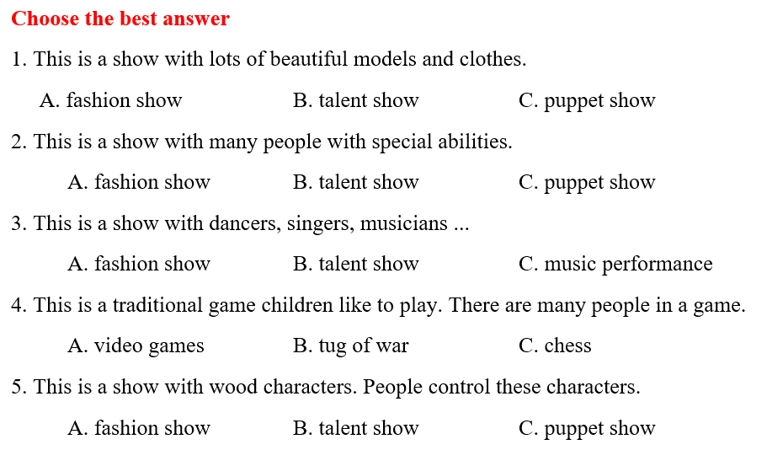  - Option 2: Actor / Actress  - Ask some Ss to volunteers to be the actor / actress  - Ask the volunteers to use body language to illustrate some festival activities  - Have the rest of the class guess what festival activity is being simulated.  - Call Ss to give answers  - Give feedback  - Lead to the new lesson | - Greet T  - Work in pairs  - Read answers  Answer keys  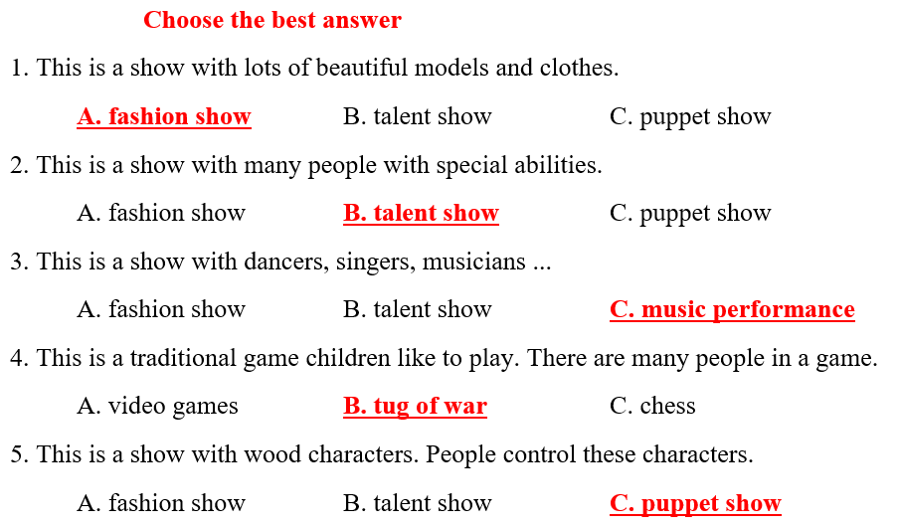  - Volunteer  - Act  - Guess the festival activities  - Give answers  - Listen

B. New lesson (35’)
- Activities 1: Grammar: The Present Simple for future use (15’)
a) Objective: Ss know how to use the Present Simple for future actions.
b) Content:
- Listening and repeating
- Grammar explanation
c) Products: Ss can use the Present simple to talk about the future activities.
d) Competence: communication, collaboration, creativity.
e) Organization of the activity:
Teacher’s Activities | Students’ Activities
a. Listen and repeat  - Have Ss look at the picture  - Play the audio (CD1 – Track 47), ask Ss to listen and read the speech bubbles  - Play the audio again and have Ss listen and repeat  *Grammar box:  - Ask Ss to make comments on the black bold verb form in the examples  - Have Ss retell the form and usage of the Present Simple tense  - Lead to the grammar table and explain the usage of the Present Simple for future activities  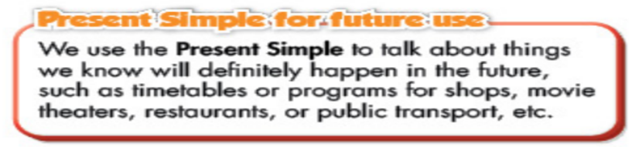  - Ask Ss to pay attention to the verbs for events and activities, the verbs for the events and activities avenue  - Have some Ss read the sentences aloud  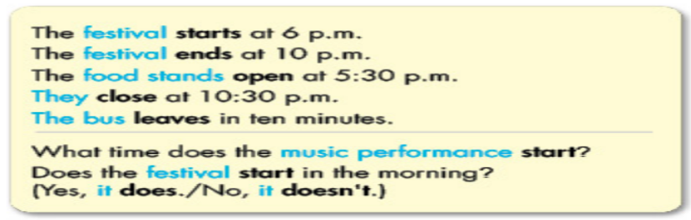  - Have Ss make more sentences, using the Present Simple tense for future activities  - Get feedback | - Look  - Listen and read  - Listen and repeat  - Comment  - Retell  Expected answers  The Preset Simple tense  Be: S + am / is / are (not) …  (?) Am / Is / Are + S …  Normal verb:  (+) S + V_{s/es}  (-) S + don’t / doesn’t + V. _{bare infinitive}  (?) Do / Does + S + V. _{bare infinitive}  - Listen and take notes  - Read  - Make sentences
- Activity 2: Practice (20’)
a) Objective: Ss can get used to using the Present Simple for future activities.
b) Content:
- filling in the blanks, using the Present Simple.
- answering the questions.
c) Products: Ss can understand and apply the use the Present Simple in communication.
d) Competence: collaboration, creativity, communication.
e) Organization of the activity:
Teacher’s Activities | Students’ Activities
b. Fill in the blanks, using the Present Simple  - Option 1:  - Use the example to demonstrate this activity  - Have Ss use the Present Simple to fill in the blanks, draw attention to the question form  - Have pairs check each other’s work  - Have Ss share their answers with the class by writing down on the board  - Check Ss’ answers, correct if necessary  - Option 2:  - Use the example to demonstrate this activity  - Have Ss use the Present Simple to fill in the blanks, draw attention to the question form  - Have pairs check each other’s work  - Call Ss to give answers by answering multiple choice questions (format: game “Lucky Number?”)  - Check Ss’ answers, correct if necessary  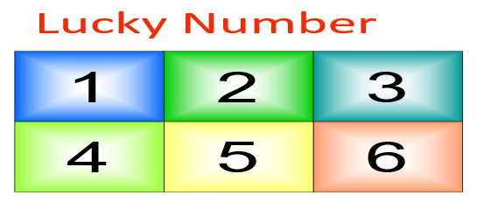  c. Answer the questions  - Demonstrate the activity, using the example  - Have Ss look at the Note box, explain  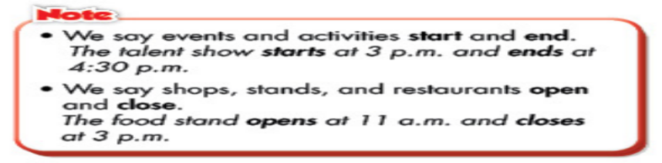  - Let Ss answer the questions  - Go round and give help if necessary  - Have Ss work in pairs to check each other’s work  - Call Ss to write answers on the board  - Check and correct Ss’ answers  d. Practice the conversation with your partner  - Option 1:  - Have Ss practice the conversation in pairs  - Have some Ss demonstrate the activity in front of the class  - Give feedback and evaluation  - Option 2:  - Follow the same steps as option 1  - Give an extra activity  - Give Ss handouts with information of a festival  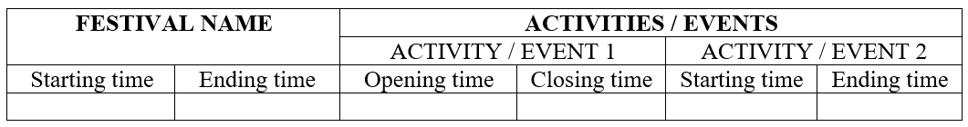  - Have Ss:  + Fill in the table  + Practice asking and answering about the festival and festival activities  - Have some Ss demonstrate the activity in front of the class  - Give feedback and evaluation | - Look and listen  - Work in pairs  - Write answers  Answer keys  2. open 3. leaves 4. close  5. ends 6. leave  - Look and listen  - Work in pairs  - Give answers  Answer keys  2. open 3. leaves 4. close  5. ends 6. leave  - Look and listen  - Do the task  - Work in pairs  - Write answers  Answer keys  1. It starts at 11 a.m.  2. It ends at 10 p.m.  3. They open at 12.30 p.m.  4. It leaves in 10 minutes  - Work in pairs  - Ask and answer  - Work in pairs  - Present  Sample table  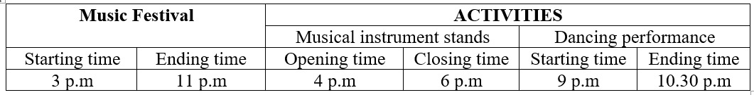

C. Consolidation (3’)
* Present Simple for future action:
Form: Be: S + am / is / are (not) …
(?) Am / Is / Are + S …
Normal verb:
(+) S + V_{s/es}
(-) S + don’t / doesn’t + V. _{bare infinitive}
(?) Do / Does + S + V. _{bare infinitive}
Usage: The Present Simple is used to talk about things we know that will definitely happen in the future such as timetable, plans, schedule.

D. Homework (2’)
- Make 2 sentences, using the Present Simple for future activities.
- Do exercises in WB: Lesson 2 - Grammar and Writing (page 23).
- Prepare: Lesson 2 – Pronunciation and Speaking (page 35 – SB).

