Week: Date of planning:
Period: Date of teaching:

UNIT 9: NATURAL DISASTERS

Lesson 4: Communication
I. OBJECTIVES
By the end of this lesson, students will be able to:
1. Knowledge:
- Use the lexical items related to natural disasters.
- Practise giving and responding to bad news.
2. Competences:
- Develop communication skills and creativity
- Be collaborative and supportive in pair work and teamwork.
- Actively join in class activities
3. Personal qualities
- Develop awareness of Natural disasters.
- Be concerned to Natural disasters.
II. MATERIALS
- Grade 8 textbook, Unit 9- Communication
- Computer connected to the Internet
- Projector / TV/ pictures and cards
- Phần mềm tương tác hoclieu.vn
III. PROCEDURES
1. WARM-UP (5 mins)
a. Objectives:
- To create an active atmosphere in the class before the lesson.
- To lead into the new lesson.
b. Content:
Answering the questions
c. Expected outcomes:
Ss can answer the questions about the picture.
d. Organisation
TEACHER AND STUDENTS’ ACTIVITIES | CONTENTS
- Teacher show a picture about one disaster.  - Teacher asks Ss to work individually and answer the questions.  - Teacher invites some Ss to talk in front of the class.  - Teacher comments on their answers and leads to the new lesson.  - Teacher observes and gives feedback. | Answering the questions:  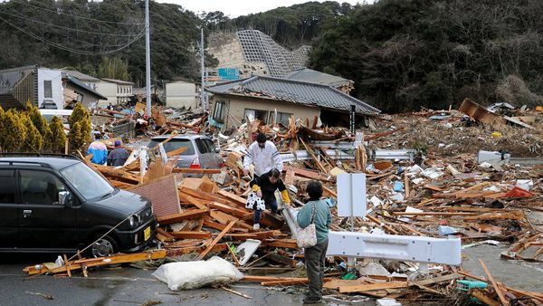  1. What do you see in the picture?  2. How do you feel?
2. ACTIVITY 1: PRESENTATION (5 mins)
a. Objectives:
- To introduce the new words related to natural disasters.
- To help Ss understand more clearly the meaning of some words.
- To help Ss use the words in specific contexts.
b. Content:
Vocabulary: Shake, fahrenheit, richter scale.
c. Expected outcomes:
Ss know how to pronounce the new words correctly and use them in appropriate situations.
d. Organisation
TEACHER AND STUDENTS’ ACTIVITIES | CONTENTS
Vocabulary:  - Teacher introduces the vocabulary.  - Teacher explains the meaning of the new vocabulary, using pictures and translation.  - Teacher writes new words on the board.  - Students listen and repeat in individual first then the whole class.  - Teacher call 3- 4 Ss to read the words again.  - Teacher checks students’ understanding with the “What and where?” technique.  - Teacher observes and gives feedback. | New words:  1. Shake (v)  2. Fahrenheit (n)  3. Richter scale (n)
3. ACTIVITY 2: PRACTICE (13ms)
a. Objectives:
- To introduce ways of giving and responding to bad news.
- To help Ss practise giving and responding to bad news.
b. Content:
- Listen and read the dialogue below. Pay attention to the highlighted sentences.
- Work in pairs. Practise giving and responding to bad news in the following situations.
c. Expected outcomes:
Ss know how to give and respond to bad news.
d. Organisation
TEACHER AND STUDENTS’ ACTIVITIES | CONTENTS
Task 1. Listen and read the dialogue below. Pay attention to the highlighted sentences.
(6 mins)
- Teacher plays the recording for Ss to listen and read the dialogue between Mark and Phong.  - Teacher asks Ss to pay attention to the highlighted sentences and tells them that these are two ways to give and respond to bad news.  - Teacher has Ss practise the dialogue in pairs.  - Teacher calls on some Ss to practise the dialogue in front of the class.  - Teacher observes and gives feedback. |  | Mark: Phong, why are you so sad?  Phong: My grandparents called this morning. A flood destroyed their house.  Mark: I’m sorry to hear that.  Phong: It also damaged all of their crops.  Mark: That’s awful. I hope your grandparents are safe.
Task 2. Work in pairs. Practise giving and responding to bad news in the following situations. (7 mins)
- Teacher asks Ss to work in pairs to read the given situations and make similar dialogues, using the language they have learnt.  - Ss use the language and make similar dialogues.  - Teacher moves around to observe and provides help.  - Teacher calls on some pairs to practise in front of the class.  - Teacher comments on their performance.  - Teacher observes and gives feedback. |  | Situations:  – You have a friend in a mountainous area. A landslide destroyed his family’s garden yesterday. You share this news with your classmate.  – You hear that a big earthquake hit a city. You share this news with your classmate.
4. ACTIVITY 3: PRODUCTION (17ms)
a. Objectives:
- To help Ss identify the natural disasters described in the short texts.
- To check Ss’ knowledge of different natural disasters via a questionnaire.
- To provide Ss with a chance to communicate with each other and confirm their knowledge of natural disasters.
b. Content:
- Read the short passages below. Decide which natural disaster each person below is talking about.
- Choose the correct answer to each question to see how much you know about natural disasters.
- Work in pairs. Compare your answers. Then check your answers with the key on page 101. How many points did each of you get?
c. Expected outcomes:
Ss know more about natural disasters.
d. Organisation
TEACHER AND STUDENTS’ ACTIVITIES | CONTENTS
Task 3. Read the short passages below. Decide which natural disaster each person below is talking about. (6 mins)
- Teacher asks Ss to work in pairs to read the three short texts and decide what natural disaster each person is talking about.  - Teacher asks Ss to prepare an explanation for their answers.  - Teacher elicits answers from Ss.  - Teacher confirms the correct answers. |  | Answer key:  Nam: landslide  Ann: tornado  Tom: earthquake
Task 4. Choose the correct answer to each question to see how much you know about natural disasters. (6 mins)
- Teacher tells Ss that they are going to answer a questionnaire to see how much they know about natural disasters.  - Teacher has Ss read through the questionnaire quickly and explain any new words.  - Teacher asks Ss to answer the questions individually. |  | Answer key:  1. A  2. B  3. C  4. B  5. C  6. A
Task 5. Work in pairs. Compare your answers. Then check your answers with the key on page 101. How many points did each of you get?. (5 mins)
- Teacher asks Ss to work in pairs to compare their answers.
- Teacher asks Ss to note down the answers and then check them with the key on page 101.
- Teacher has Ss calculate the points each of them earns.
- Teacher asks some Ss to report their answers and points to the class.
- Teacher observes and gives feedback.
5. CONSOLIDATION (5 mins)
a. Wrap-up
- Teacher asks Ss to summarise the main points of the lesson.
b. Homework
- Learn by heart all the words that they have just learnt.
- Do exercises in the workbook.
- Prepare for Lesson 5 – Skills 1

