BÌA
TABLE OF CONTENTS
PART A: INTRODUCTION 1
1. Rationale 1
2. Significance of the study 1
PART B: CONTENT 2
CHAPTER A: THEORETICAL BACKGROUND 2
1. Gifted Education: Unique Needs and Challenges 2
2. Reading and listening comprehension in cognitive development 2
3. The role of AI in education 3
4. AI in reading comprehension exercises 3
5. AI in listening comprehension exercises 3
CHAPTER B: APPLYING AI PLATFORMS IN DESIGNING READING AND LISTENING COMPREHENSION EXERCISES FOR GIFTED STUDENTS IN NATIONAL TEAM 4
1. Designing AI-powered reading exercises 4
1.1. Adaptive texts and dynamic difficulty adjustment 4
1.2. Personalized reading recommendations 5
1.3. Real-time feedback and interactive annotations 5
1.4. Advanced content generation with AI-based storytelling 6
2. AI-enhanced listening activities 6
2.1. AI-driven adaptive listening exercises 6
2.2. Real-time pronunciation feedback 7
2.3. Adaptive listening tasks 7
2.4. Cognitive load and focus in listening 7
3. Some sample exercises designed by AI platforms 8
3.1. Reading Comprehension exercises 8
3.2. Listening exercises 17
4. Discussion: Advantages and Disadvantages of applying AI platforms in designing reading and listening exercises for gifted students 24
4.1. Advantages 24
4.2. Disadvantages 25
PART C: CONCLUSION 25
I. Summary of findings 25
II. Implications for education and Recommendations 26
III. Future research directions 28
REFERENCES 29

PART A: INTRODUCTION

1. Rationale

AI is rapidly transforming many professions, and education is no exception. Among those most impacted are gifted learners, also the students who think, learn, and create at levels well beyond their peers. Their unique cognitive profiles and faster learning pace often require specialized instruction that traditional classrooms struggle to provide.

These students are highly discerning and thrive when engaged in purposeful, intellectually challenging work. However, they are frequently placed in classrooms that fail to match their abilities, leading to boredom, under-stimulation, and a lack of meaningful learning experiences. Gifted students often tolerate the slower pace designed for the average learner, which can limit their potential and dull their enthusiasm. Reading and listening comprehension is especially vital for gifted learners, as it supports not only the understanding of complex texts, but also skills like analysis, evaluation, and creative problem-solving. Yet, standard comprehension activities often fall short of engaging their higher-order thinking.

AI has the potential to bridge this gap. With its ability to personalize instruction and deliver real-time feedback, AI can offer tailored learning pathways that match gifted students’ pace, interests, and level of complexity. It enables educators to design more adaptive, dynamic, and meaningful educational experiences, finally aligning instruction with the needs of the most cognitively advanced learners.

2. Significance of the study
This study aims to dive into how AI can be utilized in crafting reading and listening comprehension exercises specifically designed for gifted students. The research will highlight the ways in which AI technologies can be leveraged to develop content that meets the unique intellectual needs of these learners, all while encouraging critical thinking and independent learning. Here are the specific goals of this research:
- To investigate how AI platforms can create personalized reading and listening comprehension exercises that align with the cognitive and intellectual strengths of gifted students.
- To examine the potential advantages of AI-driven comprehension exercises in enhancing engagement, critical thinking, and cognitive growth for gifted learners.
- To look into the challenges and limitations that come with integrating AI into gifted education, especially regarding reading and listening comprehension tasks.
- To offer practical advice for educators on effectively incorporating AI technologies into their teaching methods for gifted students.
The results of this research will help deepen our understanding of how AI can serve as a powerful tool for tailoring instruction and fostering a more engaging and intellectually stimulating learning environment for gifted students. Additionally, the findings will provide insights on how AI can nurture the higher-order cognitive skills essential for gifted learners, empowering them to achieve their fullest potential both academically and personally.
In this research, we explored a key hypothesis: that using certain AI platforms to create reading and listening comprehension exercises can significantly enhance the English proficiency of gifted students in the National Team. The writers’ goal is to make a meaningful contribution to the field of gifted education by showcasing how AI can help craft more effective and engaging learning experiences. The insights gained from this study could have a real impact on educational practices, curriculum development, and the future of integrating AI into personalized learning, especially for gifted students in the National Team and across all English-major classes.

PART B: CONTENT

CHAPTER A: THEORETICAL BACKGROUND

1. Gifted Education: Unique Needs and Challenges
Gifted students demonstrate exceptional intellectual or creative abilities that set them apart from peers, yet standard classrooms often fail to meet their needs. Research (Tomlinson, 2014; VanTassel-Baska, 2003) emphasizes the importance of differentiated instruction, as typical curricula often lack the depth required to stimulate advanced thinkers.
When tasks rely too heavily on memorization and surface-level recall, gifted learners may experience boredom and underachievement (Betts & Neihart, 1988). Standard reading and listening activities rarely provide the complexity needed for higher-order thinking. Educational frameworks like Bloom’s Taxonomy highlight the need to engage gifted students through activities that demand analysis, evaluation, and synthesis—skills that challenge them to explore language, themes, and deeper meanings in texts and audio content.

2. Reading and listening comprehension in cognitive development
Reading and listening comprehension are essential skills that play a crucial role in the cognitive development of students, especially when it comes to fostering critical thinking, problem-solving, and creativity. For gifted students, these skills become even more vital, as they help them navigate and engage with complex concepts. Gifted learners often shine in reading comprehension tasks, but they need texts that truly challenge their intellectual abilities. Research (Terman, 1925; Reis & Renzulli, 2009) emphasizes the need to provide gifted students with intricate and abstract reading materials that push them to dive deep into analysis, critically evaluate information, and interpret creatively.
On the other hand, listening comprehension goes beyond just grasping spoken content; it also involves understanding tone, intent, and the deeper themes at play. Gifted students thrive on listening tasks that prompt them to infer meanings, assess arguments, and pull together information from various auditory sources (VanTassel-Baska & Brown, 2007). Ultimately, reading and listening comprehension are interconnected skills that rely on cognitive processes like making inferences, analyzing context, and applying critical reasoning. To effectively support gifted learners, instructional strategies should seamlessly blend both reading and listening activities, fostering a well-rounded approach to cognitive development.

3. The role of AI in education
AI is becoming a game-changer in the world of education, bringing in tools that really boost personalization, adaptability, and engagement. One of the standout features of AI in education is its knack for creating personalized learning experiences. By leveraging machine learning algorithms and data analysis, AI can customize content to fit each student’s unique needs, tweaking the complexity, pacing, and focus of tasks based on how they perform in real-time. For gifted learners, this means that comprehension exercises stay intellectually engaging and perfectly matched to their advanced skills.
Platforms like DreamBox, Knewton, and Smart Sparrow harness adaptive learning technologies to craft dynamic learning paths. Research shows that AI-driven systems can significantly boost reading and listening comprehension by generating tailored texts, analyzing sentiment and tone, and providing instant feedback. Tools like OpenAI’s GPT-4 and Socratic by Google showcase how AI can create intricate reading passages, develop adaptive listening tasks, and support student learning effectively.

4. AI in reading comprehension exercises
AI-driven tools have the potential to transform reading comprehension by crafting adaptive, personalized tasks that cater to the unique intellectual needs of gifted students. Here are some specific applications:
- Dynamic text generation: Tools like GPT-4 and QuillBot can produce texts with varying levels of complexity. These platforms also empower educators to modify texts based on student performance, introducing advanced vocabulary, abstract concepts, or literary techniques as necessary.
- Advanced question generation: AI systems can formulate comprehension questions that cover Bloom’s Taxonomy, prompting gifted students to engage in higher-order thinking. For instance, AI can create questions that ask students to analyze themes, evaluate arguments, or synthesize information from various sources (like Socrative or Quizlet).
- Real-time feedback: AI platforms offer instant feedback on reading comprehension tasks, helping students identify their mistakes and providing suggestions for improvement. This feature is especially beneficial for promoting self-directed learning among gifted students.

5. AI in listening comprehension exercises
Listening comprehension, which requires processing auditory information and interpreting spoken language, can also benefit from AI-driven tools. Applications include:
- Speech-to-text and transcription: Platforms like Otter.ai and Google Speech-to-Text can transcribe audio content. These tools help gifted students focus on critical aspects of spoken language, such as tone, intent, and argument structure.
- Adaptive listening tasks: AI-powered platforms like Listenwise and LingQ provide personalized listening exercises that adjust to the student's proficiency level. For gifted learners, this may include tasks with varied accents, faster speech rates, or more complex content to enhance auditory processing skills.
- Sentiment and tone analysis: Advanced AI systems can analyze the sentiment and tone of spoken content, challenging students to infer speaker intent and evaluate emotional cues. This feature is particularly beneficial for helping gifted students develop a nuanced understanding of language.

CHAPTER B: APPLYING AI PLATFORMS IN DESIGNING READING AND LISTENING COMPREHENSION EXERCISES FOR GIFTED STUDENTS IN NATIONAL TEAM

1. Designing AI-powered reading exercises

1.1. Adaptive texts and dynamic difficulty adjustment
AI can adjust reading materials to match the cognitive level and preferences of gifted students, ensuring they remain challenged without becoming overwhelmed.
AI-powered platforms like OpenAI's GPT-4, QuillBot, and INK Editor are capable of creating or adapting texts based on the student's level. These tools can generate passages with varying levels of complexity, ranging from simpler descriptions to more advanced analytical texts, making it ideal for gifted students.
Platform Example: GPT-4 can generate reading passages on a wide variety of topics, from history and literature to complex scientific concepts. For example, if a gifted student is reading about the concept of artificial intelligence, GPT-4 could start by explaining the basics of AI in simple language and gradually increase the complexity, introducing advanced concepts such as machine learning algorithms, neural networks, and ethical implications as the student demonstrates understanding.
If a gifted student encounters difficulty with certain aspects of the text, AI platforms can simplify specific vocabulary or provide more detailed explanations of key concepts. Similarly, if a student demonstrates a strong grasp of the content, the AI can expand the material with more sophisticated concepts, encouraging deeper engagement with the subject matter.
Platform Example: QuillBot allows users to paraphrase or simplify texts by adjusting complexity based on student performance. In a comprehension exercise, a gifted student may be tasked with reading a dense passage, and if they struggle with specific terminology, QuillBot can rephrase or provide definitions to support understanding.

1.2. Personalized reading recommendations
AI can personalize reading lists for gifted students by analyzing their interests, strengths, and reading history, encouraging deeper exploration and intellectual growth. For example, a student interested in literature and culture might be recommended One Hundred Years of Solitude alongside post-colonial non-fiction, with follow-up suggestions like works by Bioy Casares or Edward Said.
In addition to reading, AI platforms generate adaptive questions aligned with Bloom’s Taxonomy, progressing from recall to higher-order thinking. Tools like Socrative, Quizlet, and Knewton adjust question difficulty in real time. For instance, if a student answers a factual question correctly, Socrative might follow up with an analytical prompt such as, “How would you critique the author’s solution to climate change?”
Platform Example: Quizlet helps deepen comprehension by adapting to students’ responses and offering instant feedback, while Knewton identifies specific learning gaps—like difficulty with figurative language—and recommends targeted resources to improve. This immediate, personalized support helps gifted students refine their understanding and stay intellectually engaged.

1.3. Real-time feedback and interactive annotations
AI systems can provide immediate, interactive feedback to guide students in their understanding of a text, prompting them to engage more deeply with the material.
Example: When a gifted student reads a passage from The Great Gatsby, the AI may highlight key phrases such as "social mobility" or "American Dream." Clicking on these terms provides the student with an expanded definition, relevant historical context, and thought-provoking questions like "How does Gatsby's pursuit of wealth reflect the limitations of the American Dream?" The system might prompt the student to analyze the significance of this passage in relation to the novel's broader themes, helping them refine their critical thinking.
Understanding the emotional and tonal elements of a text is also an essential aspect of advanced reading comprehension. AI platforms can perform sentiment analysis to help gifted students identify underlying emotions, biases, or rhetorical strategies employed by authors. AI models like IBM Watson and TextBlob can analyze the sentiment and tone of a given text, providing insights into how an author's tone influences the message. These insights help students understand subtext and emotional appeal, which are key to interpreting complex literary works and nonfiction texts.
Platform Example: IBM Watson Natural Language Understanding analyzes texts for tone, sentiment, and even emotion, which can help students identify how an author's emotional state or bias may influence the content. In a reading comprehension task, for instance, the AI might highlight a passage where the author uses a sarcastic tone, prompting the student to analyze how this affects the reader's perception of the subject matter. TextBlob is another tool that performs sentiment analysis and can be used in reading comprehension exercises to guide gifted students in recognizing shifts in tone or identifying subtle emotions in a text. Students might be asked, "What is the mood of the narrator in this passage, and how does it influence your interpretation of the text?"

1.4. Advanced content generation with AI-based storytelling
AI can generate creative writing prompts that push students to think critically and creatively, incorporating complex themes and academic theories into their storytelling.
Platform Example: An AI-powered creative writing tool could suggest the following prompt for a gifted student: "Write a dystopian short story where society's value system is determined by artificial intelligence, and the protagonist questions the fairness of this system. Incorporate themes from philosophy, such as John Rawls' theory of justice or Michel Foucault's ideas on power and surveillance." The AI could also suggest narrative structures and character archetypes that challenge the student's ability to craft complex, meaningful plots.

2. AI-enhanced listening activities
Listening comprehension exercises are all about how we process, remember, and interpret spoken language, which is quite different from reading comprehension. When it comes to creating these exercises for gifted students, it can be a bit tricky. These bright learners need more than just the ability to remember what they hear; they also have to dive into more complex tasks. This includes critically analyzing tone, picking up on hidden themes, and assessing arguments. AI tools can really boost listening comprehension by offering tailored content, personalized feedback, and real-time adjustments to task difficulty, making sure that gifted students are always being pushed to grow.

2.1. AI-driven adaptive listening exercises
AI-powered systems have the ability to design listening exercises, adjusting the difficulty of audio content to match each student's skill level. For instance, a talented student might kick off a listening task with a straightforward podcast episode about the solar system. The AI would first gauge their understanding by asking follow-up questions like, "What’s the main difference between terrestrial and gas giant planets?" Depending on how the student responds, the AI could then gradually introduce more challenging material, such as a lecture on the history of space exploration or a discussion on the ethical considerations of colonizing Mars.
Platform Example: Tools like Google Text-to-Speech and Descript can generate or adapt audio content based on what the student needs. These platforms can produce a variety of voice tones, accents, and speech patterns, ensuring that gifted students encounter different speaking styles and levels of complexity. For example, Descript enables users to create and edit podcasts, audiobooks, and other spoken content. Teachers can leverage Descript to design custom listening exercises featuring a wide array of voices and complexities, perfect for advanced listening comprehension tasks. Imagine a gifted student listening to a passage about historical events, with Descript adjusting the tone, pace, and accent to reflect various contexts, making the listening experience more intricate.

2.2. Real-time pronunciation feedback
For students learning new languages or refining their communication skills, real-time pronunciation feedback from AI can help them improve their fluency and auditory comprehension. For example, suppose a gifted student is learning French. The AI system listens to their pronunciation of words and phrases in a virtual conversation and provides real-time corrections. For instance, if the student mispronounces "croissant" by stressing the wrong syllable, the AI might say, "Try again: the correct pronunciation is 'krwah-sahn.'" Additionally, the system could offer audio examples from native speakers for comparison.
AI can provide real-time feedback on listening comprehension tasks, helping gifted students process spoken information more effectively while offering advanced analysis of their performance.
Platform Example: Platforms like Otter.ai and Speechmatics provide real-time transcription and feedback on spoken content. These tools allow students to listen to audio recordings while simultaneously reading transcriptions, enhancing their ability to identify key details, tone, and context. Otter.ai transcribes audio content and provides real-time analysis of spoken language. Gifted students could listen to a podcast discussing political speeches, and Otter.ai would transcribe the speech in real-time. The AI could then analyze key points and even detect shifts in tone or emotion, helping the student better understand the speaker's intent.

2.3. Adaptive listening tasks
AI platforms like Rewordify and Knewton can adapt the difficulty of listening tasks based on the student's ability, ensuring that gifted learners are always engaged at an appropriate level of challenge. AI-powered platforms can adapt audio content by altering the complexity of the speech, sentence structure, and vocabulary to meet the gifted student's needs.
Platform Example: Rewordify adjusts the complexity of audio content, providing personalized listening exercises that help gifted students develop both comprehension and vocabulary skills. If a student struggles with a particular audio segment, the platform can provide definitions or context to ensure full understanding.

2.4. Cognitive load and focus in listening
Listening comprehension involves processing and retaining information over time. AI systems can help manage cognitive load by chunking information, guiding students through the material step by step, and adjusting the difficulty of listening tasks. AI platforms like Listenwise offer a personalized approach to listening comprehension, delivering content in manageable chunks and guiding students through the material with pauses and guided questions.
Platform Example: Listenwise specializes in providing podcast-based listening exercises for students, offering real-time interaction and feedback. Gifted students can engage with high-level content on topics like current events, social issues, and scientific discoveries, while the system adjusts the pace and complexity based on the student's performance.

3. Some sample exercises designed by AI platforms

3.1. Reading Comprehension exercises
Step 1: Choose the reading text from the reading sources
Step 2: Use i2OCR - Free Online OCR, OnlineOCR.net or ChatGPT to extract the image/PDF file into text
Wheat: a troublemaker
A. Grains, such as wheat, oat, and rice, have been systematically grown for about 10,000 years. They weren't just another addition to humans’ nutrition, but the cornerstone of our civilisation. For all we know, the Natufian culture was the first to benefit from the Agricultural Revolution. The Natufians were groups of hunter-gatherers, who lived in the Fertile Crescent or the Near East—the land that nowadays spreads over Syria, Palestine, Israel, and Lebanon. Among the food they gathered was barley, einkorn, and emmer. It was growing the land that enabled them to permanently settle in a particular place. They were probably the first group of people whose culture obviated the need to constantly move about, and it must have been the first time that the notion of free time had found its expression, since those tribes no longer needed to devote all their time to their survival. Wheat's astounding ability to flourish in a wide variety of climates and altitudes and, mainly, the opportunity to maintain the seeds for long periods of time were the elements that rendered farming the new super-weapon, not only for human survival, but also for civilisation at large.
B. All great civilisations were based on a specific grain. The Babylonians and Egyptians relied on wheat, the Chinese on rice, the Inca, the Maya, and the Aztecs on corn. Roughly speaking, nowadays, America is premised on corn, Asia on rice, and almost the rest of the world on wheat. Of course, wheat reigns supreme almost everywhere and, although it comes second to corn in terms of world annual production, this is due to the use of corn for animal food. Therefore, for the past ten millennia, wheat has been the basic human food. There have gradually emerged some new kinds and varieties of wheat coming from natural breeding, as well as from human intervention, since farmers chose to sow seeds with better characteristics. The first cultivated wheat, and “father” of all types of wheat, is einkorn.
C. A little later came from natural breeding tetraploid wheats, such as emmer and durum, then from yet another natural breeding came hexaploid wheats, like spelt and aestivum, which is the most widespread today. These were mainly the types of wheat grown by humankind up until the 50’s and 60's. Then, a staggering scientific intervention was made, which led to the varieties of dwarf and semi-dwarf wheat. The scientist responsible for this development was awarded a Nobel Peace Prize in 1970, and earned a lot of great distinctions, among them the Congressional Gold Medal and the Presidential Medal of Freedom, which are the highest distinctions a citizen can earn in the USA. He is often referred to as “the man who saved 1 billion lives.” His name is Norman Borlaug (1914-2009).
D. For a decade, Borlaug conducted rigorous experiments in Mexico for the purposes of improving wheat, and increasing its production and resistance to diseases. That is why he made 6,000 breedings, until he created the aestivum variety, which is a semi-dwarf wheat. This seed was like a dwarf in size, but a giant in production. It was a real wonder of productivity. Gradually, the vast golden wheat fields, almost as tall as a human being, were replaced with the short champions of the labs. Compared to the old traditional varieties, the new ones had yields 8 times higher per acre! Which farmer could resist the temptation of adopting the new varieties? After the 70's, the hundreds of new modified varieties spread fast all around the world.
Step 3: Use Grammarly to check grammar, spelling mistakes
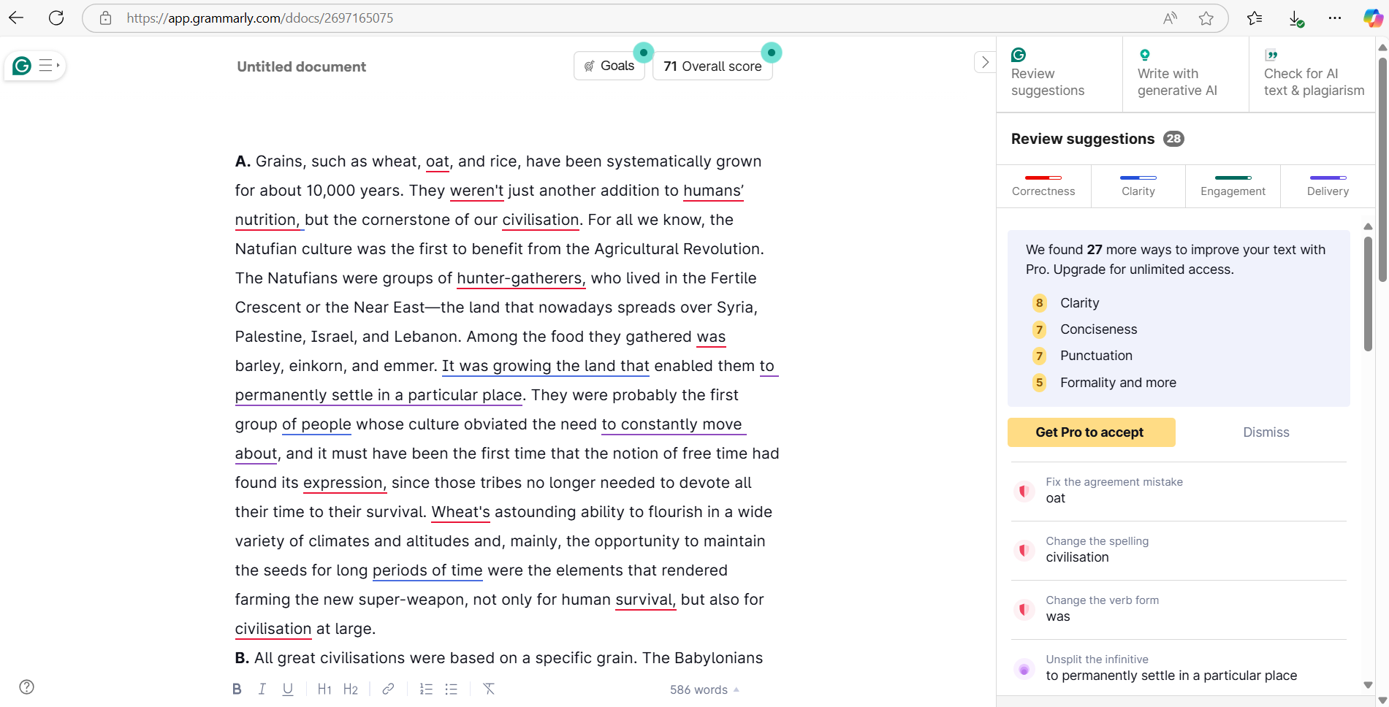
Then ask Grammarly to improve the text:
Wheat: a troublemaker
A. Grains such as wheat, oats, and rice have been systematically cultivated for about 10,000 years. These grains were not merely an addition to human nutrition; they were the cornerstone of civilization. The Natufian culture is believed to be the first to benefit from the Agricultural Revolution. The Natufians were groups of hunter-gatherers who lived in the Fertile Crescent, which encompasses present-day Syria, Palestine, Israel, and Lebanon. Among the foods they gathered were barley, einkorn, and emmer. The ability to cultivate land allowed them to settle permanently in one location, marking a significant shift in lifestyle. This was likely the first instance where the concept of leisure time emerged, as these tribes no longer needed to devote all their energy to survival. Wheat’s remarkable ability to thrive in various climates and altitudes, along with the capacity to store seeds for long periods, made farming a powerful tool, not just for human survival, but for the development of civilization as a whole.
B. Great civilizations have historically been built on specific grains. The Babylonians and Egyptians depended on wheat, the Chinese on rice, and the Inca, Maya, and Aztec cultures on corn. Today, it can be said that the economy of America is based on corn, Asia on rice, and many other parts of the world on wheat. Although wheat comes second to corn in global annual production—largely due to its use as animal feed—it has been the primary food source for humans for the past ten millennia. Over time, various new types and varieties of wheat have emerged through natural breeding and human intervention, as farmers selected seeds with desirable traits. The first cultivated wheat, known as einkorn, is considered the ancestor of all wheat varieties.
C. Following einkorn, natural breeding led to the development of tetraploid wheats, such as emmer and durum. Hexaploid wheats, like spelt and aestivum (the most widespread variety today), also arose through natural processes. These were primarily the types of wheat cultivated by humans until the 1950s and 1960s. Then, a remarkable scientific breakthrough occurred, leading to the introduction of dwarf and semi-dwarf wheat varieties. The scientist behind this advancement was awarded the Nobel Peace Prize in 1970 and received numerous prestigious honors, including the Congressional Gold Medal and the Presidential Medal of Freedom, the highest awards that a citizen can receive in the USA. He is often referred to as “the man who saved 1 billion lives.” His name is Norman Borlaug (1914-2009).
D. For a decade, Borlaug conducted rigorous experiments in Mexico aimed at improving wheat quality, increasing production, and enhancing resistance to diseases. He carried out 6,000 breeding experiments, resulting in the creation of the aestivum variety, a semi-dwarf wheat. This seed was diminutive in size but produced remarkable yields, proving to be exceptionally productive. Gradually, the tall traditional wheat fields were replaced by these shorter, high-yielding varieties developed in laboratories. When compared to older varieties, the new ones boasted yields eight times higher per acre! Which farmer could resist the allure of adopting these new varieties? After the 1970s, the hundreds of modified wheat varieties quickly spread around the globe.
Step 4: Use different AI platforms to design the exercises
a. Use Claude to summarize the passage:
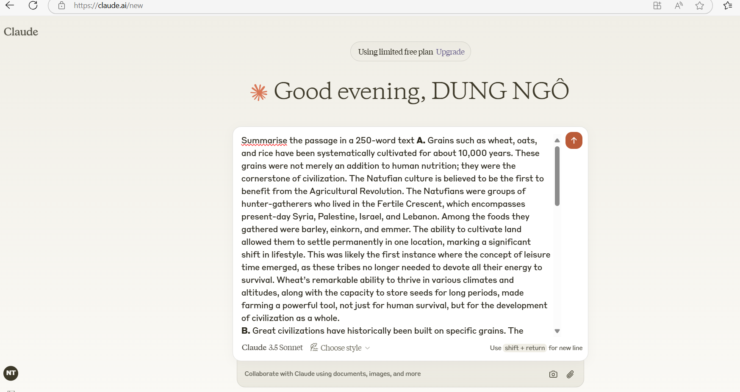

Here's a 250-word summary of the passage:
The text traces the evolution and significance of grain cultivation, particularly wheat, throughout human history. Beginning approximately 10,000 years ago, the systematic cultivation of grains marked a pivotal moment in human civilization, with the Natufian culture in the Fertile Crescent being among the first to practice agriculture. This transition enabled permanent settlements and introduced the concept of leisure time, as communities no longer needed to devote all their energy to survival. The passage highlights how different civilizations were built upon specific grains: the Babylonians and Egyptians relied on wheat, the Chinese on rice, and the Mesoamerican cultures on corn. While corn currently leads global production, wheat has been humanity's primary food source for millennia. The text traces wheat's evolution from its ancestor, einkorn, through natural breeding to tetraploid varieties like emmer and durum, and finally to hexaploid wheats like spelt and aestivum. A significant breakthrough occurred in the mid-20th century with Norman Borlaug's development of dwarf and semi-dwarf wheat varieties. Through extensive experimentation in Mexico, involving 6,000 breeding experiments, Borlaug created a semi-dwarf aestivum variety that dramatically increased yields, producing eight times more per acre than traditional varieties. This achievement earned him numerous prestigious awards, including the Nobel Peace Prize, and led to his recognition as "the man who saved 1 billion lives." After the 1970s, these modified wheat varieties spread globally, transforming agricultural productivity worldwide.
- An open-cloze exercise can be designed from the summary:
Read the following passage and fill in each blank ONE suitable word:
The text traces the evolution and significance of grain cultivation, particularly wheat, throughout human history. Beginning approximately 10,000 years ago, the (1) ______ cultivation of grains marked a pivotal moment in human civilization, with the Natufian culture in the Fertile Crescent being among the first to practice agriculture. This transition (2) ______ permanent settlements and introduced the concept of leisure time, as communities no longer needed to devote all their energy to survival. The passage highlights how different civilizations were built (3) ______ specific grains: the Babylonians and Egyptians relied on wheat, the Chinese on rice, and the Mesoamerican cultures on corn. While corn currently (4) ______ global production, wheat has been humanity's primary food source for millennia. The text traces wheat's (5) ______ from its ancestor, einkorn, through natural breeding to tetraploid varieties like emmer and durum, and finally to hexaploid wheats like spelt and aestivum. A significant breakthrough occurred in the mid-20th century with Norman Borlaug's development of dwarf and semi-dwarf wheat (6) ______. Through extensive experimentation in Mexico, involving 6,000 breeding experiments, Borlaug created a semi-dwarf aestivum variety that (7) ______ increased yields—producing eight times more per acre than traditional varieties. This achievement (8) ______ him numerous prestigious awards, including the Nobel Peace Prize, and led to his (9) ______ as "the man who saved 1 billion lives." After the 1970s, these modified wheat varieties spread globally, (10) ______ agricultural productivity worldwide.
b. Use Copilot to make Multiple Choice questions according to the passage
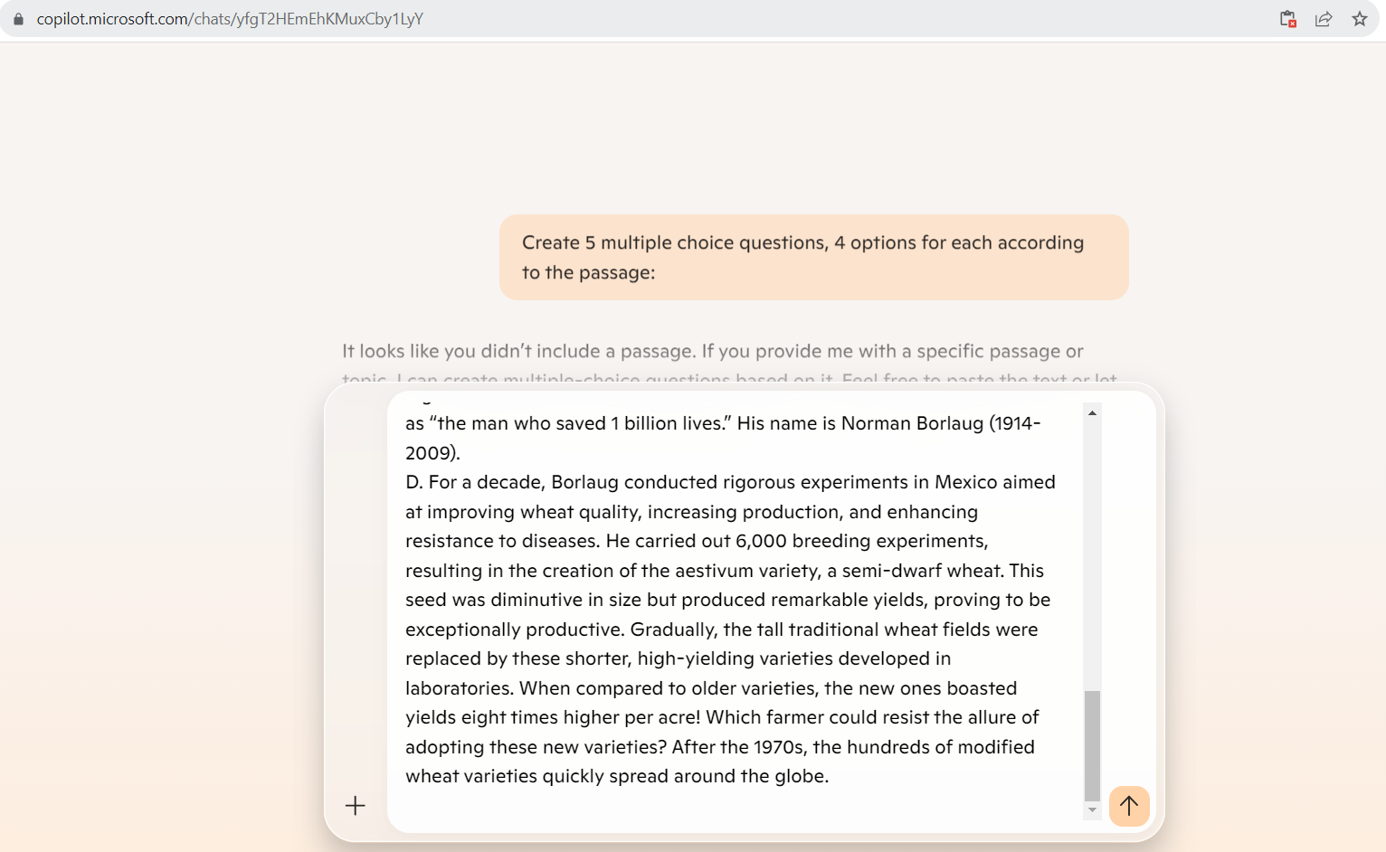
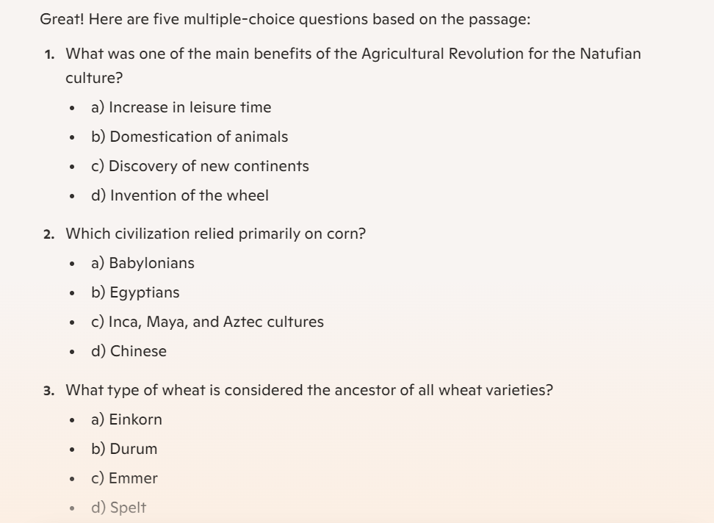 | 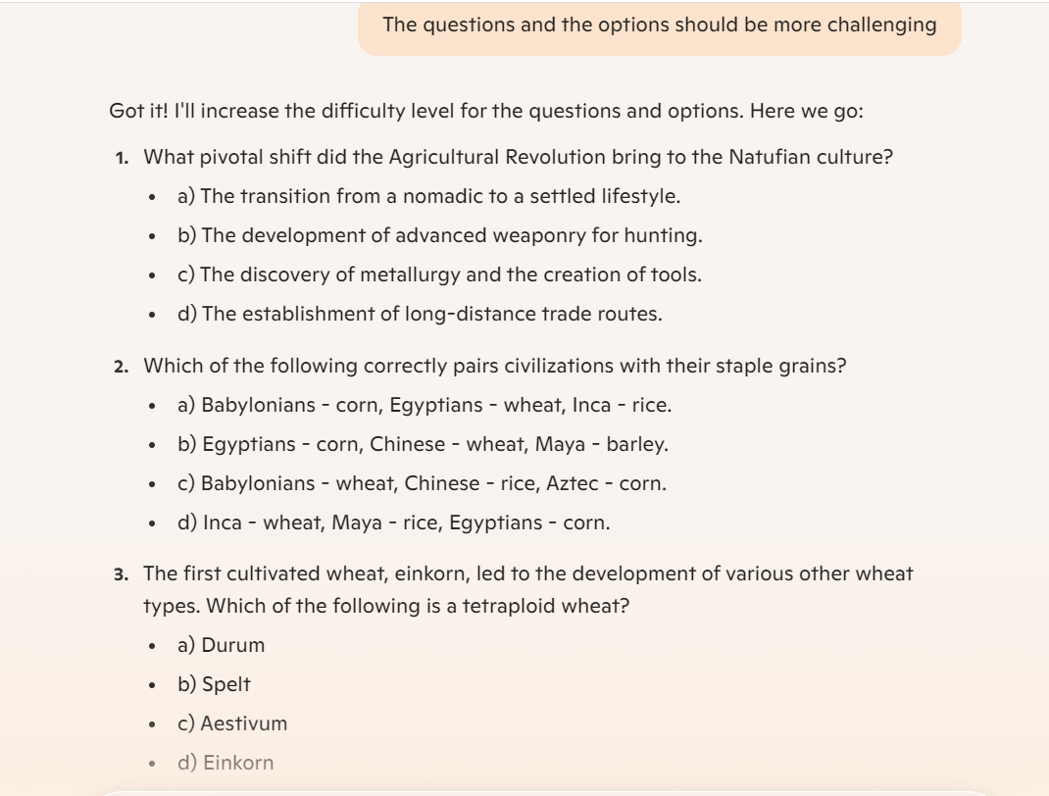
The final production can be as follows:
Read the passage and choose the best answer A, B, C, or D to answer the following questions.
Wheat: a troublemaker
A. Grains such as wheat, oats, and rice have been systematically cultivated for about 10,000 years. These grains were not merely an addition to human nutrition; they were the cornerstone of civilization. The Natufian culture is believed to be the first to benefit from the Agricultural Revolution. The Natufians were groups of hunter-gatherers who lived in the Fertile Crescent, which encompasses present-day Syria, Palestine, Israel, and Lebanon. Among the foods they gathered were barley, einkorn, and emmer. The ability to cultivate land allowed them to settle permanently in one location, marking a significant shift in lifestyle. This was likely the first instance where the concept of leisure time emerged, as these tribes no longer needed to devote all their energy to survival. Wheat’s remarkable ability to thrive in various climates and altitudes, along with the capacity to store seeds for long periods, made farming a powerful tool, not just for human survival, but for the development of civilization as a whole.
B. Great civilizations have historically been built on specific grains. The Babylonians and Egyptians depended on wheat, the Chinese on rice, and the Inca, Maya, and Aztec cultures on corn. Today, it can be said that the economy of America is based on corn, Asia on rice, and many other parts of the world on wheat. Although wheat comes second to corn in global annual production—largely due to its use as animal feed—it has been the primary food source for humans for the past ten millennia. Over time, various new types and varieties of wheat have emerged through natural breeding and human intervention, as farmers selected seeds with desirable traits. The first cultivated wheat, known as einkorn, is considered the ancestor of all wheat varieties.
C. Following einkorn, natural breeding led to the development of tetraploid wheats, such as emmer and durum. Hexaploid wheats, like spelt and aestivum (the most widespread variety today), also arose through natural processes. These were primarily the types of wheat cultivated by humans until the 1950s and 1960s. Then, a remarkable scientific breakthrough occurred, leading to the introduction of dwarf and semi-dwarf wheat varieties. The scientist behind this advancement was awarded the Nobel Peace Prize in 1970 and received numerous prestigious honors, including the Congressional Gold Medal and the Presidential Medal of Freedom, the highest awards that a citizen can receive in the USA. He is often referred to as “the man who saved 1 billion lives.” His name is Norman Borlaug (1914-2009).
D. For a decade, Borlaug conducted rigorous experiments in Mexico aimed at improving wheat quality, increasing production, and enhancing resistance to diseases. He carried out 6,000 breeding experiments, resulting in the creation of the aestivum variety, a semi-dwarf wheat. This seed was diminutive in size but produced remarkable yields, proving to be exceptionally productive. Gradually, the tall traditional wheat fields were replaced by these shorter, high-yielding varieties developed in laboratories. When compared to older varieties, the new ones boasted yields eight times higher per acre! Which farmer could resist the allure of adopting these new varieties? After the 1970s, the hundreds of modified wheat varieties quickly spread around the globe.
Question 1. What pivotal shift did the Agricultural Revolution bring to the Natufian culture?
a) Transition from a nomadic to a settled lifestyle.
b) Development of advanced weaponry and tools for hunting.
c) Discovery of metallurgy and the creation of durable tools.
d) Establishment of extensive long-distance trade networks.
Question 2. Which of the following correctly pairs civilizations with their staple grains?
a) Babylonians - corn, Egyptians - wheat, Inca - rice.
b) Egyptians - corn, Chinese - wheat, Maya - barley.
c) Babylonians - wheat, Chinese - rice, Aztec - corn.
d) Inca - wheat, Maya - rice, Egyptians - corn.
Question 3. The first cultivated wheat, einkorn, led to the development of various other wheat types. Which of the following is a tetraploid wheat?
a) Durum, a wheat used for pasta production.
b) Spelt, an ancient wheat with a tough husk.
c) Aestivum, the most widespread wheat variety today.
d) Einkorn, considered the ancestor of all wheat.
Question 4. Norman Borlaug is renowned for his work in wheat cultivation. Which of the following honors did he NOT receive for his contributions?
a) Nobel Peace Prize, for his scientific achievements.
b) Congressional Gold Medal, a prestigious US award.
c) Pulitzer Prize, for groundbreaking journalism work.
d) Presidential Medal of Freedom, highest US civilian award.
Question 5. Borlaug's introduction of semi-dwarf wheat varieties revolutionized agriculture. What was the primary reason for the adoption of these varieties by farmers globally?
a) Increased resistance to severe drought conditions.
b) Enhanced productivity and remarkably higher yields.
c) Greater adaptability to extremely acidic soil conditions.
d) Shorter growing season compared to traditional wheat.
c. Use Gemini to make Multiple Matching exercise according to the passage
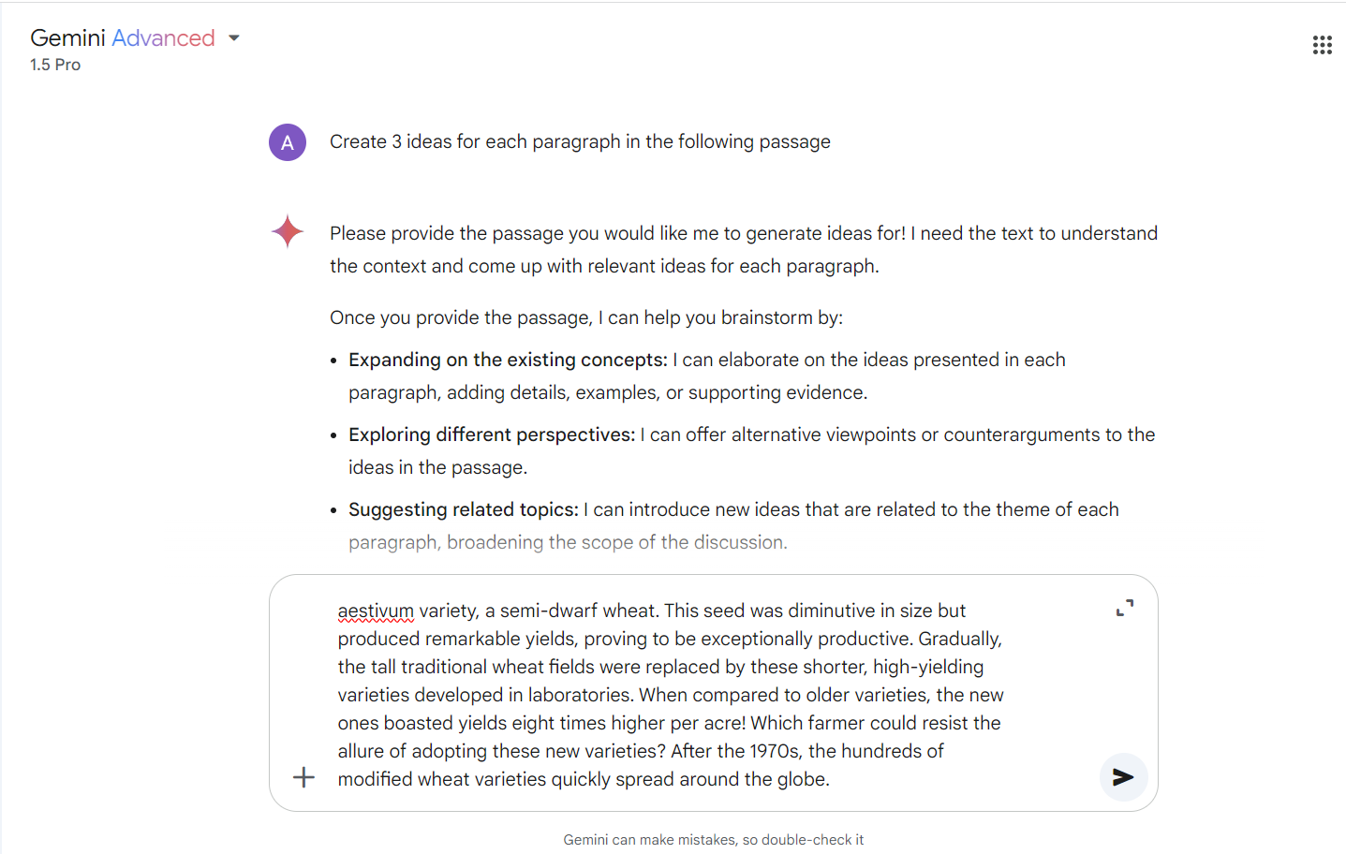 | 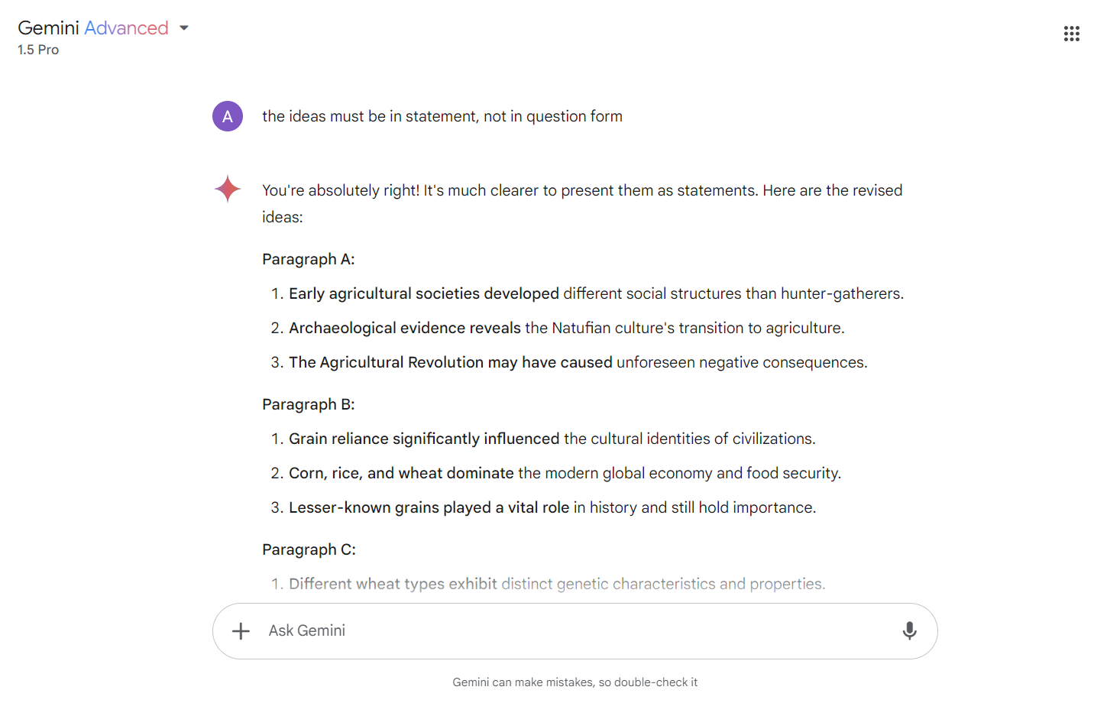
The final production can be as follows:
You are going to read an extract from a book on wheat. Choose from the sections (A-D), some sections may be chosen more than once.
Wheat: a troublemaker
A. Grains such as wheat, oats, and rice have been systematically cultivated for about 10,000 years. These grains were not merely an addition to human nutrition; they were the cornerstone of civilization. The Natufian culture is believed to be the first to benefit from the Agricultural Revolution. The Natufians were groups of hunter-gatherers who lived in the Fertile Crescent, which encompasses present-day Syria, Palestine, Israel, and Lebanon. Among the foods they gathered were barley, einkorn, and emmer. The ability to cultivate land allowed them to settle permanently in one location, marking a significant shift in lifestyle. This was likely the first instance where the concept of leisure time emerged, as these tribes no longer needed to devote all their energy to survival. Wheat’s remarkable ability to thrive in various climates and altitudes, along with the capacity to store seeds for long periods, made farming a powerful tool, not just for human survival, but for the development of civilization as a whole.
B. Great civilizations have historically been built on specific grains. The Babylonians and Egyptians depended on wheat, the Chinese on rice, and the Inca, Maya, and Aztec cultures on corn. Today, it can be said that the economy of America is based on corn, Asia on rice, and many other parts of the world on wheat. Although wheat comes second to corn in global annual production—largely due to its use as animal feed—it has been the primary food source for humans for the past ten millennia. Over time, various new types and varieties of wheat have emerged through natural breeding and human intervention, as farmers selected seeds with desirable traits. The first cultivated wheat, known as einkorn, is considered the ancestor of all wheat varieties.
C. Following einkorn, natural breeding led to the development of tetraploid wheats, such as emmer and durum. Hexaploid wheats, like spelt and aestivum (the most widespread variety today), also arose through natural processes. These were primarily the types of wheat cultivated by humans until the 1950s and 1960s. Then, a remarkable scientific breakthrough occurred, leading to the introduction of dwarf and semi-dwarf wheat varieties. The scientist behind this advancement was awarded the Nobel Peace Prize in 1970 and received numerous prestigious honors, including the Congressional Gold Medal and the Presidential Medal of Freedom, the highest awards that a citizen can receive in the USA. He is often referred to as “the man who saved 1 billion lives.” His name is Norman Borlaug (1914-2009).
D. For a decade, Borlaug conducted rigorous experiments in Mexico aimed at improving wheat quality, increasing production, and enhancing resistance to diseases. He carried out 6,000 breeding experiments, resulting in the creation of the aestivum variety, a semi-dwarf wheat. This seed was diminutive in size but produced remarkable yields, proving to be exceptionally productive. Gradually, the tall traditional wheat fields were replaced by these shorter, high-yielding varieties developed in laboratories. When compared to older varieties, the new ones boasted yields eight times higher per acre! Which farmer could resist the allure of adopting these new varieties? After the 1970s, the hundreds of modified wheat varieties quickly spread around the globe.
In which sections are the following ideas detected:
- Early agricultural societies developed different social structures than hunter-gatherers.
- Archaeological evidence reveals the Natufian culture's transition to agriculture.
- The Agricultural Revolution may have caused unforeseen negative consequences.
- Grain reliance significantly influenced the cultural identities of civilizations.
- Corn, rice, and wheat dominate the modern global economy and food security.
- Lesser-known grains played a vital role in history and still hold importance.
- Different wheat types exhibit distinct genetic characteristics and properties.
- Norman Borlaug's work revolutionized wheat production and saved countless lives.
- The Green Revolution raises ethical concerns about intensive agriculture practices.
- Borlaug overcame numerous challenges in developing and promoting dwarf wheat.

3.2. Listening exercises
Step 1: Choose 1 video from Youtube: How social media impacts your mental health
Step 2: Use Vidau.ai or y2mate.nu to convert Youtube into mp3 audio file

Step 3: Use Elsa to transcribe the audio file
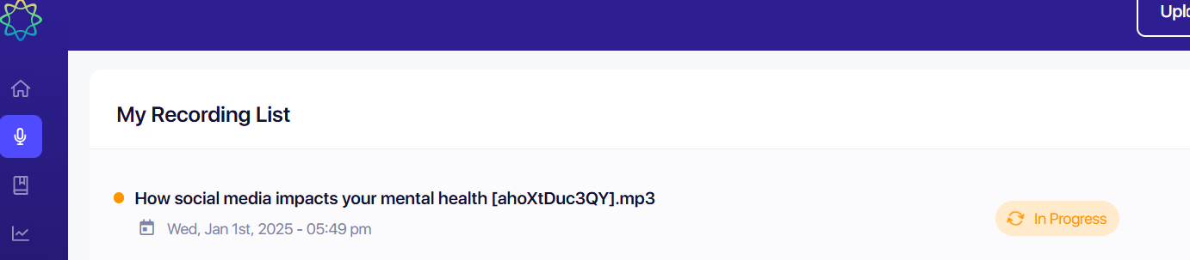
Host: Social media. It seems we just can't get enough of it. According to Neilson, last year, Americans streamed 21 million years’ worth of video. That's up 21% from the previous year. And that can lead to over-stimulation. Joining us this morning to discuss is Doctor Nicole Andrioli, a PhD with Pathways Psychological Services. Good morning. So, good to see you morning. And not only are people scrolling, but now they're switching back and forth from different apps. I mean, what is getting us so caught up in this?
Dr. Nicole Andrioli: Right? And that need for constant stimulation. So, there's a couple of reasons. One, it's habit-forming. So, we get into these habits where when we're bored, when we're idle, sometimes when we're anxious, we're reaching to do the same things over and over again to fill that need. So, that's one of the reasons. A big one is the dopamine release that we experience when we are constantly scrolling and seeking out new, interesting and exciting information. The release of dopamine in the brain is reinforcing. So, we're constantly seeking that out. So, if we're going through our social media feed, and we are experiencing the dopamine release, but then all of a sudden, you know, I've been on this app for a little while. It's starting to get a little mundane, a little boring. Let me switch over to this other app so that I can find something new and exciting to look at.
Host: And it seems all of the scrolling is kind of changing people's view of themselves and the world too.
Dr. Nicole Andrioli: Absolutely. There's a huge connection between social media use and overuse and how we feel about ourselves from a mental health perspective. There's research that shows that it's connected to anxiety, depression, loneliness, social isolation. If you think about the things that you're look at, looking at these really curated over-edited versions of people's lives, it's creating anxiety in us. If we feel as though we're not keeping up with their expectations and their achievements. It can cause body image issues. We can also be really overwhelmed with the wealth of information that we are receiving, not being able to really discern what is considered misinformation or fake news. And let's not forget the influence that the algorithm plays. It's constantly feeding us content that's very aligned with what it thinks our beliefs are. So, now we're receiving very limited information. We're not getting exposure to diverse information and it's keeping things going very polarized.
Host: So, you have some tips to help us manage that screen time. The first is focus time. What is that?
Dr. Nicole Andrioli: So, think about focus time as setting up very specific carved out time where I'm gonna focus on this task that needs to be done. So, I'm going to eliminate distractions. And distractions can be everything from clutter to notifications on your phone or your laptop to noise in the backgrounds. It's really important to, um, focus on not multitasking, but single tasking, which is something that most of us aren't very good at anymore.
Host: And you also say you need to focus some time on silence. Tell me about reflection as part of the tips.
Dr. Nicole Andrioli: Reflection plays a big role. It's really hard to be aware of our behavior and change behavior if we're not aware of what the behavior is. So, the reflection piece of it is really understanding what are social media habits? When are we reaching for our phones? Is it because we're bored? Is it because we're procrastinating? How long are we staying on social media? And the really important piece is, how is it making us feel? How is it affecting us? So, being able to really sit in silence and reflect and be really honest with yourself is really important to that.
Host: Well, Doctor Nicole Andreale, it's good to see you. Thank you so much.
Step 4: Use ChatGPT or Grammarly to check grammar and spelling mistakes
Then, according to different purposes, use different AI platforms to design the tasks.
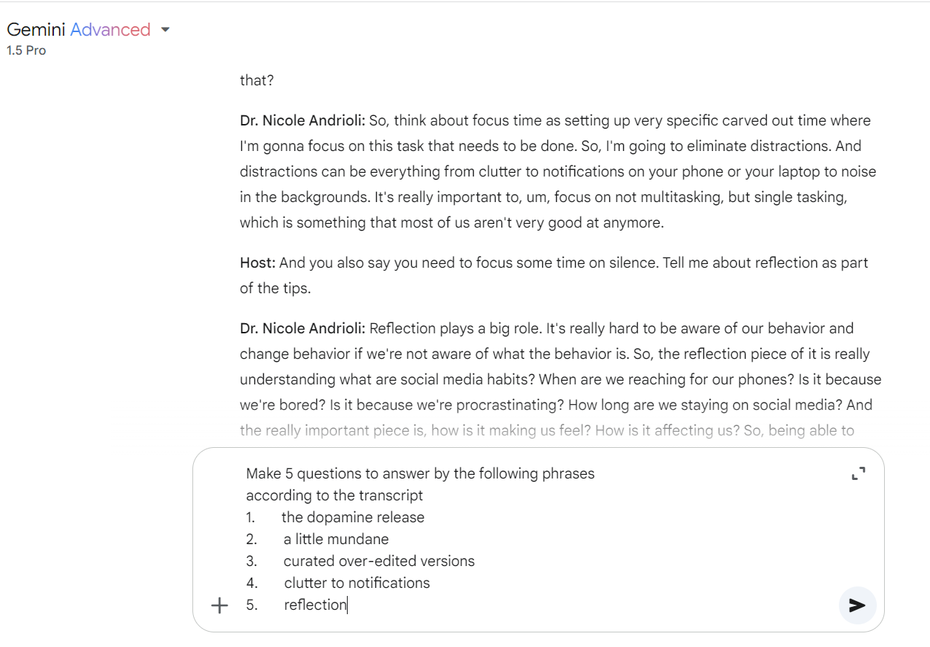
Here are 5 questions designed by Gemini:
1. What is a primary reason people get hooked on social media, and how does it affect the brain?
- Answer: the dopamine release
2. How might someone feel if they've been scrolling through the same social media app for a while?
- Answer: a little mundane
3. What contributes to anxiety and body image issues when browsing social media?
- Answer: curated over-edited versions
4. What are some examples of distractions that should be eliminated during focus time?
- Answer: clutter to notifications
5. What practice is crucial for understanding and changing one's social media habits?
- Answer: reflection
The exercise can be designed as follows:
For questions 1-5, listen to part of an interview about the impact of social media and answer the questions. Write NO MORE THAN FOUR WORDS taken from recording for each answer.
1. What is a primary reason people get hooked on social media, and how does it affect the brain?
_______________________________________________________________________________
2. How might someone feel if they've been scrolling through the same social media app for a while?
_______________________________________________________________________________
3. What contributes to anxiety and body image issues when browsing social media?
_______________________________________________________________________________
4. What are some examples of distractions that should be eliminated during focus time?
_______________________________________________________________________________
5. What practice is crucial for understanding and changing one's social media habits?
_______________________________________________________________________________
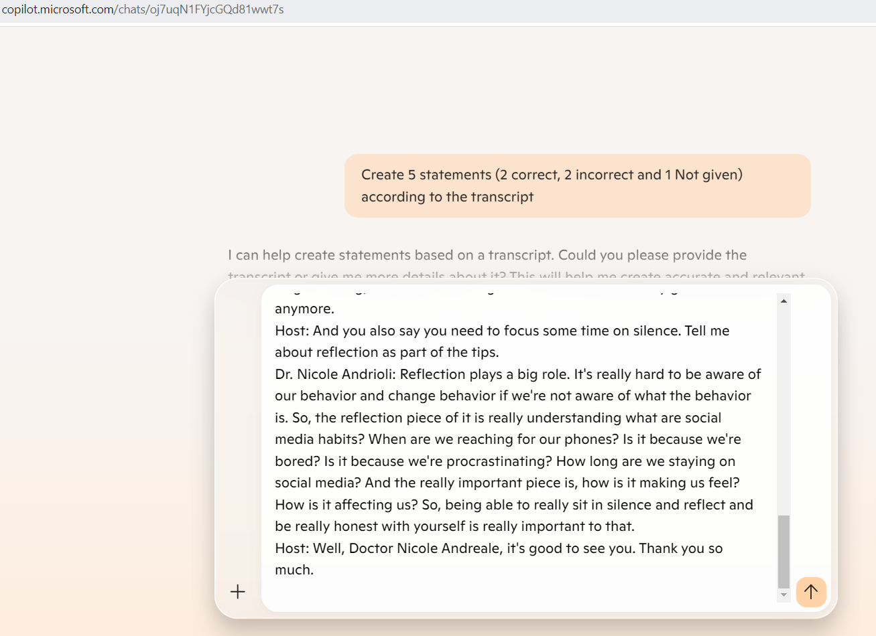
Here are 5 questions designed by Copilot:
Correct Statements:
- Social media use and overuse are connected to mental health issues such as anxiety, depression, loneliness, and social isolation.
- The release of dopamine in the brain when using social media reinforces the habit of constantly scrolling and seeking new information.
Incorrect Statements:
- Dr. Nicole Andrioli suggests that multitasking is the best way to manage screen time effectively.
- According to Neilson, Americans streamed 21 million hours’ worth of video last year.
Not Given Statement:
- Dr. Nicole Andrioli mentions specific social media platforms like Facebook and Instagram in the discussion.
The exercise can be designed as follows:
For questions 6-10, listen to part of an interview about the impact of social media and decide whether these statements are True (T), False (F), or Not given (NG).
6. Social media use and overuse are connected to mental health issues such as anxiety, depression, loneliness, and social isolation.
7. The release of dopamine in the brain when using social media reinforces the habit of constantly scrolling and seeking new information.
8. Dr. Nicole Andrioli suggests that multitasking is the best way to manage screen time effectively.
9. According to Neilson, Americans streamed 21 million hours’ worth of video last year.
10. Dr. Nicole Andrioli mentions specific social media platforms like Facebook and Instagram in the discussion.
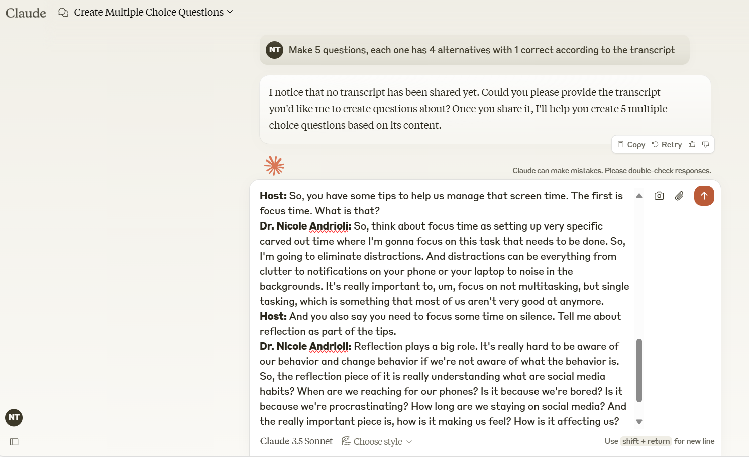
Here are 5 questions designed by Claude:
1. According to Nielsen, how much did video streaming increase from the previous year?
a) 15% b) 18% c) 21% d) 25%
2. What is one of the main reasons people constantly switch between social media apps?
a) To save battery life
b) To connect with different friend groups
c) To seek dopamine release through new and exciting content
d) To avoid advertisements
3. Which of these was NOT mentioned as a mental health impact of social media use?
a) Anxiety b) Depression c) Schizophrenia d) Social isolation
4. What is Dr. Andrioli's recommendation regarding task management?

a) Multitasking as much as possible
b) Single tasking with eliminated distractions
c) Taking frequent social media breaks
d) Working in noisy environments

5. According to Dr. Andrioli, why is reflection important when managing social media use?

a) To increase followers on social platforms
b) To improve internet connection speed
c) To understand our habits and their effects on us
d) To reduce phone battery consumption

The exercise can be designed as follows:
For questions 11-15, listen to part of an interview about the impact of social media and choose the answer (A, B, C or D) which fits best according to what you hear.
1. According to Nielsen, how much did video streaming increase from the previous year?
a) 15% b) 18% c) 21% d) 25%
2. What is one of the main reasons people constantly switch between social media apps?
a) To save battery life
b) To connect with different friend groups
c) To seek dopamine release through new and exciting content
d) To avoid advertisements
3. Which of these was NOT mentioned as a mental health impact of social media use?
a) Anxiety b) Depression c) Schizophrenia d) Social isolation
4. What is Dr. Andrioli's recommendation regarding task management?

a) Multitasking as much as possible
b) Single tasking with eliminated distractions
c) Taking frequent social media breaks
d) Working in noisy environments

5. According to Dr. Andrioli, why is reflection important when managing social media use?

a) To increase followers on social platforms
b) To improve internet connection speed
c) To understand our habits and their effects on us
d) To reduce phone battery consumption
Then, according to different purposes, use different AI platforms to design the tasks.
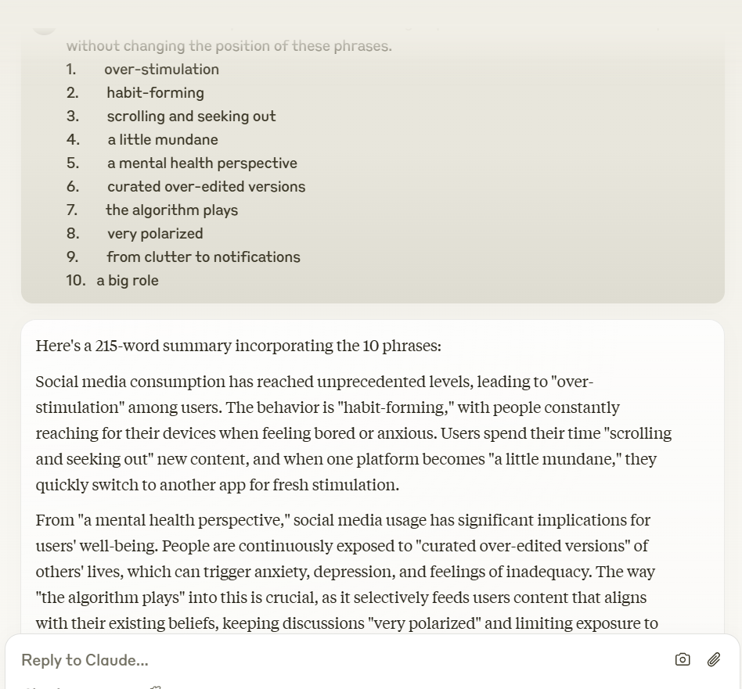
Here is the summary designed by Claude:
Social media consumption has reached unprecedented levels, leading to over-stimulation among users. The behavior is habit-forming, with people constantly reaching for their devices when feeling bored or anxious. Users spend their time scrolling and seeking out new content, and when one platform becomes "a little mundane," they quickly switch to another app for fresh stimulation.
From "a mental health perspective," social media usage has significant implications for users' well-being. People are continuously exposed to "curated over-edited versions" of others' lives, which can trigger anxiety, depression, and feelings of inadequacy. The way "the algorithm plays" into this is crucial, as it selectively feeds users content that aligns with their existing beliefs, keeping discussions "very polarized" and limiting exposure to diverse viewpoints.
To manage screen time effectively, experts recommend implementing focused work periods by eliminating distractions ranging "from clutter to notifications" on devices. Additionally, reflection plays "a big role" in understanding and modifying social media habits. This involves honestly evaluating when and why we reach for our phones, how long we spend on social media, and most importantly, how it affects our emotional state and overall well-being.

The exercise can be designed as follows:
For questions 16-25, listen to part of an interview about the impact of social media and Write NO MORE THAN FOUR WORDS taken from the recording for each answer.
Social media consumption has reached unprecedented levels, leading to (16) __________________ among users. The behavior is (17) __________________ , with people constantly reaching for their devices when feeling bored or anxious. Users spend their time (18) __________________ new content, and when one platform becomes (19) __________________ they quickly switch to another app for fresh stimulation.
From (20) __________________ social media usage has significant implications for users' well-being. People are continuously exposed to (21) __________________ of others' lives, which can trigger anxiety, depression, and feelings of inadequacy. The way (22) __________________ into this is crucial, as it selectively feeds users content that aligns with their existing beliefs, keeping discussions (23) __________________ and limiting exposure to diverse viewpoints.
To manage screen time effectively, experts recommend implementing focused work periods by eliminating distractions ranging (24) __________________ on devices. Additionally, reflection plays (25) __________________ in understanding and modifying social media habits. This involves honestly evaluating when and why we reach for our phones, how long we spend on social media, and most importantly, how it affects our emotional state and overall well-being.

4. Discussion: Advantages and Disadvantages of applying AI platforms in designing reading and listening exercises for gifted students

4.1. Advantages
- Personalized Learning Paths: AI platforms can analyze the individual strengths and weaknesses of gifted students and tailor reading and listening exercises to meet their unique needs. This personalized approach ensures that students remain challenged and engaged without being overwhelmed.
- Interactive and Engaging Content: AI enables the creation of dynamic and interactive exercises, such as gamified quizzes, real-time feedback, and adaptive difficulty levels. This helps gifted students stay motivated and enhances their learning experience.
- Efficient Use of Time: AI platforms can generate diverse and high-quality exercises quickly, saving teachers valuable time. Teachers can focus more on mentoring students rather than creating or grading assignments manually.
- Exposure to Real-world Contexts: AI can curate authentic reading and listening materials, such as news articles, podcasts, or interviews, aligning with students’ interests and preparing them for real-world applications of language skills.
- Continuous Feedback and Improvement: AI platforms provide instant feedback to students, helping them identify and correct errors immediately. This fosters self-paced learning and encourages students to take ownership of their progress.
- Enhanced Analytical Insights for Teachers: AI systems can analyze student performance data and offer insights into their learning patterns, helping teachers identify areas that require more attention or additional support.

4.2. Disadvantages
Limited Creativity and Flexibility: While AI can generate exercises, it may lack the creative and nuanced approach of a human teacher in designing contextually rich and thought-provoking tasks suitable for gifted students.
- Dependence on Technology: Over-reliance on AI platforms might reduce students' ability to learn through traditional methods and may limit their interaction with peers and teachers, potentially hindering collaborative skills.
- High Initial Investment: Implementing AI platforms requires significant financial resources for purchasing software, hardware, and training teachers to use the technology effectively.
- Potential Lack of Cultural Relevance: AI-generated materials might not always reflect the cultural nuances or specific educational goals of high schools for the gifted, which could make some exercises less effective.
- Privacy and Data Security Concerns: Using AI platforms often involves collecting and storing student data, which raises concerns about the security and ethical use of sensitive information.
- Risk of Oversimplification: AI platforms might oversimplify complex language tasks, which could lead to a lack of depth in the exercises, potentially under-challenging gifted students.
To maximize the benefits of AI platforms while addressing the disadvantages, it is crucial to adopt a blended approach. Teachers should use AI as a supplementary tool to enhance their teaching methods rather than replacing traditional approaches. Regular evaluation of AI-generated materials for cultural and contextual relevance and ensuring strict data privacy protocols will ensure the platform aligns with the goals of high schools for the gifted.

PART C: CONCLUSION

I. Summary of findings
This study delves into how educators and students can weave AI into the fabric of reading and listening activities designed for gifted students. The goal is to provide them with personalized, intellectually engaging, and adaptable learning experiences. The findings clearly show that AI has immense potential to cater to the unique educational needs of gifted learners in several significant ways.
With AI-driven tools, educators can craft dynamic, individualized learning experiences for these students. Thanks to adaptive systems, AI can tweak the difficulty of reading and listening materials on the fly, ensuring that students are consistently challenged without feeling overwhelmed. By personalizing the learning journey, AI empowers students to move at their own pace and dive into advanced topics that truly spark their interest. One of the biggest hurdles with gifted learners is keeping them engaged. Traditional curricula often miss the mark when it comes to providing enough intellectual stimulation, which can lead to boredom or disengagement. AI steps in to change that by delivering highly relevant, thought-provoking content that adapts based on the student’s responses. This ability to tackle increasingly complex material not only fosters a sense of achievement but also ignites an intrinsic motivation to learn.
Moreover, AI-powered tools do more than just help with basic comprehension; they also encourage higher-order thinking. For instance, AI can prompt students to analyze, synthesize, and evaluate information by presenting them with complex scenarios in both reading and listening exercises. This approach allows gifted students to engage in tasks that promote deeper cognitive involvement, such as problem-solving, debating, and theoretical reasoning.
AI systems offer quick, personalized feedback that really helps students sharpen their understanding and skills. Whether it’s through interactive reading notes, vocabulary breakdowns, or listening comprehension tests, AI makes sure the feedback is timely, relevant, and constructive. This ongoing feedback loop allows students to fix mistakes, tweak their strategies, and dive deeper into the material. AI also supports multimodal learning by blending text, audio, and visual elements to suit various learning styles. This method boosts comprehension, making the content more engaging and easier to grasp. For gifted students, who often excel at processing different types of information at once, this multimodal strategy can lead to richer learning experiences and better retention.
In short, AI provides a powerful platform for creating and delivering highly personalized, challenging, and stimulating reading and listening activities tailored for gifted students. Research indicates that AI can meet the unique educational needs of these learners by increasing engagement, encouraging independent study, and fostering intellectual growth.

II. Implications for education and Recommendations
Schools and educators should think about weaving AI tools into the curriculum for gifted learners, particularly when it comes to reading and listening comprehension. AI can tailor content to individual needs, provide varied learning experiences, and push students in ways that traditional methods often fall short. This could mean embracing AI platforms that offer personalized reading lists, engaging audio-visual lessons, and instant feedback.
To effectively harness AI in gifted education, teachers will need proper training on how to incorporate these tools into their teaching. Professional development programs that focus on AI literacy and the smart use of AI-driven educational tools will be crucial. Educators must learn to pinpoint the right AI tools for various learning goals and how to track student progress using insights from AI data. While AI holds great promise for enriching the learning experiences of gifted students, we must also think about equitable access to these resources. Gifted students in underfunded schools or districts might miss out on advanced AI technologies. To address this, educational policymakers should strive to ensure that all students, regardless of their socioeconomic status, can access these groundbreaking tools. This could involve forming public-private partnerships, providing subsidies for AI resources, or launching initiatives aimed at closing the digital divide.
With the integration of AI tools comes the responsibility to protect student data. Since AI systems often gather detailed information about students' performance, preferences, and progress, it’s vital for educators, schools, and developers to ensure that this data is safeguarded and used ethically. Policies should be established to protect the privacy of gifted students, especially when AI tools are employed for personalized learning as follows:
1. Invest in AI-enhanced tools and platforms for gifted education
To optimize the learning experience for gifted students, educational institutions should invest in AI-powered tools and platforms specifically designed for advanced learners. These platforms should:
- Offer adaptive learning systems that can dynamically adjust content to match the learner's cognitive abilities.
- Include multimodal learning experiences that combine reading, listening, and interactive elements to cater to different learning preferences.
- Allow for personalized learning pathways that align with the student's interests and academic goals.
2. Incorporate AI into teacher professional development
Teachers play a critical role in the effective integration of AI into the classroom. As such, it is important to:
- Develop professional development programs to train educators on how to use AI tools effectively.
- Focus on helping teachers understand how AI can support differentiated instruction, provide personalized feedback, and assess student progress.
- Encourage teachers to experiment with AI tools in the classroom and share best practices with their peers.
3. Foster collaboration between educators and AI developers
- The development of AI tools for education should be done in close collaboration with educators to ensure that the tools meet the specific needs of gifted students. This collaboration can help ensure that AI platforms:
- Address the unique cognitive and emotional needs of gifted learners.
- Provide advanced content that challenges students intellectually, while ensuring that the material remains accessible and engaging.
- Allow for flexibility in content delivery, enabling students to explore a wide range of topics that cater to their academic and personal interests.
4. Promote equity in access to AI tools
- As AI has the potential to enhance learning for all students, special attention should be paid to equity in its deployment. Schools should strive to:
- Ensure that AI tools are accessible to all gifted students, regardless of their socioeconomic status or geographic location.
- Partner with tech companies and government organizations to provide affordable access to AI-powered learning tools.
- Advocate for public funding or grants that allow schools, particularly in low-income areas, to access high-quality AI-based educational resources.

III. Future research directions
This study lays a solid groundwork for understanding how AI can be applied in gifted education, but there's still a need for more research to dive into its long-term effects. The current study is relatively small, with a limited number of participants. It would be beneficial to conduct a similar study with a larger group of subjects in different schools to gain a more comprehensive evaluation of the effectiveness of English teaching.
In summary, AI holds incredible promise for enhancing the educational experiences of gifted students, especially in reading and listening comprehension. By offering personalized, adaptive, and intellectually engaging content, AI can encourage deeper engagement, critical thinking, and independence among these learners. However, to implement this successfully, we need thoughtful planning, teacher training, and a strong commitment to equity and ethical standards. With the right support and resources, AI can truly transform how we meet the needs of gifted learners, helping them achieve their full academic potential and equipping them for the challenges of an increasingly complex world.

REFERENCES

- Betts, G. T., & Neihart, M. (1988). Profiles of the Gifted and Talented. Waco, TX: Prufrock Press.
- Duke, N. K., & Pearson, P. D. (2002). Effective practices for developing reading comprehension. In A. E. Farstrup & S. J. Samuels (Eds.), What research has to say about reading instruction (3rd ed., pp. 205-242). International Reading Association.
- Holmes, W., Bialik, M., Fadel, C., & Trilling, B. (2023). Artificial intelligence in education: Promises and implications for teaching and learning. Center for Curriculum Redesign.
- Luckin, R., Holmes, W., Griffiths, M., & Forcier, L. B. (2016). Intelligence unleashed: An argument for AI in education. Pearson.
- Reis, S. M., & Renzulli, J. S. (2009). The Schoolwide Enrichment Model: A How-to Guide for Educational Excellence (3rd ed.). Mansfield Center, CT: Creative Learning Press.
- Rost, M. (2011). Teaching and researching listening (2nd ed.). Pearson Education.
- Siegle, D. (2012). The Misunderstood Child: Understanding and Coping with Your Child's Learning Disabilities. New York, NY: Guilford Press.
- Tomlinson, C. A. (2014). The Differentiated Classroom: Responding to the Needs of All Learners (2nd ed.). Alexandria, VA: ASCD.
- VanTassel-Baska, J. (2003). Identification and Assessment of Gifted Students. Waco, TX: Prufrock Press.
- VanTassel-Baska, J., & Brown, E. F. (2007). Comprehensive Curriculum for Gifted Learners (3rd ed.). Boston, MA: Pearson Education.
- Webb, J. T., Gore, J. L., Amend, E. R., & DeVries, A. R. (2007). A Parent's Guide to Gifted Children. Scottsdale, AZ: Great Potential Press.
- Winebrenner, S. (2001). Teaching Gifted Kids in the Regular Classroom: Strategies and Techniques Every Teacher Can Use to Meet the Academic Needs of the Gifted and Talented. Minneapolis, MN: Free Spirit Publishing.

