**Mã đề 9.1.36**

**ĐỀ KIỂM TRA CUỐI KỲ I NĂM HỌC: 2022-2023**

**MÔN: TIẾNG ANH LỚP 9**

*Thời gian làm bài: 60 phút*

**A. LISTENING (2.0 POINTS**)

**I. Listen and choose the correct picture (1.0 point)**

*1. How does the man travel to Liverpool?* (nhận biết)

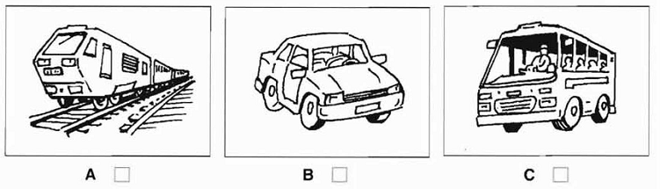

*2. Which bill has just arrived?*(nhận biết)

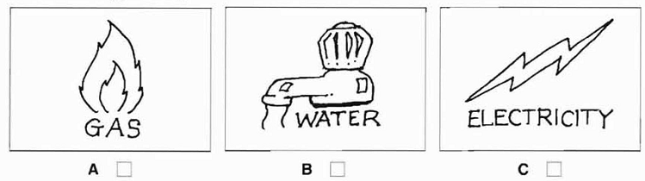

*3. What will they do tomorrow afternoon?* (thông hiểu)

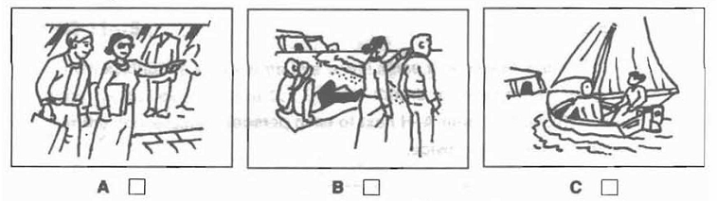

*4. How did the man hear about the fire?* (thông hiểu)

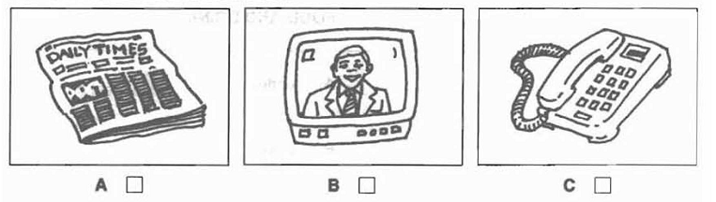

*5. What time did Mr Thompson ring?* (thông hiểu)

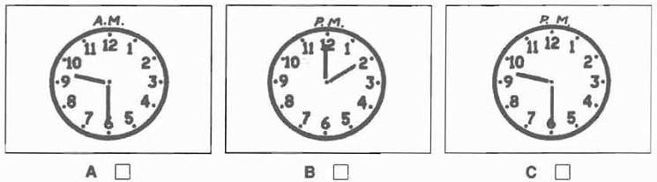

**II. Listen and write (1.0 point)**

**SPORT CLUB**

1. Where is it: Next to the ______________________factory (nhận biết)

2. Open which day: From_________________to Tuesday (nhận biết)

3. Times: Opens______________________ closes 10.30 (thông hiểu)

4. Club name: The ____________________Sports Club (thông hiểu)

5. Club phone number: ______________________ (nhận biết)

**B. GRAMMAR - VOCABULARY AND LANGUAGE FUNCTION (2.0 POINTS**)

**Choose the best answer to complete the sentence:**

1. My grandparents __________this workshop 30 years ago. (ngữ pháp - thông hiểu)

|  |  |  |
| --- | --- | --- |
| A. set up | B. passed down | C. faced up to |

2. Bat Trang is famous for its __________products. (từ vựng – nhận biết)

|  |  |  |
| --- | --- | --- |
| A. pottery | B. conical hat | C. silk |

3. When my brother was small, he _______ kites with my father. (ngữ pháp - thông hiểu)

A. was used to make B. used to make C. used to making

4. Air pollution is the__________problem in Beijing. (ngữ pháp – nhận biết)

A. more serious B. most serious C. most seriously

5. Mr. Long said that he________in Ho Chi Minh City. (ngữ pháp – nhận biết)

A. has lived B. is living C. lived

6. Some people think that schools put too much ___ on students nowadays. (từ vựng – thông hiểu)

A. interest B. emotion C. pressure

7. It is hard for people of different ____ to get along in an extended family. (từ vựng – thông hiểu)

A. generations B. families C. genders

8. It was very dark,_________ we decided to come home. (từ vựng – nhận biết)

|  |  |  |
| --- | --- | --- |
| A. because | B. if | C. so |

9. **Nhung**: “I am from Tay Ho village” - **Mark**: “_________” (chức năng NN – thông hiểu)

|  |
| --- |
| A. Conical hats are beautiful. B. Is it a craft village in Hue? C. I own a workshop. |

10. **Vy**: Would you mind lending me your bike? **Ha:** _______. (chức năng NN – nhận biết)

A. No, of course not B. Yes, let’s C. Good idea

**C. READING COMPREHENSION (2.0 POINTS)**

**I. Choose the word that best fits the blank space in the following passage (1.0 point)**

Living in a city has a number of drawbacks. Firstly, there is the problem of traffic (1)___ and traffic accidents. The increase in population and the increasing number of vehicles have (2)___ many accidents to happen every day. Secondly, air pollution (3) ___ affects people's health, and it also has a bad (4)___ on the environment. More and more city dwellers suffer from coughing or breathing problems. Thirdly, the city is noisy, even at night. Noise pollution comes from the traffic and from construction sites. Buildings are always being knocked down and rebuilt. These factors contribute to making city life (5)___ difficult for its residents.

1. A. calm B. jams C. light D. legacy (nhận biết)

2. A. caused B. made C. done D. got (thông hiểu)

3. A. actively B. negatively C. positively D. weakly (thông hiểu)

4. A. pressure B. consequence C. influence D. result (thông hiểu)

5. A. mostly B. very C. much D. more (nhận biết)

**II. Read the following passage then choose the correct answer (1.0 point)**

You can do a few things to make homework less stressful. First, be sure you understand what you have to do in your assignment. Write it down in your notebook if you need to, and don’t be afraid to ask questions about what is expected.

Second, use any extra time you have at school to work on your homework. Many schools have libraries that are specifically designed for students to study or to get their homework done.

Third, pace yourself. You need to plan your time. If it is a heavy homework day, you will need to **devote** more time to your homework.

Whenever you need some help, the first person you should ask for help is your teacher. Sometimes, it is good to have someone explain something that you are not completely sure of. In addition, you might also be able to get some help from another student. If there is a friend who is a good student, think about asking that person to study with you.

*36. In order to make homework less stressful, the first thing to do is ______.*(nhận biết)

A. to remember the deadline

B. to go to the school library as soon as possible

C. to understand what you have to do in your assignment

D. to know who can do it for you

*37. If you have any extra time at school, you should______.* (nhận biết)

A. use it to make your day planner B. study or get your homework done

C. use it to understand the assignment D. spend time with your friends

*38. When a student needs some help, the first person to ask for help is ______.* (nhận biết)

A. the best student at school B. his teacher

C. a member in his family D. his friend

*39. The word "devote" in the third paragraph can be best replaced by the word "______".* (thông hiểu)

A. reduce B. develop C. waste D. spend

*40. What is the main idea of the passage?* (thông hiểu)

A. Students can follow some advice to avoid worrying about homework.

B. Students should ask their teachers for help when they need it.

C. Students can do their homework in school libraries.

D. Students might get some help from their friends.

**D. WRITING (2.0 POINTS)**

**I. Rewrite the sentences in other way with the same meaning (1.0 point)**

1. Peter said: “I am listening to K-pop now”. (vận dụng)

=> Peter said that ………………………………………………………...….

2. Lan doesn’t know how to paint on ceramic pots. (vận dụng)

=> Lan wishes ..................................................................................................

3. Marry couldn’t decide when she should start her journey. (vận dụng)

=> Marry couldn’t decide when………………………………………………

4. David has good relationship with most of his colleagues. (vận dụng)

=> David gets ………………………………………………………………

5. People reported that two girls had been injured in the accident. (vận dụng)

=> It …………………………………………………………………………

**II. (1.0 point)** **Imagine that your Australian pen friend is coming to Viet Nam and will spend a day in your hometown/city. He/She has asked for your advice on the places of interest they should go to and the things they can do there.**

**Write an email to give him/her some information.** (vận dụng cao)

**E. SPEAKING (2.0 POINTS)**

Topic 1: Talk about the advantages of city life.

Topic 2: Talk about the disadvantages of city life.

Topic 3: Talk about one of the famous wonder of Viet Nam.

Topic 4: Talk bout your stress or pressure at school/ at home.

**THE END**

|  |
| --- |
| **HƯỚNG DẪN CHẤM ĐỀ KIỂM TRA HỌC KỲ I**  **NĂM HỌC: 2022 – 2023**  **Môn: Tiếng Anh 9 (Hệ 10 năm)** |

**A. LISTENING( 2.0 POINTS)**

**I. Listen and choose the correct picture (1.0 point). 0.2x5= 1point**

|  |  |  |  |  |
| --- | --- | --- | --- | --- |
| 1.C | 2. B | 3. B | 4. C | 5.A |

**II. Listen and write (1 point): 0.2x5= 1pt (wrong spelling: 0pt)**

|  |  |  |  |  |
| --- | --- | --- | --- | --- |
|  |  |  |  |  |

1. chocolate 2. Friday 3. 9.15(a.m)/nine fifteen 4. Hurley 5. 400319

**B. GRAMMAR- VOCABULARY AND LANGUAGE FUNCTION( 2.0 POINTS)**

**Choose the best answer to complete the sentence:**

1. A 2. A 3. B 4. B 5. C

6. C 7. A 8. C 9. B 10. A

**C. READING( 2.0 POINTS)**

**I. (1,0 point): 0.2pt/1**

|  |  |  |  |  |
| --- | --- | --- | --- | --- |
| 1. B | 2. A | 3. B | 4. C | 5. D |

**II. (1,0 point): 0.2pt/1**

|  |  |  |  |  |
| --- | --- | --- | --- | --- |
| 1. C | 2. B | 3. B | 4. D | 5. A |

**D. WRITING ( 2.0 POINTS)**

**I. Rewrite these sentences (1.0 point): 0.2pt/1**

1. Peter said (that) he was listening to K-pop then.

2. Lan wishes she knew how to paint on ceramic pots.

3. Marry couldn’t decide when to start her journey.

4. David gets on well with most of his colleagues.

5. It was reported that two girls had been injured in the accident.

**II. Write an email (1.0 point)**

**1. Form:**

- Correct form **(**0.1 point)

**2. Task fulfillment:**

- Task completed with relevant information (0.2 point)

- Well-organized (0.2 point)

**3. Language**:

- Accurate grammar (0.2 point)

- Appropriate vocabulary (0.2 point)

- Correct spelling and punctuation (0.1 point)

**E. SPEAKING (2.0 POINTS)**

***1. Introduction:***

Introduce yourself with basic information (name, class, age, hobby, family, etc.)(0.5 point)

(nhận biết)

***2. Each of Ss will draw lots to choose one of the following topics***: (1.5 point)

Topic 1: Talk about the advantages of city life.

Topic 2: Talk about the disadvantages of city life.

Topic 3: Talk about one of the famous wonder of Viet Nam.

Topic 4: Talk bout your stress or pressure at school/ at home.

*2.1: Talk about the topic*: 0.5 point (thông hiểu)

*2.2. Answer T’s questions about the topic*: 1.0 point (vận dụng)

**Topic 1: Talk about the advantages of city life.**

**Suggestions:** (thông hiểu)

+ Living condition

+ Entertainment

+ Studying/ health care/ … conditions,

+ ……

**Questions:** (vận dụng cao)

1. Do you like city life? What attracts you most?

2. Which city would you like to live in the future? Why?

**Topic 2: Talk about the disadvantages of city life.**

**Suggestions:**

+ the environment

+ the cost of living

+ traffic, crime, ….

+ ……..

**Questions:**

1. You think city life has such disadvantages, so do you want to live in the city in the futre? Why?

2. Which is the worst thing about city life? Do you think it can be solved in the future?

**Topic 3: Talk about one of the famous wonder of Viet Nam.**

**Suggestions:**

A wonder of Viet Nam you studied or you know: name, location, what is it famous for, activities when visiting, ………….

**Questions:**

1. Why do you choose this wonder to introduce?

2. What will you do to introduce this wonder to other people in our country or in the world?

**Topic 4: Talk bout your stress or pressure at school/ at home.**

**Suggestions:**

+ Your stress at school or at home or both? What is your problem?

+ Did you overcome or not?

+ Who can you ask for help?

……………

**Questions:**

1. It is necessary to have life skills for teenagers, which skills do you have? Which skills would you like to learn?

2. If you want to become a designer, but you parents want you to become a doctor because they think that designer is difficult to find job in the future. What would you do in this situation?

**THE END**