ĐỀ MINH HỌA SỐ 07
KỲ THI TỐT NGHIỆP TRUNG HỌC PHỔ THÔNG NĂM 2025
(Đề thi có 08 trang)
Môn thi: TIẾNG ANH
Thời gian làm bài: 50 phút, không kể thời gian phát đề
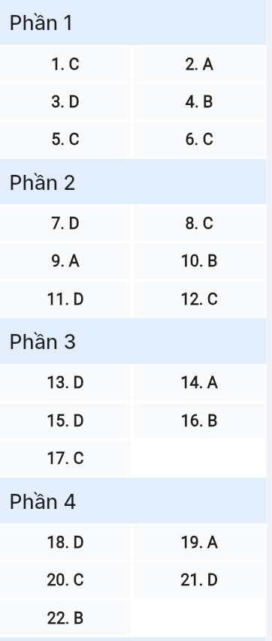
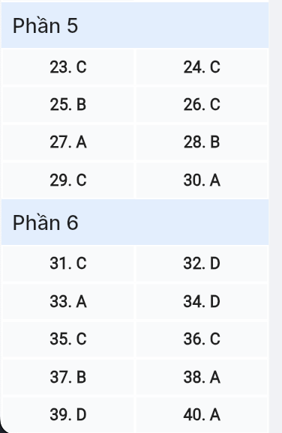
Read the following advertisement and mark the letter A, B, C or D on your answer sheet to indicate the option that best fits each of the numbered blanks from 1 to 6.
GALAXY Z7: BREAKTHROUGH TECHNOLOGY IN YOUR HANDS!
Are you searching for a smartphone that can truly keep up with your lifestyle? The new Galaxy Z7 is designed for those who want to (1) ______ advantage of advanced technology in every moment. With its (2) ______ you can enjoy seamless multitasking and smooth performance for all your favorite apps. The Galaxy Z7 features a high-resolution dual-lens camera (3) ______ your memories in stunning detail even in low light. We've crafted its interface so that navigation is intuitive and each feature is explained (4) ______ you through easy-to-follow prompts. Its long-lasting battery is ready to power you through busy days, which is perfect for those who crave for (5) ______. Embrace innovation and let this smartphone (6) ______ what's possible.

Question 1 [695601]: A. make B. get C. take D. keep
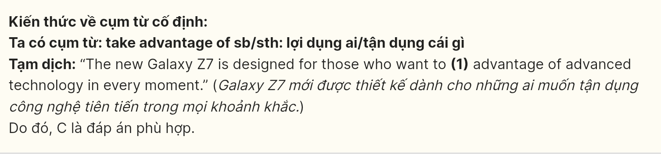
Question 2 [695602]: A. fast processing speed B. speed processing fast
C. fast speed processing D. processing speed fast
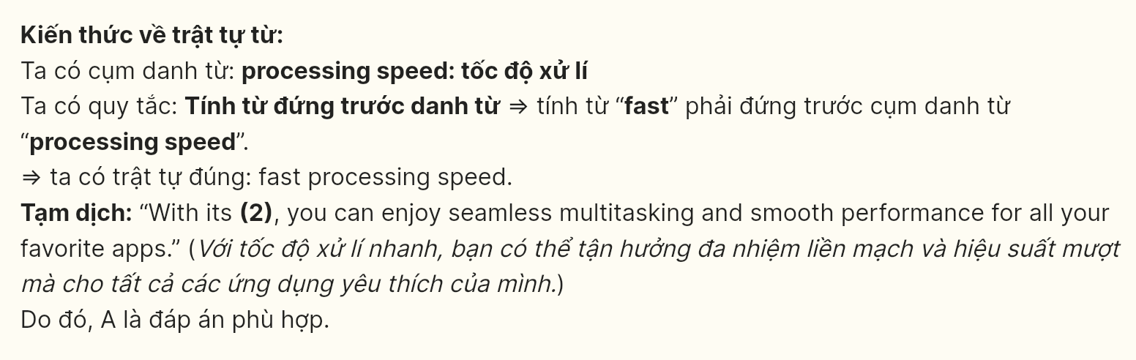
Question 3 [695603]: A. captured B. which capture C. is capturing D. capturing

Question 4 [695604]: A. for B. to C. in D. from
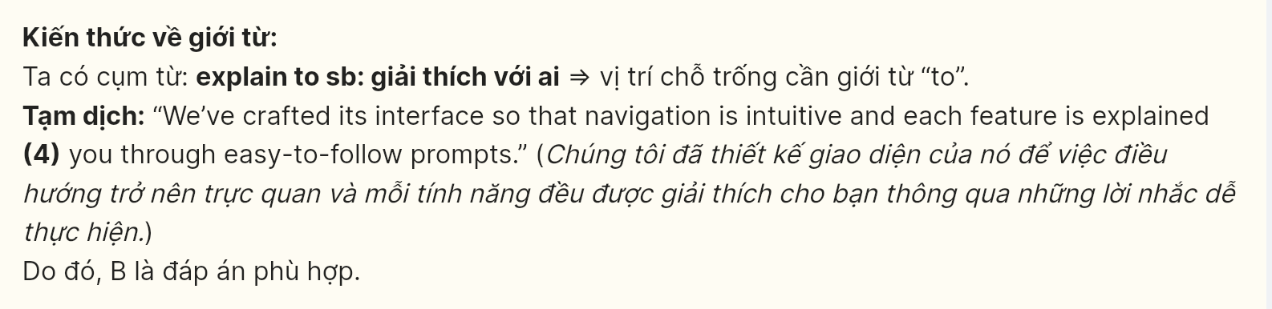
Question 5 [695605]: A. flexible B. flexibly C. flexibility D. inflexible
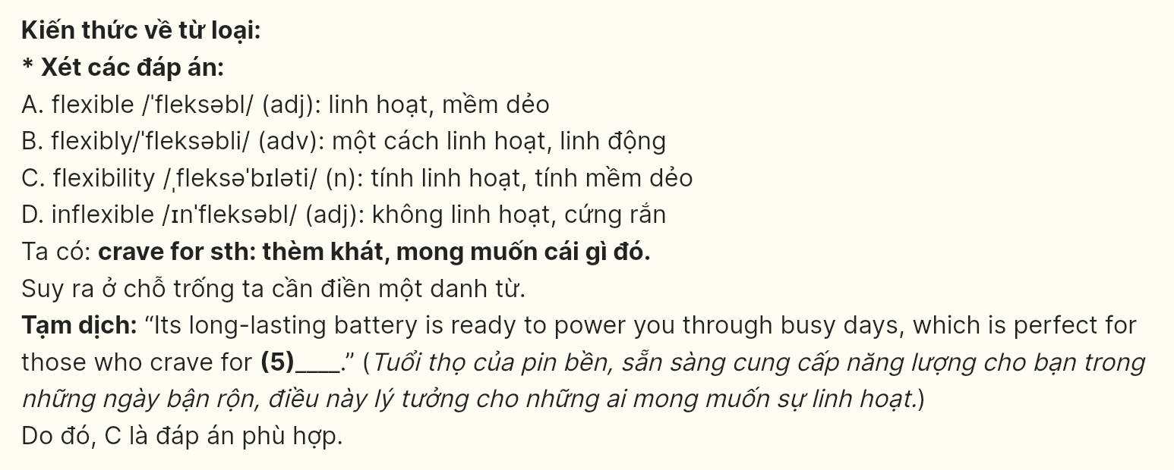
Question 6 [695606]: A. to redefine B. redefining C. redefine D. to redefining
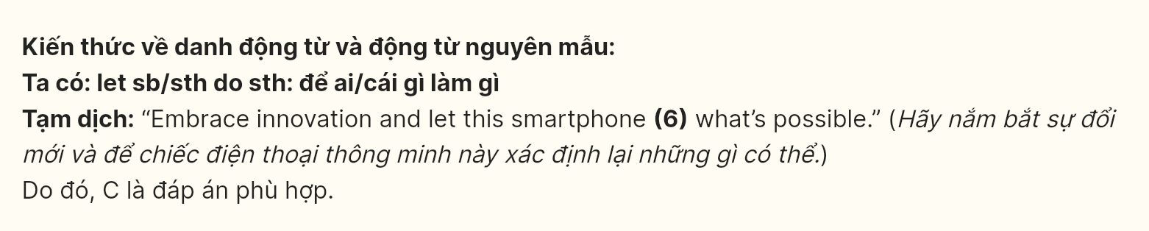
Read the following leaflet and mark the letter A, B, C or D on your answer sheet to indicate the option that best fits each of the numbered blanks from 7 to 12.
🌟 The Advantages of Joining a Group Tour 🌟
Discover stress-free and enriching travel experiences
🌍 The Drawbacks of Solo Travel:
While solo travel has its appeal, it comes with obstacles, such as (7) ______ areas and sorting out accommodations. These initial challenges can cause (8) ______ confusion with budgeting and scheduling. Planning everything on your own is often much more stressful and time-consuming.
🌟 Tour Benefits:
- Stress-Free Planning: Forget about (9) ______ all the details yourself. Let our team take care of the logistics so you can focus on enjoying your trip.
- Expert Guidance: Gain unique (10) ______ about each destination from experienced local guides. (11) _______ you might miss out on valuable knowledge and tips that aren’t found in guidebooks.
Variety of Choices: Group tours offer a wide (12) ______ of options, ensuring something for every traveler.
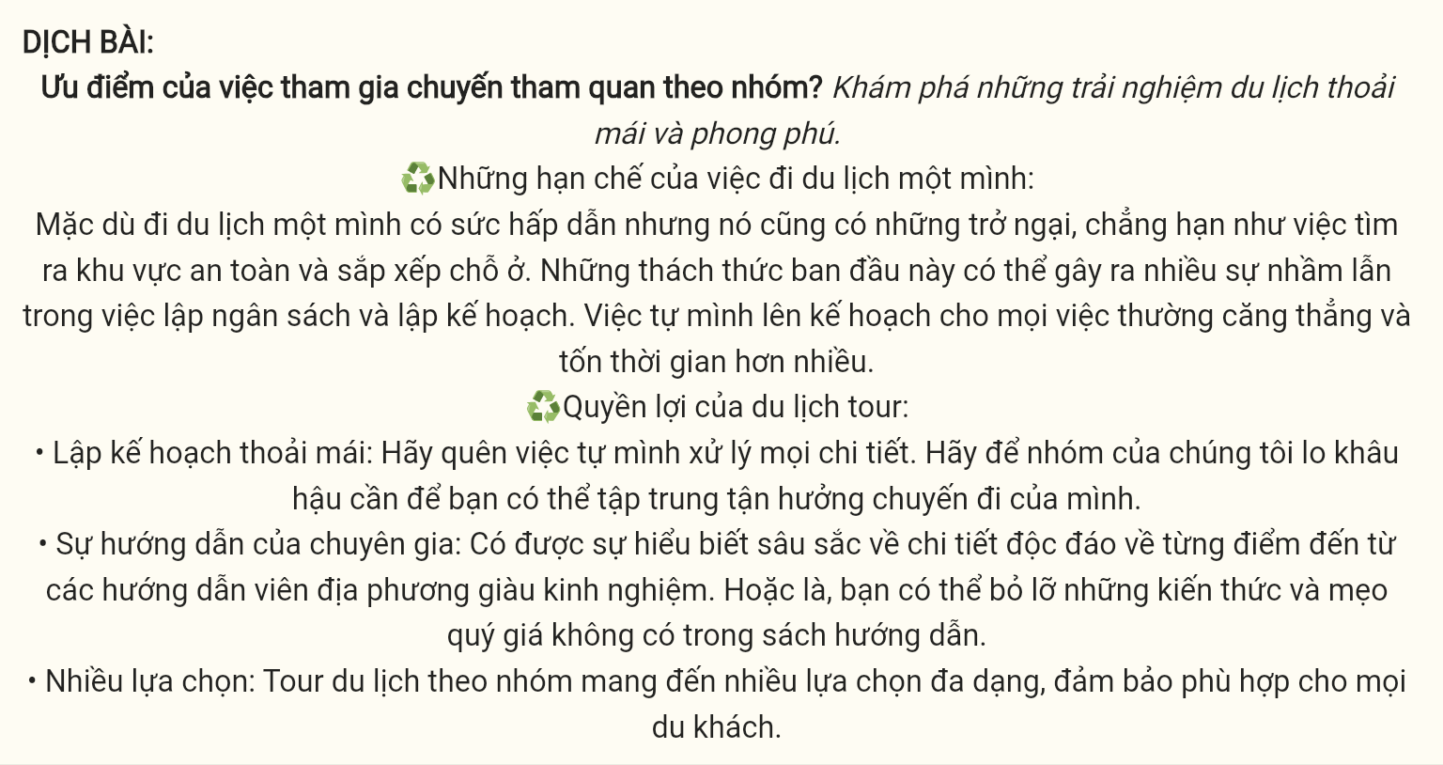
Question 7 [695607]: A. cutting out B. breaking down C. running D. figuring out
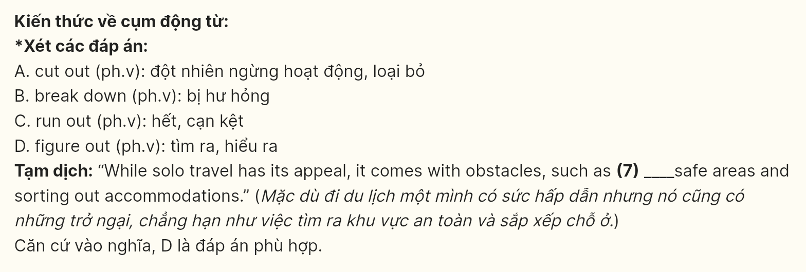
Question 8 [695608]: A. each B. a few C. a lot of D. a number of
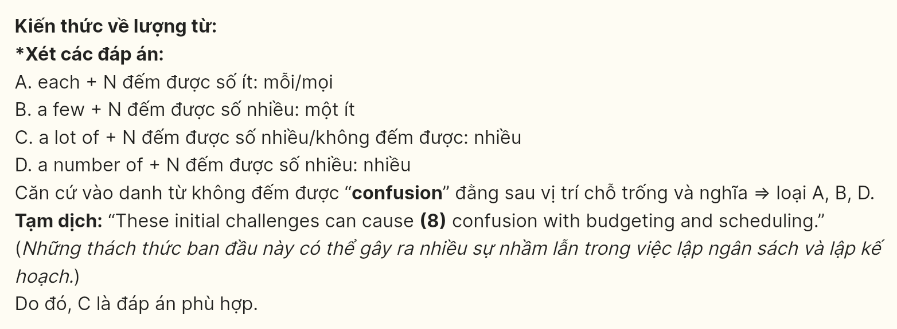
Question 9 [695609]: A. handling B. composing C. exploring D. settling
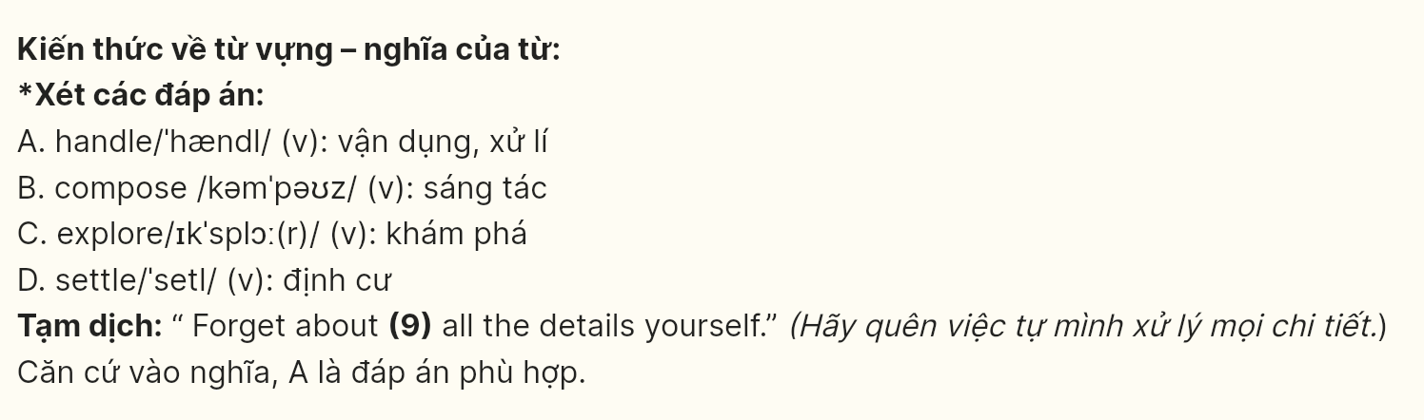
Question 10 [695610]: A. visions B. insights C. theories D. majors
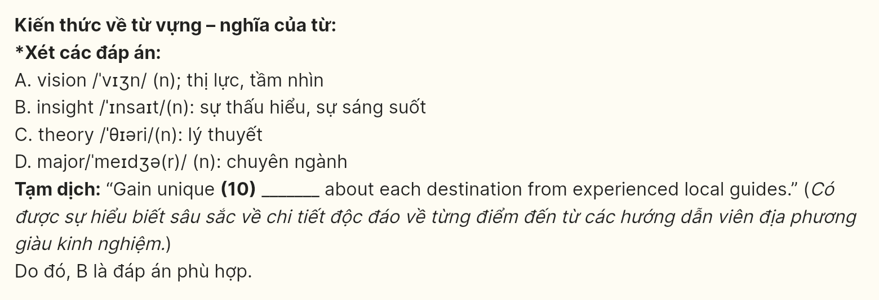
Question 11 [695611]: A. Therefore B. Accordingly C. Consequently D. Otherwise
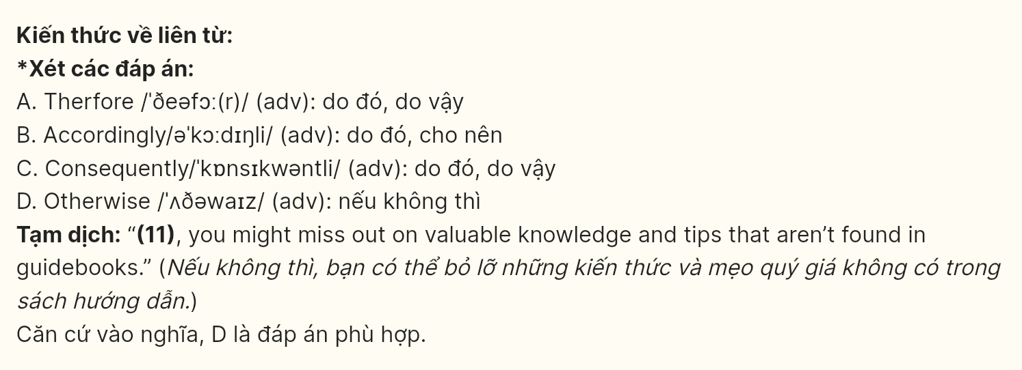
Question 12 [695612]: A. amount B. level C. range D. rate

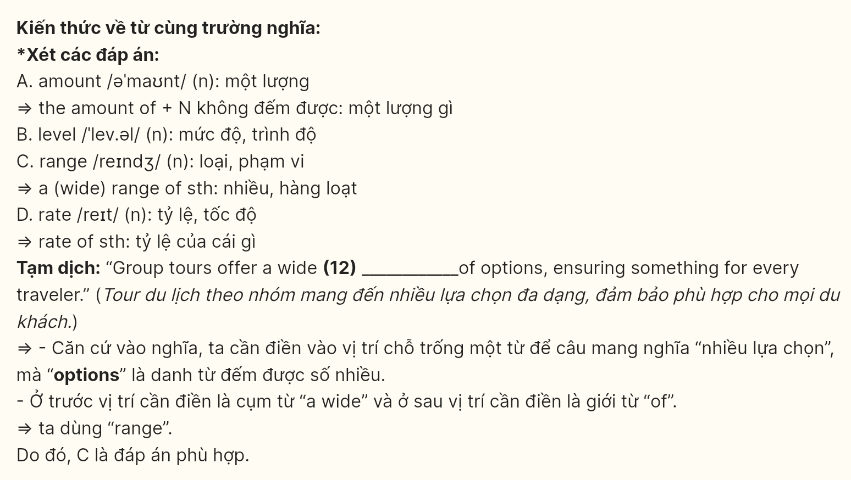 Mark the letter A, B, C or D on your answer sheet to indicate the best arrangement of utterances or sentences to make a meaningful exchange or text in each of the following questions from 13 to 17.
Question 13 [695613]: Trùng đáp án
a. Karen: Hi Thomas! Oh my gosh, it’s been ages! I’ve been well, thanks. How about you? And how’s your family?
b. Thomas: Hi Karen! It’s so good to see you after so long! How have you been?
c. Thomas: I’m doing great, thank you! Everyone’s doing well—my parents are enjoying retirement, and my brother just moved back to town.
A: c-a-b B: b-c-a C: c-b-a D: b-a-c

Question 14 [695614]:
a. Steven: Malala Yousafzai. Her courage in fighting for girls’ education is incredible.
b. Paul: Absolutely, she’s a true role model. Do you think her story has influenced more young people to stand up for their beliefs?
c. Steven: Have you heard Elon Musk’s story? He faced so many challenges to make an impact.
d. Paul: Yes, I admire his determination. Who else do you find inspiring?
e. Steven: Definitely. I think her story empowers people to make a difference no matter how tough the circumstances.
A: c-d-a-b-e B: c-b-a-d-e C: e-b-a-d-c D: e-d-c-a-b
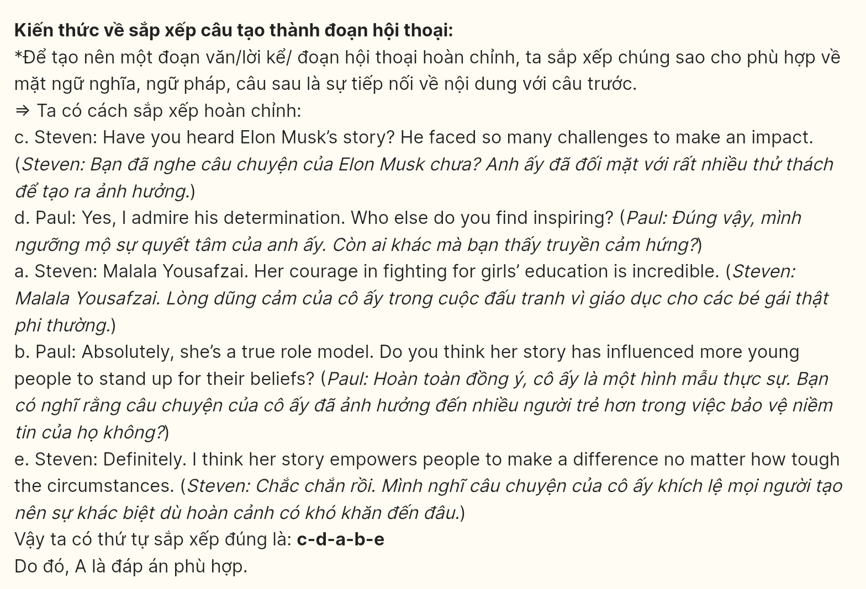
Question 15 [695615]:
Hi Emily,
a. Remember, asking questions is the best way to learn.
b. I heard you’ve started a new internship, and I just wanted to get in touch to see how it’s going.
c. Everyone understands you’re still learning, so don’t feel pressured to know everything.
d. If you need any advice, feel free to contact me. I’m always here to help when you need it.
e. Starting something new can be overwhelming at first, but it’s also a great opportunity for growth. Good luck with everything!
Kind regards,
Alex
A: b-d-c-a-e B: c-a-d-e-a C: e-b-c-a-d D: b-e-c-a-d

Question 16 [695616]:
a. He walked through the streets, recalling childhood memories and sensing the continuous development of his hometown.
b. His hometown had changed a lot, with the green fields now replaced by modern high-rise buildings.
c. Even with all the changes, Mark’s love for his hometown remained unwavering.
d. When Mark returned to his hometown after many years away, he felt both happy and nostalgic.
e. Despite this, Mark still recognized the familiar people, who retained the kind and simple nature of the countryside.
A. b-d-a-e-c B. d-b-e-a-c C. e-b-a-d-c D. a-b-d-e-c
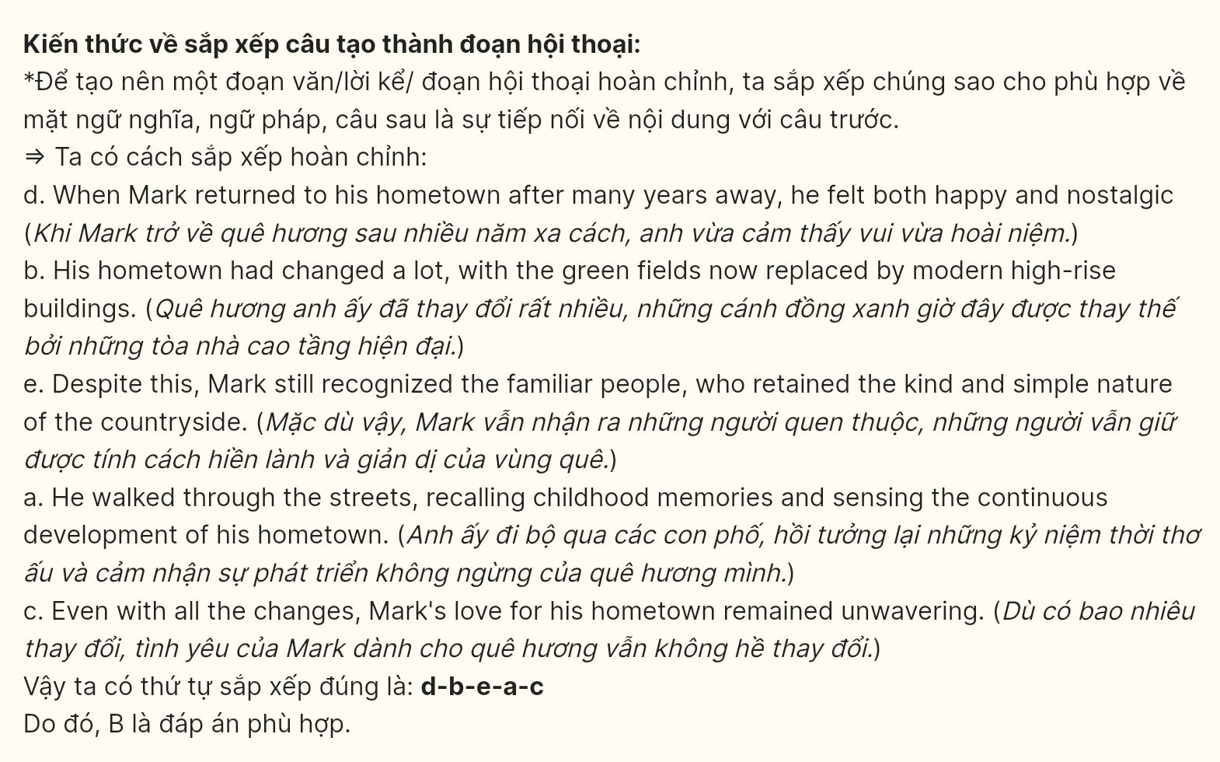
Question 17 [695617]:
a. Another challenge is the need to adapt to independent living, which can create considerable stress as they must manage their time and finances on their own.
b. Studying at a university far from home presents several disadvantages.
c. However, despite these challenges, this experience helps students develop greater independence and personal growth.
d. One significant issue is that students often feel lonely and disconnected in a new environment without their close friends.
e. Furthermore, being away from family means lacking emotional and material support, especially during difficult times.
A. b-a-d-c-e B. b-e-d-c-a C. b-d-a-e-c D. b-c-a-e-d
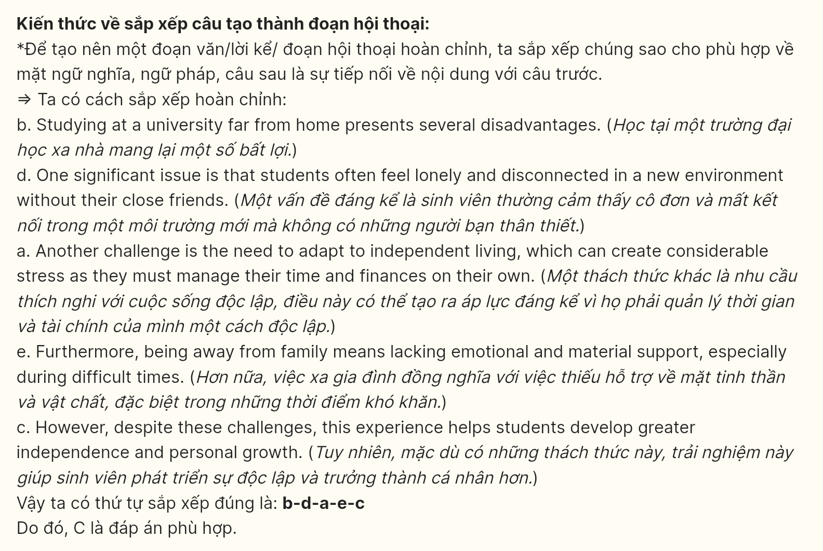
Read the following passage and mark the letter A, B, C, or D on your answer sheet to indicate the option that best fits each of the numbered blanks from 18 to 22.
Taking selfies, a cultural phenomenon, (18) _______. A selfie is a self-portrait taken with a smartphone or camera. This trend has gained immense popularity, especially among younger generations, (19) _______. The ease of taking and sharing selfies has made them a staple in modern communication.
Selfies serve various purposes beyond just capturing images. (20) _______. Additionally, selfies can be a form of self-expression as individuals often choose specific angles, filters, and settings to convey their mood or personality. This ability to curate one’s image has led to the rise of social media influencers who rely on selfies to connect with their audiences and promote brands.
However, the selfie trend is not without its criticisms. Constantly judged by others on social media, (21) _______. Some argue that the obsession with selfies can lead to unrealistic beauty standards and a distorted sense of self. (22) ______.

Question 18 [695618]:
A. which transforms the way people capture and share moments
B. in which the way people capture and share moments has changed
C. transforming the way people capture and share moments
D. transforms the way people capture and share moments
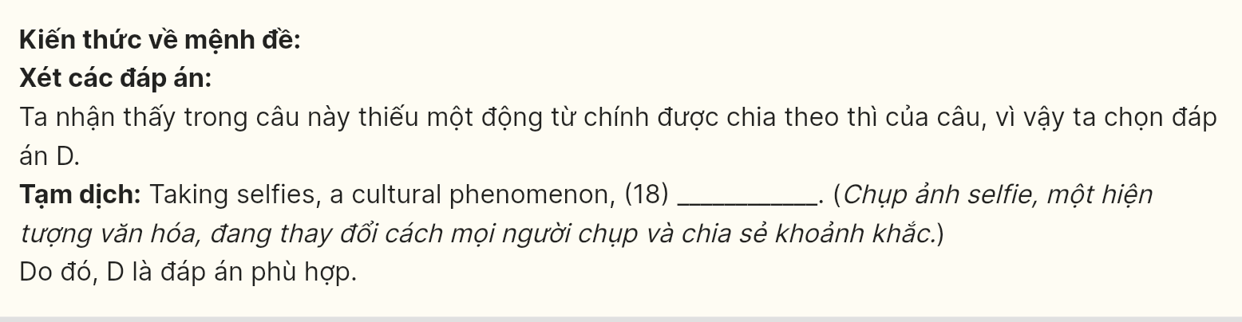
Question 19 [695619]:
A. who use selfies to express their identity and showcase their experiences
B. from whom the use of selfies for self-expression and showcasing experiences
C. use selfies to express their identity and showcase their experiences
D. express their identity and showcase their experiences through selfies
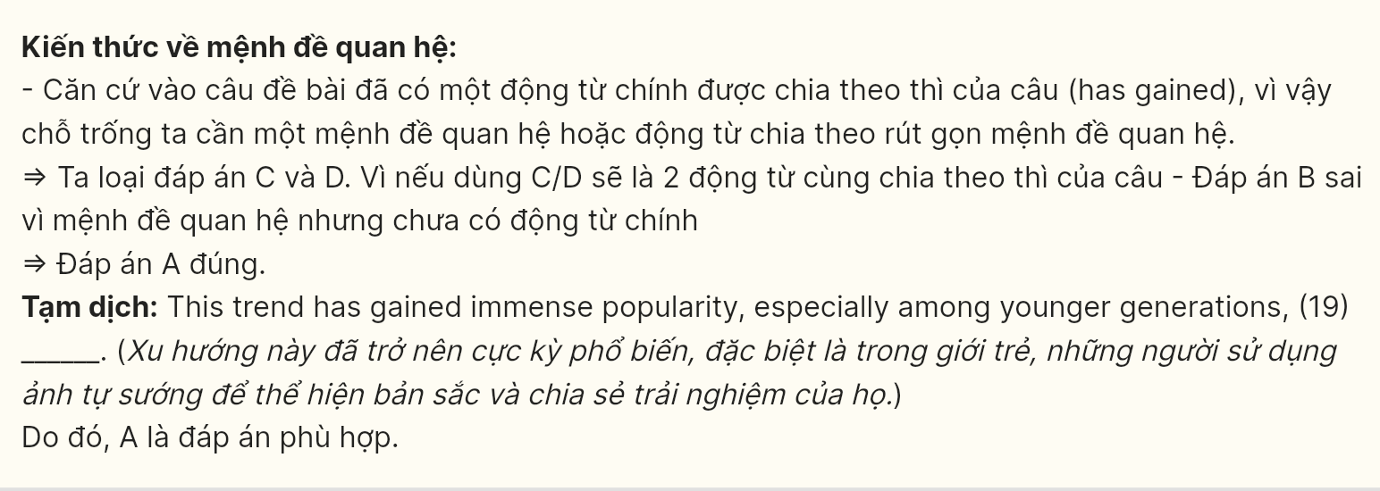
Question 20 [695620]:
A. Using them to create a visual diary, vacations and celebrations are significant life events for many people
B. A visual diary of significant life events is a typical example of many people’s vacations and celebrations
C. Many people use them to create a visual diary of significant life events such as vacations and celebrations
D. Vacations and celebrations lead to the creation of a visual diary of many people’s significant life events

Question 21 [695621]:
A. development of inadequacy and low self-esteem is a direct result
B. feelings of inadequacy and low self-esteem can be experienced
C. inadequacy and low self-esteem are developed by individuals
D. individuals may develop feelings of inadequacy and low self-esteem

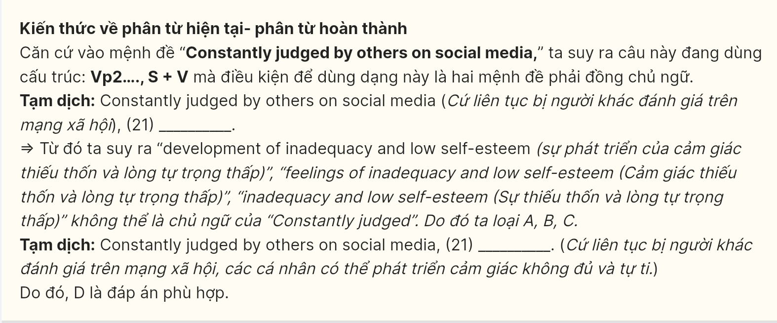
Question 22 [695622]:
A. Focusing too much on the perfect selfie, genuine moments may be overlooked and detracted from real-life experiences
B. Excessive focus on the perfect selfie may detract from real-life experiences, causing genuine moments to be overlooked
C. Genuine moments are overlooked so that excessive focus on the perfect selfie can’t be detracted from real-life experiences
D. Upon focusing on the perfect selfie, real-life experiences may be detracted, causing genuine moments to be overlooked
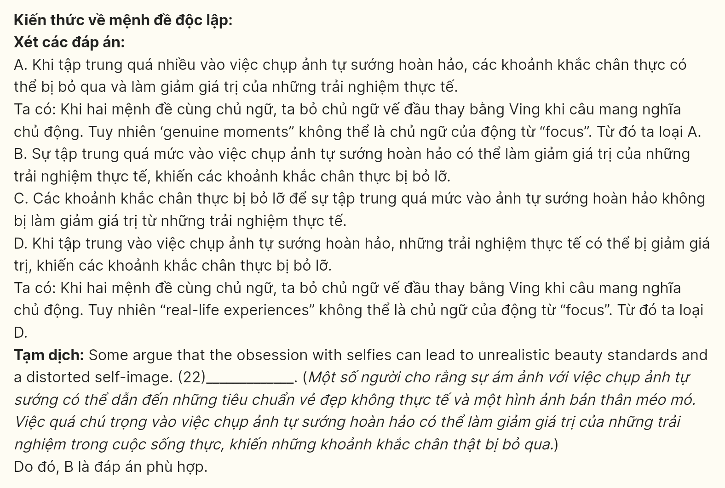
Read the following passage and mark the letter A, B, C, or D on your answer sheet to indicate the best answer to each of the following questions from 23 to 30.
Environmental protection has become a critical issue as climate change and pollution pose serious threats to our planet. Cities around the world are recognizing the urgent need for immediate action to safeguard natural resources and ensure a sustainable future. One city making significant strides is San Francisco, which aims to become a zero-waste city by implementing various eco-friendly initiatives.
The city plans to achieve its goal by improving waste management practices and promoting recycling and composting. By providing residents with the necessary tools and education, San Francisco encourages its citizens to reduce their waste properly. This approach not only minimizes landfill contributions but also conserves valuable resources and energy, thereby benefiting the environment.
Additionally, the city is investing in renewable energy sources such as solar and wind power. By transitioning to clean energy, San Francisco aims to reduce its carbon footprint and decrease reliance on fossil fuels. Furthermore, the local government supports initiatives to increase public transportation options, making it easier for residents to choose eco-friendly travel alternatives. While some residents prefer driving their cars, others are eager to adopt sustainable transportation methods. This investment not only reduces traffic congestion but also lowers emissions.
Ultimately, these efforts reflect a commitment to creating a cleaner and healthier environment for future generations. By prioritizing sustainable practices and engaging the community, cities like San Francisco are setting an example for others to follow. Protecting our environment requires collective action and dedication, ensuring that natural habitats are preserved and that everyone can enjoy a better quality of life.

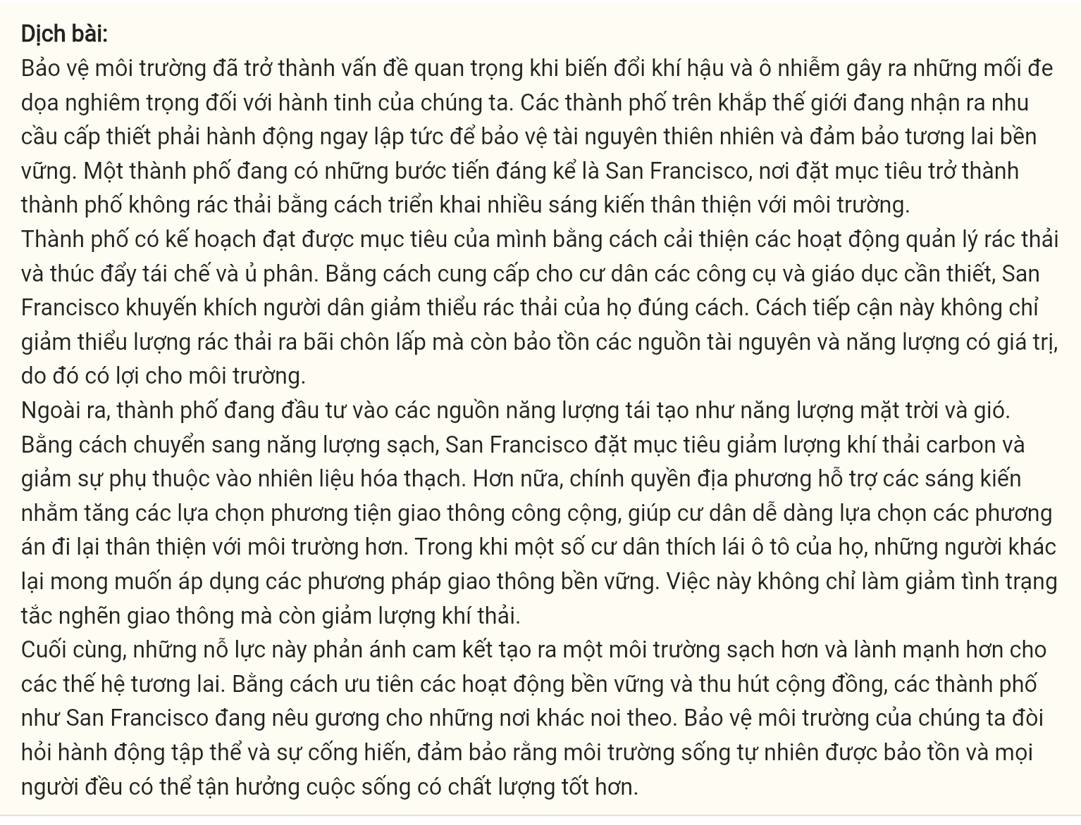
Question 23 [695623]: Which of the following is NOT mentioned as a method used by San Francisco to reduce waste?
A. Encouraging recycling and composting
B. Offering residents important tools
C. Promoting the use of reusable containers
D. Enhancing waste management practices
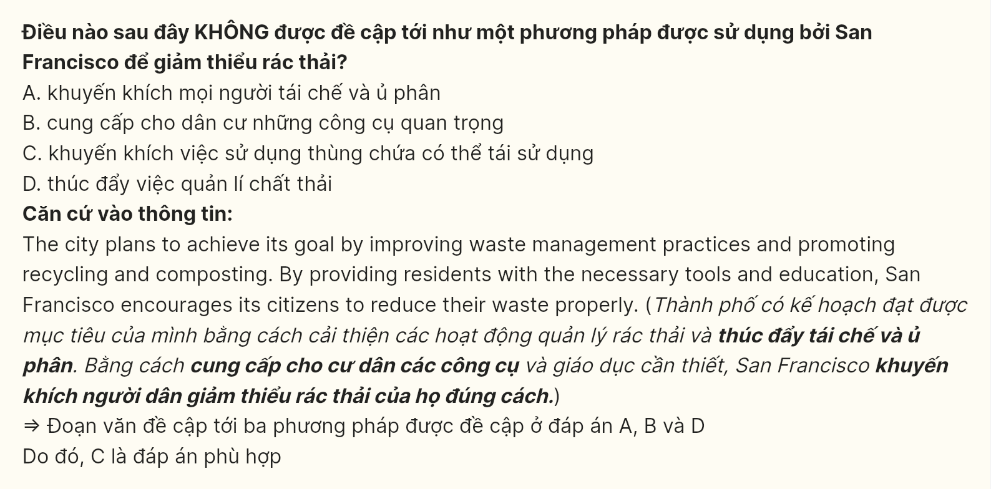
Question 24 [695624]: The word strides in paragraph 1 is OPPOSITE in meaning to _____:
A. Preventions B. Compensations C. Setbacks D. Improvements
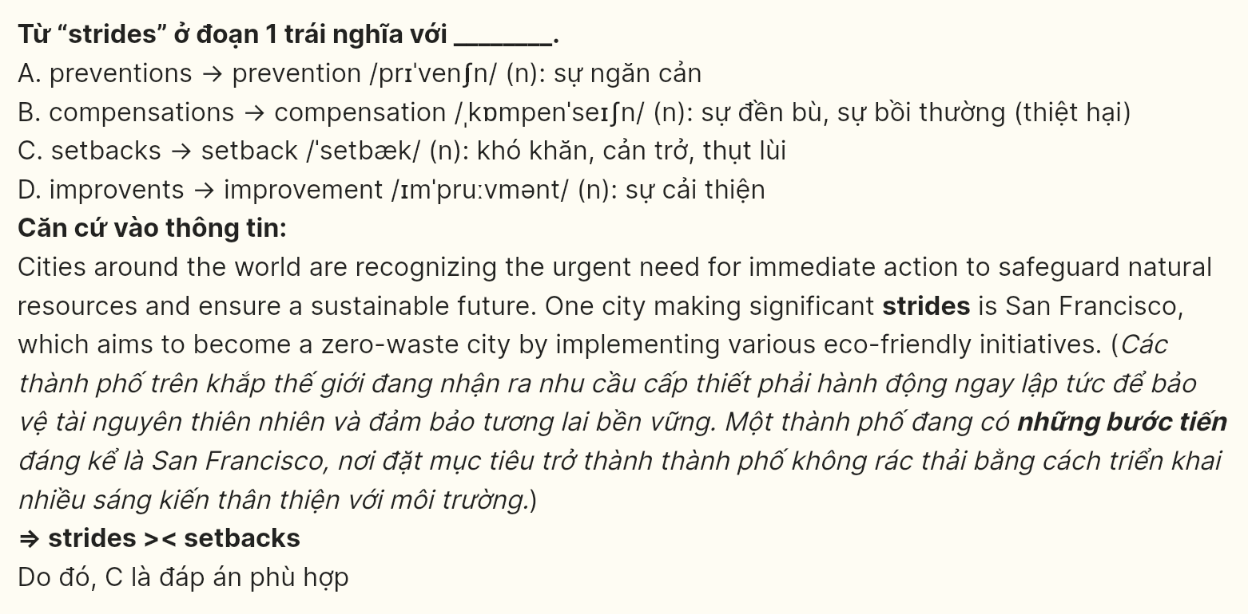
Question 25 [695625]: The word their in paragraph 2 refers to _____:
A. Practices B. Residents C. Tools D. Resources
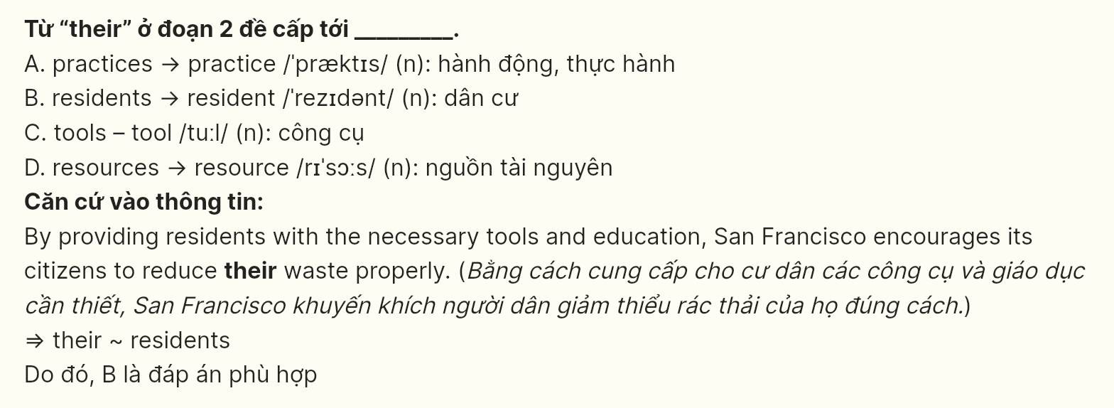
Question 26 [695626]: The word reliance in paragraph 3 could be best replaced by:
A. Concentration B. Belief C. Dependence D. Consumption
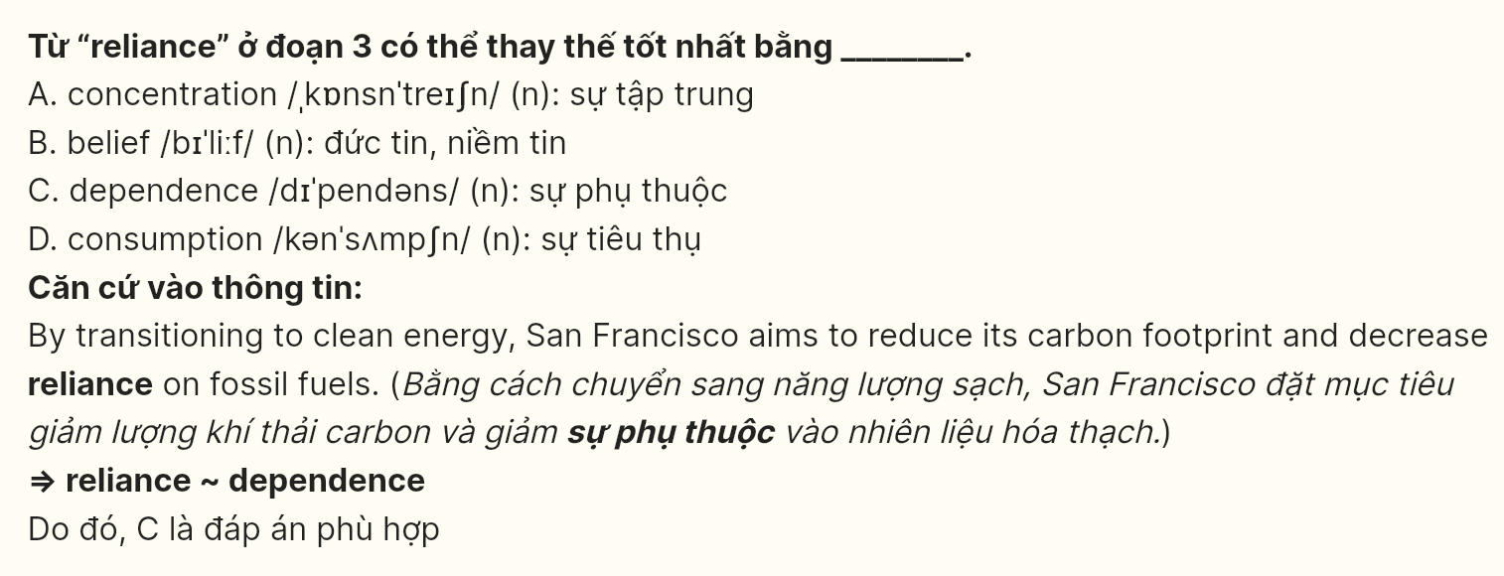
Question 27 [695627]: Which of the following best paraphrases the underlined sentence in paragraph 4?
A. Cities such as San Francisco are serving as a model for others to emulate by emphasizing sustainable practices and involving the community.
B. Cities such as San Francisco are demonstrating strategies that others might consider adopting by focusing on sustainable practices.
C. Cities like San Francisco are showcasing methods that others can learn from by implementing various environmental policies and seeking input from residents.
D. Cities such as San Francisco are presenting practices that other urban areas may want to adopt by developing urban infrastructure.
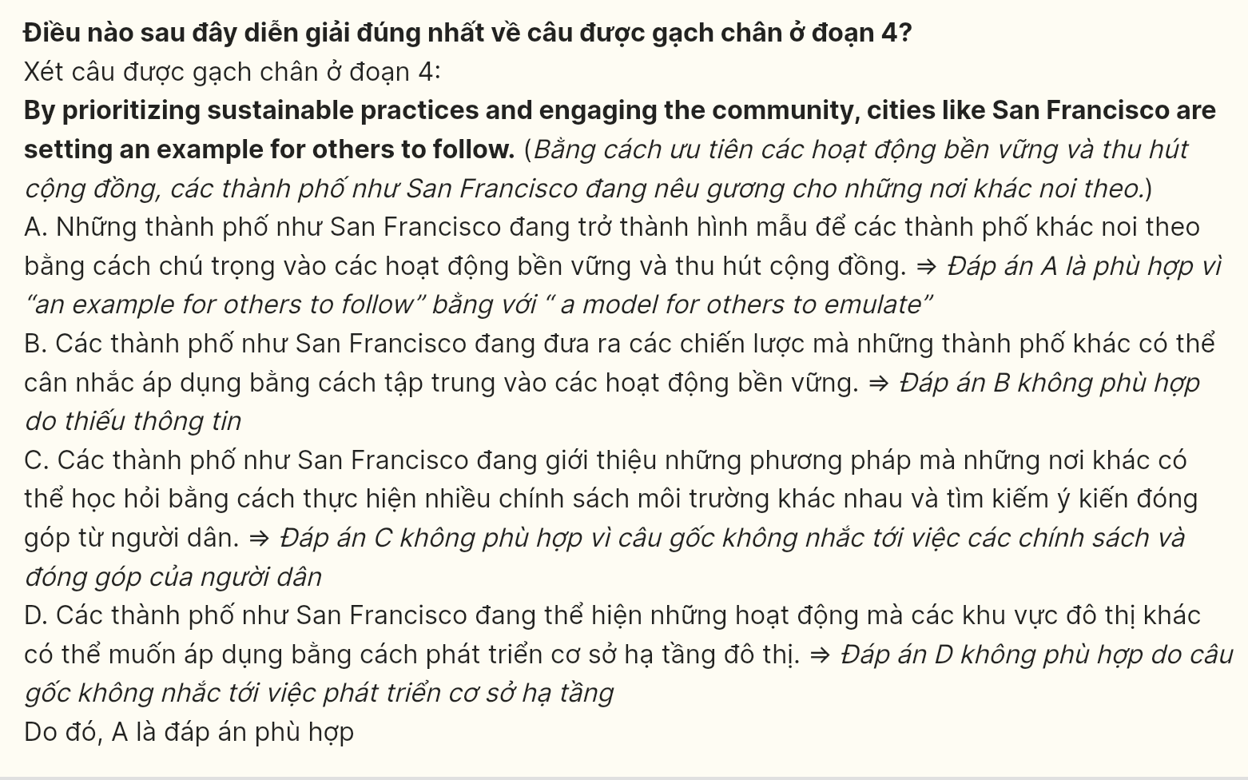
Question 28 [695628]: Which of the following is TRUE according to the passage?
A. San Francisco is the only city in the world taking measures to protect the environment.
B. San Francisco’s initiatives aim to reduce both waste and carbon emissions.
C. Residents are discouraged from using public transportation in San Francisco.
D. The focus on sustainable practices has decreased the quality of life for citizens.
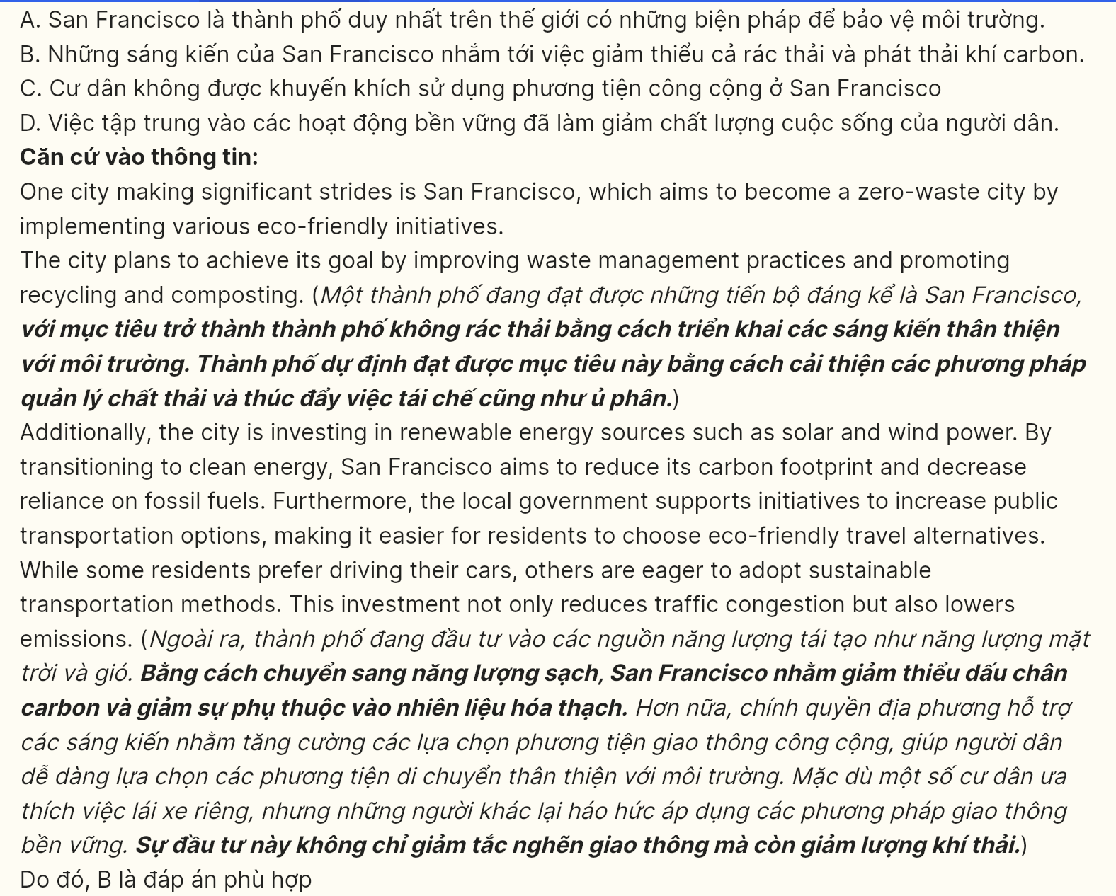
Question 29 [695629]: In which paragraph does the writer mention a contrastive relationship?
A. Paragraph 1 B. Paragraph 2 C. Paragraph 3 D. Paragraph 4
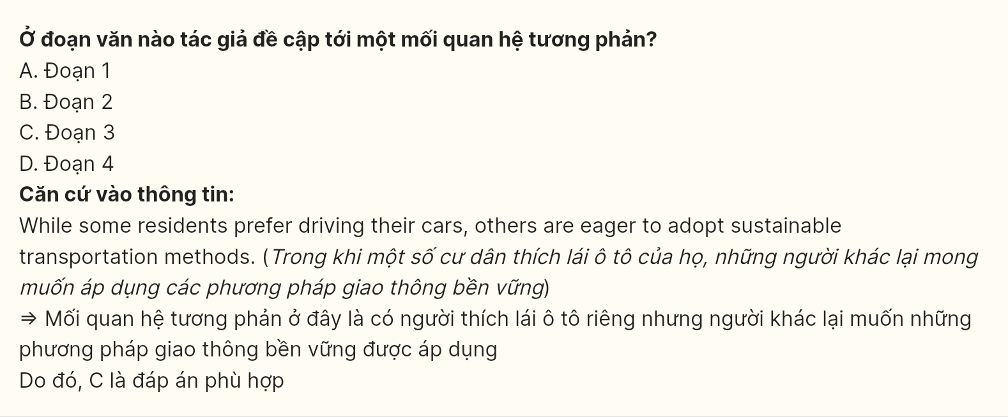
Question 30 [695630]: In which paragraph does the writer mention an example of a city striving to eliminate waste entirely?
A. Paragraph 1 B. Paragraph 2 C. Paragraph 3 D. Paragraph 4
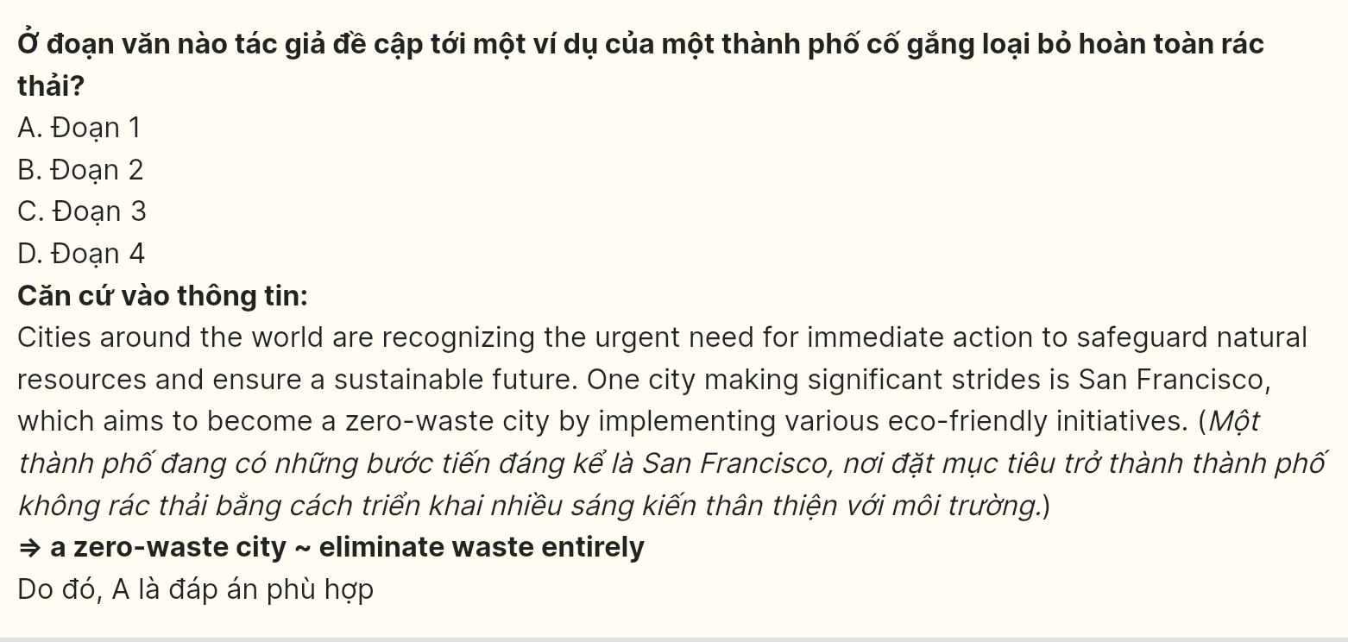
Read the following passage and mark the letter A, B, C, or D on your answer sheet to indicate the best answer to each of the following questions from 31 to 40.
In many households, the responsibility for maintaining the home often falls disproportionately on mothers. This unequal distribution of chores can lead to significant stress and burnout, as they juggle cooking, cleaning, and caring for children. The pressure of managing these tasks single-handedly can negatively impact their mental health and overall well-being, creating an urgent need for a more equitable division of household responsibilities. Without a fair sharing of duties, resentment can build up, straining family relationships and reducing overall harmony at home.
[I] Sharing household chores offers a viable solution to alleviate this burden. [II] When tasks such as laundry, dishwashing, and grocery shopping are divided among all family members, the workload lightens for everyone involved. [III] By encouraging all members to contribute, households can cultivate an environment where everyone feels responsible for maintaining their shared space. [IV] Such collaboration also teaches children the importance of contributing to the household, as it instills a sense of responsibility from a young age.
Additionally, engaging chores together provides valuable opportunities for bonding. Activities like cooking dinner as a family or cleaning the house while listening to music can transform mundane tasks into enjoyable experiences. These moments not only strengthen relationships but also teach important life skills, such as cooperation and time management, particularly to younger members of the household. Shared experiences in completing chores can become cherished memories that enhance family cohesion. Effective communication plays a crucial role in successfully sharing household chores. Families should establish a clear system for dividing tasks that considers individual strengths and preferences. Regular discussions can help ensure that everyone is on the same page and feels valued in their contributions. By fostering an open dialogue, households can create a fair and balanced approach to chores that benefits everyone involved, leading to a more harmonious home environment.
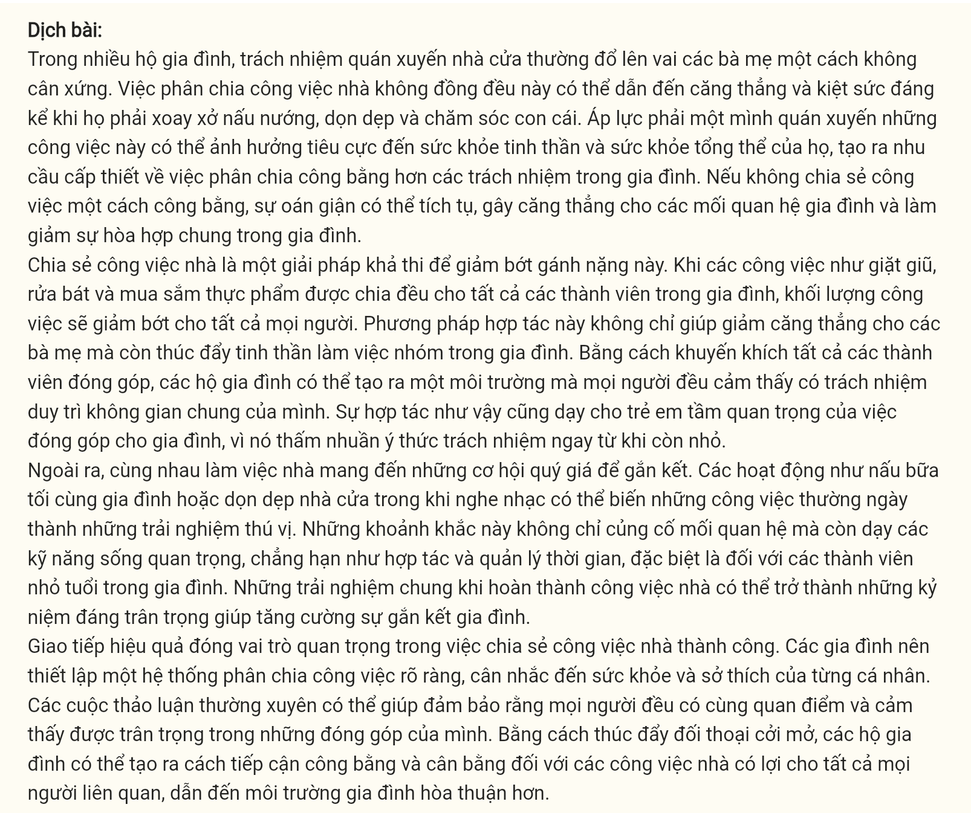
Question 31 (696531): Where in paragraph 2 does the following sentence best fit?
This collaborative approach not only reduces stress for mothers but also fosters a sense of teamwork within the family unit.
A. [I] B. [II] C. [III] D. [IV]
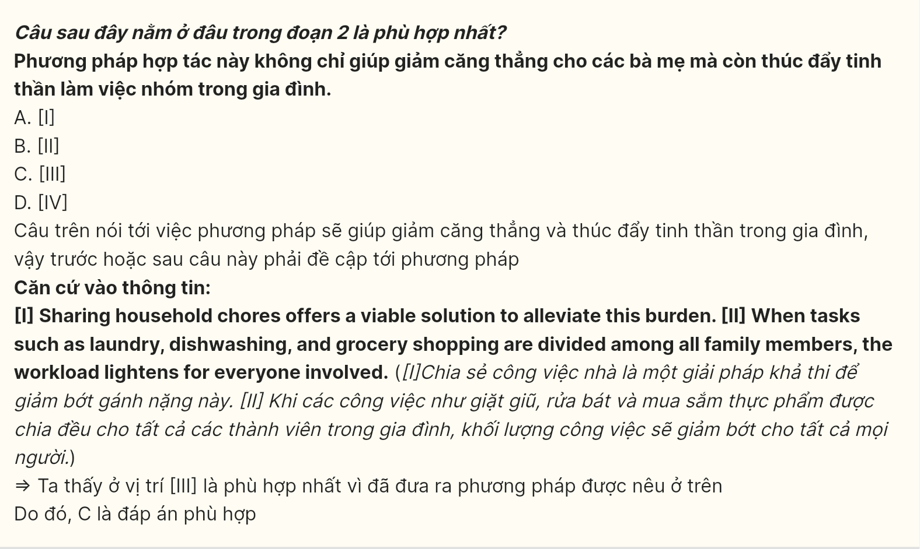
Question 32 (696532): The word juggle in paragraph 1 could be best replaced by _______.
A. neglect B. divide C. restrict D. manage
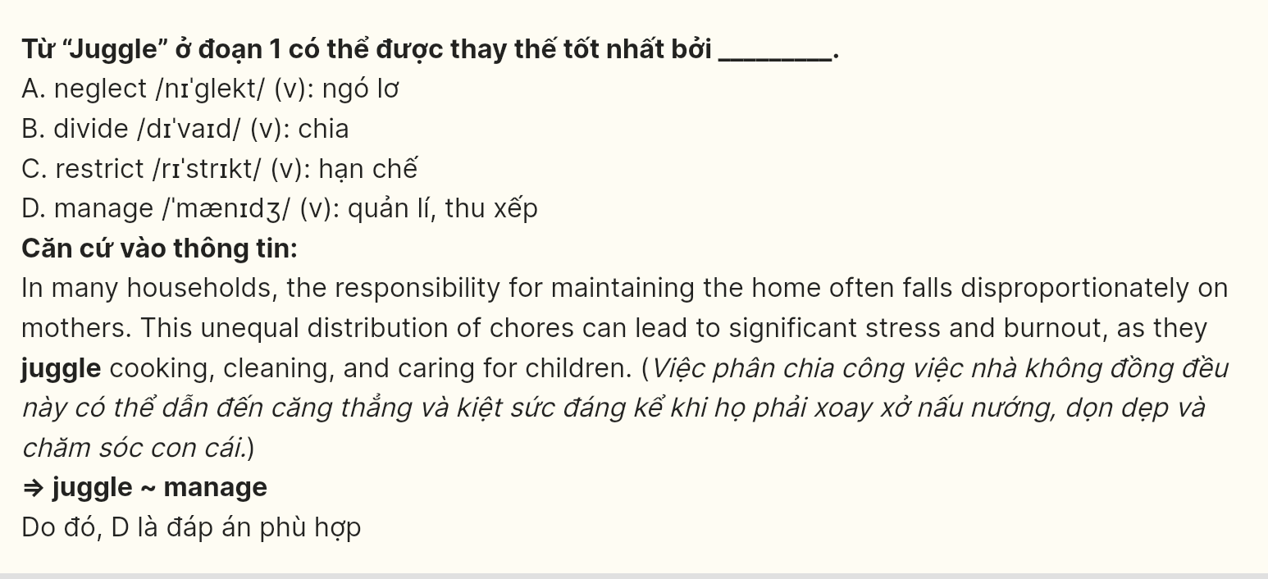
Question 33 (696533): The word it in paragraph 2 refers to _______.
A. collaboration B. importance C. household D. responsibility
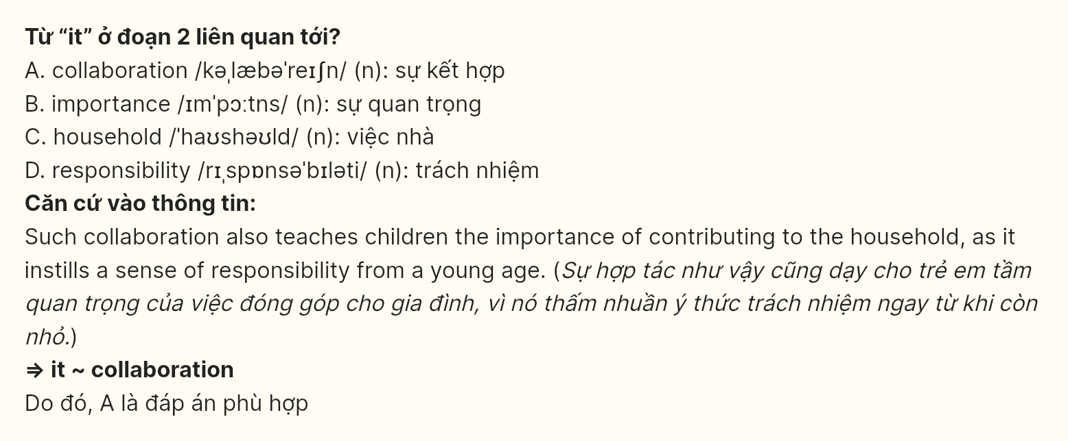
Question 34 (696534): According to paragraph 1, which of the following is NOT a consequence of the unequal distribution of household chores?
A. increased stress levels for mothers
B. diminished harmony within the household
C. strained relationships within the family
D. financial burden on household members
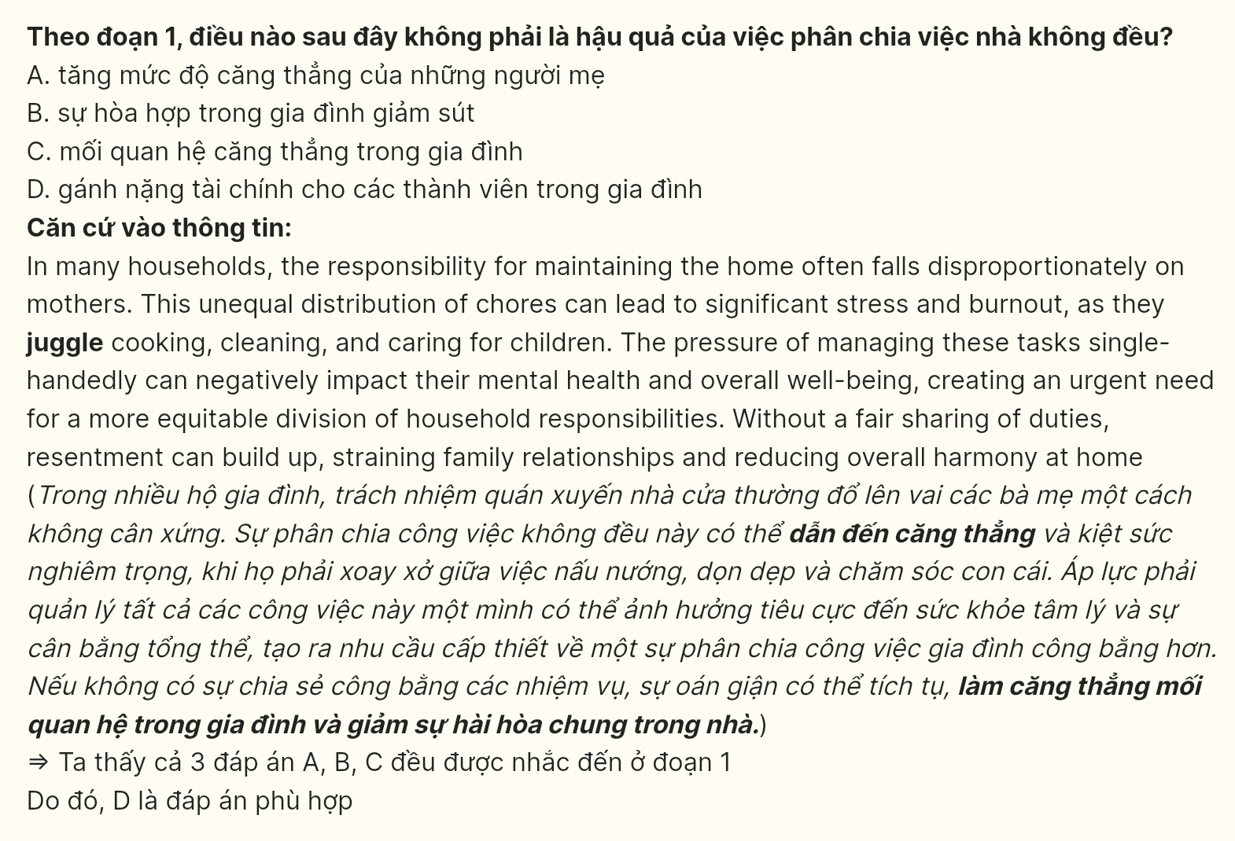
Question 35 (696535): Which of the following best summarizes paragraph 3?
A. Engaging in household chores together creates enjoyable experiences that can enhance family relationships and teach children important skills.
B. Cooking and cleaning as a family can help strengthen bonds and create cherished memories for all members.
C. Shared chores provide opportunities for families to bond and teach valuable skills, especially to younger children, enhancing overall cohesion.
D. Listening to music while cleaning can make chores enjoyable, but it does not significantly impact family dynamics or learning.
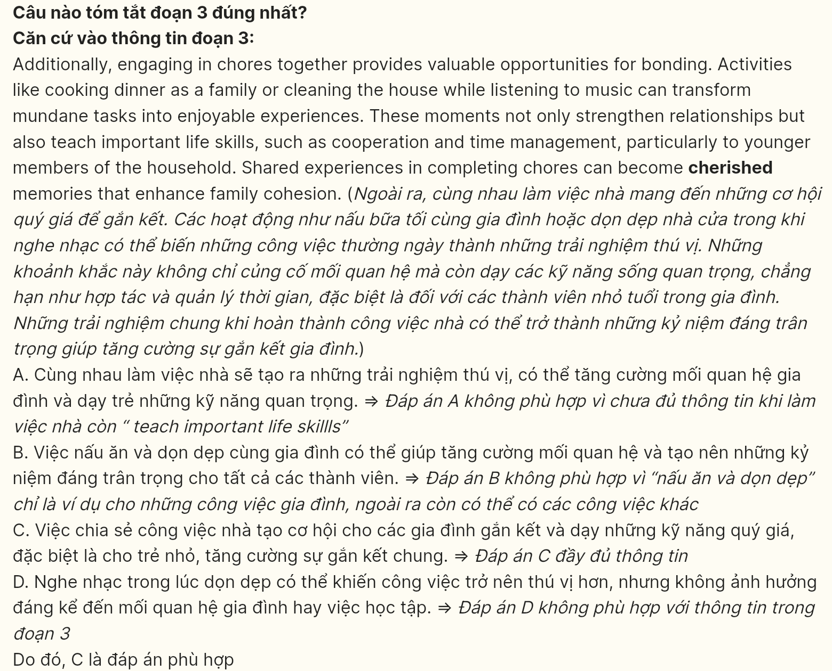
Question 36 (696536): The word cherished in paragraph 3 is OPPOSITE in meaning to _______.
A. comfortable B. selfless C. unpleasant D. harmonious
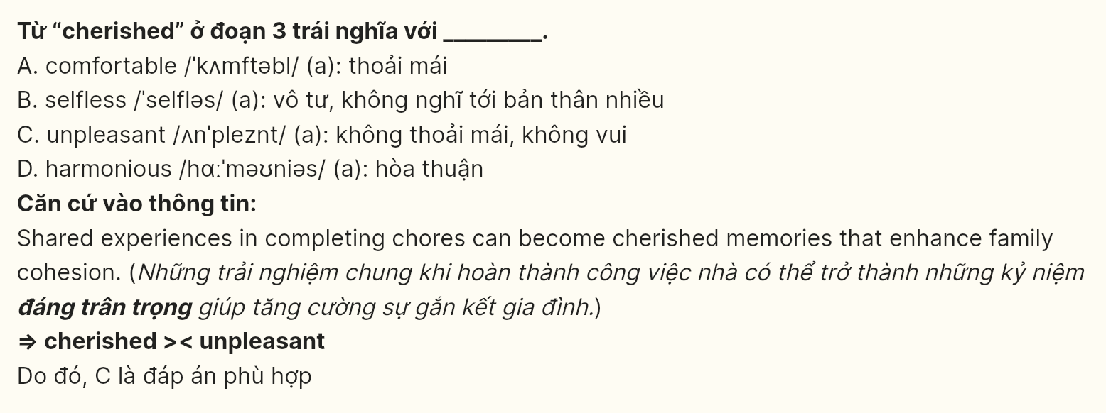
Question 37 (696537): Which of the following is TRUE according to the passage?
A. Fathers are typically responsible for managing all household chores by themselves.
B. Engaging in household tasks together can improve family cohesion and teach essential life skills.
C. Sharing household responsibilities can lead to increased stress and conflict among family members.
D. Children do not gain any valuable skills from participating in household chores.
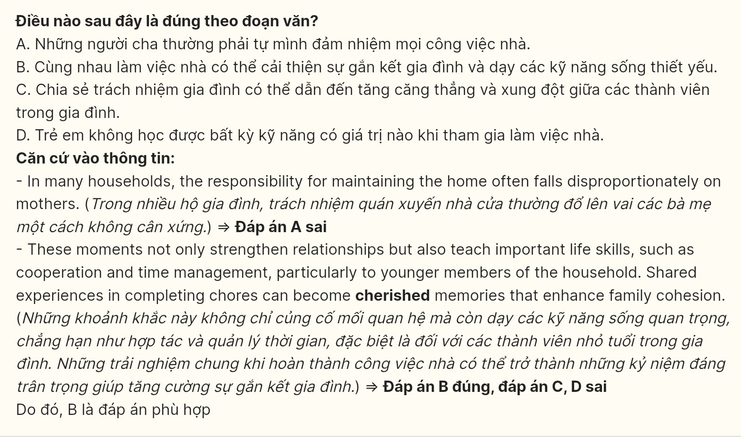
Question 38 (696538): Which of the following best paraphrases the underlined sentence in paragraph 4?
A. Families should create a specific system for distributing tasks that takes individual strengths and preferences into account.
B. Families need to develop a flexible approach to sharing responsibilities that consider individual skills and preferences.
C. Families should implement an informal method for allocating tasks based on general opinions rather than individual strengths.
D. Families must prioritize a random system for assigning chores without considering personal strengths and preferences.
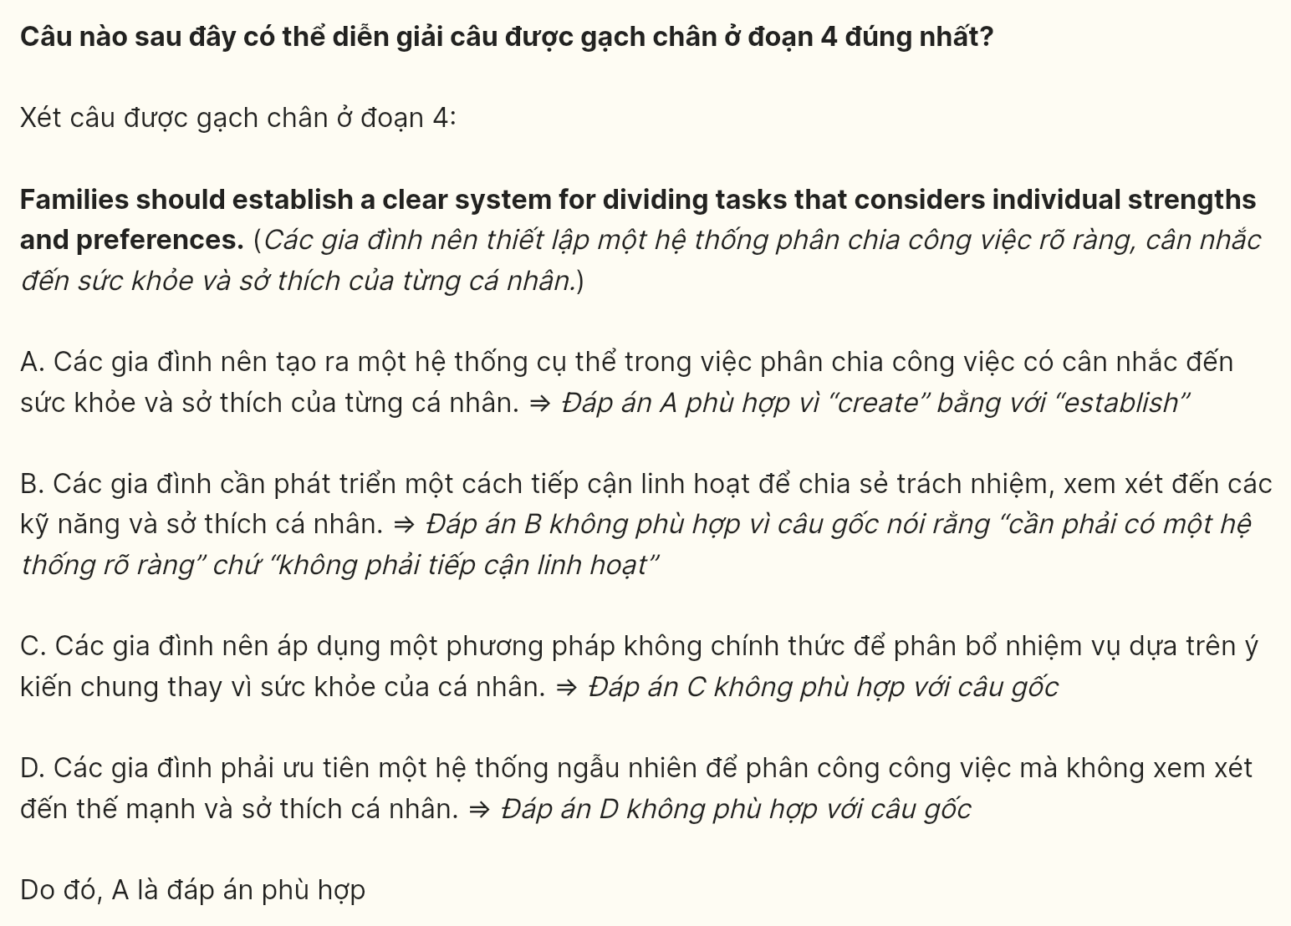
Question 39 (696539): Which of the following can be inferred from the passage?
A. Families that fail to communicate regularly are less likely to manage their household tasks efficiently and effectively.
B. Frequent discussions help foster an environment where family members feel obligated to participate in household chores.
C. Family members who feel undervalued in their contributions are more likely to become disengaged from household responsibilities.
D. Regular discussions can help ensure that all family members are aligned and appreciate the significance of their contributions.
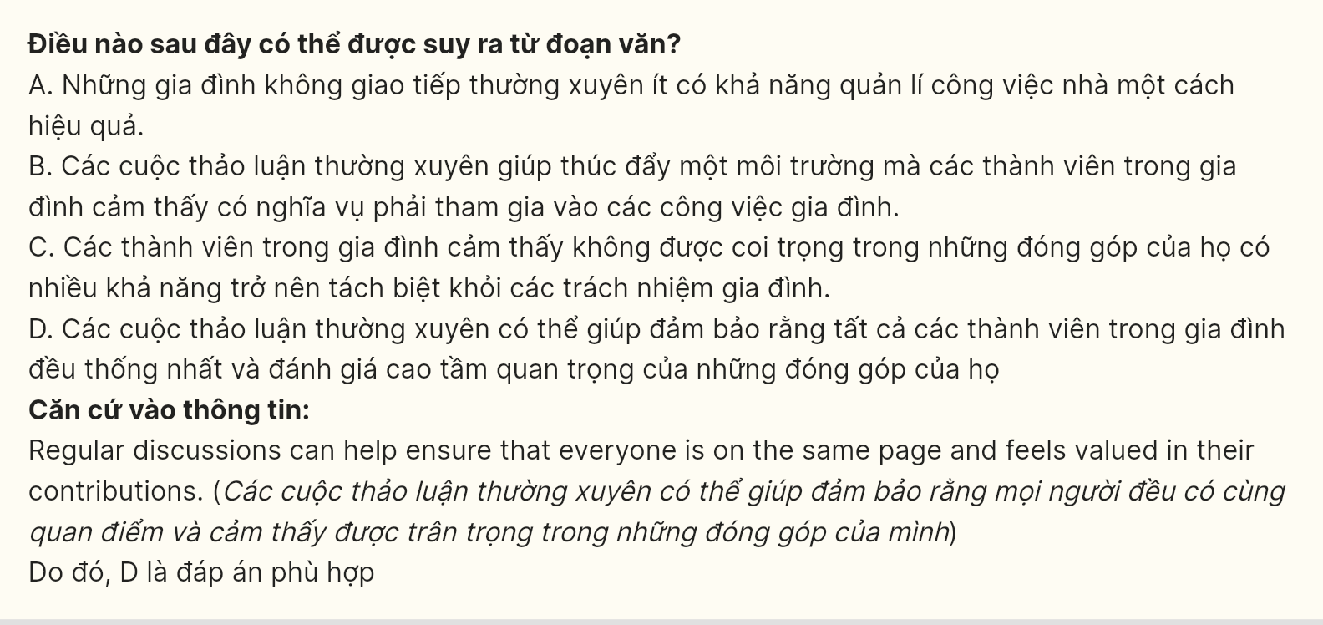
Question 40 (696540): Which of the following best summarizes the passage?
A. The division of household chores often falls unfairly on mothers, leading to stress and a need for equitable sharing among family members to improve well-being.
B. Families should implement a strict system for dividing chores, ensuring that all tasks are managed effectively by individual strengths and preferences.
C. Sharing responsibilities in household chores fosters teamwork, enhances family bonds, and provides opportunities for children to learn important life skills.
D. Effective communication and cooperation in managing household tasks are essential for creating a harmonious environment and reducing conflict within families.
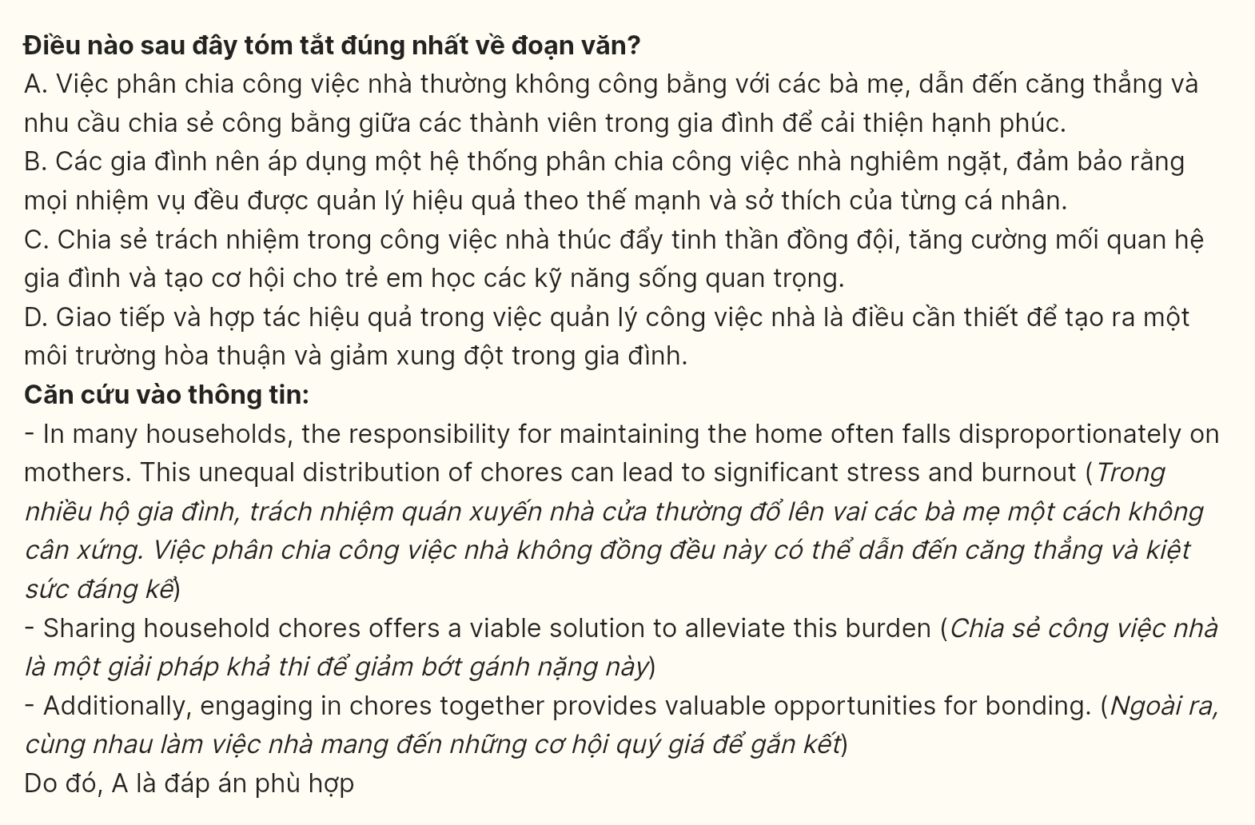
----- THE END -----

