School: ……………………………………….. | Date:………………………………..
Class: ……………………………..................... | Period: ………………………..........

UNIT 5: FOOD and DRINKS
Lesson 4 – Review (Pages 94, 95)

I. OBJECTIVES
By the end of the lesson, Ss will be able to:
1.1. Language knowledge and skills
- review words about containers and quantities of food and drinks (bunch, carton, flour, butter, fridge, supermarket, spaghetti, tablespoon, etc.) and talk about them.
- review grammar: Indefinite and definite articles; much and many; countable and uncountable nouns.
- review how to make shopping list.
- pronoun some sounds correctly: “s” endings, /ei/ and /æ/.
- put stress on nouns with two and three syllables.
1.2. Competences
- improve speaking, listening, reading and writing skills.
- improve the use of English.
1.3. Attributes
- have positive attitude in English language learning so that they actively participate in all classroom activities.
- review the old lesson and have good preparation for the first semester test.

II. TEACHING AIDS AND LEARNING MATERIALS
1. Teacher’s aids: Student book and Teacher’s book, class CDs, Digital Book (DCR phần mềm tương tác SB, DHA (từ vựng/ cấu trúc) phần mềm trò chơi tương tác), projector/interactive whiteboard / TV (if any), PowerPoint slides, handouts.
2. Students’ aids: Student’s book, workbook, notebook.

III. ASSESSMENT EVIDENCE
Performance Tasks | Performance Products | Assessment Tools
- Listening: You will hear Justin and his dad talking in the kitchen. For each question, choose the correct answer (A, B, or C) You will hear the conversation twice. | - Ss’ answers. | - T’s feedback/Peers’ feedback.
- Reading: Read the text. Choose the best word (A, B, or C) for each space. | - Ss’ answers. | - T’s feedback/Peers’ feedback.
- Vocabulary: Match the words with the descriptions. | - Ss’ answers. | - T’s feedback/Peers’ feedback.
- Grammar: Fill in the blanks with a, an, the, much, or many. | - Ss’ answers. | - T’s feedback/Peers’ feedback.
-Pronunciation: Circle the word that has the underlined part pronounced differently from the others.  + Circle the word that differs from the other three in the position of primary stress in each of the following questions. | - Ss’ answers/ presentation. | - T’s observation, T’s feedback/Peers’ feedback.

IV. PROCEDURES
A. Warm up: (5’)
a) Objective: Introduce the new lesson and set the scene for Ss to acquire new language; get students' attention at the beginning of the class by enjoyable and short activities as well as to engage them in the follow-up steps.
b) Content: Review vocabulary.
c) Expected outcomes: Ss are ready for the new lesson.
d) Organization of the activity:
TEACHER’S ACTIVITIES | STUDENTS’ ACTIVITIES
- Option 1: Leave Me Out!  - Give some words about food and container with incorrect spelling.  - Have Ss look at each incorrect word and leave out 1 letter to make the word correct.  - Call Ss to give answers, then pronounce the words and give meaning.  - Correct Ss’ pronunciation if necessary.  - Lead to the new lesson.  *Illustration:  1. bunnch  2. tablespoony  3. brutter  4. cartion  5. fryidge  6. spagheetti  - Option 2: Touch and Guess  - T can divide class into 2 groups to play this game or let the whole class take part the game.  - Prepare some real objects / food such as a banana, a carton of milk, a bar of chocolate, some candies, a tablespoon, a teaspoon, a tomato, an egg, a lemon, …  - Put these things in a bag or a box in order that Ss can’t see them.  - Have some Ss volunteer to touch the things in the box / bag, then explain the objects in English.  - Have the whole class guess and give name of the things in the box / bag.  - Score marks or give present to each Ss who has the right answer.  - Lead to the new lesson.  *Illustration: Possible things in the box / bag   | - Do the task.  - Give answers.  - Listen.  Answer keys  1. bunch  2. tablespoon  3. rutter  4. carton  5. fridge  6. spaghetti  - Take part in the games.  - Listen.

B. New lesson (35’)
- Activity 1: Listening (7’)
a) Objective: Help Ss improve their listening skill.
b) Content:
- You will hear Justin and his dad talking in the kitchen. For each question, choose the correct answer (A, B, or C) You will hear the conversation twice.
c) Expected outcomes: Ss listen in details and get familiar with the listening test format.
d) Organization of the activity:
TEACHER’S ACTIVITIES | STUDENTS’ ACTIVITIES
You will hear Justin and his dad talking in the kitchen. For each question, choose the correct answer (A, B, or C) You will hear the conversation twice.  - Have Ss read through the listening part.  - Demonstrate the activity on DCR by using the example.  - Play the audio (CD 2 – Track 38).  - Have Ss check answers with pairs and then give answers.  - Check answers as a whole class using DCR. | - Read in silence.  - Listen and then give answers.  Answer keys  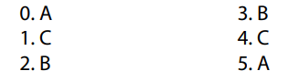
- Activity 2: Reading (7’)
a) Objective: Students can improve their reading skill.
b) Content:
- Read the text. Choose the best word (A, B, or C) for each space.
c) Expected outcomes: Ss read for comprehension and get familiar with the reading test format.
d) Organization of the activity:

TEACHER’S ACTIVITIES | STUDENTS’ ACTIVITIES
Read the text. Choose the best word (A, B, or C) for each space.  - Demonstrate the activity on DCR by using the example.  - Have Ss look and read, then choose the correct answer, underline the supporting ideas for their answers.  - Call Ss to give answers, explain.  - Give feedback and evaluation. | - Observe and listen.  - Work individually.  - Give answers, explain.  Answer keys  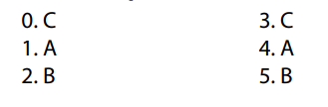

- Activity 3: Vocabulary (7’)
a) Objective: Ss can review vocabulary about community services.
b) Content: Match the words with the descriptions.
c) Expected outcomes: Ss produce the new language successfully, and they can use these words in speaking and writing.
d) Organization of the activity:
TEACHER’S ACTIVITIES | STUDENTS’ ACTIVITIES
Match the words with the descriptions.  - Have Ss read the phrases and words.  - Ask Ss to work in pairs to match the words with the descriptions.  - Have Ss give answers, tell the meaning of the words /phrase again.  - Check answers as a whole class using DCR. | - Read the phrases and words.  - Work in pairs to match.  - Give answers.  Answer keys  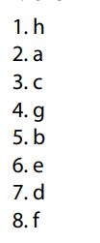
- Activity 4: Grammar (10’)
a) Objective: Ss can review the use of English: How much / How many / indefinite and definite articles.
b) Content:
- Fill in the blanks with a, an, the, much, or many.
c) Expected outcomes: Ss produce the new language successfully, and they can use the grammar points in speaking and writing.
d) Organization of the activity:
TEACHER’S ACTIVITIES | STUDENTS’ ACTIVITIES
Task a. Fill in the blanks with a, an, the, much, or many.  - Ask Ss to work individually to fill in the blanks with a, an, the, much, or many.  - Have Ss work in pairs to check each other’s work.  - Call Ss to give answers, explain for their choice.  - Check answers as a whole class using DCR. | - Work individually.  - Work in pairs.  - Give answers.  Answer keys  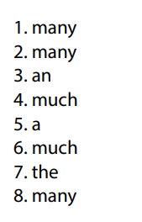
- Activity 5: Pronunciation (4’)
a) Objective: Ss can review the word stress and vowels, last consonant of “s” endings.
b) Content:
- Circle the word that has the underlined part pronounces differently from the others.
- Circle the word that differs from the other three in the position of primary stress in each of the following questions.
c) Expected outcomes: Ss produce the new language successfully.
d) Organization of the activity:
TEACHER’S ACTIVITIES | STUDENTS’ ACTIVITIES
Task a. Circle the word that has the underlined part pronounced differently from the others.  - Have Ss distinguish the sound: /“s” endings, /ei/ and /æ/.  - Ask Ss to work individually to circle the answer.  - Have Ss work in pairs to check each other’s work.  - Call Ss to give answers, pronounce the words again.  - Give feedback, correct Ss’ pronunciation if necessary.  Task b. Circle the word that differs from the other three in the position of primary stress in each of the following questions.  - Remind Ss some basic rules of putting stress on nouns with 2 or 3 syllables.  - Ask Ss to work individually.  - Have Ss work in pairs to check each other’s work.  - Call Ss to give answers, pronounce the words again.  - Give feedback, correct Ss’ pronunciation if necessary. | - Listen.  - Work individually.  - Work in pairs.  - Give answers.  Answer keys  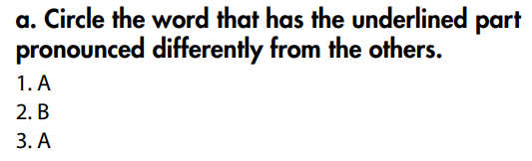  - Listen.  - Work individually.  - Work in pairs.  - Give answers.  Answer keys  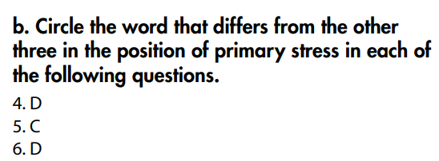

C. Consolidation and homework assignments (5’)
* Consolidation:
* Grammar of Unit 5: Indefinite and definite articles; much and many; countable and uncountable nouns.
* Vocabulary of Unit 5: Words about containers and quantities of food and drinks (bunch, carton, flour, butter, fridge, supermarket, spaghetti, tablespoon, …).

* Homework:
- Review vocabulary, grammar of unit 5.
- Do the exercises in WB: Review of Unit 5 (page 66).
- Do exercises in Tiếng Anh 7 i-Learn Smart World Notebook: Review Units 1-5 (pages 34 & 35).
- Do the Semester 1 Test in Tiếng Anh 7 i-Learn Smart World Notebook (pages 68 & 69).
- Have good preparation for the first semester test.
- Prepare: Unit 6 – New words and Listening (page 44 – SB).

D. Reflection
a. What I liked most about this lesson today:
…………………………………………………………………………………………
- What I learned from this lesson today:
…………………………………………………………………………………………
c. What I should improve for this lesson next time:
…………………………………………………………………………………………

