School: …………………………………………………..  Class: ……………………………………………………..  Full name: ………………………………………………. | Mark:

SPEAKING TEST 2 (SEMESTER 1)
(Units 3 & 4)

TASK 1 |  |  | Let’s talk about a club in your neighbourhood.  The following questions may help you.
 | 1. | What is your neighbourhood like?
 | 2. | What are the clubs in your neighbourhood?
 | 3. | Which club do you join?
 | 4. | What are the main activities of the club?
 | 5. | How do these activities benefit the community?

TASK 2 | Work in pairs. Each of you receives a card. Use the clues on your card to make questions about your friend’s picture. Use the picture on your card to answer your friend’s questions.

CARD A
Ask your friends about his/ her picture. Listen to his/ her answers. |  | 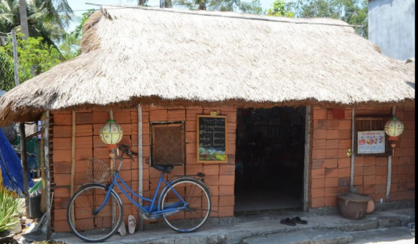
1. | What kind/ house/ is?
2. | Where/ you/ often/ find/ it?
3. | What/ you/ like/ about/ this?
4. | What/ you/ dislike/ about/ this?
5. | What/ will/ do/ if/ you/ live in it?
 |  | Answer your friend’s questions about this picture.

CARD B
Ask your friends about his/ her picture. Listen to his/ her answers. |  | 
1. | What kind/ house/ is?
2. | Where/ you/ often/ find/ it?
3. | What/ you/ like/ about/ this?
4. | What/ you/ dislike/ about/ this?
5. | What/ will/ do/ if/ you/ live in it?
 |  | Answer your friend’s questions about this picture.

