

Tiết thứ ....
UNIT 7: TRAFFIC
Lesson 6: Skills 2

Class | Date of teaching | Attendence
7A | ..../09/2022
7B | ..../09/2022
7C | ..../09/2022
I. OBJECTIVES: By the end of this unit, students will be able to gain the following things:
1. Knowledge:
+ Listening
- use the lexical items related to the topic Traffic
- listen for main ideas and specific information about traffic problems in Mumbai.
+ Writing: write about traffic problems in your area.
+ Pronunciation:
+ Vocabulary: Use the words about means of transport.
+ Grammar:
2. Competence:
a) General competencies:
- Students will be able to know more words and phrases about means of transport.
- Develop communication skills and cultural awareness
- Be collaborative and supportive in pair work and teamwork
- Actively join in class activities
b) Specific competencies:
- Group work and independent working, pair work, linguistic competence, cooperative learning and communicative competence.
- Sts can introduce themselves or one another fluently.
3. Qualities: The love of traffic; The awareness about importance of trafffic; Be ready to talk about means of transport; Know some daily activities in the street.
- Develop self-study skills.
II. PREPARATIONS
Teacher: Grade 7 text book, laptop, TV, pictures and realia, Computer connected to the Internet, Sach mem.vn
Students: Text books, pencils, pics, blank papers, realia,….
III. PROCEDURE:
In each activity, each step will be represented as following:
* Task delivering
** Task performance
*** Report and discussion
 Judgement
Activity 1. WARM UP (5’-IW, GW)
* Aim:
To activate students’ prior knowledge and vocabulary related to the lesson.
To lead in the lesson.
* Content: BRAIN STORMING:

* Product: Having a chance to speak English and focus on the topic of the lesson.
* Implementation: Teacher’s instructions…
Teacher’s & Student’s activities | Content
BRAIN STORMING:
* Teacher writes on the board the word “Traffic problems” and asks Ss some questions:
+ What does this word mean?
+ What do we have to suffer from these problems?
+ Can you name some traffic problems?
** Ss think of these questions and discuss with their partners if needed.
*** Teacher calls some students to give their answers.
 Teacher listens and give comments.
Teacher introduces students the content of the lesson: “In the lesson today, we are going to listen to a person talking about traffic problems in his city - Mumbai.”
Activity 2. KNOWLEDGE FORMATION (15'- PW, IW)
* Aim:
To help Ss brainstorm the topic and prepare for the listening text.
To help Ss develop their skill of listening for main idea.
* Content: Listening
* Product: Ss learn how to use them.
* Implementation: Teacher’s instructions…
Teacher’s & Student’s activities | Content
Task 1: What can you see in this picture? What is special about it?  * Teacher asks Ss to work in pairs to the problems they can find in the picture.  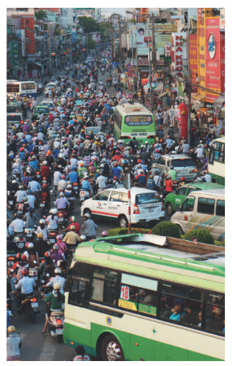  ** Ss work with their partner to do the task.  *** Teacher calls on some Ss to answer.   Teacher gives comments and leads Ss to task  Task 2: Listen to the recording and choose the correct answer A, B, or C  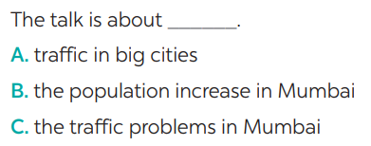  * Teacher asks Ss to read and underline the key words.  ** Ss work independently to guess then listen to the recording once to check their guess.  *** Teacher calls on some students to give the answers the have listened. | Task 1: What can you see in this picture? What is special about it?  Suggested answers:  In the picture, there are numerous vehicles running on the road: motorbikes, cars, and buses. They seem to be caught up the a traffic jam.  Task 2: Listen to the recording and choose the correct answer A, B, or C  * Aswer: C
Activity 3. PRACTICE (15’-IW, PW, GW)
* Aim:
To help students develop their skill of listening for specific information.
To help Ss use what they have listened to life context.
To help Ss prepare ideas to write a passage.
* Product: Students’ answers.
* Implementation:
Teacher’s Student’s activities | Content
Task 3: Listen again and write ONE word or number in each gap  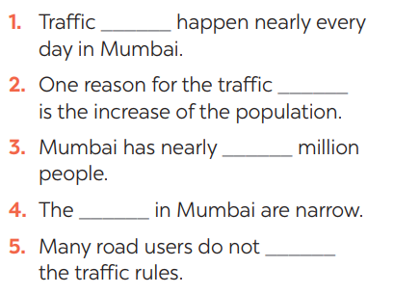   Teacher plays the recording again and confirms the correct answers for their prediction. | Task 3: Listen again and write ONE word or number in each gap  Answer key:
Task 4: Discuss: Compare traffic problems in Mumbai to the traffic problems in Hanoi.  * Teacher tells Ss to work in groups to discuss and compare traffic problems in Mumbai to the traffic problems in Hanoi. Write down onto the notebooks in full sentences  ** Ss work in groups. Teacher moves around and offers help if needed.  *** Teacher invites some Ss to share their answers.   Teacher corrects if needed. | Task 4: Discuss: Compare traffic problems in Mumbai to the traffic problems in Hanoi.  E.g. The traffic jams in Hanoi is as serious and frequent as they are in Mumbai.
Task 5: Tick the traffic problems in big cities in Viet Nam  * Teacher writes on the board “Your city’s Traffic Problems” and asks Ss to Tick the traffic problems in big cities in Viet Nam and asks them to give out more problems that they see in their city.  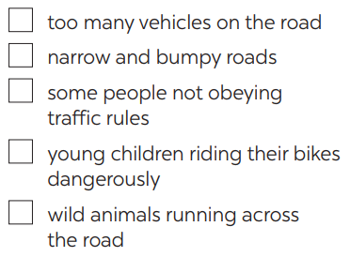  ** Ss think of it and can discuss with their partners.  *** Teacher calls on some Ss to raise their ideas.   Teacher listens and confirms. | Task 5: Tick the traffic problems in big cities in Viet Nam  Suggested answers:  Too many vehicles  Narrow roads  People’s awareness
Activity 4. APPLICATION (7’-IW, PW, GW)
* Aim:
To help Ss practise writing a passage about 70 words about the traffic problems in their town / city.
To peer check, cross check and final check students’ writing.
* Content: Writing
* Product: Students’work.
* Implementation: Teacher’s instructions
Task 6: Write a paragraph of about 70 words about the traffic problems in your town / city.  * Teacher tells Ss that they are going to write a passage about the traffic problems in your town / city.  ** Teacher reminds Ss of the structure of a passage and steps to make an outline for the passage.  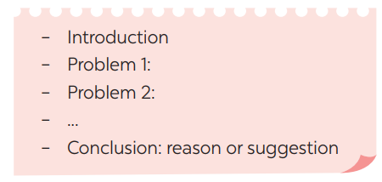  ** Ss work independently to do the task and try to use the notes from the previous tasks.  Teacher goes around and help if necessary.  Peer check and cross check  *** Teacher asks Ss to share their writing with their partners. Then, call on some Ss to show their writing in front of the class.   Teacher checks ideas, grammar, vocabulary and gives comments. | Task 6: Write a paragraph of about 70 words about the traffic problems in your town / city.  Suggested answers:  The most serious traffic problem in our city – Hanoi is the traffic jams. Although the public transport system in Hanoi is quite modern and covenient, many people prefer using their own motorbikes. The reason for that is because most roads and streets in Hanoi are quite smalls and include many tiny lanes. Therefore, using private vehicles allows them to get there without walking long distance. The situation usually gets worse at rush hours when people all go to work or return home from work and schools. In conclusion, people should try to use public transport more often to reduce the traffic jams and exhaust.
* Wrap up  - To consolidate what students have learnt in the lesson.  * Homework:  To allow students finalize their passage after being checked by friends and the teacher.  - To prepare for the next lesson:  Looking back. | * Wrap up  Teacher asks students to talk about what they have learnt in the lesson.  * Homework:  - Exercises in the workbook  - To prepare for the next lesson:  Looking back.
V. FEEDBACK:
With 7A ……………………………………………………………………………..…
With 7B …………………………...……………………………………..……………
With 7C ………………………………………………………………………….……

