UNIT 8: SHOPPING
Lesson 1: Getting started – My favourite shopping place

I. OBJECTIVES
By the end of this lesson, Ss will be able to:
1. Knowledge
- Gain an overview about the topic Shopping
- Gain vocabulary to talk about shopping
2. Competences
- Develop communication skills and creativity
- Be collaborative and supportive in pair work and teamwork
- Actively join in class activities
3. Personal qualities
- Show interest in and respect for different types of shopping places

II. MATERIALS
- Grade 8 textbook, Unit 8, Getting started
- Computer connected to the Internet
- Projector / TV
- hoclieu.vn

Language analysis
Form | Pronunciation | Meaning | Vietnamese equivalent
1. open-air market (n) | /ˌəʊpən ˈeə ˈmɑːkɪt/ | a market happening or existing outside rather than inside a building | chợ họp ngoài trời
2. home-grown (adj) | /ˌhəʊm ˈɡrəʊn/ | (of plants, fruit and vegetables) grown in a person’s garden | tự trồng
3. home-made (adj) | /ˌhəʊm ˈmeɪd/ | made at home, rather than produced in a factory and bought in a shop | tự làm
4. bargain (v) | /ˈbɑːɡən/ | to discuss prices, conditions, etc. with somebody in order to reach an agreement that is acceptable | mặc cả
5. farmers’ market (n) | /ˈfɑːməz mɑːkɪt// | a place where farmers and growers sell food directly to the public | chợ nông sản
6. price tag (n) | /ˈpraɪs tæɡ/ | ​a label on something that shows how much you must pay | nhãn ghi giá mặt hàng
7. convenience store (n) | /kənˈviːniəns stɔː/ | a small local shop that sells food, newspapers, etc. and has long opening hours | cửa hàng tiện lợi

Assumption
Anticipated difficulties | Solutions
Ss may not know enough vocabulary relating to the topic to understand the conversation. | Provide the necessary vocabulary for students to understand the conversation.

III. PROCEDURES
1. WARM-UP (5 mins)
a. Objectives:
- To create an active atmosphere in the class before the lesson;
- To lead into the new unit.
b. Content:
- Chatting
c. Expected outcomes:
- Pupils can answer some questions of the teacher about shopping
d. Organisation

TEACHER’S AND STUDENTS’ ACTIVITIES | CONTENTS
CHATTING  - T asks ss some questions about the topic:  1. Do you like shopping?  2. Where do you often go shopping?  3. Can you name some markets or supermarkets that you know?  4. Do you prefer shopping in an open-air market or in a supermarket?  - T leads to the new unit. Write the unit title SHOPPING on the board. Ask Ss to guess what they are going to learn about in this unit. | Students’ own answers
e. Assessment
- T listen to Ss’ answers and give feedback

2. ACTIVITY 1: PRESENTATION (5 mins)
a. Objectives:
- To set the context for the introductory dialogue;
- To introduce the topic of the unit.
b. Content:
- Vocabulary pre-teaching
c. Expected outcomes:
- Students can identify some new words/phrases about shopping.
- Students get ready for the lesson.
d. Organisation

TEACHER’S AND STUDENTS’ ACTIVITIES | CONTENTS
Vocabulary pre-teaching  - Teacher introduces the vocabulary.  - Teacher explains the meaning of the new vocabulary by pictures/ explanations/ examples.  - Teacher reveals that these seven words will appear in the reading text and asks students to open their textbooks to discover further. | New words:  1. open-air market (n)  2. home-grown (adj)  3. home-made (adj)  4. bargain (v)  5. farmers’ market (n)  6. price tag (n)  7. convenience store (n)
e. Assessment
- Teacher checks students’ pronunciation and gives feedback.

3. ACTIVITY 2: PRACTICE (25 mins)
a. Objectives:
- To help Ss read for specific information about markets.
- To help Ss learn words and phrases related to different markets and their features;
- To help Ss further understand the text.
b. Content:
- Task 1: Listen and read.
- Task 2: Mai and Alice mentioned four places where they can buy things. Complete the list.
- Task 3: Match the types of markets with the features.
- Task 4: Complete the sentences with the words and phrases from the box.
c. Expected outcomes:
- Students get some information about different markets and their features, understand the conversation and topic of the lesson
d. Organisation

TEACHER’S AND STUDENTS’ ACTIVITIES | CONTENTS
Task 1: Listen and read. (6 mins)
Set the context:  - Teacher has Ss to look at the pictures in the book and answer the questions.  - T encourages ss to answer the questions, but doesn’t confirm their answers.  - Teacher plays the recording for ss to listen and read along. Then invite some pairs of Ss to read the conversation aloud.  - T refers to the questions previously asked and confirms the correct answer. | Questions:  - What do you think Mai and Alice are talking about?  - What are the pictures about?  - What are the people in the pictures doing?  Suggested answer:  - Mai and Alice are talking about different types of markets.  - The pictures are about Bac Ha Open-air Market.  - The people in the picture are buying and selling things.
Task 2: Mai and Alice mentioned four places where they can buy things. Complete the list.
(6 mins)
- Encourage ss to do the task without reading the conversation again. If they can’t, let them refer to the conversation for the answers.  - Teacher checks the answers as a class and gives feedback. | Answer key:  1. open-air market  2. farmers’ market  3. supermarket  4. convenience store
Task 3: Match the types of markets with the features. (6 mins)
- Ask Ss to look at the two types of markets first and see if they can remember any information about them from the conversation. Encourage them to say it.  - Ask ss to do the task individually or in pairs.  - Ask Ss to say the words / phrases aloud. Make sure they pronounce the words and phrases correctly.  - Teacher checks the answers as a class and gives feedback. | Answer key:  1. a, c  2. b, d, e
Task 4: Complete the sentences with the words and phrases from the box. (7 mins)
- Call on some ss to read the words and phrases in the box aloud. Correct their pronunciation if needed.  - Ask ss to work independently to fill each blank with a word or phrase from the box.  - Check the answers as a class. | Answer key:  1. bargain  2. convenience store  3. home-grown  4. price tag  5. home-made
e. Assessment
- Teacher checks students’ answers individually and gives feedback.

4. ACTIVITY 3: PRODUCTION (5 mins)
a. Objectives:
- To introduce various types of speciality shops.
- To create a fun atmosphere in the class.
b. Content:
- Task 5: GAME: Listing
c. Expected outcomes:
- Ss can list as many types of speciality shops as possible.
d. Organisation

TEACHER’S AND STUDENTS’ ACTIVITIES | CONTENTS
Task 5: GAME: Listing
Work in groups. Quickly write down the names of some speciality shops. The group with the most correct answers wins.
- To lead in, write the words “music shop” and “sports shop” on the board. Ask Ss what they can buy from each shop. Then write the word “speciality shops” above the two shops.  - Allow Ss some time to write down the names of as many speciality shops as possible.  - Call on some Ss to read aloud their list. Find the Ss with the most correct answers. | Suggested answer:  clothes shop, florist’s, bakery, butcher’s, bookshop, greengrocer’s, stationer’s, dairy, candy shop, café, music shop, computer shop, barber’s, hairdresser’s, gift shop, pet shop, shoe shop, etc.
e. Assessment
- T and other Ss listen and comment.

5. CONSOLIDATION (5 mins)
a. Wrap-up
- Ask Ss to name some shops they have learnt in the lesson.
- If there is an overhead projector in the classroom, show the dialogue, highlight the key words related to the topic.
b. Homework
- Name some places for shopping they have learnt about in the lesson.
- Learn new words and phrases by heart.
- Start preparing for the Project of the unit:
Teacher randomly puts Ss in groups of 4 or 5 and asks them to brainstorm about a shopping place that they would like to have in their neighbourhood and make a poster about it. Students will show and present their posters in Lesson 7 – Looking back and Project. (Teacher should check the progress of students’ preparation after each lesson.)

BOARD PLAN

Date of teaching
Unit 8: Shopping
Lesson 1: Getting started
* Vocabulary
1. open-air market (n)
2. home-grown (adj)
3. home-made (adj)
4. bargain (v)
5. farmers’ market (n)
6. price tag (n)
7. convenience store (n)
* Practice:
Task 1: Listen and read.
Task 2: Complete the list.
Task 3: Match.
Task 4: Complete the sentences.
Task 5: Game: Listing.
*Homework

UNIT 8: SHOPPING
Lesson 2: A closer look 1

I. OBJECTIVES
By the end of this lesson, Ss will be able to:
1. Knowledge
- Identify some nouns related to the topic of shopping, some types of shops and their characteristics as well.
- Distinguish two consonant blends /sp/and /st/
2. Competences
- Develop competencies of communication, cooperation, and self-management.
- Be collaborative and supportive in pair work and teamwork
- Actively join in class activities
3. Personal qualities
- Raise ss’ awareness of responsible shopping and have good attitude to shopping

II. MATERIALS
- Grade 8 textbook, Unit 8, A closer look 1.
- Computer connected to the Internet
- Projector / TV
- hoclieu.vn

Language analysis
Form | Pronunciation | Meaning | Vietnamese equivalent
1. shopaholic (n) | /ˌʃɒpəˈhɒlɪk/ | a person who enjoys shopping very much and spends too much time or money doing it | người nghiện mua sắm
2. on sale | /ɒn seɪl/ | being offered at a reduced price | đang (được bán) hạ giá
3. discount shop (n) | /ˈdɪskaʊnt /ʃɒp/ | a shop that sells things very cheaply, often in large quantities or from a limited range of goods | cửa hàng hạ giá

Assumption
Anticipated difficulties | Solutions
Ss may lack vocabulary related to the topic of shopping, some types of shops, and their characteristics, so they may have difficulty completing the tasks | T is willing to provide them with enough vocabulary related to the topic

III. PROCEDURES
1. WARM-UP (5 mins)
a. Objectives:
- To create an active atmosphere in the class before the lesson;
b. Content:
- Warm-up activity: Video watching
c. Expected outcomes:
- Ss can get some information from the video and answer questions related to the video and the topic of the lesson.
d. Organisation

TEACHER’S AND STUDENTS’ ACTIVITIES | CONTENTS
Game: Video watching  - Give Ss a few minutes to watch a video and ask ss some questions about the clip.  - T leads in the new lesson. | Video link: https://www.youtube.com/watch?v=d-jE5WJ7J28\  Suggested questions:  - Do you know the film? What is its name? (Confession of a shopaholic)  - What is the film about? (It’s about a girl who is addicted to shopping)
e. Assessment
- T checks ss’ vocabulary and give feedback

2. ACTIVITY 1: VOCABULARY (20 mins)
a. Objectives:
- To visually introduce some nouns related to the topic of shopping.
- To introduce more types of shops and their characteristics.
- To provide ss with an opportunity to use some vocabulary in sentences
b. Content:
- Vocab pre-teaching.
- Task 1: Write the words and phrases under the correct pictures.
- Task 2: Match the shopping places with their characteristics.
- Task 3: Complete the sentences with the words and phrases from the box.
c. Expected outcomes:
- Ss can identify new words related to the topic of shopping.
- Ss can use the learned words/phrases in context.
d. Organisation

TEACHER’S AND STUDENTS’ ACTIVITIES | CONTENTS
Vocabulary pre-teaching (5 mins)
- Teacher introduces the vocabulary.  - Teacher explains the meaning of the new vocabulary with pictures/ explanations/ examples. | New words:  1. shopaholic (n)  2. on sale  3. discount shop (n)
Task 1: Write the words and phrases under the correct pictures. (3 mins)
- Ask Ss to read the words and phrases, then look at the pictures and do the task.  - Check the answers as a class.  - Have Ss then read the words and phrases aloud. Correct their pronunciation if needed.  - If necessary, ask Ss for the Vietnamese equivalents of these words and phrases. | Answer key:  1. price tag  2. shopaholic  3. on sale  4. browsing  5. Internet access
Task 2: Match the shopping places with their characteristics. (6 mins)
- Ask Ss to read the names of different places for shopping and see if they know any of their characteristics.  - Allow Ss some time to do the matching.  - Call on some Ss to give their answers.  - Check the answers as a class. | Answer key:  1. e  2. a  3. d  4. b  5. c
Task 3: Complete the sentences with the words and phrases from the box. (6 mins)
- Ask Ss to read the words and phrases provided.  - Ask Ss to work individually.  - Call on some Ss to say their answers.  - Check Ss’ answers as a class.  - T can also ask some Ss to read out their answers. Then have Ss read the sentences aloud as a class. Correct Ss’ pronunciation if necessary. | Answer key:  1. speciality shops  2. browsing  3. bargain  4. range of products  5. shopaholic
e. Assessment
- Teacher checks students’ pronunciation and gives feedback.

3. ACTIVITY 2: PRONUNCIATION (12 mins)
a. Objectives:
- To help Ss identify how to pronounce the sounds /sp/ and /st/;
- To help Ss practise pronouncing the sounds /sp/ and /st/ correctly in words and sentences
b. Contents:
- Task 4: Listen and repeat the words. Pay attention to the sounds /sp/ and /st/.
- Task 5: Listen and repeat the sentences. Pay attention to the underlined words.
c. Expected outcomes:
- Students can pronounce the two sounds in words and sentences.
d. Organisation

TEACHER’S AND STUDENTS’ ACTIVITIES | CONTENTS
Task 4: Listen and repeat the words. Pay attention to the sounds /sp/ and /st/. (6 mins)
- Have some Ss read out the words. Correct them if needed.  - Play the recording for them to listen and repeat the words as a class, in groups, and individually. Play the recording as many times as necessary. | 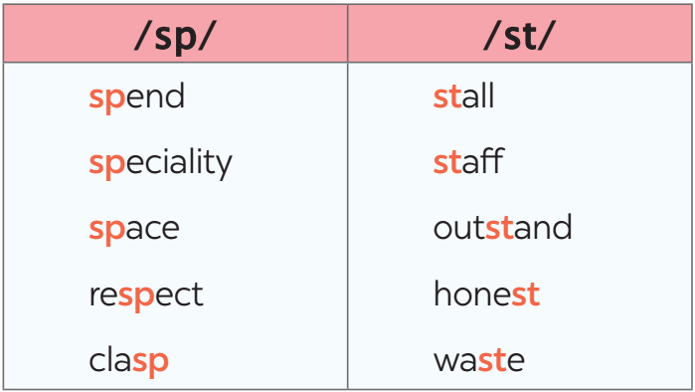
Task 5: Listen and repeat the sentences. Pay attention to the underlined words. (6 mins)
- Have Ss read the sentences, paying attention to the underlined words with the sounds /sp/ and /st/.  - Play the recording for Ss to listen and repeat each sentence. Correct them if needed  - Call some Ss to read the sentences individually. Correct them if needed | 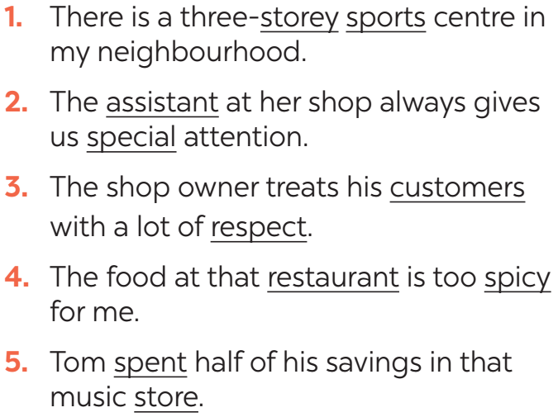
e. Assessment
- Teacher checks students' pronunciation and gives feedback.

4. ACTIVITY 3: PRODUCTION (5 mins)
a. Objectives:
- To test students' quick reaction to the targeted sounds
b. Content:
- Game: Whispering
c. Expected outcomes:
- Distinguish between the sounds /sp/ and /st/
d. Organisation
TEACHER’S AND STUDENTS’ ACTIVITIES | CONTENTS
Game: Whispering
- Teacher explains the rule:  RULE:  + Work in 2 teams  + Players stand in a line.  + The teacher whispers 5 words one by one from one person to the next until it gets to the end of the line. The last person in the line repeats the words.  + The team with more correct words will win. | 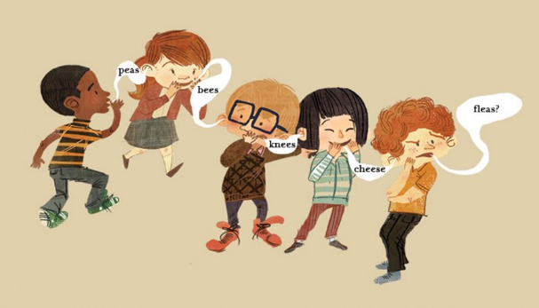
e. Assessment
- T and Ss listen and give corrections to others’ pronunciation

4. CONSOLIDATION (4 minutes)
a. Wrap-up
- Ask Ss to summarise what they have learned in the lesson.
- Ask them to list some nouns related to shopping learned in the lesson.
- Ask them to list some shopping places and characteristics
- Ask ss to give 2 sounds learned in the lessons and give examples.
b. Homework
- Name a list of shopping places
- Find 5 more words with the sounds /st/ and /sp/
- Do exercise in the Workbook

BOARD PLAN

Date of teaching
Unit 8: Shopping
Lesson 2: A closer look 1
* Vocabulary
1. shopaholic (n)
2. on sale (adv)
3. discount shop (n)
Task 1: Write the words and phrases.
Task 2: Match.
Task 3: Complete the sentences.
* Pronunciation
Task 4: Listen and repeat the words.
Task 5: Listen and repeat the sentences
*Homework

UNIT 8: SHOPPING
Lesson 3: A closer look 2

I. OBJECTIVES
By the end of this lesson, Ss will be able to:
1. Knowledge
- Revise and use some adverbs of frequency
- Identify how to use the present simple for future events
- Understand the difference in the use of present simple and future simple when talking about future activities.
2. Competences
- Develop competencies of communication, cooperation, and self-management.
- Be collaborative and supportive in pair work and teamwork
- Actively join in class activities
3. Personal qualities
- Raise ss’ awareness of responsible shopping and have good attitude to shopping

II. MATERIALS
- Grade 8 textbook, Unit 8, A closer look 2.
- Computer connected to the Internet
- Projector / TV
- hoclieu.vn

Language analysis
Types of sentences | Definition | Examples
1. Adverbs of frequency | To say how often we do things and how often things happen.  There are six main adverbs of frequency that we use in English: always, usually (or normally), often, sometimes, rarely, and never | - They usually buy discount goods.
2. Present simple for future events | We use the present simple with a future meaning to talk about timetables or schedules. | - The train leaves at 4:30, so we still have a lot of time.

Assumption
Anticipated difficulties | Solutions
Ss may get confused about the use of present simple and future simple when talking about future activities. | T should be ready to find examples and give clear explanations to distinguish them.

III. PROCEDURES
1. WARM-UP (4 mins)
a. Objectives:
- To create an active atmosphere in the class before the lesson;
b. Content:
- Brainstorming
c. Expected outcomes:
- Having a chance to speak English and focus on the topic of the lesson.
d. Organisation

TEACHER’S AND STUDENTS’ ACTIVITIES | CONTENTS
Brainstorming
- Ss work in two teams.  - Give Ss 2 minutes to write as many adverbs of frequency as possible.  - The team with the most correct sentences wins.  - T leads in the lesson A CLOSER LOOK 2 on page 85. | Adverbs of frequency:  always, usually, normally, often, sometimes, rarely, never, seldom, frequently, occasionally
e. Assessment
- T checks ss’ answers and gives feedback

2. ACTIVITY 1: PRESENTATION (7 mins)
a. Objectives:
- To review ss’ knowledge of adverbs of frequency
- To revise ss’ knowledge of the present simple
b. Content:
- Revision
c. Expected outcomes:
- Ss can recall the main adverbs of frequency and their use.
- Ss can use the present simple sentences for future actions.
d. Organisation
TEACHER’S AND STUDENTS’ ACTIVITIES | CONTENTS
1. Adverbs of frequency
- T gets ss to list all the adverbs of frequency they can remember and the elicits the use of adverbs of adverbs of frequency from ss.  - T confirms the answer and gets ss to take notes | 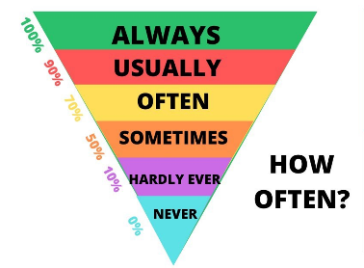
2. Present simple for future events
- T asks ss to recall the forms and uses of the present simple.  - T introduces the use of the present simple for future actions. | 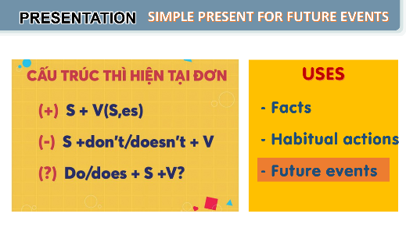
e. Assessment
- Teacher listens to students’ answers and gives feedback.

3. ACTIVITY 2: PRACTICE (24 mins)
a. Objectives:
- to revise and use some adverbs of frequency.
- to apply the use of present simple for future actions.
- to understand the difference in the use of present simple and future simple when talking about future activities.
b. Content:
- Task 1: Complete the sentences with the adverbs of frequency from the box.
- Task 2: Read the schedule of the field trip for the grade 8 students tomorrow and underline the verbs in the sentences. Then answer the questions.
- Task 3: Write A next to a sentence if it refers to a timetable, schedule, or plan, and B if it is an unplanned future action.
- Task 4: Choose the correct answer to complete each sentence.
c. Expected outcomes:
- Students can practise using adverbs of frequency in contexts
- Students can use the present simple for future actions.
d. Organisation

TEACHER’S AND STUDENTS’ ACTIVITIES | CONTENTS
Task 1: Complete the sentences with the adverbs of frequency from the box. (4 mins)
- Ask Ss to do the activity individually.  - Have Ss read the sentences and decide which adverb in the box best describes the frequency of the action.  - Call on some Ss to read aloud their answers.  - Check the answers as a class. Explain if needed. | Answer key:  1. always  2. rarely  3. never  4. often  5. sometimes
Task 2: Read the schedule of the field trip for the grade 8 students tomorrow and underline the verbs in the sentences. Then answer the questions. (5 mins)
- Have Ss do this activity individually or in pairs.  - Ask them to read the schedule and underline the verb in each sentence.  - Allow them some time to answer the questions.  - Call on some Ss to give their answers.  - Confirm the correct answers as a class.  - Have Ss read the Remember! box. Explain if needed. | Answer key:  Verbs: leaves, arrive, watch, starts, return  1. The present simple.  2. Future activities. (Refer to the word “tomorrow” in the task instructions.)
Task 3: Write A next to a sentence if it refers to a timetable, schedule, or plan, and B if it is an unplanned future action. (6 mins)
- Write scheduled future activity and unplanned future activity on the board. Say two sentences: The bus leaves at 11:00 and we have plenty of time. and Don’t move. I’ll answer the phone. Ask Ss which sentence is a scheduled future activity and which one is an unplanned future activity. Then write them underneath their correct categories.  - Ask Ss to work individually or in pairs.  - Call on 2 - 3 Ss to read aloud their answers.  - Confirm the correct answers as a class. Explain if needed. | Answer key:  1. B  2. A  3. A  4. A  5. B
Task 4: Choose the correct answer to complete each sentence. (5 mins)
- Have Ss do this activity individually.  - Ask Ss to read each sentence carefully and decide which option best completes the sentence.  - Call on some Ss to read out their answers.  - Confirm the correct answers as a class. | Answer key:  1. opens  2. will make  3. won’t buy  4. is  5. Does
e. Assessment
- Students do peer correction
- Teacher checks students’ answers as a class and gives feedback.

4. ACTIVITY 3: PRODUCTION (5 mins)
a. Objectives:
- To provide Ss with a real-life practice to use the present simple to talk about events.
b. Content:
- Task 5: Work in pairs. Ask and answer to check planned events for the community fair next month.
c. Expected outcomes:
- Ss can use the present simple to talk about the future events.
d. Organisation

TEACHER’S AND STUDENTS’ ACTIVITIES | CONTENTS
Task 5: Work in pairs. Ask and answer to check planned events for the community fair next month. (5 mins)
- Have Ss work in pairs.  - Ask Ss to read the example so that they know what they have to do.  - Allow Ss some time to read the schedule and ask and answer about the time of different events.  - Call on some pairs to say aloud their questions and answers. Ask the whole class to follow and correct if they make a mistake. | 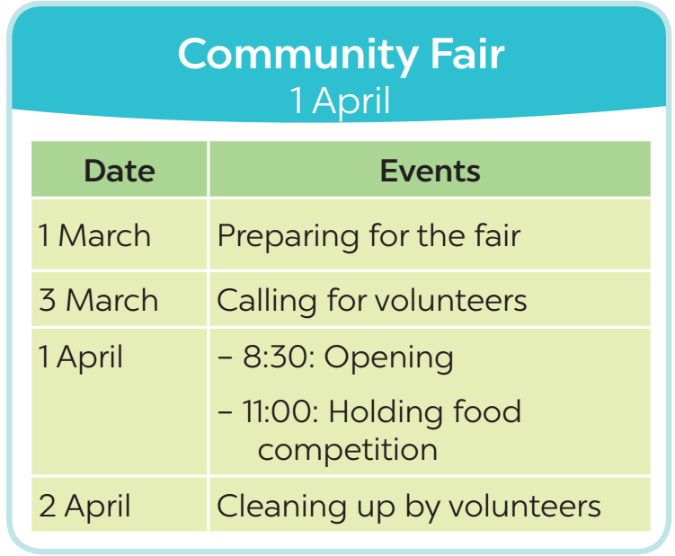
e. Assessment
- T corrects any grammar and pronunciation mistakes if necessary.

5. CONSOLIDATION (4 mins)
a. Wrap-up
- Ask Ss to summarise what they have learnt in the lesson.
- Have them say out loud the adverbs of frequency they learned in the lesson.
- Have them retell the form and uses of the present simple
b. Homework
- Learn the use of adverbs of frequency by heart.
- Make 5 sentences using the simple present for future actions
- Do the exercises in the Workbook

BOARD PLAN

Date of teaching
Unit 8: Shopping
Lesson 3: A closer look 2
* Warm-up
1. Adverbs of frequency
100% | always
90% | usually
80% | normally
70% | often
40% - 50% | sometimes
20% - 30% | occasionally
5% - 10% | rarely
0% | never
2. Present simple
a. Form:
(+) S+ V(s/es)
(-) S + don’t/ doesn’t + V
(?) Do/ Does + S + V?
b. Uses:

Task 1: Complete the sentences.
Task 2: Underline the verbs. Answer the questions.
Task 3: Write A: a timetable, schedule or plan; and B: unplanned future action.
Task 4: Choose the correct answer.
Task 5: Ask and answer.
*Homework

UNIT 3: SHOPPING
Lesson 4: Communication

I. OBJECTIVES
By the end of this lesson, Ss will be able to:
1. Knowledge
- Making complaints in English
- Listen and talk about favourite shopping places.
3. Competences
- Develop competencies of communication, cooperation, and self-management.
- Be collaborative and supportive in pair work and group work.
4. Personal qualities
- Raise ss’ awareness of responsible shopping
- Have good attitude towards others by making polite complaints

II. MATERIALS
- Grade 8 textbook, Unit 8, Communication.
- Computer connected to the Internet
- Projector / TV
- hoclieu.vn

Language analysis
Making complaints | Examples
- I’m calling/ writing to make a complaint about…  - I’m not happy with … | - I’m calling to make a complaint about the backpack I ordered from you last week.  - I’m not happy with the colour.

Assumption
Anticipated difficulties | Solutions
Some Ss may have difficulty getting enough information to ask and answer what each person likes about their shopping | T should give suggestions or let ss listen more times to get enough information.

III. PROCEDURES
1. WARM-UP (3 mins)
a. Objectives:
- To create an active atmosphere in the class before the lesson;
b. Content:
- Chatting
c. Expected outcomes:
- Ss can make appropriate complaints in the given situation

TEACHER’S AND STUDENTS’ ACTIVITIES | CONTENTS
Chatting:  - T gives ss a situation:  Suppose that you ordered a hat online, but when you got it, it didn’t have the same colour as you ordered. What would you do in that case?  - T leads in the new lesson: If we aren’t satisfied with something you ordered, we can make complaints. There are two ways of making complaints that we will learn in Lesson 4. Communication.  - Ask Ss to look at COMMUNICATION on page 86. | Expected answers:  - Making complaints
e. Assessment
- T checks ss’ answers and give feedback

2. ACTIVITY 1: EVERYDAY ENGLISH (12 mins)
a. Objectives:
- To introduce how to make a complaint;
- To help Ss practise making a complaint.
b. Content:
- Task 1: Listen and read the dialogue. Pay attention to the highlighted parts.
- Task 2: Work in pairs. In turn, make complaints about the situations below.
c. Expected outcomes:
- Students can make complaints in the specific situations
d. Organisation
TEACHER’S AND STUDENTS’ ACTIVITIES | CONTENTS
Task 1: Listen and read the dialogue. Pay attention to the highlighted parts. (5 mins)
- Play the recording for Ss to listen and read the conversation where Tom makes complaints about the SMART backpack he bought the previous week. Ask Ss to pay attention to the highlighted parts.  - Elicit the structures for making a complaint. Have Ss practise the conversation in pairs. | To make a complaint, you can use:  - I’m calling/ writing to make a complaint about….  - I’m not happy with ….
Task 2: Work in pairs. In turn, make complaints about the situations below. (7 mins)
- Ask Ss to work in pairs to make similar dialogues.  - Tell them to use the contexts given and the sample requests.  - Give feedback on their dialogues. | 1. The cans of fish you bought at the shop expired five days ago.  • I’m calling to make a complaint about the cans of fish I bought at your shop five days ago. It was expired.  2. An assistant at the shop was not very helpful.  I’m not happy with an assistant at the shop. She was not very helpful.
e. Assessment
- Teacher listens to students’ complaints and gives feedback.

3. ACTIVITY 2: MY FAVOURITE SHOPPING PLACE (25 mins)
a. Objectives:
- To help Ss practise listening for general and specific information.
- To provide Ss with some samples to help them talk about their favourite shopping places.
b. Content:
- Task 3: Listen to three people talking about their favourite shopping places and tick the place they mention.
- Task 4: Work in pairs. Take turns to ask and answer what each person in 3 likes about their shopping place.
c. Expected outcomes:
- Ss can identify some different favourite shopping places
- Students can apply what they have learnt to talk about their favourite places to shop.
d. Organisation

TEACHER’S AND STUDENTS’ ACTIVITIES | CONTENTS
Task 3: Listen to three people talking about their favourite shopping places and tick the place they mention. (7 mins)
- Have Ss read the instructions and the table so that they know what they have to do while listening to the recording.  - Play the recording and ask Ss to listen and tick the correct answers.  - Call on some Ss to read their answers.  - Confirm the correct answers as a class. | Answer key:  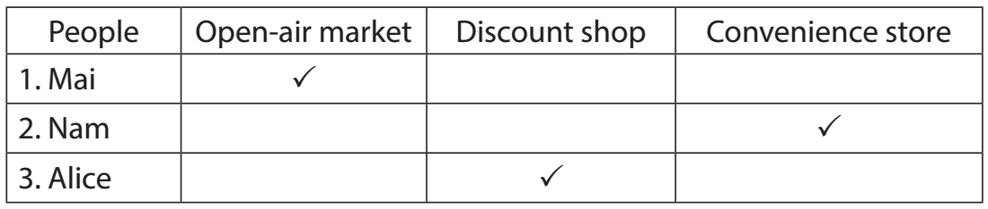
Task 4: Work in pairs. Take turns to ask and answer what each person in 3 likes about their shopping place. (8 mins)
- Have Ss work in pairs.  - Have Ss take turns to ask and answer about what each person in 3 likes about the place where they shop.  - Call on 2 - 3 pairs to share their lists. Make comments. | Suggested answers:  1.  A: What does Mai like about shopping at an open-air market?  B: The products are home-grown and home-made. And the market goers know one another, so they  can chat happily while selling and buying.  2.  A: What does Nam like about shopping at a convenience store?  B: They are convenient because they are everywhere. It saves him time.  3.  A: What does Alice like about shopping at a discount shop?  B: There is a wide range of goods there. Everything is cheaper than at other places.
Task 5: Work in groups. Share your favourite shopping place with your group. (10 mins)
- Have Ss work in groups.  - T gets Ss to apply what they have learnt so far in this unit (ideas, vocabulary, grammar) to talk about their favourite places to shop.  - Allow Ss some time to talk in their groups. Go round and give support if needed.  - Ask some Ss to share their ideas with the class. | You can include:  - The name of the place  - The reason(s) why you like it
e. Assessment
- T checks Ss’ answers, listens to their talks and gives feedback on their pronunciation and content.

3. CONSOLIDATION (4 mins)
a. Wrap-up
- Ask Ss what they have learnt in the lesson.
- Ask Ss to retell 2 ways of making complaints and list some favourite shopping places
b. Homework
- Learn the ways to make complaints by heart.
- Write a paragraph of 50 - 70 words about your favourite shopping place.
- Do the exercises in the Workbook

BOARD PLAN

Date of teaching
Unit 8: Shopping
Lesson 4: Communication
* Everyday English
Making a complaint
- I’m calling/ writing to make a complaint about…
- I’m not happy with …
Task 1: Listen and read.
Task 2: Make complaints.

* My favourite shopping place
Task 3: Listen and tick.
Task 4: Ask and answer about their shopping place.
Task 5: Share your favourite shopping place.

*Homework

UNIT 8: SHOPPING
Lesson 5: Skills 1

I. OBJECTIVES
By the end of this lesson, Ss will be able to:
1. Knowledge
- use the lexical items related to the reason(s) people go shopping.
- make a conversation to ask and answer about a new shopping centre and
2. Skills:
- read for specific information (scanning) about reasons people go to shopping centres through multiple-choice questions and gap-filling exercise
- practise asking and answering questions for information about a new shopping centre and a shopping place in their own area.
3. Competences
- develop communication skills and creativity
- be collaborative and supportive in pair work and teamwork
- develop presentation skill
- actively join in class activities
4. Personal qualities
- raise ss’ awareness of responsible shopping

II. MATERIALS
- Grade 8 textbook, Unit 8, Skills 1
- Computer connected to the Internet
- Projector / TV
- hoclieu.vn

Language analysis
Form | Pronunciation | Meaning | Vietnamese equivalent
1. customer (n) | /ˈkʌstəmə(r)/ | a person or an organisation that buys goods or services from a shop or business | khách hàng
2. try on (v) | /traɪ ɒn/ | to put on a piece of clothing to see if it fits and how it looks | thử (quần áo)
3. decoration (n) | /ˌdekəˈreɪʃn/ | a thing that makes something look more attractive on special occasions | đồ trang trí
4. wander (v) | /ˈwɑːndər/ | to walk slowly around or to a place, often without any particular sense of purpose or direction | đi lang thang, thả bộ

Assumption
Anticipated difficulties | Solutions
1. Ss may lack knowledge about some lexical items. | Provide Ss with the meaning and pronunciation of words.
2. Ss may not have sufficient reading, speaking and cooperating skills. | - Let Ss read the text again (if needed).  - Create a comfortable and encouraging environment for Ss to speak.  - Encourage Ss to work in pairs, and in groups so that they can help each other.  - Provide feedback and help if necessary.

III. PROCEDURES
1. WARM-UP (3 mins)
a. Objectives:
- To create an active atmosphere in the class before the lesson;
- To elicit from Ss some reasons why they go shopping
b. Content:
- Chatting: reasons why Ss go shopping
c. Expected outcomes:
- Ss can answer some questions about why they go shopping
d. Organisation

TEACHER’S AND STUDENTS’ ACTIVITIES | CONTENTS
Chatting:  - Ask ss questions to elicit from ss the reasons why they go shopping.  + Do you like shopping?  + How often do you go shopping?  + Why do you go to shopping centres?  - Ask Ss to discuss the reasons why they go shopping  - Ask Ss to look at SKILLS 1 on page 87-88. | Expected answers:  - Yes/ No  - I go shopping twice a week/ every day….  - I like shopping because….
e. Assessment
- T listens to ss’ answers and gives feedback

2. ACTIVITY 1: READING (26 mins)
a. Objectives:
- To help Ss develop their reading skill for general and specific information.
b. Content:
- Task 1: Read the list below and tick (v) the most common reason(s) why you go shopping.
- Vocabulary pre-teaching
- Task 2: Read the passage and choose the correct answer A, B, or C.
- Task 3: Fill in each blank with ONE word from the passage.
c. Expected outcomes:
- Ss can gain some new words, identify some reason(s) people go shopping through a text and identify some specific information in the text
d. Organisation
TEACHER’S AND STUDENTS’ ACTIVITIES | CONTENTS
Task 1: Read the list below and tick the most common reason(s) why you go shopping. (3 mins)
- Have Ss work individually.  - Ask Ss to read the words and phrases and tick the one(s) that is / are correct for them.  - Call on some Ss to share their answers with the class. | 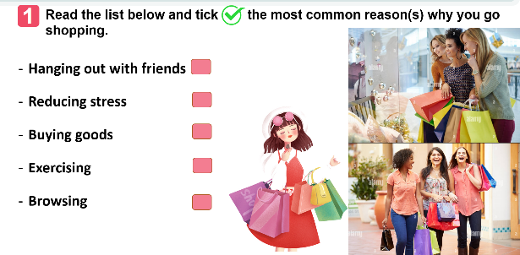
Vocabulary pre-teaching  - Teacher asks ss to look through the text.  - Teacher gets ss to guess the meaning of the new vocabulary through context  - Teacher confirms the answers then gets ss to read orally and take notes of all the four words in their notebooks. | * Vocabulary:  1. customer (n)  2. try on (v)  3. decoration (n)  4. wander (v)
Task 2: Read the passage and choose the correct answer A, B, or C. (10 mins)
- Have Ss read the text in detail first. Then ask them to read each question and choose the correct answer for it.  - Ask ss to find the information in the reading text.  - Call on some Ss to share their answers. Ask them where they find the information for their answers.  - Confirm the correct answers as a class. Explain if needed. | Answer key:  1. C  2. A  3. B  4. B  5. A
Task 3: Fill in each blank with ONE word from the passage. (10 mins)
- Ask Ss to read each sentence carefully, then refer to the text to look for the answer. Have them complete the task.  - Have Ss compare their answers in pairs and discuss if there are any differences in their answers.  - Call on some Ss to share their answers with the class. Ask them where they find the information for their answers.  - Confirm the correct answers as a class. | Answer key:  1. sales  2. try  3. entertainment  4. decorations  5. free
e. Assessment
- T checks the answers as a class and gives feedback.

3. ACTIVITY 2: SPEAKING (15 mins)
a. Objectives:
- To help Ss practise asking and answering questions for information about a new shopping centre
- To provide an open opportunity for Ss to talk about a shopping place in their own area
b. Content:
- Task 4: Work in pairs. Ask and answer about a new shopping centre.
- Task 5: Work in pairs. Ask and answer about a shopping centre, a supermarket, or an open-air market in your area. Take notes of your partner’s answers and report them to the class.
c. Expected outcomes:
- Students can speak about a new shopping centre and a shopping place in their own area.
d. Organisation

TEACHER’S AND STUDENTS’ ACTIVITIES | CONTENTS
Task 4: Work in pairs. Ask and answer about a new shopping centre. (9 mins)
- Ask Ss to work in pairs, each having their card (A or B). Make sure that they know how to work with the cards.  - Allow them some time to prepare the questions and to read the information for the answers. Then ask them to start asking and answering about the new shopping centre. Go around and monitor. Give help if needed.  - Call on some Ss to share their conversation with the class. Comment on their conversation.  - This activity helps prepare Ss for 5. | Suggested questions:  1. Where is the new shopping centre?  2. How many shops are there / does it have?  3. What kind of entertainment does it offer / have / can we find there?  4. What are its opening hours?  5.What date does the shopping centre open?
Task 5: Work in pairs. Ask and answer about a shopping centre, a supermarket, or an open-air market in your area. Take notes of your partner’s answers and report them to the class. (5 mins)
- Have Ss work in pairs.
- Ask Ss to reflect on the conversation in 4 and read the suggestions for 5.
- Allow Ss some time to carry out their conversation. Remind them to take notes of their partner’s answers. Go round and offer help if needed.
- Call on some Ss to report to the class what they find out about their partner’s shopping place. Comment on their presentation.
e. Assessment
- T asks the class to give feedback on their friends’ questions and answers, and pronunciation.
- T gives feedback on their reports in terms of language, reasoning skills, and pronunciation.

4. CONSOLIDATION (3 mins)
a. Wrap-up
- Ask Ss what they have learnt in the lesson.
- Ss retell the reasons why we go to shopping centres and information about new shopping centres.
b. Homework
- Learn the new words by heart.
- Make a speech introducing a new shopping centre in your city.
- Do the exercises in the Workbook

BOARD PLAN

Date of teaching
Unit 8: SHOPPING
Lesson 5: Skills 1
* Reading
Task 1: Read and tick.
Vocabulary:
1. customer (n)
2. try on (v)
3. decoration (n)
4. wander (v)
Task 2: Read and choose the correct answer.
Task 3: Fill in each blank.

* Speaking
Task 4: Ask and answer about a new shopping centre.
Task 5: Ask and answer. Take notes and report.
*Homework

UNIT 8: SHOPPING
Lesson 6: Skills 2

I. OBJECTIVES
By the end of this lesson, Ss will be able to:
1. Knowledge
- listen for specific information about online shopping.
- write a paragraph about the advantages and disadvantages of a type of shopping.
2. Competences
- develop communication skills and creativity
- be collaborative and supportive in pair work and group work
- actively join in class activities
3. Personal qualities
- raise their awareness of online shopping
- have the appropriate attitude toward the different types of online shopping.

II. MATERIALS
- Grade 8 textbook, Unit 8, Skills 2
- Computer connected to the Internet
- Projector / TV
- hoclieu.vn

Language analysis
Form | Pronunciation | Meaning | Vietnamese equivalent
1. access (n) | /ˈækses/ | the opportunity or right to use something or to see somebody/ something | quyền truy cập vào
2. purchase (v) | /ˈpɜːtʃəs/ | to buy something | mua sắm
3. shipping (n) | /ˈʃɪpɪŋ/ | the activity of carrying people or goods from one place to another by ship or by some other means | việc chuyển hàng,  giao hàng
4. overshopping (v) | /ˈəʊvə(r) ˈʃɒpɪŋ/ | the activity of going to shops and buying too many things or ordering too many things online | mua sắm quá đà

Assumption
Anticipated difficulties | Solutions
1. Ss may lack knowledge about some lexical items. | Provide Ss with the meaning and pronunciation of words.
2. Ss may not have sufficient listening, writing and co-operating skills. | - Let Ss listen again (if needed).  - Encourage Ss to work in pairs, in groups so that they can help each other.  - Provide feedback and help if necessary.

III. PROCEDURES
1. WARM-UP (3 mins)
a. Objectives:
- To create an active atmosphere in the class before the lesson;
- To help ss focus on the listening and writing topic
b. Content:
- Chatting activity
c. Expected outcomes:
- Students can answer some questions about shopping.
d. Organisation

TEACHER’S AND STUDENTS’ ACTIVITIES | CONTENTS
Chatting:  - Ask ss two questions to elicit from ss the reasons why they go shopping.  Have you ever shopped online?  What do you need to shop online?  - Ask Ss to discuss the reasons why they go shopping  - Ask Ss to look at SKILLS 2 on page 89. | Suggested answers:  - Yes/ No  - To shop online, we need…
e. Assessment
- T check ss’ answers and gives feedback

2. ACTIVITY 1: LISTENING (25 mins)
a. Objectives:
- To improve Ss’ skill of listening for general and specific information.
- To improve Ss’ listening comprehension and note-taking skills.
b. Content:
- Vocabulary pre-teaching
- Task 1: Work in pairs. Discuss and tick (v) the things related to online shopping.
- Task 2: Listen to a talk about online shopping and fill in each blank with a suitable word.
- Task 3: Listen again and choose the correct answer A, B, or C.
c. Expected outcomes:
- Gain more new words about online shopping
- Identify specific information about online shopping through listening
d. Organisation
TEACHER’S AND STUDENTS’ ACTIVITIES | CONTENTS
Vocabulary pre-teaching (6 mins)
- Teacher introduces the vocabulary.  - Teacher explains the meaning of the new words through pictures or explanations.  - Teacher reveals that these four words will appear in the talk and asks students to open their textbooks to discover further. | Vocabulary:  1. access (n)  2. purchase (v)  3. shipping (n)  4. over shopping (v)
Task 1: Work in pairs. Discuss and tick (v) the things related to online shopping. (5 mins)
- Have Ss work individually.  - Ask Ss to read the word and phrases and tick the one(s) they think is / are correct.  - Call on some Ss to share their answers. | Answer key: 1, 3, 4
Task 2: Listen to a talk about online shopping and fill in each blank with a suitable word. (7 mins)
- Have Ss read the sentences carefully and decide what information they need to fill in each blank.  - Play the recording for Ss to do the task.  - Have Ss share their answers in pairs.  - Invite some Ss to share their answers with the class.  - Confirm the correct answers as a class.  - Play the recording again if needed, stop at places where Ss are having difficulties. | Answer key:  1. service  2. seller’s  3. money  4. shipping  5. shopaholic
Task 3: Listen again and choose the correct answer A, B, or C. (7 mins)
- Play the recording. Have Ss do the task individually.  - Invite some pairs to share their answers with the class.  - Confirm the correct answers as a class.  - Play the recording again if needed, stop at the place where Ss are having difficulties. | Answer key:  1. B  2. C  3. C
e. Assessment
- T checks the answers as a class and gives feedback.

3. ACTIVITY 2: WRITING (15 mins)
a. Objectives:
- To provide Ss with vocabulary and ideas about the advantages and disadvantages of different types of shopping.
- To improve ss’ writing skill with a paragraph about the advantages and disadvantages of a type of shopping.
b. Content:
- Task 4: Work in pairs. Choose a type of shopping from the list. Discuss and take notes of its advantages and disadvantages.
- Task 5: Write a paragraph (80-100 words) about the advantages or disadvantages of a type of shopping. Use the ideas in 4.
c. Expected outcomes:
- Students can write a paragraph about the advantages or disadvantages of a type of shopping.
d. Organisation

TEACHER’S AND STUDENTS’ ACTIVITIES | CONTENTS
Task 4: Work in pairs. Choose a type of shopping from the list. Discuss and take notes of its advantages and disadvantages. (5 mins)
- Have Ss work in pairs.  - Ask Ss to read the list and choose the one they would like to talk about.  - Allow Ss some time to discuss and take notes of the advantages and disadvantages of the type of shopping they have chosen. Remind them to listen for the structures and expressions. Move around to oﬀer help if needed.  - Invite some Ss to share their answers to the class. | Suggested answers:  1. Shopping online  Advantages: easy, convenient, save the trouble of travelling, time, and money.  Disadvantages: the products you receive might not exactly be what you expect, you can return an item, but you have to pay for the shipping, and you can easily become a shopaholic.  2. Shopping at a supermarket  Advantages: easy, convenient, availability of many goods under one roof, a lot of promotions, don’t have to bargain, safe from heat and rain, no need to travel to multiple shops.  Disadvantages: unnecessary shopping because of discounts and convenience.  3. Shopping at an open-air market  Advantages: you can bargain, sellers can share advice about the things you buy, you can taste what you buy (bread, fruits…), develop close relations between sellers and buyers.  Disadvantages: limited operating hours, the number of sellers depends on weather, not easy to return items, affected by the weather (hot, rainy, snowy…), often lacks parking lots.
Task 5: Write a paragraph (80-100 words) about the advantages or disadvantages of a type of shopping. Use the ideas in 4. (10 mins)
- Ask Ss to read the notes of their discussion in 4.  - Allow them some time to write out the paragraph. Go round and offer help if needed.  - Call on some Ss to read aloud their writings to the class. Comment on their writing. | Suggested answer:  I often go shopping at the open-air market near my house. However, there are some things I do not like about it. Firstly, it is outdoor. On rainy or hot days, it is uncomfortable to shop. Secondly, the sellers usually ask for a higher price than the value of the goods, so you have to bargain. It is not easy if you do not know the actual price of an item. Another disadvantage is hygiene. Fresh products like vegetables are often not very clean.
e. Assessment
- T gives feedback on their writing in terms of spelling, grammatical mistakes, cohesion, and content.

4. CONSOLIDATION (3 mins)
a. Wrap-up
- Ask Ss what they have learned in the lesson.
- Ss tell the whole class about the advantages or disadvantages of a kind of shopping.
b. Homework
- Do the exercises in the Workbook.
- Rewrite the paragraph in the notebook.

BOARD PLAN

Date of teaching
Unit 8: Online shopping
Lesson 6: Skills 2
* Listening
Vocabulary:
1. access (n)
2. purchase (v)
3. shipping (n)
4. over shopping (v)
Task 1: Discuss and tick.
Task 2: Listen and fill in each blank.
Task 3: Listen and choose the correct answer.

* Writing
Task 4: Discuss and take notes.
Task 5: Write a paragraph.

*Homework

UNIT 8: SHOPPING
Lesson 7: Looking back and project

I. OBJECTIVES
By the end of this lesson, Ss will be able to:
1. Knowledge
- review the vocabulary (shopping and online shopping) and grammar (adverbs of frequency and present simple for future events) of Unit 8
- apply what they have learnt (vocabulary and grammar) into practice through a project.
2. Competences
- Develop communication skills and creativity
- Autonomy & self-study
- Develop critical thinking skills
- Be collaborative and supportive in pair work and teamwork
3. Personal qualities
- work hard to prepare for the project
- have a positive attitude toward shopping places and dream shopping places.

II. MATERIALS
- Grade 8 textbook, Unit 8, Looking back and project
- Computer connected to the Internet
- Projector / TV
- hoclieu.vn

Assumption
Anticipated difficulties | Solutions
1. Ss may not have sufficient speaking, writing and co-operating skills when doing the project. | - Encourage Ss to work in pairs, in groups so that they can help each other.  - Provide feedback and help if necessary.

III. PROCEDURES
1. WARM-UP (5 mins)
a. Objectives:
- To create an active atmosphere in the class before the lesson;
b. Content:
- Kim’s game
c. Expected outcomes:
- Students can list as many types of shops as they can remember from the video.
d. Organisation
TEACHER’S AND STUDENTS’ ACTIVITIES | CONTENTS
Kim’s game:  - T asks students to work in groups of three or four students.  - Get ss to watch a video and try to remember all types of shops mentioned in the clip without taking notes.  Video link: Types of STORES for Kids - Going Shopping Around the City - Vocabulary for Kids  - After finishing watching the clip, ss write down as many stores/ shops as possible.  - T gets ss to swap the posters among groups and give corrections after T shows the answers.  -The group with the most correct answers will win.  - T leads in the lesson. | Answers:  1. bakery  2. fruit store  3. butcher shop  4. fish market  5. pastry shop  6. flower shop  7. shoe shop  8. toy store  9. stationery shop  10. book store  11. hardware store  12. jewellery store  13. pharmacy
e. Assessment
- T checks ss’ answers and gives feedback.

2. ACTIVITY 1: LOOKING BACK (22 mins)
a. Objectives:
- To help Ss review the vocabulary and grammar learnt
b. Content:
- Task 1: Match the words and phrases (1-5) with the meanings (a-e).
- Task 2: Complete the sentences with the words and phrases from the box.
- Task 3: Complete each sentence with a suitable adverb of frequency.
- Task 4: Use the correct tense and form of the verbs in brackets to complete the sentences.
c. Expected outcomes:
- Recall the vocabulary learnt
- Recall the uses of adverbs of frequency and present simple for future events and practise through grammar exercises.
d. Organisation
TEACHER’S AND STUDENTS’ ACTIVITIES | CONTENTS
Task 1: Match the words and phrases (1-5) with the meanings (a-e). (4 mins)
- Have Ss do this activity individually.  - Ask Ss to read the words and phrases (1 - 5) and the meanings (a - e) and match them.  - Allow them to compare their answers with their partners.  - Call on some Ss to share their answers with the class.  - Confirm the correct answers. | Answer key:  1. b  2. d  3. a  4. e  5. c
Task 2: Complete the sentences with the words and phrases from the box. (5 mins)
- Have Ss do this activity individually.  - Ask Ss to read the sentences carefully, then refer to the words and phrases in the box to choose the correct answers.  - Allow Ss to compare their answers with their partners.  - Confirm the correct answers as a class. | Answer key:  1. on sale  2. bargain  3. Internet access  4. home-grown  5. offline
Task 3: Complete each sentence with a suitable adverb of frequency. (6 mins)
- Have Ss do this activity individually.  - Ask Ss to read the sentences and decide which adverb of frequency to use for each sentence.  - Call on some Ss to share their answers with the class.  - Confirm the correct answers as a class. | Answer key:  1. always  2. always / often / usually  3. never  4. often / usually  5. rarely
Task 4: Use the correct tense and form of the verbs in brackets to complete the sentences. (6 mins)
- Ask Ss to read each sentence carefully and decide which tense to use.  - Call on some Ss to read their answers and explain their choices.  - Confirm the correct answers as a class. Explain if needed. | Answer key:  1. leaves  2. is  3. can use  4. lasts  5. don’t have
e. Assessment
- Teacher checks students’ answers and corrects Ss’ language and pronunciation if necessary.

3. ACTIVITY 2: PROJECT (15 mins)
a. Objectives:
- To encourage Ss to use their imagination to design a dream shopping place.
- To improve Ss’ teamwork and public speaking skills.
b. Content:
- Picture presentation: Your dream shopping place
c. Expected outcomes:
- Students can present their posters about dream shopping places.
d. Organisation

TEACHER’S AND STUDENTS’ ACTIVITIES | CONTENTS
Your dream shopping place  - Ask Ss to read the instructions again (T has already been assigned the project since the first lesson of the Unit and checked their progress after each lesson). Let students have some time to check their posters for the final time and make any adjustments if necessary.  - T has groups show their posters and present them to the class. | Students’ posters & presentations
e. Assessment
- T listens to their presentation, and gives feedback.

4. CONSOLIDATION (2 mins)
a. Wrap-up
- Ask Ss to complete the self-assessment table.
- Identify any difficulties and provide further practice.
b. Homework
- Do the exercises in the Workbook

BOARD PLAN

Date of teaching
Unit 8: Shopping
Lesson 7: Looking back & Project
* Warm-up

* Looking back:
Task 1: Match.
Task 2: Complete the sentences.
Task 3: Complete each sentence.
Task 4: Complete the sentences.

* Project

*Homework

