|  |  |
| --- | --- |
| **Mã đề 7.1.10** | **ĐỀ KIỂM TRA, ĐÁNH GIÁ GIỮA HỌC KỲ I**  **NĂM HỌC 2022 - 2023**  Môn:Tiếng Anh - lớp 7  Thời gian : 60’ |

**A.LISTENING**

**Part 1. You will hear five short conversations. You will hear each conversation twice. There is one question for each conversation. Circle the correct picture A, B or C. (1pt)**

1. Where is the woman going to go on holiday this year?

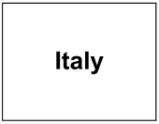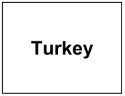

A B C

1. What time was the man’s appointment?

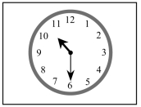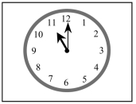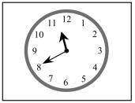

A B C

1. What will the weather be like?

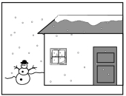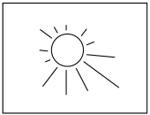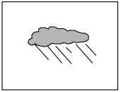

A B C

1. How far is the nearest supermarket?

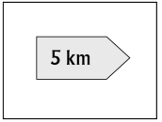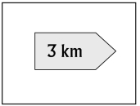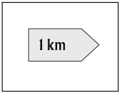

A B C

5. Which table does Sally like?

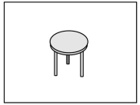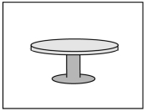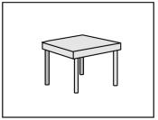

A B C

**Part 2: You will hear a man asking for information about a train.  
Listen and complete questions.  
You will hear the conversation twice.**

Train

To: Newcastle

Day of journey:(1) ....................................................

Train leaves at: (2) ....................................................

Return ticket costs: £ (3)....................................................

Food on train: Drinks and (4)....................................................

Address of travel agency: 22 (5).................................................... Street

**B. GRAMMAR- VOCABULARY- LANGUAGE FUNCTION**

**Choose the word that has the underlined part pronounced differently from the others**

1. A. go B. photo C. piano D. collect

2. A. watch B. catch C. school D. teach

**Choose the best answer among A, B, C or D that best completes each sentence.**

3. ________are those who do not have a home and really need help.

A. elderly people B. sick children C. homeless people D. disabled people

4. She often _______money to charitable organisations.

A. donate B. volunteer C. recycle D. plant

5. I think I_______him before.

A. meet B. met C. will meet D. have met

6. When I was a little boy, I often_________ the piano.

A. play B. played C. plays D. have play

7. Eat______junk food. It makes you fat!

A. less B. fewer C. more D. many

8. My grandparents _____exercise in their free time.

A. play B. collect C. go D. do

9. I find this hobby interests because carved eggshells are unique gifts for families and friends.

A. find B. interests C. carved D. unique gifts

10. You’re tired although you stayed up late watching TV last night.

A. You’ve B.although C. stayed up D. watching

11. Hoa looks red. She was outdoors yesterday. Perhaps she has _______.

A. sunburn B.flu C. spots D. stomachache

12. His father writes for a magazine . He is a _______.

A. worker B. journalist C. doctor D. teacher

13___________is it from your house to school? -500 meters.

A. How old B. How many C. How far D. How much

14. All of us enjoy _______ to classical music.

A. listen B. listens C. listening D. listened

15. She has a backache now, ______she can’t carry heavy things.

A. so B. because C.but D. or

**C. READING(2.5pts)**

**I. Choose the best word to fill in the blank(1pt)**

Headache is a very common disease. The symptoms (1)........ a headache are various. People may (2)........... pains only one side of the head. Sometimes when the pain goes away, the head is sore. People have a headache (3) ............. they work too hard or they are too nervous about something. (4)........... can help cure the disease but people usually have to do more than taking tablets. They can prevent headaches by changing their diets or their (5)............... or simply by going to bed.

1. A. on B. in C. of D. at

2. A. be B. have C. happen D. take

3. A. when B. but C. so D. and

4. A. Medicine B. Doctor C. Sport D. Fruit

5. A. life B. lifestyles C. hobbies D. working

**II. Read the passage then answer the questions (1.5pts).**

**WHY DON’T YOU WANT TO BECOME A VOLUNTEER?**

There are many reasons for becoming a volunteer. First, volunteering is good for you because it can provide physical and mental rewards. When you do voluntary work, you can reduce your stress and improve your health because you feel more joyful to bring happiness to other people. Second, volunteering saves money with valuable community services. For example, the estimated value of volunteer’s time is up to 15.39 USD per hour according to the recent statistics in America. Third, volunteering brings people together. Volunteers support families with **daycare** and eldercare, tutoring and other activities after school. They can create a close friendship in the community. Finally, doing voluntary work helps you develop your knowledge. You can learn a lot through outdoor activities and community services. It is easily understood that more and more people are doing voluntary work today because of these reasons.

**1.**Why can voluntary work offer you mental and physical rewards?

A. It can reduce stress. B. It can improve your health.

C. It makes you happy. D. A, B and C.

**2.**Volunteering can save money because it provides the estimated value of volunteer’s time which is up to 15.39 USD ________.

A. per hour B. per day

C. per month D. per week

**3.**What does the word **daycare** in bold in the passage mean?

A. daily meals B. care at night

C. care during the day D. daily reading

**4.**Which one of the following is NOT a reason people want to be a volunteer?

A. Volunteers can create a close friendship in the community.

B. Volunteers can improve their knowledge.

C. Volunteers can learn many things through outdoor activities.

D. Volunteers want to become famous people.

**5.**Doing voluntary work is helpful because ____________.

A. it does not enable you to meet many people in your community.

B. it can improve your knowledge through outdoor activities and community services

C. it is so boring that no one is interested in

D. it does not involve many outdoor activities and community service

**D. WRITING(3pts)**

**I.Rewrite the following sentences without changing its meaning(1.0 pt).**

1. Hoa was sick, so she could not go to school yesterday.

→ Because …………………………………………………………………………

2. The last time I saw him was 3 years ago

→ I haven’t …………………………………………………………………….......

3. I find making pottery interesting.

→ I think....................................................................................................................

4. My sister is interested in reading comics.

→ My sister enjoys.....................................................................................................

5. I spend twenty minutes walking to school every morning.

→It takes…………………………………………………………………………….

**II. Use the following cues to make a sentences(1.5pts).**  
  
1. Why/Nam/not go/school/yesterday?  
……………………………………………………………………………………….  
2. balanced diet/mean/you/eat/variety/foods/without/too much/anyting.  
……………………...……………………………………………………………….  
3. Our children/interest/read/books/history/geography.  
………………………………………………………………………………………..  
4. necessary/you /stop/smoke/one.  
………………………………………………………………………………………..  
5. The Browns/move/flat/city/last week.

……………………………………………………………………………..…………

|  |  |  |  |  |
| --- | --- | --- | --- | --- |
| **Mã đề 7.1.10** | | | HƯỚNG DẪN CHẤM  Môn:Tiếng Anh - lớp 7  Hướng dẫn chấm gồm: 02trang | |
| Câu | Ý | Đáp án | | Điểm |
| 1. Listening | 1 | B | | 0,2 |
| 2 | B | | 0,2 |
| 3 | A | | 0,2 |
| 4 | B | | 0,2 |
| 5 | C | | 0,2 |
| 1 | Tuesday | | 0,2 |
| 2 | 11:30 | | 0,2 |
| 3 | 40 | | 0,2 |
| 4 | Sandwiches | | 0,2 |
| 5 | MALLET | | 0,2 |
| B. Grammar, vocabulary and language function | 1 | D | | 0,2 |
| 2 | C | | 0,2 |
| 3 | C | | 0,2 |
| 4 | A | | 0,2 |
| 5 | C | | 0,2 |
| 6 | B | | 0,2 |
| 7 | A | | 0,2 |
| 8 | D | | 0,2 |
| 9 | B | | 0,2 |
| 10 | B | | 0,2 |
| 11 | A | | 0,2 |
| 12 | B | | 0,2 |
| 13 | C | | 0,2 |
| 14 | C | | 0,2 |
|  | 15 | A | | 0,2 |
| C. Reading-I | 1 | C | | 0,2 |
| 2 | B | | 0,2 |
| 3 | A | | 0,2 |
| 4 | A | | 0,2 |
| 5 | B | | 0,2 |
| C. Reading-II | 1 | D | | 0,3 |
| 2 | A | | 0,3 |
| 3 | C | | 0,3 |
| 4 | D | | 0,3 |
| 5 | B | | 0,3 |
| D. Writing-I | 1 | Because Hoa was sick, so she could not go to school yesterday. | | 0,2 |
| 2 | I haven’t seen him for 3 years. | | 0,2 |
| 3 | I think that making pottery is interesting. | | 0,2 |
| 4 | My sister enjoys reading comics. | | 0,2 |
| 5 | It takes me twenty minutes to walk to school every morning. | | 0,2 |
| D. Writing-II | 1 | Why didn't Nam go to school yesterday? | | 0,3 |
| 2 | Balanced diet " means you it a variety of foods without eating anything too much. | | 0,3 |
| 3 | Our children are interested in reading books about history and geography. | | 0,3 |
| 4 | It's necessary for you to stop smoking at one. | | 0,3 |
| 5 | The Browns moved to a new flat in the city last week. | | 0,3 |