School: ……………………………………….. | Date:……………………………………..
Class: ……………………………..................... | Period: 6

UNIT 1: FREE TIME
Lesson 2.2 - Grammar, pages 9 & 10
1. Objectives
By the end of this lesson, students will be able to…
1.1. Language knowledge/ skills
- practice and use Present Simple for future meaning and Preposition of Time
1.2. Competences
- improve Ss’ communication, collaboration, analytical, critical thinking skills.
1.3. Attributes
- have healthy lifestyles.
- spend free time in a good way.
2. Teaching aids and materials
- Teacher’s aids: Student’s book and Teacher’s book, class CDs, DCR– Phần mềm tương tác trực quan, DHA – Ứng dụng trò chơi tương tác, projector / interactive whiteboard /TV (if any), PowerPoint slides.- Students’ aids: Student’s book, Workbook, Notebook.
3. Assessment Evidence
Performance Tasks | Performance Products | Assessment Tools
- Read about Present Simple for future meaning and prepositions of time, then fill in the blanks to complete a conversation.  - Read the examples and circle the correct words.  - Answer the questions using the given prepositions and the information on your schedule.  - Work in pairs: Take turns asking and answering about the schedule. | - Ss’ answers.  - Ss’ answers.  - Ss’ answers.  - Ss’ answers. | - Observation.  - Observation.  - Observation.  - Observation.
4. Procedures
A. Warm up: 5’
a. Objective: to review vocabulary about free time activities.
b. Content: vocabulary game
c. Expected outcomes: Ss can list many words about leisure activities they have learned.
d. Organization
Teacher’s activities | Students’ activities
Word race  - Divide the class into groups of four  - Ask Ss to work in groups to list as many words about free time activities as possible in two minutes. (on a piece of paper)  - Check their answers and decide the winner with the most correct words. | -Work in groups to list as many words about free time activities as possible.
B. New lesson (35’)
1. Presentation: 15’
a. Objective: to help Ss know the future use of Simple Present Tense and how to use prepositions of time correctly.
b. Content: tasks a & b.
c. Expected outcomes: Ss can use Simple Present Tense to talk about a set schedule with correct prepositions of time.
d. Organization
Teacher’s activities | Students’ activities
Simple Present Tense with future meaning  - Ask Ss to read the sentences below and answer the questions:  a) What tense is used?  b) Are they about present or future?  I have soccer practice at 7 tonight.  I have English club on Friday at 8 p.m.  - Pick some Ss to give the answers.  - Check their answers.  - Introduce the future meaning of Simple Present Tense to talk about a set schedule.  Prepositions of time  - Ask Ss to read the sentences below and complete the rules with until, or from…to…:  a) We can use … to say how long something lasts.  b) We can use … to say up to the time mentioned.  Do you want to go cycling from 5 to 6 p.m.?  I have English club until 5 p.m.  - Pick some Ss to give the answers.  - Check their answers.  Task a: Read about Present Simple for future meaning and prepositions of time, then fill in the blanks.  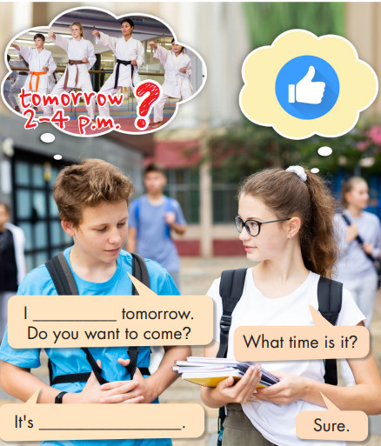  - Ask Ss to read about Present Simple for future meaning and prepositions of time, look at the picture and fill in the blanks with appropriate words.  - Get Ss to check with their partners.  - Pick some Ss to give their answers.  Task b. Listen and check your answers. Listen again and repeat.  - Ask Ss to listen and check.  - Pick some Ss to share their ideas.  - Check their answers.  - Ask Ss to listen again and repeat chorally.  - Pick some pairs to read the conversation again and check their pronunciation if necessary. | - Read the sentences below and figure out the answers to the questions.  Answer keys:  - Simple Present Tense.  - They are about future.  -Listen and take notes.  -Read the sentences and complete the rules.  Answer keys:  - from…to…  - until  - Read about Present Simple for future meaning and prepositions of time, look at the picture and fill in the blanks.  - Check with their partners.  - Give their answers.  -Listen and check.  - Give their answers.  Answer keys:  have karate class; from 2 to 4 p.m.  -Listen and repeat.
2. Practice: 15’
a. Objective: to help Ss practice using Simple Present Tense to talk about a set schedule and use prepositions of time correctly.
b. Content: tasks a, b, and c.
c. Expected outcomes: Ss can talk about a set schedule using Present Simple Tense and prepositions of time appropriately.
d. Organization:
Teacher’s activities | Students’ activities
Task a: Read the examples above and circle the correct words.  1. I have shuttlecock practice in/until/on 5 p.m. on Saturday.  2. Do/Does you want to see a movie on the weekend?  3. I can't meet in the morning. I'm busy in/to/at 10 a.m.  4. My sewing class is from/on/until 2 p.m. to 4:30 p.m.  5. It's OK. The band practice hasn't/doesn't/don't start until 2 p.m.  6. I'd love to come. I don't have any plans in/from/on Saturday night.  7. Yes, I can come. I'm free from 10 a.m. to/in/from 4:30 p.m  - Introduce the task.  - Ask Ss to read the sentences carefully and circle the correct words.  - Let Ss check with their partner.  - Pick some students to give their answers and give reasons.  - Check their answers. | - Read and circle the correct words.  - Check with their partner.  - Give their answers.  Answer Keys:  1. until 2. Do 3. at 4. from  5. doesn’t 6. on 7. to
Task b: Answer the questions using the given prepositions and the information on your schedule.  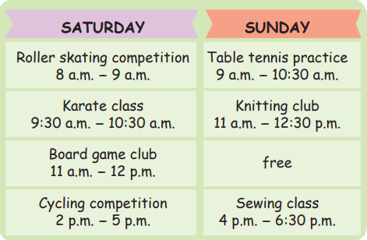  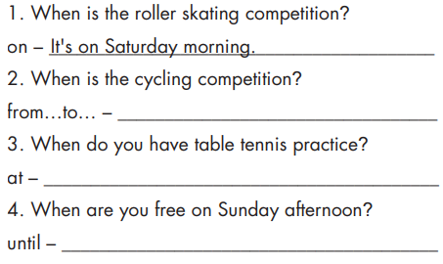  - Ask Ss to answer the questions using the given prepositions and the information on the schedule.  - Let Ss check with their partner.  - Pick some Ss to write their answers on the board.  - Check their answers.  Task c: In pairs: Take turns asking and answering about the schedule. Do you do any of these activities? When?  - Ask Ss to work in pairs to ask and answer about the schedule in task b.  - Pick some pairs to speak.  - Give feedback. | - Answer the questions using the given prepositions and the information on the schedule.  - Check with their partner.  - Write their answers on the board.  Answer keys:  1. It’s on Saturday morning.  2. It’s from 2 p.m. to 5 p.m. (on Saturday).  3. I have table tennis practice at 9 a.m. (on Sunday).  4. I’m free (on Sunday afternoon) until 4 p.m.  -Work in pairs to ask and answer about the schedule in task b.  Sample:  A: When do you have karate class?  B: I have karate class on Saturday at 9:30 a.m.
3. Production: 5’
a. Objective: to help Ss use the language in real situation.
b. Content: Speaking activity.
c. Expected outcomes: Ss can talk about their schedule using Present Simple Tense and prepositions of time appropriately.
d. Organization:
Teacher’s activities | Students’ activities
- Ask Ss to work in pairs to ask and answer about their schedule on the weekends.  - Pick some pairs to speak.  - Give feedback. | - Work in pairs to ask and answer about their schedule on the weekends  Sample:  A: What do you do on Saturday morning?  B: I go swimming from 7 a.m. to 8a.m.
C. Consolidation and homework assignments: 5’
- Grammar: Simple Present Tense with future meaning to talk about a set schedule and prepositions of time: until, from…to…
- Do exercises in workbook on page 5.
- Prepare the next lesson: Lesson 2.3 – Pronunciation & Speaking, pages 10 & 11.
- Do the exercises in Tiếng Anh 8 i-Learn Smart World notebook (page 9).

5. Reflection

a. What I liked most about this lesson today:
…………………………………………………………………………………………
b. What I learned from this lesson today:
…………………………………………………………………………………………
c. What I should improve for this lesson next time:
…………………………………………………………………………………………

