|  |  |
| --- | --- |
| **Mã đề 6.2.46** | **BÀI KIỂM TRA GIỮA KÌ II**  **NĂM HỌC 2022-2023**  **MÔN: TIẾNG ANH LỚP: 6** |

**A. Listening**

**Question 1: Listen and choose the correct answer A, B or C (1pt)**

*1. Where are the onions? 2. What’s Tom doing?*

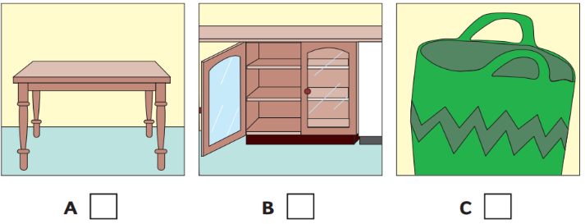 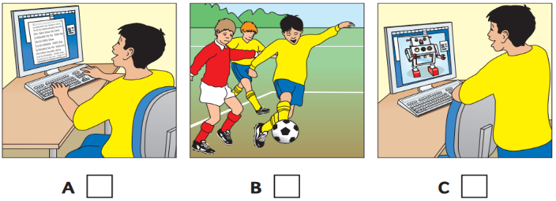

*3. Which is Tony’s Mum? 4. What does Anna like doing on the beach?*

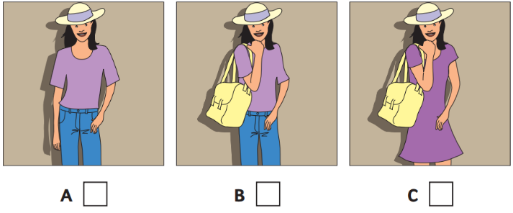 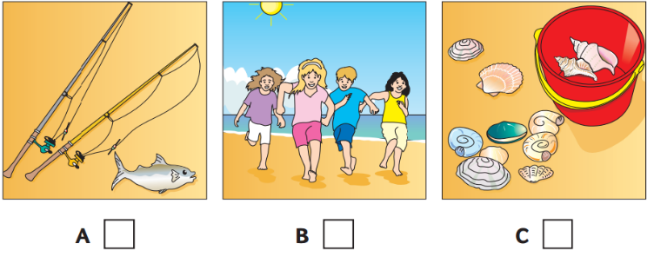

*5. Where’s the goat?*

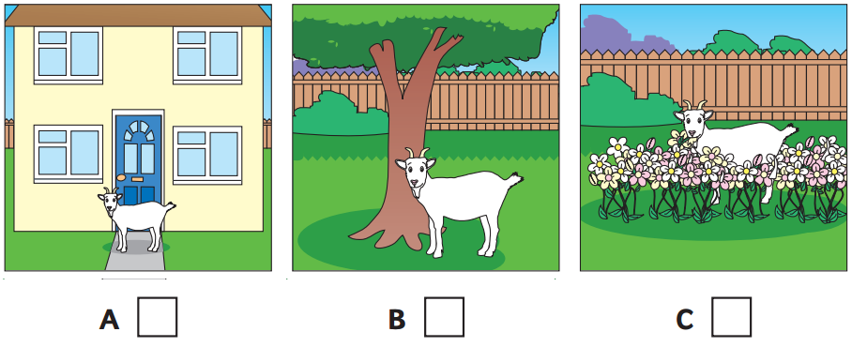

**Question 2: Listen and write (1pt)**

**GUITAR LESSONS**

6. Where: next to …............................……..

7. Address: ……………........……London Street

8. Day of lesson: …………………….......…………...

9. Name of teacher: Mr. ……….................................…..

10. Teacher's telephone number: …………….........……………

**B. Grammar, vocabulary and language function**

**Question 3: Choose the best option A, B or C to complete the sentences (3 pts).**

11. My brother likes watching TV _________ I like going out with my friends.

A. and                        B. or                                    C. but

12. ___________ do you go to the gym? – By bus.

A.What B. How C.Why

13. I like _________ programmes. They make me laugh.

A. sport B. comedy C. educational

14. Kien is not very ___________. He never plays games.

A. sport B. sporting C. sporty

15. _________ TV so much! It’s not good for you.

A. Don’t watch B. Not watch C. No watch

16. Vietnamese students play different sports and games ___________ the break time.

A. in B. on C. during

17. I’m tired, __________ I go to bed early.

A. so B. but C. and

18. Our car is old, _________ it drives beautifully.

A. and B. but C. or

19. Karate is a form of martial ____________ .

A. arts B. skill C. Fighting

20. We ___________out with our friends last night.

A. goed B. go C. went

21. Linda is _________ cousin.

A. his B. he C. him

22. This craft isn’t mine. It’s __________.

A. him B. she C. hers

23. These clothes aren’t ______.

A. our B. ours C. we

24. “Tom and Jerry” is my favourite ____________ .

A. cartoon B. comedy C. news

25. You must learn the ________ of the game before playing.

A. rules B. agreements D. sayings

CCccc **C. Reading**

**Question 4: Which notice (A-E) says this (26-30)*. (1pt)***

|  |  |  |
| --- | --- | --- |
| 26. Don't smoke here.  27. Things are cheaper here.  28. Everyone can make a call from here.  29. Children can’t come here on Sunday  30. Put this in a cold place. | A. | **Making a phone call here** |
| B. | **Open daily (except Sunday)**  **No smoking** |
| C. |  |
| D. |  |
| E. |  |
|  |  |

**Question 5. Choose the letter A, B or C to complete the passage below. (1,0 pt)**

There are two main (31) -------- of sports:  team sports and individual sports. Team sports (32) ---------such sports as baseball, basketball and volleyball. Team sports require two separate teams. The teams (33)--------- against each other. They compete against each other in order to get the best score. (34) ----- example, in a football game, if team A gets 4 points and team B (35) ------ 2 points, team A wins the game. Team sports are sometimes called competitive sports.

31. A. kind B. kinds C. kinding

32. A. is B. were C. are

33. A. play B. to play C. playing

34. A. at B. for C. in

35. A. getting B.gets C. get

**Question 6*.* Read the passage and choose the correct answer A, B or C). (1,0 pt)**

Paris is my favorite city. It is the capital city of France. It is very well-known as the City of Light. It is located on the Seine River. It covers an area of 105.4 square kilometers. You can see many fascinating things and sights in Paris. The most popular landmark is Eiffel tower. In Paris, you will find many shopping areas. One of the famous shopping areas is Mont Mart. It has a lot of wine shops, bakeries, clothing shops, restaurants, etc.

36. Is Paris the capital of Singapore?

A. Yes, it is      B. No, it isn’t      C. Yes, it does

37. Where’s Paris?

A. in Antarctica      B. in England      C. on Seine river

38. What is the area of Paris?

A. under 100 sq. km.      B. over 100 sq. Km C. uner 50 sq. km.

39. What is the most popular landmark in Paris?

A. Eiffel tower B. Paris      C. Seine river

40. Is Mont Mart one of the famous shopping areas?

A. Yes, it is      B. Yes, it will      C. No, it isn’t

**D. WRITING**

**Question 7. Choose A, B or C to indicate the sentence that is closest in meaning to each of the following questions (1,0pt).**

41. ***Lan is tall. Mai is taller.***

A. Mai is tallest than Lan.

B. Mai is taller than Lan.

C. Lan is taller than Mai.

**42**. ***What is your favourite sport?***

A. What sport do you like?

B. What sport do you play?

C. Do you like playing sport?

**43**. ***I have a lot of homework tonight. I can’t watch The voice kids show***

A. I have a lot of homework tonight, but I can’t watch *The voice kids* show

B. I have a lot of homework tonight and I can’t watch *The voice kids* show

C. I have a lot of homework tonight, so I can’t watch *The voice kids* show

***44. This girl is very intelligent.***

A. What is a intelligent girl!

B. What an intelligent girl!

C. What an very intelligent girl!

45. *Helen's favorite sport is table tennis.*

A. Helen likes playing table tennis.

B. Helen like play sports table tennis.

C. Helen likes to playing table tennis.

**Question 8*.*** Write a postcard of about 50 words about your holiday in a city (1,0 pt).

**You can use these clue questions:**

+ What city is it?

+ What is it like? (the weather, the people, the food)

+ What can you see and do there?

Start with:

Dear Lan,

........................................................................................................................................................

.......................................................................................................................................................

Love,

Trang

|  |  |
| --- | --- |
| **Mã đề 6.2.46** | **HƯỚNG DẪN CHẤM ĐỀ KIỂM TRA**  **GIỮA HỌC KÌ II**  **Năm học 2022 - 2023**  **MÔN: TIẾNG ANH - LỚP 6**  **Thời gian làm bài: 60 phút** |

|  |  |  |
| --- | --- | --- |
| **Question** | **Key** | **Point** |
| **A. Listening (2pts)** | Question 1: 1. A 2. C 3. B 4. C 5. C  Question 2:6. library 7. 102 8. Saturday  9. Bagley 10. 314479 | 0.2 for each |
| **B. Grammar & vocabulary**  **(3 pts)** | Question 3.  11. C 12. B 13. B 14. C 15. A 16. C 17. A 18. B  19. A 20. C 21. A 22. C 23. B 24. A 25. A | 0.2 for each |
| **C. Reading**  **(3 pts)** | Question 4: 26. C 27. D 28. A 29. B 30. E  Question 5: 31. C 32. A 33. B 34. A 35. B  Question 6: 36. B 37. C 38. B 39. A 40. A | 0.2 for each |
| **D. WRITING**  **(2 pts)** | Question 7:**Choose A, B or C to indicate the sentence ...**  41. B 42. A 43. C 44. B 45. A  Question 8:**Write a postcard of about 50 words about your holiday in a city (1,0 pt).**   * Accurate grammar and vocabulary. * Good contents. | 0.2 for each  1pt |