UNITS | VOCABULARY | GRAMMAR
Unit 4  ALL THINGS HIGH-TECH | - Devices  - High-tech jobs  - Computers  - Video/PC/Mobile games | - Modals  - Infinitive (to-infinitive, infinitive without to)  - -ing form
Tiếng Anh 7 – RIGHT ON

UNIT 4 TEST
Note: Each correct answer earns 0.2 points.

I. PRONUNCIATION (0.8 points)
A. Choose the word whose underlined part is pronounced differently.
1. A. design B. mechanic C. device D. repair
2. A. virtual B. relative C. router D. portal
B. Choose the word that has a different stressed syllable from the rest.
3. A. speaker B. platform C. tablet D. connect
4. A. interact B. engineer C. adventure D. understand

II. VOCABULARY AND GRAMMAR (2.4 points)
Choose the best option (A, B, C or D) to complete each of the following questions.
5. I use the __________ a lot, especially when I play games, because I want to move around the screen quickly.
A. keyboard B. mouse C. router D. speakers
6. Danny enjoys __________ simulation games. He usually ______ games in the evening after finishing his homework.
A. to play / plays B. playing / playing C. playing / plays D. to play / is playing
7. It was snowy this morning, so we decided __________ in and play computer games.
A. to stay B. staying C. and stay D. to staying
8. I’m sorry, but you __________ use headphones because I can’t work with that noise.
A. need B. can C. mustn’t D. have to
9. My uncle is a(n) __________. He always helps me fix the hardware or software on my computer.
A. engineer B. IT technician C. designer D. mechanic
10. Students __________ to pay fees to use this learning app. They can install it free of charge.
A. mustn’t B. shouldn’t C. needn’t D. don’t have
11. ______ are a great way to keep in touch with friends and family. You can read messages, hear people’s voices and also see their faces.
A. Texting messages B. Phone calls
C. Video chats D. Posts
12. Can I borrow your __________? I need to save my work, so I can continue doing it when I’m back home.
A. tower B. screen C. USB flash drive D. console
13. Harry’s parents got really angry __________ him because he played computer games all day and forgot to do his homework.
A. for B. with C. about D. to
14. Student A: Do you like problem-solving games?
Student B: _________
A. I play computer games a lot. B. I’m crazy about them. They are cool.
C. I’m not interested in games consoles. D. No, I find them interesting.
15. What does the sign mean?
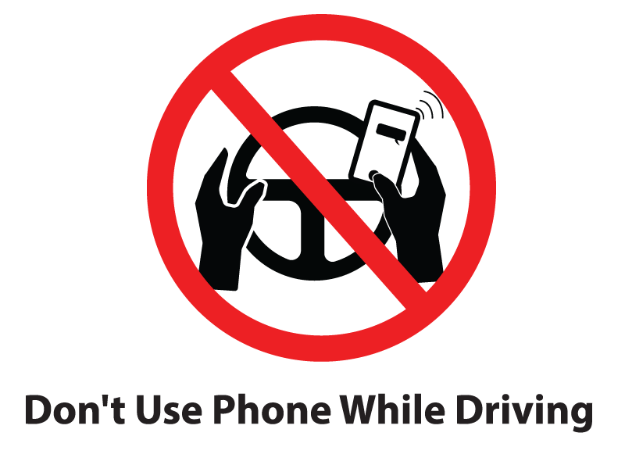 | A. You should be careful when you use your phone and drive the car.  B. You needn’t use your phone when you are behind the wheel.  C. You mustn’t use your phone while you are driving.  D. You can’t send text messages if you have a car.
16. What does the sign mean?
 | A. It’s an obligation to fly a drone in this area.  B. You must stop controlling the drone before you enter this place.  C. You shouldn’t buy any drones in this area.  D. It’s against the rules to fly a drone in this area.

III. WORD FORMATION (1.2 points)
Write the correct form of the words in brackets.
17. Just by wearing a virtual __________ headset, gamers feel as if they are actually in a new environment and have a real experience. (REAL)
18. If you want to become a game __________, you need to be creative and have strong skills in computing. (DESIGN)
19. Computers are very __________ because we can use them for all kinds of online activities, such as reading books, surfing the Internet or watching films. (USE)
20. The Internet can be a fantastic place to connect with friends, but you should be ___________ about unknown people online. (CARE)
21. We don’t have __________ to enter the computer lab without our teachers. (PERMIT)
22. This website has easy __________ for taking great photos with a digital camera. (INSTRUCT)

IV. LISTENING (2 points)
A. You will listen to an announcement about a competition. For questions 23-27, complete the notes with the correct information. Write ONE WORD AND / OR ONE NUMBER.

The competition is on Saturday, 14th (23) ___________.
People can dress as their favourite video game characters.
The shop is open from 9 a.m. to (24) ___________.
The competition starts at 11 a.m.
Prizes include a games console, (25) ___________ and T-shirts.
People can buy (26) ___________ and listen to music from (27) ___________.

B. You will hear a dialog between two people. Write short answers for each question from 28 to 32.

28. What are they going to do on Saturday?
→
29. When is Colin’s birthday?
→
30. What do they want to buy for Colin?
→
31. What time do they agree to meet?
→
32. How will Jack go to Lily’s house?
→

V. READING (2 points)
A. Read the following passage. For each of the questions from 33 to 37, write T if the statement is TRUE, F if the statement is FALSE and NI if there is NO INFORMATION on it.

Nowadays, teenagers use digital technologies for everyday activities like keeping in touch with friends on social media, relaxing and doing schoolwork. There are some tips that they need to know to avoid online risks. Firstly, keep your personal information private. Never tell a stranger where you live or your phone number. If you’re not sure whether you should share something or not, ask a parent. You should also think carefully before you post. As soon as a message or a photo is put online, someone can take a screenshot of it and it can be online forever. Secondly, be choosy about your online friends. It’s not safe to meet an online friend in person. Keep in mind that online friends are not the same as real in-person friends. Some people might say they’re in seventh grade online but actually are adults. Moreover, don’t be mean or embarrass other people online. Tell an adult right away if someone says something to you that makes you uncomfortable. Also, tell an adult if you see anyone bullying or saying unkind stuff to other children.

33. You shouldn’t share your personal information with strangers.
34. It’s easy to remove a post or a photo after you put it online.
35. Meeting up online friends can be dangerous.
36. People always lie about who they are online.
37. It’s necessary to tell an adult when someone online upsets you.

B. Read the following passage on Tien’s blog. For each question from 38 to 42, choose the correct option A, B, C or D.
My parents gave me a new tablet for my birthday. It’s (38) _________ one on the market right now, so I can carry it easily in one hand. It has a touchscreen and two cameras, one at the front and one at the back. I can do lots of things with my tablet. In the evenings, I often spend one hour surfing the Internet or chatting online with my friends. I hardly ever interact (39) _________ strangers, because my parents keep telling me not to trust everyone or everything online. Sometimes I (40) _________ my homework to my teachers by email. Every weekend, I make video calls to my grandparents in the USA. Besides, I often use it on the bus to read e-books. I also enjoy watching films and TV programmes on my tablet. The (41) _________ lasts for a very long time. However, I (42) _________ use my tablet in class during lessons. It’s against the school’s rules. Teachers can take away phones and tablets if students don’t follow the rules. I think I can’t live without my tablet.

38. A. smaller B. the smallest C. the small D. less small
39. A. for B. to C. with D. about
40. A. send B. post C. upload D. download
41. A. speaker B. connection C. router D. battery
42. A. can B. mustn’t C. have to D. needn’t

VI. WRITING (1.6 points)
A. Rewrite the following sentences without changing their meaning. Use the given word(s) if any.
43. I advise you to shop at Internet shops with a padlock icon beside the web address.
→ You .
44. Simon is really into playing strategy games.
→ Simon loves .
45. It’s not necessary for me to vacuum the floor because we have a robot cleaner.
→ I don’t .
46. We have permission to use mobile phones in science class to find information for the project.
→ We .
B. Use the given words or phrases to make complete sentences.
47. My sister / enjoy / read books / e-book reader / before / go to bed.
→
48. Finally / I / decide / take / computer programming course.
→
49. Joanne / like / take / photos / and / hope / become / photographer / one day.
→
50. Jack / promise / help / me / install / anti-virus software.
→
***End – Of – Test***

