ĐỀ THAM KHẢO TUYỂN SINH 10
TRƯỜNG THCS NGUYỄN TRÃI
I. Circle the word whose underlined part is pronounced differently from the rest.
1. A. used B. weighed C. washed D. suprised
2. A. caravan B. moral C. value D. action
II. Circle the word whose main stressed syllable is different from that of the others.
3. A. remind B. forget C. result D. follow
4. A. ordinary B. valuable C. society D. secondary
III. Choose the word/ phrase (A, B, C or D) that best fits the space in each sentence.
5. An: How could the man get these achievements?
Kiet: He said hard work was the key ______ his success.
A. on B. at C. to D. with
6. Tom: How long have been learning English here?
Nam: I have been studying here ______ 2015.
A. since B. in C. on D. for
7. Kim: Where should I wait for you?
Lien: I will meet you _____ the entrance of the theater.
A. in B. at C. on D. with
8. Kim: __________ her injury, she has no choice but take a few days off to recover.
Lien: That’s a terrible news! I hope she will get better soon.
A. Because of B. Despite C. Thanks to D. According to
9. Sam: The smell of the milk in the fridge is __________. I think it has gone off.
Katy: Really? I’ll throw it away.
A. boring B. relaxing C. fascinating D. disgusting
10. Dung: What’s your opinion about electricity now and then
Nga: It ___________ a luxury, but now it’s a necessity.
A. would be B. used to be C. was being D. had been
11. Eve: I was so delighted to see how quickly my new dog ___________ well with cat.
David: I can see. They are inseparable companions now.
A. found out B. cheered up C. shouted at D. got on
12. Mark: What do you want to be in the future?
Helen: I want to become a nurse in the belief that I’ll be able to make positive __________ on people’s lives.
A. labels B. impacts C. differences D. relationships
13. Ben: Congratulations! You’ve won first prize.
Nam: _____
A. Don’t behave in such a bad manner! B. I’m glad to share this moment with you guys.
C. Better luck next time! D. I’d love to, but I can’t.
14. Mary: Which subjects do you think is best: Music or Science?
Tom: _____. They’re totally different subjects.
A. It’s very kind of you. B. I think you should
C. Thanks for your help D. It’s up to you
IV. Look at the sign / picture. Choose the best answer (A, B, C or D) for each sign / picture.
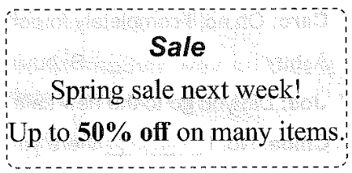 | - What does the notice say?  - All item will be 50% off in the spring.  - After the spring sale many items will cost 50% more.  - Half of the items will be sold next week.  - Many items will be half-price next week.

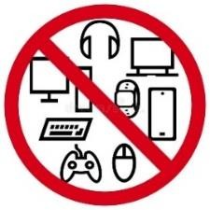 | - What does the sign say?  - Electronic devices are banned here.  - Only smartphones are allowed to be used in this area.  - Make sure that your cell phones are in silent mode  - The shop offers a wide range of e-gadgets.
V. Read the passage below and choose one correct answer for each question.
Stress is often believed to cause serious harm to our physical and mental well-being. But, do all types of stress badly affect our health? According to researchers from Yale University, those who look on the (17)________ side of stress enjoy better health, greater life satisfaction, and superior work performance over those who regard stress as a (18)_______ of negative emotions. Their findings suggest that, during stress, the body releases (19)__________ adrenalin and cortisol. These hormones have been given a bad rap for making us “sick”. However, stress can enhance immunity and create mental toughness although chronic exposure to the hormones can take a (20)_________ on our immune system, making us feel flat and (21)_________ out.
Stress is inevitable, but its effects are not. What we need to do is focus on making meaning out of it. (22)__________, if children are stressed about an exam, parents can use it as an opportunity to encourage positive and equally true statements. They can say, “Show your skills, and see how well you can concentrate when you put your mind to it.”
(Adapted from The Benefits of Stress by Melbourne Child Psychology & School Psychology Services)
- A. dim B. bright C. smart D. white
- A. source B. search C. suit D. surge
- A. neither B. either C. both D. only
20. A. toll B. pain C. brain D. pale
21. A. turned B. worn C. made D. calmed
22. A. For example B. As a result C. In contrast D. Whereas

VI. Read the passage, and choose the best answer.
Traditional markets have long played an important role in Vietnamese commerce and community life. However, these bustling places are now facing an existential threat as consumers flock to online platforms. The convenience and competitive pricing of online shopping leaves age-old markets struggling to survive, forcing businesses to adapt or perish. Hà Nội’s historic wholesale markets, Đồng Xuân and Hôm markets, are typical of this transformation. “Customers buy everything online, and they don’t go to the market anymore,” one long-time clothing vendor said. Once-crowded aisles are now empty, and the chatter of bargaining has been replaced by the bored scrolling of vendors on their phones. This results from the difficulty of matching the aggressive pricing of online sellers. High overhead costs like rent, employee salaries and transportation have become too much of a heavy burden for vendors.
Another challenge faced by traditional retailers is their limited physical location. While online retailers can reach customers from all over the world, vendors at local markets only restricts their reach to a specific geographical area. Consumers living far from markets have to travel over a long distance to buy groceries. Such challenge requires vendors to expand their reach by offering online shopping options.
It is certain that the future of Việt Nam’s retail sector will be a combination of tradition and technology. The challenge for traditional markets is not just about survival; it is about finding ways to integrate and offer an experience e-commerce cannot replicate.
(Adapted from www.vneconomy.vn)
FB: Thầy Đình (Dạy Tiếng Anh)

- There has been a drop in consumer numbers going to traditional markets.
- Market vendors have no difficulty in competing with online retailers thanks to overhead costs.
- Online retailers fail to reach a large number of consumers these days.
- Traditional sellers are suggested to provide more shopping options.
- What does the passage mainly discuss?
A. Challenges faced by traditional markets.
B. The rise of e-commerce and digital marketplaces.
C. How to apply technology to supermarkets.
D. Governmental interference in online shopping.
- What can be inferred from the passage?
A. Traditional markets like Đồng Xuân and Hôm have gradually disappeared.
B. Market vendors get used to online advertising and selling their products on social media.
C. The growth rate of online shopping is expected to increase by 20 per cent by 2030.
D. Rapid digitalization requires traditional retailers to adapt themselves to the new environment.
VII. Word forms.
29. This program aims to _____________ traditional games among high school students. (POPULAR)
30. Although his contribution was _____________, the whole team still appreciated it. (CONSIDER)
31. It is important to wear clothes that fit _____________ during long flights. (COMFORT)
32. Your advice was very _____________, saving me a lot of time. (USE)
33. His _____________ in the project was crucial to its success. (INVOLVE)
34. It is vital to communicate clearly to avoid _____________ during the meeting (UNDERSTAND)

VIII. Look at the entry of the word ‘resource’ in a dictionary. Use what you can get from the
entry to complete the sentences with two or three words.
35. ____________________ are produced by wind, sun, and other sources that will never run out.  36. Many of these countries have ____________________, so they are incapable of dealing with the demands of their growing populations. | 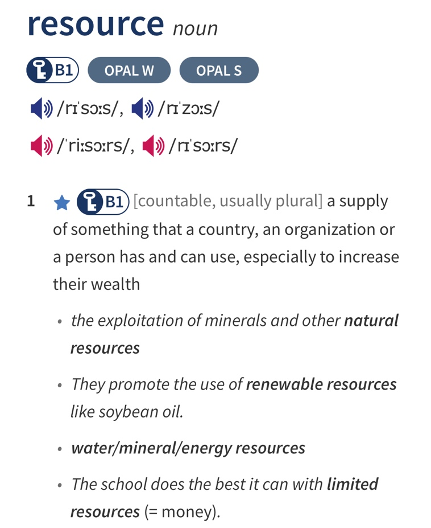
FB: Thầy Đình (Dạy Tiếng Anh)

IX. Rewrite these sentences, beginning with the words given.
37. I’m afraid I don’t have time to talk to you.
→ I wish
38. The music was too loud for me to concentrate on my work.
→ Because of
39. I have never met such a kind person as Dean.
→ Dean is
40. I think planting more trees around the neighborhood is a great idea. (FAVOR)
→ I am

