
PART 2: VOCABULARY

Task 1. Look at the pictures and write the letter in the box.

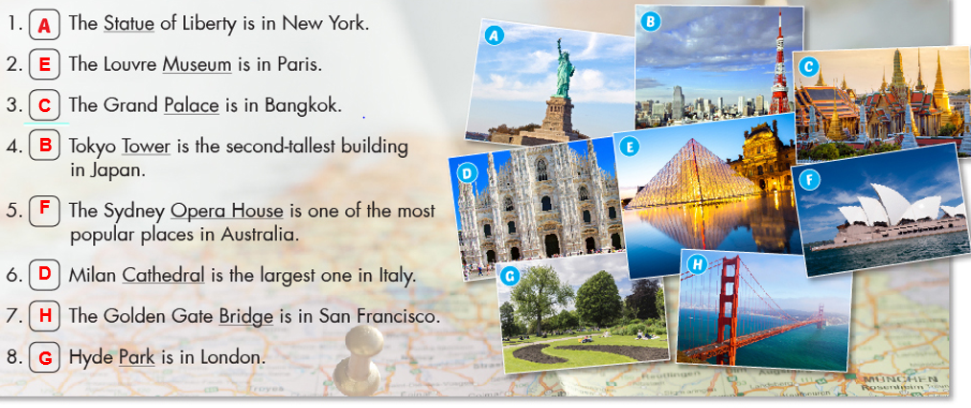

Task 2. Match the words with the descriptions .

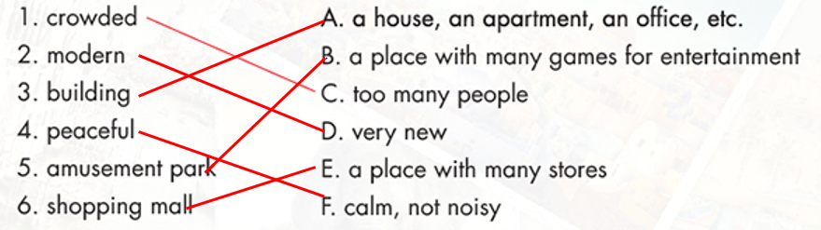
Task 3. Write the suitable word for each picture.

 |  |  | 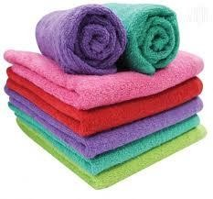 |  |  |  |  |  | 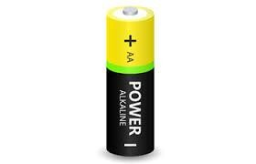 |  |  |  |  |  | 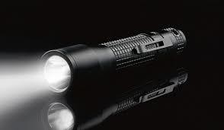
 | 1. towel |  |  |  |  |  | 2. battery |  |  |  |  |  | 3. flashlight
 |  |  | 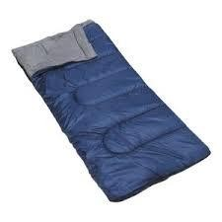 |  |  |  |  |  | 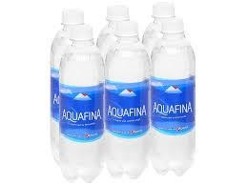 |  |  |  |  |  | 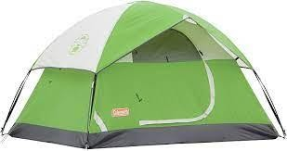
 | 4. sleeping bag |  |  |  |  |  | 5. bottled water |  |  |  |  |  | 6. tent
 |  |  |  |  |  |  |  |  | 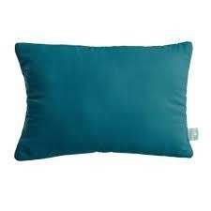 |  |  |  |  |  | 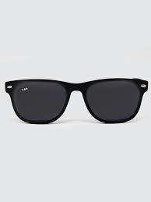
 | 7. sneakers |  |  |  |  |  | 8. pillow |  |  |  |  |  | 9. sunglasses
 |  | 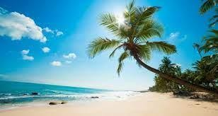 |  |  |  |  |  |  |  |  |  |  |  | 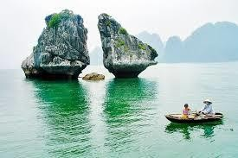
10. beach |  |  |  |  |  | 11. highland |  |  |  |  |  | 12. bay
 |  | 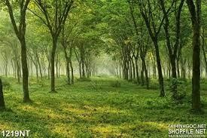 |  |  |  |  |  | 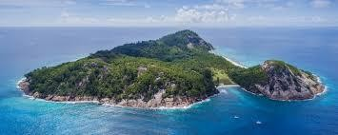 |  |  |  |  |  | 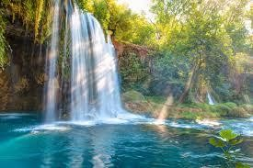
13. forest |  |  |  |  |  | 14. island |  |  |  |  |  | 15. water fall
 |  | 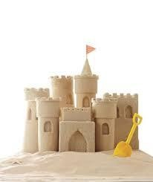 |  |  |  |  |  | 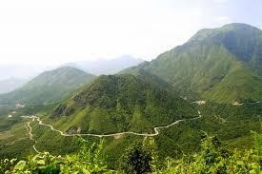 |  |  |  |  |  | 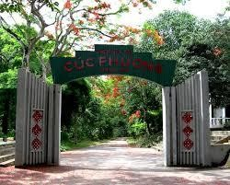
16. sandcastle |  |  |  |  |  | 17. mountain |  |  |  |  |  | 18. national park

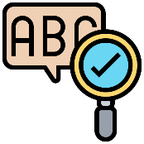

PART 3: GRAMMAR

Task 1. Use “should/shouldn’t” to fill in the blanks to complete the sentences.

  - Tom shouldn’t eat so many lollipops. It’s bad for his teeth.
  - He’s fifteen. He shouldn’t drive a car.
  - Pregnant women shouldn’t smoke as it can damage the baby.
  - We should go somewhere exciting for our holiday.
  - People shouldn’t drive fast in the town centre.
  - You should ask the teacher for help you if you don’t understand the lesson.
  - Should I buy the dress or the skirt?
  - She shouldn’t tell lies.
  - That’s a fantastic book. You should read it.
  - The doctor said: “You should eat healthy food. You shouldn’t eat fast food. You shouldn’t watch so much TV. You should walk 1 hour a day. You should drink fruit juice and water. You
shouldn’t drink wine or beer.
  - You shouldn’t be so selfish.
  - I don’t think you should smoke so much.
  - You should exercise more.
  - I think you should try to speak to her.
  - You are overweight. You should go on a diet.
  - Where should we park our car?
  - You should never speak to your mother like this.
  - The kids shouldn’t spend so much time in front of the TV.
  - Should I tell her the truth or should I say nothing?
  - I think we should reserve our holiday in advance.
Task 2. Use “can/can’t” to fill in the blanks to complete the sentences.

  - I (can/ can’t) speak French. I picked it up while I was in France.
  - I (can/ can’t) come to the party. I am really busy.
  - We (can/ can’t) hear you. The music is so loud.
  - Where are my keys? I (can/ can’t) find them.
  - I (can/ can’t) believe it. We won two million dollars.
  - We (can/ can’t) meet tomorrow if you want.
  - (Can/ Can’t) you make me a cup of tea, please?
  - He (can/ can’t) jump. His leg hurts so much.
  - Illiterate people (can/ can’t) read and write.
  - Fish (can/ can’t) swim.
  - (Can/can’t) you swim? - Yes, I (can/can’t)
  - I’m sorry I (can/can’t) help you today, I’m really busy.
  - Please (can/can’t) you buy some milk on your way home? - I (can/can’t) leave the house because I’m looking after the baby.
  - I (can/can’t) ride a bike but I (can/can’t) drive a car.
  - I just (can/can’t) manage to wake up on time, I’m always late.
  - Hello, (can/can’t) I help you? - Actually, no you (can/can’t). This restaurant is awful and we’ve been waiting here for half an hour. We’re leaving.
  - I have a special talent, I (can/can’t) touch my nose with my tongue (can/can’t) you?
  - (Can/Can’t) I go to the bathroom please?- Yes, of course you (can/can’t).
  - Look! It’s right there! (Can/Can’t) you see it? It’s so obvious!
I’ve never been able to eat breakfast in the mornings. I (can/can’t) talk to anyone either
Task 3. Choose A, B, C or D to complete the sentences.

- I like English _ I like French very much.
  - and B. but C. or D. so
- My brother likes Maths he doesn’t like history.
  - and B. but C. or D. so
- The children forgot their homework, the teacher was angry with them.
  - and B. but C. or D. so
- Can you read write English words?
  - and B. but C. or D. so
- Are the questions right wrong?
  - and B. but C. or D. so
- It’s great _ it’s fun.
  - and B. but C. or D. so
- Would you like tea hot chocolate for your breakfast?
  - and B. but C. or D. so
- Our car is old, it drives beautifully.
  - and B. but C. or D. so
- It was very warm, we all went swimming.
  - and B. but C. or D. so
- Do we have French Music after the break?
A. and B. but C. or D. so
- I like sugar in my tea, I don’t like milk in it.
A. and B. but C. or D. so
- We were very tired happy after our flight to Sydney.
  - and B. but C. or D. so
- Jane was cold, he put on a coat.
  - and B. but C. or D. so
- Julie has a guitar, she plays it really well.
  - and B. but C. or D. so
- Maria tried to read a novel in French, it was too difficult.
A. and B. but C. or D. so
- He lives in London, he studies at a college.
A. and B. but C. or D. so
- You can go to the tourist office _ ask them for any information you need.
A. and B. but C. or D. so
- Does Miss Smith like the red boots the black and white sandals?
A. and B. but C. or D. so
- Lynda likes Tom he is in love with Annette.
A. and B. but C. or D. so
- Geraldine Chaplin is a great actress she is less well-known than her father Charlie Chaplin.
A. and B. but C. or D. so

LISTENING
Task 1: Listen and fill in the blanks.

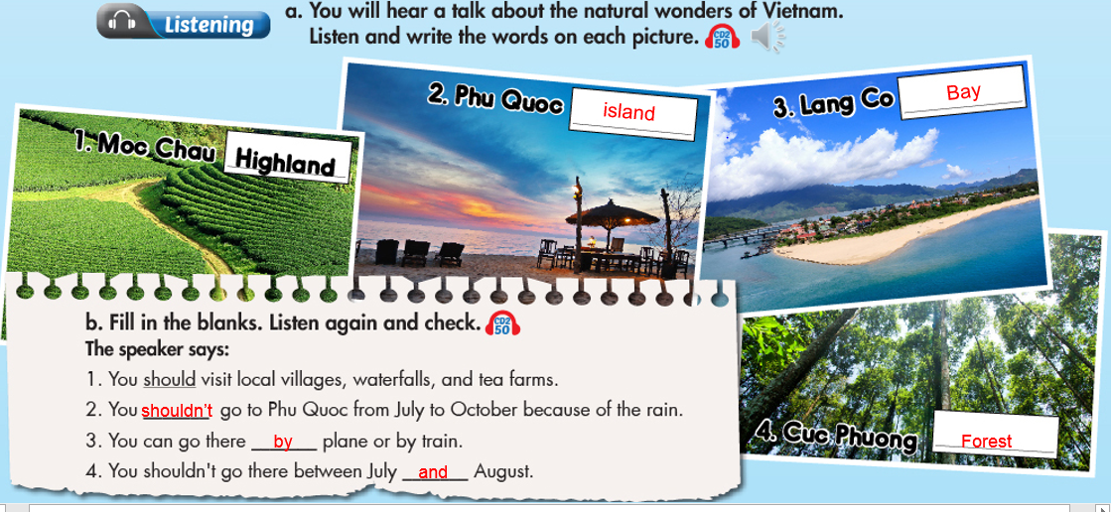
Task 2: Listen to the passage and decided if the statements are true (T) or False ( F)

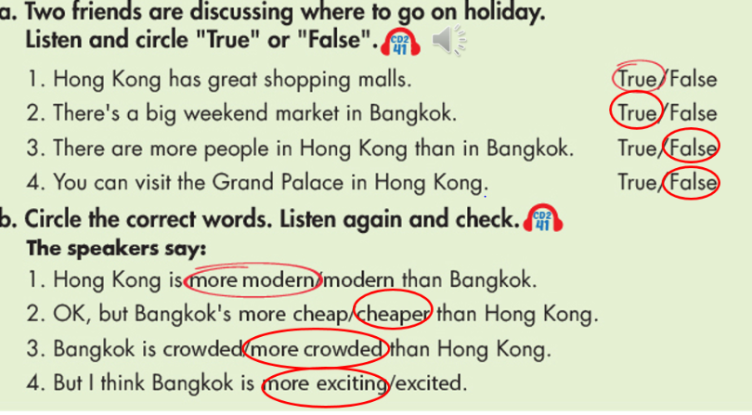

SPEAKING

Task 1. Match the questions and answers. Then practice.

1-D 2-F 3-C 4-B 5-E 6-A
Task 2.

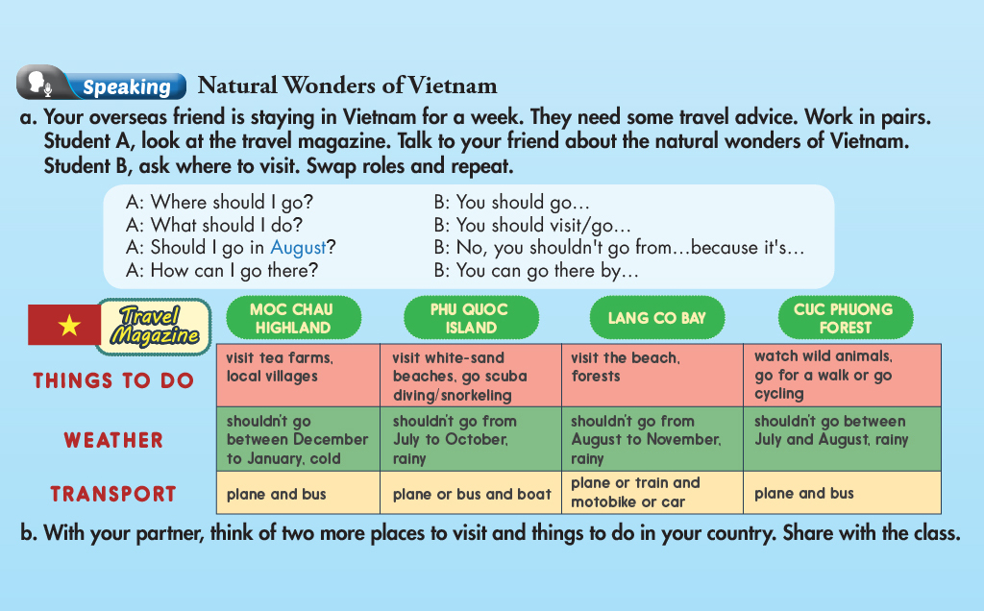
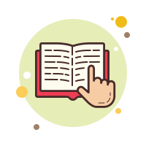
READING

Task 1.

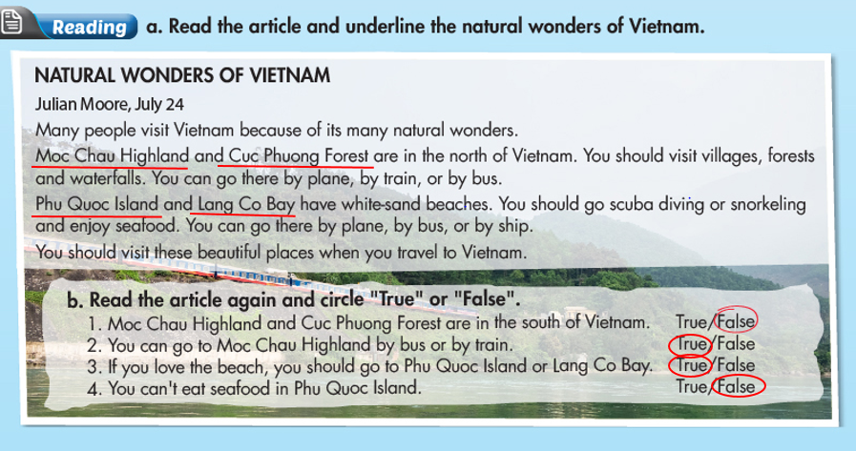

Task 2. Read and choose the correct answer (A, B, C or D)

1-B 2-C 3-D 4-C 5-B


WRITING

Task 1. Look at the travel brochures and choose a place you'd like to go with your friends on vacation. Write a paragraph about your choice using the given information.
Write 50 to 60 words.

I think we should go to The Red Canyon. It's a beautiful place. We can go rock climbing and rafting there. It takes about three hours by car to to get there. We can stay at a hotel by the canyon. We can't go swimming. It's too dangerous.

Task 2. Read the information below and write a postcard telling your friend about Boy of Islands.
Write 50 to 60 words.

Hello Liam,

I'm having a great time in New Zealand. It's beautiful. When you're here, we should travel to see some of New Zealand's natural wonders Bay of Islands has amazing beaches. We can go fishing and surfing. The weather is very nice and sunny. The seafood is really delicious. You should try it when you come here.
Can't wait to see you.
Paul

