UNIT 10: ENERGY SOURCES
Lesson 1: Getting started – Types of energy sources
I. Objectives
By the end of this lesson, Ss will be able to gain:
1. Knowledge
- An overview about the topic energy sources
- Vocabulary to talk about types of different energy sources.
2. Core competence
- Develop communication skills and cultural awareness
- Be collaborative and supportive in pair work and teamwork
- Actively join in class activities
3. Personal qualities
- Develop awareness of travelling in town/city
- Be concerned to the local traffice
II. Materials
- Grade 7 textbook, Unit 10, Getting started
- Computer connected to the internet
- Projector/ TV/ pictures and cards
- sachmem.vn

Language analysis
Form | Pronunciation | Meaning | Vietnamese equivalent
1. energy source (n.phr.) | /ˈenədʒi sɔːs/ | A source from which useful energy can be extracted or recovered. | nguồn năng lượng
2. coal (n) | /kəʊl/ | A hard black mineral that is found underground and burnt to produce heat. | than
3. renewable (a) | /rɪˈnjuːəbl/ | Can be replaced naturally and can be used without the risk of using it all up | có thể tái tạo
4. run out (phr v) | /rʌn aʊt/ | To use up or finish a supply of something | cạn kiệt

Assumptions
Anticipated difficulties | Solutions
- Students may not be able to recognise types of energy.  - Students may not know how to work in teams. | - Give specific examples and ask questions to activate students’ knowledge.  - Give short, clear instructions and help if necessary.

Board Plan
Date of teaching
Unit 10: Energy source
Lesson 1: Getting started – Types of energy sources
* Warm-up: BRAIN STORMING
I. Vocabulary
1. energy source (n.phr) /ˈenədʒi sɔːs/: nguồn năng lượng
2. coal (n) /kəʊl/: than
3. renewable (a) /rɪˈnjuːəbl/: có thể tái tạo
4. run out (phr v) /rʌn aʊt/: cạn kiệt
5. replace (v) / rɪˈpleɪs/: thay thế
II. Practice
Task 1: Read for main ideas: What are Lan and her father talking about?
Task 2: Read the conversation again and answer the questions.
Task 3: Match the words / phrases in the box with the correct pictures.
Task 4: Complete each of the sentences with the correct word from the conversation
* Homework

Procedures
Notes
In each activity, each step will be represented as following
* Deliver the task
** Implement the task
*** Discuss
**** Giving comments or feedback

Stage | Stage aim | Procedure | Interaction | Time
Warm-up | - To activate students’ knowledge on the topic of the unit  - To enhance students’ skills of cooperating with team mates | BRAIN STORMING  * Teacher gives instructions  - One of the students in the group go to the board.  - Teacher secretly show 1 picture of a mean of transport to that student. He/She has to mime the picture and the other has to guess. Of course the other groups will also be allowed to guess.  - take turns go to the board until finish all the pictures.  **** Teacher checks and corrects if Ss pronounce the words incorrectly. | T-Ss  T-S  S-Ss  T-Ss | 5 mins
Vocabulary - pre-teach | To help students use key language more appropriately before they read and listen | VOCABULARY  * Teacher introduces the vocabulary by:  + Providing the synonym or antonym of the words.  + Providing the pictures of the words.  + Providing the definition of the words.  1. enery source (n)  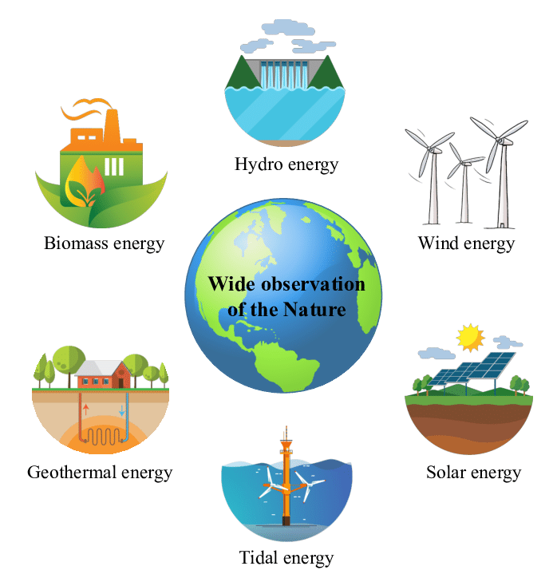  2. coal (n)    3. renewable (a): Can be replaced naturally and can be used without the risk of using it all up  4. run out (phr v): To use up or finish a supply of something  ** Ss say the words.  **** Teacher shows and says the words aloud and asks Ss to repeat them.  * Teacher asks Ss to translate the word into Vietnamese  Concept check: Yes/No questions | T-S | 5 mins
Lead-in/ pre-read and listen | - To get students interested in the topic  - To set the context  - To help Ss understand the main idea of the text | Task 1. Read for main ideas: What are Lan and her father talking about?  * Teacher asks Ss to look at the picture (p.107), answer the question:  What are Lan and her father talking about?  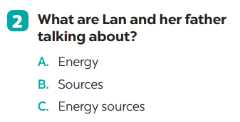  Answer: C | T-S | 3 mins
Controlled practice | - To practise reading and listening for specific information  - To practise scanning  - To develop Ss' knowledge of vocabulary | Task 2: Read the conversation again and answer the questions.  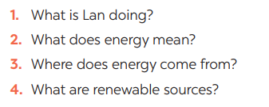  * Teacher asks Ss to work individually to read and listen to the conversation and answer the questions and then share their answers with their partners who sit next to them. (peer check)  ** Ss do exercise 3 individually  *** Ss share and discuss with their partners to write all answer down on the notebooks.  **** Teacher corrects their answers as a class.  Answers  1. Lan is doing a project on energy sources.  2. It’s power that we use to provide us with light, heat or electricity.  3. It comes from many different sources like coal, oil, natural gas, … and renewable sources  4. Renewable sources are those we can easily replace them such as: water, sun,… | T-S  S-S  T-S | 7 mins
 | - To help Ss gain more knowledge about the topic  - To help Ss practice using what they have learnt in sentences. | Task 3: Match the words / phrases in the box with the correct pictures.  *** Teacher nominates Ss to read the words aloud and  **** Teacher checks and gives the correct answers.  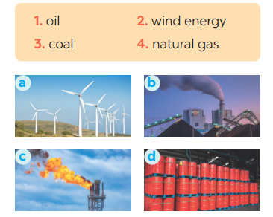  Suggested answers:  1. c 2. a 3. b 4. d  Task 4: Complete each of the sentences with the correct word from the conversation  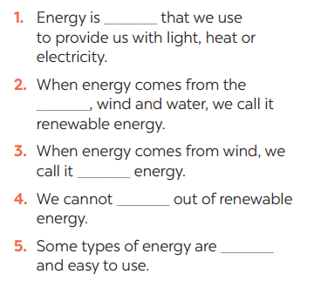  * Teacher asks Ss to work individually to find the words/phrases from the conversation and then share their answers with their partners who sit next to them. (peer check)  ** Ss do exercise 5 individually  **** Teacher corrects their answers as a class.  Answers  1. power  2. sun  3. wind  4. run  5. cheap | T-S  S  T-S-S  T-S | 10 mins
Less controlled practice | - To help Ss practising talking about energy  - To practise team working  - To give students authentic practice in using target language | Task 5: Group discussion    * Teacher gives Ss clear instructions in order to make sure Ss know what to do  - ask students to discuss within their groups to answer the questions:  1. What is the best source of energy?  2. Why do you think it is the best one?  + Students discuss with their partners and take notes  - observer Ss while they are talking, note their language errors  ** Ss do as instructed. Then present what they have discussed.  **** Teacher gives Ss feedback.  - choose some useful or excellent words/ phrases/ expressions/ word choices Ss have used to suggest other students use them  - choose some typical errors and correct as a whole class without nominating the students’ names. | T-S  T  S-S | 10 mins
Wrap up | To help Ss memorise the target language and skills that they have learned | - Vocabulary of sources of energy  - Talking about energy sources. | T-Ss | 1 min
Homework | To help Ss practise the target language | Homework:  - Exercises in the workbook | T-Ss | 1 min

UNIT 10: ENERGY SOURCES
Lesson 2: A closer look 1
I. Objectives
By the end of this lesson, Ss will be able to gain:
1. Knowledge
- Vocabulary about sources of energy.
- Pronunciation: Stress in three-syllable words
2. Core competence
- Develop communication skills and cultural awareness
- Be collaborative and supportive in pair work and teamwork
- Actively join in class activities
3. Personal qualities
- Develop awareness of energy sources and energy saving.
II. Materials
- Grade 7 textbook, Unit 10, A closer look 1.
- Computer connected to the internet
- Projector/ TV/ small boards, markers.
- sachmem.vn

Language analysis
Form | Pronunciation | Meaning | Vietnamese equivalent
1. solar energy (n.phr.) | /ˈsōlər ˈenədʒi / | Energy that comes from the sun | năng lượng mặt trời
2. hydro energy (n.phr.) | / ˈhīdrō ˈenədʒi / | Energy that comes from the wind | năng lượng nước
3. nuclear (n) | / njuː.klɪər / | the power produced when the nucleus of an atom is divided or joined to another nucleus | hạt nhân

Assumptions
Anticipated difficulties | Solutions
- Students may not be able to recognise the energy sources and much knowledge about the topic  - Students may not know how to work in teams. | - Give specific examples and ask questions to activate students’ knowledge.  - Give short, clear instructions and help if necessary.

Board Plan
Date of teaching
Unit 10: ENERGY SOURCES
Lesson 2: A closer look 1
* Warm-up: Crossword
I. Vocabulary
1. solar energy (n.phr.) /ˈsōlər ˈenədʒi/: năng lượng mặt trời
2. hydro energy (n.phr.) /ˈhīdrō ˈenədʒi/: năng lượng nước
3. nuclear (n) /njuː.klɪər/: hạt nhân
II. Practice
Task 1: Match the types of energy in A with the energy sources in B
Task 2: Write the phrases to label the pictures
Task 3: Complete the sentences with the words and phrases from 1 or 2.
Task 4: Listen and repeat. Pay attention to the stressed syllables in the words.
Task 5: Listen and repeat, paying attention to the stressed syllables in the underlined words

* Homework

Procedures
Notes
In each activity, each step will be represented as following
* Deliver the task
** Implement the task
*** Discuss
**** Giving comments or feedback

Stage | Stage aim | Procedure | Interaction | Time
Warm-up | - To activate students’ knowledge on the topic of the unit  - To enhance students’ skills of cooperating with team mates | CROSSWORDS  * Teacher gives instructions  ** Ss are divided into 2 groups  - Teacher show the crosswords onto the screen with hints/clues and students choose each line and take turn to answer.  - take turns to write until finish all the words or find out the key word.  Answers:  1- Sun  2- cOal  3- oiL  4- renewAble  5- natuRal gas  **** Teacher checks and corrects if Ss pronounce the words incorrectly. | T-Ss  T-S  S-Ss  T-Ss | 5 mins
Vocabulary - pre-teach | To help students use key language more appropriately | VOCABULARY  * Teacher introduces the vocabulary by:  + Providing the synonym or antonym of the words.  + Providing the pictures of the words.  + Providing the definition of the words.  1.    2.  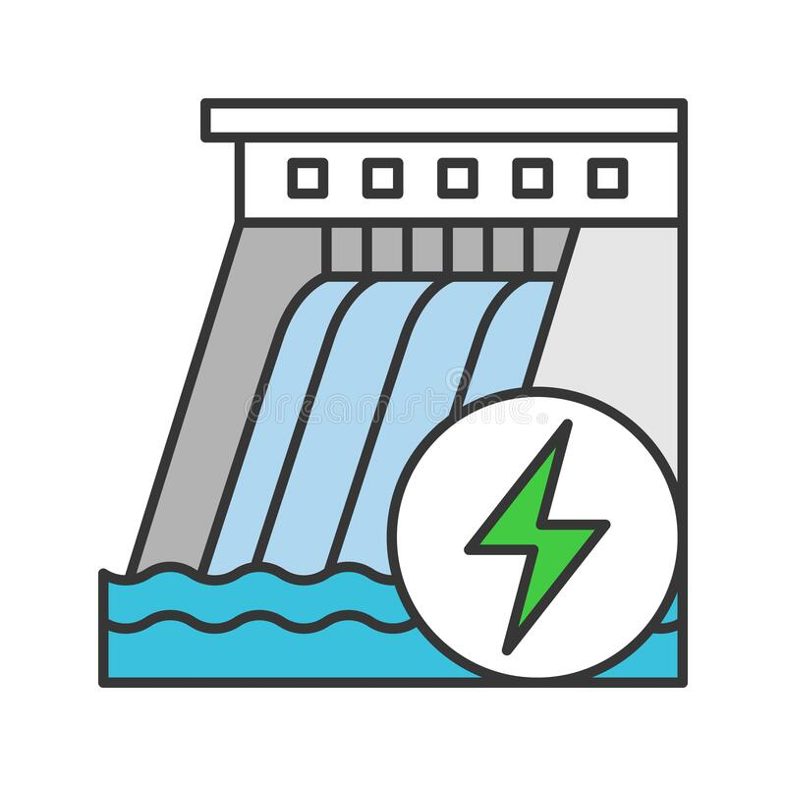  3.  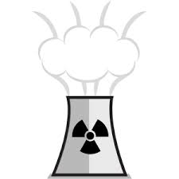  ** Ss say the words.  **** Teacher shows and says the words aloud and asks Ss to repeat them.  * Teacher asks Ss to translate the word into Vietnamese | T-S | 5 mins
Lead-in/ pre-read and listen | - To get students interested in the topic  - To set the context  - To help Ss understand the main idea of the text | Task 1. Match the types of energy in A with the energy sources in B  * Teacher asks Ss to look at the table and match the energy with its source.  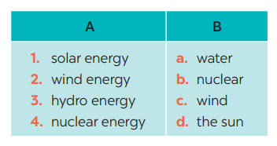  Answers:  1- D 2 – C 3 – A 4 – B  ** Ss work out and answer questions in pairs.  *** Ss share their answers as a whole class.  **** T asks them to to check their answers.  * Teacher asks students to make full sentences to tell about the sources of different energy. Then tell share them to share their sentences with a partner and correct for them. | T-S | 3 mins
Controlled practice | - To practise identifying the meanings of road signs.  - To develop Ss' knowledge of vocabulary | Task 2: Write the phrases to label the pictures:  * Teacher asks Ss to look at the pictures and use the knowledge from Task 1 to guess the pictures.  Then work and share their answers with their partners who sit next to them. (peer check)  ** Ss do exercise 3 in pairs.  *** Ss share and discuss with their partners to write all words/ phrases down on the notebooks.  **** Teacher corrects their answers as a class.  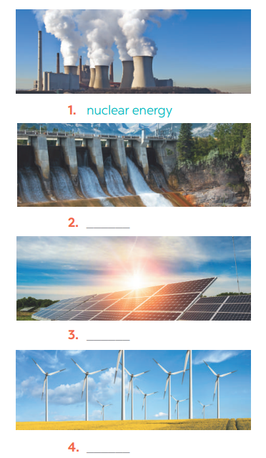  Answers  1. Nuclear energy  2. Hydro energy  3. Solar energy  4. Wind energy | T-S  S-S  T-S | 7 mins
 | - To help Ss deeply understand how to read the road signs  - To practise the targetted language in life context. | Task 3: Complete the sentences with the words and phrases from 1 or 2.  * Teacher gives students time to do the exercise individually, then share their sentences.  *** Teacher nominates Ss to say the sentences aloud.  **** Teacher checks and gives the corrections if they have mistakes.  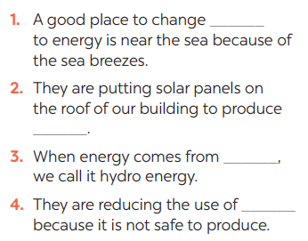  Answers  1. wind  2. solar energy  3. water  4. nuclear | T-S  S-S  T-S | 10 mins
Pronunciations | - To help Ss identify the and classify the sounds  - To give students authentic practice in using pronouncing sounds in common words | Task 4: Listen and repeat. Pay attention to the stressed syllables in the words.  * Teacher gives Ss time to listen and practice pronouncing the words with correct primary stress.  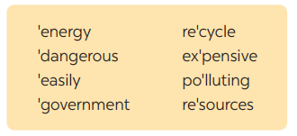  Task 5: Listen and repeat, paying attention to the stressed syllables in the underlined words.  ** Ss do as instructed  **** Teacher gives Ss feedback.  - choose some common mispronounced words and suggest students practise using them.  - choose some typical errors and correct as a whole class  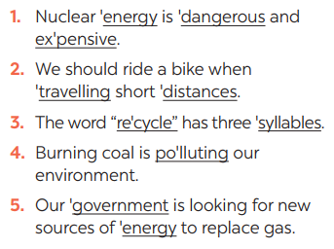 | T-S  T  S-S | 10 mins
Wrap up  Homework | To help Ss memorise the target language and skills that they have learned | - Vocabulary about sources of energy.  - Pronunciation: Stress in three-syllable words  Homework:  - Exercises in the workbook | T-Ss

UNIT 10: ENERGY SOURCES
Lesson 3: A closer look 2
I. Objectives
By the end of this lesson, Ss will be able to gain:
1. Knowledge
Know how to use: THE PRESENT CONTINUOUS

Structure | Examples
1. Affirmative sentences: S + be + Ving | She is playing basketball in the school yard.
2. Negative sentences: S + be not + Ving | They are not using solar energy.
3. Y/N questions: Be + S + Ving? | Are you working on your Project?
4. W questions: W + S + be + Ving? | Where is your brother studying?
2. Core competence
- Develop communication skills and cultural awareness
- Be collaborative and supportive in pair work and teamwork
- Actively join in class activities
3. Personal qualities
- Develop awareness of conserving the energy sources
II. Materials
- Grade 7 textbook, Unit 10, A closer look 2.
- Computer connected to the internet
- Projector/ TV/ pictures.
- sachmem.vn

Assumptions
Anticipated difficulties | Solutions
- Students may not know how to work in teams or fully understand the exercises and tasks. | - Give short, clear instructions and help if necessary.

Board Plan
Date of teaching
Unit 10: ENERGY SOURCES
Lesson 3: A closer look 2
* Warm-up: JUMBLE SENTENCES
I. Grammar: THE PRESENT CONTINUOUS
II. Practice
Task 1: Work in pairs. Tell your partner what the people in the pictures are doing
Task 2: Complete the sentences, using the present continuous form of the verbs in brackets.
Task 3: Circle the correct form of the verb in each sentence.
Task 4: Write sentences about what the people are doing or not doing, using the suggestions
Task 5: Work in pairs. Ask and answer the following questions.

* Homework

Procedures
Notes
In each activity, each step will be represented as following
* Deliver the task
** Implement the task
*** Discuss
**** Giving comments or feedback

Stage | Stage aim | Procedure | Interaction | Time
Warm-up | - To activate students’ knowledge on the topic of the unit  - To enhance students’ skills of cooperating with team mates | JUMBLE SENTENCES  * Teacher gives instructions  ** Teacher divides the class into 4 groups. Teacher delivers a set of word cards which are jumble sentences in present continuous to each group.  ** Students will have to work in groups to create as many correct sentences from the word cards as possible. The group with more correct sentences will be the winner.  Suggested answers:  1. She is learning English now.  2. They are not using solar energy.  3. Are you working on your Project?  4. Where is your brother studying?  5. She is playing basketball in the school yard.  **** Teacher checks and corrects if Ss make the sentences incorrectly. | T-Ss  T-S  S-Ss  T-Ss | 5 mins
Presentation | To introduce students the form of the key grammar and how to use them appropriately | the present continuous  - Teacher says: “This lesson today is going to tell you about “The present continuous”  * Teacher draws students’ attention to the grammar point and the example  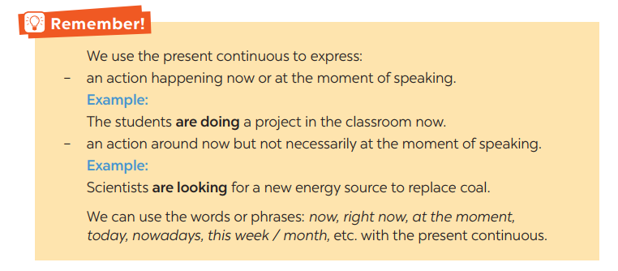  ** Ss read the grammar explicit and study the example.  *** Ss may discuss within groups/pairs before answering.  **** Teacher shows and says the sentences aloud and asks Ss to make similar sentences. | T-S | 5 mins
Practice/ Controlled practice | - To get students interested in the topic  - To set the context  - To help Ss understand the main idea of the text | Task 1. Work in pairs. Tell your partner what the people in the pictures are doing  * Teacher asks Ss to look at the pictures and work in pairs. Teacher asks them how would they ask and answer (using Present continuous)  ** Ss work out and answer questions with a partner.  *** Ss share their answers in pairs.  **** T asks them to to check their answers.  * Then tell share them to share their sentences as a whole in class and correct for them.    Answers:  a- She is teaching maths/ is writing on the board.  b- They are play football/soccer.  c- She is riding her bike/bicycle.  d- She is cooking.  c- She is singing.  f- He is watering the flowers/plans/is doing gardening. | T-S | 3 mins
Controlled practice | - To practise using the present continuous. | Task 2: Complete the sentences, using the present continuous form of the verbs in brackets.  * Teacher asks students to reaf the instructions carefully and do the exercise individually.  ** Ss do exercise then share with their partner.  *** Ss can check and correct for their partner  **** Teacher corrects their answers as a class.  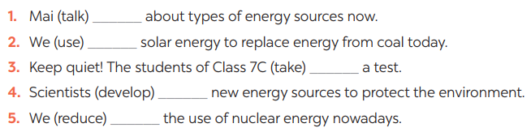Answer:  - is talking  - are using  - are taking  - are developing  - are reducing | T-S  S-S  T-S | 7 mins
 | - To practise the present continuous  - To practise making sentences using the present continuous  - To practise speaking using the present continuous | Task 3: Circle the correct form of the verb in each sentence  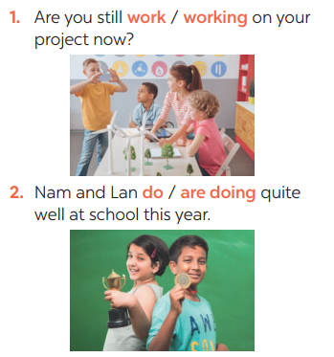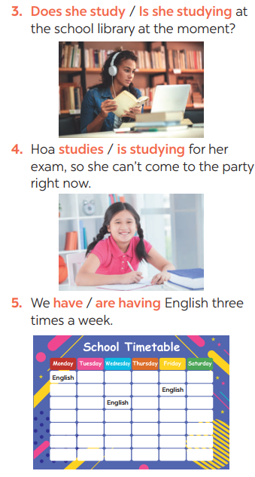*  * Teacher asks students questions to make sure students understand the instructions  *** Teacher nominates Ss to read aloud the correct sentences.  **** Teacher checks and gives the corrections if they have mistakes.  Task 4: Write sentences about what the people are doing or not doing, using the suggestions.  * Teacher gives Ss time to do the exercise individually and peer check with their partner.  *** Teacher nominates Ss to read aloud the sentences. Then asks them to underline the words/phrases that can be found in Present continuous sentences  **** Teacher checks and gives the corrections if they have mistakes.  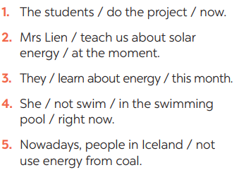  Answers:  1- The students are doing the project now.  2- Mrs. Lien is teaching us about solar energy at the moment.  3- They are learning about energy this month.  4- She isn’t swimming in the swimming pool right now.  5- Nowadays, people in Iceland aren’t using energy from coal.  Task 5: Work in pairs. Ask and answer the following questions.  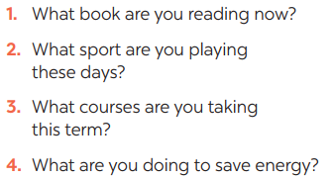  ** Ss work in pairs as instructed. Ss take note while doing the task.  **** Teacher walks around to give instructions and corrections (if nedded).  ***Teacher calls some students to report their partner’s answers using present continuous. Then gives Ss feedback  - choose some common mistakes and suggest students how to avoid them.  - choose some typical errors and correct as a whole class | T-S  S-S  T-S  T-S  T  S-S  T- Ss | 20  mins
Wrap up  Homework | To help Ss memorise the target language and skills that they have learned | - The present continuous  Homework:  - Exercises in the workbook | T-Ss | 2 mins

UNIT 10: ENERGY SOURCES

Lesson 4: Communication

I. Objectives
By the end of this lesson, students will be able to:
1. Knowledge
- Everyday English: Asking for explanations
- Speaking skill: how well your partner saves energy.
2. Core competence
- Develop communication skills
- Be collaborative and supportive in pair work and team work
- Actively join in class activities
3. Personal qualities
- Be benevolent and responsible
II. Materials
- Grade 7 textbook, Unit 10, Communication
- Computer connected to the internet
- TV/ Pictures/ Projector
- sachmem.vn

Language analysis
Anticipated difficulties | Solutions
1. Students may lack knowledge about the topic. | Provide students with information about the knowledges they do not know.
2. Students may have underdeveloped reading, speaking and co-operating skills. | - Encourage students to work in pairs, in groups so that they can help each other.  - Provide feedback and help if necessary.
3. Some students might excessively talk in the class. | - Define expectation in explicit detail. Have excessive talking students practise.  - Continue to define expectations in small chunks (before every activity).

Board Plan
Date of teaching
UNIT 10: ENERGY SOURCES
Lesson 4: Communication
*Warm-up
BRAINSTORMING
I. Everyday English:
Task 1: Listen and read the conversation. Pay attention to the highlighted questions.
Task 2: Work in pairs. Make similar conversations to ask for explanations.
II. Practice: Saving energy
Task 3: Work in pairs. Ask your partner the following questions and tick his or her answers in the boxes.
Task 4: Work in groups. Speech: how well your partner saves energy
Task 5: Answer the questions in 3 on your own. Speech: how well you save energy
* Homework

Procedures
Notes
In each activity, each step will be represented as following
* Deliver the task
** Implement the task
*** Discuss
**** Giving comments or feedback

Stage | Stage aim | Procedure | Interaction | Time
Warm-up | To introduce the lesson. | Game: BRAINSTORMING  TYPES OF ENERGY  * Teacher divides class into 2 teams and asks them to think of “TYPES OF ENERGY”  ** Ss have 1 min to think of the words related to the topic or they can discuss with their partners.  *** Each member from each team turn by turn run to the board and write one word.  **** Teacher corrects their answers.  - The team which has more correct words will be the winner  Suggested answers:  Solar, hydro, coal, natural gas, oil, wind,… | T-Ss | 5 mins
Lead in | To lead in the lesson. | Teacher leads students into the lesson by telling what they are going to learn: “We are going to learn how to ask and answer for explanations and find out how well we save energy”. | T-Ss | 1 min
* EVERYDAY ENGLISH
Presentation | To let students know the structure to ask and answer for explanation. | Task 1: Listen and read the conversation. Pay attention to the highlighted questions.  * Teacher plays the record for SS to listen and read the conversation.  ** Ss listen and practice saying with their partners.  *** Teacher calls some pairs to read aloud.  **** Teacher corrects pronunciation if needed.  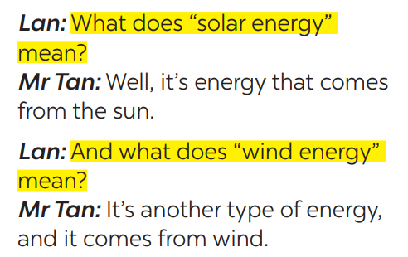  * Teacher asks Ss to pay attention to the highlighted parts and asks them some questions to elicit the new structure:  - Which tense do we use to ask and answer?  - Which question word and verb do we use?  - …..  ** Ss answer teacher’s questions to find out new structure to ask and answer for explanations.  *** Some students give the new structure to the teacher.  **** Teacher corrects and writes on the board:  - Structure:  to ask:  - What do/does + S + mean?  to answer:  - S + mean(s)/be … | T-Ss | 10 mins
Practice | To help students practise  on how to ask and answer for explanations. | Task 2: Work in pairs. Make similar conversations to ask for explanations.  * Teacher has SS look at the phrases in Ex 2 to make similar dialogue.  ** Ss work in pairs to make similar dialogue.  *** Teacher calls some pairs to present it in front of the class.  **** Teacher gives feedback and some comments.  Suggested answers:  A: What does hydro energy mean?  B: It’s energy that comes from the sun. What does nuclear energy mean?  A: It’s energy that comes from the nuclear power. | Pair work  T-Ss | 8 mins
* SAVING ENERGY
Presentation | - To provide students with more awareness of ways to save energy and help them practice the skill of speaking. | Task 3: Work in pairs. Ask your partner the following questions and tick his or her answers in the boxes.  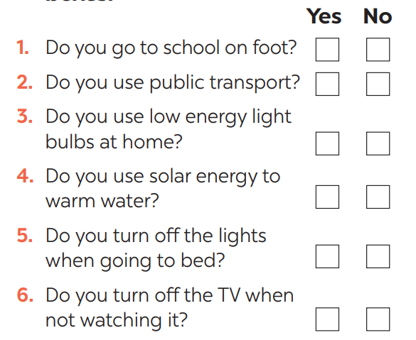  * Teacher asks Ss to work in pairs and tick.  ** Ss so the task in pairs  Task 4: Work in groups. Speech: how well your partner saves energy.  * Teacher gives students time to prepare. Meanwhile, teacher walks around the classroom to help students if they have difficulties find proper words/phrases/structures  *** Teacher calls some Ss to read aloud their work  **** Teacher let Ss listen and correct mistakes (if needed).  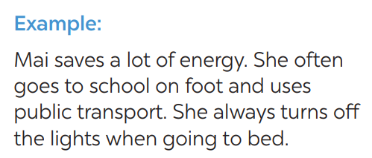 | T- Ss  S-S  T-Ss  T-S  S  T-Ss | 7 mins
Practice | To help students practicing speaking about saving energy | Task 5: Answer the questions in 3 on your own. Speech: how well you save energy  * Teacher allows students time to answer the questions onto their notebooks and prepare.  ** Ss work individually.  *** Ss can practicing sharing to their partners  **** Teacher calls some students to read aloud their work. Teacher let Ss listen and correct mistakes (if needed).  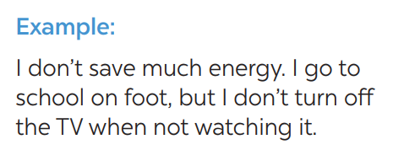 | S  Pair work  T- Ss | 6 mins
Consolidation | To consolidate what students have learnt in the lesson. | Teacher asks students to talk about what they have learnt in the lesson. | T-Ss | 1 min
Homework | To prepare for the next lesson:  Skills 1. | Do exercises in the workbook. | T-Ss | 1 min

UNIT 10: ENERGY SOURCES

Lesson 5: Skills 1

I. Objectives
By the end of this lesson, students will be able to gain:
1. Knowledge
+ Reading:
- read for specific information about renewable and non-renewable sources of energy.
+ Speaking:
- talk about advantages and disadvantages of different sources of energy
2. Core competence
- Develop communication skills
- Be collaborative and supportive in pair work and team work
- Actively join in class activities
3. Personal qualities
Be benevolent and responsible
II. Materials
- Grade 7 textbook, Unit 10, Skills 1
- Computer connected to the internet
- TV/ Pictures, cards
- sachmem.vn

Language analysis
Form | Meaning | Pronunciation | Vietnamese equivalent
1. produce (v) | to make things, mostly in large quantity | /prəˈdjuːs/ | sản xuất
2. limited (a) | not very great in amount or extent | /ˈlɪmɪtɪd/ | bị hạn chế
3. available (a) | that you can get, buy or find | /əˈveɪləbl/ | có sẵn

Anticipated difficulties | Solutions
1. Students may lack knowledge about some lexical items. | Provide students with the meaning and pronunciation of words.
2. Students may have underdeveloped reading, speaking and co-operating skills. | - Let students read the text again  (if needed).  - Create a comfortable and encouraging environment for students to speak.  - Encourage students to work in pairs, in groups so that they can help each other.  - Provide feedback and help if necessary.
3. Some students will excessively talk in the class. | - Define expectation in explicit detail.  Have excessive talking students practise.  - Continue to define expectations in small chunks (before every activity).

Board Plan
Date of teaching
Unit 10: Energy sources
Lesson 5: Skills 1
* Warm-up
HANGMAN
I. Reading:
1. Vocabulary
- produce (v) /prəˈdjuːs/ sản xuất
- limited (a) /ˈlɪmɪtɪd/ bị hạn chế
- available (a) /əˈveɪləbl/ có sẵn
2. Discussion: Ex 1: Look at the picture. Discuss
a, What are the main energy sources in Viet Nam?
B, What type(s) of energy sources will we use in the future?
3. Practice
Task 1: Read the text and choose the best option to complete the sentences.
Task 2: Read the text again and answer the questions:
II. Speaking:
Task 3: Work in groups. Discuss and put the following words or phrases in the appropriate columns.
Task 4: Work in pairs. Ask and answer questions about the advantages and disadvantages of different energy sources.
Task 5: Presentation
* Homework

Procedures
Notes
In each activity, each step will be represented as following
* Deliver the task
** Implement the task
*** Discuss
**** Giving comments or feedback

Stage | Stage aim | Procedure | Interaction | Time
Warm-up | To introduce the topic of reading. | Game: Hangman  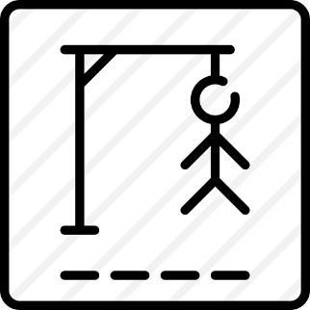  R E N E W A B L E  * Teacher divides class into 2 teams and asks them to think of the word which has 9 letters in it related the topic “ENERGY SOURCES”.  ** Ss have 1 min to think of the words related to the topic or they can discuss with their partners.  *** Each member from each team turn by turn guesses the letter in the secret word.  **** Teacher corrects their answers.  - The team which can find or guess the secret first will be the winner. | Group work | 5 mins
Lead in | To lead in the lesson about Skills 1. | READING  - Teacher leads students into the lesson by telling what they are going to learn: “We are going to read a passage about renewable and non-renewable source of energy.” | T-Ss | 2 mins
Pre-Reading (Pre-teach vocabulary) | To provide students with some lexical items before reading the text  To introduce words related to skin conditions to Ss and help Ss have a general idea of what they are going to read. | Vocabulary  - Teacher introduces the vocabulary by:  + Providing the definition of the words and gives examples  - produce (v) /prəˈdjuːs/ sản xuất  = to make things, mostly in large quantity  Examples: Companies produce many toys for children before Christmas.  - limited (a) /ˈlɪmɪtɪd/ bị hạn chế  = not very great in amount or extent  Examples: coal, oil, …  - available (a) /əˈveɪləbl/ có sẵn  = that you can get, buy or find  Examples: The coal takes a long time to be available again.  Concept check: Rub out and Remember  DISCUSSION  * Teacher asks Ss to work in pairs to look at the Picture in Ex1 and discuss to answer the questions.  ** Ss work in pairs.  *** Teacher calls some Ss to check what they have discussed.  **** Teacher corrects  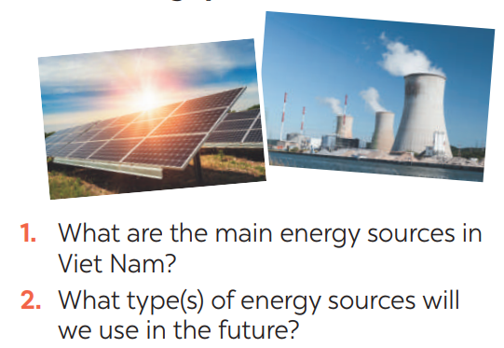  Suggested keys:  1. Coal, oil, hydro,…  2. Wind, solar,… | T-Ss  T – Ss  Pair works  T - Ss | 8 mins
While-Reading | To help Ss develop their reading skill for details and specific information (skimming and scanning)  To help Ss further develop their reading skill for specific information (scanning). | Task 1: Read the text and choose the best option to complete the sentences.  * Teacher gives Ss time to: read each question, locate where the information appears in the text, read that part carefully and circle the correct answer.  ** Ss do the task independently  *** Teacher tells Ss to compare their answers in pairs before calling some of them to check.  **** Teacher confirms the correct answer and explains if needed.  1. Non-renewable sources are cheap  and ______.  A. available  B. easy to use  C. expensive  2. ______ come from the sun, wind or water.  A. Renewable sources  B. All energy sources  C. Non-renewable sources  3. When energy comes from water,  we call it ______.  A. wind energy  B. solar energy  C. hydro energy  4. Renewable energy sources are better  for ______.  A. the environment  B. our cars  C. hydro energy  Answer key:  1. B 2. A 3. C 3. A  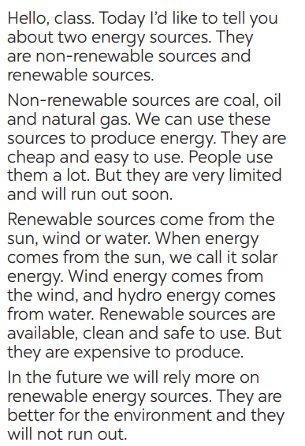  Task 2: Read the text again and answer  the questions  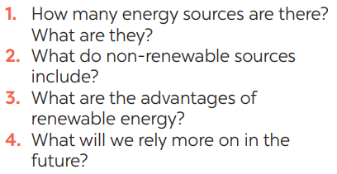  * Teacher asks Ss to do the exercise carefully and individually.  ** Ss do the task independently.  *** Teachers has Ss compare their answers in pairs and call some Ss to give their ideas.  **** Teacher checks and confirms the correct answers.  Answer key:  1. There are two energy sources. They  are non-renewable sources and renewable sources.  2. Non-renewable sources are coal, oil  and natural gas.  3. Renewable sources are available, clean and safe to use.  4. In the future, we will rely more on  renewable energy sources. | T- Ss  S  T- Ss  T- Ss  S  Ss-Ss  T-Ss | 9 mins
Post-Reading  & Pre-Speaking | - To check students’ reading comprehension.  - To help Ss talk about how they apply the rules in the reading to themselves. | Task 3: Work in groups. Discuss and put the following words or phrases in the appropriate columns.  * Teacher asks Ss to work in groups and tells them to focus on the table.  ** Ss work in groups. Teacher goes around and listens and gives help if needed.  *** Teacher calls on some Ss to share their answers with the class. Teacher encourages  **** Teacher listens and corrects if needed  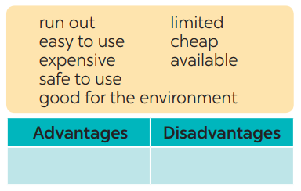  Answer key:  Advantages: easy to use, safe to use, good for environment, cheap, available  Disadvantages: run out, expensive, limited, cheap | T-Ss  Group works  T- Ss | 5 mins
While-Speaking | To provide Ss an opportunity to ask and answer questions about the advantages and disadvantages of different types of energy sources. | Task 4: Work in pairs. Ask and answer questions about the advantages and disadvantages of different energy sources  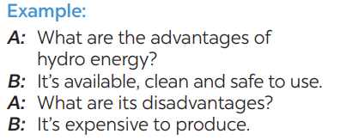  * Teacher has Ss work in pairs and asks them to take turns to ask and answer  ** Ss work in pairs to do the task. Teacher goes around, listens and gives help if needed.  *** Teacher calls on some pairs to share their answers with the class.  **** Teacher comments and correct | T- Ss  Pair-works  T- Ss | 7 mins
Post-Speaking | To help students practice presenting the advantages and disadvantages of different types of energy source | Task 5: Give the advices on dangerous situations on the road.  * Teacher has students work in groups to prepare a presentation (poster/pictures/notes…)  *** Teacher calls on some groups to share their answers with the class.  **** Teacher comments and corrects if needed. | T-Ss  Ss-Ss | 3 mins
Consolidation | To consolidate what students have learnt in the lesson. | Teacher asks students to talk about what they have learnt in the lesson. | T-Ss | 2 mins
Homework | To prepare for the next lesson Skills 2. | Do exercises in the workbook. | T-Ss | 1 min

UNIT 10: ENERGY SOURCES

Lesson 6: Skills 2

I. Objectives
By the end of this lesson, students will be able to:
1. Knowledge
+ Listening
- use the lexical items related to the topic Energy sources
- listen for main ideas and specific information about the topic how to save energy at home.
+ Writing: Write a paragraph of about 70 words about how you save energy at home.
2. Core competence
- Develop communication skills
- Be collaborative and supportive in pair work and team work
- Actively join in class activities
3. Personal qualities
Be benevolent and responsible
II. Materials
- Grade 7 textbook, Unit 10, Skills 2
- Computer connected to the internet
- Pictures
- sachmem.vn

Anticipated difficulties | Solutions
1. Students may lack knowledge and experiences about the topic. | Prepare some hand-outs.
2. Students may have underdeveloped listening, writing and co-operating skills. | - Play the recording many times if any necessary.  - Encourage students to work in pairs, in groups so that they can help each other.  - Provide feedback and help if necessary.
3. Some students might excessively talk in the class. | - Define expectation in explicit detail.  Have excessive talking students practise.  - Continue to define expectations in small chunks (before every activity).

Board Plan
Date of teaching
Unit 10: Energy sources
Lesson 6: Skills 2
* Warm-up: PASS THE CHALK
I. Listening
Task 1: Work in pairs. Answer the questions
Task 2: Listen and circle the phrases you hear
Task 3: Listen again and tick T (True) or F (False) for each sentence
Task 4: Discuss: What is the most effective way to save energy.
II. Writing:
Task 5: Work in pairs. Read some ways to save energy at home. Choose three ways and write them in your notebook.
Task 6: Write a paragraph of about 70 words about how to save energy at home
Peer check and cross check
* Homework

Procedures
Notes
In each activity, each step will be represented as following
* Deliver the task
** Implement the task
*** Discuss
**** Giving comments or feedback

Stage | Stage aim | Procedure | Interaction | Time
Warm-up | To activate students’ prior knowledge and vocabulary related to the lesson | PASS THE CHALK  * Teacher writes on the board the word “HOW TO SAVE ENERGY” and and divide the class into 2 groups.  ** Ss take turns to go to the board  *** Teacher calls some students to give their answers.  **** Teacher listens and give comments. | T-Ss  Group work | 5 mins
Lead in | To introduce the new lesson. | - Teacher introduces students the content of the lesson: “In the lesson today, we are going to listen to a person talking about how to save energy at home.” | T-Ss | 1 min
Pre-Listening | To help Ss brainstorm the topic and prepare for the listening text.  To help Ss develop their skill of listening for specific information | Task 1: What can you see in this picture? What is special about it?  * Teacher asks Ss to work in pairs to answer the questions in the picture.  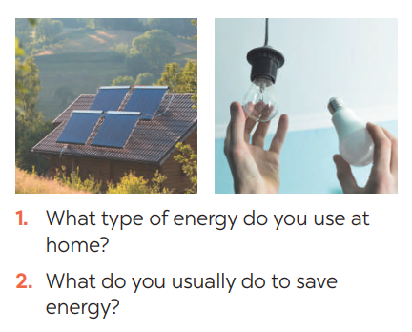  ** Ss work with their partner to do the task.  *** Teacher calls on some Ss to answer.  **** Teacher gives comments and leads Ss to task  Suggested answers:  - solar energy  - turn off the tap while brushing your teeth, use paper fan, …  Task 2: Listen and circle the phrases you hear  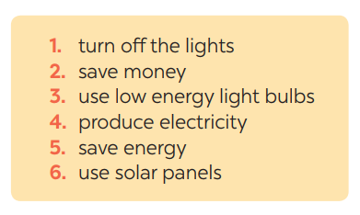  * Teacher asks Ss to read and underline the key words.  ** Ss work independently to guess then listen to the recording once to check their guess.  *** Teacher calls on some students to give the answers the have listened. | T-Ss  Pair work  T- Ss  T- Ss  S  T- Ss | 3 mins
While-Listening | To help students develop their skill of listening for details. | Task 3: Listen again and tick T (True) or F (False) for each sentence  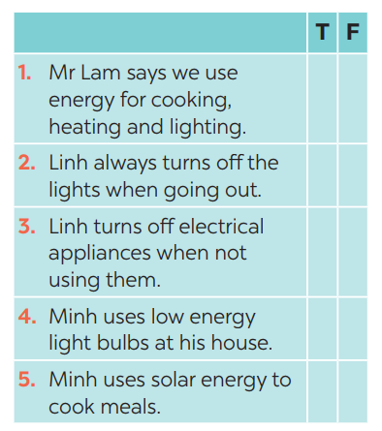  * Teacher asks Ss to read and underline the key words.  ** Ss work independently listen to the recording and tick T or F  *** Teacher calls on some students to give the answers the have listened.  Answer key:  1. 3. 5.  2. 4. | T-Ss | 10 mins
Post-Listening | To help Ss use what they have listened to life context. | Task 4: Discuss: What is the most effective way to save energy?  * Teacher tells Ss to work in groups to discuss and find out “What is the most effective way to save energy”. Write down onto the notebooks in full sentences  E.g. The most effective way to save energy is only read and write in day light  ** Ss work in groups. Teacher moves around and offers help if needed.  *** Teacher invites some Ss to share their answers.  **** Teacher corrects if needed. | Group work | 5 mins
Pre-Writing | To help Ss prepare ideas to write a passage. | Task 5: Work in pairs. Read some ways to save energy at home. Choose three ways and write them in your notebook.  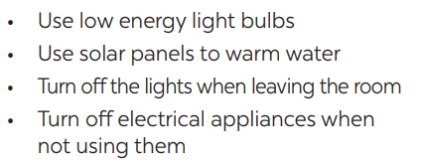  * Teacher asks Ss to write the methods they use to save energy at home then asks them to give out more if they can.  ** Ss think of it and can discuss with their partners.  *** Teacher calls on some Ss to raise their ideas.  **** Teacher listens and confirms. | T-Ss  S-S  T-Ss | 5 mins
While-Writing | To help Ss practise writing a passage about  70 words about how you save energy at home | Task 6: Write a paragraph of about 70 words about how you save energy at home.  * Teacher tells Ss that they are going to write a passage about how you save energy at home.  ** Teacher reminds Ss of the structure of a passage and steps to make an outline for the passage.  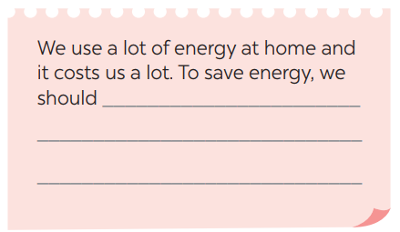  ** Ss work independently to do the task and try to use the notes from the previous tasks.  Teacher goes around and help if necessary. | T-Ss | 10 mins
Post-Writing | To peer check, cross check and final check students’ writing. | Peer check and cross check  *** Teacher asks Ss to share their writing with their partners. Then, call on some Ss to show their writing in front of the class.  **** Teacher checks ideas, grammar, vocabulary and gives comments.  Suggested answers:  We use a lot of energy at home and it costs us a lot. To save energy, we should try making use of natural light more instead of keep the lights unnecessarily in the morning and afternoons. Moreover, we should unplug your electrical gadgets when not in use. These devices consume at least 10% of electricity even when inactive. Therefore, unplug them to save electricity. Most importantly, installing solar panels can help you excessively. They are very economical and help in saving a lot of energy. This can help in getting cheap electricity and protect the environment. | Ss-Ss  T-Ss | 3 mins
Consolidation | To consolidate what students have learnt in the lesson. | Teacher asks students to talk about what they have learnt in the lesson. | T-Ss | 1 mins
Homework | To allow students finalize their passage after being checked by friends and the teacher. | Rewrite the passage on the notebook. | T-Ss | 1 min

UNIT 7: ENERGY SOURCES

Lesson 7: Looking back & Project

I. Objectives
By the end of this lesson, students will be able to:
1. Knowledge
- review the vocabulary and grammar of Unit 10
- apply what they have learnt (vocabulary and grammar) into practice through a project.
2. Core competence
- Develop communication skills and creativity
- Be collaborative and supportive in pair work and team work
- Actively join in class activities
3. Personal qualities
- Be benevolent and responsible
- Develop self-study skills
II. Materials
- Grade 7 textbook, Unit 10, Looking back & Project
- Computer connected to the internet
- TV/ Pictures, A0 cards and colours
- sachmem.vn

Anticipated difficulties | Solutions
1. Students may have underdeveloped speaking, writing and co-operating skills when doing project. | - Encourage students to work in pairs, in groups so that they can help each other.  - Provide feedback and help if necessary.
2. Some students might excessively talk in the class. | - Define expectation in explicit detail.  Have excessive talking students practise.  - Continue to define expectations in small chunks (before every activity).

Board Plan
Date of teaching
Unit 10: Energy sources
Lesson 7: Looking back & Project

* Warm-up
QUICK REVISION CHECK
I. Looking back
Task 1: Match the adjectives in A with the nouns in B to make phrases
Task 2: Complete the sentences, using the phrases in 1
Task 3: Complete the sentences by using the correct form of the present continuous or present simple of the verbs in brackets.
Task 4: Find ONE mistake in each sentence and correct it
II. Project
Saving energy at school
Task 5: Discussion: Which tips can be applied in your school.
Task 6: Poster presentation: How to save energy in your school
* Homework

Procedures
Notes
In each activity, each step will be represented as following
* Deliver the task
** Implement the task
*** Discuss
**** Giving comments or feedback

Stage | Stage aim | Procedure | Interaction | Time
Warm-up | To help students revise the vocabulary items they have learnt in the unit.  To enhance students’ skills of cooperating with team mates. | Quick revision check  * Teacher asks Ss to think of what they have learnt already in Unit 10.  ** Ss work in pairs to do the task.  ***Teacher calls some students to retell.  **** Teacher confirms and leads them to do all the exercises in books. | T- Ss  Pair work  T - Ss | 3 mins
Looking back | To help Ss revise the vocabulary items (verbs) they have learnt in the unit.  To help Ss revise the vocabulary items (adjectives) they have learnt in the unit  To help Ss revise grammar points.  To help Ss revise the grammar points of the unit | Task 1: Match the adjectives in A with the nouns in B to make phrases  * Teacher has Ss work individually.  ** Ss do this activity individually, then compare their answers with their partners.  *** Teacher asks for Ss’ answers. **** Teacher confirms the correct ones and asks students to make sentences using the phrases.  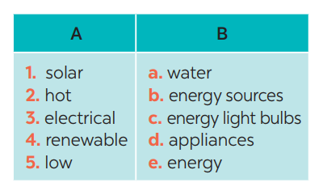  Answer keys:  1. e 2. a  3. d 4. b 5. c  Task 2: Complete the sentences, using the phrases in 1  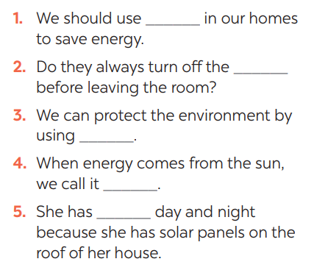  * Teacher has Ss work individually.  ** Ss do this activity then compare their answers with their partners.  *** Teacher asks for Ss’ answers. **** Teacher confirms the correct ones  Answer keys:  1. low energy light bulbs  2. electrical applicances  3. renewable energy sources  4. solar energy  5. hot water  Task 3: Complete the sentences by using the correct form of the present continuous or present simple of the verbs in brackets.  * Teacher asks Ss to recall the structures of “The present continuous”, and tell them to do Ex 3 in the book.  ** Ss do the exercise individually and swap with their partners.  *** Teacher calls some Ss to check their answer.  **** Teacher confirms the correct answer.  1. Look! It (rain) ______ heavily.  2. Normally they (start) ______ school at eight o’clock in the morning.  3. He hasn’t got a bike at the moment, so he (walk) ______ to school this week.  4. He always (do) ______ his homework in the evening.  5. I’m afraid I have no time to help just now. I (write) ______ an essay  Answer keys:  1- is raining  2- start  3- is walking  4- does  5- am writing  Task 4: Find ONE mistake in each sentence and correct it  * Teacher asks Ss to do the task.  ** Ss work individually to do the task.  *** Teacher calls Ss to give out their answers.  **** Teacher checks and confirms their answer.  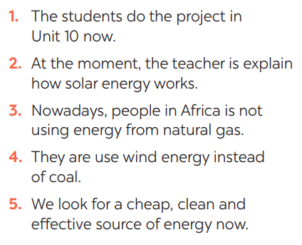  Answer keys:  1. do -> are doing  2. explain -> explaining  3. is -> are  4. use -> using  5. look -> are looking | T-Ss  S  Ss-Ss  T-Ss | 16 mins
Project | To help Ss develop team work skills and pratice using what they have learnt to make a poster | Task 5: Discussion: Which tips can be applied in your school.  * Teacher asks Ss to dicuss in groups of 4-6  * Teacher also has Ss spend some time to make their brainstorm, narrow down the ideas, make a poster out of these ideas and practise presenting within their groups.  ** Ss discuss with their group memebers.  *** Some students raise their ideas and explain their answers among groups  **** Teacher listens, correct (if needed) and confirms.  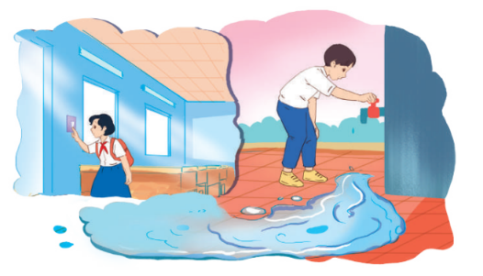  Task 6: : Poster presentation: How to save energy in your school  * Teacher asks Ss to work in groups of 4 – 6 to stick their posters onto the classroom’s wall and present about them.  ** Ss work in group to do the task.  *** Teacher calls some groups to present their poster to the class  **** Teacher confirms and corrects. | Group work | 22 mins
Consolidation | To consolidate what students have learnt in the lesson. | Teacher asks students to talk about what they have learnt in the lesson. | T-Ss | 3 mins
Homework | To prepare for the next lesson. | Prepare for the next lesson: Unit 11 – Getting started. | T-Ss | 1 min

Giaoandethitienganh.info

