Unit 2: HUMANS AND THE ENVIRONMENT
TEST 2
Mark the letter A, B, C, or D on your answer sheet to indicate the word whose underlined part differs from that of the other three in pronunciation in each of the following questions.
Question 1: A. emission B. encourage C. electric D. energy
Question 2: A. cycle B. club C. carbon D. cut
Mark the letter A, B, C, or D on your answer sheet to indicate the word that differs from the other three in the position of stress in each of the following questions.
Question 3: A. calculate B. chemical C. awareness D. natural
Question 4: A. sustainable B. situation C. material D. refillable
Mark the letter A, B, C, or D on your answer sheet to indicate the correct answer to each of the following questions.
Question 5: We can ______ a cleaner lifestyle by recycling our waste.
A. calculate B. create C. estimate D. adopt
Question 6: It's important to cut down ____ plastic use to help the planet.
A. in B. at C. on D. by
Question 7: Solar panels are great energy ________ for our homes.
A. resources B. materials C. encourages D. appliances
Question 8: Three years ago, my local environment __________ by a paper company which released tons of waste into Hau river.
A. is polluted B. were polluted C. was polluted D. are polluted
Question 9: I think people _______ polluting the environment in the near future.
A. is going to stop B. will stop C. are going to stop D. will be stopping
Read the following advertisement/announcement and mark the letter A, B, C, or D on your answer sheet to indicate the correct option that best fits each of the numbered blanks from 10 to 12.
ECO-FRIENDLY PAPER BAGS!
Let’s choose our eco-friendly paper bags for your (10)________ use to protect the environment!
Our eco-friendly paper bags are special as they are:
- Made (11)________ 100% recycled paper.
- Strong and durable, perfect for carrying groceries and (12)________ items.
- Available in different sizes for all your needs.
What are you waiting for? Make the switch to our eco-friendly paper bags today!
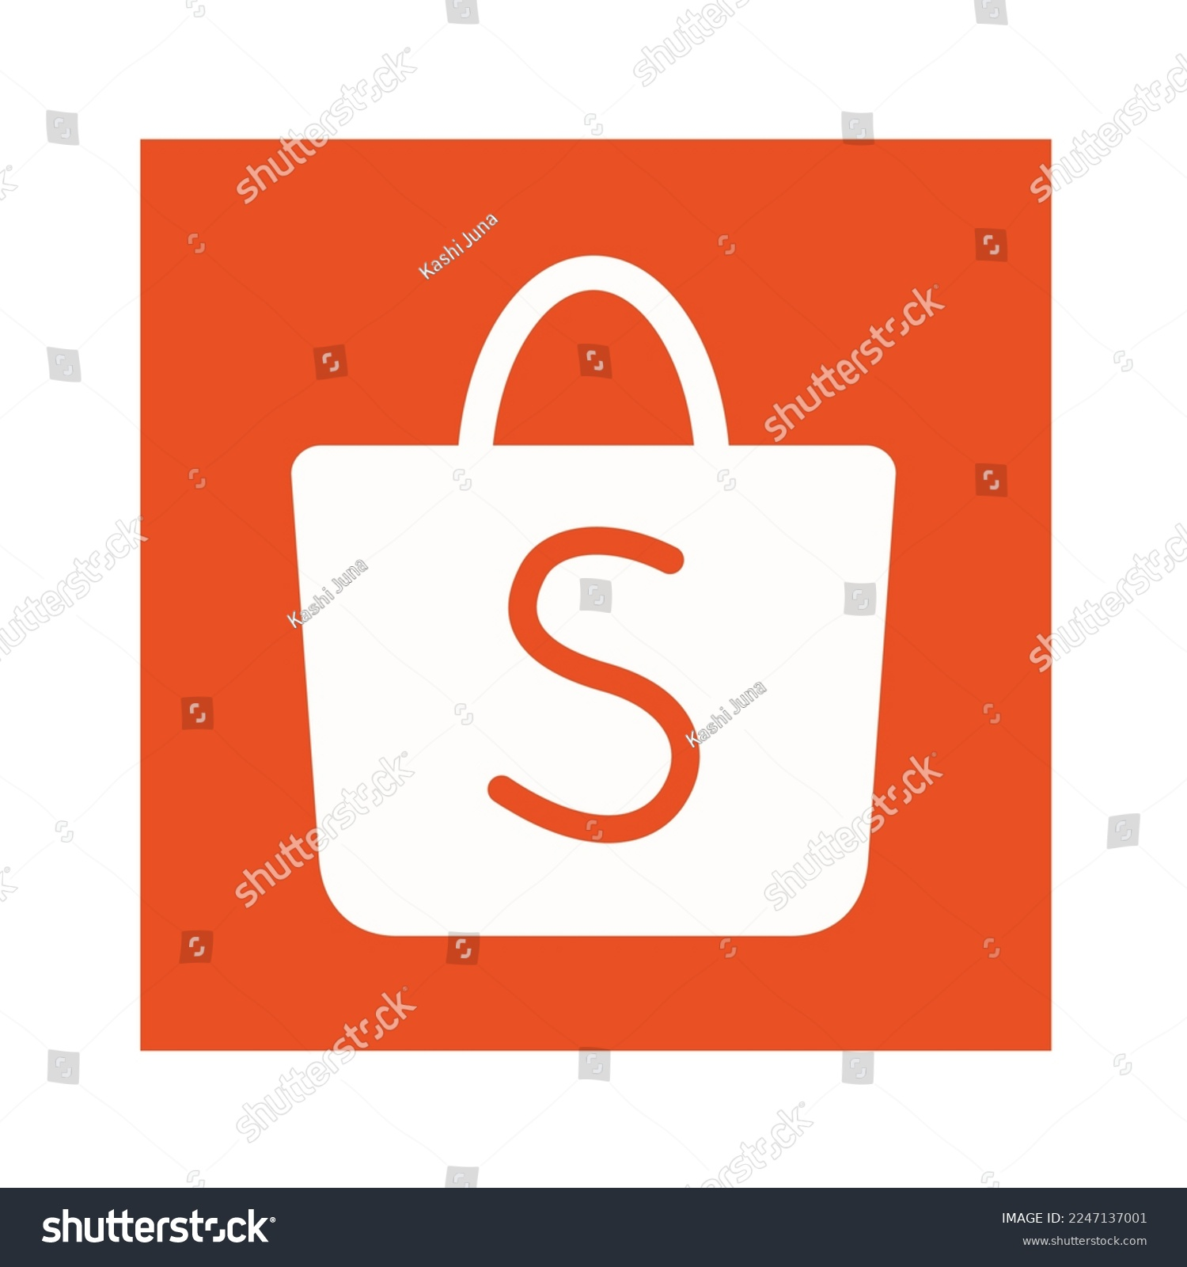 https://shopee.vn
https://www.facebook.com
Question 10: A. day B. daily C. date D. daylong
Question 11: A. of B. by C. from D. in
Question 12: A. other B. another C. others D. the others
GREEN EVENT
I am excited to announce our school's Green Event!
We (13)________ together to help our planet. Here are some important details:
- Date: Next Friday
- Time: 10:00 AM to 2:00 PM
Activities:
- Recycling workshop: Learn how to recycle properly.
- Clean-up walk: Join us in (14)________ litter around the school.
- (15)________ crafts: Make fun crafts from recycled materials.
We look forward to seeing everyone there and making a big difference together!
Thank you,
Question 13: A. would work B. are going to work C. is going to work D. will work
Question 14: A. picking up B. holding up C. building up D. setting up
Question 15: A. Refillable B. Friendly C. Eco-friendly D. Organic
Mark the letter A, B, C, or D on your answer sheet to indicate the correct arrangement of the sentences to make a meaningful paragraph/letter in each of the following questions.

Question 16:
i. Moreover, refillable bottles are often made from durable materials, ensuring longevity and reducing the frequency of replacement.
ii. Consequently, this small change in daily habits can lead to a substantial decrease in environmental footprint, promoting a more sustainable lifestyle for future generations.
iii. One significant benefit of using a refillable bottle is the positive impact on the environment.
iv. Additionally, by choosing a refillable bottle, individuals decrease their reliance on single-use plastics.
v. Firstly, it reduces the amount of plastic waste, which is a major contributor to pollution.
A. v – iv – i – ii – iii B. v – i – iv – ii – iii
C. iii – iv – i – v – ii D. iii – v – iv – i– ii

Question 17:
i. Furthermore, we took part in a clean-up event at a local park, which showed us the importance of keeping nature clean.
ii. Dear Binh, I wanted to share my experience from a recent field trip focused on eco-friendliness.
iii. In conclusion, this trip was very educational and inspired me to be more mindful of my environmental impact.
iv. Best regards,
v. Next, we explored a community garden and discovered how growing our own food helps the environment.
vi. First, we visited a recycling center, where we learned how to sort and recycle waste properly.
A. ii – vi – v – i – iii – iv B. ii – v – i – iii – iv – iv
C. ii – iii – i – vi – v – iv D. ii – v – iv – iv – vi – i
Mark the letter A, B, C, or D on your answer sheet to indicate the correct option that best fits each of the numbered blanks from 18 to 23.
Plastic bags are a big problem for our oceans. Many people use plastic bags every day, but when they are thrown away, they often end up in the sea. This happens because (18)________. They can float in the water for a long time and travel far from (19)________.
In the ocean, (20)________. For example, turtles might mistake plastic bags for jellyfish and eat them. This can make the turtles sick or even kill them. Fish and other sea creatures can also get tangled in plastic bags, (21)________.
Moreover, as plastic bags break into tiny pieces, they turn into microplastics. (22)________ can spread throughout the ocean and mix with the water. This makes the water dirty and unsafe for all sea animals.
(23)________, we can use fewer plastic bags and choose reusable bags instead. By doing this, we can help keep our oceans clean and protect the animals that live there. Small changes in our habits can make a big difference for the environment.
Reference https://www.eltngl.com
Question 18: A. plastic bags are not easy to break down
B. plastic bags are easy to be broken down
C. it takes a fortnight to break down plastic
D. it needs several days to be broken down
Question 19: A. where they were thrown away B. which they throw away
C. where they are thrown away D. which they are throwing away
Question 20: A. plastic bags can cause serious harm to sea animals
B. plastic bags can do serious harm to landfill animals
C. plastic bags cannot cause serious harm to the ocean
D. plastic bags can do seriously harm to ocean creatures
Question 21: A. which will protect them B. that is hurting or killing them.
C. that is going to protect them D. which can hurt or kill them.
Question 22: A. That tiny pieces B. This small piece
C. These tiny pieces D. Those small piece
Question 23: A. Helping solve that problem B. To help solve this problem
C. Helped solve that problem D. To helping solve this problem
Read the following passage and mark the letter A, B, C, or D on your answer sheet to indicate the correct option that best fits each of the numbered blanks from 24 to 28.
Many fruits (24)________ with bad chemicals called fertilizers. These chemicals help the plants grow faster. However, the chemicals are not good for people. When people eat the fruits, the chemicals can make them sick. The chemicals in the fertilizers are strong. They stay in the fruit even after it is picked. This means the chemicals get inside the fruit and people eat them. This is not (25)________. In addition, some fruits have a lot of these bad chemicals. (26)________, apples, strawberries, and grapes often have many chemicals from the fertilizers. These chemicals can (27)________ harm to human’s bodies. As a result, it is better to buy fruits that are grown without the bad fertilizers. These are called (28)________ fruits which do not have the harmful chemicals. They are safer for people to eat and better for their health.
Reference https://www.britannica.com
Question 24: A. are grown B. is grown C. was grown D. were grown
Question 25: A. healthy B. unhealthy C. health D. healthiness
Question 26: A. However B. Therefore C. Although D. For example
Question 27: A. have B. get C. do D. take
Question 28: A. chemical B. organic C. global D. sustainable
Read the following passage and mark the letter A, B, C, or D on your answer sheet to indicate the correct answer to each of the questions from 29 to 33.
Do you like eating healthy food? Organic food is good for you and the environment. Organic farmers do not use bad chemicals to grow food. They use natural ways to make the food grow. This helps keep the air and water clean.
When we eat organic food, we feel good. We have more energy, and we do not get sick as much. Also, the soil is happy when we use organic farming. The soil is like a big filter that keeps the water clean. When we use chemicals, the soil gets polluted, and the water gets dirty. But with organic farming, the soil is healthy, and the water becomes clean.
We can help the environment by choosing to buy organic food. It can be a little more expensive, but it is worth it. We can also grow our own organic food at home. We can plant vegetables and fruits in our garden and take care of them. It is fun and good for the environment. Therefore, let's eat healthy and help the planet!
Reference: https://organicfood.vn
Question 29: What is the best title of the passage?
A. Healthy Food B. Harmful Chemicals
C. Natural Vegetables D. Organic Food
Question 30: What does the word “they” in the 1st paragraph refer to?
A. food B. chemicals C. people D. farmers
Question 31: The word “choosing” in the last paragraph is closest in meaning to ___________.
A. adopting B. calculating C. following D. considering
Question 32: According to the passage, what is NOT the benefit of eating organic food?
A. we feel more optimistic B. we have more power
C. we can work effectively D. we are not usually ill
Question 33: According to the passage, how can we grow our own organic food at home?
A. buy organic food at supermarkets B. eat healthy and help the planet
C. take care of the planted vegetables D. plant vegetables and fruits in our garden
Read the following passage and mark the letter A, B, C, or D on your answer sheet to indicate the correct answer to each of the questions from 34 to 40.
Reducing, reusing, and recycling are simple yet powerful ways to help our environment. When we reduce, we use less of something. For example, we can reduce our use of plastic by carrying a reusable bag when we go shopping. This helps to cut down on waste and keeps our planet clean.
Reusing means finding new ways to use old things. Instead of throwing away an old shirt, we can turn it into a cleaning cloth. We can also reuse containers for storing food or other items. By reusing, we save money and resources, and we create less waste.
Recycling is turning old items into new ones. We can recycle paper, plastic, glass, and metal. Many communities have recycling bins where we can put our recyclable items. Recycling helps to save natural resources and reduces the amount of trash in landfills.
By practicing these three actions, we can make a big difference. Reducing, reusing, and recycling help to protect our environment and keep it clean for future generations. It's easy to start with small changes in our daily lives. For example, using a refillable bottle instead of buying bottled water, or turning off lights when we leave a room.
Every little bit helps. If everyone does their part, we can create a healthier and cleaner planet. Let’s all remember to reduce, reuse, and recycle every day. Together, we can make the world a better place for everyone.
Reference: https://solarschools.net
Question 34: What would be the best title for the passage?
A. Reduce, Reuse, Recycle: Simple Steps for a Healthier Planet
B. Reduce, Reuse, Recycle: Ways to Save Money for Your Family.
C. The importance of “Reduce, Reuse, Recycle” in our daily life.
D. How to start adapting “Reduce, Reuse, Recycle” in our daily life.
Question 35: The word “cut down on” in paragraph 1 is opposite in meaning to ______.
A. increase B. decrease C. reduce D. limit
Question 36: The word “it” in paragraph 2 refers to ______.
A. an old thing B. an old shirt
C. a piece of cloth D. a cleaning cloth
Question 37: According to the passage, recycling helps to ______________.
A. increase natural resources B. limit the amount of waste
C. turn old items into new ones D. recycle paper, plastic, glass, and metal
Question 38: The phrase “refillable bottle” in paragraph 4 means that ______.
A. this bottle can be used once only B. this bottle can be used again
C. this bottle can be harmful D. this bottle can be harmless
Question 39: According to the passage, which of the following is NOT true?
A. When we reduce, we use a smaller amount of something.
B. Reusing is to find new methods to make use of old stuff.
C. Reducing, reusing, and recycling are future generations.
D. We reduce less waste when we practice reusing things.
Question 40: It can be inferred from the passage that ______.
A. The world will be a better place for future generations.
B. Our planet is going to be a healthier and cleaner place.
C. We need to reduce, reuse, and recycle every day.
D. Individual contributions can make a great difference.
------------------HẾT------------------
- Thí sinh không được sử dụng tài liệu;
- Giám thị không giải thích gì thêm.

