School: ……………………………………….. | Date:………………………………..
Class: ……………………………..................... | Period: …………………………......

UNIT 2: HEALTH
Lesson 2.1 – New words and Listening (Page 15)

I. OBJECTIVES
By the end of the lesson, Ss will be able to:
1.1. Language knowledge and skills
- give advice and persuade someone to have a healthy lifestyle.
- practice listening to a conversation between a student and his doctor (for general and specific details).
- offer help politely and practice offering help.
1.2. Competences
- improve communication, collaboration, and critical thinking skills.
1.3. Attributes
- give advice and persuade someone to have a healthy lifestyle.
- lead a healthy lifestyle for themselves.

II. TEACHING AIDS AND LEARNING MATERIALS
1. Teacher’s aids: Student book and Teacher’s book, class CDs, Digital Book (DCR phần mềm tương tác SB, DHA (từ vựng/ cấu trúc) phần mềm trò chơi tương tác), projector/interactive whiteboard / TV (if any), PowerPoint slides.
2. Students’ aids: Student’s book, workbook, notebook.

III. ASSESSMENT EVIDENCE
Performance Tasks | Performance Products | Assessment Tools
- Activate some health problems that Ss may know.  - Number the pictures.  - Listen and repeat.  - Discuss more health problems and advice and note them down.  - Listen to Jacob visiting his doctor. Circle the reason for Jacob’s visit.  - Listen and fill in the blanks.  - Speak: What do you do when you’re sick? Why? | - Ss’ answers.  - Ss’ answers.  - Ss’ performance.  - Ss’ answers/ presentation.  - Ss’ answers.  - Ss’ answers.  - Ss’ answers/ presentation. | - T’s feedback.  - T’s observation/ DCR.  - T’s feedback/Peers’ feedback.  - T’s feedback/Peers’ feedback.  - T’s feedback/Peers’ feedback.  - T’s feedback/Peers’ feedback.  - T’s observation and feedback / DCR

IV. PROCEDURES
A. Warm up: (5’)
a) Objective: Introduce the new lesson and set the scene for Ss to acquire new language; get students' attention at the beginning of the class by enjoyable and short activities as well as to engage them in the follow-up steps.
b) Content: Introduce words about health problems and advice.
c) Expected outcomes: Ss get to know some new words they are going to study in the lesson.
d) Organization of the activity:
TEACHER’S ACTIVITIES | STUDENTS’ ACTIVITIES
- Option 1: Number the pictures. Listen and repeat.  - Use the “New words” part a.– page 15 for the warm-up activity.  - Show pictures and words (using DCR), have Ss look at the pictures and read phrases from 1-8, then number the pictures (in pairs).  - Call Ss to give answers.  - Give feedback and show correct answers.  - Lead to the new lesson.  - Play the audio (CD1 – Track 17), have Ss listen and repeat.  - Correct Ss’ pronunciation if necessary.  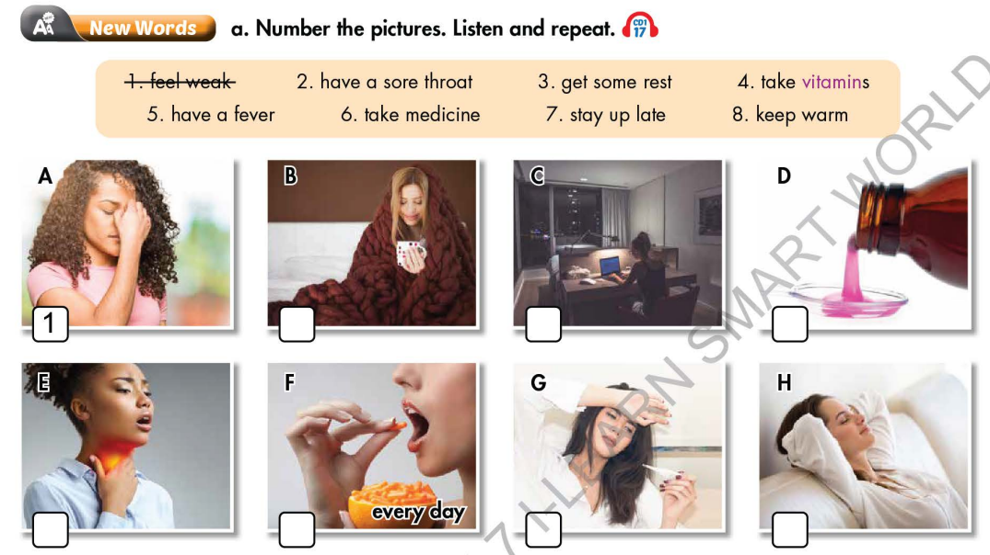  - Option 2: Health problems and advice  - Give Ss some phrases about health problems and equivalent advice, but not in order.  - Have Ss work in pairs to match health problems with suitable advice.  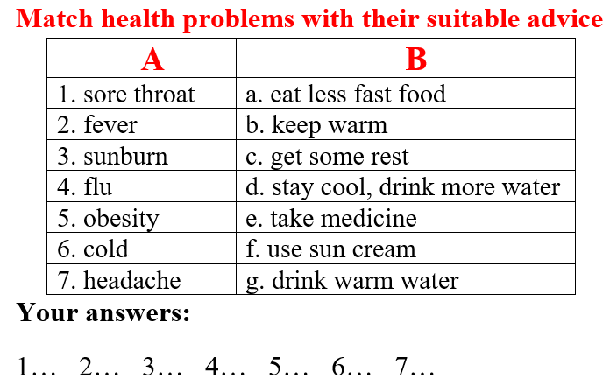  - Call Ss to give answers.  - Give feedback and evaluation.  àLead to the new lesson | - Work in pairs.  - Give answers.  - Listen.  - Listen and repeat.  Answer keys  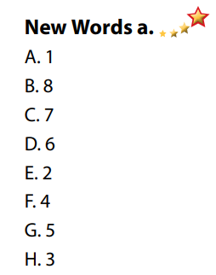  - Work in pairs.  - Give answers.  - Listen.  Answer keys  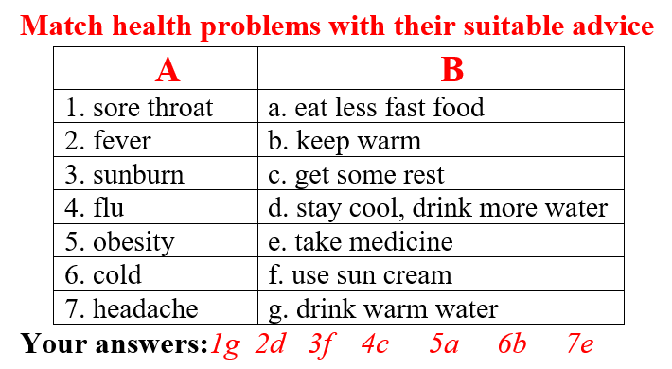

B. New lesson (35’)
- Activity 1: Pre-Listening (Vocabulary) (12’)
a) Objective: Ss get to know words and phrase about health problems and how to give advice.
b) Content:
- Vocabulary study (feel weak, have a sore throat, get some rest, take vitamins, have a fever, take medicine, stay up late, keep warm).
- Speaking: Discuss more health problems and advice and note them down (page 15).
c) Expected outcomes: Ss know how to pronounce the new words / phrases correctly and use them when talking about health problems and giving advice.
d) Organization of the activity:
TEACHER’S ACTIVITIES | STUDENTS’ ACTIVITIES
Task a. Number the pictures. Listen and repeat.  - Option 1 (If the teacher hasn’t used this part for the Warm-up activity.)  - Demonstrate the activity, using the example (using DCR).  - Have Ss number the pictures.  - Divide class into pairs and have them check their answers with their partners.  - Call Ss to give answers (read or write).  - Check answers as a whole class.  - Play audio (CD1 – Track 17). Have Ss listen and repeat.  - Correct Ss’ pronunciation.  - Option 2: Filling in the blanks (If the teacher has used part a. for the Warm-up activity.)  - Have Ss review the words they have known in the warm-up activity by filling in the blanks (T uses different pictures from those in the textbook).  - Call Ss to give answers (read or write).  - Check answers as a whole class.  - Call some Ss to read the words again.  - Correct Ss’ pronunciation if necessary.  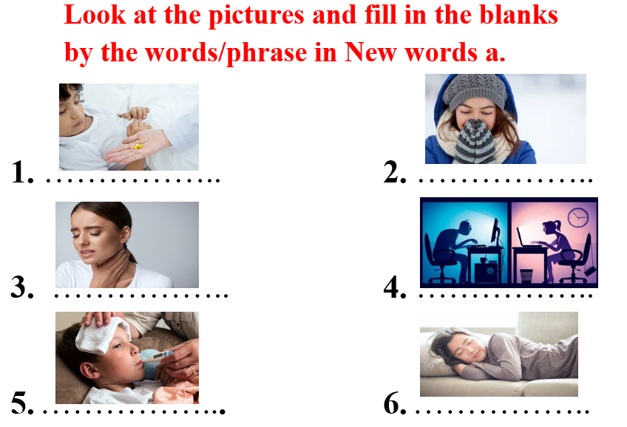  Task b. In pairs: Discuss more health problems and advice and note them down.  - Have Ss work in pairs to discuss more health problems and advice and note them down.  - T can ask Ss to use the health problems and advice they have known in the Warm-up activity as a reference.  - Have some pairs share their ideas with the class.  - Give feedback and evaluation. | - Look and listen.  - Work individually.  - Work in pairs.  - Give answers.  - Listen and repeat.  Answer keys  - Work in pairs.  - Give answers.  - Read.  Answer keys  1. take medicine  2. keep warm  3. have a sore throat  4. stay up late  5. have a fever  6. get some rest  - Work in pairs.  - Present.  Suggested ideas
- Activity 2: While - Listening (17’)
a) Objective: Students can develop their listening skill.
b) Content: Listen to a conversation between Jacob and his doctor, circle the reason for Jacob’s visit and then listen again to fill in the blanks.
c) Expected outcomes: Students can listen and understand general and specific information about a health problem and how to overcome it.
d) Organization of the activity:
TEACHER’S ACTIVITIES | STUDENTS’ ACTIVITIES
Task a. Listen to Jacob’s visiting the doctor. Circle the reason for Jacob’s visit.  - Have Ss read the sentence, guess the answer (using DCR).  - Play audio (CD1 - Track 18).  - Have Ss listen and circle the correct answer.  - Check answer as a whole class.  Task b. Now, listen and fill in the blanks  - Have Ss read the through the uncompleted sentences in task b, guess what types of words / parts of speech that will be possible for each blank (using DCR).  - Play the audio again (CD1 - Track 18).  - Have Ss listen and fill in the blanks.  - Have Ss check answers with their partners.  - Call Ss to give answers.  - Give feedback and show correct answers. | -Work individually.  - Listen.  - Circle the correct answers.  Answer keys  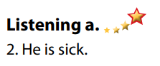  - Read and guess.  - Do the task.  - Check answers.  Answer keys  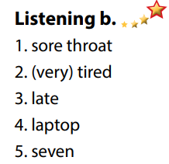

- Activity 3: Post - Listening (6’)
a) Objective: Students can use the vocabulary and the content in listening part to develop their speaking skill.
b) Content: Speaking: What do you do when you are sick?
c) Expected outcomes: Students can have a free-talk about how to overcome sickness.
d) Organization of the activity:
TEACHER’S ACTIVITIES | STUDENTS’ ACTIVITIES
Conversation skill  - Have Ss look at the Conversation box and read (using DCR).  - Play audio (CD 1 - Track 19), have Ss listen and repeat.  - Ask Ss to find more ways to offer help.  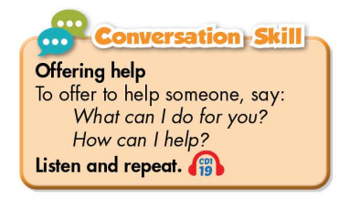  Task c. What do you do when you are sick? Why?  - Have Ss work in pairs to discuss.  - Observe and give help if necessary.  - Call some pairs to share their ideas with the class.  - Give feedback and evaluation.  - For more practice, have Ss play a game with DHA. | - Look and read.  - Listen and repeat.  - Give answers.  - Work in pairs.  - Present.

C. Consolidation and homework assignments (4’)
* Consolidation:
- Words about health problems and giving advice: feel weak, have a sore throat, get some rest, take vitamins, have a fever, take medicine, stay up late, keep warm.
- Language to offer help: What can I do for you? / How can I help? / May I help you? …

* Homework
- Learn the new words by heart.
- Practice asking and answering about giving advice for a health problem.
- Do the exercises in WB: New words + Listening (pages 10, 11).
- Do the vocabulary exercise in Tiếng Anh 7 i-Learn Smart World Notebook (page 12).
- Play consolation games in Tiếng Anh 7 i-Learn Smart World DHA App on www.eduhome.com.vn
- Prepare: Lesson 2 – Grammar (page 16 – SB).

D. Reflection
a. What I liked most about this lesson today:
…………………………………………………………………………………………
- What I learned from this lesson today:
…………………………………………………………………………………………
c. What I should improve for this lesson next time:
…………………………………………………………………………………………

