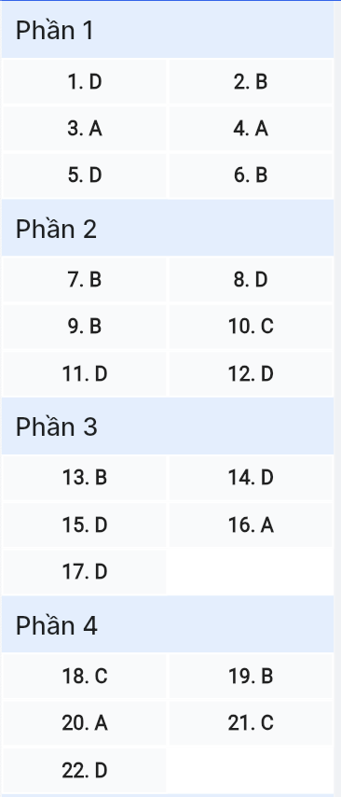
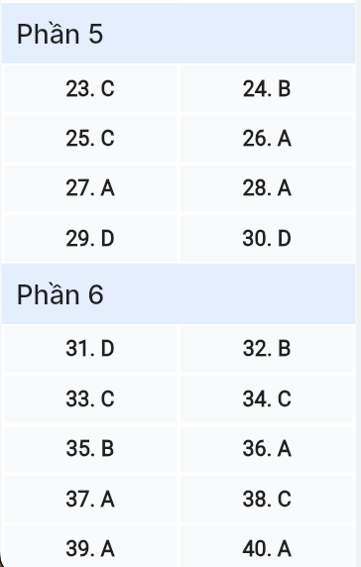
ĐỀ MINH HỌA SỐ 10
KỲ THI TỐT NGHIỆP TRUNG HỌC PHỔ THÔNG NĂM 2025
(Đề thi có 08 trang)
Môn thi: TIẾNG ANH
Thời gian làm bài: 50 phút, không kể thời gian phát đề

Read the following advertisement and mark the letter A, B, C or D on your answer sheet to indicate the option that best fits each of the numbered blanks from 1 to 6.
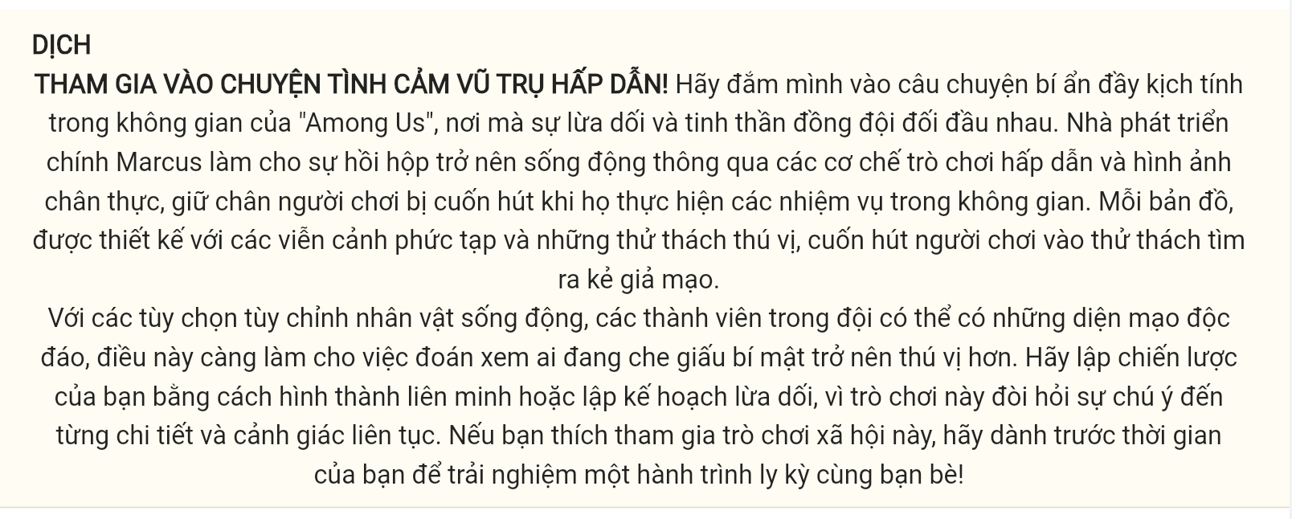
ENGAGING IN THE THRILLING SPACE MYSTERY!
Immerse yourself in the thrilling Space Mystery of "Among Us," where (1) ______ meets teamwork. Lead developer Marcus (2) ______ suspense to life with engaging gameplay mechanics and immersive visuals, keeping players captivated as they navigate space missions. Each map, (3) ______ with intricate scenarios and exciting challenges, draws players into the challenge of uncovering impostors.
With (4) ______, team members can adopt unique appearances which makes it even more intriguing to guess who's hiding secrets. Set your strategy by forming alliances or plotting your deceptions, because this game demands attention to detail and constant vigilance. If you fancy (5) ______ this social game, reserve your time (6) ______ advance to experience a thrilling journey with your friends!
(Adapted from SciTechDaily)
Question 1 [696504]: A. deceptive B. deceive C. deceptively D. deception
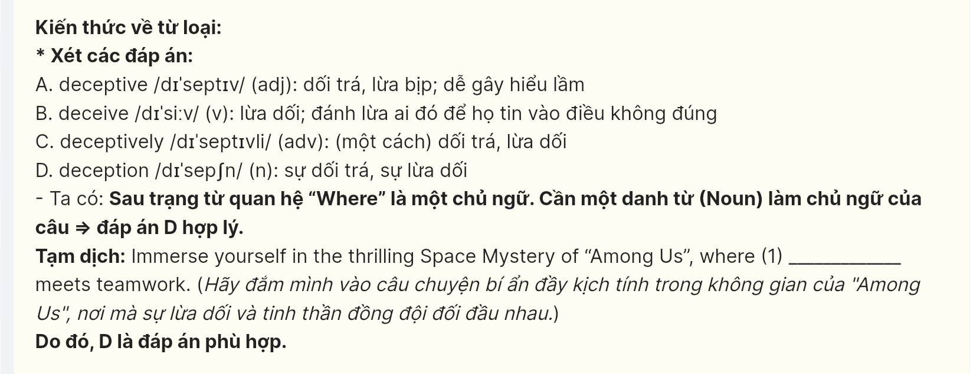
Question 2 [696505]: A. puts B. brings C. keeps D. stays
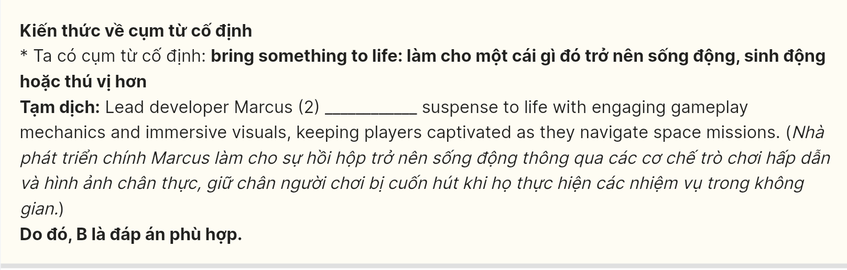
Question 3 [696506]: A. designed B. designing C. which designs D. design
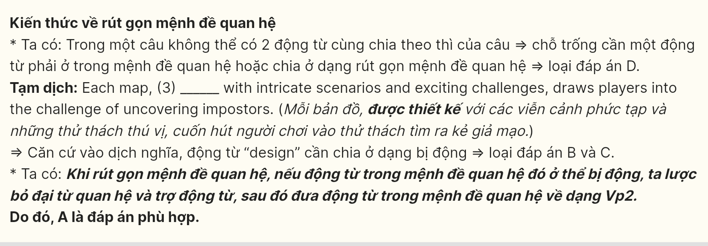
Question 4 [696507]: A. vivid character customization options B. character vivid customization options
C. character customization vivid options D. customization vivid character
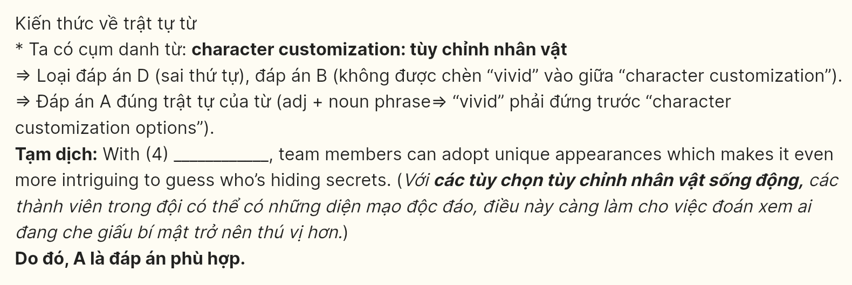
Question 5 [696508]: A. to joining B. to join C. join D. joining
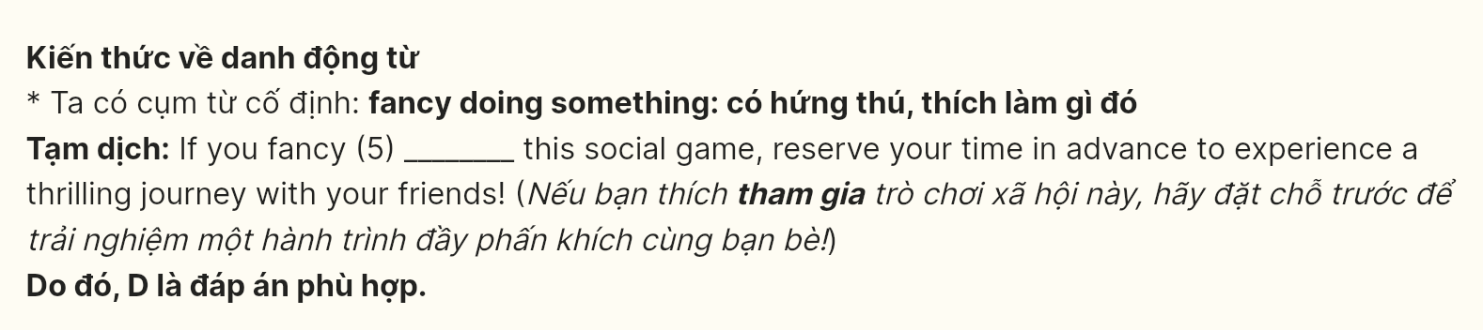
Question 6 [696509]: A. over B. in C. at D. on
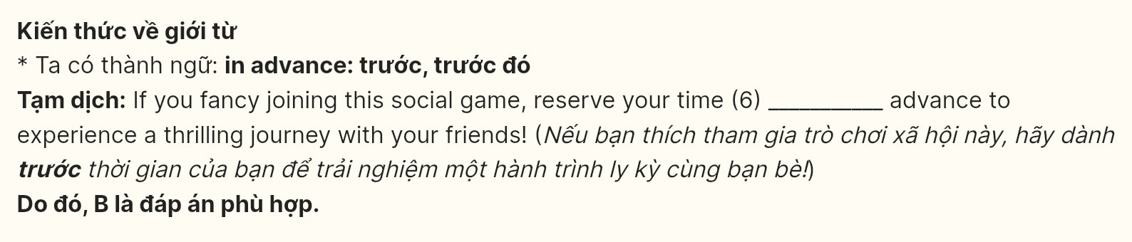
Read the following leaflet and mark the letter A, B, C or D on your answer sheet to indicate the option that best fits each of the numbered blanks from 7 to 12.
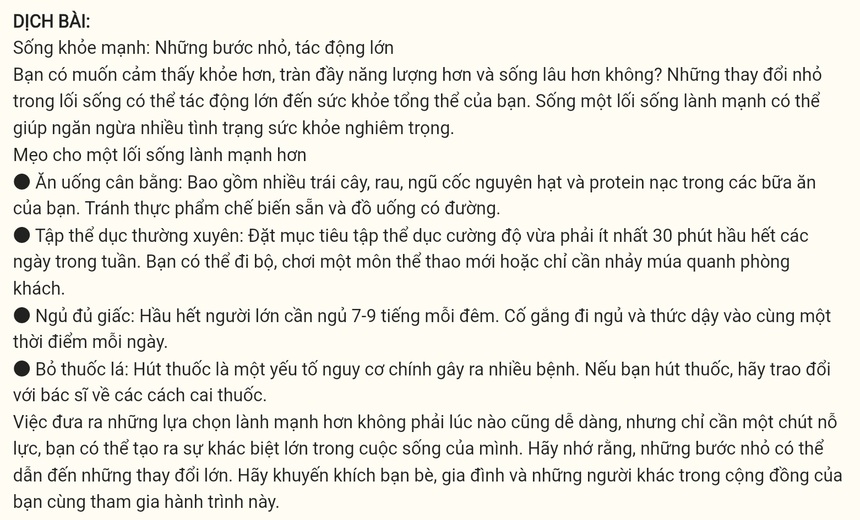
Healthy Living: Small Steps, Big Impact
Are you looking to feel better, have more energy, and live longer? Making small changes to your lifestyle can have a big impact on your overall health. Living a healthy lifestyle can prevent a (7) ______ of serious health conditions.
Tips for a healthier lifestyle
- Eat a balanced diet: Include plenty of fresh vegetables, whole grains, and lean protein in your meals. (8) ______ processed foods and sugary drinks.
- Get regular exercise: Aim for at least 30 minutes of moderate-intensity exercise most days of the week. You could go for a walk, (9) ______ a new sport, or simply dance around your living room.
- Get enough sleep: Most adults need 7 - 9 hours of sleep each night. Try to go to bed and wake up at the same time each day.
- Quit smoking: Smoking is a major risk factor for many (10) ______. If you smoke, talk to your doctor about ways to quit.
Making healthier choices is not always easy, (11) ______ with a little effort, you can make a big difference in your life. Remember, small steps can lead to big changes. (12) ______ your friends and family, and others in your community, to join you on this journey.
Question 7 [696510]: A. large amount B. lot C. many D. much
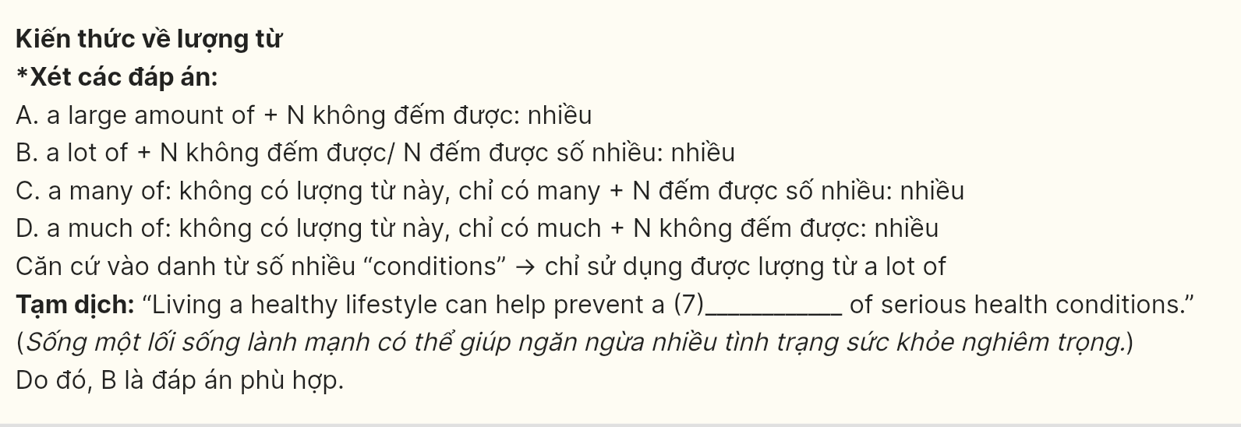
Question 8 [696511]: A. Conserve B. Invent C. Destroy D. Avoid
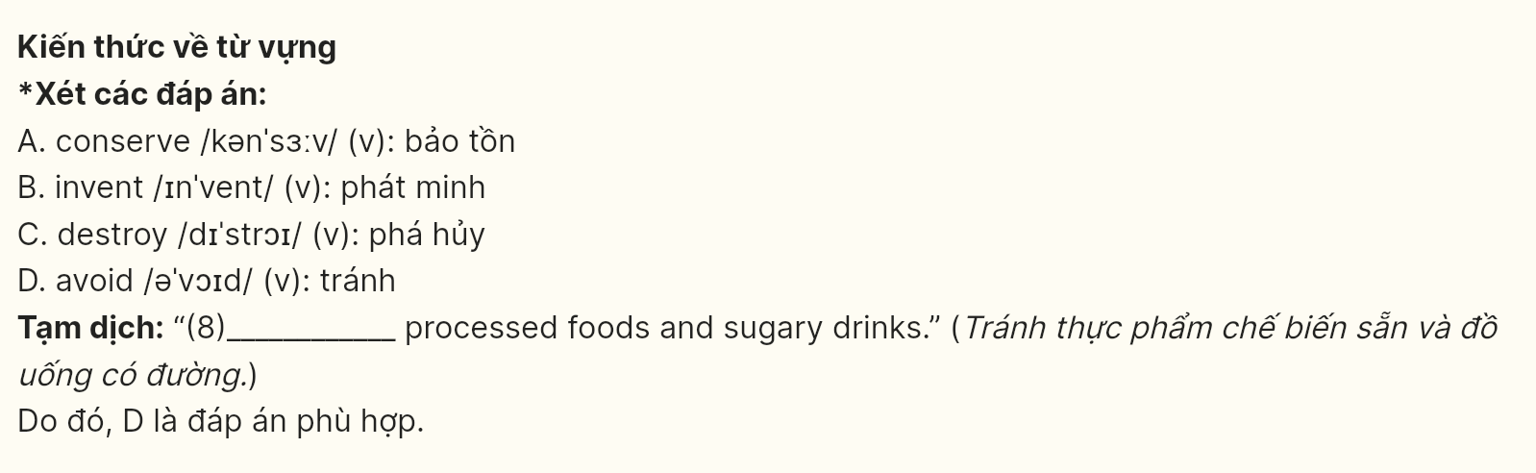
Question 9 [696512]: A. rush out B. take up C. pick up D. break into
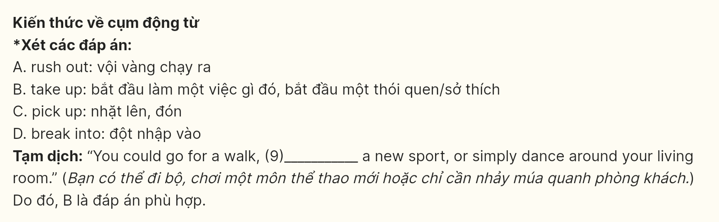
Question 10 [696513]: A. ailments B. injuries C. diseases D. illnesses
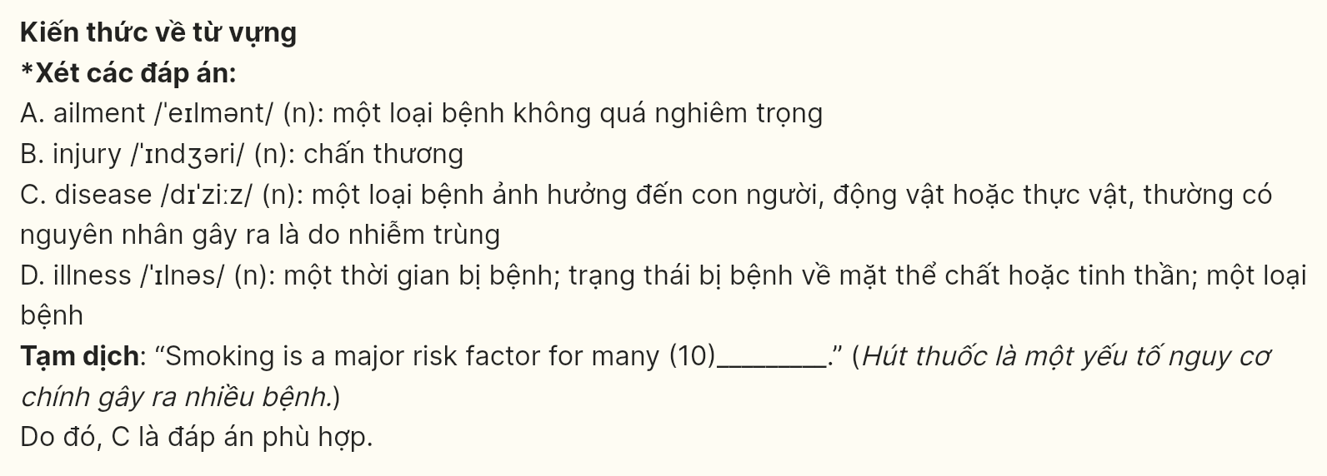
Question 11 [696514]: A. therefore B. so C. although D. but
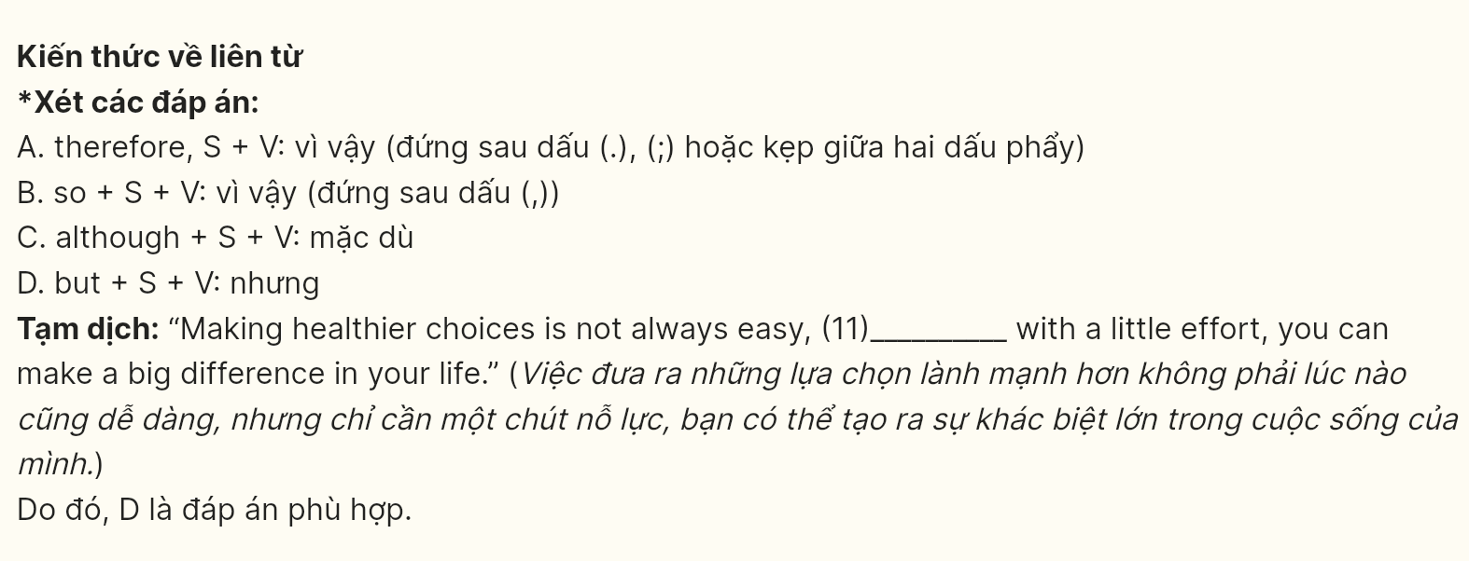
Question 12 [696515]: A. Determine B. Contribute C. Appreciate D. Encourage
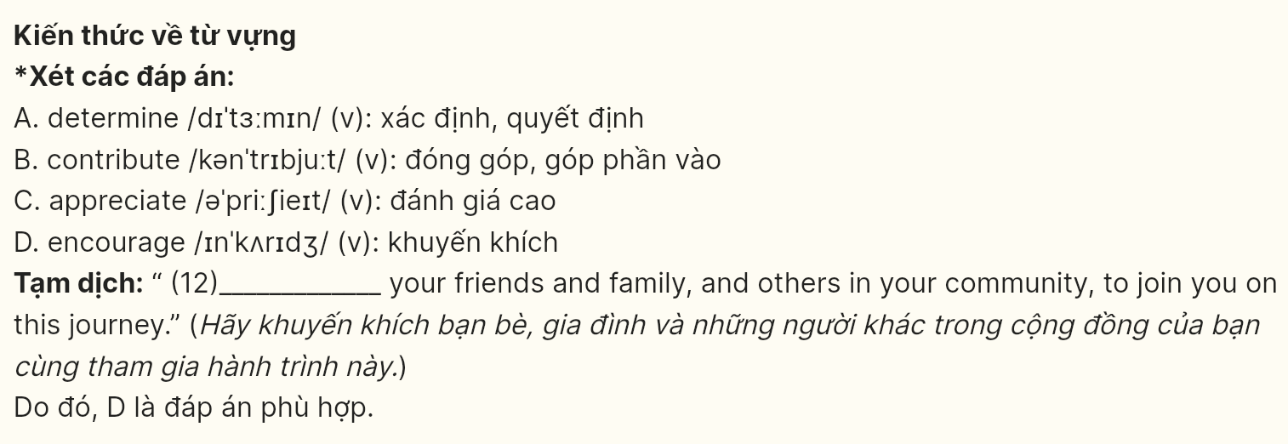
Mark the letter A, B, C or D on your answer sheet to indicate the best arrangement of utterances or sentences to make a meaningful exchange or text in each of the following questions from 13 to 17.
Question 13 [696516]:
a. Alex: That’s awesome! I think we’ll make a real difference together.
b. Alex: I’m so excited about the upcoming community clean-up event! Have you signed up yet?
c. Emma: Yes, I signed up last week! It feels good to contribute to our neighborhood.
A: c-a-b B: b-c-a C: c-b-a D: a-c-b
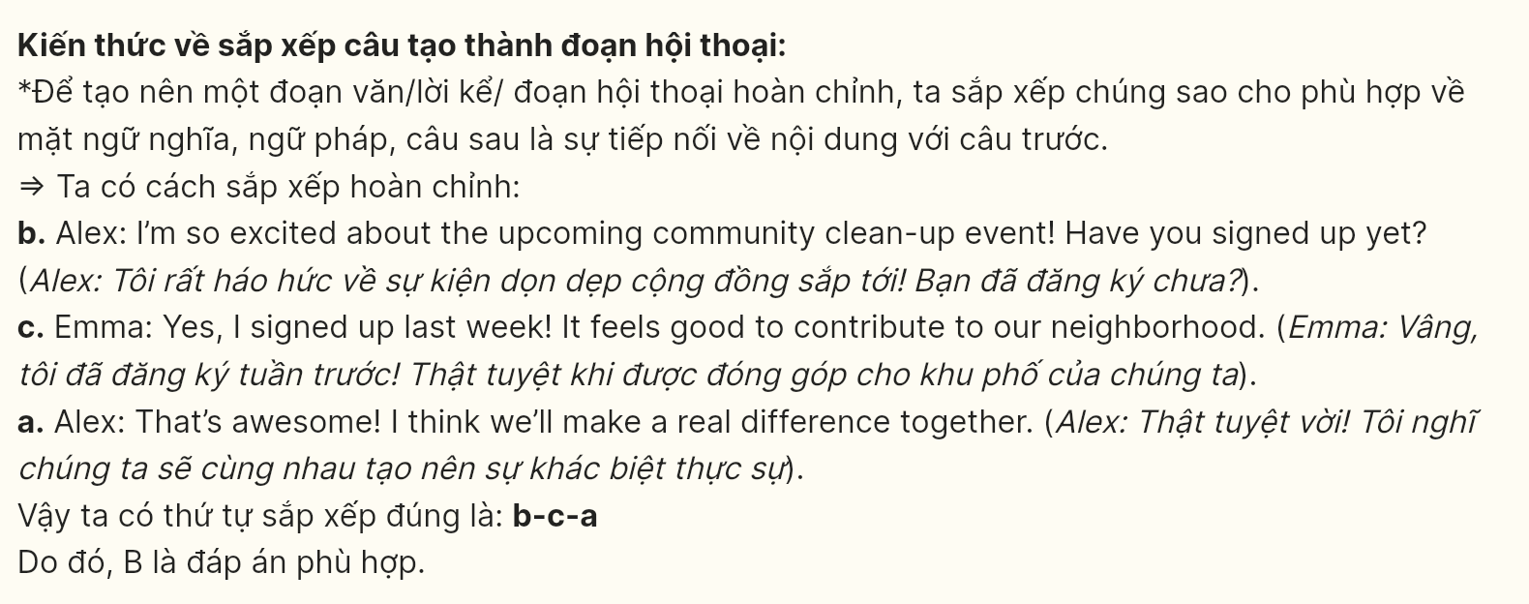
Question 14 [696517]:
a. Mark: Which country are you considering?
b. Jenna: I’m thinking about Spain because of its rich history and vibrant lifestyle.
c. Mark: That sounds exciting!
d. Mark: What made you decide to study abroad?
e. Jenna: I want to experience a different culture and learn a new language.
A: c-b-a-e-d B: c-e-d-b-a C: d-b-a-e-c D: d-e-a-b-c
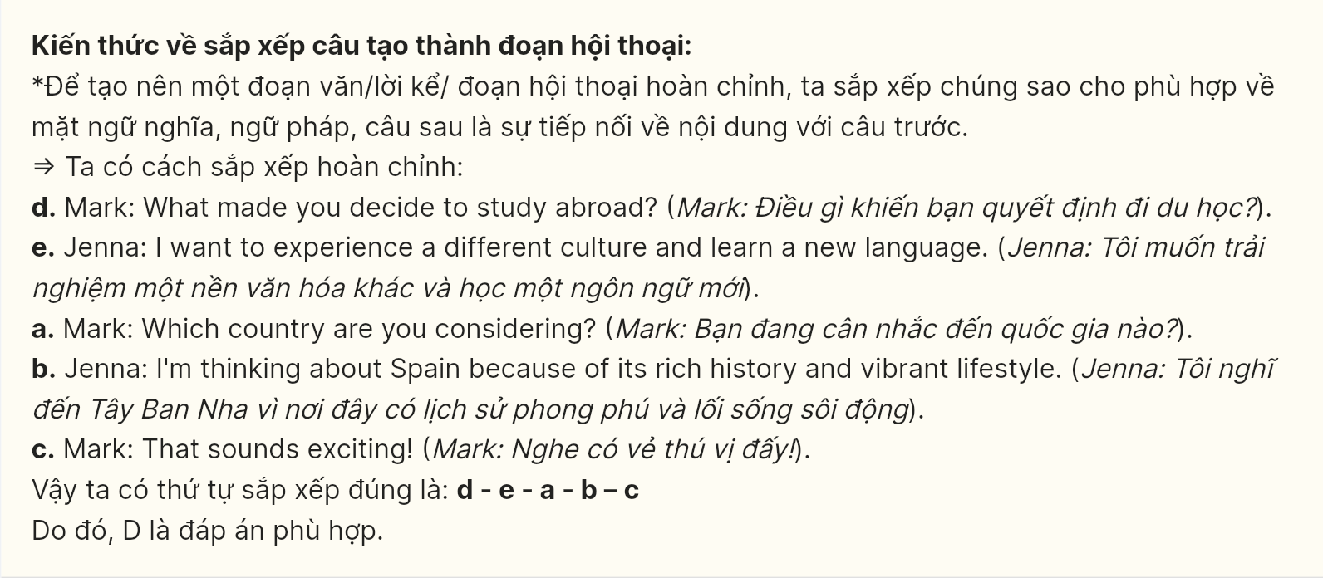
Question 15 [696518]:
Dear Jamie,
a. First, organizing local clean-up events can significantly impact our surroundings and engage more residents.
b. This approach can lead to a greater awareness of environmental issues among the community members.
c. I hope you’re doing well. I’ve been reflecting on ways we can contribute to environmental conservation in our community.
d. Moreover, educating children about the importance of recycling and sustainability in schools can foster a sense of responsibility from a young age.
e. Ultimately, preserving our natural spaces is essential for future generations.
Best wishes,
John
A. d-b-a-e-c B. b-e-a-d-c C. a-d-b-c-e D. c-a-d-b-e
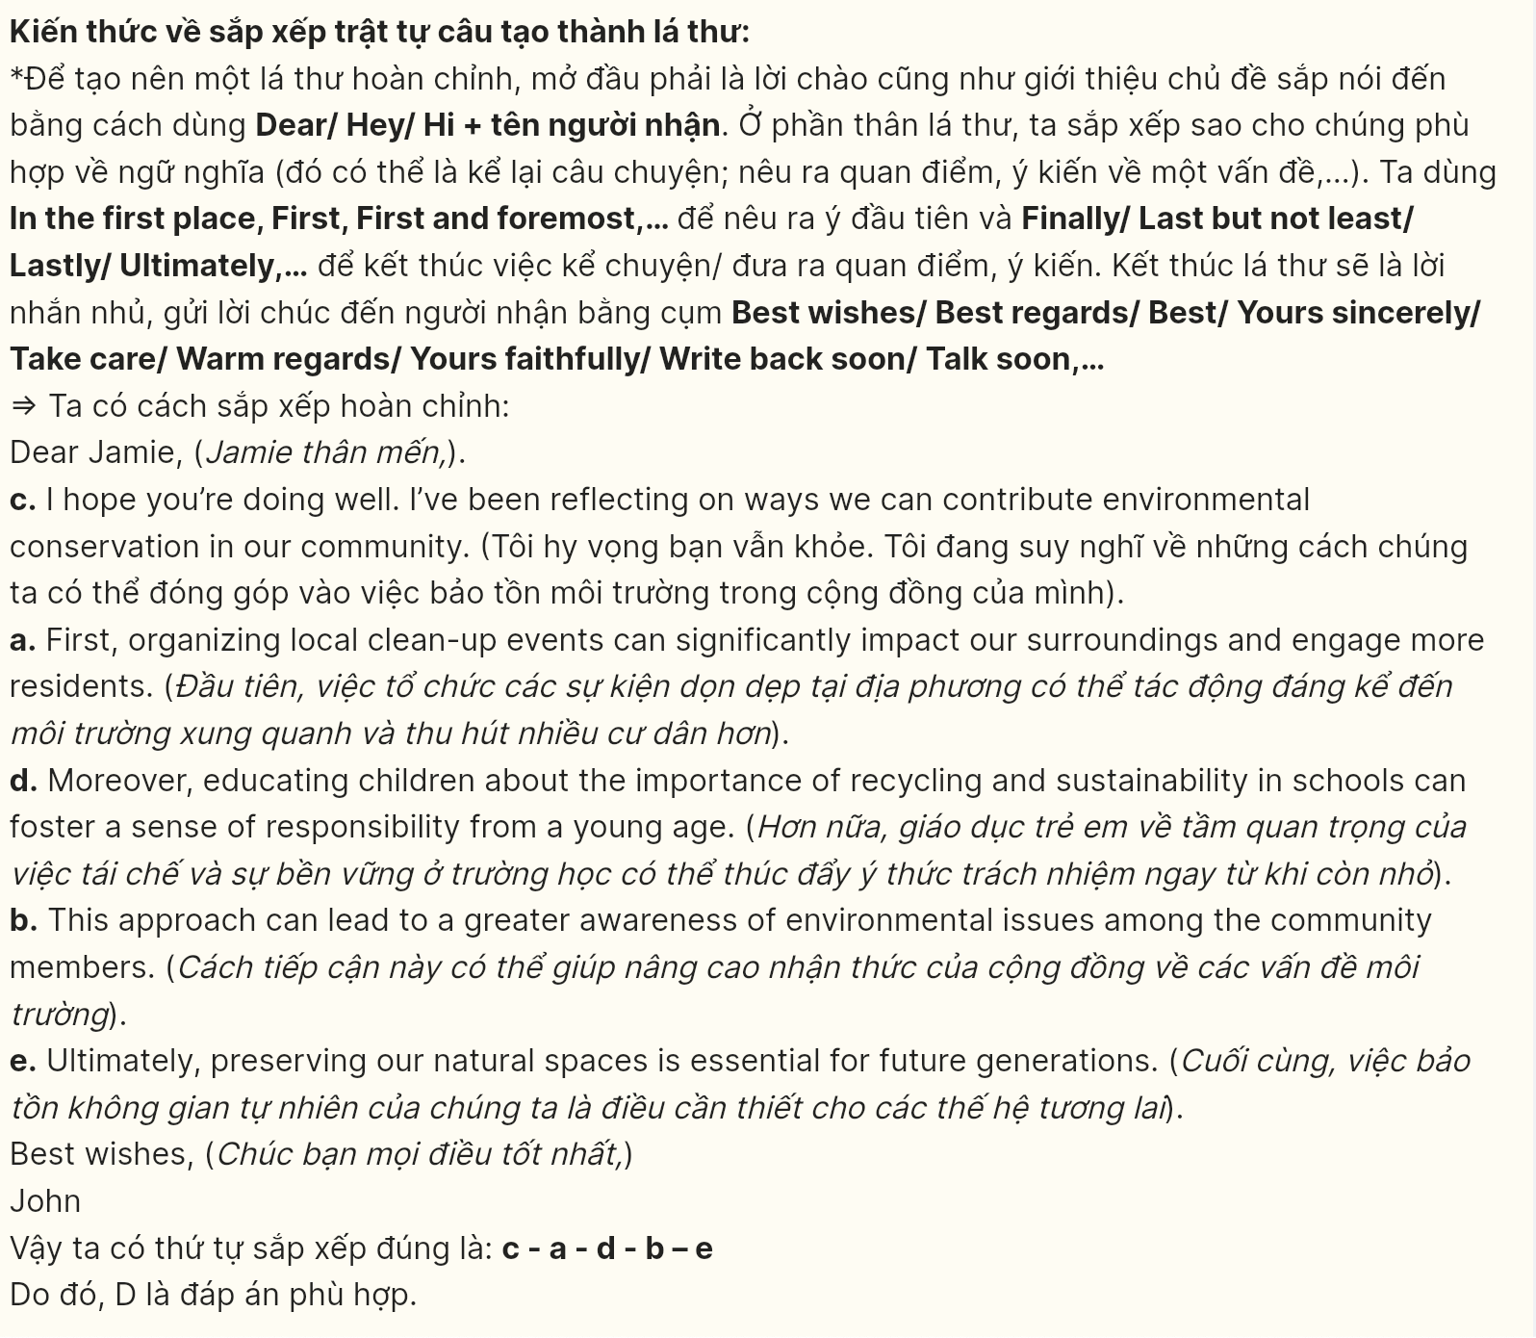
Question 16 [696519]:
a. Lastly, having a part-time job can cause students to feel stressed, fatigued, and overwhelmed, potentially harming their mental health by increasing levels of stress, anxiety, and depression.
b. Additionally, long hours and tight deadlines may leave students with inadequate time for studying, completing assignments, and preparing for exams.
c. First, it can adversely affect students’ academic performance, as juggling work and studies can be quite difficult.
d. Taking on part-time jobs while studying can have several drawbacks.
e. In summary, part-time jobs can negatively impact academic performance and contribute to stress. Students should carefully consider these factors before taking on a part-time job.
A. c-d-b-a-e B. a-b-c-d-e C. b-c-d-a-e D. c-a-d-b-e
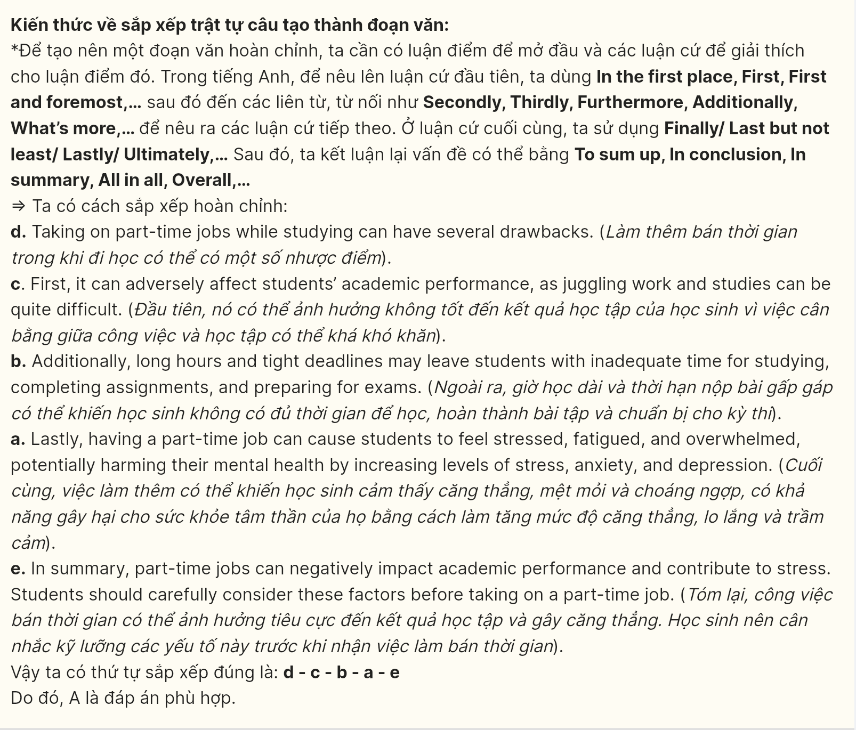
Question 17 [696520]:
a. While working with diverse groups and organizing community events can be challenging, the joy of making a positive impact on people’s lives is profoundly rewarding.
b. I have enhanced my skills through numerous training sessions and by taking on various leadership roles in different initiatives.
c. I began my volunteer journey 2 years ago, and it quickly realized my passion for community service and outreach programs.
d. In conclusion, my experience in mobilizing teams and executing successful community projects has shaped me into a dedicated volunteer leader.
e. My ability to connect with individuals from various backgrounds is one of my greatest assets in this role.
A. d-a-c-e-b B. b-e-c-a-d C. c-d-a-b-e D. c-b-e-a-d
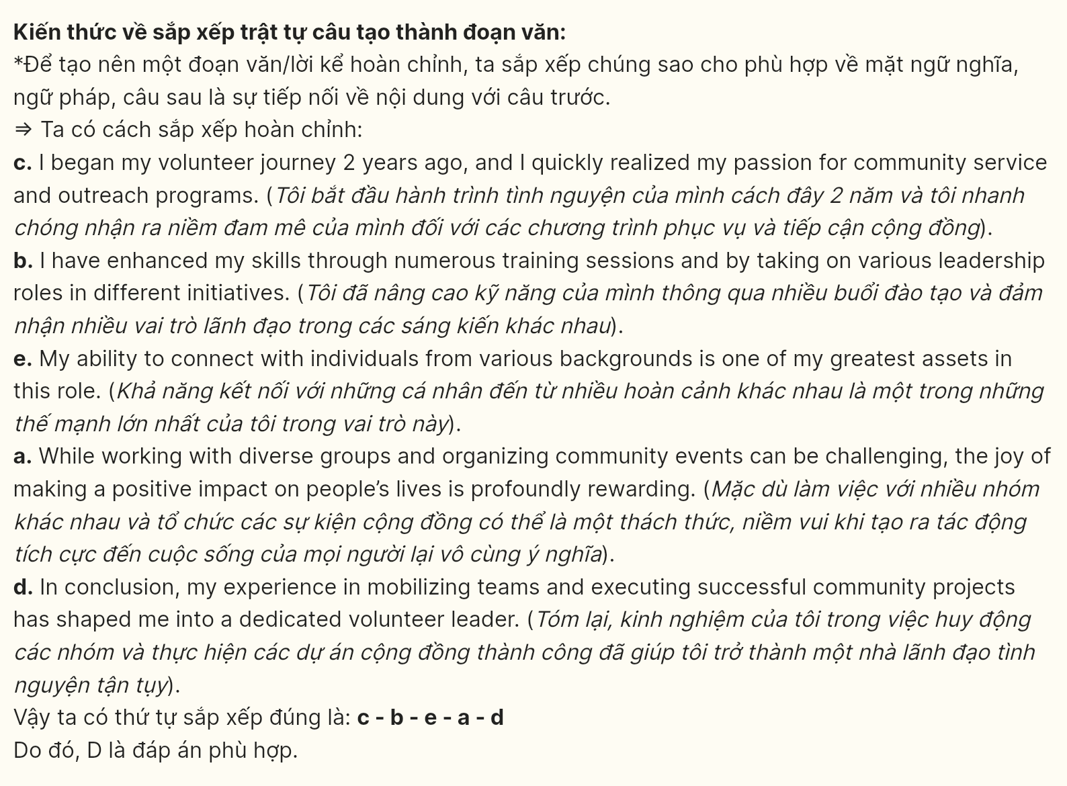
Read the following passage about cultural traditions and mark the letter A, B, C, or D on your answer sheet to indicate the option that best fits each of the numbered blanks from 18 to 22.
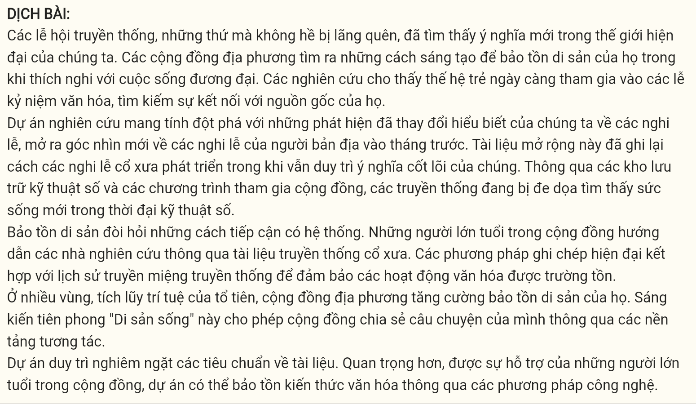
Traditional festivals, far from fading into obscurity, (18) _____ Local communities find innovative ways to preserve their heritage while adapting to contemporary life. Studies show younger generations increasingly participate in cultural celebrations, seeking connection with their roots.
The groundbreaking research project (19) _____ opened new perspectives on indigenous ceremonies last month. This extensive documentation captured how ancient rituals evolved while maintaining their core significance. Through digital archives and community engagement programs, endangered traditions find new life in the digital age.
Heritage preservation demands systematic approaches. (20) _____ Modern documentation methods work alongside traditional oral histories to ensure cultural practices endure.
Throughout many regions, (21) _____ This pioneering “Living Heritage” initiative enables communities to share their stories through interactive platforms.
The project maintains strict documentation standards. More importantly, supported by local community elders, (22) ________
(Adapted from the Real IELTS)
Question 18 [696521]:
A. whose significance has been found renewed in our modern world
B. which are finding renewed significance in our modern world
C. have found renewed significance in our modern world
D. having found renewed significance in our modern world
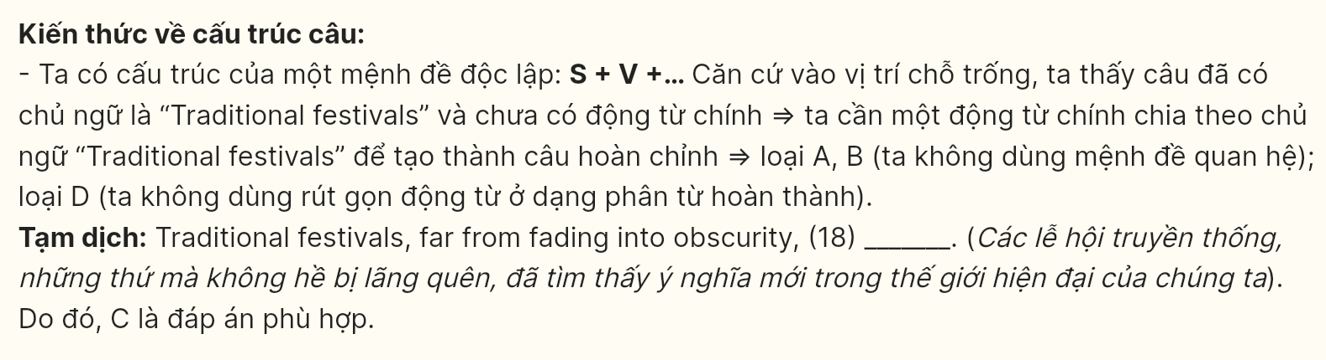
Question 19 [696522]:
A. whose findings transformation in our understanding of ritual practices
B. of which findings transformed our understanding of ritual practices
C. may have our understanding of ritual practices transformed its findings
D. transformed our understanding of ritual practices with its findings
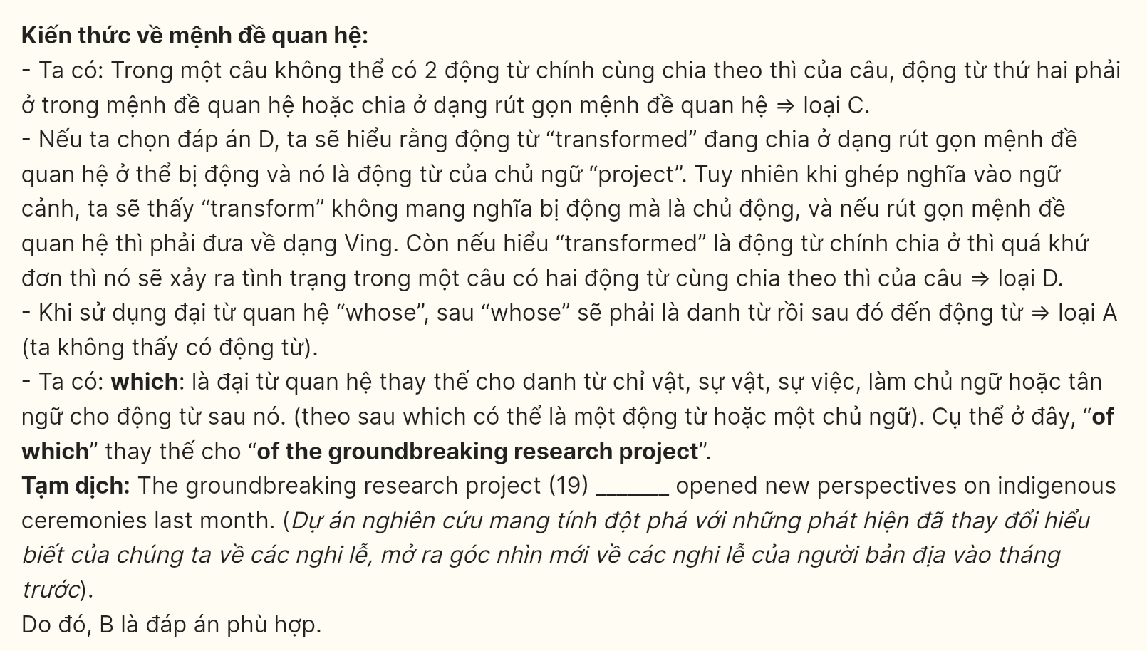
Question 20 [696523]:
A. Community elders guide researchers through ancient traditional documentation
B. Traditional documentation is used to guide community elders through research
C. To guide researchers through traditional documentation, it is done by community elders
D. Research is guided by traditional documentation through community elders
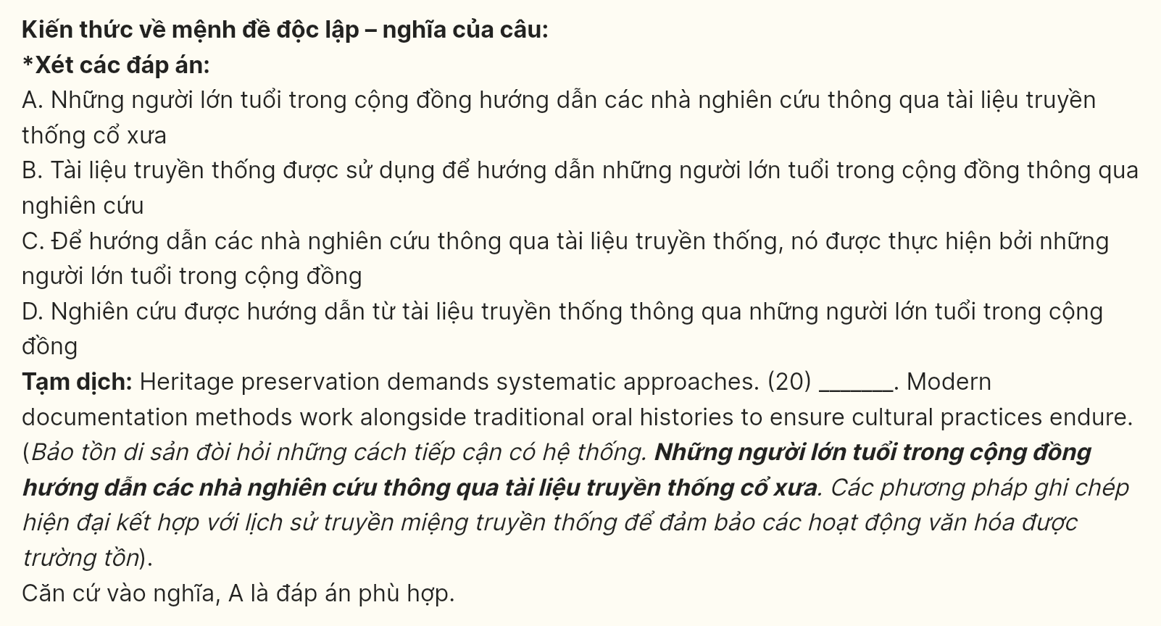
Question 21 [696524]:
A. local communities preserve their heritage in order to gather ancestral wisdom
B. having been gathered ancestral wisdom, the heritage preservation goes on
C. gathering ancestral wisdom, local communities enhance their heritage preservation
D. ancestral wisdom is gathered, local communities will preserve their heritage
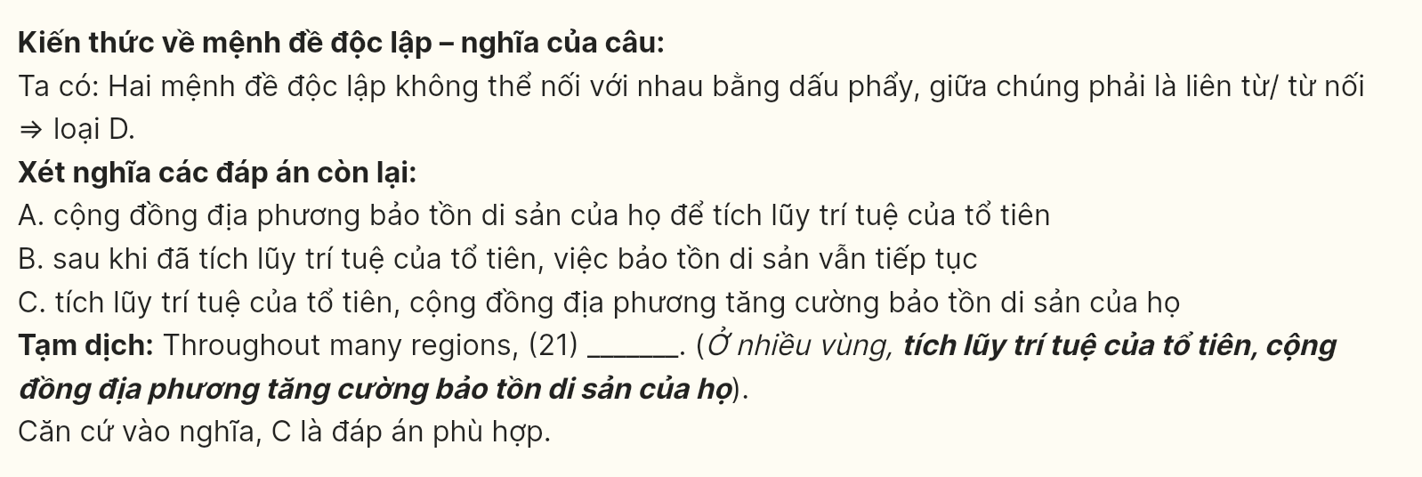
Question 22 [696525]:
A. cultural knowledge passes down through generations with technological methods
B. receiving cultural knowledge through generations requires technological methods
C. researchers could transmit cultural knowledge through technological methods
D. the project could preserve cultural knowledge through technological methods
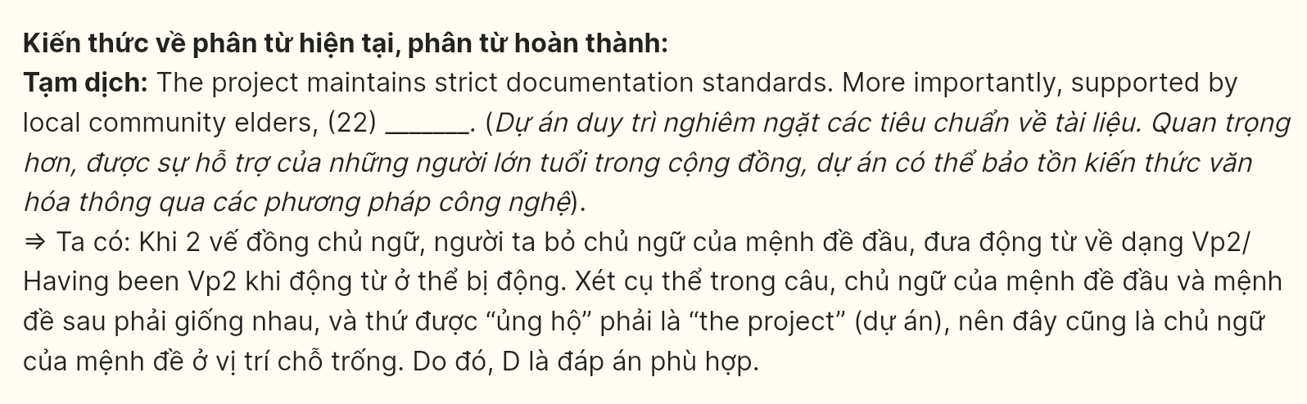
Reading the following passage and mark the letter A, B, C, or D on your answer sheet to indicate the best answer to each of the following questions from 23 to 30.
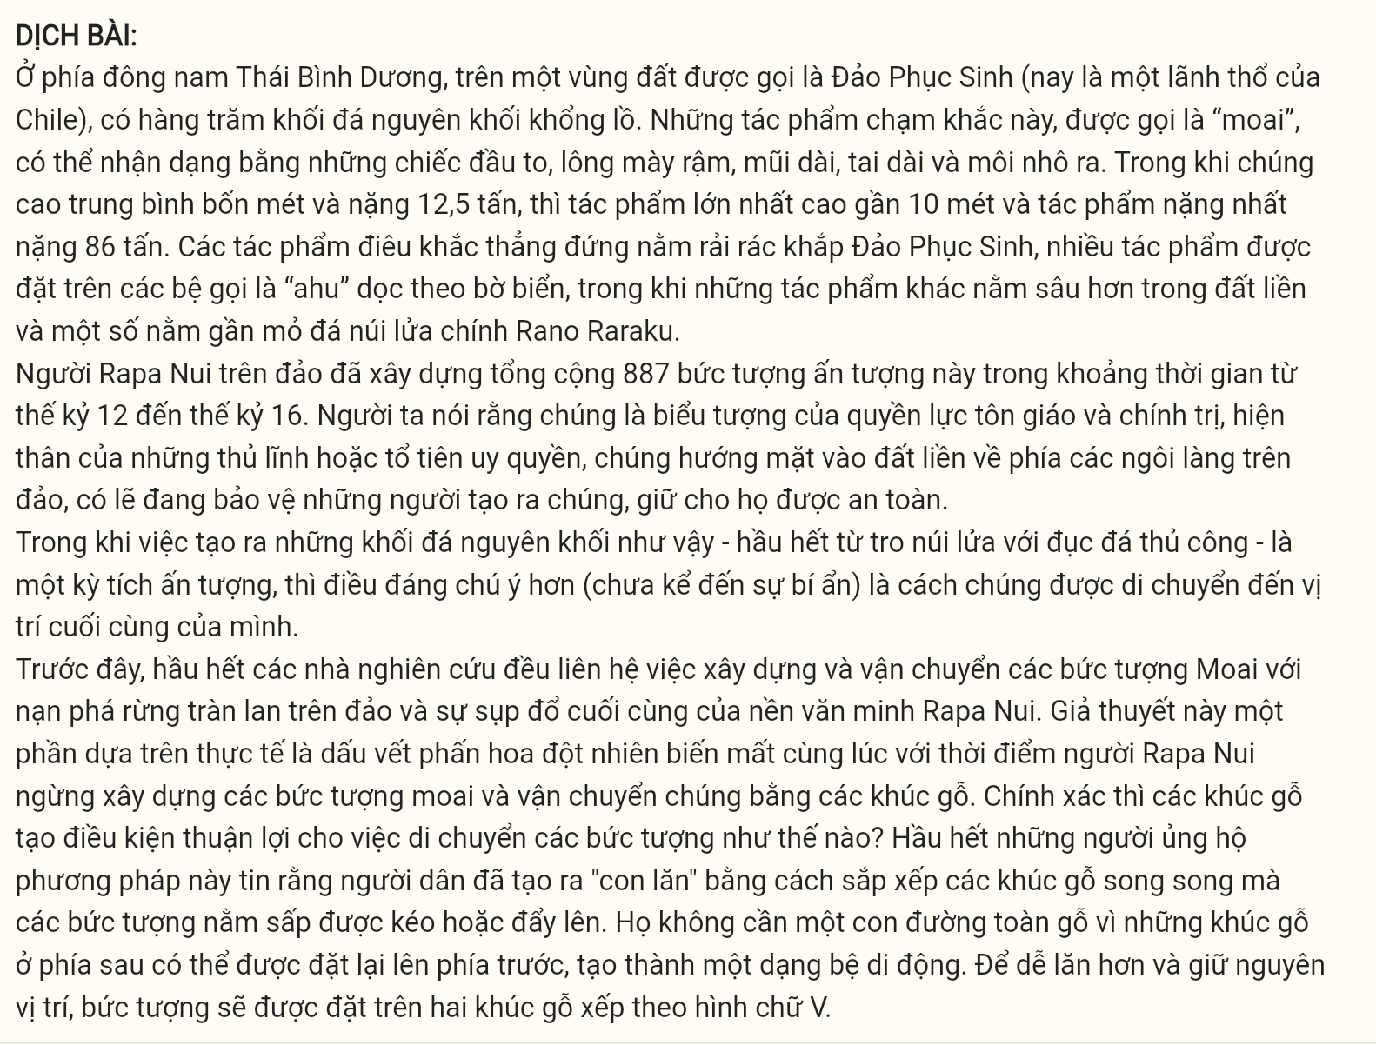
In the southeastern Pacific Ocean, on the piece of land known as Easter Island (now a territory of Chile), stand several hundred massive stone monoliths. These carvings, called "moai," are recognizable by their oversized heads, heavy brows, long noses, elongated ears, and protruding lips. While they average four meters in height and 12.5 tonnes, the largest is almost 10 meters tall, and the heaviest weighs 86 tons. The upright sculptures are scattered around Easter Island, many installed on platforms called "ahu" along the coast, while others are more inland, and several stand near the main volcanic quarry of Rano Raraku.
The Rapa Nui people of the island built a total of 887 of these impressive statues between the 12th and 16th centuries. They were, it is said, symbols of religious and political authority, embodiments of powerful chiefs or ancestors who faced inland toward the island's villages, perhaps watching over their creators, keeping them safe.
While the very creation of such monoliths—most out of volcanic ash with stone hand chisels—is an impressive feat, what is more remarkable (not to mention mysterious) is how they were transported to their resting places.
In the past, most researchers associated the building and transportation of the moai with widespread deforestation on the island and the eventual collapse of the Rapa Nui civilization. This hypothesis is based, in part, on the fact that the pollen record suddenly disappeared at the same time as the Rapa Nui people stopped constructing the moai and transporting them with the help of wooden logs. How exactly would logs facilitate the movement of the statues? Most proponents of this method believe that the people created "rollers" by arranging parallel logs on which the prone statues were pulled or pushed. They would not have required an entire roadway of logs since logs from the back could be placed at the front, creating a moving platform of sorts. To make it easier to roll, and keep in position, the statue would be placed on two logs arranged in a V shape.
(Adapted from TOEFL READING)
Question 23 [696526]: Which of the following is NOT mentioned as a physical characteristic of the Moai statues?
A. oversized heads B. long noses C. elongated torsos D. protruding lips
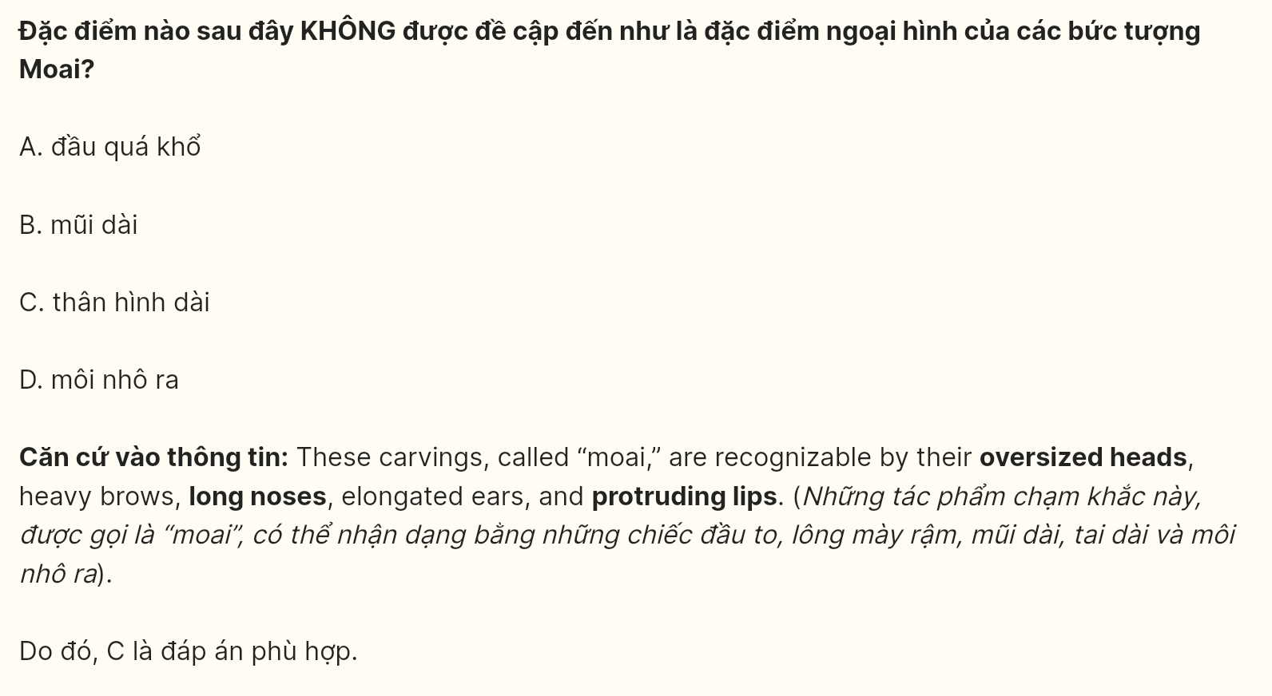
Question 24 [696527]: The word “they” in paragraph 1 refers to ________.
A. ancestors B. moai statues C. ahu platforms D. volcanic quarries
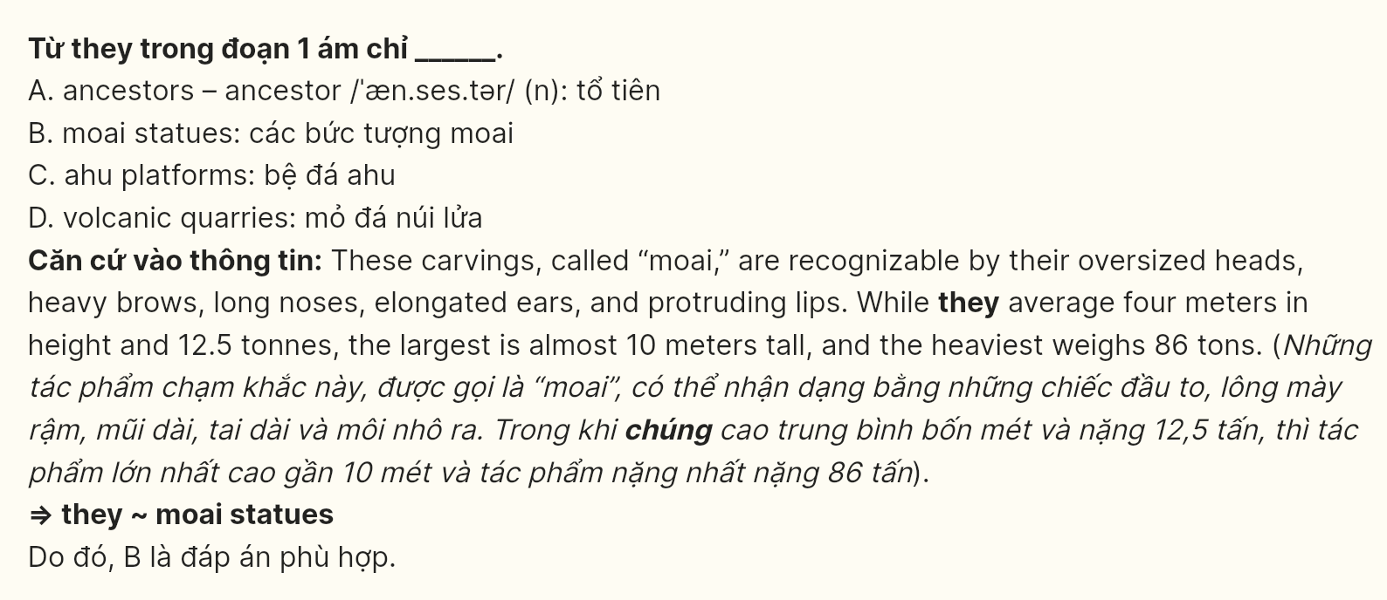
Question 25 [696528]: The word impressive in paragraph 2 is OPPOSITE in meaning to ________.
A. imposing B. extraordinary C. moderate D. splendid
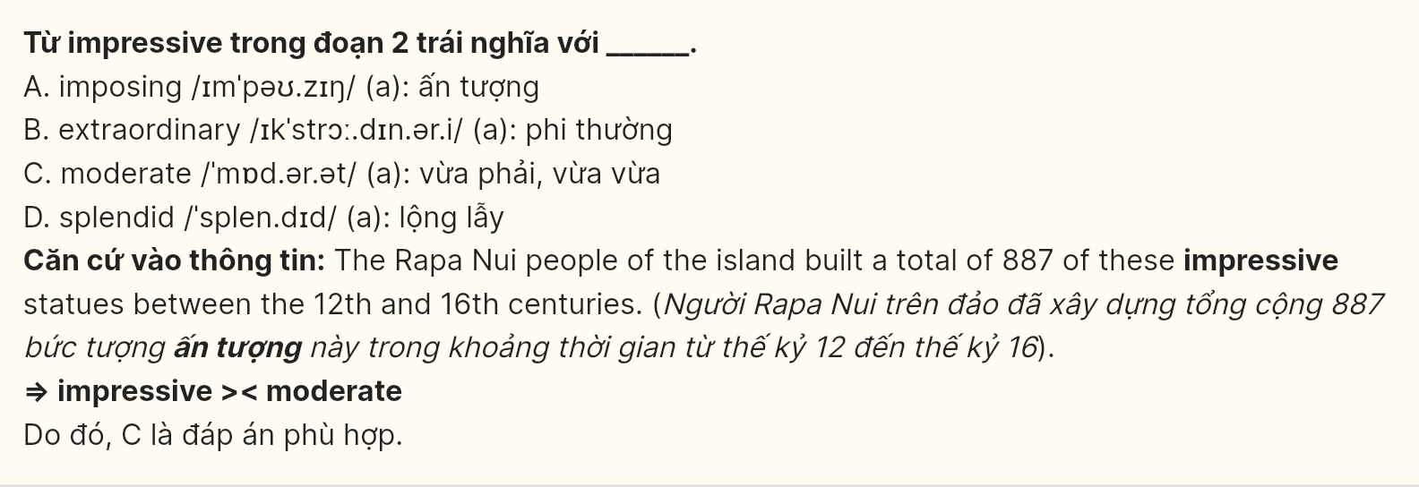
Question 26 [696529]: The word facilitate in paragraph 4 could best be replaced by ________.
A. assist B. obstruct C. handle D. manipulate
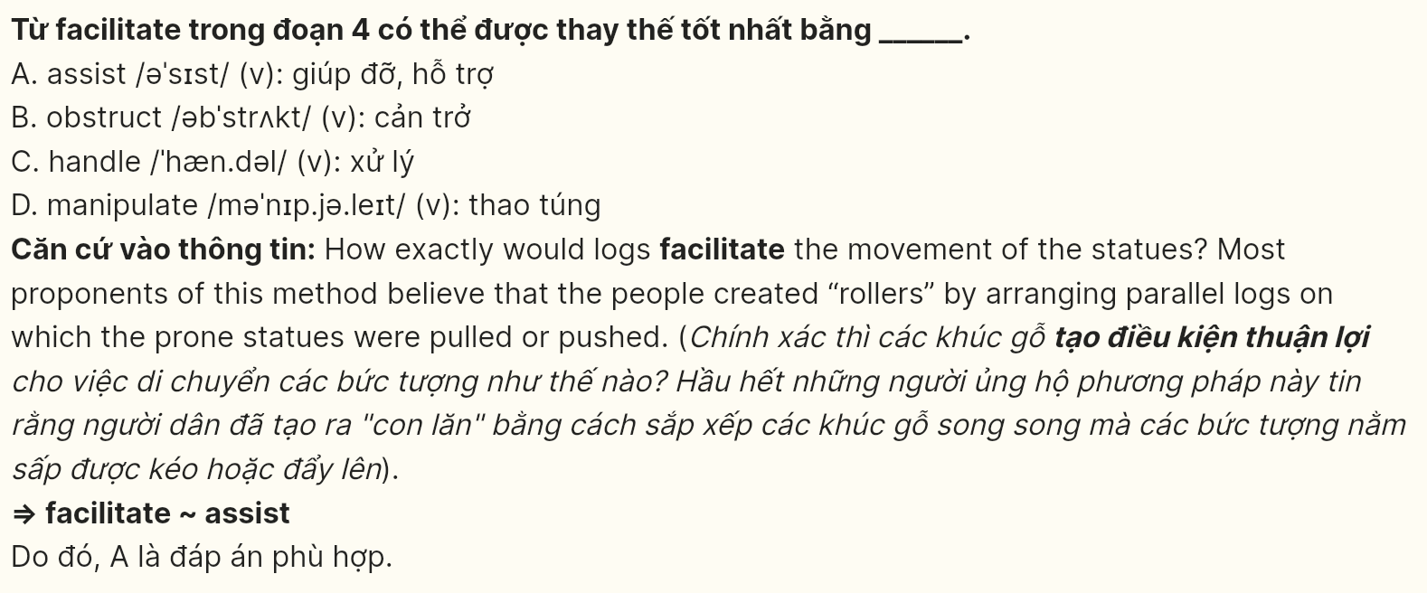
Question 27 [696530]: Which of the following best paraphrases the underlined sentence in paragraph 4?
A. Researchers believe that constructing and moving the moai may have led to deforestation and the decline of the Rapa Nui society.
B. The Rapa Nui civilization collapsed because they cut down forests to create farmland for food production.
C. Researchers think that deforestation on the island prevented the Rapa Nui from building and transporting additional moai.
D. The Rapa Nui people stopped making moai to avoid further damage to the island's natural resources.
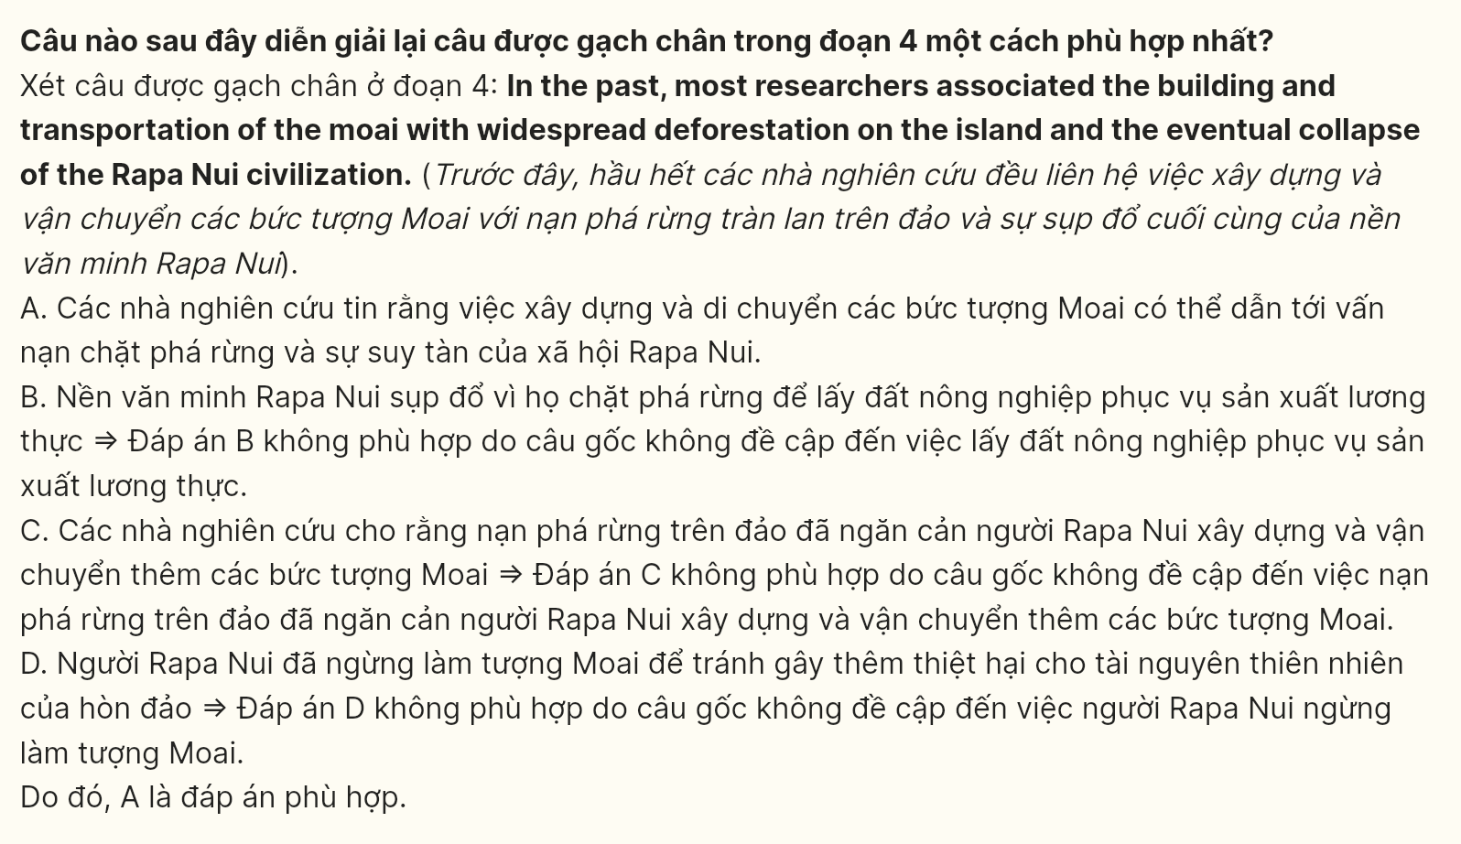
Question 28 [696531]: Which of the following is TRUE according to the passage?
A. The heaviest moai statue weighs 86 tons.
B. The moai statues were carved from limestone.
C. The statues face outward toward the ocean.
D. The Rapa Nui used advanced technology to carve the statues.
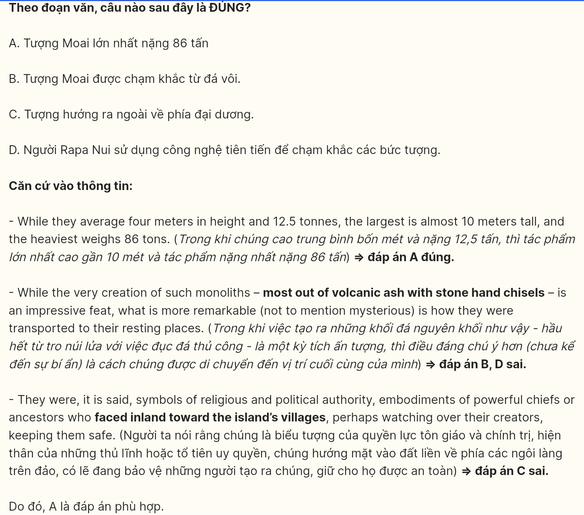
Question 29 [696532]: In which paragraph does the author discuss a causal relationship?
A. Paragraph 1 B. Paragraph 2 C . Paragraph 3 D. Paragraph 4
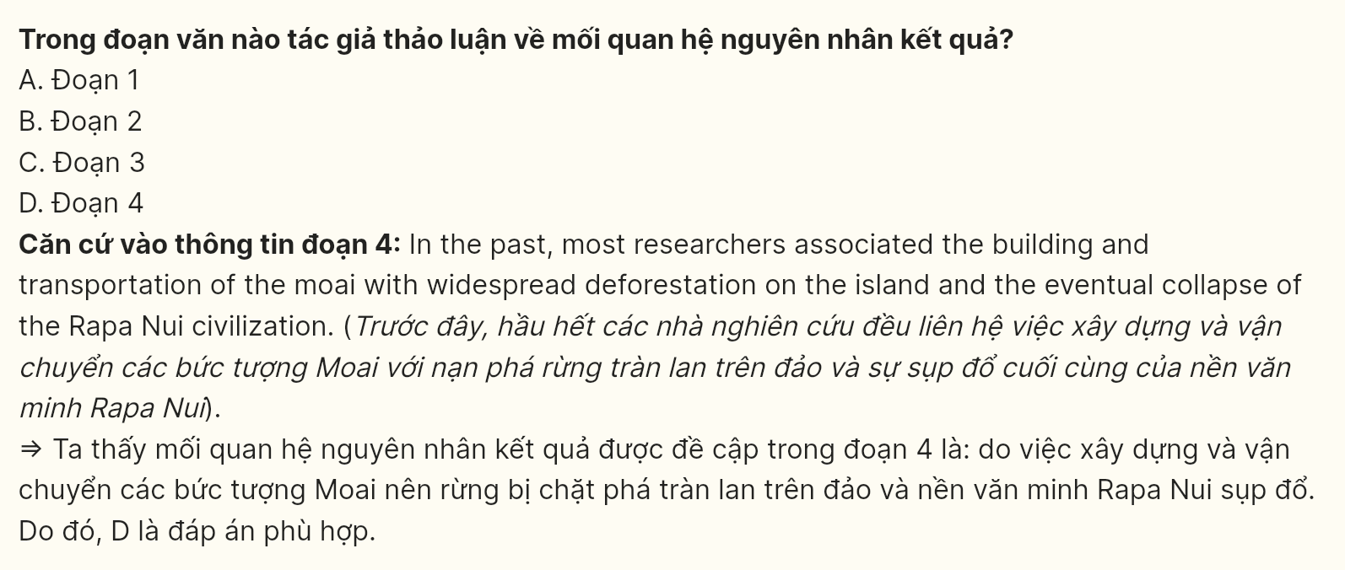
Question 30 [696533]: In which paragraph does the writer discuss the possible technique used to move the statues?
A. Paragraph 1 B. Paragraph 2 C . Paragraph 3 D. Paragraph 4
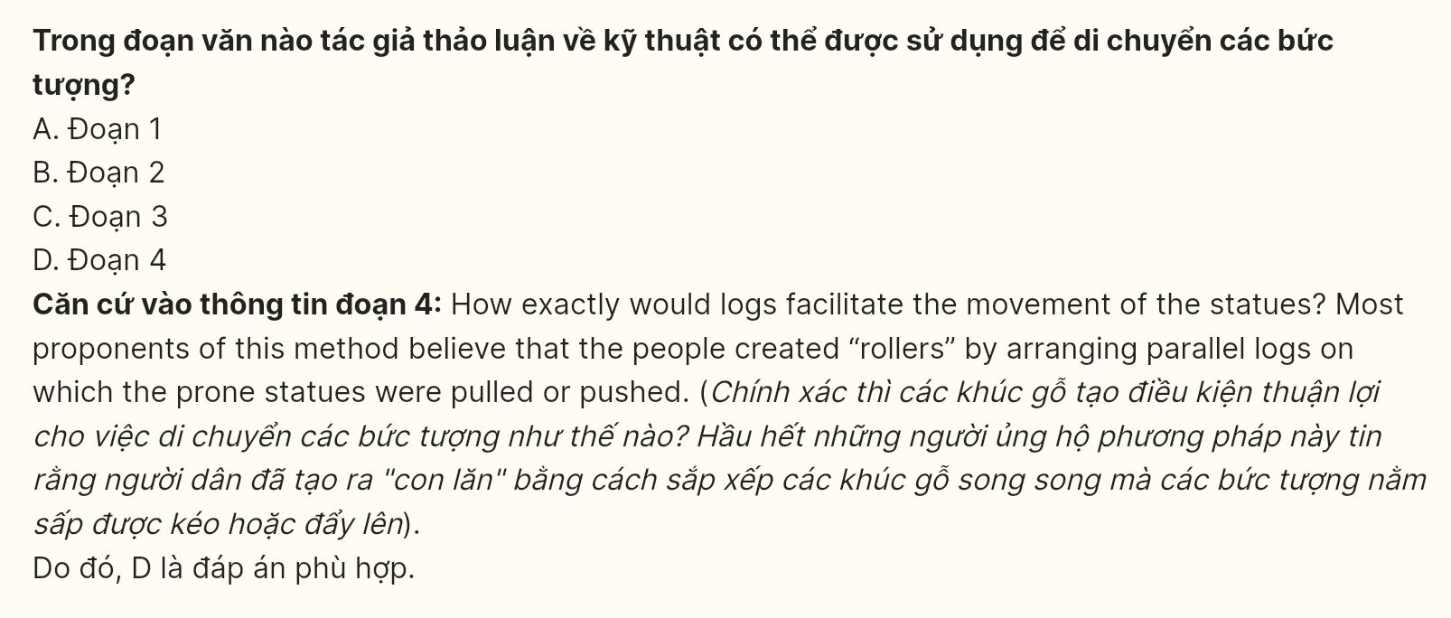
Read the following passage about tourism and mark the letter A, B, C, or D on your answer sheet to indicate the option that best fits each of the numbered blanks from 31 to 40.
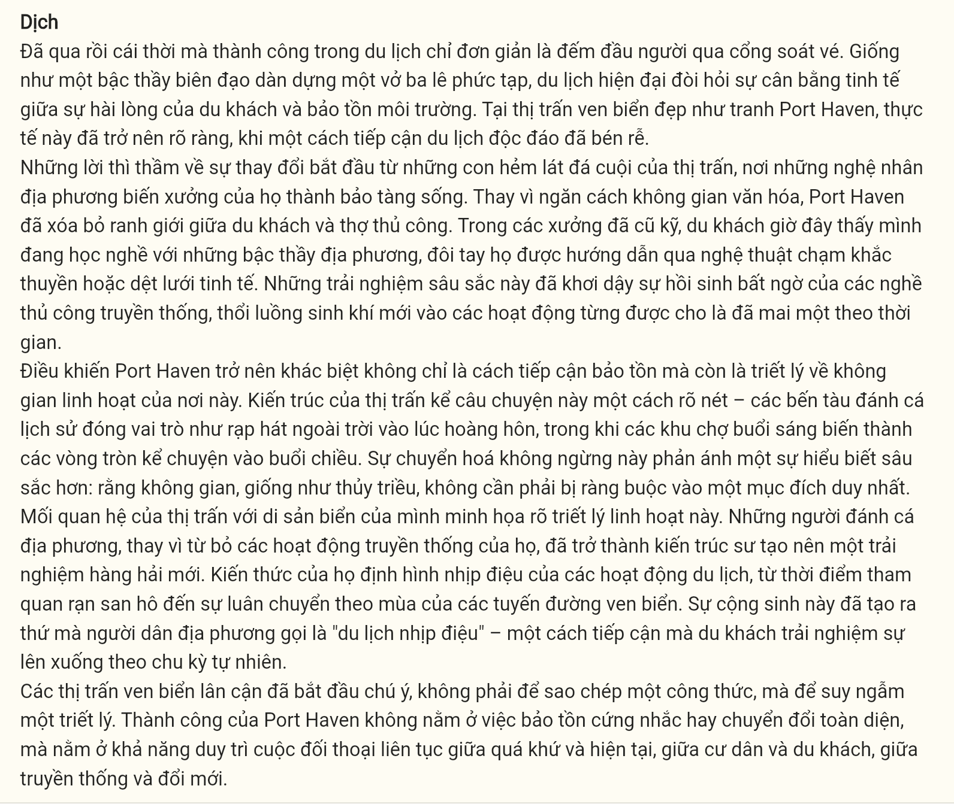
[I] Gone are the days when success in tourism meant merely counting heads through turnstiles. [II] Like a master choreographer orchestrating an intricate ballet, modern tourism demands a delicate balance between visitor satisfaction and environmental stewardship. [III] In the picturesque coastal town of Port Haven, this reality has come into sharp focus, where an unconventional approach to tourism has taken root. [IV]
The whispers of change began in the town’s cobblestone alleys, where local artisans transformed their workshops into living museums. Rather than crowding off cultural spaces, Port Haven has dissolved the boundaries between visitors and craftsmen. In weathered workshops, tourists now find themselves apprenticed to local masters, their hands guided through the subtle art of boat carving or net weaving. These immersive encounters have sparked an unexpected renaissance of traditional crafts, breathing new life into practices once thought lost to time.
What sets Port Haven apart is not merely its approach to preservation, but its philosophy of fluid spaces. The town’s architecture tells this story eloquently—historic fishing wharves double as open-air theaters at dusk, while morning markets metamorphose into storytelling circles by afternoon. This constant transformation reflects a deeper understanding: that spaces, like the tides themselves, need not be bound to single purposes.
The town’s relationship with its marine heritage exemplifies this fluid approach. Local fishermen, rather than abandoning their traditional practices, have become the architects of a new maritime experience. Their knowledge shapes the rhythm of tourist activities, from the timing of coral reef visits to the seasonal rotation of coastal trails. This symbiosis has created what locals call “rhythmic tourism”—an approach where visitors experience ebb and flow with natural cycles.
Neighboring coastal towns have begun to take notice, not of a formula to replicate, but of a philosophy to ponder. Port Haven’s success lies not in rigid preservation or wholesale transformation but in its ability to maintain a constant dialogue between past and present, resident and visitor, tradition and innovation.
(Adapted from https://learnenglish.britishcouncil.org/)
Question 31 [696534]: Where in paragraph 1 would the following sentence best fit?
Under this innovative approach, tourists become active participants rather than passive observers.
A. [I] B. [II] C. [III] D. [IV]
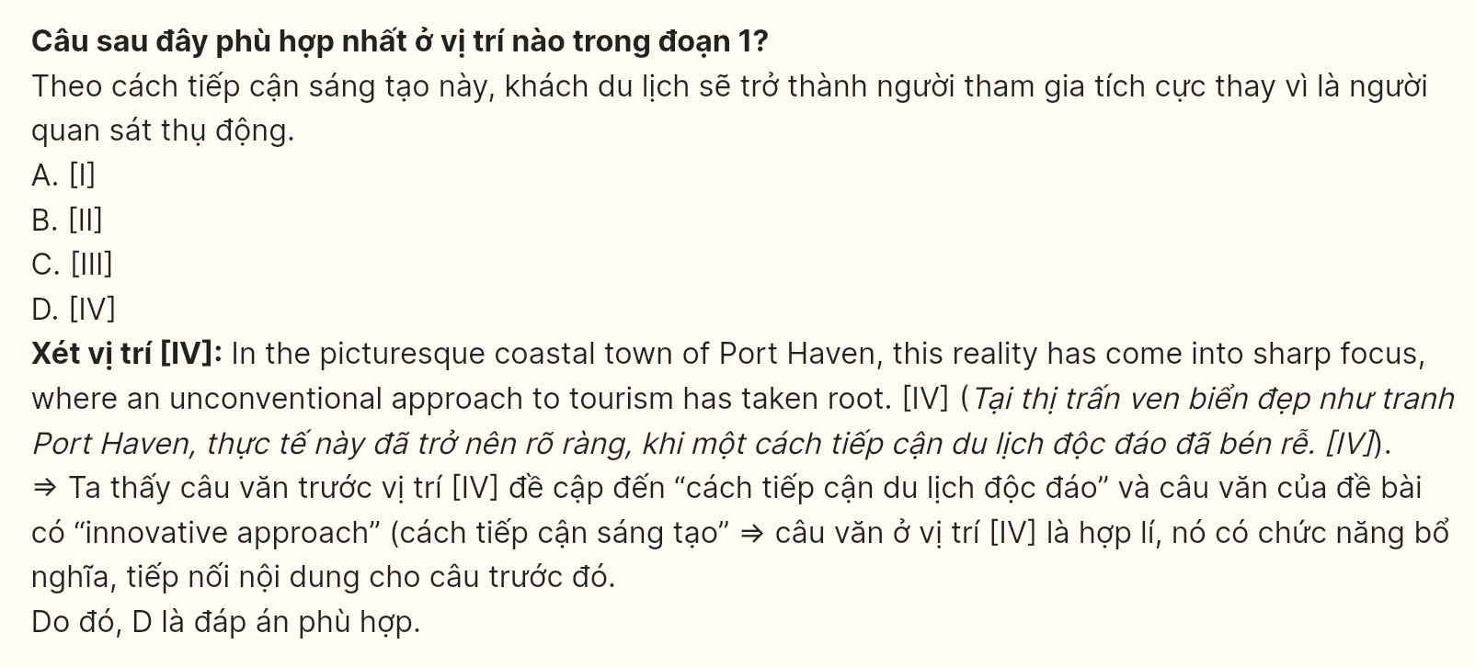
Question 32 [696535]: The phrase “taken root” in paragraph 1 could best be replaced by ________.
A. become an indispensable part B. begun to be widely accepted
C. achieved noticeable results D. introduced a temporary trend
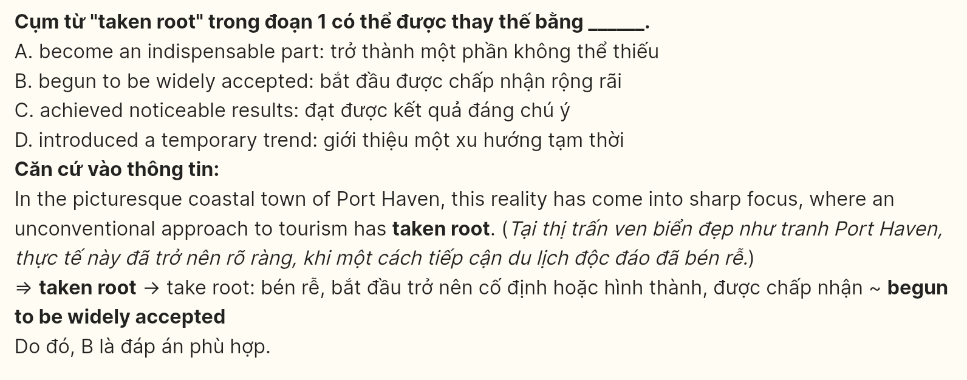
Question 33 [696536]: The word “their” in paragraph 2 refers to ________.
A. local masters B. workshops C. tourists D. hands
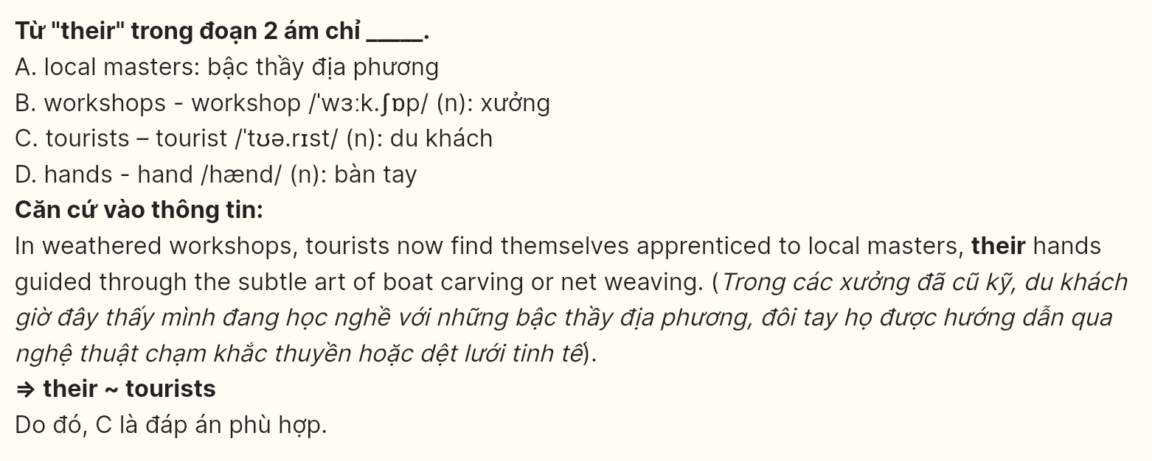
Question 34 [696537]: According to paragraph 2, which of the following is NOT an element of Port Haven’s workshops?
A. craft demonstrations B. hands-on instruction
C. written documentation D. skill transmission
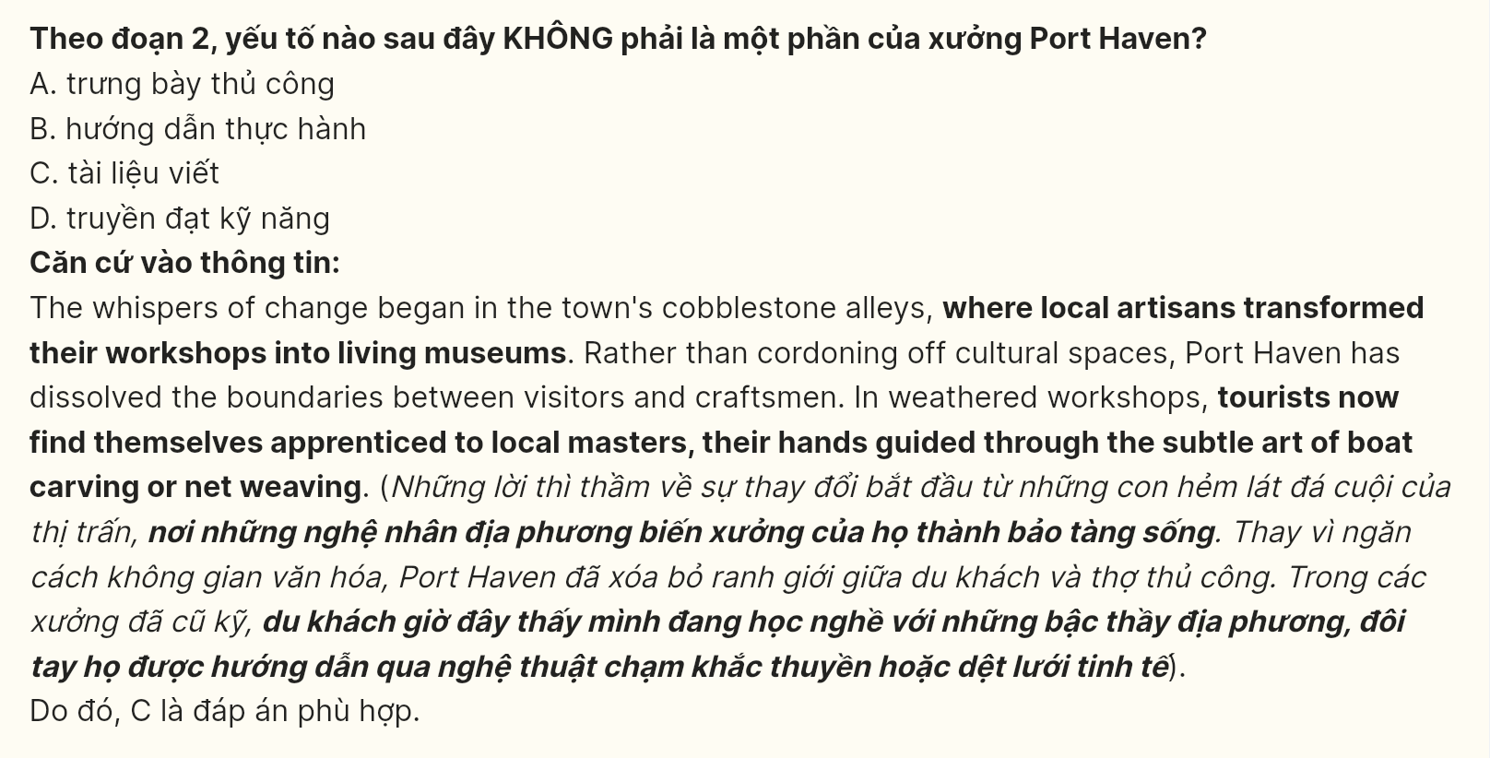
Question 35 [696538]: The word “dissolved” in paragraph 2 is OPPOSITE in meaning to ________.
A. dispersed B. initiated C. merged D. diffused
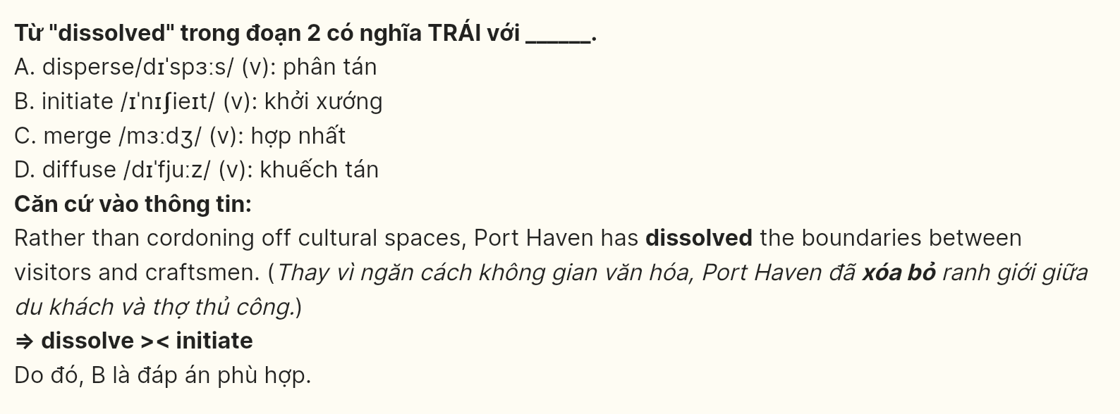
Question 36 [696539]: Which of the following best summarizes paragraph 4?
A. Fishermen in the town shape visitor experiences through seasonal and ecological awareness.
B. Traditional fishing practices evolve alongside contemporary tourism development patterns.
C. Local knowledge systems integrate environmental cycles with tourism management.
D. Coastal heritage preservation balances economic incentives with cultural authenticity.
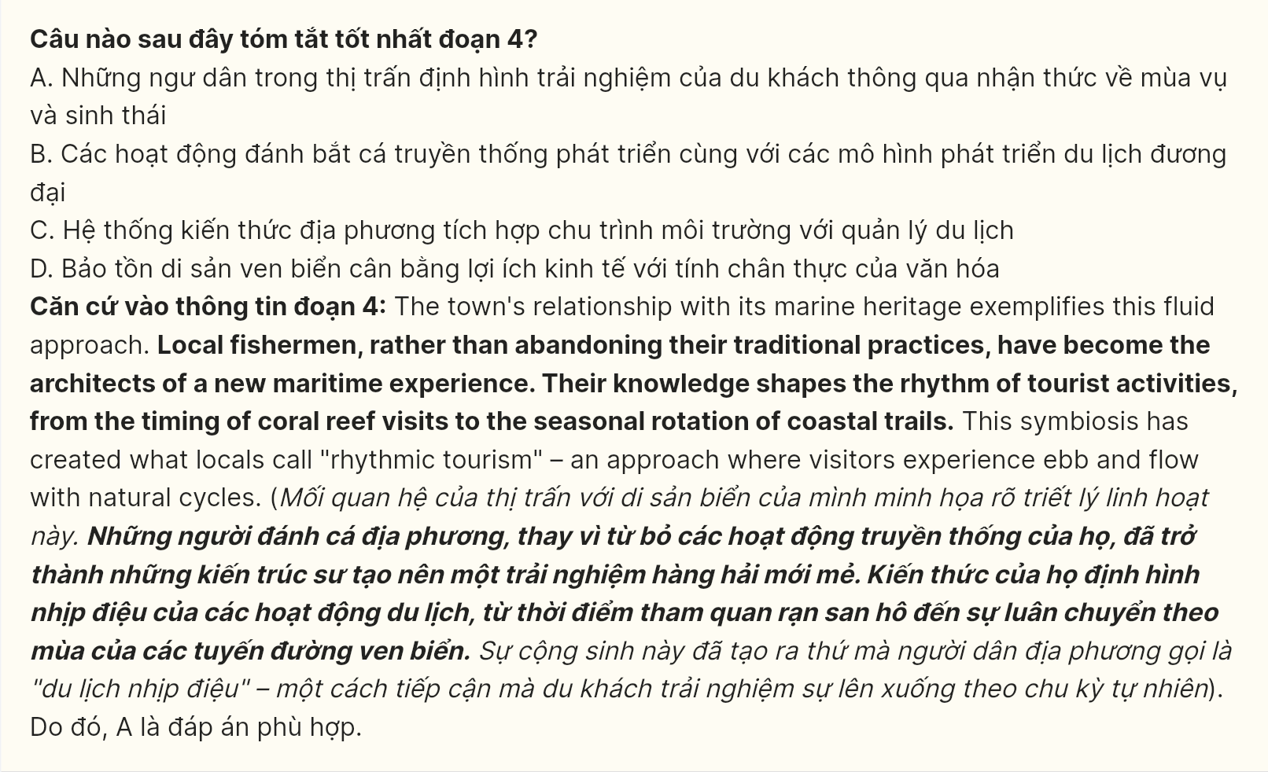
Question 37 [696540]: Which of the following statements is TRUE according to the passage?
A. Local masters have converted their traditional workspaces into interactive cultural venues.
B. Traditional workshops operate as museums where cultural practices are demonstrated.
C. Craftsmen transfer their skills to tourists through systematic training programs daily.
D. Workshop spaces combine historical preservation with modern learning approaches.
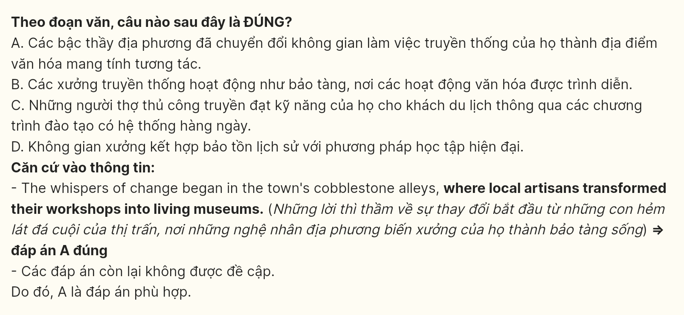
Question 38 [696541]: Which of the following best paraphrases the underlined sentence in paragraph 3?
A. The distinguishing feature of Port Haven is not only its commitment to preservation but also its innovative use of adaptable spaces.
B. The reason Port Haven is notable lies not solely in its preservation methods but in its perspective on multifunctional areas.
C. The uniqueness of Port Haven stems from more than just its preservation strategies; it also embraces a philosophy of versatile spaces.
D. The characteristic that defines Port Haven is not just its focus on conservation but its philosophy regarding fixed uses for historical sites.
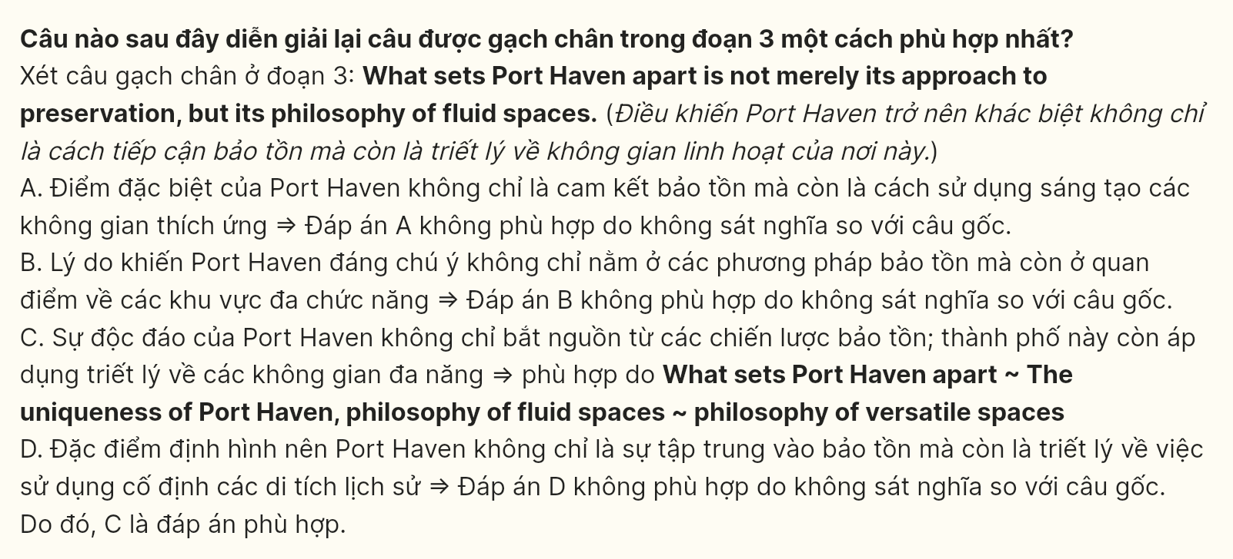
Question 39 [696542]: What can be inferred from the passage?
A. Physical guidance via craft processes produces deeper engagement than visual instruction alone.
B. The continuous adaptation of market spaces leads to increased community participation rates.
C. Regular interaction between fishermen and visitors creates lasting environmental awareness.
D. The combination of storytelling and crafts develops a more comprehensive cultural understanding.
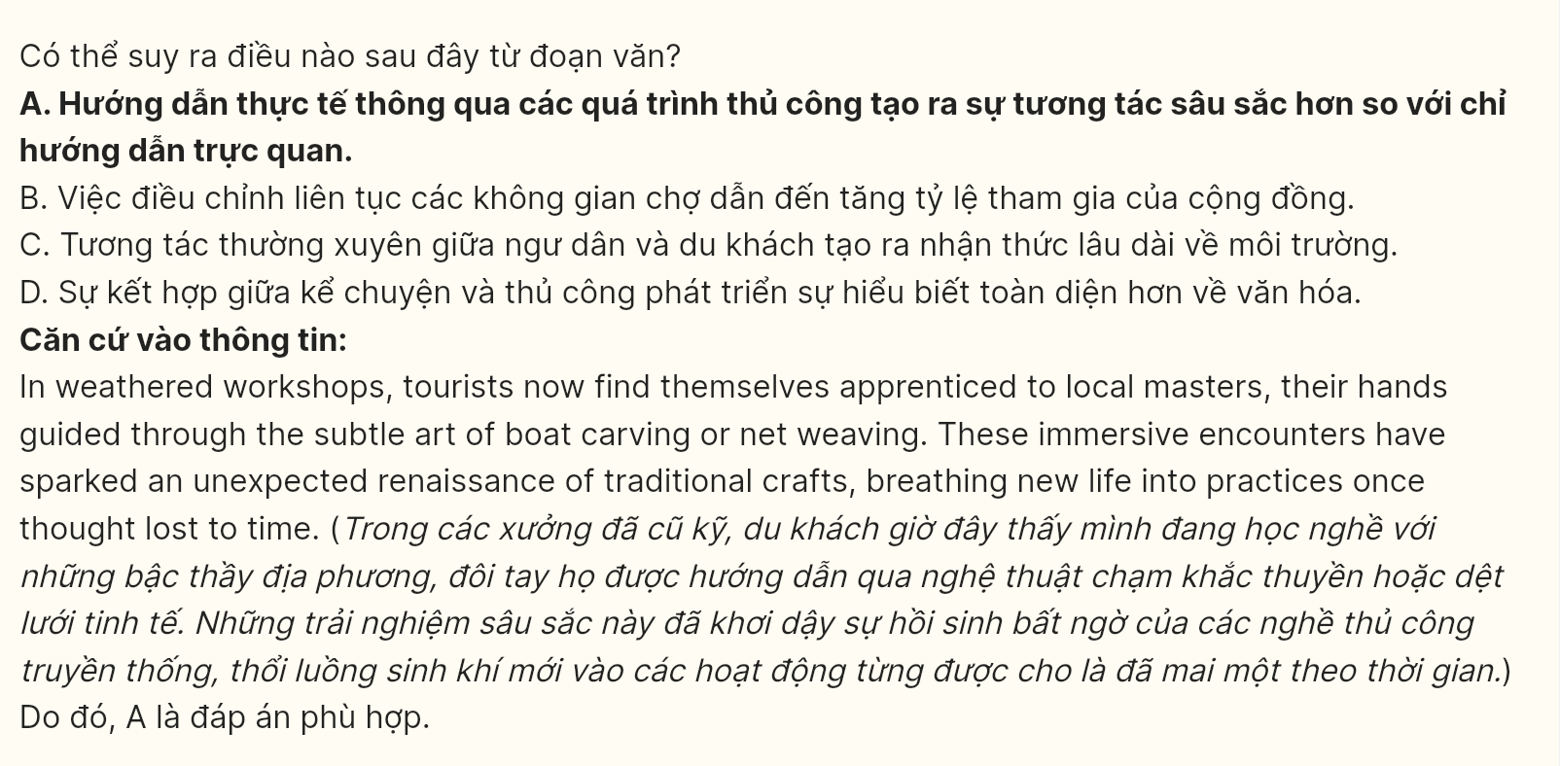
Question 40 [696543]: Which of the following best summarizes the passage?
A. Port Haven exemplifies how tourism can transcend conventional preservation methods by integrating visitor experiences with living cultural practices while maintaining environmental harmony.
B. The transformation of traditional spaces into dynamic cultural venues demonstrates the successful fusion of heritage preservation with contemporary tourism demands and ecological consciousness.
C. Through innovative approaches to space utilization and cultural engagement, Port Haven has established a sustainable model that respects both visitor expectations and local traditions.
D. The town’s success in balancing cultural preservation with tourism development illustrates the potential for creating immersive experiences while fostering resilient community practices.
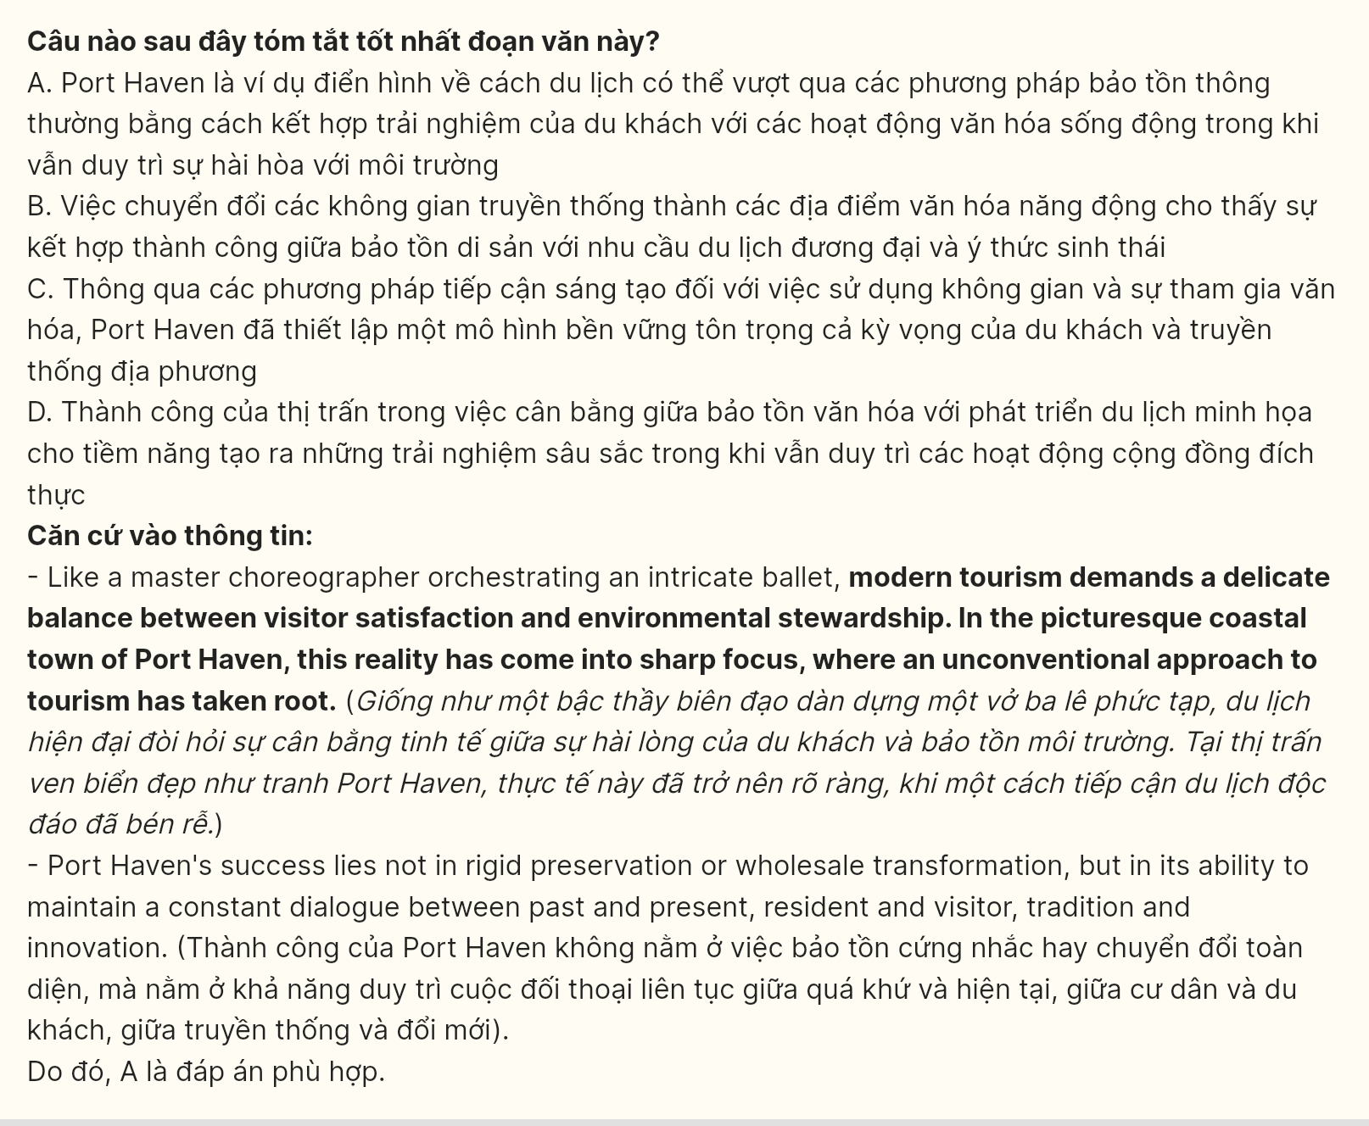

----- THE END -----

