|  |  |
| --- | --- |
|  |  |

**Họ tên thí sinh: .................................................................**

**Số báo danh: ......................................................................**

**Mã Đề: 019.**

**Câu 1.** When does the science club meet?

Science Club Notice:

Science club opening soon! Meets Tues/Thurs after school in room 205. First meeting on Sept. 14th at 3:30 pm.

**A.** Sunday afternoon  **B.** Saturday morning

**C.** Monday and Wednesday after school  **D.** Tuesday and Thursday after school

**Câu 2.** What does this sign mean?

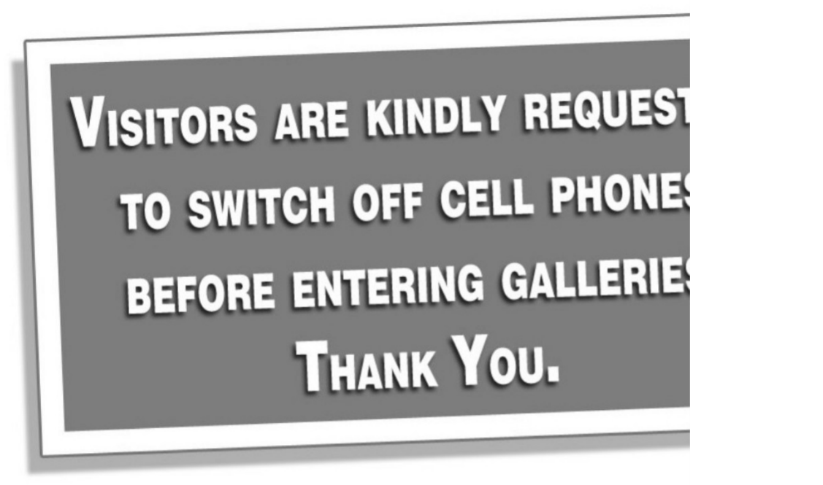

**A.** Visitors should turn off cell phones after visiting the galleries.

**B.** Visitors are allowed in the galleries with a cell phone.

**C.** Visitors should turn off their cell phones when they are in the galleries.

**D.** Visitors should use their cell phones in the galleries.

**Câu 3.** Which of the following statements is true?



**A.** The IT course is for advanced learners.

**B.** The IT course covers hardware, software, networking, and security.

**C.** The IT course does not provide a certificate.

**D.** The IT course starts on 1st October.

**Câu 4.** What is true about the Iceland advertisement?

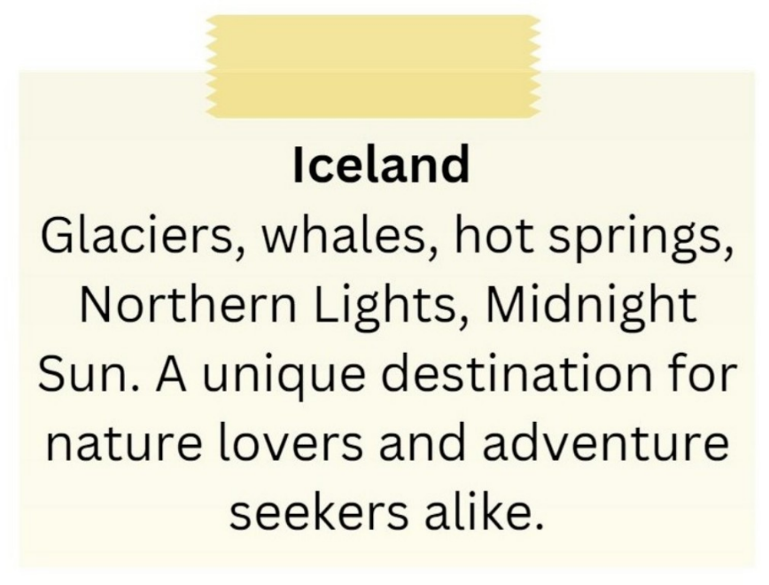

**A.** It emphasizes tropical beaches and sunbathing.

**B.** It showcases skyscrapers and bustling city life.

**C.** It is exclusively for adventure seekers.

**D.** It includes attractions such as glaciers, whales, hot springs, and the Northern Lights.

**Câu 5.** **Look at the signs. Choose the best answer for the question.**

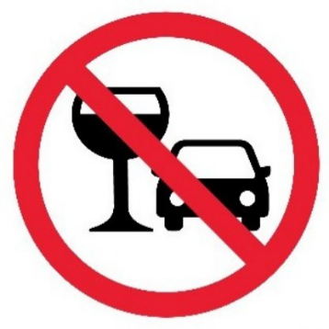

**A.** You should stop driving if you want to drink water.

**B.** You cannot use glasses in the car.

**C.** You mustn’t drink anything while you are driving.

**D.** You are not allowed to drink alcohol before and while driving.

**Câu 6.** **Look at the signs. Choose the best answer for the question.**

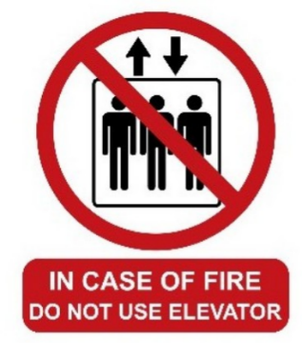

**A.** For your safety, do not use the elevator during a fire.

**B.** You mustn’t use the elevator when it is on fire.

**C.** Three people cannot ride the elevator at the same time during a fire.

**D.** If there is a fire, you don’t have to use the elevator.

**Câu 7.** **Look at the signs. Choose the best answer for the question.**

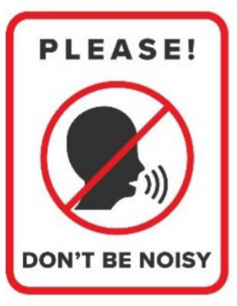

**A.** You mustn’t talk in this area.  **B.** You must be quiet in this area.

**C.** You shouldn’t speak to anyone in this area.  **D.** You don’t have to raise your voice in this area.

**Câu 8.** How much ice cream do you need to buy to get the discount?

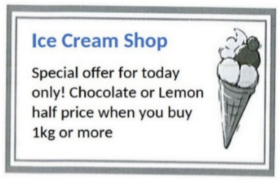

**A.** 1kg or more  **B.** 500g or more  **C.** 2kg or more  **D.** Exactly 1kg

**Câu 9.** What is true about the New Zealand advertisement?

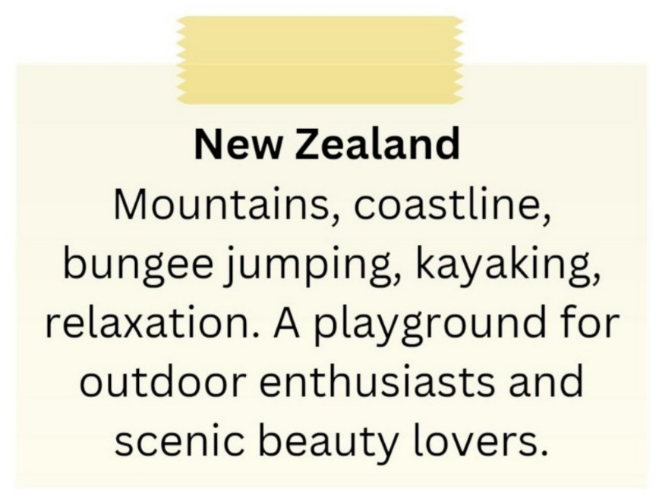

**A.** It is a destination for indoor activities and cultural experiences.

**B.** It highlights mountains, coastline, bungee jumping, and kayaking.

**C.** It is not suitable for outdoor enthusiasts.

**D.** It primarily appeals to relaxation enthusiasts.

**Câu 10.** What special offer is available at the new fast food restaurant?

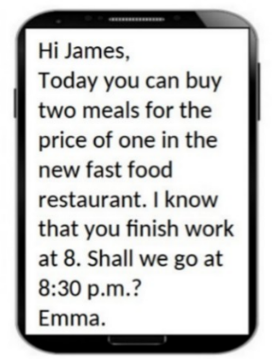

**A.** Two meals for the price of one  **B.** 50% off all menu items

**C.** Free drinks with every meal  **D.** Buy one get one free dessert

**----HẾT---**