LỚP 6 HK1 FORM 2026 TEST 3

Mark the letter A, B, C or D on your answer sheet to indicate the word whose underlined part differs from the other three in pronunciation in each of the following questions.
Question 1. A. cheap B. sea C. near D. peaceful
Question 2. A. lively B. city C. village D. delicious

Mark the letter A, B, C or D on your answer sheet to indicate the word that differs from the other three in the position of primary stress in each of the following questions.
Question 3. A. beautiful B. difficult C. interesting D. polluted
Question 4. A. seafood B. famous C. police D. building

Mark the letter A, B, C or D on your answer sheet to indicate the correct answer to each of the following questions.
Question 5. I love my neighbour hood because it is . There are not many cars.
A. Peaceful B. crowded C. expensive D. noisy
Question 6. Ha Noi is than Hoi An.
A. Noisier B. more noisy C. noisy D. more noisily
Question 7. This book is . I don’t like it.
A. Interesting B. cheap C. boring D. busy
Question 8. It’s rainy and very cold there, so must a waterproof coat.
- He-take B. she -takes C, they-taking D, you -taking
Question 9. Visitors can join activities in Ha Long Bay.
A. Excitement B. excitingly C. excite D. exciting
Question 10. You can see spectacular scenery the falls.
A. In B. on C. from D. at
Question 11. Tet is the biggest and most important in Vietnam.
A. Festival B. decoration C. occasion D. tradition
Question 12. Adam: “ Happy New Year! I wish you joy and laughter from Januray to December.”
Peter: “Thank you. ”
- Wishing you funny all year
- I wish you are funny all year round.
- I hope that the coming year bring you peace and prosperity.
- I wish you a year full of fun.

Read the following announcement and mark the letter A, B, C or D on your answer sheet to indicate the correct option that best fits each of the numbered blanks from 13 to 16.

WELCOME TO MY NEIGHBOURHOOD
My neighbourhood is quiet and clean. There is a supermarket (13) my house. The park is (14)
the supermarket and the school. On weekends, we often (15) football in the park. The people here are very (16) and helpful.
Question 13. A. next | B. near | C. between | D. in front
Question 14. A. next | B. near | C. between | D. behind
Question 15. A. play | B. plays | C. playing | D. played
Question 16. A. kind | B. noisy | C. lazy | D. boring
Question 17: Put the sentences (a-c) in the correct order, then fill in the blank to make a logical text.
A popular news website has added new features. Here’s what users can now enjoy. _________
a. The website now offers live updates and breaking news alerts.
b. Users can also watch video clips and read articles on various topics.
c. The new features aim to provide the latest news in a more engaging way.
A. a-c-b
B. b-a-c
C. c-a-b
D. a-b-c
Question 18: Choose the sentence that you can end the text (in Question 17) most appropriately.
A. The website’s design has been updated to make it easier to navigate.
B. Many users have praised the website for its fast and reliable news updates.
C. The new features have led to an increase in daily visitors to the website.
D. The website plans to add more interactive elements in the future.

Read the following passage and mark the letter A, B, C or D on your answer sheet to indicate option that best fits each numbered blank from 19 to 24.
The Ha Long Bay is (19) in Quang Ninh Province in Vietnam. The name of the bay is roughly translated to descending dragon in Vietnamese. The bay is a UNESCO World Heritage (20) and is lined by over a 1600 limestone islands and islets. Legend has it that, when the Vietnamese were protecting their territory (21)
invaders, they offered prayers to their gods who then sent dragons as the protectors of the place. (22)
the invaders were approaching via sea, the dragons spat out Jewels creating islands that lined the bay and obstructed the ships and boats of the invaders. Ha Long Bay is one of the (23) popular tourist destinations and is visited by hundreds of thousands of tourists each year. You can opt for a (24) cruise, that will take you as close to a lot of these islets.
Question 19. A. visited B. located C. followed D. discovered
Question 20. A. Nature B. Sight C. Wonder D. Site
Question 21. A. from B. with C. to D. by
Question 22. A. What B. Where C. When D. Which
Question 23. A. much B. many C. more D. most
Question 24. A. train B. boat C. plane D. bus

Mark the letter A, B, C or D on your answer sheet to indicate the sentence that closest in meaning to the original sentence in each of the following questions.
Question 25. Their rule is wearing a swimsuit in the pool.
    - You mustn’t wear a swimsuit in the pool.
    - You must wear a swimsuit in the pool.
    - You must to wear a swimsuit in the pool.
    - You mustn’t to wear a swimsuit in the pool.
Question 26. They don’t allow children to travel alone.
- Children mustn’t travel alone.
- Children must travel alone.
- Children are allowed to travel alone.
- Children should travel alone.

Mark the letter A, B, C or D on your answer sheet to indicate the sentence that is made from the given cues in each of the following questions.
Question 27. It/ be/ 2,600/ kilometre/ long.
- It is 2,600 kilometre long.
- It be 2,600 kilometre long.
- It has 2,600 kilometre long.
- It has 2,600 kilometres lengthen.
Question 28. You/ must/ brush/ teeth/ three times/ day.
- You must brush your teeth three times a day.
- You must to brush your teeth three times a day.
- You must brushing your teeth three times a day.
- You must to brushing your teeth three times a day.
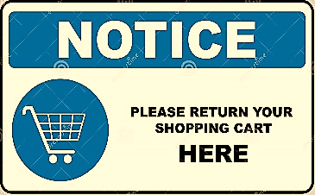
Question 29: What does the sign tell you?
A. Return your cart anywhere in the parking lot.
B. Return the cart to the designated cart area.
C. Keep the cart in your car until you get home.
D. Return the cart at the store entrance.

Question 30:

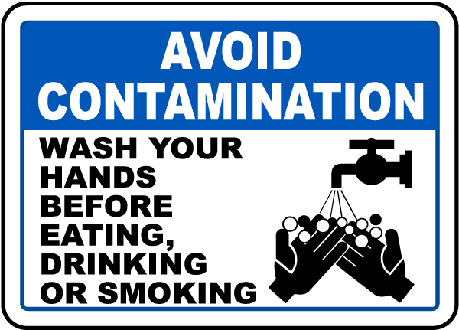
A. Wash your hands only if they look dirty before eating.
B. It is fine to eat without washing your hands first.
C. Wash your hands before you eat to keep everything clean and safe.
D. Wash your hands after eating, not before you start.

Read the following passage and mark the letter A, B, C or D on your answer sheet to indicate the correct answer to each of the following questions from 31 to 36.
Nha Trang is one of the most important tourist hubs of Vietnam, thanks to its beautiful beaches with fine and clean sand and the clear ocean water with mild temperature all year round. There are several resort such as Vinpearl, Diamond Bay and Ana Mandara and amusement and water parks, in the city and on islands off the coast. The possibly most beautiful street of Nha Trang is Tran Phu Street along the seaside, sometimes referred to as the Pacific Coast Highway of Vietnam.
Lying off Nha Trang is the Hon Tre Island (Bamboo Island), with a major resort operated by the Vinpearl Group. The Vinpearl Cable Car, a gondola lift system, links the mainland to the five-star resort and theme park on Hon Tre Island.
Question 31. Nha Trang is considered as one of the most beautiful tourist hubs in Vietnam because
- it has several resorts such as Vinpearl, Diamond Bay and Ana Mandra
- it has beautiful coastal villages with mild temperature all year round
- it has beautiful beaches and clear ocean water with mild temperature all year round
- The Vinpearl Cable Car links the main land to the five-star resort on Hon Tre Island
Question 32. Accoridng to the text, Diamond Bay is the name of a/an .
A. Resort B. Cable car C. Beach D. Island
Question 33. The Pacific Coast Highway of Vietnam referred to in Nha Trang
A. The city B. The islands C. Tran Phu Street D. Vinpearl Group
Question 34. The word “major” is CLOSEST in meaning to .
A. Modern B. expensive C. beautiful D. main
Question 35. According to the text, which of the following statements is NOT true?
- The HonTre island (Bamboo island) is not on the main land of Nha Trang.
- HonTre island is one of the most important tourist hubs of Vietnam.
- Tourists can go to Hon Tre island from the mainland of Nha Trang by cable car.
- Tran Phu street is possibly the most beautiful street of Nha Trang.
Question 36. The word “important” is OPPOSITE in meaning to .
A. Crucial B. unnecessary C. attractive D. unattractive

Four phrases/ sentences have been removed from the text below. For each question, mark the letter A, B, C or D on your answer sheet to indicate the correct option that best fits each of the numbered blanks from 37 to 40.
(37) . They believe that the first-footer of a family determines their luck for the next year. Usually, people will invite a good-tempered, (38) . During Tet, people visit relatives and friends to exchange best wishes. (39) . They will receive lucky money for good blessings. Family gathering is really important because (40) . At Tet every house is usually decorated by flowers and colored lights.

- Vietnamese has a lot of tradition at Tet
- Children will dress in new clothes
- it's time family members get together after a long year
- moral and successful person to visit their houses
Question 37 A Question 38 D Question 39 B Question 40 C

