LỚP HỌC THẦY (CÔ) ___________________________ ĐỀ ÔN TẬP: READING SIGNS/ NOTICES – A2
Test 11
Thời gian làm bài: [Time]
Họ và tên: ________________________________________________ Lớp: 9/___
Nội dung:
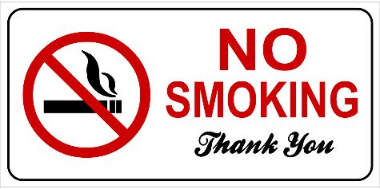
Question 1: What does the sign suggest?

A. Smoking is allowed anywhere you like without restrictions.
B. Smoking is not permitted in this area.
C. Only certain types of smoking are allowed in this area.
D. Smoking is only permitted in special rooms designed for it.
Question 2: What does the notice advise?
Keep your personal belongings in your locker. Do not leave them in common areas.

A. Leave your belongings in common areas B. Leave your belongings in your locker
C. Share your locker with others D. Take your belongings home every day
Question 3: What does the sign suggest?
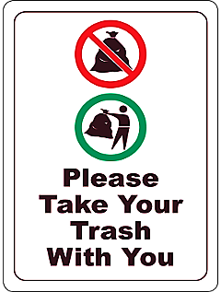

A. Leave your trash in the designated bins provided in the area.
B. Take your trash with you when you leave this place.
C. Only take your trash with you if it is recyclable.
D. You can leave your trash in any area around here.
Question 4: What does the notice ask you to do?
Please keep the noise to a minimum in the library. This helps others study and read

A. Do not listen to music in the library to keep it quiet.
B. Keep the noise level low in the library
C. Watch movies with the volume at its highest.
D. Play music in the library
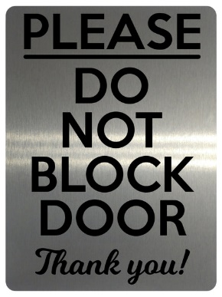
Question 5: What does the sign suggest?

A. It is okay to block the door if it is open.
B. Only block the door during the night if needed.
C. You should block the door if it is too cold outside.
D. Ensure that the door is always kept clear and not blocked.
Question 6: What does the notice require?
Please do not feed the birds in the park. It may make them sick
A. Feed the birds without letting others know B. Play with the birds
C. Do not feed the birds any food D. Only give the birds water, do not feed the birds
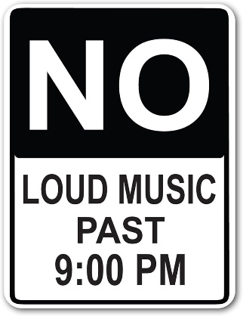
Question 53: What does the sign suggest?

A. Loud music can be played at any time during the night.
B. Only classical music is permitted to be loud after 9 PM.
C. You are allowed to play loud music only before 9 PM.
D. Make sure to keep the music quiet after 9 PM.
Question 7: What should you do with your ID card?
Remember to bring your ID card when you enter the building. You will need it to go through security.
A. Leave your ID card at home B. No ID card required
C. Show your ID card upon entry D. Bring your ID card for security check
Question 8: What does the sign suggest?
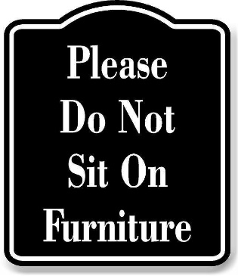
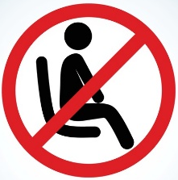

A. You can sit on the furniture if you want.
B. Only some pieces of furniture can be used for sitting.
C. Sitting on the furniture is not allowed here.
D. You may sit on the furniture only during designated breaks.
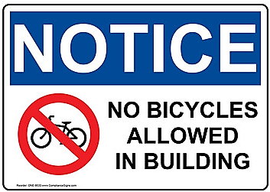
Question 9: What does the sign suggest?

A. You are allowed to bring your bicycle into the building whenever you want.
B. All bicycles must be left outside and not brought into the building.
C. Only smaller bicycles are not allowed in the building, larger bicycles are allowed.
D. All bicycles must be left outside the building and not brought inside.
Question 10: What is true about the announcement from the library?
"Attention all students: Please note that our library will now open at 10:00 AM and close at 6:00 PM, Monday through Friday. Our weekend hours remain the same. Thank you for your cooperation."
A. Change in the library's hours on weekends.
B. Change in the library's location.
C. Change in the library's opening and closing times on weekdays.
D. Change in the library's phone number.
[HẾT]

