
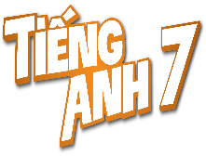
Tiết thứ ......
UNIT 7: ENERGY SOURCES
Lesson 7: Looking back & Project
Class | Date of teaching | Attendence
7... | ...../........./202....
7… | ..../......../202...
7…. | ..../......../202....
I. OBJECTIVES: By the end of this unit, students will be able to gain the following things:
1. Knowledge:
- Review the vocabulary and grammar of Unit 10
- Apply what they have learnt (vocabulary and grammar) into practice through a project
2. Competence:
a) General competencies:
- Develop communication skills and creativity
- Be collaborative and supportive in pair work and team work
- Actively join in class activities
b) Specific competencies:
- Develop communication skills.
- Be cooperative and supportive in pair work and teamwork.
- Actively join in class activities.
3. Qualities:
- To educate the love of music and art.
- Be ready to know the words about music and arts.
- Develop self-study skills.
II. PREPARATIONS
- Teacher: Grade 7 text book, laptop, projector / TV/ pictures and cards.....
- Students : Text books, studying equipment….
III. PROCEDURE:
Notes: In each activity, each step will be represented as following:
* Deliver the task.
* Implement the task.
* Discuss.
* Give comments or feedback.
Activity 1. WARM UP (5’-IW, GW)
* Aim:
To help students revise the vocabulary items they have learnt in the unit.
To enhance students’ skills of cooperating with team mates.
* Content: saving energy resources and asks students to think of it.
* Product: Having a chance to speak English and focus on the topic of the lesson.
* Implementation: Teacher’s instructions…
Teacher’s & Student’s activities | Content
Quick revision check  * Teacher asks Ss to think of what they have learnt already in Unit 10.  ** Ss work in pairs to do the task.  ***Teacher calls some students to retell.  **** Teacher confirms and leads them to do all the exercises in books.  Task 1: Match the adjectives in A with the nouns in B to make phrases  * Teacher has Ss work individually.  ** Ss do this activity individually, then compare their answers with their partners.  *** Teacher asks for Ss’ answers. **** Teacher confirms the correct ones and asks students to make sentences using the phrases.  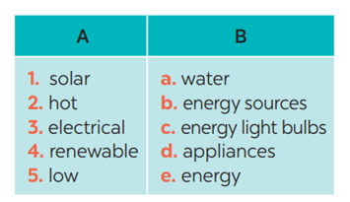 | Answer keys:  1. e 2. a  3. d 4. b 5. c
Activity 2. KNOWLEDGE FORMATION (15'- PW, IW)
* Aim:
- To help Ss revise the vocabulary items (verbs) they have learnt in the unit
- To help Ss revise grammar points.
* Content: Teach some new words.
* Product: Students’s answer.
* Implementation: Teacher’s instructions…
Teacher’s & Student’s activities | Content
Task 2: Complete the sentences, using the phrases in 1  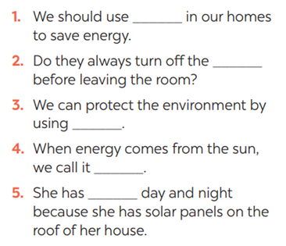* * Teacher has Ss work individually.  ** Ss do this activity then compare their answers with their partners.  *** Teacher asks for Ss’ answers.  **** Teacher confirms the correct ones | Task 2: Complete the sentences, using the phrases in 1  Answer keys:  1. low energy light bulbs  2. electrical applicances  3. renewable energy sources  4. solar energy  5. hot water
Task 3: Complete the sentences by using the correct form of the present continuous or present simple of the verbs in brackets.  * Teacher asks Ss to recall the structures of “The present continuous”, and tell them to do Ex 3 in the book.  ** Ss do the exercise individually and swap with their partners.  *** Teacher calls some Ss to check their answer.  **** Teacher confirms the correct answer.  1. Look! It (rain) ______ heavily.  2. Normally they (start) ______ school at eight o’clock in the morning.  3. He hasn’t got a bike at the moment, so he (walk) ______ to school this week.  4. He always (do) ______ his homework in the evening.  5. I’m afraid I have no time to help just now. I (write) ______ an essay | Task 3: Complete the sentences by using the correct form of the present continuous or present simple of the verbs in brackets.  Answer keys:  1- is raining  2- start  3- is walking  4- does  5- am writing
Activity 3. PRACTICE (15’-IW, PW, GW)
* Aim:
To help Ss revise the grammar points of the unit
* Product: Students’s answers.
* Implementation: Teacher’s instructions…
Teacher’s Student’s activities | Content
Task 4: Find ONE mistake in each sentence and correct it  * Teacher asks Ss to do the task.  ** Ss work individually to do the task.  *** Teacher calls Ss to give out their answers.  **** Teacher checks and confirms their answer.  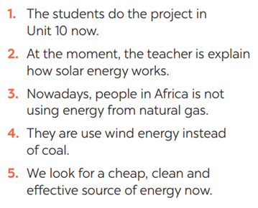 | Task 4: Find ONE mistake in each sentence and correct it  Answer keys:  1. do -> are doing  2. explain -> explaining  3. is -> are  4. use -> using  5. look -> are looking
Activity 4. APPLICATION (7’-IW, PW, GW)
* Aim:
To help Ss develop team work skills and pratice using what they have learnt to make a poster
To consolidate what students have learnt in the lesson.
To prepare for the next lesson.
* Content: Apply what they have learnt (vocabulary and grammar) into practice through a project.
* Product: Posters exhibition
* Implementation: Teacher’s instructions
Task 5: Discussion: Which tips can be applied in your school.  * Teacher asks Ss to dicuss in groups of 4-6  * Teacher also has Ss spend some time to make their brainstorm, narrow down the ideas, make a poster out of these ideas and practise presenting within their groups.  ** Ss discuss with their group memebers.  *** Some students raise their ideas and explain their answers among groups  **** Teacher listens, correct (if needed) and confirms.    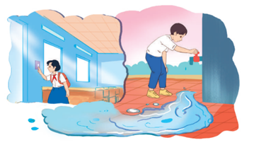  Task 6: : Poster presentation: How to save energy in your school  * Teacher asks Ss to work in groups of 4 – 6 to stick their posters onto the classroom’s wall and present about them.  ** Ss work in group to do the task.  *** Teacher calls some groups to present their poster to the class  **** Teacher confirms and corrects*  Consolidate  Teacher asks students to talk about what they have learnt in the lesson  Home assignment  Prepare for the next lesson: Unit 5 – Getting Started | \  * Home assignment  Prepare for the next lesson: Unit 5 – Getting Started
V. FEEDBACK:
With 7 ……………………………………………………………………………..…
With 7…………………………...……………………………………..……………
With 7 ………………………………………………………………………….……

