School: ……………………………………….. | Date:……………………………………..
Class: ……………………………..................... | Period: 72

UNIT 5: TRAVEL AND TRANSPORTATION
Reading 5a – Vocabulary expansion and further practice (Cont., page 81)

1. Objectives
By the end of this lesson, students will be able to…
1.1. Language knowledge/ skills
- learn and use some vocabulary for transportation in the future: hoverboard, self-driving bus, hyperloop train, flying taxi, hoverbike, electric car.
- learn and practise some prepositional phrases.
- learn and practise abbreviations.
- practise talking about transportation in the future.
- write a tweet about how to get around in the capital city.
1.2. Competences
- improve Ss’ communication, collaboration, analytical, critical thinking skills.
1.3. Attributes
- Build their interests for transportations.
- become knowledgeable people.
2. Teaching aids and materials
- Teacher’s aids: Student’s book and Teacher’s book, class CDs, IWB – Phần mềm tương tác trực quan, projector/interactive whiteboard /TV (if any), PowerPoint slides.
- Students’ aids: Student’s book, Workbook, Notebook.
3. Assessment evidence
Performance Tasks | Performance Products | Assessment Tools
- Answer the question.  - Discuss the question.  - Fill in the blanks.  - Choose the correct prepositional phrases.  - Write a tweet. | - Ss’ answers.  - Ss’ answers.  - Ss’ answers.  - Ss’ answers.  - Ss’ answers/ presentation. | - Observation.  - Observation.  - Observation.  - Observation.  - Rubric.

4. Procedures
A. Warm up: 5 minutes
a. Objectives: to introduce the topic and review some vocabulary related to the topic.
b. Content: Vocabulary about means of transport.
c. Expected outcomes: Ss can recall some vocabulary and think about the topic.
d. Organization

Teacher’s activities | Students’ activities
Classify the means of transport into three groups: bike, boat, bus, taxi, plane, ship, car, helicopter, cruise, air balloon.  + roadways:  + waterways:  + airways:  - Ask Ss to classify the means of transport into three groups.  - Check Ss’ answers. | - Think about the means of transport and classify them.  - Check answers.  Suggested answers:  + roadways: bike, bus, taxi, car  + waterways: boat, ship, cruise  + airways: plane, helicopter, air balloon

B. Vocabulary presentation: 10 minutes
a. Objectives: to present some vocabulary for transportation in the future.
b. Content: Task 4.
c. Expected outcomes: Ss can know and remember the words related to the topic.
d. Organization
Teacher’s activities | Students’ activities
Task 1: Listen and repeat. Which of the means of transport exist nowadays?  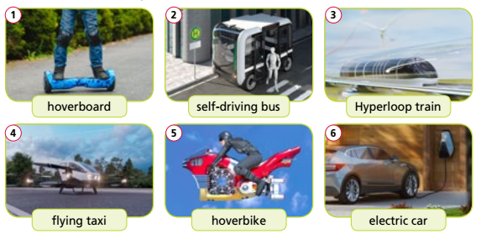  - Ask Ss to look at the picture and guess the meanings of the words.  - Play the recording, using the IWB with pauses for Ss to repeat chorally and/or individually.  - Check Ss’ pronunciation and intonation.  - Check if Ss remember the words. | - Look at the pictures and guess the meanings of the words.  - Listen to the recording and repeat.  - Take notes.  - Answer teacher’s questions.

C. Vocabulary practice: 15 minutes
a. Objectives: to help Ss practise talking about transportation in the future, learn some prepositional phrases and practise abbreviations.
b. Content: task 5, task 6 and task 7.
c. Expected outcomes: Ss can talk about transportation in the future, use some prepositional phrases and abbreviations to do the tasks correctly.
d. Organization:
Teacher’s activities | Students’ activities
Task 5 What will transportation be in the future? Discuss.  Example  A: I think there will be self-driving buses for people to go to work.  B: I agree. I also think there will be ﬂying taxis and electric cars.  - Explain the task and give Ss time to think  about their answers and discuss in pairs.  - Ask various Ss around the class to share  their opinions with the rest of the class. | - Listen to teacher’s explanation and read the example.  - Discuss the question with a partner.  - Share ideas to the class.  Answer Keys:  Ss’ own answers.
Task 6: Choose the correct preposition.  1. I think people will go to work by/in hoverbike in the future.  2. We decided to go to the post office by/on foot.  3. Who was in/at the car with John?  . - Explain the task and give Ss time to complete it.  - Check Ss’ answers (using the IWB). | - Do the task individually.  - Check answers.  Answer Keys  1.by 2.on 3.in
Task 7: Read the Note! box. Find examples in the text in Exercise 1.  Use abbreviations to complete the gaps.  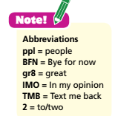  1 I’m having a ___time!  2 Morning ____. I’m on  holiday!  3 ____, a cruise is the best!  4 Need advice. Please ____.  5 That’s all from me! ____.  - Read out the Note! box and elicit examples  from the text.  - Then give Ss time to read the sentences  and complete them with an appropriate  abbreviation from the box.  - Check Ss’ answers (using the IWB). | - Listen to teacher’s explanation and read the Note! Box.  - Complete the sentences with the correct abbreviations.  Answer Keys:  1.gr8 2.ppl 3.IMO 4.TMB 5.BFN

D. Vocabulary production: 10 minutes
a. Objectives: to help Ss personalise the topic, use the language and information from the lesson to write tweets about how to get around in the capital city, get some information about popular transports for tourists in London.
b. Content: task 8 and culture spot.
c. Expected outcomes: Ss can write tweets about how to get around in the capital city, get some information about popular transports for tourists in London.
d. Organization

Teacher’s activities | Students’ activities
Task 8: Imagine you went on holiday in your country’s capital city. In groups, write tweets about how to get around like the ones in Exercise 1. Use abbreviations.  - Explain the task using IWB and ask Ss to work in small groups.  - Tell them to think of means of transport in  their capital city and then compose tweets  about them.  - Remind Ss to use abbreviations and to use  no more than 140 characters.  - Check Ss’ answers around the class. | - Work in small group to write a tweet.  - Share their tweets to the class.  Suggested Answer:  Hello ppl! The best way to see all the sights  in Hanoi is on a cyclo tour. It’s gr8! #Hanoibycyclo  IMO, the sightseeing bus tour is better. You’ll  get a gr8 view of some amazing buildings!  Yes, or you can ride a motorbike around the  city. It’s the most convenient way to travel in  the crowded city. Most ppl love that! BFN
Culture Spot  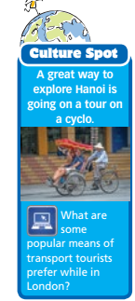  - Read out the box and then give Ss time to  research online and find out about popular  means of transport tourists prefer while in  London.  - Ask Ss to present it to the class.  - Give feedbacks. | - Read the box and find out about popular  means of transport tourists prefer while in  London.  - Share information to the class.  - Listen to teacher’s feedbacks and take notes.  Suggested Answers  The most popular means of transport tourists  prefer in London are the red double-decker  buses. Some also like to move around with  the Tube (an underground railway).

E. Consolidation and homework assignments: 5 minutes
- Vocabulary: hoverboard, self-driving bus, hyperloop train, flying taxi, hoverbike, electric car.
- Do the exercises in workbook on page 42.
- Do the vocabulary exercise in TA7 Right On! Notebook page 36.
- Prepare the next lesson: Grammar 5b (page 82).
5. Reflection

a. What I liked most about this lesson today:
…………………………………………………………………………………………
b. What I learned from this lesson today:
…………………………………………………………………………………………
c. What I should improve for this lesson next time:
…………………………………………………………………………………………

