|  |  |
| --- | --- |
|  | *Thời gian làm bài: 40 phút (Không kể thời gian giao đề)*  *-------------------------* |

**Họ tên thí sinh: .................................................................**

**Số báo danh: ......................................................................**

**Mã Đề: 009.**

**Câu 1.** **Look at the signs. Choose the best answer for the question.**



**A.** This area is supervised by camera.  **B.** You must look after your cameras in this area.

**C.** Cameras can only be used for security purposes.  **D.** Cameras can be used in this area.

**Câu 2.** What is the offer at the Tennis Club?



**A.** Tennis lessons for children on Tuesdays and Thursdays

**B.** Tennis lessons for adults on Mondays and Fridays

**C.** €10 to join the club

**D.** Tennis lessons for children on Mondays and Fridays for €5 to join

**Câu 3.** What can we infer about the current weather situation?

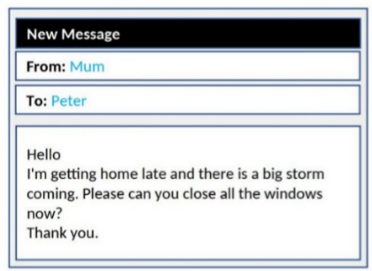

**A.** It's a sunny day  **B.** It's already raining heavily

**C.** The storm has passed  **D.** A storm is approaching

**Câu 4.** Which of the following statements is true?



**A.** The IT course starts on 1st October.

**B.** The IT course is for advanced learners.

**C.** The IT course does not provide a certificate.

**D.** The IT course covers hardware, software, networking, and security.

**Câu 5.** What discount does Adventure Park offer for groups?

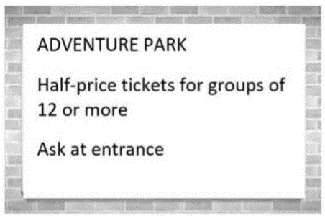

**A.** Free tickets for every 12th person  **B.** 10% off for groups of 10 or more

**C.** 50% off tickets  **D.** 25% off tickets

**Câu 6.** During what hours is the special offer available?



**A.** Only after 2 PM  **B.** All day

**C.** From 12 PM to 2 PM  **D.** From 2 PM to 12 AM

**Câu 7.** What alternative does Missie suggest if Tess can't lend her laptop?



**A.** Going to an internet cafe  **B.** Finding someone else who can lend a laptop

**C.** Using a desktop computer  **D.** Asking Tess to help with her work

**Câu 8.** What does it say?



**A.** Annie invited her friend to her house last night.  **B.** Annie went to her friend’s house last night.

**C.** Annie cooked a great meal last night.  **D.** Annie went to a restaurant last night.

**Câu 9.** **Look at the signs. Choose the best answer for the question.**



**A.** You have to choose your seat when you buy tickets.

**B.** You may sit where you like.

**C.** The tickets don’t show bus numbers.

**D.** There aren’t any numbers on the seats.

**Câu 10.** How many students is the snack shop looking for?

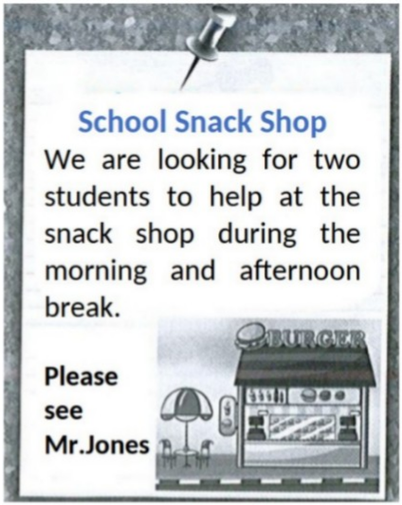

**A.** Three  **B.** Four  **C.** Two  **D.** One

**----HẾT---**