**ĐỀ KIỂM ĐỊNH CHẤT LƯỢNG HỌC SINH GIỎI LỚP 6**

**NĂM HỌC 2023-2024**

**MÔN THI: TIẾNG ANH**

Thời gian làm bài: 120 phút (Không kể thời gian giao đề)

|  |  |  |
| --- | --- | --- |
| **Điểm** | **Họ và tên, chữ ký giám khảo** | **Số phách** |
| Bằng số : ..........................................  Bằng chữ. .........................................  .......................................................... | 1........................................................  2........................................................ |  |

**SECTION A. LISTENING** (30 points)

**Part 1.** (10 points) For each question, choose the correct answer.

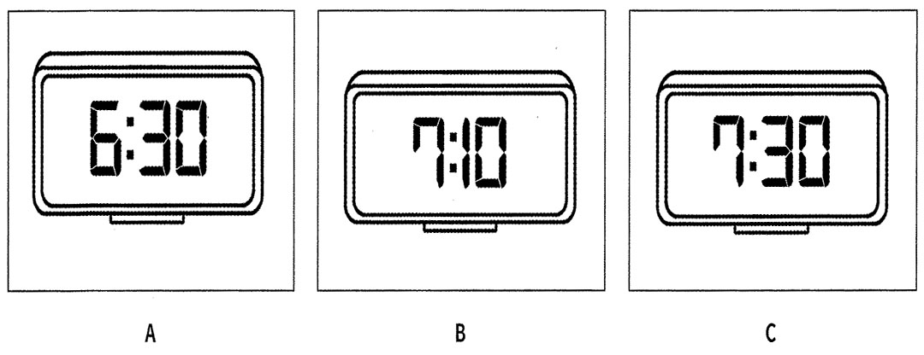**1**   What time does the nature programme start?

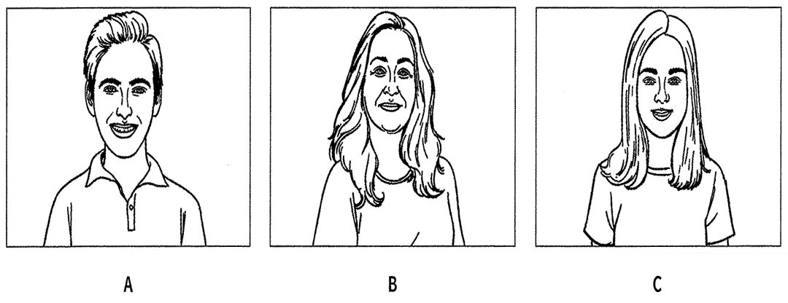**2**   Who is Diana talking to on her mobile?

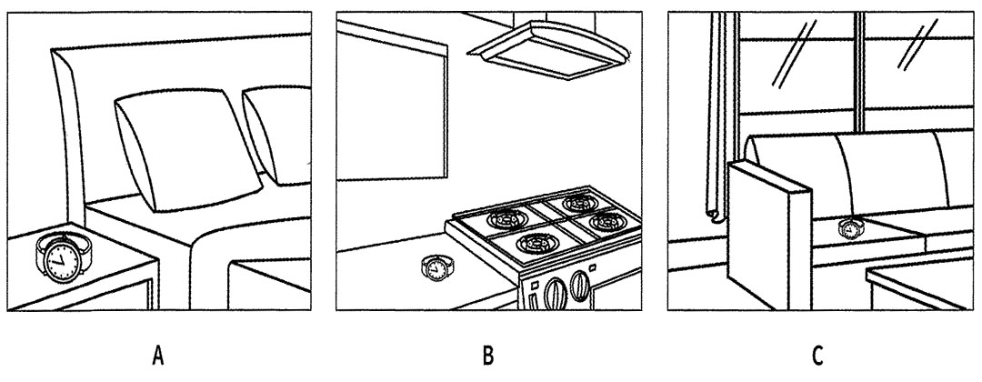**3**   Where will Henry put his mum’s watch?

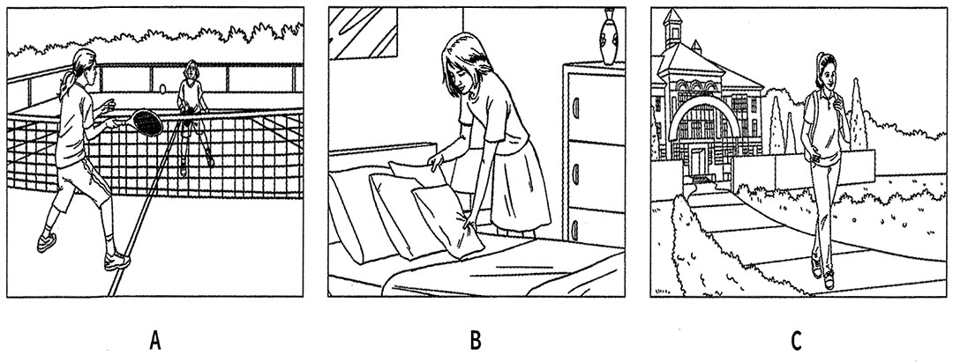**4**   Why is the girl tired?

**5**   What will the weather be like on Sunday?

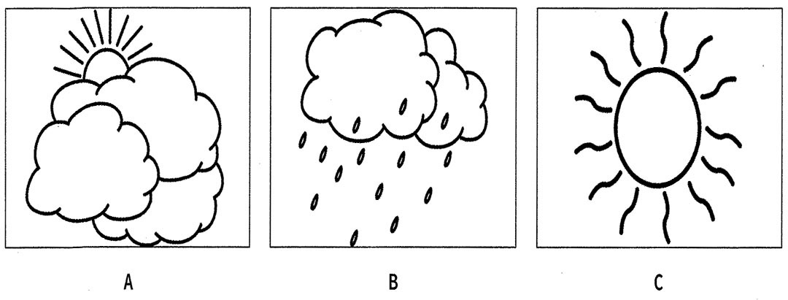

***Your answers:***

|  |  |  |  |  |
| --- | --- | --- | --- | --- |
| 1. | 2. | 3. | 4. | 5. |

**Part 2: (10 points) Questions 6-10**

For each question, write the correct answer in the gap. Write **one word**or**a number**or**a date**or**a time**.

You will hear a boy leaving a message for a friend about a football match.

|  |  |
| --- | --- |
| **Football match** | |
| Day: | Saturday |
| Name of stadium: | (**6**) ……………………………… |
| Bus number: | (**7**) ……………………………… |
| Cost of ticket: | (**8**) £ ……………………………… |
| Wear: | (**9**) ……………………………… |
| Bring: | (**10**) ……………………………… |

**Part 3:** (10 points) Questions 11-15

**For each question, choose the correct answer.**

You will hear Hitomi talking to her friend Freddie about her visit to Hardin Castle.

**11**. **Who did Hitomi go to Hardin Castle with?**

**A**  her classmates

**B** her family

**C** her neighbours

**12**. **What was the weather like?**

**A**  cold

**B** wet

**C** windy

**13.** **What do Hitomi and Freddie both like best at Hardin Castle?**

**A**  the Queen’s bathroom

**B** the yellow bedroom

**C** the dining room

**14. Freddie went to the castle because he wanted**………………………

**A**  to learn about history.

**B** to take photos.

**C** to find out about birds.

**15.** **What’s on at the castle next month?**

**A**  a running race

**B** an exhibition of old cars

**C** a painting course

***Your answers:***

|  |  |  |  |  |
| --- | --- | --- | --- | --- |
| 11. | 12. | 13. | 14. | 15. |

**SECTION B – VOCABULARY & GRAMMAR (24 points)**

**Part 1*.*** (12 points) ***Choose the best answer from A, B, C or D to complete each of the following sentences.***

**1. I don’t often go to school by bus because it _____ a lot of time. Riding a bike is healthier.**

**A. takes B. spends C. has D. gets**

2. You should pay more ________in class.

A. part B. care C. notice D. attention

3. _________ great the party was! We enjoyed ourselves very much.

|  |  |  |  |
| --- | --- | --- | --- |
| A. How is | B. What | C. What is | D. How |

4. We you if we have time.

* 1. phones B. would phone C. will phone D. Phoned

5. This is restaurant I have ever been to.

* 1. comfortable B. the most comfortable

C. more comfortable D. most comfortable

**6. Oanh: 'What a lovely house you have!" - Phuc: "_____________"**

**A. Of course not, it's not expensive B. I think so**

**C. Thank you. Hope you will drop in D. No problem**

**7.** .................coffee is this? – It’s mine.

A. Who B. Which C. Whose D. What

**8.** He has just bought ________expensive new furniture.

**A. many B. an C. some D.these**

**9.** You must do your homework more ……. in the future .

A. careful B. care C. careless D. carefully

10. My little brother……………..pictures very much.

A. enjoys to draw B. enjoy drawing C. enjoy to draw D. enjoys drawing

## 11. ***Choose the word or phrase that is CLOSEST in meaning to the underlined part in each of the following sentences.***

## This film is very **exciting**

## A**.** hard B. easy C. interesting D. difficult

## 12**. *Choose the word or phrase that is OPPOSITE in meaning to the underlined part in each of the following sentences.***

The law protects **ancient** monuments and old churches.

A. modern B. old C. traditional D. historic

***Your answers:***

|  |  |  |  |  |  |  |  |  |  |  |  |
| --- | --- | --- | --- | --- | --- | --- | --- | --- | --- | --- | --- |
| 1. | 2. | 3. | 4. | 5. | 6. | 7. | 8. | 9. | 10. | 11. | 12. |

**Part 2***.* (4 points) ***Write the correct form of the words in brackets.***

1. What is the .................. of this mountain? ( HIGH)

2. I like the city life because there are many kinds of ...............(ENTERTAIN)

3. How many……………….are there in a year in Vietnam? (CELEBRATE)

4. She doesn't have many …………… in Hanoi. (RELATE)

**Your answers:**

|  |  |  |  |
| --- | --- | --- | --- |
| 1. | 2. | 3. | 4. |

## **Part 3. (8 points) *Read the text carefully. In most of the lines 1-10 there is one extra word which does not fit. Some lines, however, are correct. If a line is correct, put a tick (****v****) in the space provided. If there is an extra word in the line, write that word in the space. There are two examples.***

|  |  |
| --- | --- |
| A hobby can be almost anything who that a person likes to do in his/her free time. Hobbyists raise pets, watch birds or hunt animals. They also climb the mountains, go fishing, go skating, or go swimming. They also paint much pictures, attend concerts and play musical instrument. They collect everything from books to butterflies and from shells to collect stamps. People have hobbies because these activities bring enjoyment, friendship, knowledge and relaxation. Hobbies are also bring interesting activities for people who have retired. People, rich or poor, old or young, sick or well, can follow a hobby regardless of their age, position, or income. Hobbies can be help a person’s mental and physical health. | 1. …**who**……..  2………*v*……  3……………..  4……………..  5……………..  6……………..  7……………..  8……………..  9……………..  10…………….. |

**SECTION C – READING** ( 36 points)

**Part 1**. (6 points). **Read the text and choose the best answer from A, B, C or D**

**Ferry to School**

Most pupils go to school each day on foot or by car, but Jordan Basford is different. He lives on the Scottish island of Egilsay. There, the school had to (**1**) ……………… because there weren’t any other pupils. The nearest school is in Rousay, across the sea. His family have a boat, but it is small, and they can (**2**) ……………… use it in good weather. A much larger boat is (**3**) ……………… in bad weather. So every day, Jordan has to (**4**) ……………… the ferry across the sea to go to school. He usually comes back home afterwards, but sometimes he phones home to say that he’s (**5**) ……………… the night at a friend’s house instead. ‘I know I have to travel a long (**6**) ……………… to school each day,’ he says. ‘But I don’t mind.’

|  |  |  |  |  |  |  |
| --- | --- | --- | --- | --- | --- | --- |
| **1** | **A** | close | **B** | complete | **C** | finish |
| **2** | **A** | almost | **B** | only | **C** | nearly |
| **3** | **A** | needed | **B** | liked | **C** | had |
| **4** | **A** | travel | **B** | make | **C** | catch |
| **5** | **A** | resting | **B** | staying | **C** | sleeping |
| **6** | **A** | way | **B** | transport | **C** | mile |

***Your answers:***

|  |  |  |  |  |  |
| --- | --- | --- | --- | --- | --- |
| 1. | 2. | 3. | 4. | 5. | 6. |

**Part 2**: (10 points*)* ***Read the passage and choose the correct answer (from A, B, C or D) for each question. Write your answers in the space provided*.**

Every year students in many countries learn English. Some of these students are young children. Others are teenagers. Many are adults. Some learn at school, others study by themselves. A few learn English just by hearing the language, in film, on television, in the office, or among their friends. But not many are lucky enough to do that. Most people must work hard to learn another language.

Learning another language! Learning English! Why do all these people want to learn English? It is difficult to answer that question. Many boys and girls learn English at school because it is one of their subjects. They study their own language, and mathematics.... and English (In England, or America, or Australia, many boys and girls study their own language, which is English and mathematics.... and another language, perhaps French, or German, or Spanish). Many adults learn English because it is useful for their work. Teenagers often learn English for their high studies, because some of their books are in English at the college or university. Other people learn English because they want to read newspapers or magazines in English.

1. According to the writer, __________.

|  |  |
| --- | --- |
| A. only adults learn English | B. no children like learning English |
| C. English is only useful to teenagers | D. English is popular in much of the world |

2. Many people learn English by ___________.

|  |  |
| --- | --- |
| A. working hard on their lesson | B. hearing the language in the office |
| C. talking with the film star | D. watching videos only |

3. Many boys and girls learn English because _________.

|  |  |
| --- | --- |
| A. English can give them a job | B. it's included in their study courses |
| C. their parents make them | D. they have to study their own language |

4. In America or Australia many school children study __________.

|  |  |
| --- | --- |
| A. English as a foreign language | B. English and Mathematics only |
| C. such foreign languages as French, German, and Spanish | D. their own language and no foreign language |

5. Many adults learn English because ___________.

|  |  |
| --- | --- |
| A. their work is useful | B. they want to go abroad |
| *C. most of their books are in English*  ***Your answers:*** | D. it helps them in their work |

|  |  |  |  |  |
| --- | --- | --- | --- | --- |
| 1. | 2. | 3. | 4. | 5. |

## **Part 3: *(14 points)******Read the three texts about three people and their business. For each question, choose the correct answer A, B or C in your Answers’ part***

**A. Noa Mintz**

Noa started a business when she was 8, holding art classes for children. Two years later, she began a party planning business for children. She doesn’t think that went very well. She thinks that because she was very young, the business wasn’t exactly perfect. These days, she is sure that she knows what she’s doing, as she has a business that finds staff to look after other people’s children. She also pays someone to help her with the business.

**B. Mikaila Ulmer**

Mikaila has opened a company called Me and the Bees. It sells lemonade, which is made with local honey. The drink is sold in several shops in Mikaila’s home town and online, and some of the money is given to nature groups that work with bees and other insects. Mikaila also shows children and their families how to get ideas to make money. She says, ‘I think I’ve got lots of good advice for them.’

**C. Jessie Chong**

When Jessie was really young, her parents told her that she should find something that she loved doing. She’s happy she did because she thinks everyone should love their work. Jessie makes jewellery and sells it online. She looks at flowers and plants, and then uses the shapes and colours she sees in her jewellery.

Which person ......

1. is helping wildlife?

2. has given someone a job?

3. gets ideas for her business from nature?

5. wants to teach children about business?

6. has opened other companies before?

7.  is pleased that she took some good advice?

8. thinks she has improved as a business person?

# *Your answers:*

|  |  |  |  |  |  |  |
| --- | --- | --- | --- | --- | --- | --- |
| 1. | 2. | 3. | 4. | 5. | 6. | 7. |

**Part 4:**(6 points) ***Fill in each numbered blank with one suitable word. Write the word in Your answers’part.***

Write **ONE** word for each gap.

Example:   0        THE

Hi guys!

This is (**0**) ……………… best holiday ever! Plakias is such (**1**) ……………… beautiful place. The meals in the hotel are fantastic. For breakfast, you can have as (**2**) ……………… as you want.  
I usually have yoghurt with lots of fruit. There’s lots for everyone in my family (**3**) ……………… do, so we’re all enjoying it. Tomorrow I’m going to try windsurfing (**4**) ……………… the first time. I’m really excited because I (**5)** ……………… never done it before, but Dad says it’s easy. In fact, I love it here so much that I (**6**) ……………… like to come back next year!

See you soon.

Jake

# *Your answers:*

|  |  |  |  |  |  |
| --- | --- | --- | --- | --- | --- |
| 1. | 2. | 3. | 4. | 5. | 6. |

**SECTION D – WRITING** (40 points)

## **Part 1.** (10 points) ***Complete the second sentence so that it has a similar meaning to the first sentence.***

1. He goes to work at seven fifteen.

=>He goes to work at …………………………………………………………………

2. The drug store is to the right of the bakery.

=>The bakery…………………………………………………………………………

3. The Red River is 1,200 kilometers long. The Nile River is 6,437 kilometters long.

=>The Nile River is much……………………………………………………………

4. Let’s play the volleyball tomorrow afternoon.

=>Why………………………………………………………………………………

5. We can’t walk there. It’s very far.

=>It’s too………………………………………………………………………………

## **Part 2:** (15 points) **. *You have received an email from your pen pal, Mary. She asks you about your TV-viewing habits. Now write an email (60-80 words) to her.***

- How much do you like watching TV?

- How many hours a day do you watch TV?

- When do you watch TV the most?

- Do you watch TV when you are eating?

- What TV programme do you watch the most?

Dear Mary,

......................................................................................................................................................................................................................................................................................................................................................................................................................................................................................................

......................................................................................................................................................................................................................................................................................................................................................................................................................................................................................................

.......................................................................................................................................................................................................................................................................................................................................................................................................................................................................................................

........................................................................................................................................................................................................................................................................................................................................................................................................................................................................................................

........................................................................................................................................................................................................................................................................................................................................................................................................................................................................................................

........................................................................................................................................................................................................................................................................................................................................................................................................................................................................................................

........................................................................................................................................................................................................................................................................................................................................................................................................................................................................................................

Love,

Mai

**Part 3** *(15 points).* ***Look at the three pictures. Write a story shown in the pictures.***

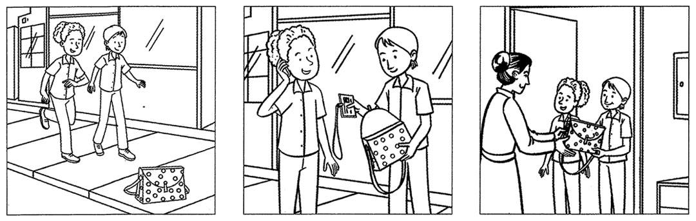

**Write about 60-80 words**.

..........................................................................................................................................................................................................................................................................................................................................................................................................................................................................................

..........................................................................................................................................................................................................................................................................................................................................................................................................................................................................................

..........................................................................................................................................................................................................................................................................................................................................................................................................................................................................................

..........................................................................................................................................................................................................................................................................................................................................................................................................................................................................................

...............................................................................................................................................................................................................................................................................................................................................................................................................................................................................................

..........................................................................................................................................................................................................................................................................................................................................................................................................................................................................................

.............................................................................................................................................................................................................................................

.............................................................................................................................................................................................................................................

..........................................................................................................................................................................................................................................................................................................................................................................................................................................................................................

..........................................................................................................................................................................................................................................................................................................................................................................................................................................................................................

..........................................................................................................................................................................................................................................................................................................................................................................................................................................................................................

.............................................................................................................................................................................................................................................

............................................................................................................................................................................................................................................

THE END.