UBND THỊ XÃ CAI LẬY **KỲ THI CHỌN HỌC SINH GIỎI CẤP THỊ XÃ**

**TRƯỜNG THCS TÂN BÌNH NĂM HỌC 2022-2023**

*(Đề thi có 06 trang)* Môn: **TIẾNG ANH**

Thời gian: **150** phút *(không kể thời gian giao đề)*

**SECTION I: LISTENING (3.0 points) (You will hear twice for each part)**

PART 1. (1.0 pt) You will hear five short conversations.

You will hear each conversation twice.

There is one question for each conversation.

For questions 1-5, put a tick  under the right answer.

1. What is John going to do tonight?

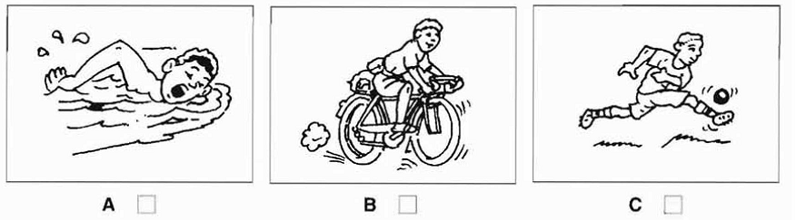

2. Which is Ben’s family?

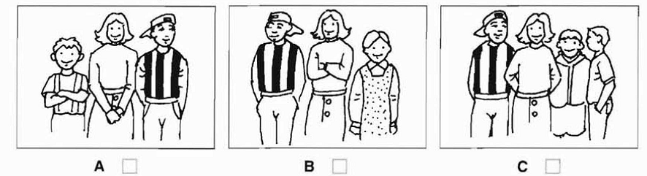

3. Which bag does the woman buy?

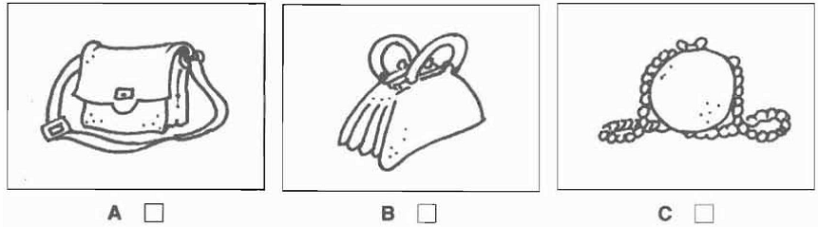

4. How much did the woman pay foe the apples?

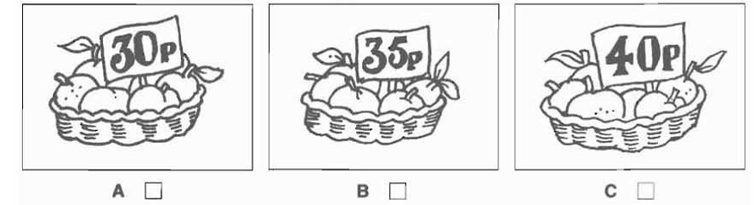

5. What time does the film start?

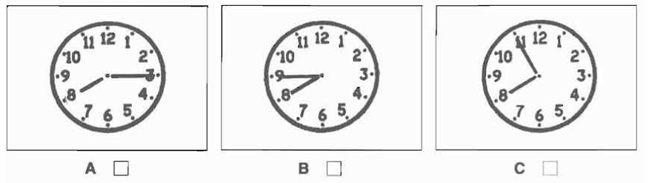

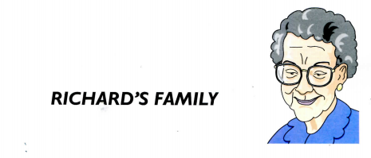PART 2 (1.0pt). Listen and write.

Oldest person: grandmother

6. Name: …………………………

7. Age: …………………………

8. Lives with: …………………………

9. Job: …………………………

10. Favourite hobby: …………………………

PART 3 (1,0pt):Listen to Amanda talking to a friend about a birthday party. Tick  A,B or C.

You will hear the conversation twice.

11. Which ice cream will they have at the party?

A. coffee  B. Lemon  C. apple 

12. Which is broken?

A. the CD player  B. the cassette recorder  C. the guitar 

13. Whose birthday is it?

A. Emma’s  B. Joan’s  C. Amanda’s sister’s 

14. What present has Amanda bought?

A. a camera  B. a video  C. a football 

15. What time should people arrive at the party?

A. 8 p. m  B. 8. 30 p. m  C. 9. 30 p. m 

**SECTION II. OTHER SKILLS (17pts):**

**PART 4. Choose the best option to complete the following sentences (3.0pts):**

16. Her ________to medicine was so great that she had little time for anything else

A. importance B. dedication C. emphasis D. reputation

17. If necessary, part of the responsibility is ________ by the internal security troops.

A. taken on B. taken over C. taken in D. taken up

18. I couldn't quite _______what they were doing because they were so far away.

A. bear out B. make out C. think out D. try out

19. The bank is reported in the local newspaper _______ in broad daylight yesterday.

A. to be robbed B. robbed

C. to have been robbed D. having been robbed

20. ________ pollution control measures are expensive, many industries hesitate to adopt them.

A. Although B. However C. Because D. On account of

21. Mr. Henry was given a medal in _______ of his service to his country.

A. gratitude B. knowledge C. recognition D. response

22. We are going to have a trip to Hanoi Capital. We need to________ arrangements for the trip carefully.

A. do B. make C. get D. pay

23. ________ that we had to ask a police officer for directions.

A. So confusing was the map B. was so confusing the map

C. The map was such confusing D. Such confusing was the map

24. By the end of this year, Chen __________ English for three years, but he will still need more training and experience before he masters the language.

A. will have been studying B. has been studying

C. has studied D. will be studying

25. It is necessary that a life-guard ________ the swimming pool while the children are taking their swimming lessons.

A. monitored B. monitors C. monitor D. monitoring

26. George wouldn't have met Mary________ to his brother’s graduation party.

A. hadn't he gone B. had he not gone

C. if he has not gone D. if he should not have gone

27. In spite of our big effort, we have not managed to _______ enough money for the renovation of the school buildings.

A. raise B. take C. rear D. score

28. She’s just bought three new dresses, _______ her if she gains weight.

A. none of them will fit B. that won’t fit

C. which none of them fit D. none of which will fit

29. Thomas received a warning for speeding. He _________ so fast.

A. shouldn’t have driven B. would have driven

C. should have driven D. might have driven

30. _______ learning a foreign language, John is smarter than Tim although they are twins.

A. On account of B. Instead of C. In terms of D. In place of

31. When a fire broke out in the Louvre, at least twenty _______ paintings were destroyed, including two by Picasso.

A. worthless B. priceless C. valueless D. worthy

32. I don’t remember ________ of your decision to change our vacation plan.

A. to tell B. being told C. telling D. to be told

33. Not having written about the required topic, ________ a low mark.

A. my presentation was given B. the teacher gives me

C. the teacher gave me D. I was given

34. I’d rather you _______at my party last night.

A. be B. were C. had been D. have been

35. I know it’s not a huge corporation to work for - but it’s better to be __________.

A. other fish to try B. a big fish in a small pond

C. a fish out of water D. plenty more fish in the sea

**PART 5**: **Use the correct form of the word in brackets to complete each sentence(2.0 pts)**

36. Most people who work feel that they are _____________ (pay)

37. I ______________how wide the stream was and fell in. (judge)

38. It was _________________of you not to offer her a drink. (hospitable)

39. He was ________________of the consequences in advance. (information)

40. He didn’t feel happy because he worked ___________________ (success).

41. Many people expressed ______________with the whole idea. (disagree)

42. English is a ________________easy language for Swedes to learn. (compare)

43. People can become infected after eating raw or ____________meat. (cook)

44. The factory’s _________has increased considerably in the past few years. (put)

45. I think it is very _____of him to expect us to work overtime every night this week.(reason)

**PART 6**: **Each of the following sentences has an error. Find the errors and correct them (1.0pt)**

46. Mary bought her mother a twenty-inches television last week.

47. He knows to repair the carburetor without taking the whole car apart.

48. Please remain in your assign seats until the instructor dismisses the class.

49. If one does not have respect for himself, you cannot expect others to respect him.

50. Japanese initially used jeweled objects to decorate swords and ceremonial items.

**PART 7*.* Read the passage and choose the best option to complete the passage. Write your answers in the space provided. (2.0 points)**

**Sound Advice for Language Learners**

            A recent issue of a language learning magazine has consulted a number of experts in the (51) ____ of second language acquisition. Their advice may prove invaluable for those (52)____ a language course. One suggestion is that you (53) ____  whether you are likely to be successful at learning a language? Did you enjoy studying languages at school, for example? Do you have enough time to learn a language? The major (54)____will be your own time and effort. Therefore, you must be sure that the course on offer leads to a (55)_____ qualification. Also, be realistic in your (56)______. If you don't set achievable aims, you are more likely to give up. Do not be deceived (57)______thinking that the most expensive courses are the best. (58) ______ around to get the best possible value for money. You should also bear in mind that the quicker you learn a language, the more quickly you forget it. Sandra Miller, a French teacher, tried to teach herself German by enrolling on a (59)______course. Already fluent in four languages and with a sound knowledge of teaching methodology her chances of (60)______ progress were high. Three years on she remembers very little. She feels her biggest mistake was not to follow up her first experience. "I should have consolidated what I'd learn by continuing to study, even if it were by myself."

51. A. branch B. field C. area D. domain

52. A. wondering B. thinking C. looking D. considering

53. A. assess        B. review C. balance D. survey

54. A. chance    B. cost C. price D. evaluation

55. A. recognized  B. understood C. valued D. regarded

56. A. sights        B. ends C. objects D. goals

57. A. by             B. about C. into D. in

58. A. nose        B. push C. run D. shop

59. A. rapid         B. crash C. quick D. Fast

60. A. achieving         B. doing C. making D. gaining

**PART 8.Read the following passage and choose the best answer to each question.(1.0pt)**

For centuries, sky watchers have reported seeing mysterious flashes of light on the surface of the Moon. Modern astronomers have observed the same phenomenon, but no one has been able to satisfactorily explain how or why the sporadically sparks. However, reaearches now believe they have found the cause.

Researchers have explained the chemical content of Moon rocks retrieved by astronauts during the Apollo missions and have found that **they** contain vlatile gases such as helium, hydrogen and argon. The researchers suggest that stray electrons, freed when the rock crakcs, may ignite these gases. Indeed, lunar rock samples, when fractured in the lab, throw off sparks.

What causes these rocks to crack to the lunar surface? The flashes are most often seen at the borders between sunlight and on the Moon, where the surface is being either intensively heated or cooled. A sudden change in temperature may cause thermal cracking. Another possibility is that meteors may stike the rocks and cause them to crack. Finally, lunar rocks may be fractured by seismic events- in other words, by tiny moonquakes.

61. According to`the passage, how long have people been aware of the mysterious light on the Moon?

A. For the last ten years

B. Since the Apollo missions

C. For hundreds of years

D. For thousands of years

62. According to the passage, the theory that Moon rocks give off sparks when they crack is supported by………………………………….

A. a telescopic study of the Moon.

B. experiments conducted by astronauts

C. observations made centuries ago

D. an analysis of rocks from the Moon

63. Which of the following can be inferred from the text?

A.Modern astronomers have found out how and why the Moon sparks

B. Researchers now know exactly why the Moon sparks

C.When lunar rocks crack, they throw off sparks.

D. Researchers have no idea why lunar rocks spark.

64. The word **“they”** in the second paragraph refers to………….

A. Moon rocks B.researchers C.Apollo missions D. gases

65.Which of the following is **NOT** mentioned as a possible cause of cracks?

A. a sudden change in temperature

B. lunar surface

C. tiny moonquakes

D. meteor strike

**PART 9.Fill in each numbered blank with ONE suitable word. (2.0 points)**

Doctors have reported that vitamins are substances required for the proper functioning of the body. In this century, thirteen vitamins have been (66)­ _________. A lack of any vitamins in a person’s body can cause (67) _________. In some cases, an excess of vitamins can also (68)­­ _________ to illness. For example, sailors in the past were prone to suffer from scurvy that is a disease resulting (69) _________ the lack of vitamin C. It causes bleeding of the gum, loss of teeth and skin rashes. Sailors suffer from scurvy because they did not eat fruits and vegetables. Fruits and vegetables (70) _________ vitamin C which is necessary for good (71) _________.

Vitamin B complex is composed of eight different vitamins. A lack of any of these vitamins will lead to different (72) _________. For instance, a person who has too little vitamin B1 will suffer from beriberi, a disease that (73) _________ heart problems and mental disorders. A lack of vitamin B2 results in eye and skin problems while deficiency of vitamin B6 causes problems of the nervous system. Too little vitamin B12 will cause anemia. The knowledge that vitamin deficiencies caused certain diseases led doctors to cure people suffering from these illnesses by giving them doses of the (74) _________ vitamins.

Today, vitamins are available in the form of pills and can easily be (75) _________ at any pharmacy.

**PART 10. Fill in each blank with a suitable preposition.(1.0pt)**

76. John and Mary used to fall ________a lot and they eventually split up.

77. He presented the award to me on behalf _________the community club.

78. Can you give us some information ______________bus tours, please?

78. For security reasons, you have to check ________two hours before your flight.

80. She nearly freaked _______when she saw the colour of her hair. It was a disaster!

**PART 11*.* Finish the second sentence in each pair in such a way that it means the same as the** **sentence before it. (1.0 point)**

81. While I strongly disapprove of your behavior, I will help you this time.

→ Despite my .

82. I only realised that I had forgotten to close the door when she told me.

→ Only when .

83. Despite Jack’s strange clothes, everybody ignored him.

→ Nobody took .

84. We will not delay our voyage whether there is a rain or not.

→ Regardless .

85. To pass the time, I looked through some magazines.

→ I whiled .

**PART 12.Complete the second sentence, using the word given in bold. Do not change the word given. You must use between two and five words, including the word given. (1.0 pt)**

86. You’d feel better if you had a quiet holiday. **(DO)**

→ A quiet holiday_________________________________________

87. By chance I was in that town when the earthquake started. **(HAPPENED)**

→ I _______________________________that town when the earthquake started.

88. Despite knowing this place very well, I got lost. **(THOUGH)**

→ I got lost__________________________________________very well.

89. Were Jack not so affluent a man, she would not be dating with him. **(BUT)**

→ ____________________________________, she would not be dating with him.

90. They listened eagerly and attentively to the President’s speech. **(EARS)**

→ They________________­­___________________ to the President’s speech.

**PART 13*.* Some people say that cell phones have improved modern life. Others believe that cell phones have caused many problems to people. What is your opinion? In about 120-150 words write an esay to assert your point of view on this issue. (3.0 pts)**

**___The end___**