School: ……………………………………….. | Date:……………………………………..
Class: ……………………………..................... | Period: 43

UNIT 4: FREE TIME
Lesson 2.3 – Pronunciation & Speaking, pages 40 & 41
1. Objectives
By the end of this lesson, students will be able to…
1.1. Language knowledge/ skills
- practice sentence stress
- give advice on what to do in a disaster, using prepositions of place and movement and conversation skill - Working through tasks in groups.
1.2. Competences
- improve Ss’ communication, collaboration, analytical, critical thinking skills.
1.3. Attributes
- know what to do/ not to do before and during a disaster.
2. Teaching aids and materials
- Teacher’s aids: Student’s book and Teacher’s book, class CDs, DCR– Phần mềm tương tác trực quan, DHA – Ứng dụng trò chơi tương tác, projector / interactive whiteboard /TV (if any), PowerPoint slides.
- Students’ aids: Student’s book, Workbook, Notebook.
3. Assessment Evidence
Performance Tasks | Performance Products | Assessment Tools
- Listen and cross out the sentence that doesn't have stress on shouldn’t.  - Take turns asking and answering about safety tips. Say at least two tips to prepare for and one tip to do during disasters.  - Make a poster with safety tips for disasters.  - Present your posters and decide which one would be the most useful in your area. | - Ss’ answers.  - Ss’ answers.  - Ss’ answers.  - Ss’ answers. | - Observation.  - Observation.  - Observation.  - Observation.
4. Procedures
A. Warm up: 5 minutes
a. Objective: to review lesson 2.2 and lead in the new lesson.
b. Content: speaking activity.
c. Expected outcomes: Ss can talk about their schedule on the weekends.
d. Organization
Teacher’s activities | Students’ activities
Speaking activity.  - Ask Ss to discuss in their group what they should/shouldn’t do when there is a bad storm.  - Give Ss three minutes.  - Go around to help if necessary.  - Pick some groups to share their ideas.  - Give feedback. | - Discuss in their group what they should/ shouldn’t do when there is a bad storm  -Share their ideas.
B. New lesson (35’)
1. Pronunciation: 10’
a. Objective: to help Ss stress shouldn’t correctly.
b. Content: task a, b, c & d.
c. Expected outcomes: Ss can stress shouldn’t correctly when giving negative advice.
d. Organization
Teacher’s activities | Students’ activities
Task a:  - Write some examples on the board:  You shouldn't open the door.  We shouldn't try to swim.  -Ask Ss to underline the word they put the stress on.  - Give feedback.  - Say that we put the stress on shouldn’t when giving negative advice.  Task b:  - Ask Ss to listen to the words and focus on  the underlined letters (using the IWB).  You shouldn't open the door.  We shouldn't try to swim.  - Gets Ss to listen again and repeat chorally.  - Pick some Ss to say the words individually and correct their pronunciation if necessary.  Task c: Listen and cross out the sentence that doesn't follow the note in "a.".  We shouldn't try to drive.  You shouldn't go to the beach.  - Ask Ss to listen and cross out the one that doesn’t have stress on shouldn’t.  - Pick some Ss to give the answers.  - Check their answers.  - Get Ss to listen again and repeat.  Task d: Read the sentences with the sentence stress noted in "a." to a partner.  - Ask Ss to work in pairs, reading the sentences to their partners with the correct stress.  - Pick some students to say the sentences and correct their pronunciation if necessary. | - Underline the word they put the stress on.  Answer keys  You shouldn't open the door.  We shouldn't try to swim.  -Listen to the words and focus on  the underlined letters.  -Listen again and repeat  - Listen and cross out the one with the different sound  - Give their answer  Answer Keys:  You shouldn’t go to the beach. -- Wrong. (The stress is on go)  -Listen again and repeat.  -Work in pairs, reading the sentences to their partners with the correct stress.
2. Practice: 15’
a. Objective: to help Ss practice talking about safety tips.
b. Content: task a & b
c. Expected outcomes: Ss can give advice on how to prepare for a disaster and how to keep safe during a disaster.
d. Organization:
Teacher’s activities | Students’ activities
Task a: Take turns asking and answering about safety tips. Say at least two tips to prepare for and one tip to do during disasters. Pass your turn for the next disaster.  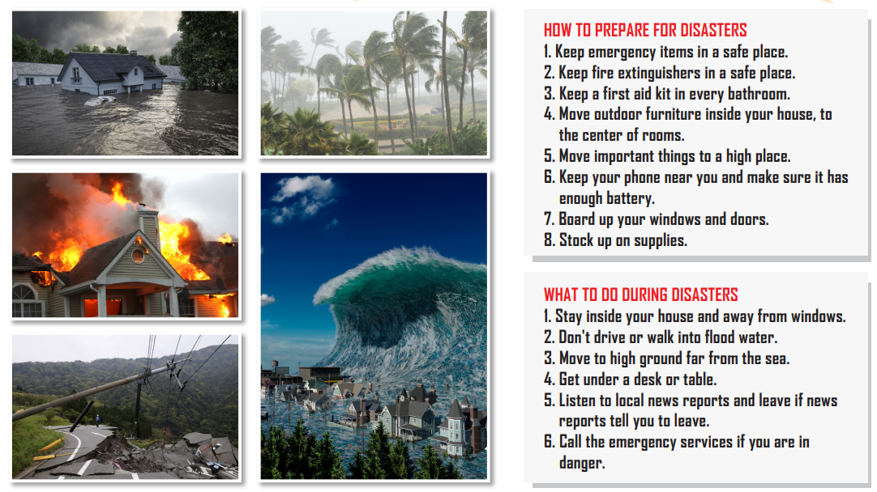  - Ask Ss to work in pairs, take turns asking and answering about safety tips. Say at least two tips to prepare for and one tip to do during disasters.  - Go around and help if necessary.  - Pick some pairs to share their ideas.  - Give feedback. | -Work in pairs, take turns asking and answering about safety tips. Say at least two tips to prepare for and one tip to do during disasters.  Sample Answer:  A: How should you prepare for a flood?  B: You should keep emergency items in a  safe place and keep your phone near you  and make sure it has enough battery.  A: What should you do during a flood?  B: You shouldn't drive or walk into flood water.
Task b: Practice with your own ideas.  - Ask Ss to work in pairs to take turns asking and answering about safety tips, using their own ideas.  - Pick some pairs to perform their conversations.  - Give feedback. | -Take turns asking and answering about safety tips, using their own ideas.  Sample Answer:  A: How should you prepare for a wildfire?  B: You should keep fire extinguishers in a safe place, and keep a first aid kit in every bathroom.  A: What should you do during a wildlife?  B: You should call the emergency services if you are in danger.
3. Speaking: 10’
a. Objective: to help Ss practice talking about what to do in a disaster.
b. Content: task a, b.
c. Expected outcomes: Ss can talk about what they should/shouldn’t do in a disaster.
d. Organization:
Teacher’s activities | Students’ activities
Task a: You're making a poster with safety tips for disasters. In pairs: Discuss what you should (or shouldn't) do before and during disasters. Then, choose one disaster and make a poster with the three best safety tips for that disaster.  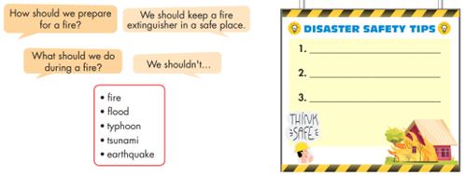  - Ask Ss to discuss what they should (or shouldn't) do before and during disasters, then choose one disaster and make a poster with the three best safety tips for that disaster.  -Give Ss some time to discuss and make their poster.  - Go around to help if necessary. | - Discuss what you should (or shouldn't) do before and during disasters, then choose one disaster and make a poster with the three best safety tips for that disaster.
Task b: Join another pair. Present your posters and decide which one would be the most useful in your area.  - Ask Ss to join another pair, present their posters and decide which one would be the most useful in their area.  - Go around to help if necessary.  - Pick some Ss to present their posters.  - Give feedback. | -Join another pair, present their posters and decide which one would be the most useful in their area.  -Present their posters  Sample answer:  We have three tips for fire safety. First, you should…
C. Consolidation and homework assignments: 5’
- Pronunciation: Stress shouldn't for negative advice
- Prepare the next lesson: Lesson 3.1 – Reading & Writing, pages 42 & 43

5. Reflection
a. What I liked most about this lesson today:
…………………………………………………………………………………………
b. What I learned from this lesson today:
…………………………………………………………………………………………
c. What I should improve for this lesson next time:
…………………………………………………………………………………………

